FDDA. Supplementary table and figures

Supplementary Table 1. Results for pre-defined endpoints
EP No. | Endpoints | FDDA (n=40) vs  Usual care (n=53) | p-value
(1) P | PGIC at 3 months, 7-point scale, Mean (95%CI, range) | 2.7 (95%CI: 2.34-3.07, range: 1-6) vs. 2.6 (95%CI: 2.33-2.96, range: 1-5) | 0.802
(2) S | PGIC at 6 months 7-point scale, Mean (95%CI, range) | 2.6 (95%CI: 2.30-2.83, range: 1-4) vs. 2.5 (95%CI: 2.26-2.82, range: 1-5) | 0.890
(3) S | Patients experiencing a reduction in fatigue ≥1 point on a 1-10 scale, at 3 or 6 months,* % | 97.4(37/38 ) vs. 78.4(40/51) | 0.011
(4) S | Time until an improvement of fatigue1 point on a 1-10 NRS, Median (Q1,Q3) | 14.0 (10,21) vs. 14.0 (7,21) | 0.741
(5) S | Mean number of points of fatigue reduction on a 1-10 NRS, Mean (range) | -2.0 (-6-1) vs. -2.1 (-7-1) | 0.885
(6) S | Patients with a PGIC response (=any improvement), %  at 3 months  at 6 months  at 3 or 6 months | 78.4(29/37) vs. 78.6(33/43)  89.2(33/37) vs. 84.0(42/50)  92.1(35/38) vs. 94.1(48/51) | 1.000  0.546  1.000
(7) S | PCP’s confidence in the established diagnosis**, Mean (range)  Month 1  Month 3 | 0.7 (0-3) vs. 0.8 (0-3)  0.6 (0-2) vs. 0.6 (0-3) | 0.609  0.750
(8) S | PCP’s assessment of patient improvement (CGIC response), Mean (range)  Month 1  Month 3 | 3.1 (2-5) vs. 2.9 (1-4)  2.7 (1-6) vs. 2.4 (1-4) | 0.318  0.231
(9a) S | Patients satisfied or very satisfied with diagnosis ***, %  Month 1  Month 2  Month 3  Month 6 | 50.0(19/38) vs. 29.8(14/47)  50.0(19/38) vs. 40.0(20/50)  45.9(17/37) vs. 31.7(13/41)  64.9(24/37) vs. 52.0(26/50) | 0.074  0.391  0.246  0.276
(9b) S | Patients satisfied or very satisfied with  treatment ***, %  Month 1  Month 2  Month 3  Month 6 | 56.8(21/37) vs. 25.0(12/48)  44.7(17/38) vs. 36.0(18/50)  64.9(24/37) vs. 31.0(13/42)  59.5(22/37) vs. 48.0(24/50) | 0.004  0.510  0.003  0.385
(10) S | PCP-reported visits per patient for the same condition (fatigue), last available value, n (median Q1,Q3) | 4.0 (3,4) vs. 3.0 (3,4) | <0.001
(11) S | Referrals (Imaging (MRI, X-ray, etc.) or other health services, n | Free text data. Not analysable
(12) S | Time to final diagnosis,**** [days], Median(Q1,Q3)  Month 1  Month 3 | 8.0(4,30) vs. 7.0(2,28)  14.0(7,30) vs. 7.0(2,30) | 0.499  0.060
CGIC, Clinical global impression of change; EP, endpoint; NRS, numerical rating scale; PCP, primary care practitioner; PGIC, Patient global impression of change; P, primary; S, secondary
* A patient experiencing a fatigue reduction ≥1 point 3 or 6 months after the first visit, if at least at one visit was made (either at V4 or V5), was reported.
** The PCP expressed confidence in established diagnosis on a scale from 0 to 4: 0="valid"; 1="probably"; 2="possible"; 3="maybe"
*** Patient satisfaction was measured on a scale from 0 to 4: 0='Very unsatisfied'; 1='Unsatisfied'; 2='Neutral'; 3='Satisfied'; 4='Very satisfied'.
**** Physician-reported number of days at 1 and 3 months.

Supplementary Figure 1. Patient treatment patterns at 1 and 3 months.

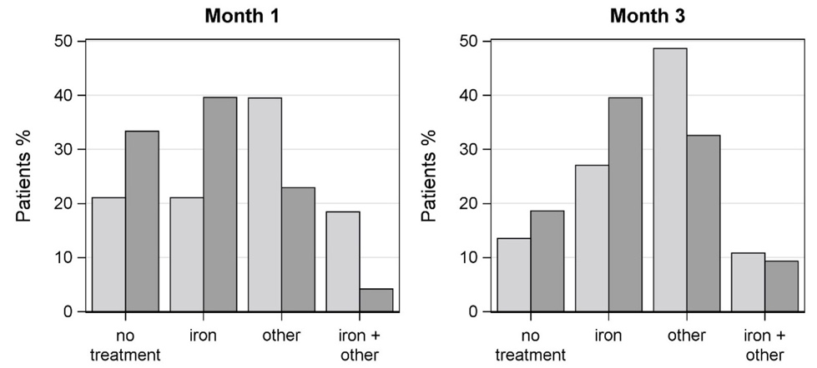

Patient treatments at 1 and 3 months. Light grey bars: FDDA. Dark grey bars: usual care.
Use of the Fatigue Differential Diagnostic Aid resulted in less patients receiving no treatment or iron treatment at 1 and 3 months, but receiving more other, non-iron replacement treatments, such as vitamins + micronutrients, natural medicine, lipid lowering, sleep, thyroid gland, depression, asthma, antibiotics.

Supplementary Figure 2. Classification of treatments delivered against fatigue at 1 month.

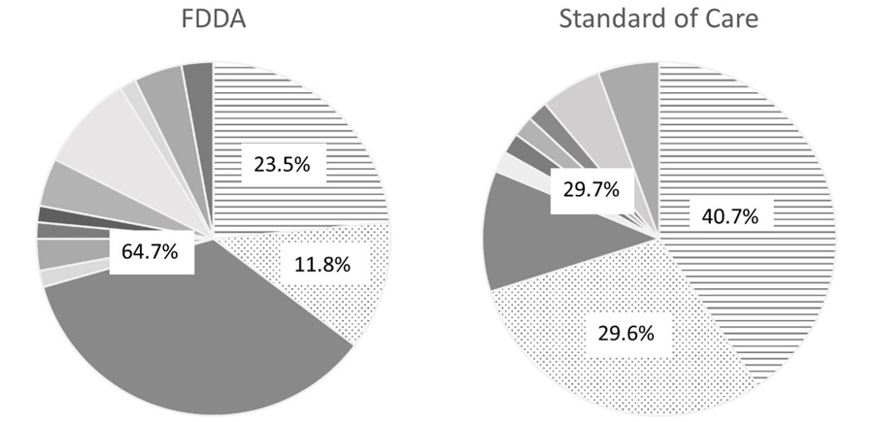
Dotted shading: no treatment. Striped shading: iron replacement therapy. Block shaded grey areas: non-iron replacement treatments, such as vitamins + micronutrients, natural medicine, lipid lowering, sleep, thyroid gland, depression, asthma, antibiotics.
Use of the Fatigue Differential Diagnostic Aid resulted in less patients receiving no treatment or iron treatment at 1 month, but in more patients receiving other, non-iron replacement treatments.

Supplementary Figure 3. Classification of treatments delivered against fatigue at 3 months.

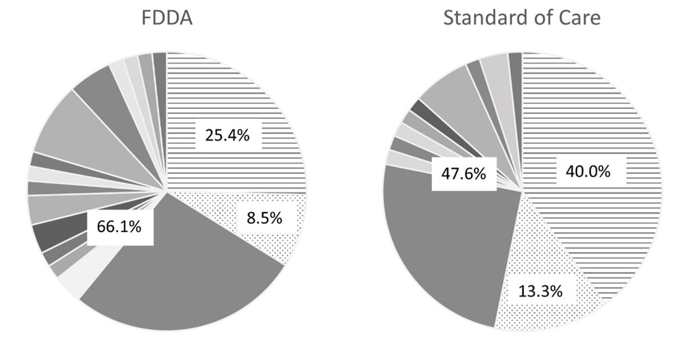

Dotted shading: no treatment. Striped shading: iron replacement therapy. Block shaded grey areas: non-iron replacement treatments, such as vitamins + micronutrients, natural medicine, lipid lowering, sleep, thyroid gland, depression, asthma, antibiotics.
Use of the Fatigue Differential Diagnostic Aid resulted in less patients receiving no treatment or iron treatment at 3 months, but in more patients receiving other, non-iron replacement treatments.

