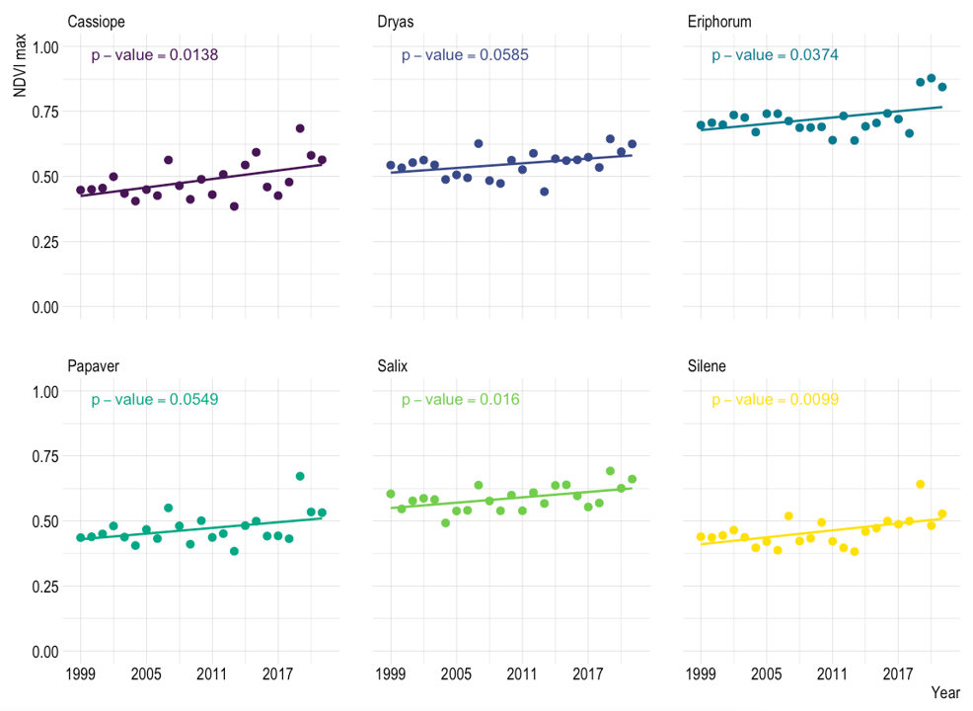
Figure S1. Trends in annual maximum NDVI for 6 different ecotypes across the Zackenberg valley. (a) Cassiope (p=0.014, n=4908), (b) Dryas (p=0.0585, n=6373), (c) Eriphorum (p=0.0374, n=4493), (d) Papaver (p=0.0549, n=2428), (e) Salix (p=0.016, n=8325), (f) Silene (p=0.0099, n=3804).
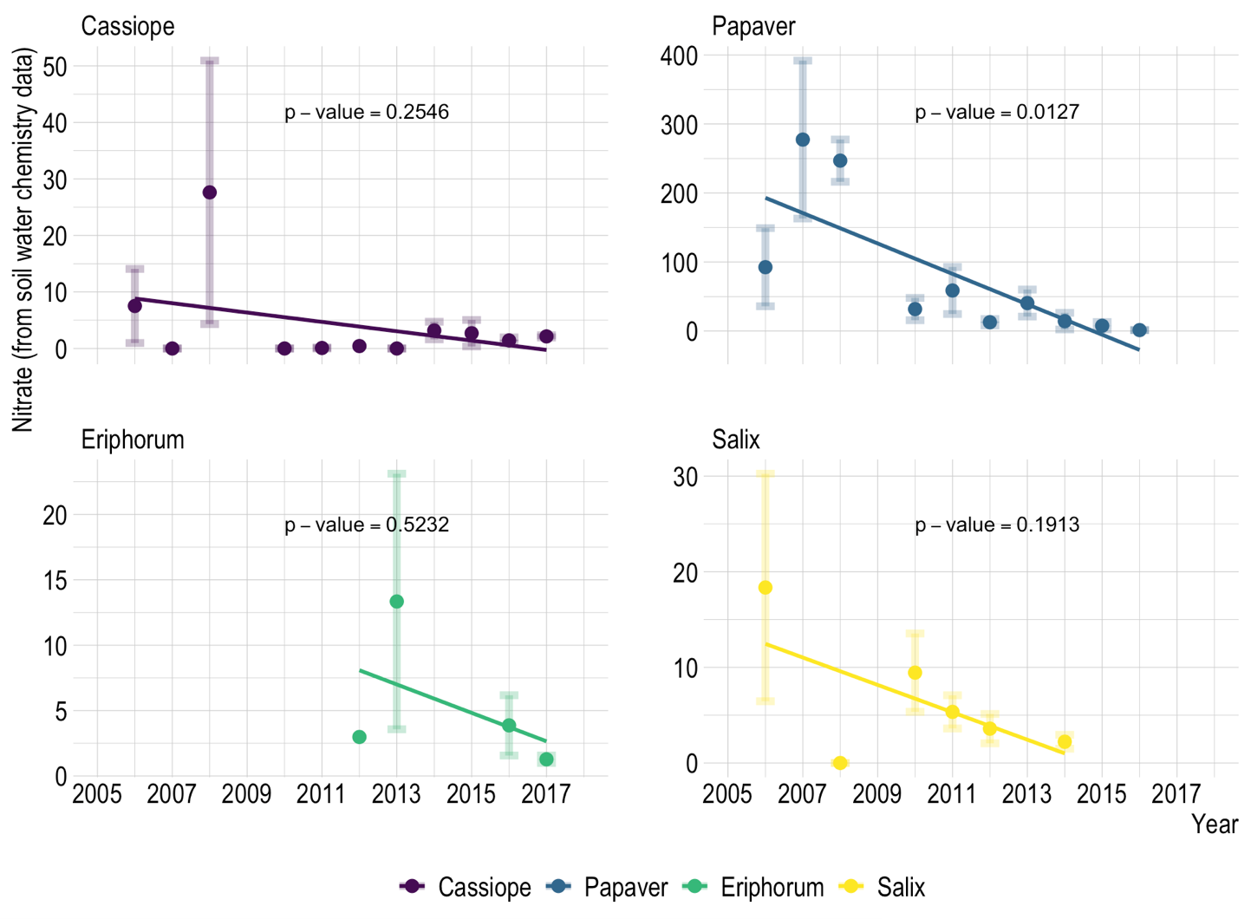
Figure S2. Decadal trends in soil water nitrate for 4 different ecotypes across the Zackenberg valley. (a) Cassiope (p=0.2546, n=55), (b) Papaver (p=0.0127, n=36), (c) Eriphorum (p=0.5232, n=17), (d) Salix (p=0.1913, n=27).

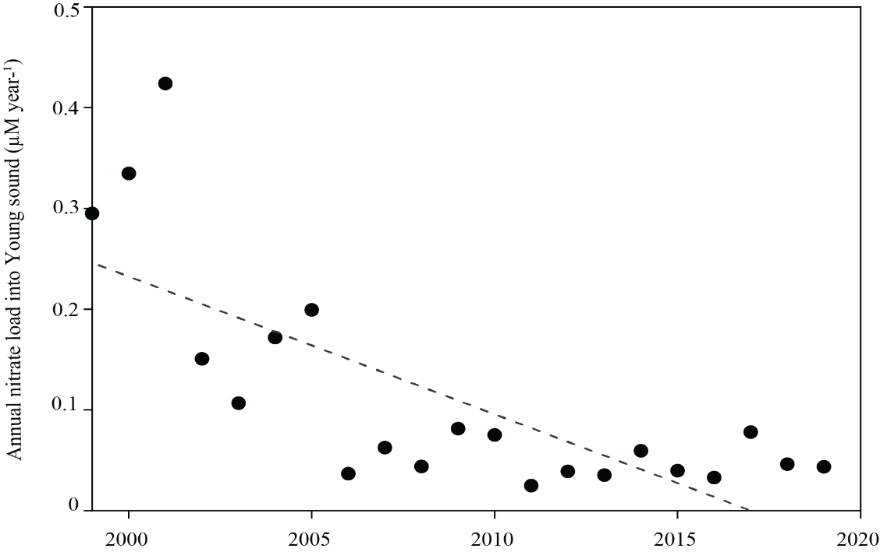
Figure S3. Annual nitrate load into the Young Sound fjord. The total mean annual nitrate river fluxes mixed into a fjord the size of Young Sound (0–50m) over 1999–2020 (slope:-0.0135 µM per year, p=0.0001, n=21).

