Supplementary Data

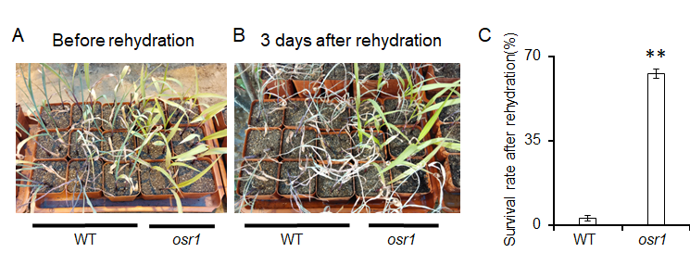
Fig. S1 Morphological phenotype and survival rate of osr1 and WT under osmotic stress and rehydration.
(A) Growth state of osr1 and WT seedlings treated with mannitol for 3 weeks after germination. (B) Growth state of osr1 and WT seedlings 3 days after rehydration. (C) Survival rate of osr1 and WT treated with mannitol after rehydration. Data are means ± SD, n > 50 for three independent experiments (Student's t-test, ** P < 0.01).

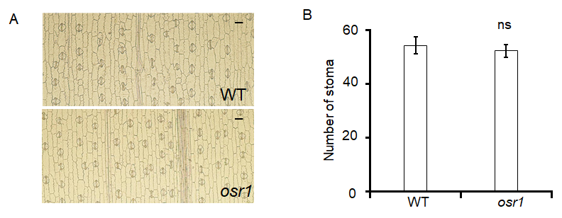
Fig. S2 Stomatal morphology and stomatal density of the WT and osr1.
(A) Compare of stomatal morphology of WT and osr1. Scale bars, 50μm. (B) Stomatal density of WT and osr1. Three independent micrographs were examined, each value representing the mean (± SD), with error bars indicating SD (Student's t-test, ns, not significant, P > 0.05).

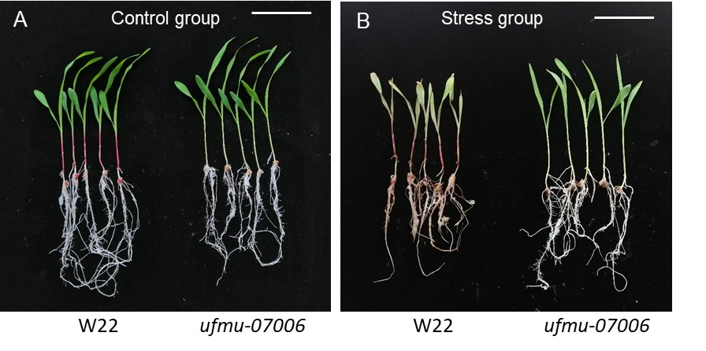
Fig. S3 Morphologic phenotypes of W22 and ufmu-07006 seedlings at age of two weeks.
(A) Morphological phenotype of W22 and ufmu-07006 under normal growth conditions. (B) Morphological phenotypes of W22 and ufmu-07006 treated with 100 mM mannitol. Scale bar, 5 cm.

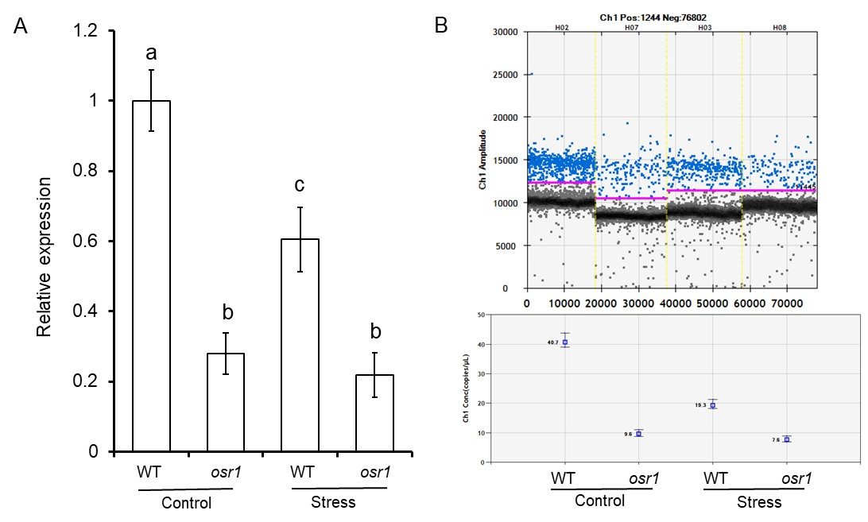
Fig. S4 Expression level of OSR1 in WT and osr1.
The results of qPCR (A) were similar to those of digital PCR (B). Relative expression of OSR1 was downregulated in WT but showed no significant change in osr1 under mannitol treatment. The relative expression of OSR1 in the mutant was significantly lower than that in the WT in both the control group and the stress group. Bars represent the mean values (±SD) of three individual basins of plants per treatment. Different letters indicate groupings of statistical differences at P < 0.01 (one-way ANOVA analysis).

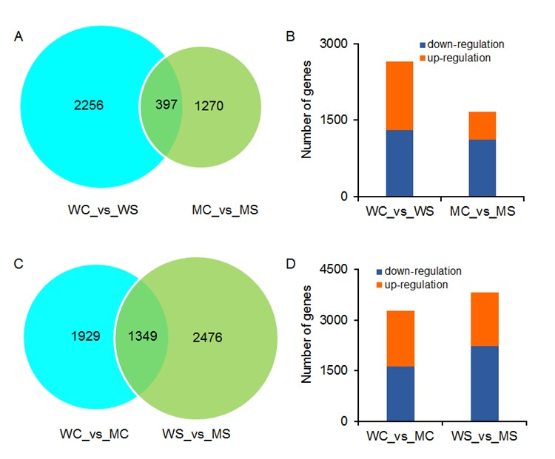
Fig. S5 Differentially expressed genes (DEGs) under normal and stress conditions in osr1 and WT.
(A) and (B) represent the number of DEGs between different groups. (C) and (D) represent up-regulated and down-regulated DEGs between different groups. WC_vs_WS for DEGs in WT between control group and stress group. MC_vs_MS for DEGs in osr1 between control group and stress group. WC_vs_MC for DEGs in control group between WT and osr1. WS_vs_MS for DEGs in stress group between WT and osr1.

Fig. S6 GO enrichment analysis of DEGs.
Enriched GO process terms for DEGs by fold-change in expression (p-value < 0.05, log₂ ^{(fold change)} > 1 or < -1), in the four groups of WC_vs_WS and MC_vs_MS with REVIGO software. The vertical axis represents different pathways and the horizontal axis represents the number of DEGs. (A) Different pathways enriched for DEGs between control group and osmosis stress group in WT. (B) Different pathways enriched for DEGs between control group and osmotic stress group in osr1. (C) Different pathways enriched for DEGs between WT and ors1 under normal condition. (D) Different pathways enriched for DEGs between WT and ors1 under osmotic stress condition.

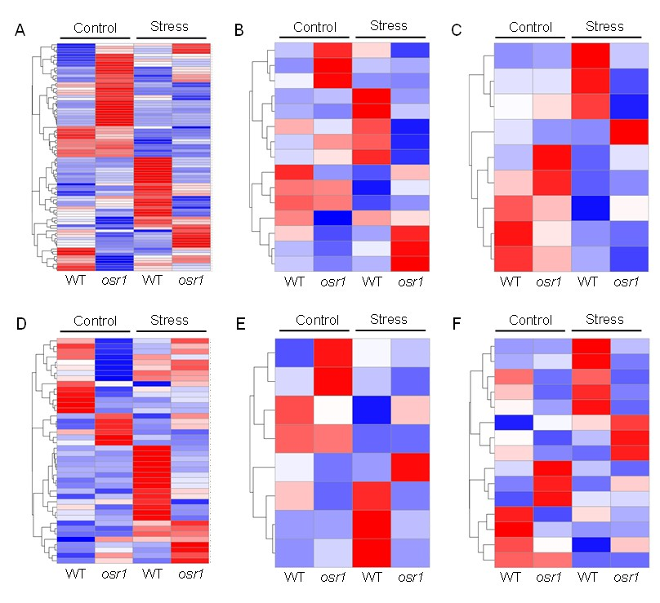
Fig. S7 Clustering of DEGs enriched in the pathway that is unique either to WT or osr1 pathways.
(A) Represents DEGs enriched in the pathway of abiotic stimulus. (B) Represents external stimulus. (C) Represents oxylipin metabolic process. (D) Represents hydrogen peroxide catabolic process. (E) Represents positive regulation of response to stimulus. (F) Represents regulation of response to stress.

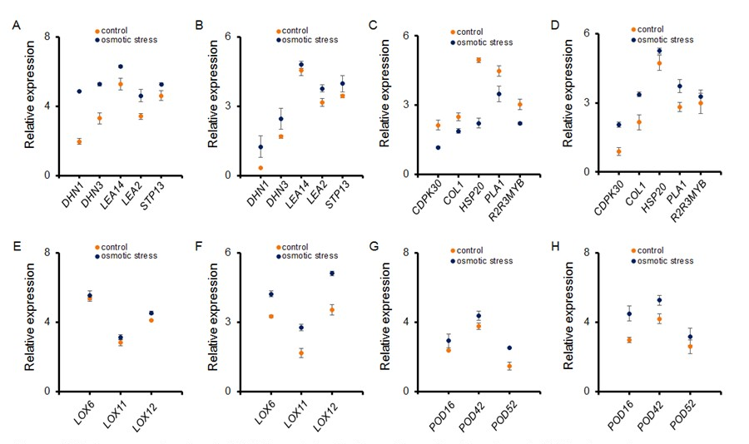
Fig. S8 The expression level of DEGs enriched in the pathway that is unique to WT or to osr1.
(A), (B), (C) and (D) represent the expression levels of DEGs in the pathway unique to WT. (E), (F), (G) and (H), represent the expression levels of DEGs in the pathway unique to osr1. (A), (C), (E) and (G) represent the expression levels of DEGs in WT. (B), (D), (F) and (H) represent the expression levels of DEGs in osr1. The data represent mean values (±SD) of three individual basins of plants per treatment.

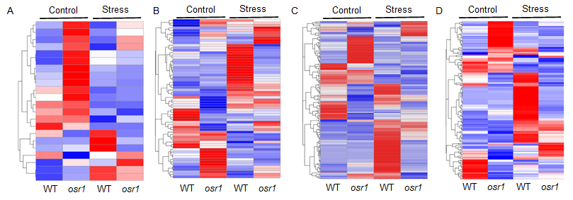
Fig. S9 Clustering of DEGs enriched in the pathways shared by WT and osr1 under normal or stress conditions.
(A) DEGs enriched in the pathway of abscisic acid. (B) Represents oxidative stress. (C) Represents hydrolase activity. (D) Represents hydrolyzing O-glycosyl compounds, hydrolase activity, acting on glycosyl bonds.

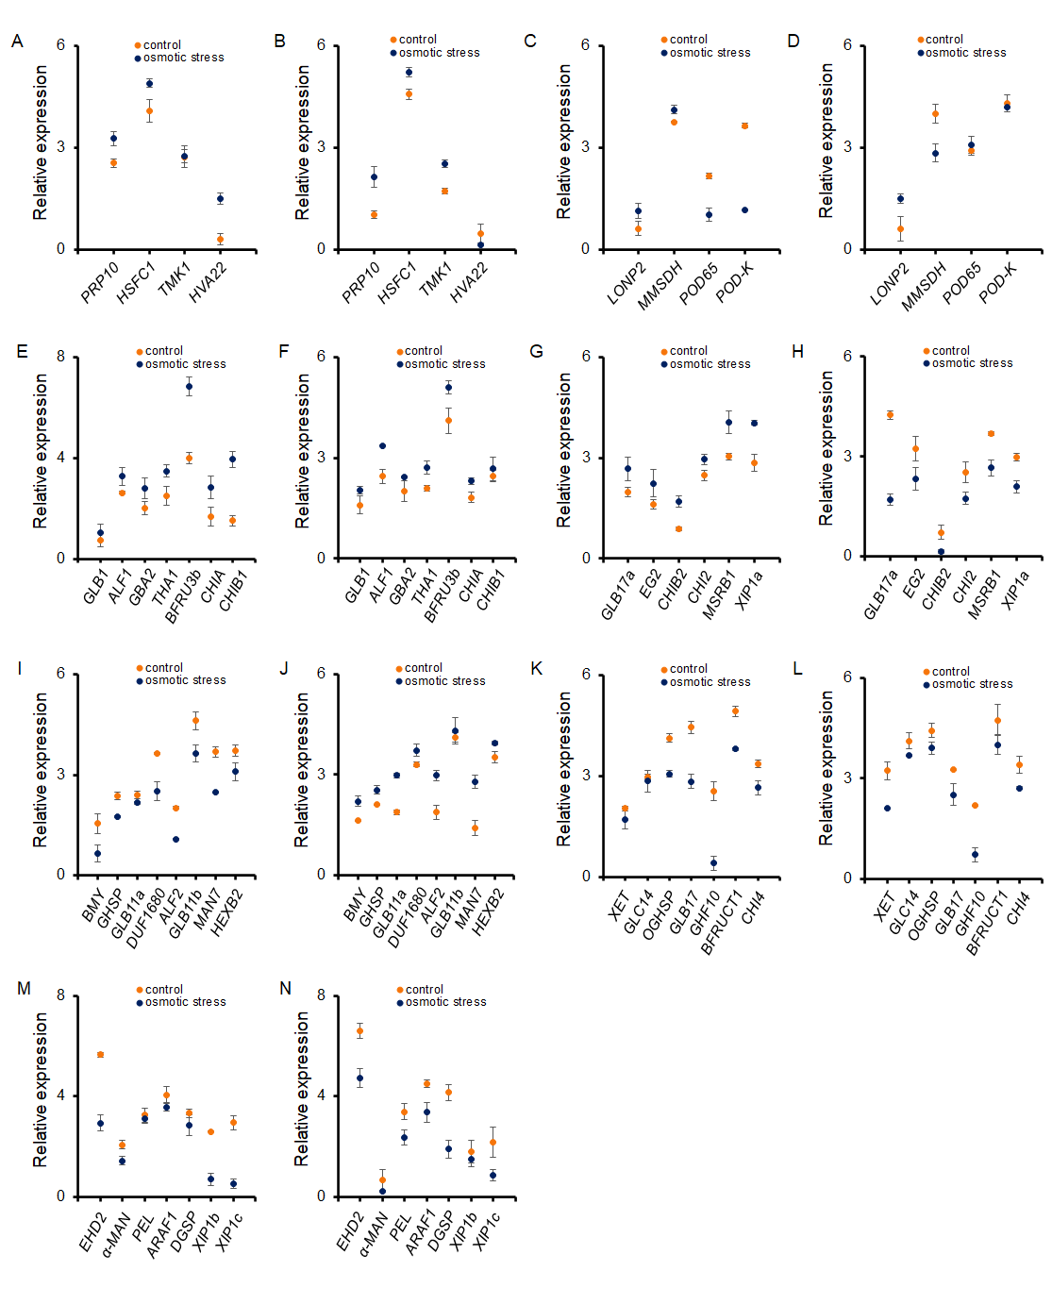
Fig. S10 The expression level of DEGs enriched in the pathway shared by WT and osr1 under normal or stress conditions.
(A) and (B) represent DEGs in the pathway of abscisic acid. (C) and (D) represent oxidative stress. (E)-(G) hydrolase activity, hydrolyzing O-glycosyl compounds and hydrolase activity, acting on glycosyl bonds. (A), (C), (E), (G), (I), (K) and (M) represent the expression levels of DEGs in WT. (B), (D), (F), (H), (J), (L) and (N) represent the expression levels of DEGs in osr1. The data represent mean values (±SD) of three individual basins of plants per treatment.

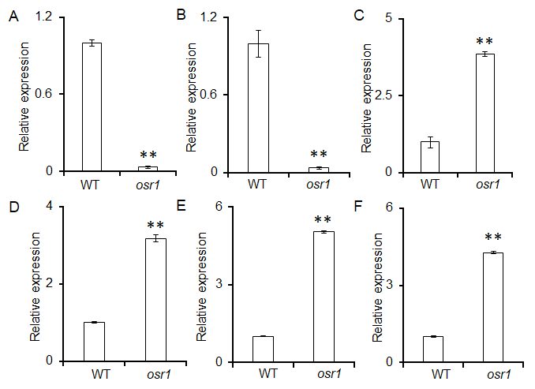
Fig. S11 Gene expression verification of RNA-Seq by qRT-PCR.
The relative expression of PP2C16a (A), PP2C16b (B), ARF3 (C), ASR3 (D), SUAR71a (E) and POD24 (F) determined by qRT-PCR were similar to the ones obtained by RNA sequencing. The values are means ± SD of three biological replicates (Student's t-test, ** P < 0.01).

