Supplementary Information

Photobiocatalytic Conversion of Solar Energy to NH₃ from N₂ and H₂O
under Ambient Condition

Nuttavut Kosem^{1*}, Yutaka Ohsaki², Xiao-feng Shen², Motonori Watanabe², Jun Tae Song² & Tatsumi Ishihara^{1,2*}
¹ Department of Applied Chemistry, Faculty of Engineering, Kyushu University, 744 Motooka, Nishi-ku, Fukuoka 819-0395, Japan.
² Mitsui Chemicals, Inc. Carbon Neutral Research Center (MCI-CNRC),
International Institute for Carbon-Neutral Energy Research (I²CNER), Kyushu University, 744 Motooka, Nishi-ku, Fukuoka 819-0395, Japan.

*Corresponding author
Nuttavut Kosem, Email: kosem_k@i2cnner.kyushu-u.ac.jp

Keywords: cyanobacteria, Anabaena variabilis, photobiocatalysis, nitrogenase, ammonia, solar-to-chemical conversion

Table of Contents
Page
Table S1 Chemical ingredients of BG11 and Allen & Arnon mediums……..……………….S3
Fig. S1 Morphology of cyanobacteria…………….…………………………………………..S4
Fig. S2 Cell density, chlorophyll a contents and heterocyst frequency…………………..……S5
Table S2 NH₃ production from different conditions of photobiocatalytic system …………....S6
Fig. S3 Various conditions of photobiocatalytic systems of NH₃ production…………………S7
Fig. S4 Cytotoxic effect of each component on cell viability of cyanobacteria…….………….S8

Table S1 Chemical compositions of BG11 medium and Allen & Arnon medium¹.
Chemicals | Concentration in medium (mg/L)
Chemicals | BG11 medium | Allen & Arnon medium
K₂HPO₄ | 29.6 | 268
MgSO₄ · 7H₂0 | 72.7 | 250
CaCl₂ · 2H₂0 | 34.9 | 75.0
NaCl | 0 | 250
KOH | 0 | 7.56
Ferric ammonium citrate | 5.82 | 0
Citric acid · 1H₂0 | 5.82 | 0
NaNO₃ | 255 | 0
FeSO₄ · 7H₂0 | 0 | 19.9
Na₂ EDTA · 2H₂0 | 0.97 | 29.7
MnCl₂ · 4H₂0 | 1.76 | 1.80
MoO₃ | 0.017 | 0.180
ZnSO₄ · 7H₂0 | 0.215 | 0.220
CuSO₄ · 5H₂0 | 0.077 | 0.079
H₃BO₃ | 2.77 | 2.86
CoCl₂ · 6H₂0 | 0.048 | 0.040
¹ H. Berberoğlu, J. Jay, L. Pilon, Int. J. Hydrog. Energy 33, 1172–1184 (2008).

Allen & Arnon medium is a nitrogen-deficient medium that can stimulate the differentiation of nitrogenase-expressing heterocysts in filamentous cyanobacteria, while BG11 medium with NaNO₃ as a nitrogen source is suitable for the propagation of vegetative cells.

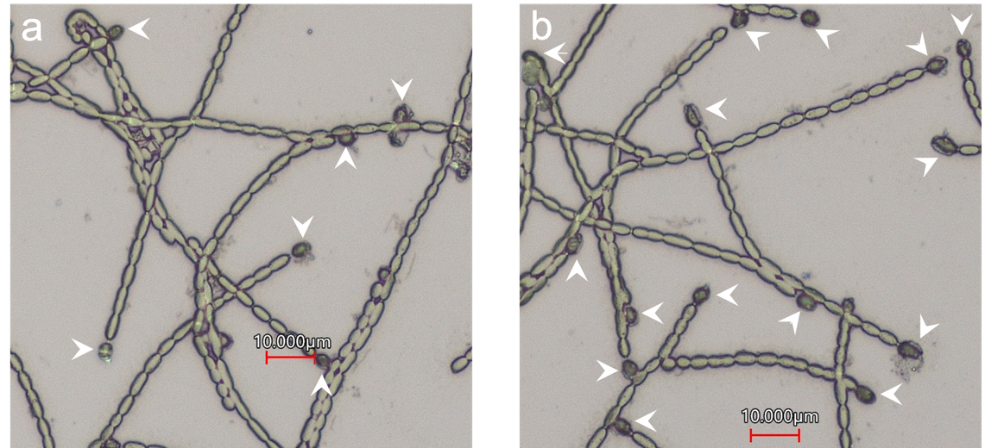

Fig. S1. Morphology of cyanobacterium A. variabilis cultivated in (a) BG11 medium and (b) Allen & Arnon (AA) medium under the light intensity of 5,000 Lux (68 μmol/m²/s) at 26°C and 140 rpm shaking incubator. The morphological structure was captured with a laser microscope at 1000 × magnification. Head arrows show the presence of heterocysts with thick cell envelopes. In this study, (a) cyanobacterial cells in BG11 medium show 6 heterocysts and 159 vegetative cells, while (b) Cyanobacterial cells in AA medium show 15 heterocysts and 135 vegetative cells.

Fig. S2. The effect of different culture mediums on (a) cell density at A₆₈₃ and (b) Chl a contents and (c) heterocyst frequency. During cultivation in BG11 or Allen & Arnon (AA) mediums, a 1-mL cell suspension was harvested at each time to determine cell density by a UV-Vis spectrophotometer at A₆₈₃. After centrifugation at 15,000 × g for 7 min, Chl a was extracted from cell pellets in 100 % methanol and monitored by a UV-Vis spectrophotometer at A₆₆₅ and A₇₂₀. In addition, the differentiation of heterocysts was directly observed under a microscope at each time point and averaged as a percentage of heterocyst frequency from every 100-cell counting. Data represent the average from three independent measurements with the error bar of standard deviation.

Table S2 NH₃ production from various conditions of cyanobacterium A. variabilis coupled to TiO₂.
Condition | H₂ production  (μmol·h⁻¹) | N₂ consumption  (μmol·h⁻¹) | NH₃ production  (μmol·h⁻¹)
1. Culture medium/Cya^{AA} | 0.25 | -0.34 | 0.07
2. Gly/Cya^{AA} | 0.37 | -0.99 | 0.33
3. Gly/TiO₂ | 0.13 | -1.03 | 0.14
4. ___/TiO₂/____/Cya^{AA} | 0.40 | -1.04 | 0.08
5. Gly/TiO₂/____/Cya^{AA} | 1.45 | -1.97 | 0.81
6. ___/TiO₂/MV²⁺/Cya^{AA} | 0.74 | -2.10 | 0.07
7. Gly/TiO₂/MV²⁺/Cya^{AA} | 3.71 | -6.49 | 1.46
8. Gly/TiO₂/MV²⁺/Cya^{BG11} | 5.99 | -0.70 | 0.26
9. Gly/TiO₂/MV²⁺/Cya^{AA}/MSX | 3.20 | -6.64 | 1.65
H₂ and N₂ gases were detected by gas chromatography, while the concentration of NH₃ was quantified by ion chromatography.
The experiments were performed using the following reaction solutions: 100 mM glycerol pH 7, 250 mg of TiO₂, 10 mM MV²⁺ and 5 g cell mass of cyanobacteria mixed in a quartz reactor under xenon lamb (400 mM/cm²).

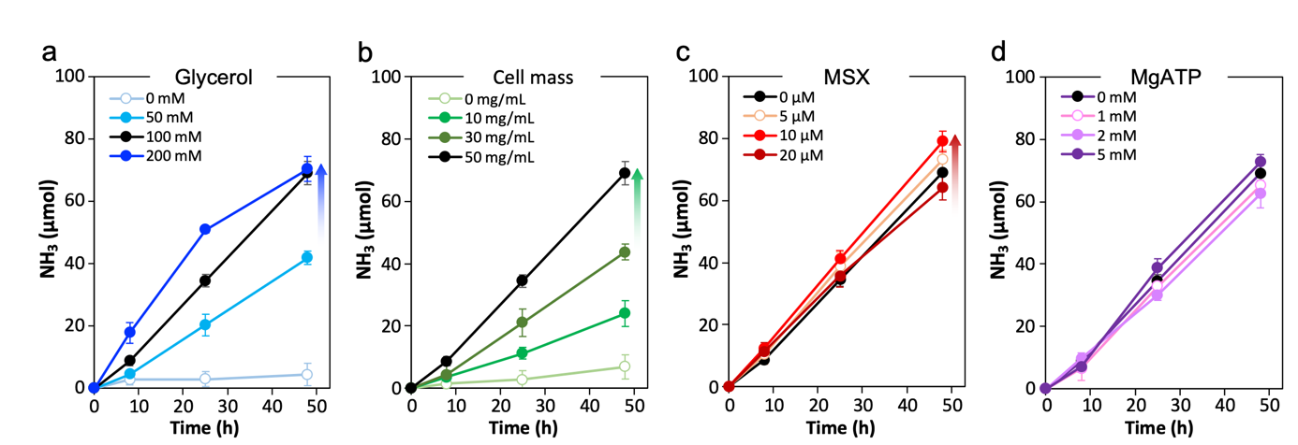

Fig. S3. Kinetic plots of NH₃ production from photobiocatalytic systems in various concentrations of (a) glycerol pH 7, (b) cell mass of cyanobacterium A. variabilis, (c) a glutamine synthetase inhibitor MSX, (d) MgATP. The results in black ( l ) were obtained from a standard condition including 100 mM glycerol pH 7, 250 mg TiO₂, 10 mM MV²⁺ and a 5 g cell mass of A. variabilis. Error bars were obtained from triplicate experiments.

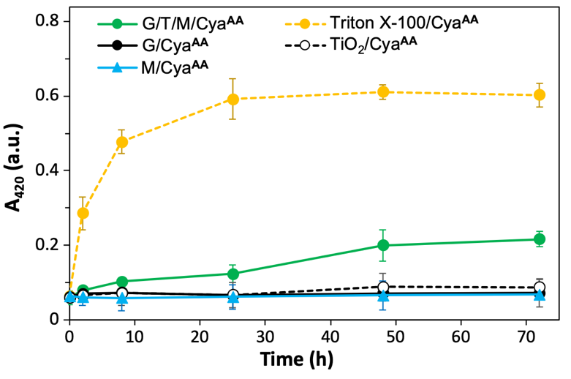

Fig. S4. Cytotoxic effect of each component against cyanobacterium A. variabilis: G, 100 mM glycerol; T, 250 mg TiO₂ and M, 10 mM MV²⁺. In addition, the effect of a complete reaction mixture including glycerol/TiO₂/MV²⁺/cyanobacteria under illumination was also determined compared to a positive control of cell damage treated by 1% Triton X-100. Cell viability was determined by β-galactosidase (β-gal) release assay¹. Data show the average from three independent measurements with the error bar of standard deviation.

¹ K.L. Griffith, R.E. Wolf, Jr., Biochem. Biophys. Res. Commun. 290 (2002) 397–402.

Results showed that each component has no cytotoxic effect on the viability of cyanobacteria. The mixture of all components under illumination caused β-gal release after the 25-h reaction time. However, only ~32.6 % of cell damage was found in the reaction mixture compared to 100 % of cell damage in Triton X-100. Although some amounts of cell damage were monitored, an increase of NH₃ concentration indicates that the biocatalytic enzyme is still active for up to 48 h.

