SUPPLEMENTARY MATERIAL
Table 1S Sampling design, analyses, and data organization of the study.
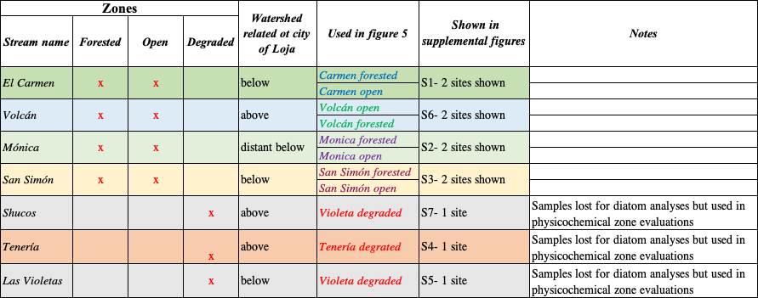
Table 2S List of diatom species identified in each stream and each zone with relative abundance. Genus name with ‘spp’ stands for observations within the genus from girdle view. Empty boxes represent that the species was not recorded.
Species | Carmen forested | Carmen open | Mónica forested | Mónica open | Volcán forested | Volcán open | Tenería degraded | Violeta degraded
Achnanthidium defllexum  (Reimer) Kingston |  |  |  |  | 7.1
Achnanthidium minutissimum (Kütz.) Czarnacki | 46.7 |  | 37.6 | 5.4 | 10.1 | 28.5 | 3.4
Achnanthidium rivulare  Potapova & Ponader | 10.7
Achnanthidium subatomus (Hust.) Lange-Bert. | 16.0 | 12.3 | 23.8 | 5.4 | 1.1
Achnanthes subhudsonis var. kraeuseli (Choln.) Cholnoky |  | 13.8
Bacillaria paradoxa Gmelin |  |  | 4.9
Cocconeis placentula Ehr. |  |  | 1.0 |  |  |  | 6.8
Eunotia exigua (Breb.) Rabenh. |  | 1.5 |  | 2.7
Fragilaria mesolepta Rabenh. |  | 4.6
Frustulia saxonica Rabenh. |  |  |  |  | 0.3
Geissleria decussis  (Østrup) Lange-Bert. & Metzeltin |  |  |  |  |  |  |  | 11.7
Gomphonema micropus Kütz |  | 3.1 |  |  | 0.3
Gomphonema minutum (Agardh) Agardh |  |  | 1.0 | 29.7 | 50.8 |  | 39.2
Gomphonema parvulum (Kütz.) Kütz | 5.3 | 20.0 | 3.0 | 8.1
Gomphonema pumilum (Grun.) Reich. & Lange-Bert. |  |  |  |  |  | 0.8
Gomphonema subclavatum (Grun.) Grunow |  | 1.5 | 2.0
Gomphonema spp | 9.3 | 6.2 |  | 10.8 | 6.6 | 68.5 | 4.7
Gyrosigma scalproides  (Rabenhorst) Cleve |  |  |  |  |  |  |  | 0.6
Hannaea arcus (Ehr.) Patrick |  | 32.3 | 3.0
Kobayasiella subtilissima (Cleve) Lange-Bert. | 2.7
Melosira varians Agardh |  |  |  |  | 0.5
Navicula angusta Grunow |  |  |  |  |  |  |  | 1.9
Navicula cryptocephala Kütz. |  |  |  |  |  |  | 0.7
Navicula germainii Wallace |  |  |  |  |  |  |  | 5.6
Navicula gregaria Donkin |  |  |  |  |  |  | 1.4 | 16.0
Navicula lanceolata Ehrenberg |  |  |  |  |  |  | 4.1
Navicula notha Wallace |  |  |  | 5.4
Navicula rostellata Kütz. |  |  |  |  |  |  | 1.4
Navicula symmetrica Patrick |  |  |  |  |  |  | 2.0 | 1.9
Navicula spp |  |  |  | 2.7 | 1.1
Nitzschia frustulum (Kütz.) Grun. |  |  |  |  |  |  | 21.6
Nitzschia palea (Kütz.) W.Smith |  | 1.5
Nitzschia linearis (Agardt) W.Smith |  |  |  |  | 0.5 | 2.3 |  | 0.6
Nitzschia recta  Hantzsch ex Rabenhorst |  |  |  |  |  |  | 2.0 | 8.6
Nitzschia nana Grunow |  |  |  |  |  |  | 0.7
Nitzschia spp |  |  |  | 5.4 |  |  | 0.7 | 1.9
Nupela sp.1 |  |  | 3.0
Odontidium mesodon (Ehrenb.) Kütz. | 1.3
Pinnularia subcapitata  Gregory | 1.3
Pinnularia  cf. viridis (Nitzsch) Ehr. |  | 1.5
Pinnularia divergentissima (Grun.) Cleve |  |  | 1.0
Planothidium lanceolatum (Breb ex Kütz.) Lange-Bert. | 4.0 | 1.5 |  | 13.5 | 0.8 |  |  | 51.2
Planothidium sp.1 | 2.7
Reimeria sinuata  (Greg.) Kociolek & Stoermer |  |  |  |  | 2.1 |  | 9.5
Rhoicosphenia abbreviata (C. Agardh) Lange-Bert. |  |  |  |  |  |  | 1.4
Synedra cf rumpens Kütz. |  |  | 17.8 | 2.7 | 1.6
Synedra spp |  |  |  | 8.1 | 7.1
Ulnaria ulna (Nitzsch) Compere |  |  | 2.0 |  | 10.1 |  | 0.7
Total abundance (cells/ml) | 52448 | 45453 | 70628 | 25874 | 264335 | 90909 | 103498 | 113287
Species richness | 10 | 12 | 12 | 12 | 13 | 4 | 16 | 10
Genera recorded | 6 | 8 | 9 | 7 | 10 | 3 | 8 | 5
Shannon Diversity Index | 0,74 | 0,85 | 0,77 | 0,96 | 0,61 | 0,32 | 0,85 | 0,67

