Supplementary Material of Article:

Depth-dependent distribution of prokaryotes in sediments of the manganese crust on Nazimov guyots of the Magellan seamounts

This supplementary material contains:
  - 7 Pages
  - 3 Supplementary Tables (Table S1- Table S3)
  - 6 Supplementary Figures (Fig. S1 - Fig. S6)

Table S1 16S rRNA gene copy numbers of sediments.
Sample | Depth (cm) | Gene abundance (copies·g⁻¹) | Group
S0_2 | 0-2 | 7.11E+09 | Surficial
S2_4 | 2-4 | 6.18E+09 | Surficial
S4_6 | 4-6 | 1.36E+09 | Surficial
S6_8 | 6-8 | 2.22E+09 | Surficial
S8_10 | 8-10 | 3.92E+08 | Deep
S10_12 | 10-12 | 5.68E+08 | Deep
S12_14 | 12-14 | 3.91E+08 | Deep
S14_16 | 14-16 | 2.76E+08 | Deep
S18_20 | 16-18 | 1.70E+08 | Deep
S20_22 | 18-20 | 3.04E+08 | Deep
S22_24 | 20-22 | 5.16E+08 | Deep
S24_26 | 22-24 | 1.57E+08 | Deep
S26_28 | 24-26 | 3.72E+08 | Deep

Table S2. Monte Carlo permutation tests between prokaryotic communities and environmental factors
Environmental factors | r | P value
Depth | 0.58 | 0.007
pH | 0.35 | 0.189
EC | 0.12 | 0.269
AP | 0.24 | 0.269
AK | 0.15 | 0.269
AN | 0.01 | 0.331
OC | 0.05 | 0.331
Mn | -0.04 | 0.455
Fe | -0.006 | 0.403
Co | 0.15 | 0.198
Ni | 0.19 | 0.089
Cu | 0.24 | 0.04
Zn | -0.012 | 0.50

Table S3. Major prokaryotes and their connected edges and average degree in different co-occurrence networks
Layer | Kingdom | Phylum | Abundance | Connected edges | Average degree
Surficial (851 nodes  in total) | Bacteria | Proteobacteria | 30.80% | 14091 | 53.76
Surficial (851 nodes  in total) | Bacteria | Planctomycetes | 7.60% | 3151 | 48.72
Surficial (851 nodes  in total) | Archaea | Thaumarchaeota | 6.40% | 2888 | 53.03
Surficial (851 nodes  in total) | Bacteria | Firmicutes | 5.30% | 2160 | 47.89
Surficial (851 nodes  in total) | Bacteria | Acidobacteria | 4.60% | 1750 | 44.70
Surficial (851 nodes  in total) | Bacteria | Bacteroidetes | 2.00% | 1097 | 64.45
Surficial (851 nodes  in total) | Bacteria | Chloroflexi | 2.20% | 1084 | 57.90
Surficial (851 nodes  in total) | Archaea | Woesearchaeota | 1.90% | 791 | 48.92
Surficial (851 nodes  in total) | Bacteria | Actinobacteria | 1.30% | 565 | 51.07
Surficial (851 nodes  in total) | Archaea | Pacearchaeota | 0.80% | 343 | 50.38
Surficial (851 nodes  in total) | Bacteria | Verrucomicrobia | 0.60% | 242 | 47.40
Surficial (851 nodes  in total) | Bacteria | Cyanobacteria/Chloroplast | 0% | 0 | 0.00
Deep  (860 nodes  in total) | Bacteria | Proteobacteria | 30.10% | 5409 | 20.90
Deep  (860 nodes  in total) | Bacteria | Planctomycetes | 6.40% | 2306 | 41.90
Deep  (860 nodes  in total) | Archaea | Thaumarchaeota | 3.60% | 664 | 21.45
Deep  (860 nodes  in total) | Bacteria | Firmicutes | 6.10% | 852 | 16.24
Deep  (860 nodes  in total) | Bacteria | Acidobacteria | 6.10% | 2889 | 55.07
Deep  (860 nodes  in total) | Bacteria | Bacteroidetes | 5.10% | 1483 | 33.81
Deep  (860 nodes  in total) | Bacteria | Chloroflexi | 2.10% | 967 | 53.54
Deep  (860 nodes  in total) | Archaea | Woesearchaeota | 1.30% | 54 | 4.83
Deep  (860 nodes  in total) | Bacteria | Actinobacteria | 7.90% | 2137 | 31.45
Deep  (860 nodes  in total) | Archaea | Pacearchaeota | 2.40% | 150 | 7.27
Deep  (860 nodes  in total) | Bacteria | Verrucomicrobia | 0.80% | 5 | 0.73
Deep  (860 nodes  in total) | Bacteria | Cyanobacteria/Chloroplast | 1.50% | 180 | 13.95

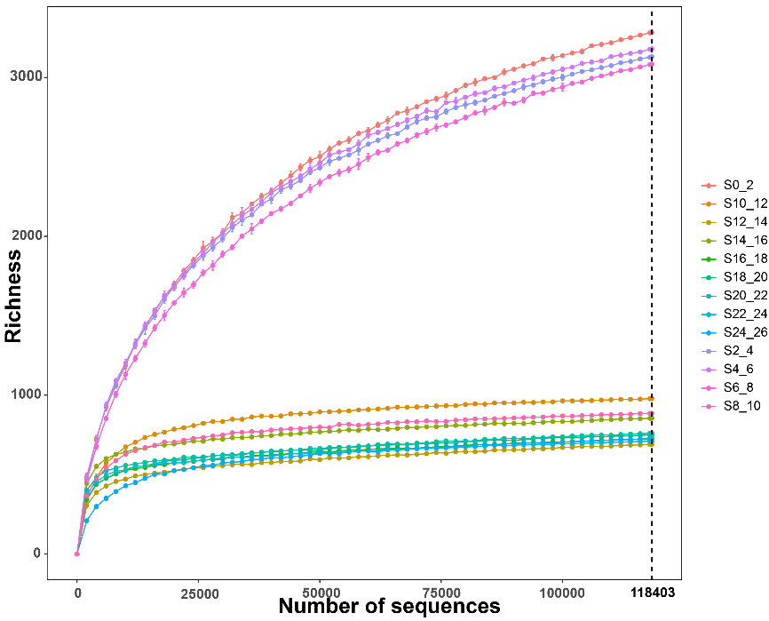

Fig. S1 Species rarefaction curves for all samples.

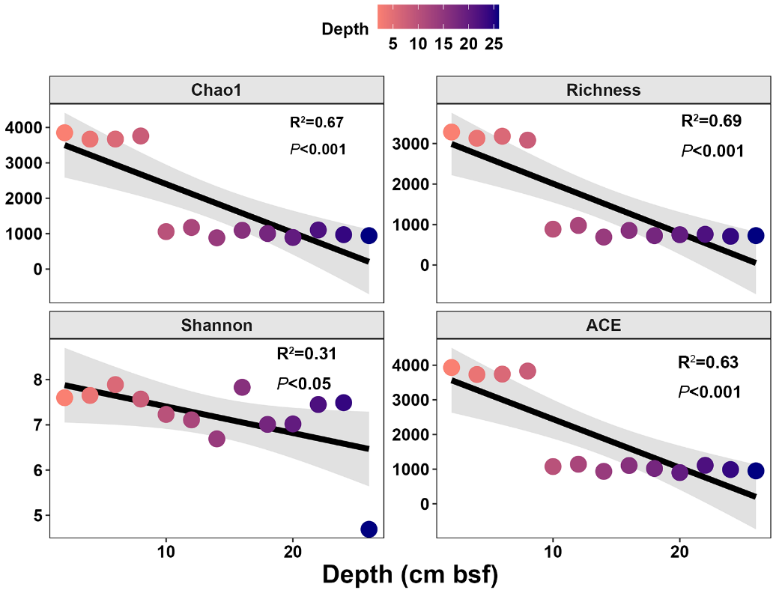
Fig. S2. Mantel test between alpha diversity and sediment depth.

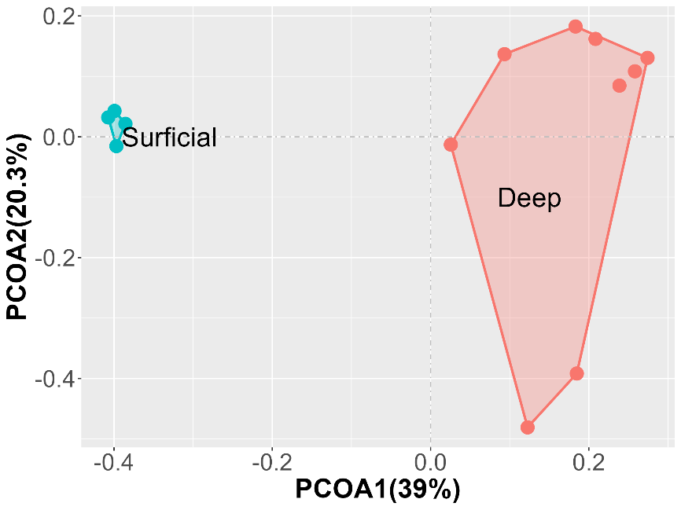
Fig. S3 Principal coordinate analysis (PCoA) of prokaryotic communities.

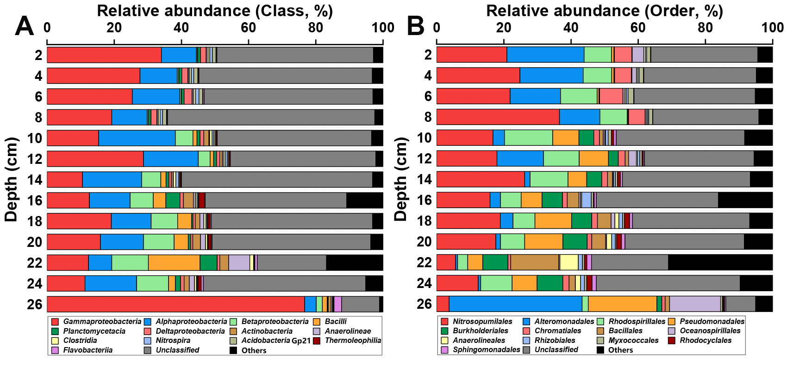
Fig. S4. Bar graph of the relative abundances of top 15 prokaryotic populations at A) class and B) order level.
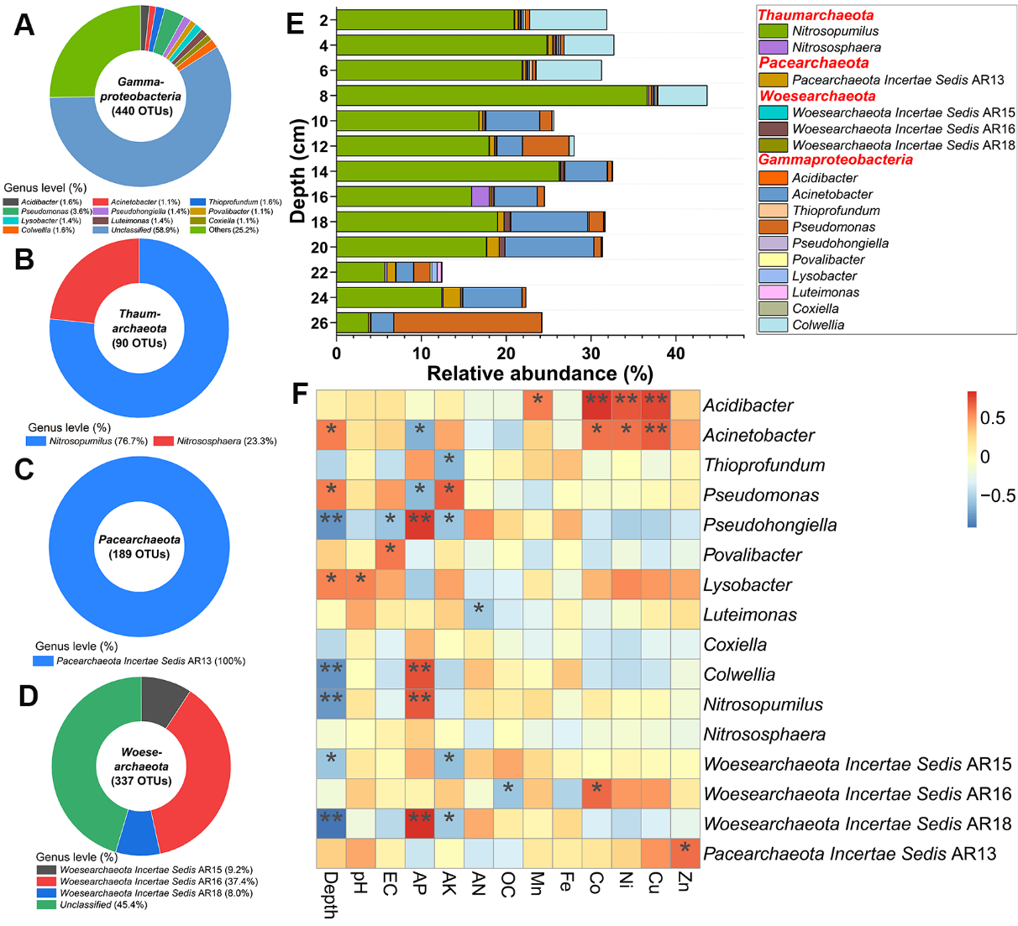
Fig. S5. The total numbers of OTUs belong to A) Gammaproteobacteria, B) Thaumarchaeota, C) Pacearchaeota, D) Woesearchaeota, and E) the change of relative abundances with depth and F) Correlation between environmental factors and prokaryotes at genus level (the color gradient on the right indicates Spearman’s rank correlation coefficients).

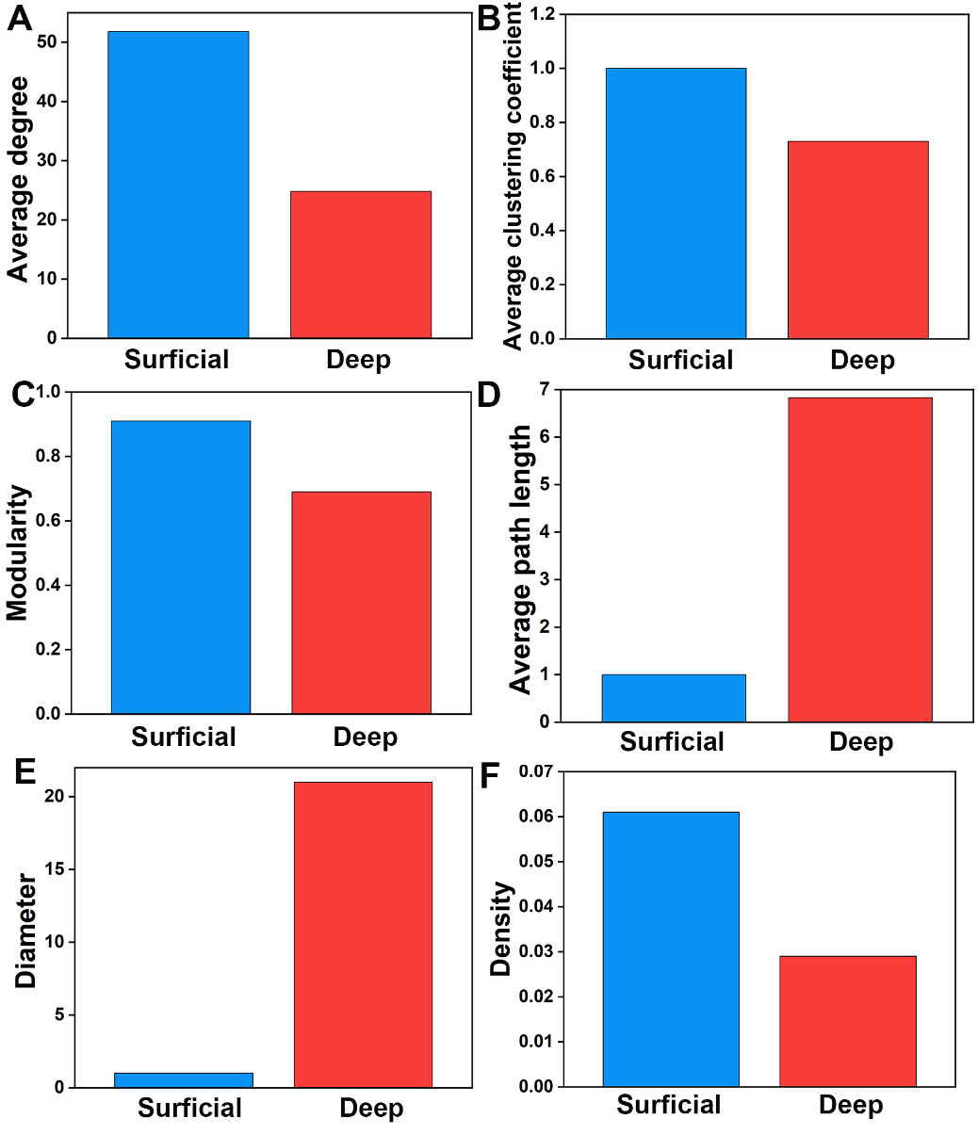
Fig. S6 Topological features of the superficial layer and sub-deep layer co-occurrence networks.

