Due to the limitation of the number of pages in the manuscript, some legends are not placed in the manuscript document, and for the supplementary information section, we have rearranged the supplementary infographic as follows（Include legends where the manuscript already exists）:

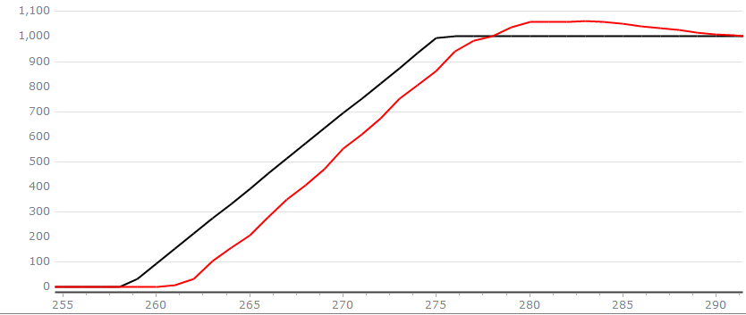
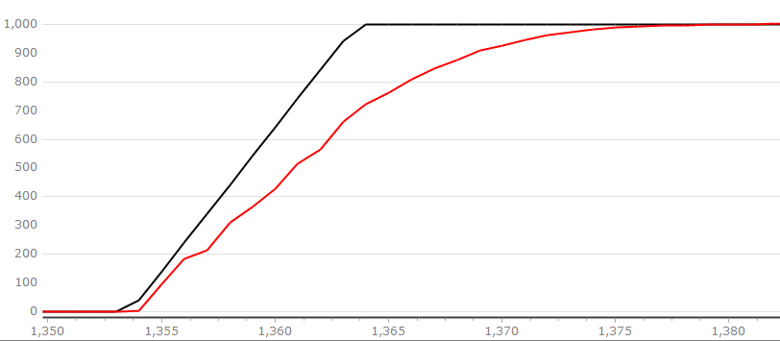

(a) (b)
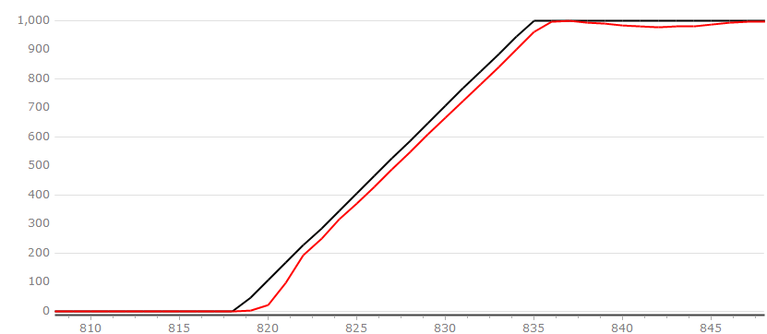

(c)
Figure 1. PMSM velocity rise curve at 1000 rpm given speed (a)LADRC (b)NLADRC (c)SADRC
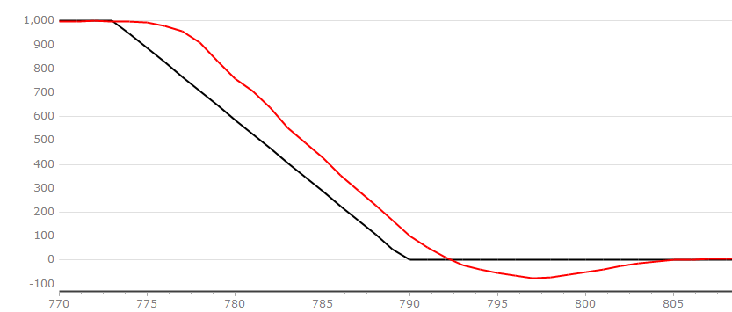
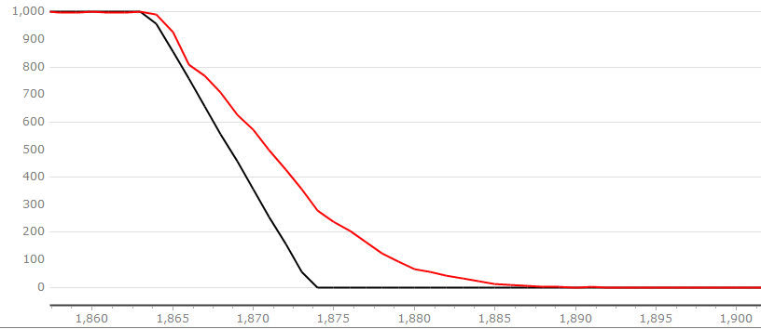

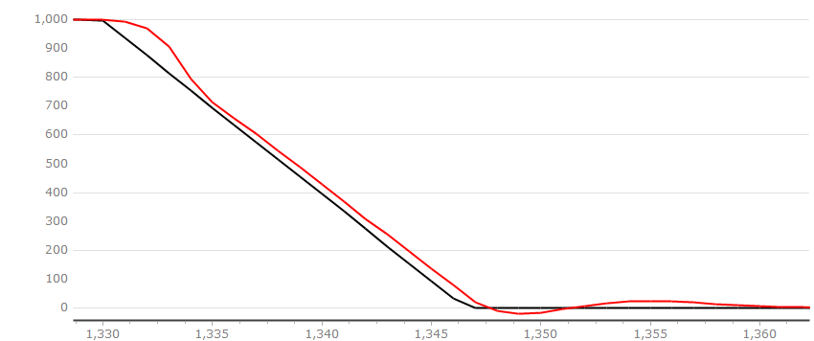
(a) (b)

(c)
Figure 2. PMSM velocity decline curve at 1000 rpm given speed (a)LADRC (b)NLADRC (c)SADRC

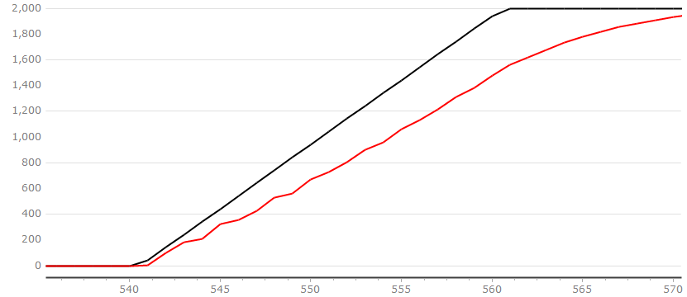
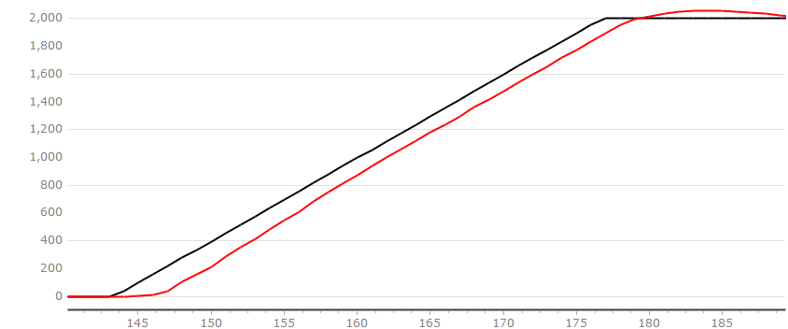

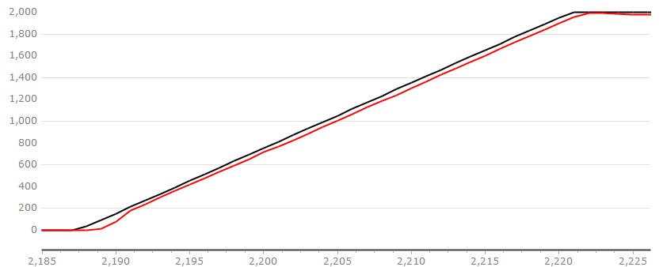
(a) (b)

(c)
Figure 3. PMSM velocity rise curve at 2000 rpm given speed (a)LADRC (b)NLADRC (c)SADRC

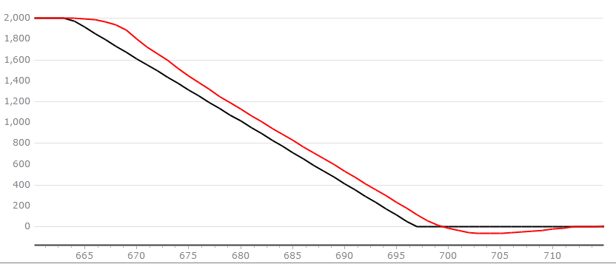
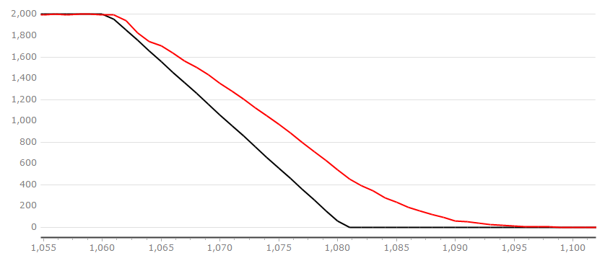

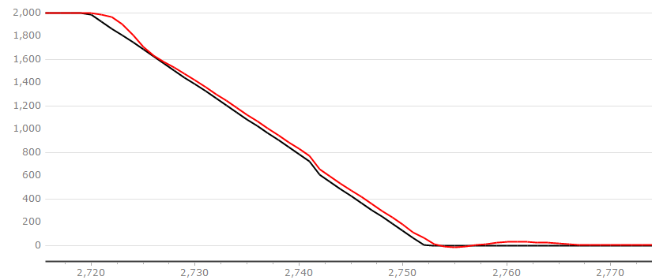
(a) (b)

(c)
Figure 4. PMSM velocity decline curve at a given speed of 2000 rpm (a)LADRC (b)NLADRC (c)SADRC

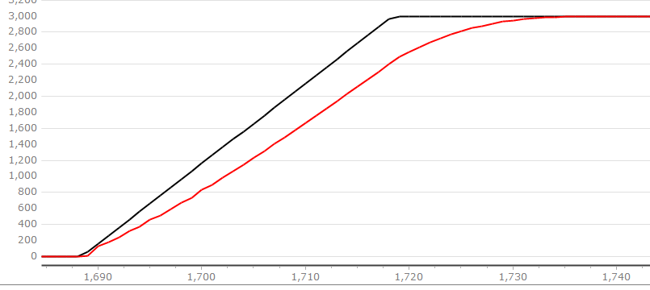
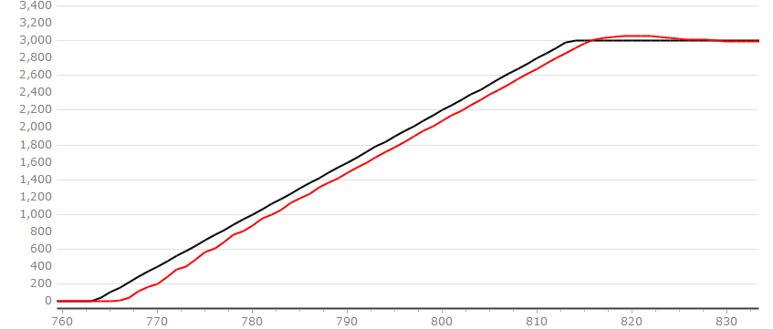

(a) (b)
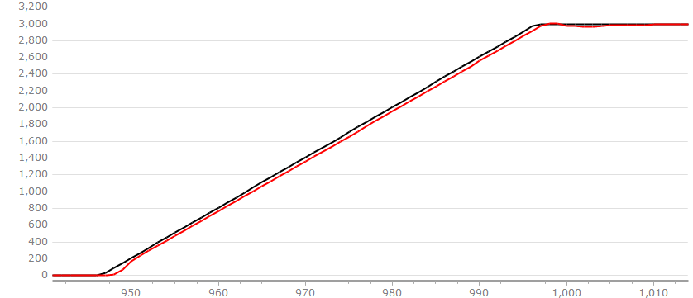

(c)
Figure 5. PMSM velocity rise curve at 3000 rpm given speed (a)LADRC (b)NLADRC (c)SADRC

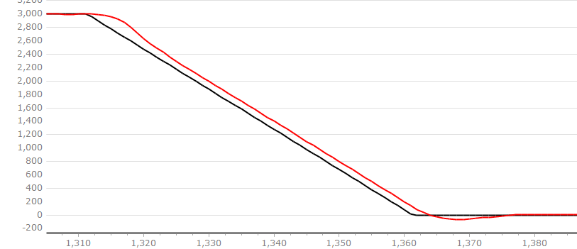
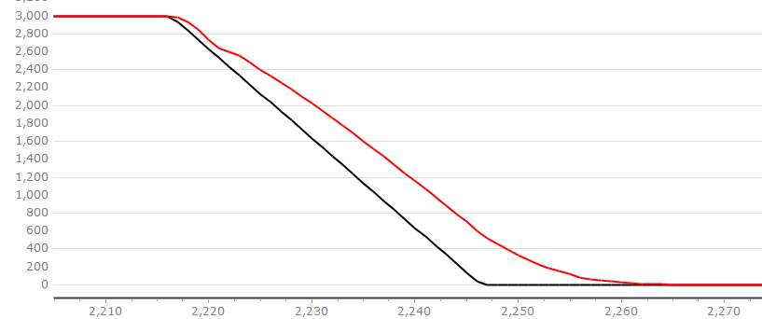

(a) (b)
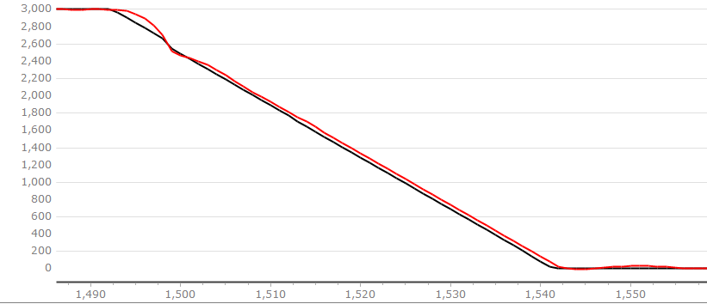

(c)
Figure 6. PMSM velocity decline curve at a given speed of 3000 rpm (a)LADRC (b)NLADRC (c)SADRC

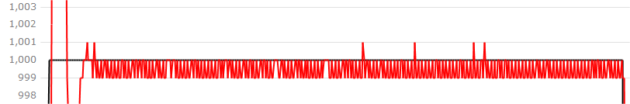

(a)
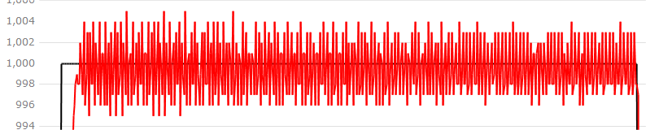

(b)

(c)
Figure 7. Steady-state curve of PMSM at a given speed of 1000 rpm (a)LADRC (b)NLADRC (c)SADRC

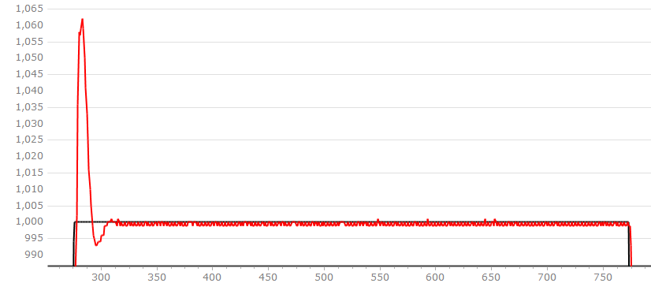

Figure 8. Overshoot graph of LADRC at 1000rpm

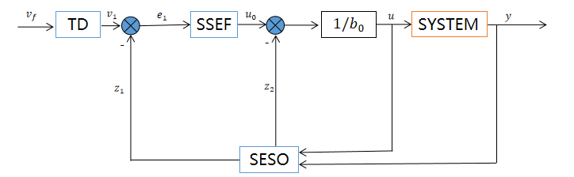

Figure 9. SADRC flow block diagram

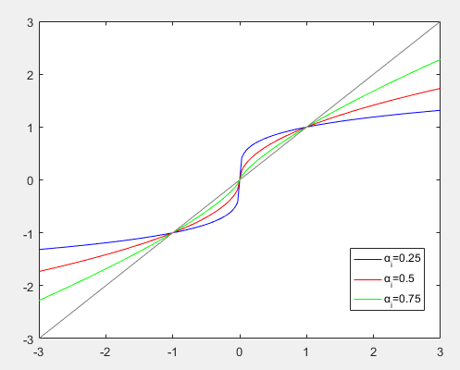

Figure 10. $fal⁡\left(e,α_{i},δ\right)$ function curve

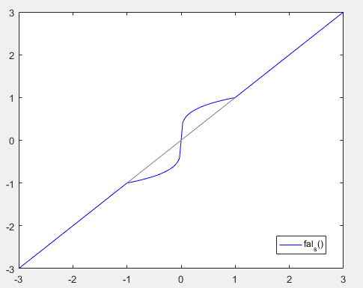

Figure 11. $fal_{s}\left(e,α_{i},δ_{1},δ_{2}\right)$ curves

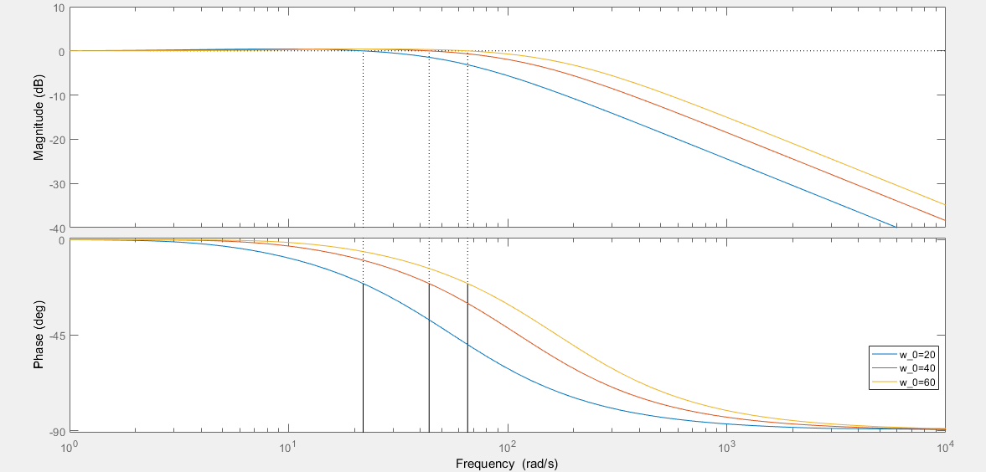

Figure 12. Bode Plot of the transfer function

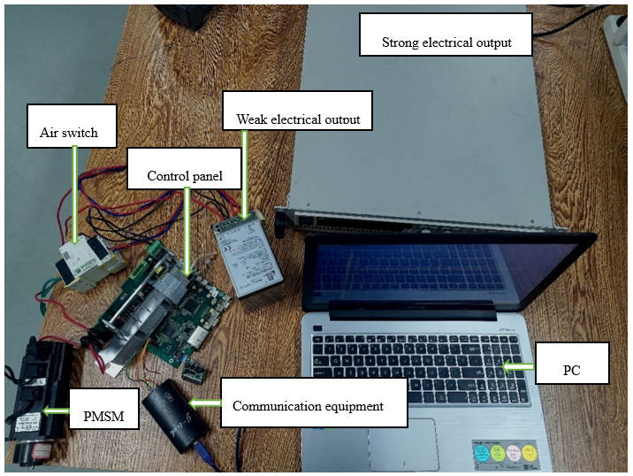

Figure 13. Experimental platform

