Synthesis and biological evaluation of prodrugs for nitroreductase based HSP90 inhibitor BIIB021as potential anticancer agents
Zheng-Rong Wu, Peng Jing, Wei Deng, Dian He*
School of Pharmacy, Lanzhou University, Lanzhou 730000, People’s Republic of China

The ¹H-NMR, ¹³C-NMR, and ESI-MS spectrum of BIIB021
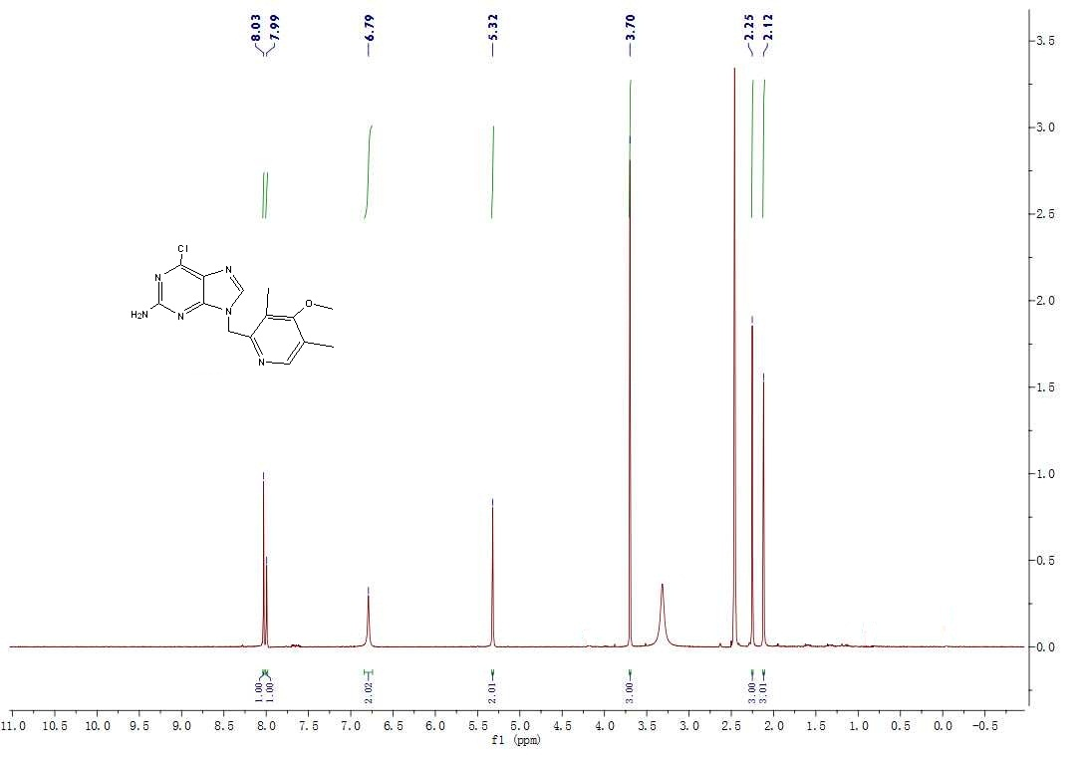

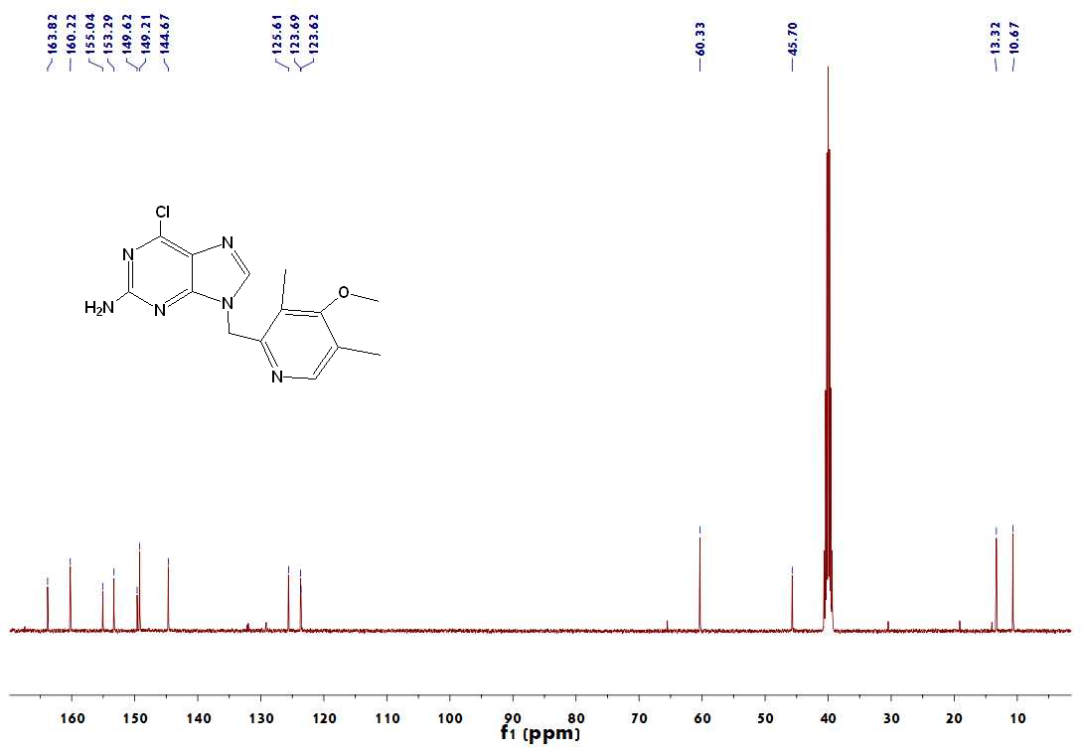
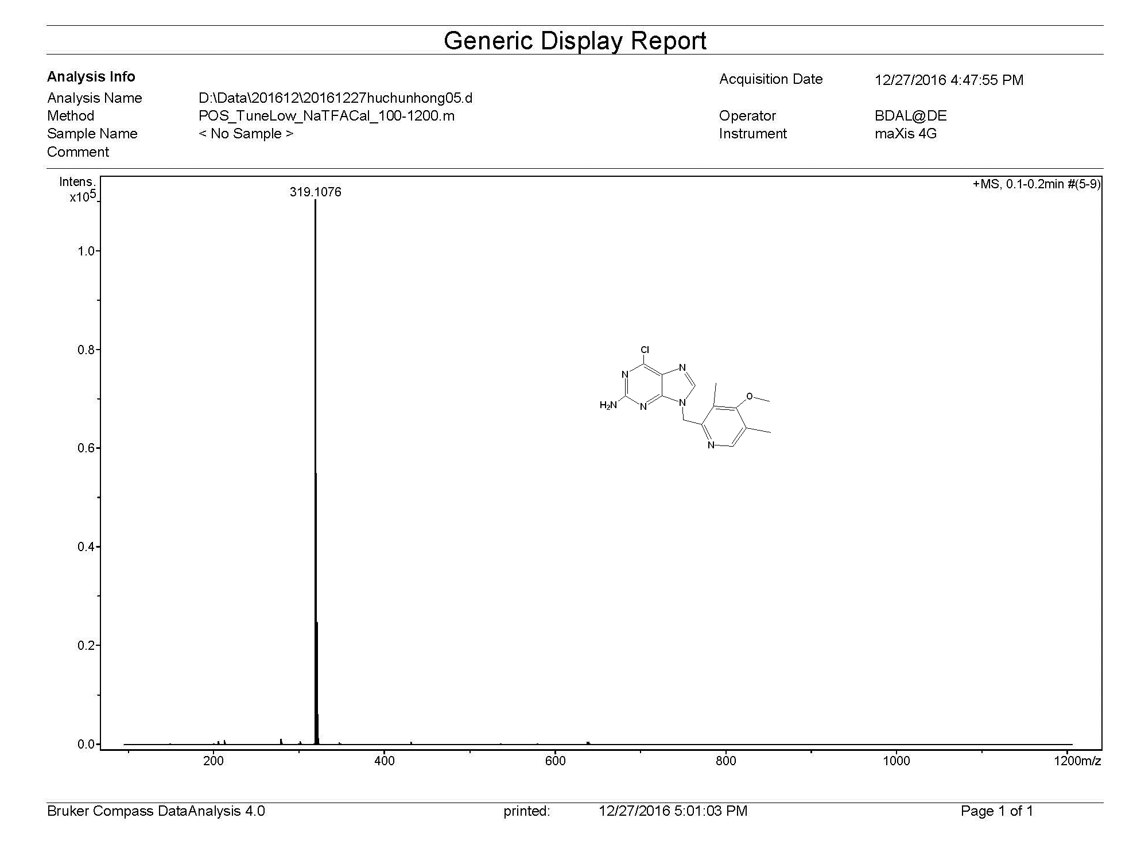
The ¹H-NMR, ¹³C-NMR, and ESI-MS spectrum of compound 1d.
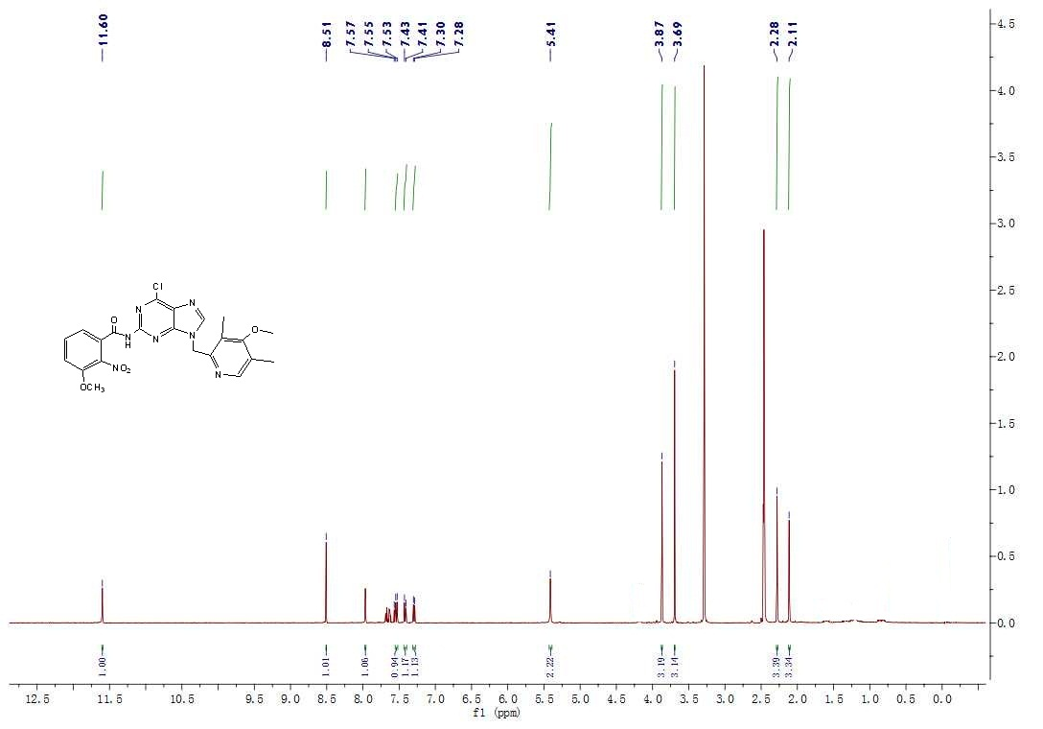
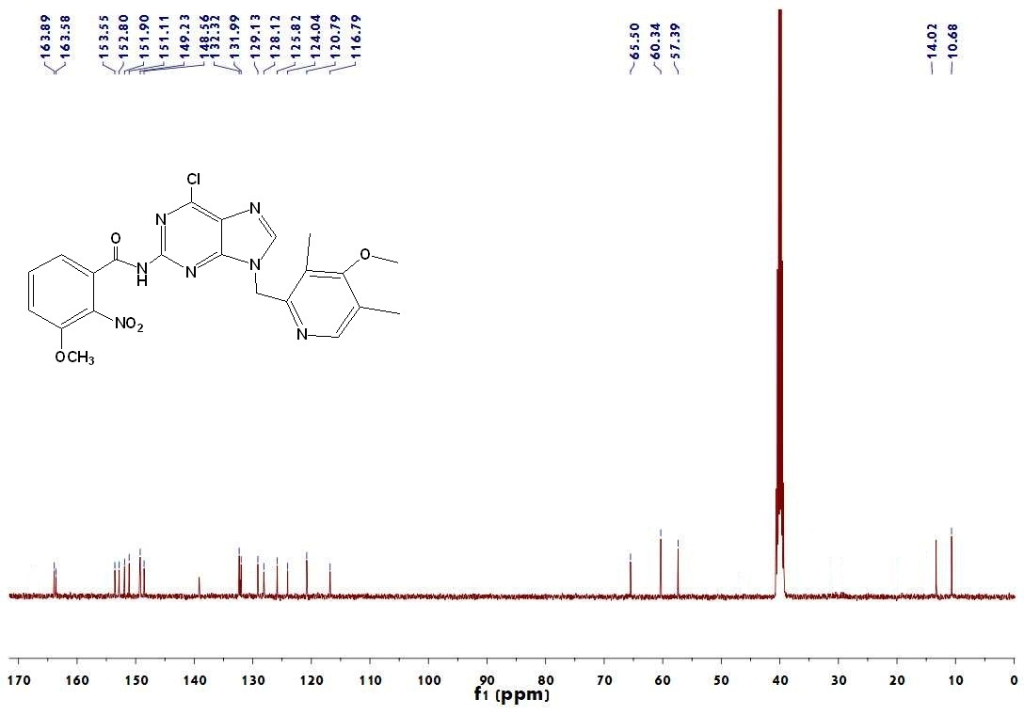
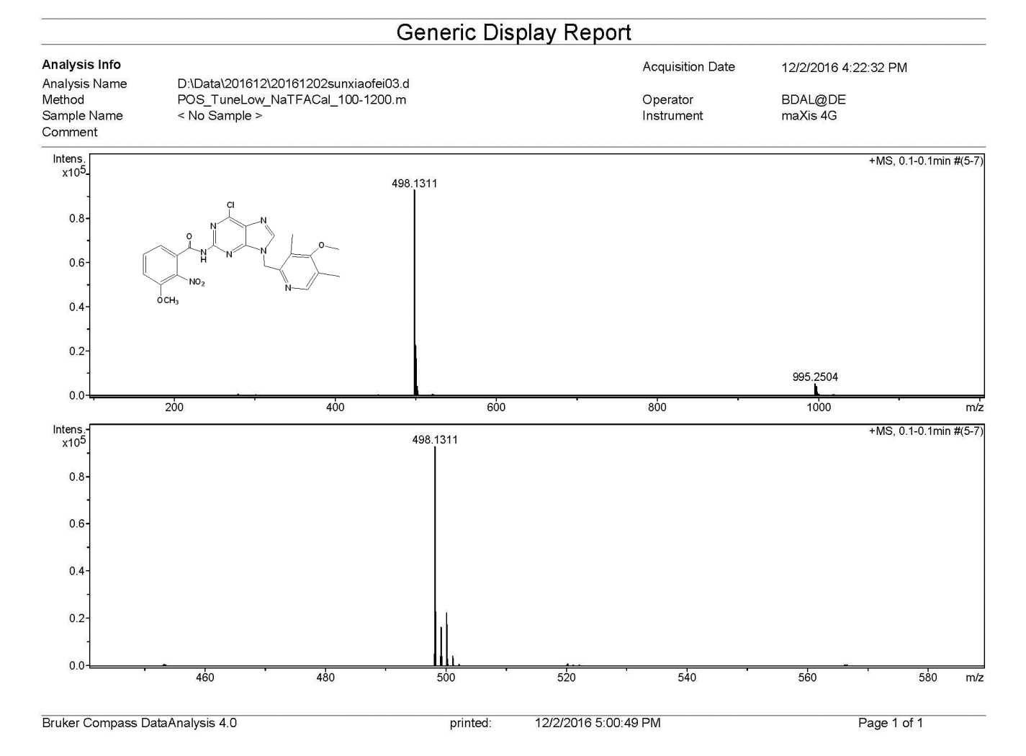
The ¹H-NMR, ¹³C-NMR, and ESI-MS spectrum of compound 1e.
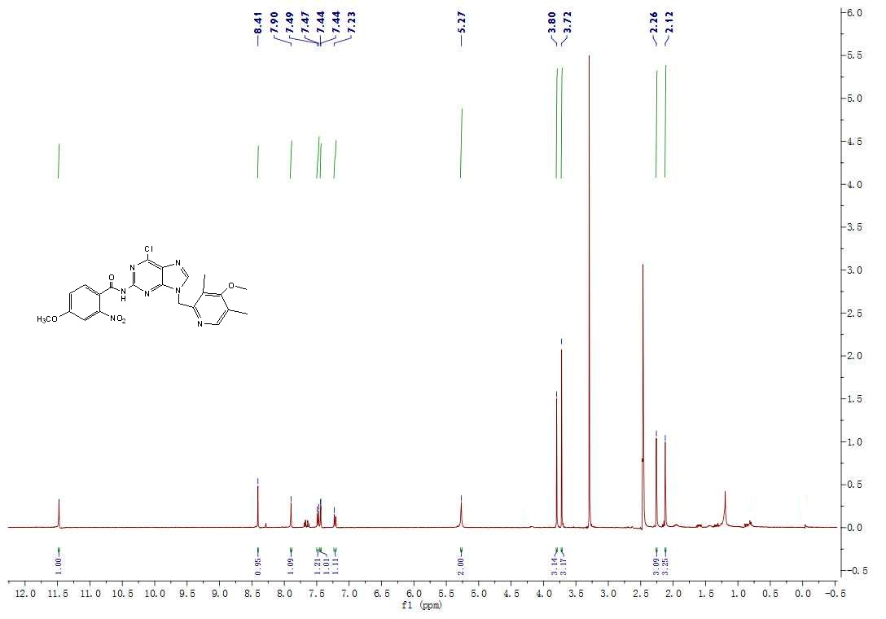
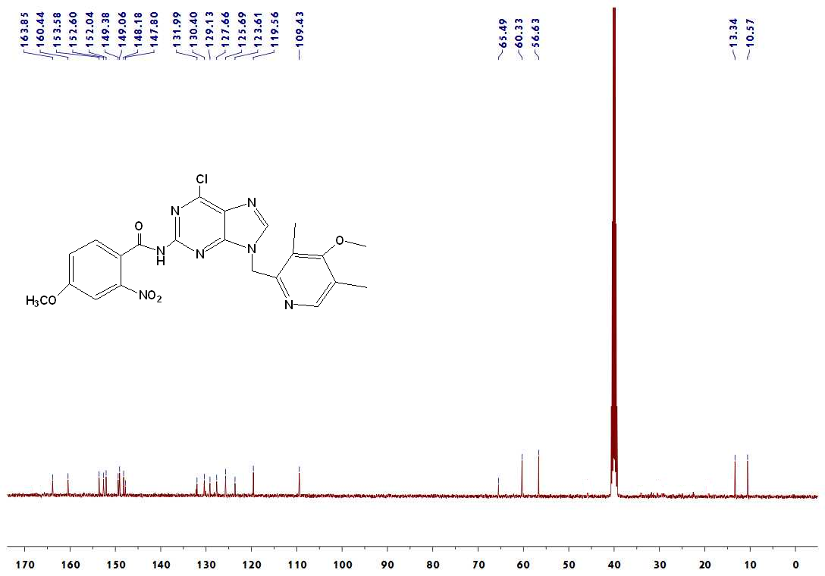
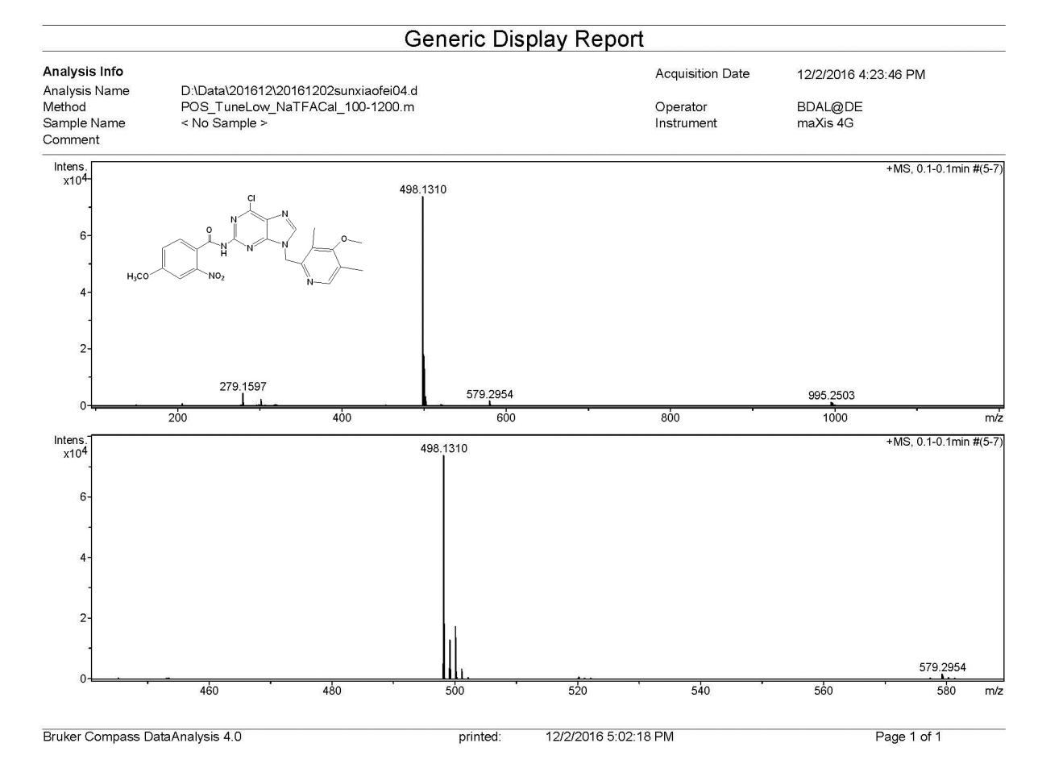
The ¹H-NMR, ¹³C-NMR, and ESI-MS spectrum of compound 2d.

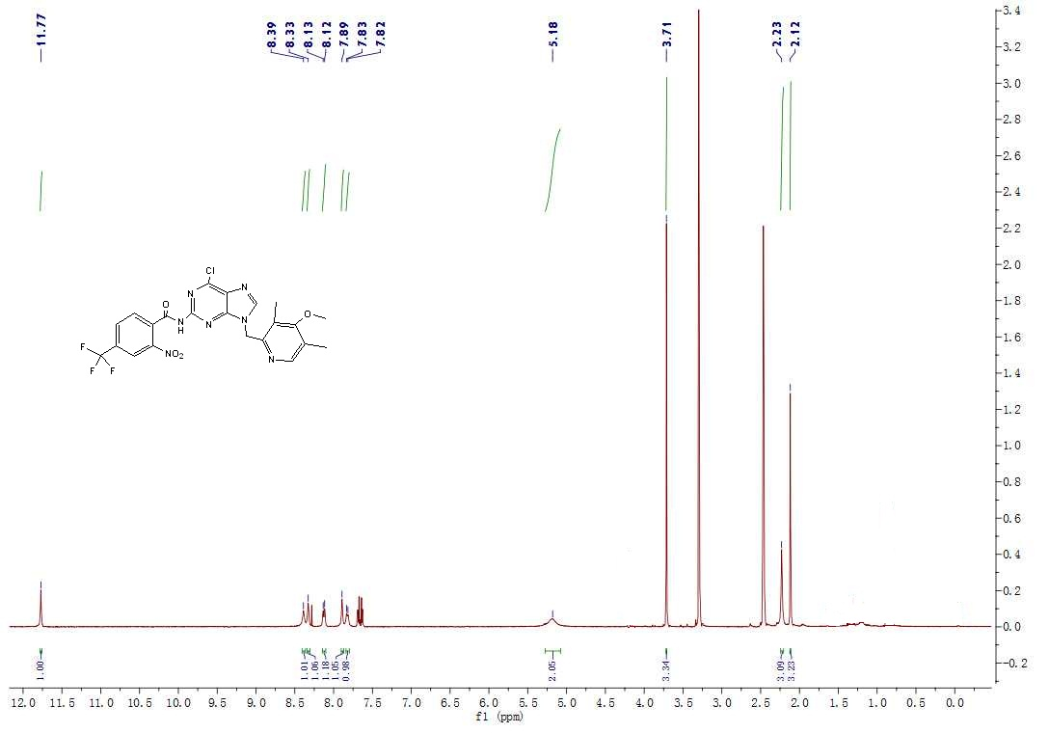
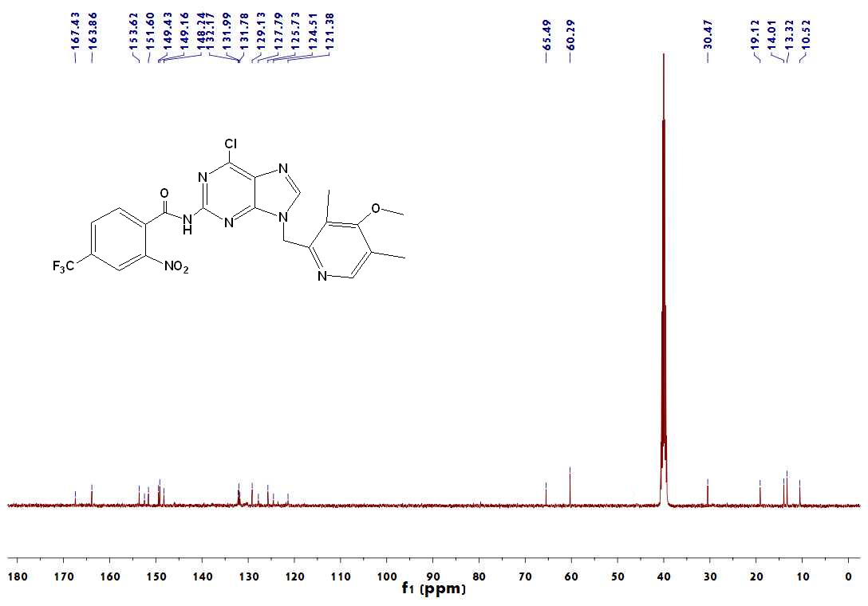
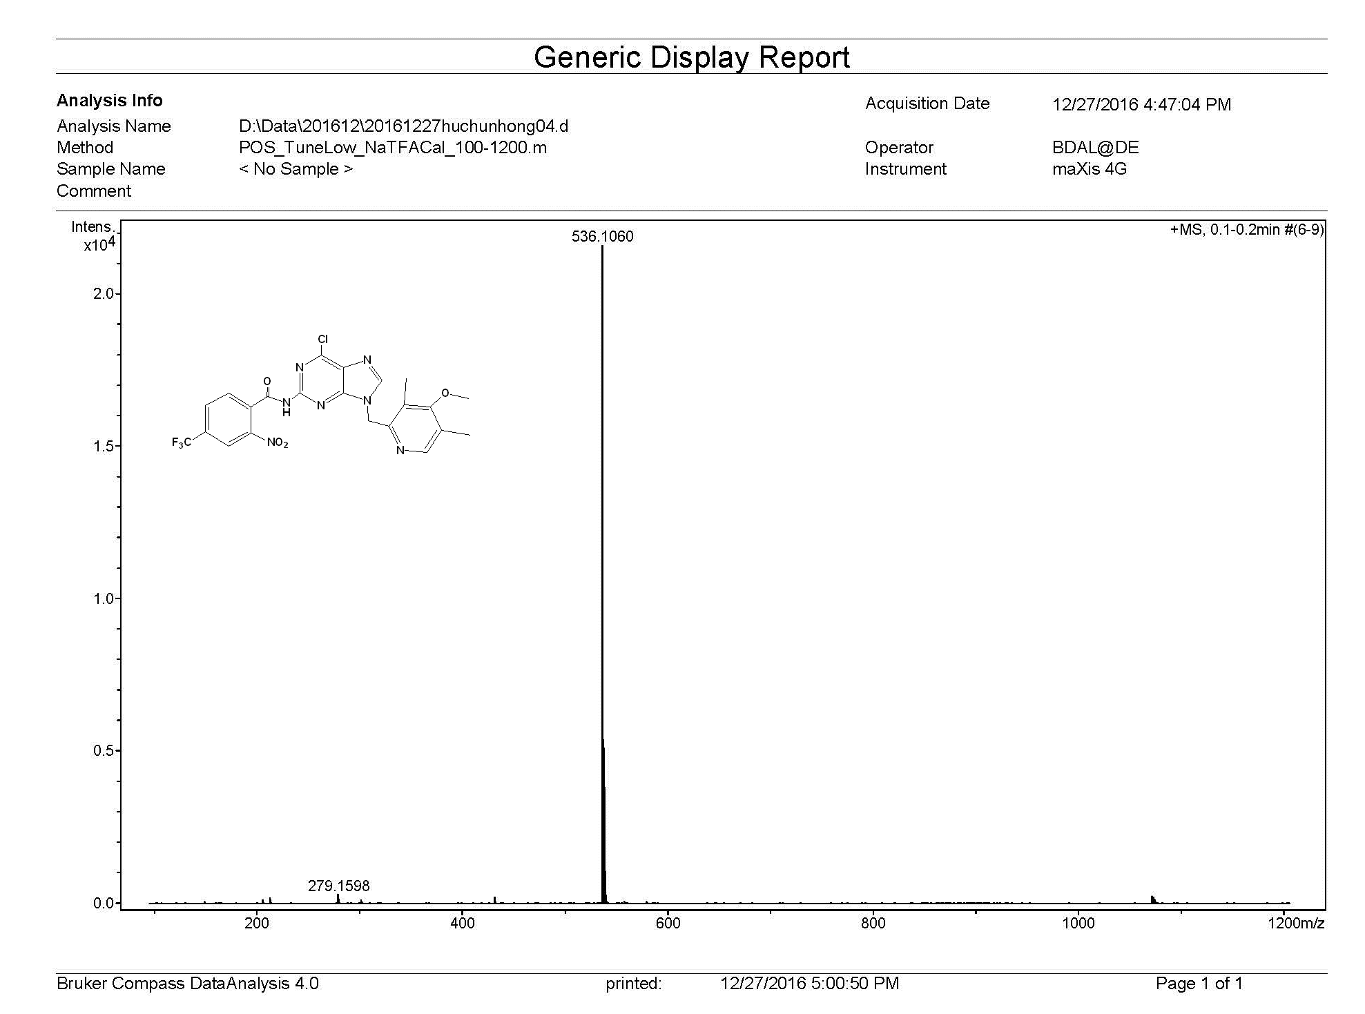
The ¹H-NMR, ¹³C-NMR, and ESI-MS spectrum of compound 2g.
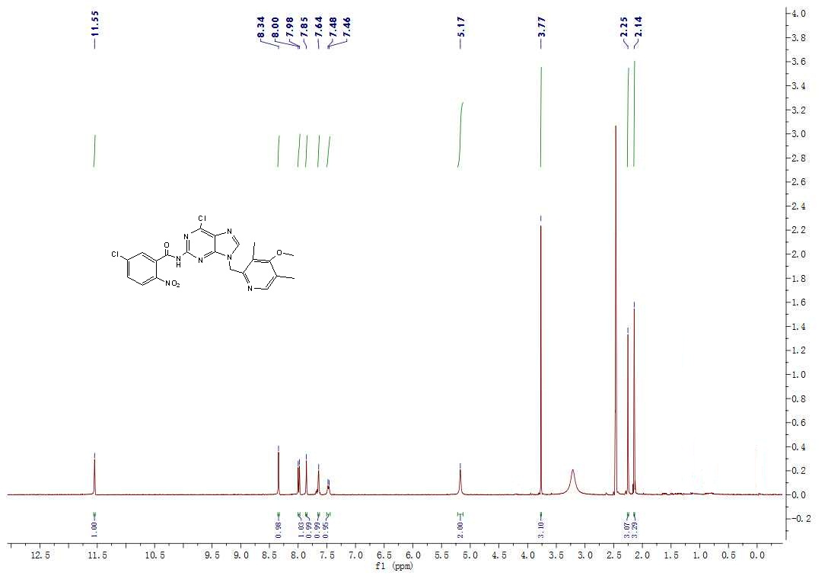
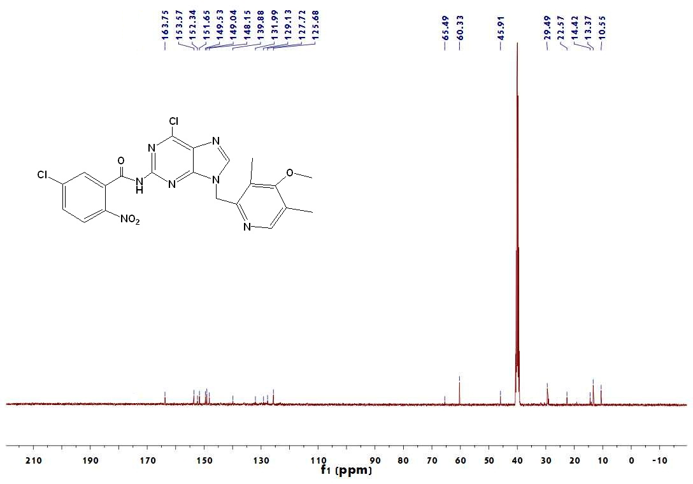
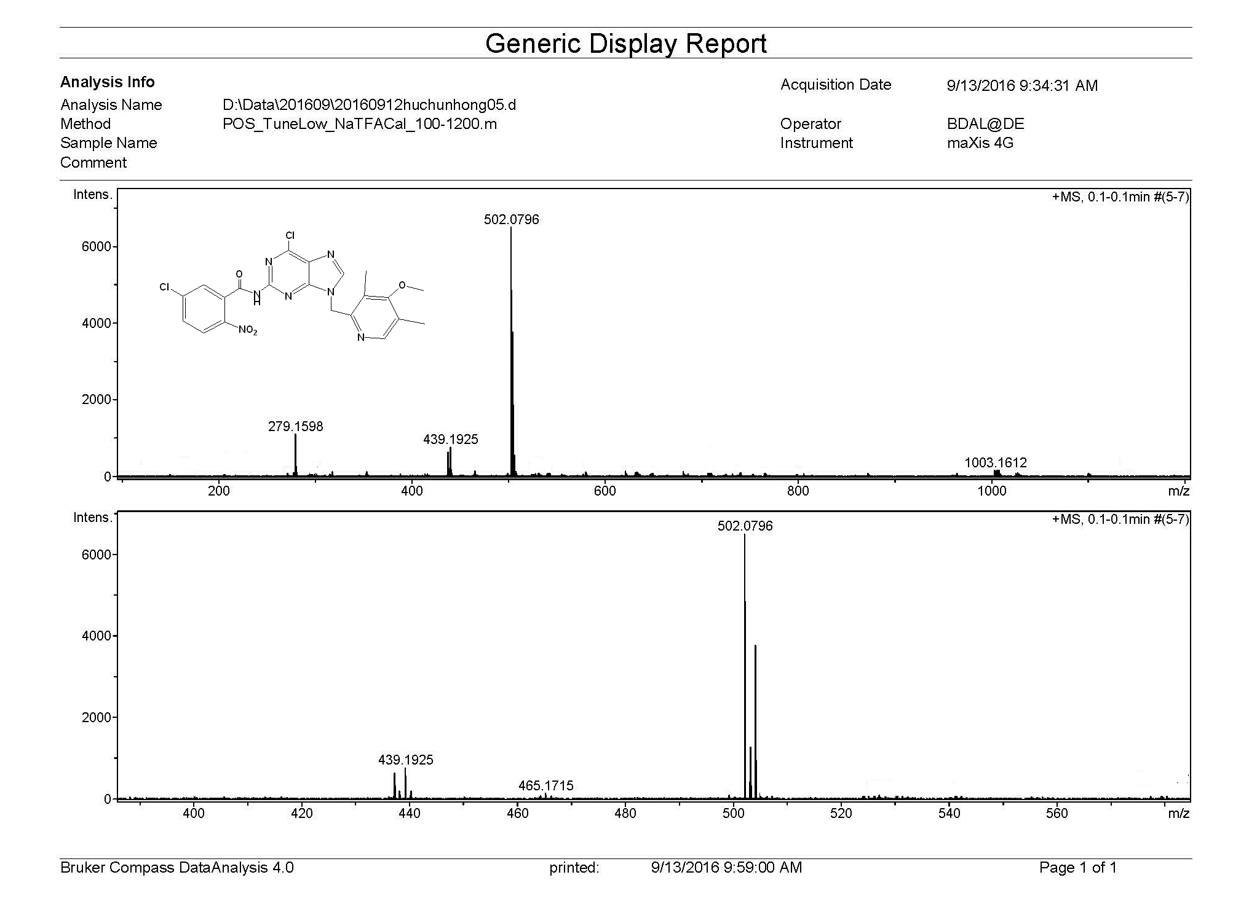
The ¹H-NMR, ¹³C-NMR, and ESI-MS spectrum of compound 2h.
