Support information

Analyzing EDS elemental of Ti and N maps displayed in Fig.S1, we can see that the composition of Ti and N of α-Ta films grown at RT and 500 ºC are close to 1:0.34 and 1:0.28 respectively, directly illustrating that they are superconducting material. The TiN_{x} with about 100 nm thick was deposited on Si substrate. The sputtering conditions of this sample are same as these that are used to be buffer layers mentioned in the article except for deposition time. Its AFM images and temperature dependence of resistance are shown in Fig.S2. There are no obvious surface defects such as black holes in the AFM image. R became zero near 4 K. These results evidenced that the thicker TiN_{x} film are compact and superconducting. Based on the same sputtering conduction, we can reasonably speculate that the TiN_{x} buffer layer used in the article have similar compact structure and superconducting properties.

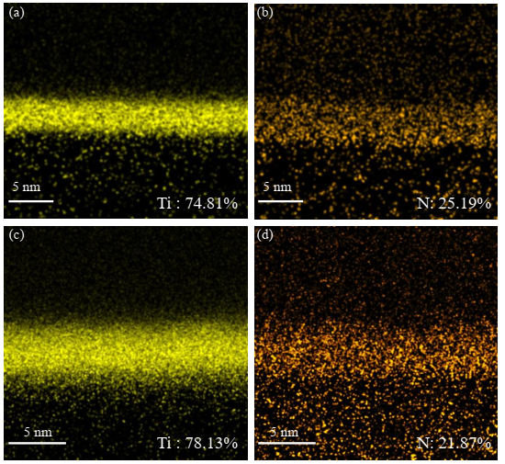
Fig.S1. EDS maps of Ti and N of α-Ta/Si films grown at RT (a,b) and 500 ºC (c,d).
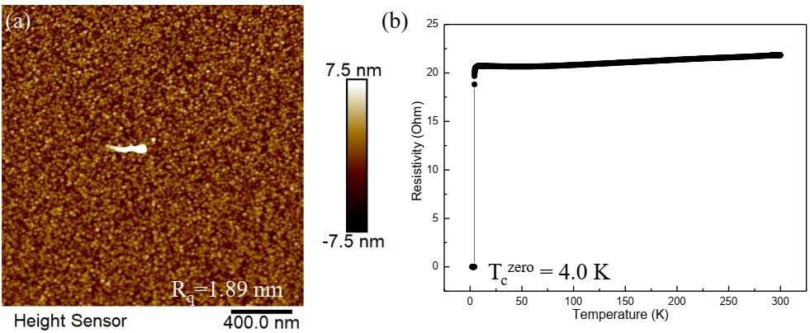
Fig.S2. The characteristic of TiN_{x} film deposited on Si substrate. (a) Large-scale AFM image; (b) Temperature dependence of resistance.

