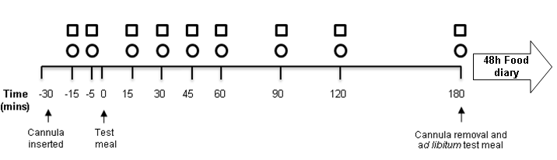
Supplemental Figure 1: Timeline of a study visit. represent timepoint at which blood samples were taken, represent timepoint at which visual analogue scales were completed. H, hour, min, minutes.

