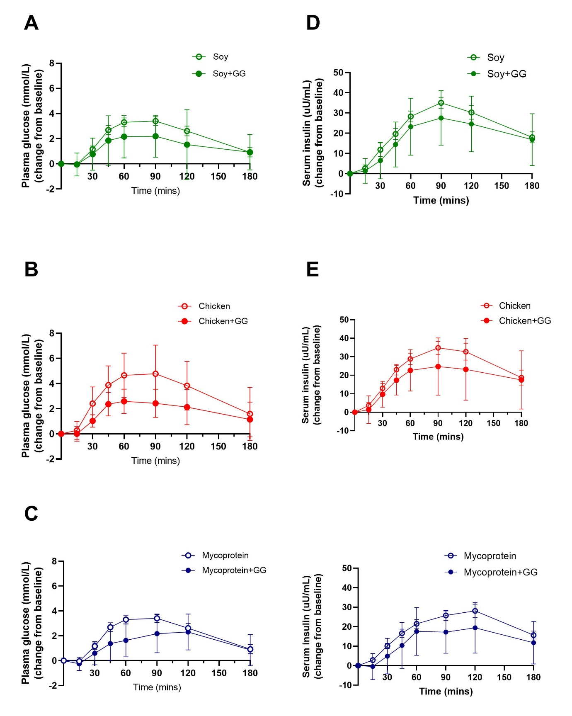 Supplemental Figure 4. Plasma glucose and serum insulin concentration over 180 min following the consumption of soy, chicken and MP with GG- or not enriched chapatis for all participants (n=21). A Change from baseline of postprandial plasma glucose over time up to 180 min (A,B,C) in which A Soy with and without GG-enriched chapati. B Chicken with and without GG-enriched chapati. C Mycoprotein with and without GG-enriched chapati, and Change from baseline of postprandial blood insulin over time up to 180 min (D,E,F) in which D Soy with and without GG-enriched chapati. E Chicken with and without GG-enriched chapati. F Mycoprotein with and without GG-enriched chapati. Test food was given at timepoint 0 min. Data represents mean±SD. The colour scheme represents the type of proteins, these being soy (green), chicken (red), and MP (blue). The filling of the circles represent the type of chapati, these being plain chapatis (empty circles) and GG-enriched chapatis (filled circles). GG, guar gum; SD, standard deviation; MP, mycoprotein; n, sample size.

