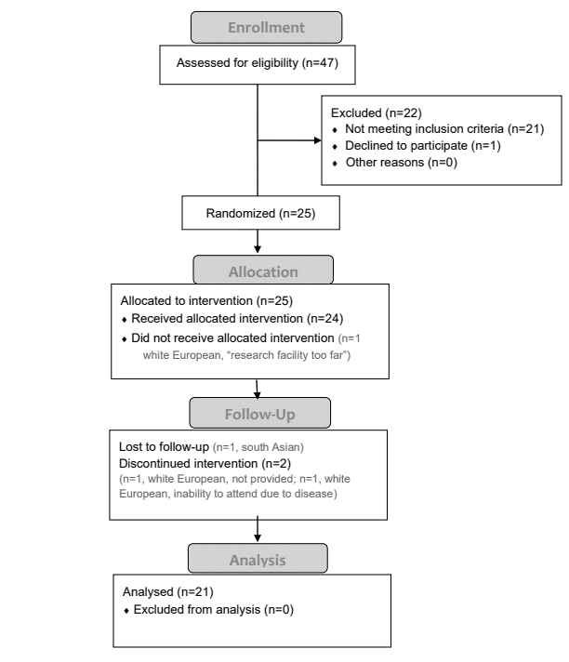
Supplemental Figure 2. Consolidated Standards of Reporting Trials (CONSORT) diagram of the flow of subjects through the study. N, sample size.

