A B
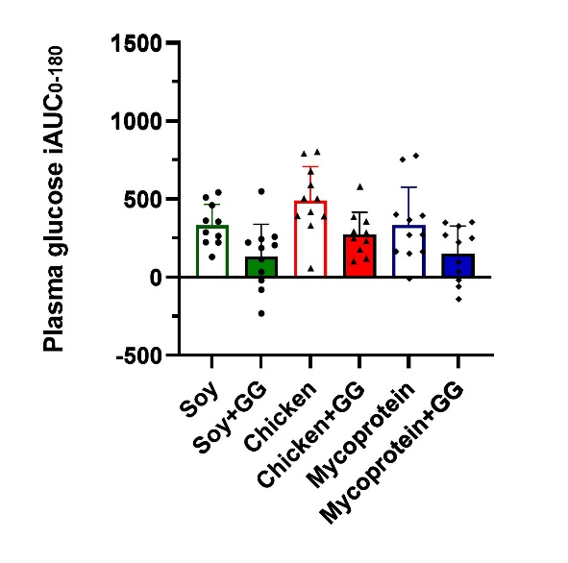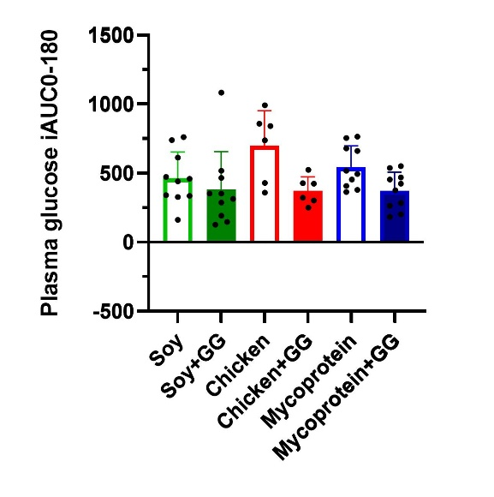
Supplemental Figure 3. Plasma glucose iAUC0-180 min in white Europeans (A) and south Asian (B) following the consumption of soy, chicken and MP with GG- or not enriched chapatis. Data represents mean±SD and individual datapoints. The colour scheme represents the type of proteins, these being soy (green), chicken (red), and MP (blue). The filling of the boxes represent the type of chapati, these being plain chapatis (empty boxes) and GG-enriched chapatis (filled boxes). GG, guar gum; iAUC, incremental area under the curve; MP, mycoprotein; n, sample size.

