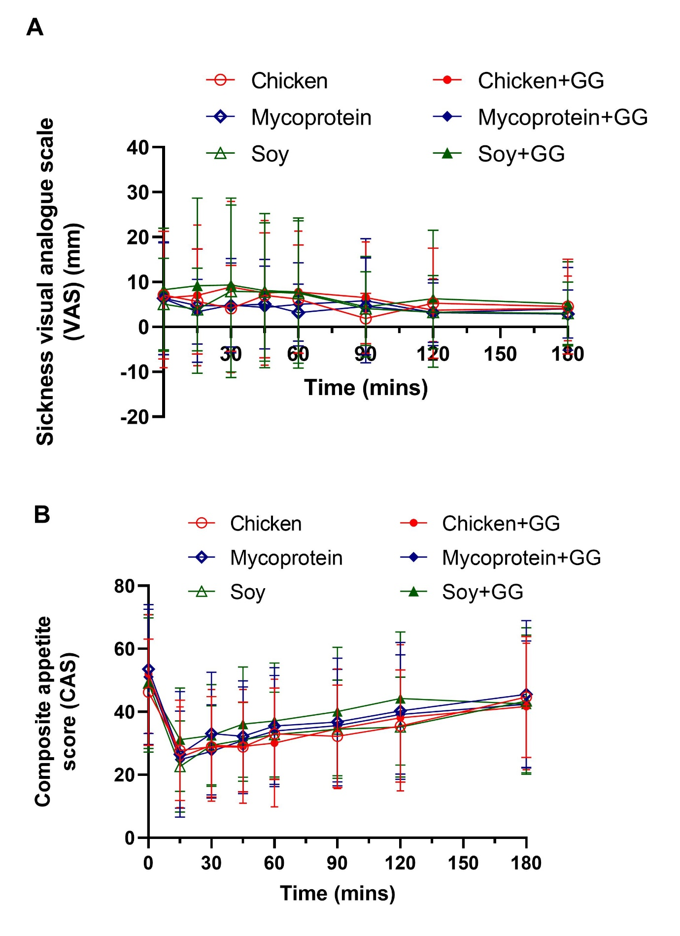Supplemental Figure 6. Sickness visual analogue scale (VAS) (A) and composite appetite score (CAS) (B) ratings (mm) over 180 min following the consumption of soy, chicken and MP with GG- or not enriched chapatis for all participants (n=21). Data represents mean±SD. The colour scheme represents the type of proteins, these being soy (green), chicken (red), and MP (blue). CAS, composite appetite score; GG, guar gum; SD, standard deviation; mm, millimetres; MP, mycoprotein; n, sample size; VAS, visual analogue scale.

