Appendix 2a, Fig: A-G. Complete blood cell count (CBC) with differential counts of white blood cells

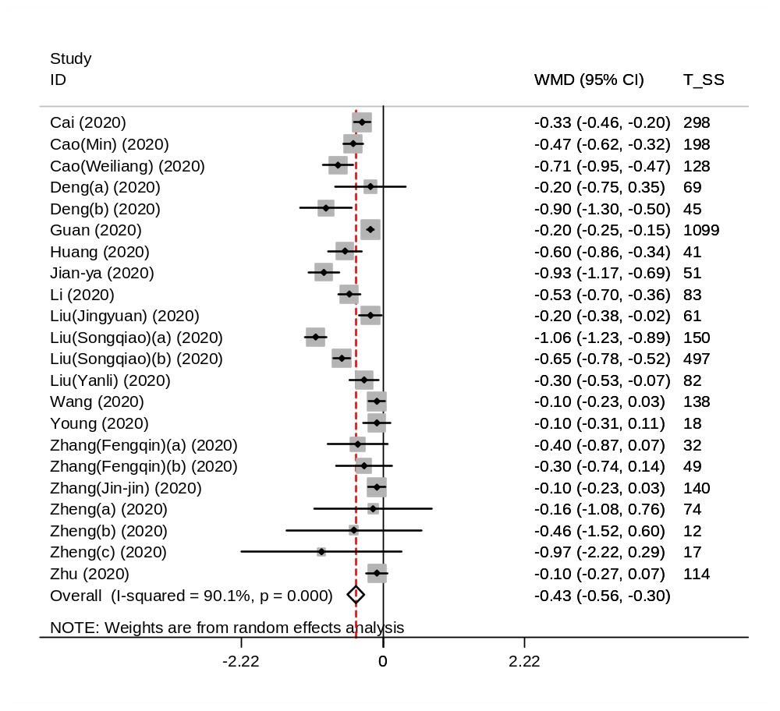

Fig. A. Lymphocyte

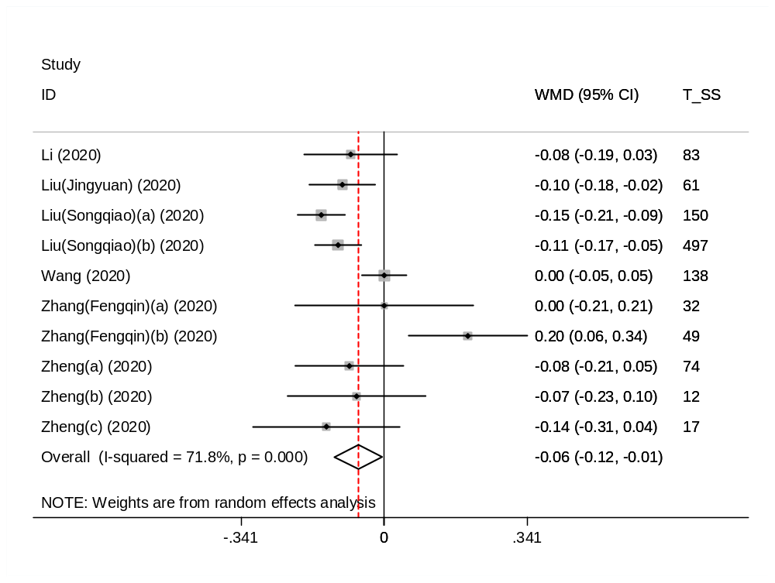

Fig. B. Monocyte

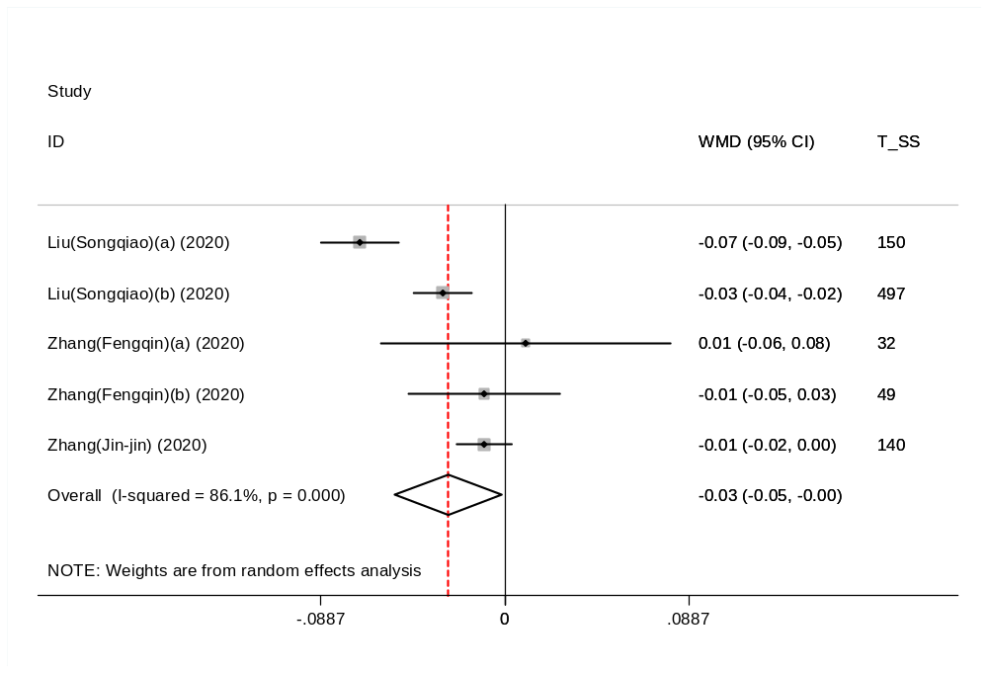

Fig. C. Eosinophil

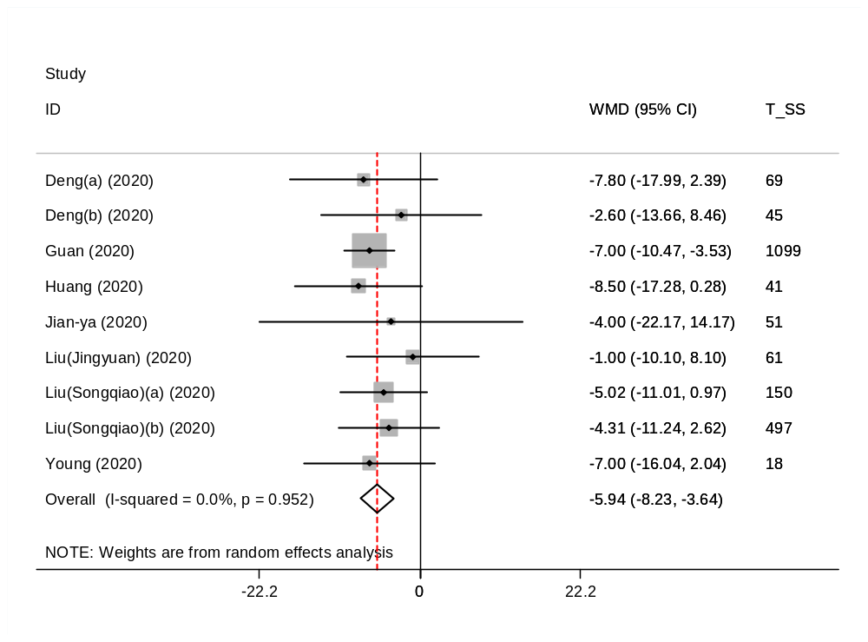

Fig. D. Haemoglubin (Hb)

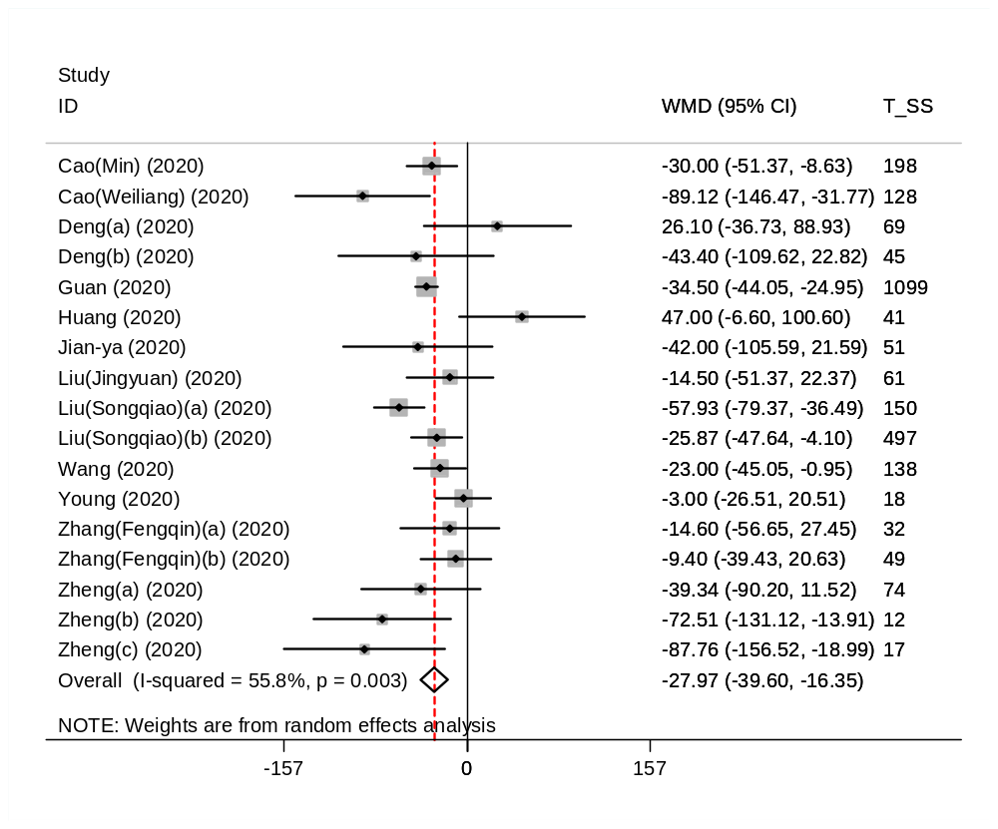

Fig. E. Platelete

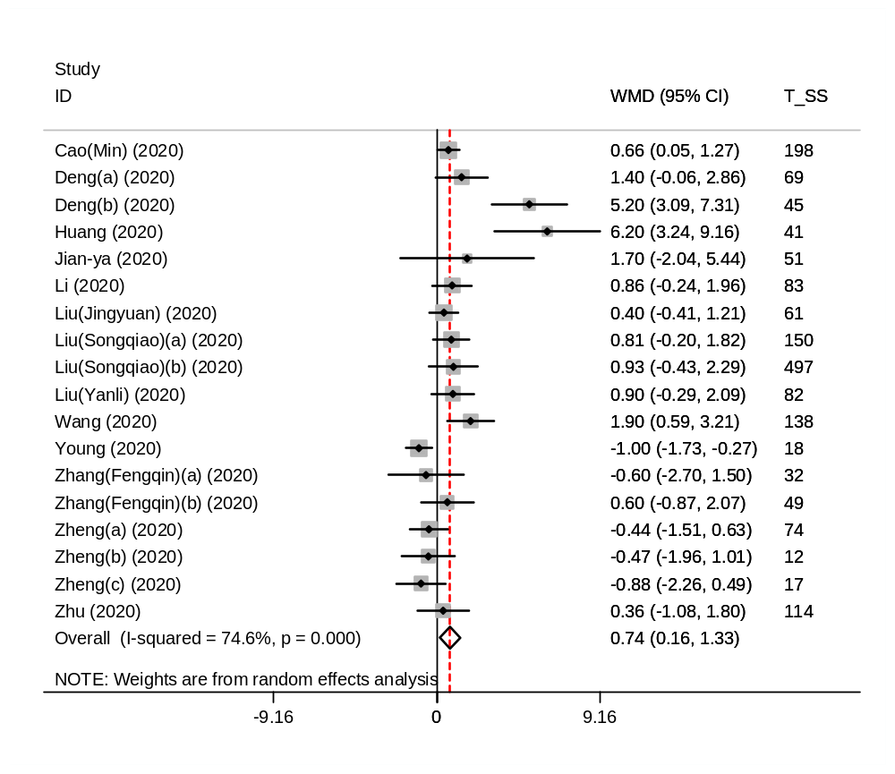

Fig. F. Neutrophil

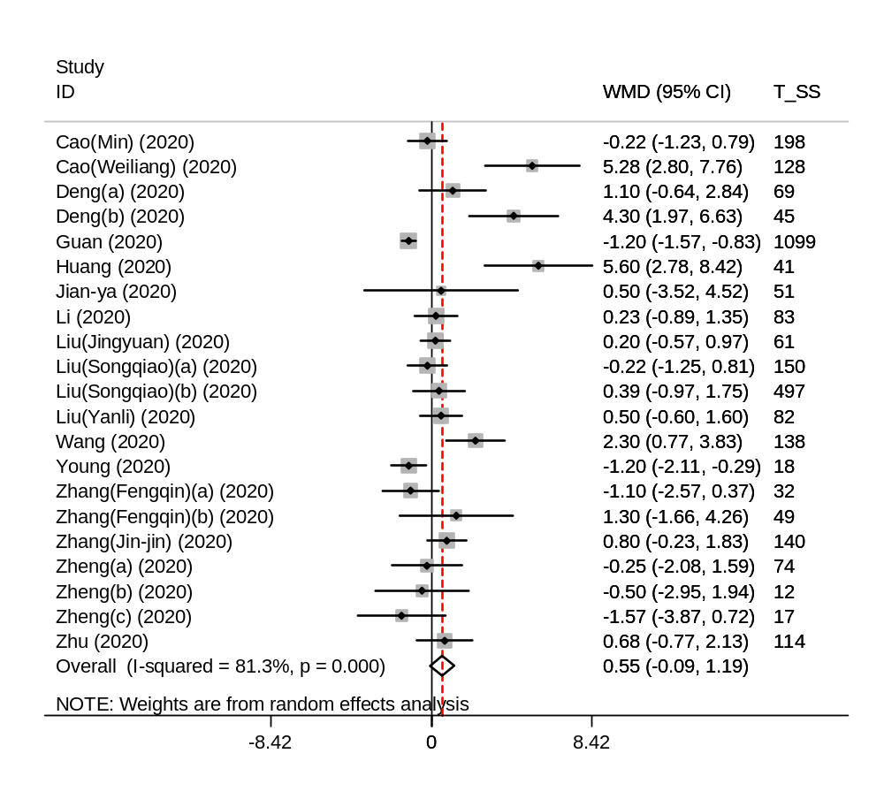

Fig. G. WBC

Appendix 2B, Fig: A-F. Liver and kidney functions

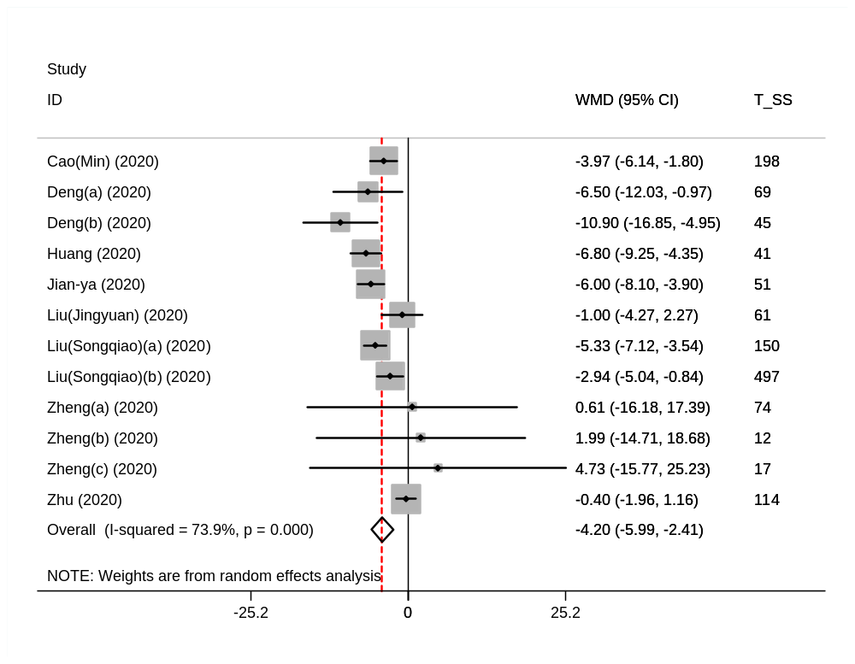

Fig. A. Albumin

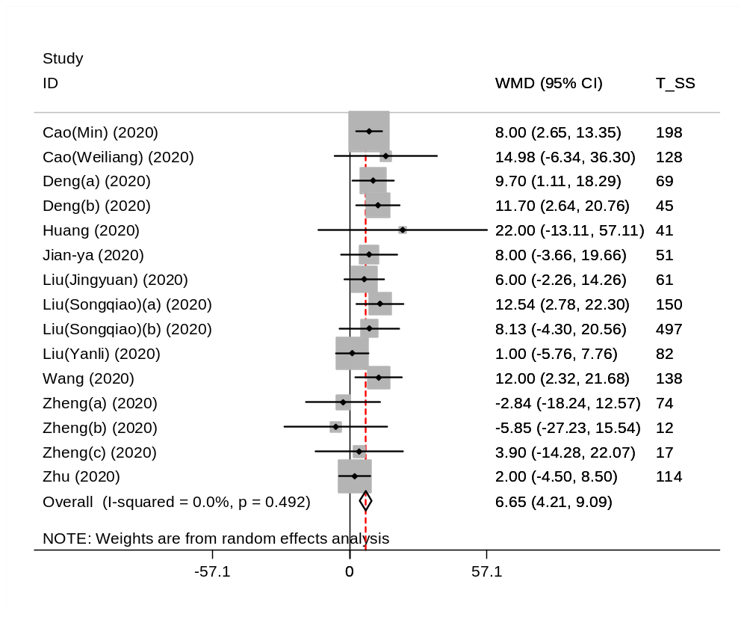

Fig. B. ALT

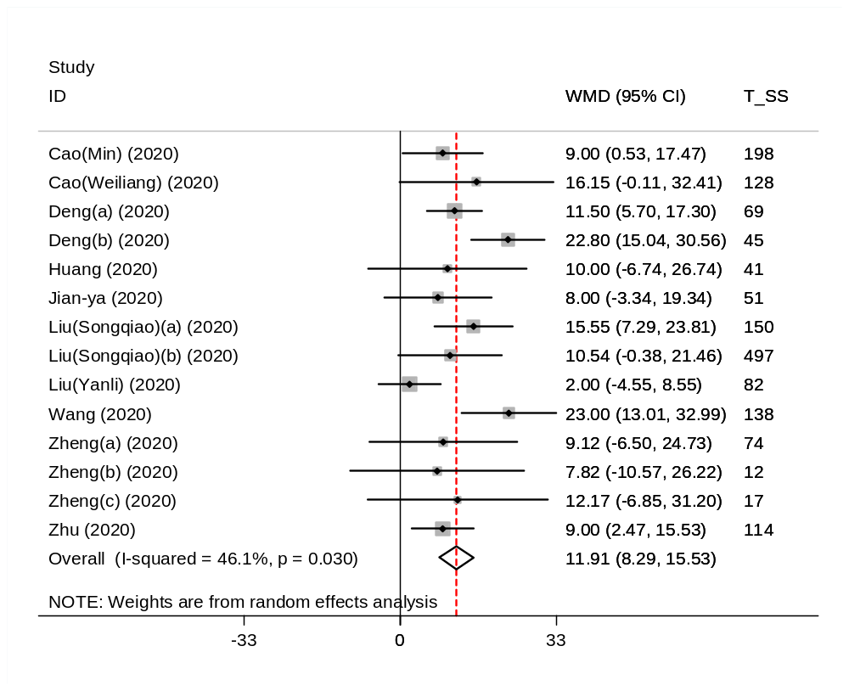

Fig. C. AST

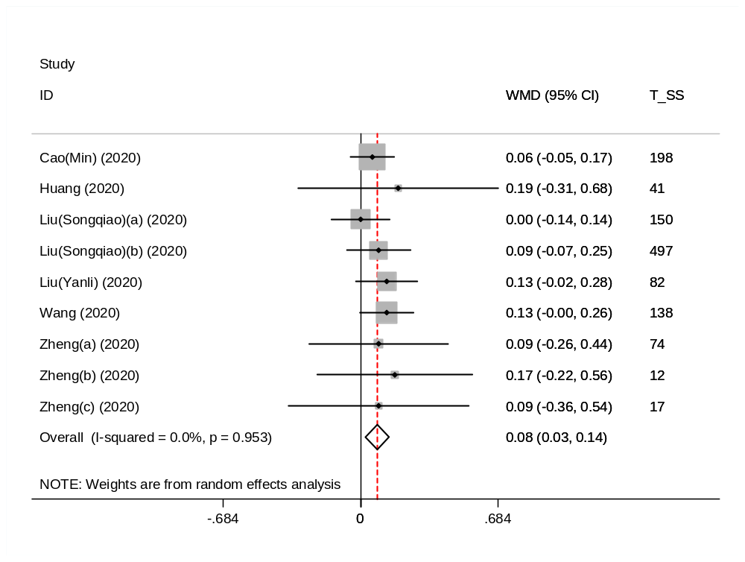

Fig. D. TBil

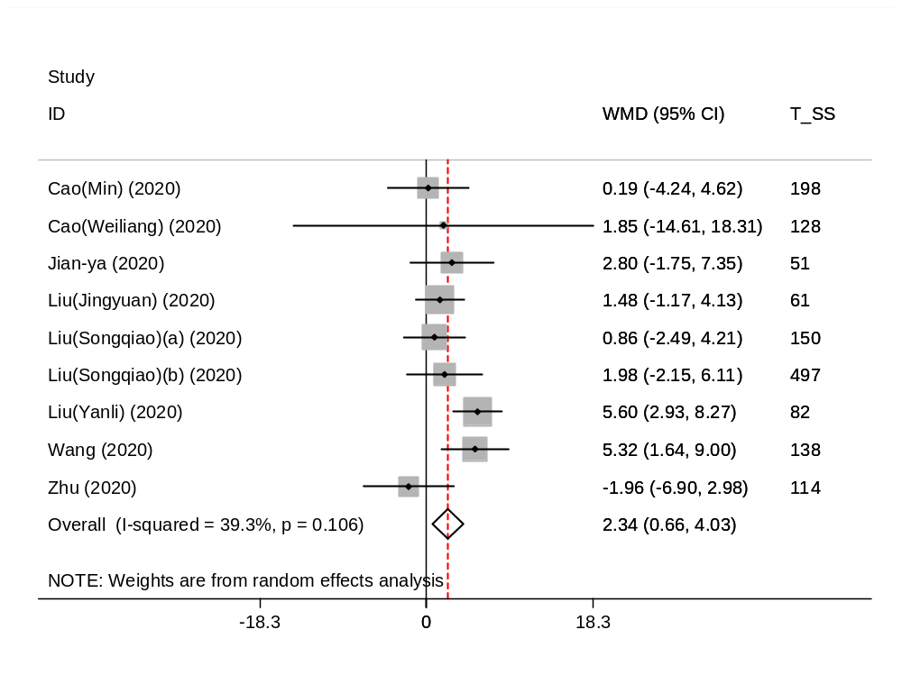

Fig. E. BUN

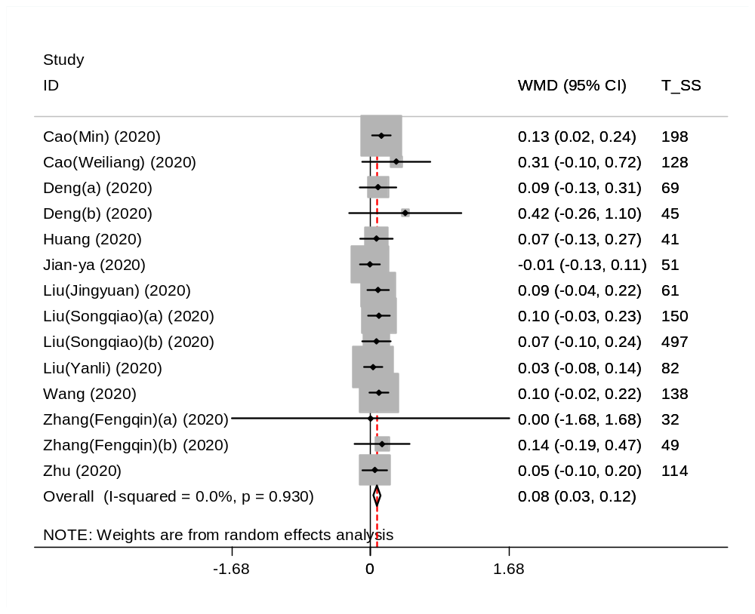

Fig. F. Cr

Appendix 2c, Fig: A-C. Myocardial enzyme, Myoglobin

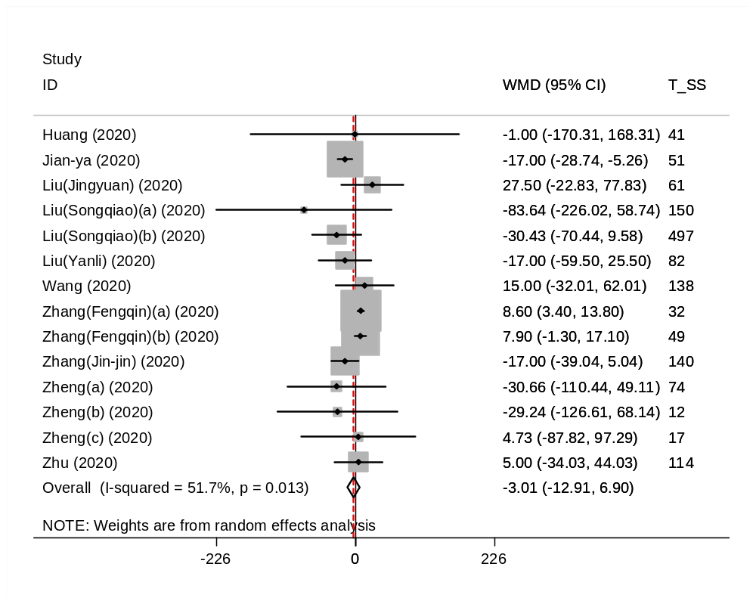

Fig. A. Creatine kinase (CK)

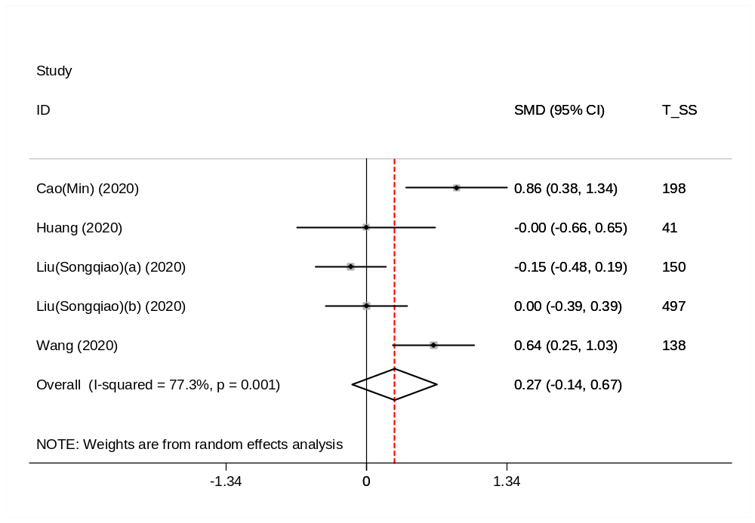

Fig. B. Troponin I (TnI)

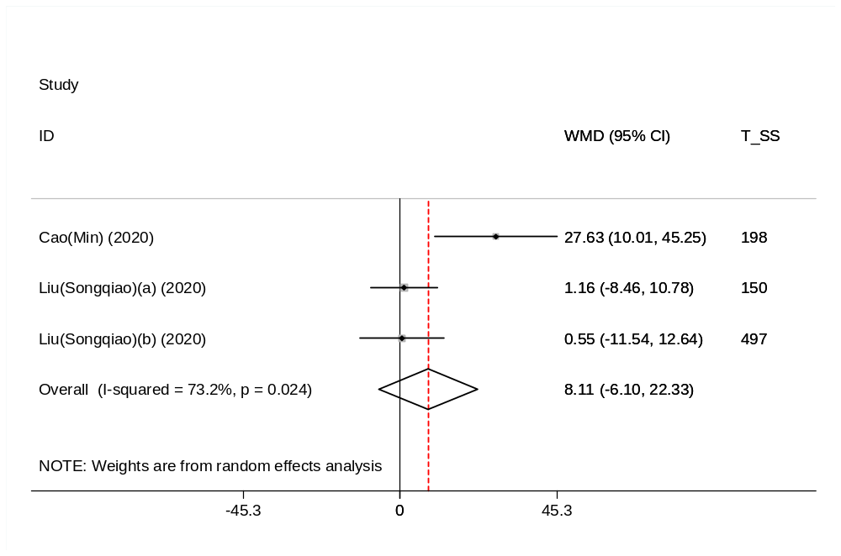

Fig. C. Myoglobin

Appendix 2d, Fig: A-E. Inflammatory markers

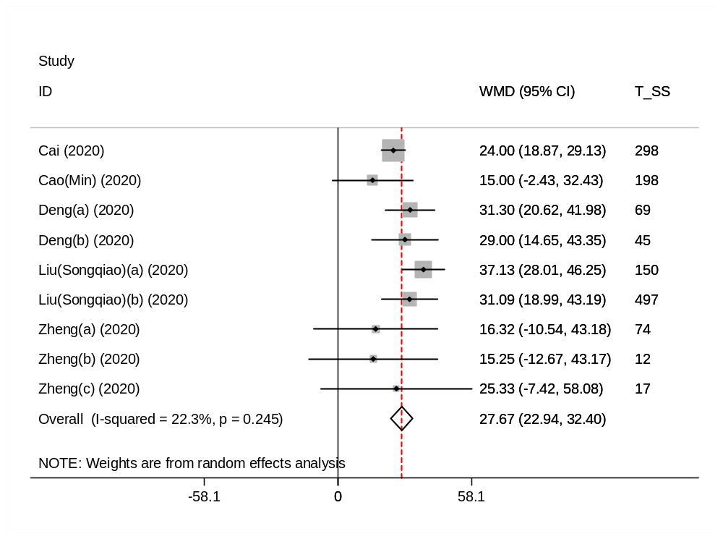

Fig. A. ESR

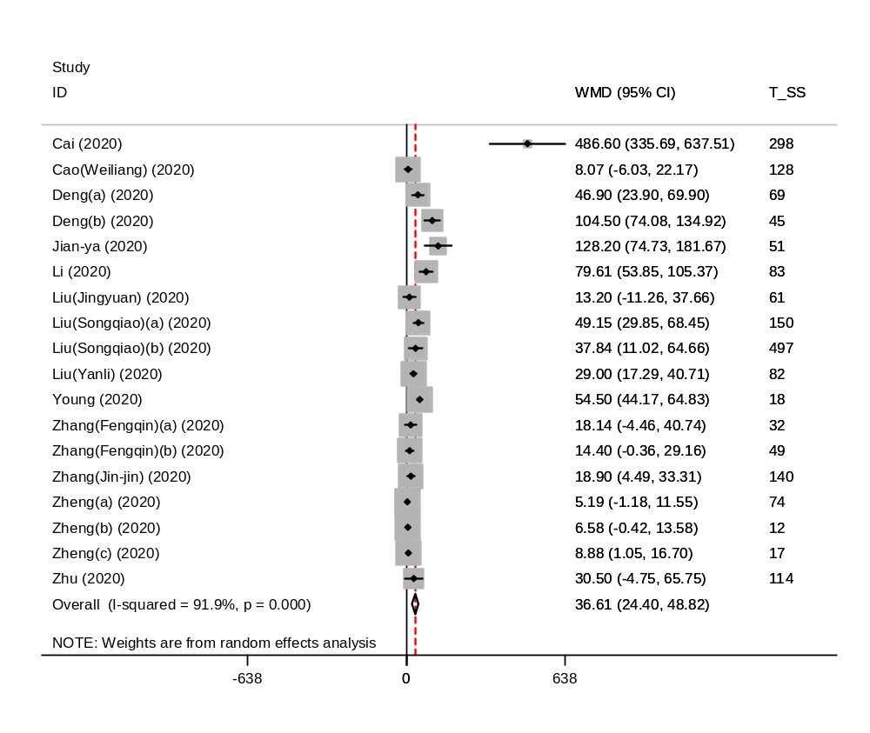

Fig. B. CRP

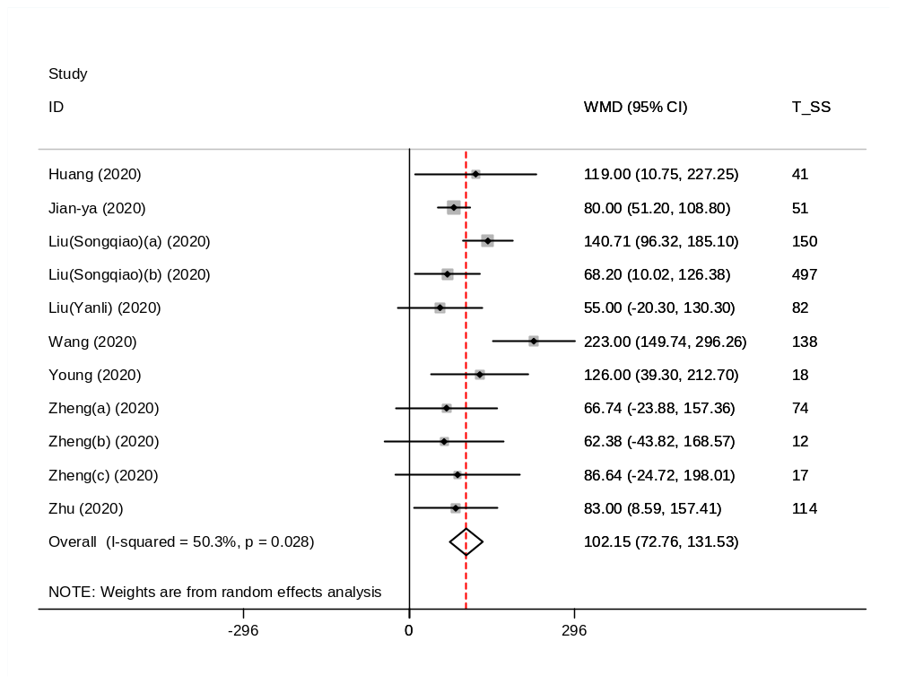

Fig. C. Lactate dehydrogenase (LDH)

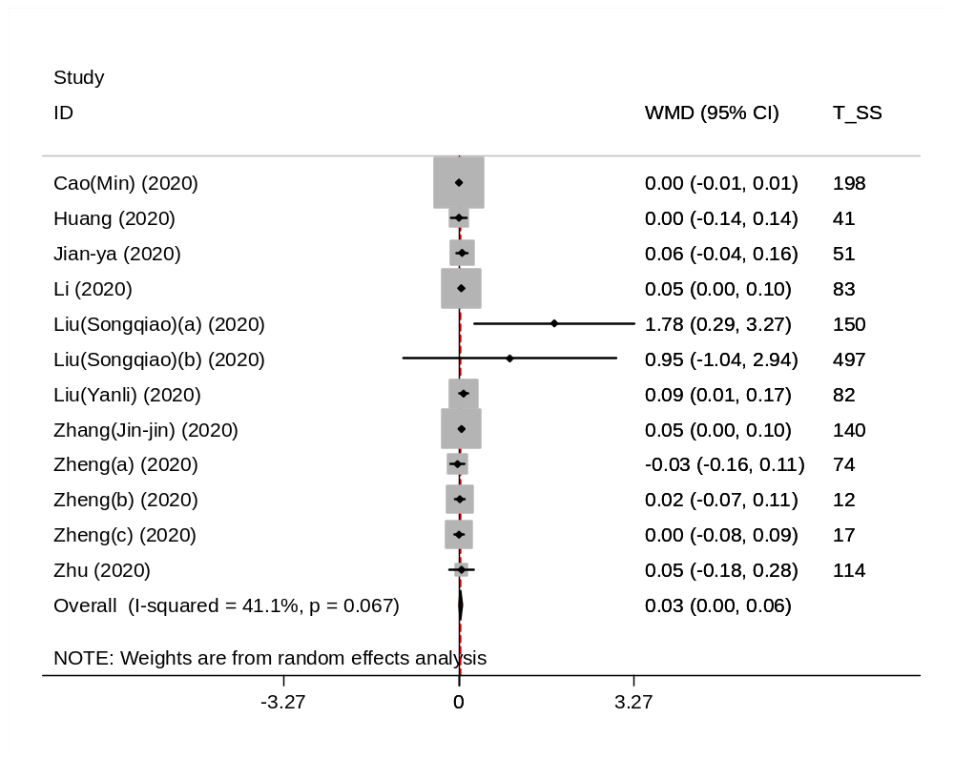

Fig. D. Procalcitonin (PCT)

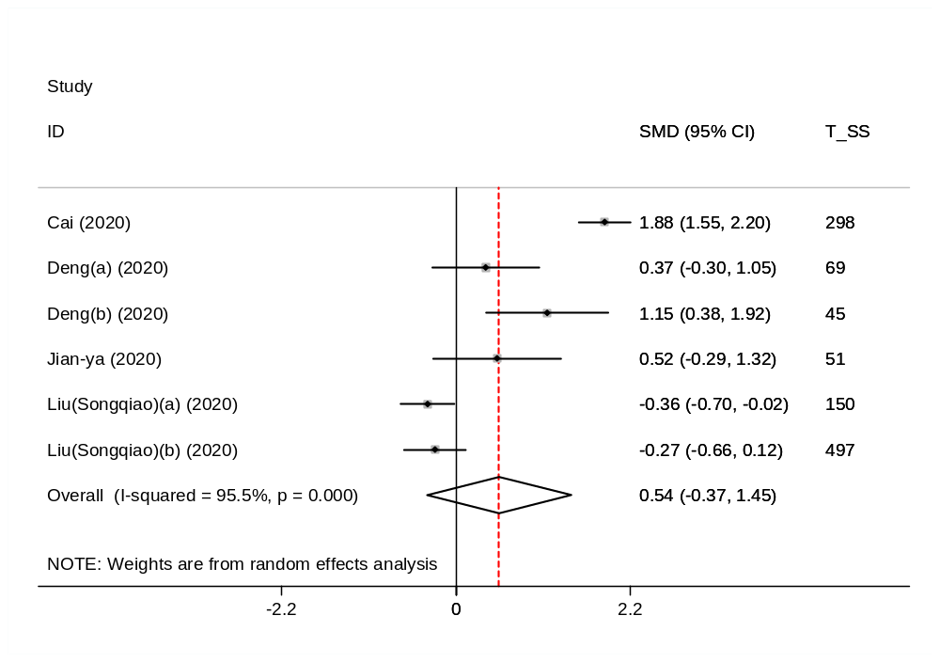

Fig. E. IL-6

Appendix 2e, Fig: A and B. Serum electrolytes

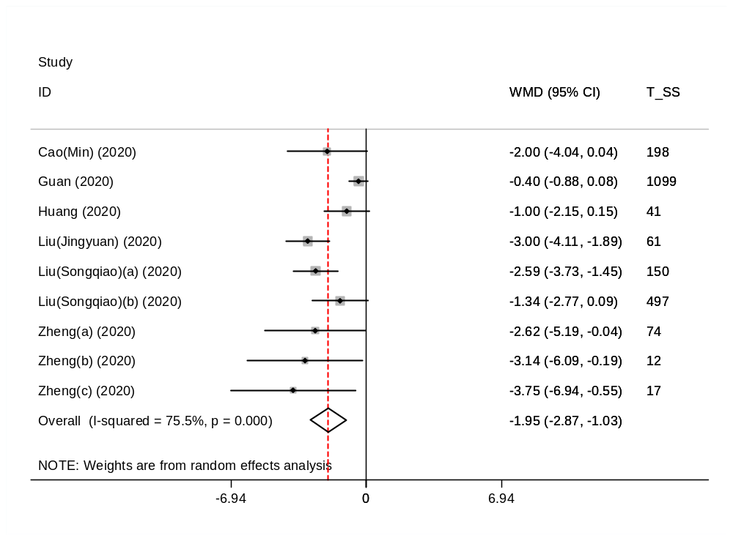

Fig. A.Sodium (Na)

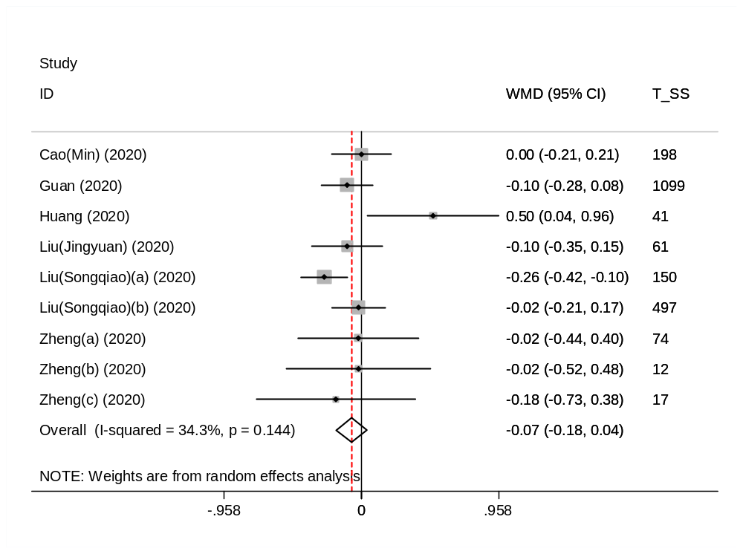

Fig. B. Potassium (K)

Appendix 2f, Fig: A-C. Serum electrolytes

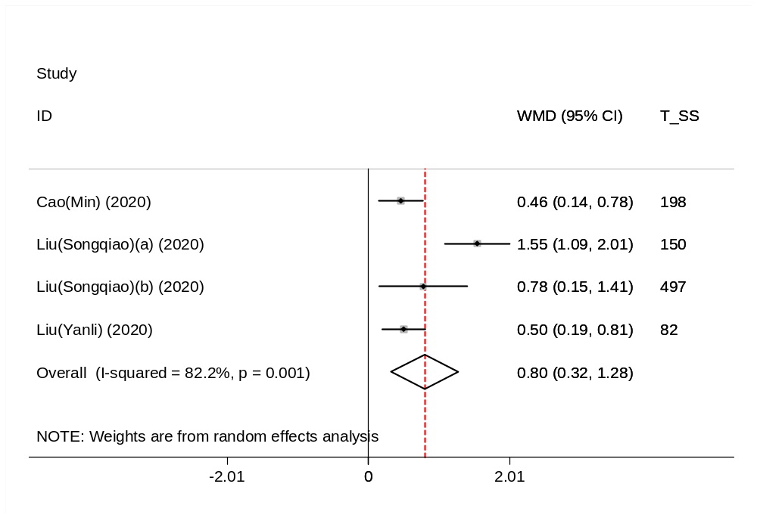

Fig. A. Fibrinogen

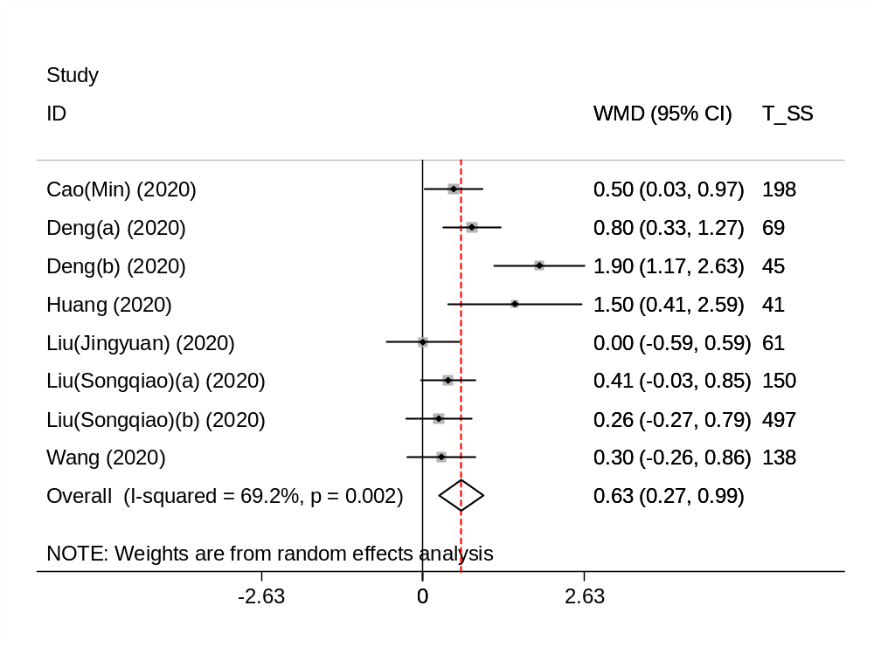

Fig. B. Protrombine (PT)

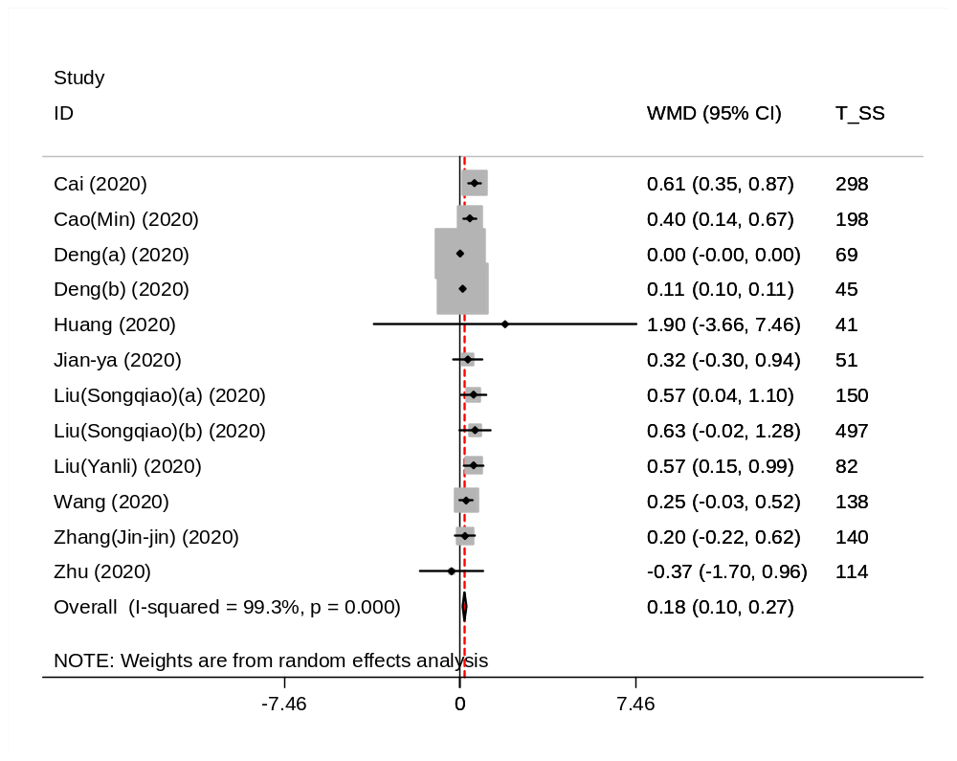

Fig. C. D-dimer

Appendix 2g, Fig: A. Glucose level

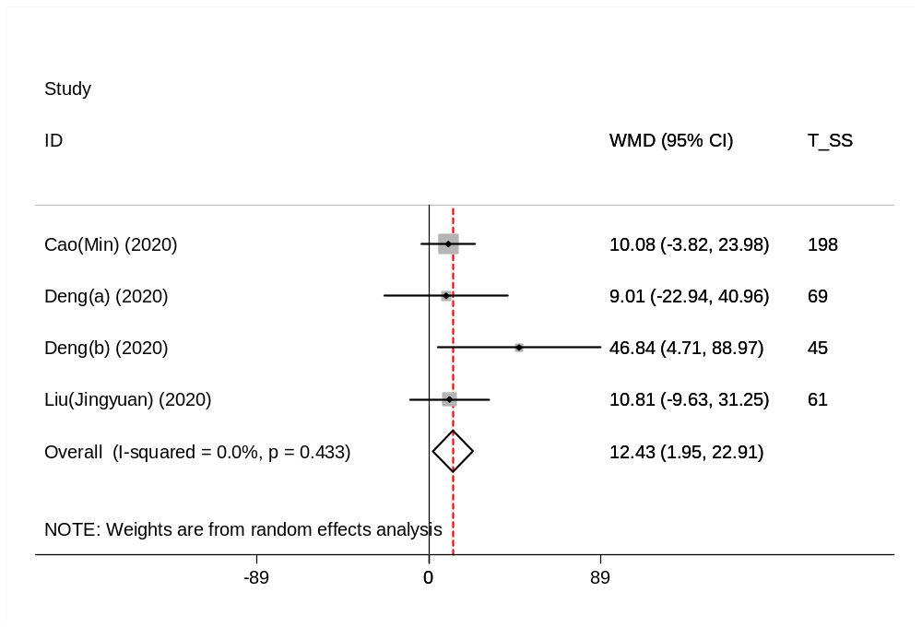

Fig: A. Glucose level

Appendix 2h, Fig: A-D. New markers of combinations

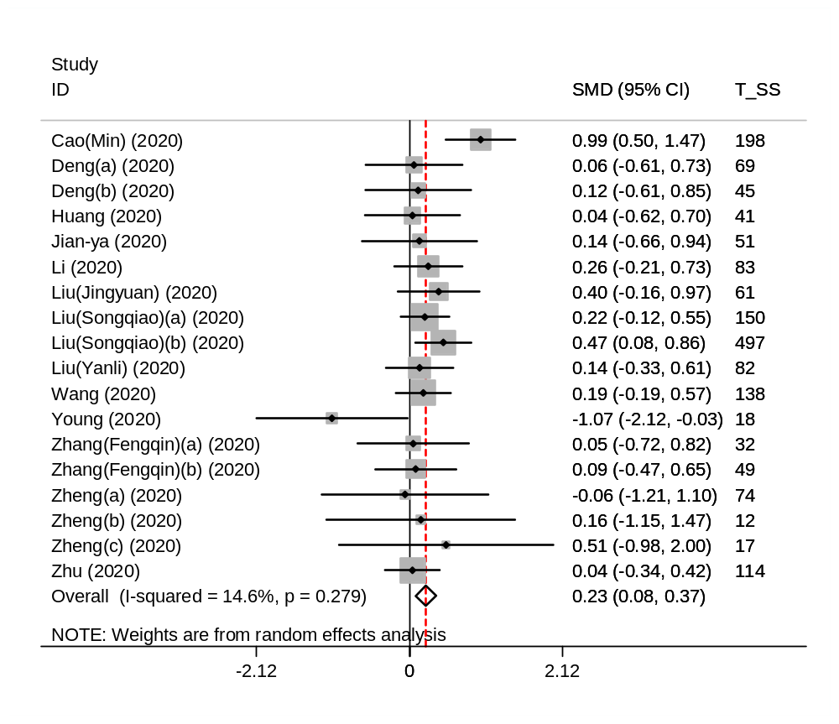

Fig A. Neutrophil‐to‐Lymphocyte ratio (NLR)

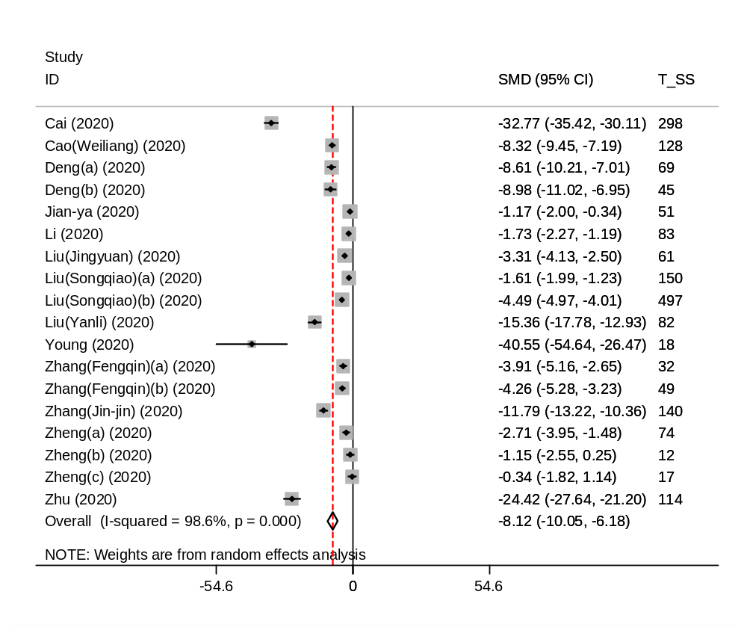

Fig B. Lymphocyte-to-C-reactive protein ratio (LCR)

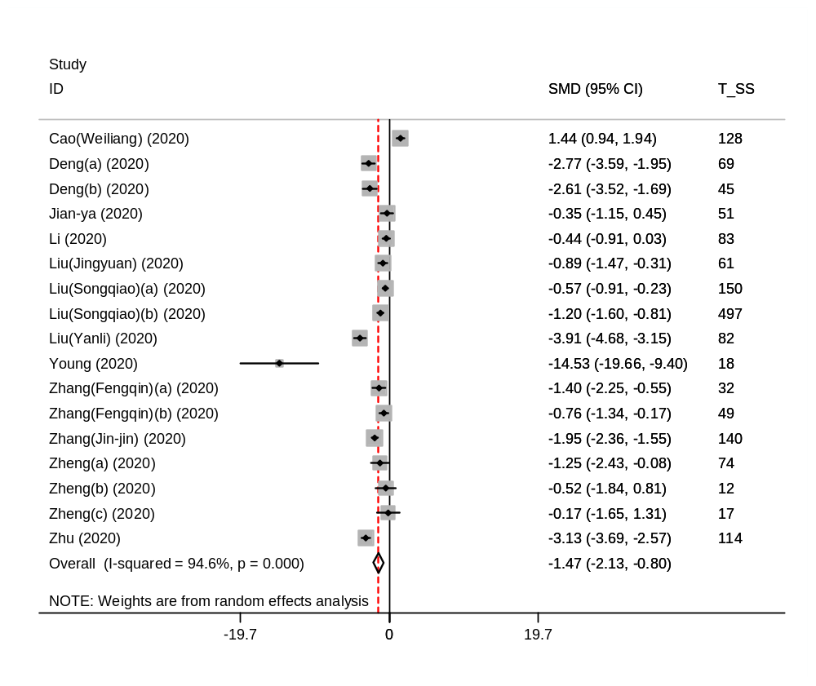

Fig C. Leukocyte-to-C-reactive protein ratio (LeCR)

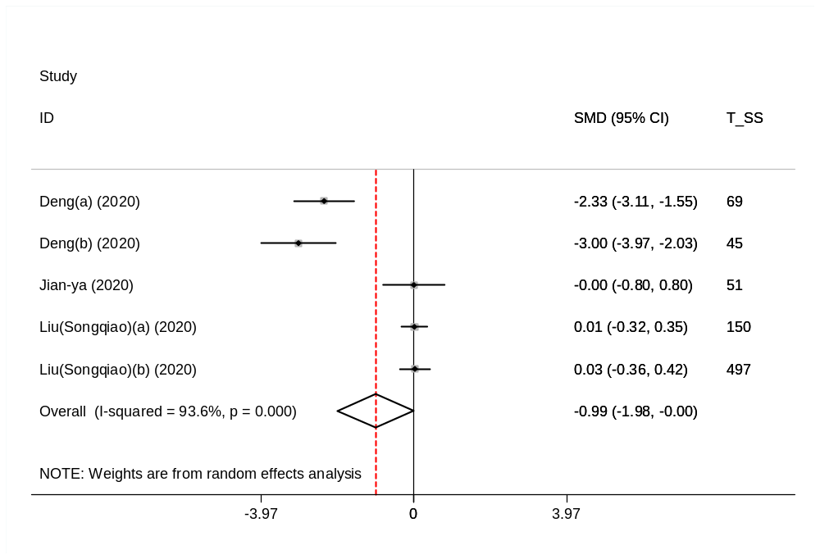

Fig D. Leukocyte-to-IL-6 ratio (LeIR)

