Table S1. Concentration of heavy metals found in Certified Reference Materials NMIJ CRM 7303-a lake sediment (means ± standard errors, in mg/kg as dry wt.) by AAS (n = 3).

Element | Certified value | Measured value | Recovery (%)
As | 8.6±1.0 | 8.2±0.04 | 95
Cr | 39.1±2.8 | 38.7±0.21 | 99
Cd | 0.342±0.017 | 0.344±0.02 | 101
Pb | 31.3±1.1 | 31.5±0.89 | 101

Table S2. Mathematical expressions and physical significances of environmental and ecological indices.
Indices | Mathematical expressions | Classification | Contamination degree | References
Geo-accumulation index, I_{geo} | $I_{geo}= {Log}_{2}\left(\frac{C_{n}}{{1.5 ×B}_{n}}\right)$ Where, C_{n} is the measured elemental concentration in sediment and B_{n} is the background heavy metal concentrations | I_{geo} < 0 | Uncontaminated | Müller, (1981)
Geo-accumulation index, I_{geo} |  | 1 ≤ I_{geo} < 2 | Uncontaminated to moderately contaminated | Müller, (1981)
Geo-accumulation index, I_{geo} |  | 2 ≤ I_{geo} < 3 | Moderately to heavily contaminated | Müller, (1981)
Geo-accumulation index, I_{geo} |  | 3 ≤ I_{geo} < 4 | Heavily contaminated | Müller, (1981)
Geo-accumulation index, I_{geo} |  | 4 ≤ I_{geo} < 5 | Heavily to extremely contaminated | Müller, (1981)
Geo-accumulation index, I_{geo} |  | I_{geo} ≥ 5 | Extremely contaminated | Müller, (1981)
Contamination factor, CF | $CF= \frac{C_{n}}{B_{n}}$ Where, C_{n} and B_{n} are the measured and background elemental concentrations in sediment & water, respectively. | CF < 1 | Low contamination | Håkanson, (1980)
Contamination factor, CF |  | 1 ≤ CF < 3 | Moderate contamination | Håkanson, (1980)
Contamination factor, CF |  | 3 ≤ CF < 6 | Considerable contamination | Håkanson, (1980)
Contamination factor, CF |  | CF ≥ 6 | Very high contamination | Håkanson, (1980)
Modified degree of contamination, mC_{d} | ${mC}_{d}=\frac{1}{n}\sum_{i=1}^{n}{{CF}_{i}}$ where, CF is the contamination factor | mC_{d} < 1.5 | Uncontaminated | Håkanson, (1980); Abrahim, and Parker, (2008)
Modified degree of contamination, mC_{d} |  | 1.5 ≤ mC_{d} < 2 | Slightly contaminated | Håkanson, (1980); Abrahim, and Parker, (2008)
Modified degree of contamination, mC_{d} |  | 2 ≤ mC_{d} < 4 | Moderately contaminated | Håkanson, (1980); Abrahim, and Parker, (2008)
Modified degree of contamination, mC_{d} |  | 4 ≤ mC_{d} < 8 | Moderately to heavily contaminated | Håkanson, (1980); Abrahim, and Parker, (2008)
Modified degree of contamination, mC_{d} |  | 8 ≤ mC_{d} < 16 | Heavily contaminated | Håkanson, (1980); Abrahim, and Parker, (2008)
Modified degree of contamination, mC_{d} |  | 16 ≤ mC_{d} < 32 | Severely contaminated | Håkanson, (1980); Abrahim, and Parker, (2008)
Modified degree of contamination, mC_{d} |  | mC_{d} > 32 | Extremely contaminated | Håkanson, (1980); Abrahim, and Parker, (2008)
Degree of contamination, C_{d} | $C_{d}=\sum_{i=1}^{n}{{CF}_{i}}$ where, CF is the contamination factor | C_{d} < 8 | Low degree of contamination | Håkanson, (1980)
Degree of contamination, C_{d} |  | 8 ≤ C_{d} < 16 | Moderate degree of contamination | Håkanson, (1980)
Degree of contamination, C_{d} |  | 16 ≤ C_{d} < 32 | Considerable degree of contamination | Håkanson, (1980)
Degree of contamination, C_{d} |  | C_{d} > 32 | High degree of contamination | Håkanson, (1980)
Enrichment factor, EF | $EF= \frac{{(C_{n}/Fe)}_{Sample}}{{(B_{n}/Fe)}_{Background}}$ Where, C_{n} is the measured elemental concentration in sediment and B_{n} is the background heavy metal concentrations | EF < 1 | Elemental mobilization | (Birch & Olmos, 2008)
Enrichment factor, EF |  | EF = 1 | Baseline data | (Birch & Olmos, 2008)
Enrichment factor, EF |  | 1 ≤ EF < 1.5 | Possible anthropogenic origin | (Birch & Olmos, 2008)
Enrichment factor, EF |  | 1.5 ≤ EF < 3 | Minor enrichment | (Birch & Olmos, 2008)
Enrichment factor, EF |  | 3 ≤ EF < 5 | Moderate enrichment | (Birch & Olmos, 2008)
Enrichment factor, EF |  | 5 ≤ EF < 10 | Severe modification | (Birch & Olmos, 2008)
Enrichment factor, EF |  | EF > 10 | Very severe modification | (Birch & Olmos, 2008)
Pollution load index, PLI | $PLI={({CF}_{1}× {CF}_{2}×… {CF}_{n})}^{\frac{1}{n}}$ where, CF is the contamination factor | PLI = 0 | Perfection | Sadhu et al. (2012)
Pollution load index, PLI |  | PLI < 1 | Baseline level | Sadhu et al. (2012)
Pollution load index, PLI |  | PLI > 1 | Contaminated | Sadhu et al. (2012)
Potential ecological risk factor, Er^{i} | ${Er}^{i}={Tr}^{i}×{CF}^{i}$ Where, Tr^{i} is the biological toxic metal response factor (Zn=1, Ni=5, Mn=1, Pb=5, Cu=5, Cr=2 and Cd=30) and CF is the contamination factor. | Er^{i} < 40 | Low risk | Håkanson, (1980)
Potential ecological risk factor, Er^{i} |  | 40 ≤ Er^{i} < 80 | Moderate risk | Håkanson, (1980)
Potential ecological risk factor, Er^{i} |  | 80 ≤ Er^{i} < 160 | Considerable risk | Håkanson, (1980)
Potential ecological risk factor, Er^{i} |  | 160 ≤ Er^{i} < 320 | High risk | Håkanson, (1980)
Potential ecological risk factor, Er^{i} |  | Er^{i} ≥ 320 | Very high risk | Håkanson, (1980)
Potential ecological risk index (PERI) | $RI=\sum_{i=1}^{n}{{Er}^{i}}$ Where Er^{i} is the potential ecological risk factor. | RI < 150 | Low risk | Håkanson, (1980)
Potential ecological risk index (PERI) |  | 150 ≤ RI < 300 | Moderate risk | Håkanson, (1980)
Potential ecological risk index (PERI) |  | 300 ≤ RI < 600 | Considerable risk | Håkanson, (1980)
Potential ecological risk index (PERI) |  | RI ≥ 600 | High risk | Håkanson, (1980)

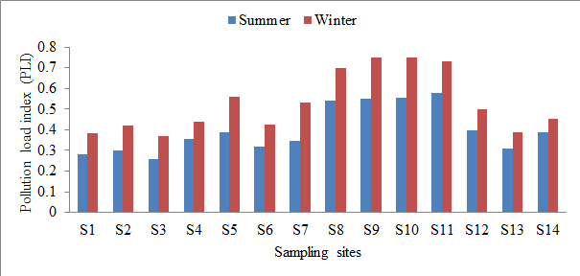
Figure S1. Pollution load index of heavy metals in sediments of an urban river (Kirtankhola) in Bangladesh during summer and winter season.

Figure S2. Toxic unit (TU) of heavy metals in sediments of an urban river (Kirtankhola) in Bangladesh during summer and winter season.
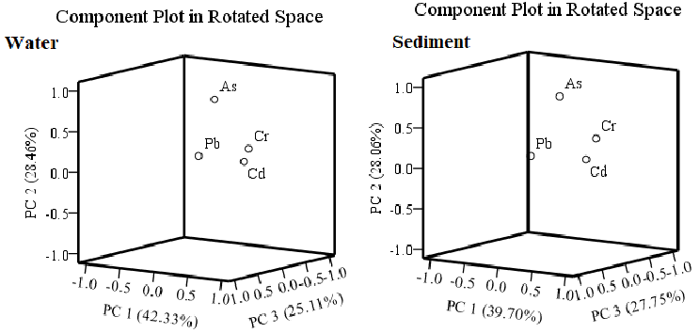
Figure S3. PCA for heavy metals in water and sediment of an urban river (Kirtankhola) in Bangladesh.

Table S3. Contamination factors, degree of contamination, contamination level, and pollution load of heavy metals in sediment collected from river of Kirtankhola, Bangladesh
Contamination factors () |  |  |  |  |  |  |  |  | Degree of contamination (C_{d}) |  | Contamination level
Sites | As |  | Cr |  | Cd |  | Pb |  | Summer | Winter | Summer | Winter
Sites | Summer | Winter | Summer | Winter | Summer | Winter | Summer | Winter
S1 | 0.31 | 0.48 | 0.57 | 0.76 | 0.13 | 0.16 | 0.28 | 0.36 | 1.29 | 1.77 | Low | Low
S2 | 0.35 | 0.59 | 0.33 | 0.45 | 0.12 | 0.14 | 0.60 | 0.84 | 1.40 | 2.02 | Low | Low
S3 | 0.30 | 0.38 | 0.38 | 0.51 | 0.06 | 0.11 | 0.65 | 0.93 | 1.39 | 1.92 | Low | Low
S4 | 0.44 | 0.61 | 0.67 | 0.74 | 0.11 | 0.13 | 0.51 | 0.64 | 1.73 | 2.12 | Low | Low
S5 | 0.33 | 0.57 | 0.63 | 0.80 | 0.19 | 0.25 | 0.59 | 0.86 | 1.74 | 2.48 | Low | Low
S6 | 0.27 | 0.46 | 0.53 | 0.71 | 0.14 | 0.17 | 0.51 | 0.56 | 1.45 | 1.91 | Low | Low
S7 | 0.22 | 0.56 | 0.44 | 0.58 | 0.22 | 0.27 | 0.65 | 0.91 | 1.54 | 2.31 | Low | Low
S8 | 0.39 | 0.64 | 0.81 | 1.06 | 0.28 | 0.31 | 0.95 | 1.13 | 2.43 | 3.15 | Low | Low
S9 | 0.40 | 0.63 | 0.74 | 1.16 | 0.29 | 0.34 | 1.07 | 1.27 | 2.50 | 3.40 | Low | Low
S10 | 0.49 | 0.84 | 0.78 | 0.95 | 0.33 | 0.41 | 0.74 | 0.95 | 2.34 | 3.15 | Low | Low
S11 | 0.50 | 0.70 | 0.93 | 1.06 | 0.29 | 0.37 | 0.83 | 1.06 | 2.55 | 3.18 | Low | Low
S12 | 0.36 | 0.47 | 0.58 | 0.69 | 0.21 | 0.24 | 0.56 | 0.77 | 1.71 | 2.17 | Low | Low
S13 | 0.38 | 0.54 | 0.46 | 0.57 | 0.10 | 0.10 | 0.51 | 0.70 | 1.45 | 1.92 | Low | Low
S14 | 0.43 | 0.55 | 0.50 | 0.56 | 0.18 | 0.19 | 0.59 | 0.71 | 1.70 | 2.02 | Low | Low

Table S4. Varimax rotated factor loadings of the elements for water and sediment of an urban river (Kirtankhola) in Bangladesh
Samples | Initial Eigen value |  |  |  |  | Rotation Sums of Squared Loadings
Samples | Component | Total | %variance | Cumulative% |  | Total | % variance | Cumulative%
Water | 1 | 3.13 | 78.26 | 78.26 |  | 1.69 | 42.33 | 42.33
Water | 2 | 0.465 | 11.61 | 89.87 |  | 1.13 | 28.46 | 70.80
Water | 3 | 0.241 | 6.03 | 95.91 |  | 1.00 | 25.11 | 95.91
Sediment | 1 | 2.98 | 74.53 | 74.53 |  | 1.58 | 39.70 | 39.70
Sediment | 2 | 0.46 | 11.50 | 86.04 |  | 1.12 | 28.06 | 67.77
Sediment | 3 | 0.38 | 9.49 | 95.53 |  | 1.11 | 27.75 | 95.53

Table S5. Correlation coefficient of heavy metals in water and sediment from Kirtankhola River, Bangladesh
Water | Cr | As | Cd | Pb
Cr | 1
As | 0.650 | 1
Cd | 0.828 | 0.580 | 1
Pb | 0.770 | 0.639 | 0.779 | 1
Sediment
Cr | 1
As | 0.684 | 1
Cd | 0.792 | 0.591 | 1
Pb | 0.618 | 0.572 | 0.696 | 1
*. Correlation is significant at the 0.05 level (2-tailed).

Figure S1. Pollution load index (PLI) of heavy metals (summer and winter season) in Kirtankhola River, Bangladesh
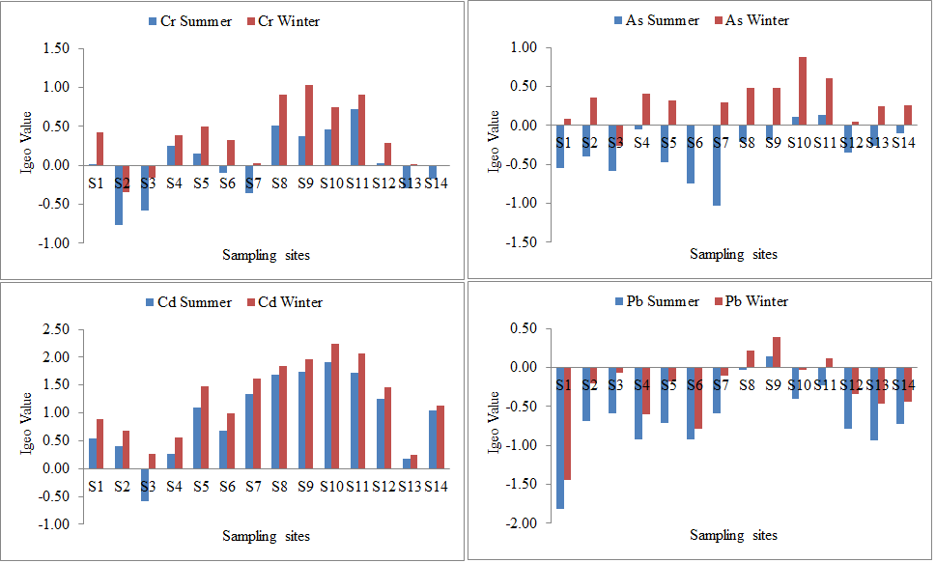
Figure S2. Geoaccumulation index of heavy metals in Kirtankhola River, Bangladesh
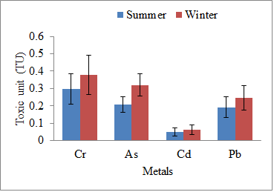
Figure S3. Toxic units of heavy metals in Kirtankhola River, Bangladesh

