Supplement
Evaluation of Using Small Volume of Interest Regions for Clinical Kidney Dosimetry in ¹⁷⁷Lu-DOTATATE Treatments

Jehangir Khan^{1,2,5}, Tobias Rydèn¹, Martijn Van Essen³, Johanna Svensson⁴, and Peter Bernhardt^{1,5}

¹Department of Medical Physics and Biomedical Engineering (MFT), Sahlgrenska University Hospital, Gothenburg, Sweden, ²Department of Medical Physics, Faculty of Medicine and Health, Örebro University Hospital, Örebro, Sweden, ³Department of Clinical Physiology, Sahlgrenska University Hospital, Gothenburg, Sweden, ⁴Department of Oncology, Institution of Clinical Sciences, Sahlgrenska Academy at University of Gothenburg, Sweden, ⁵Department of Medical Radiation Sciences, Institute of Clinical Sciences, Sahlgrenska Academy at University of Gothenburg, Sweden.

Corresponding author:
Jehangir Khan, Department of Medical Physics and Biomedical Engineering (MFT)
Sahlgrenska University Hospital, Gothenburg, SE-41345 Sweden; E-mail:
Jehangir.khan@gu.se; Phone: +46- (0) – 736772531

Running title: Small VOI in ¹⁷⁷Lu-DOTATATE dosimetry
Number of figures and tables: 3

Key Words: ¹⁷⁷Lu-DOTATATE; neuroendocrine; single-photon emission tomography; SPECT/CT; kidney dosimetry; recovery coefficient
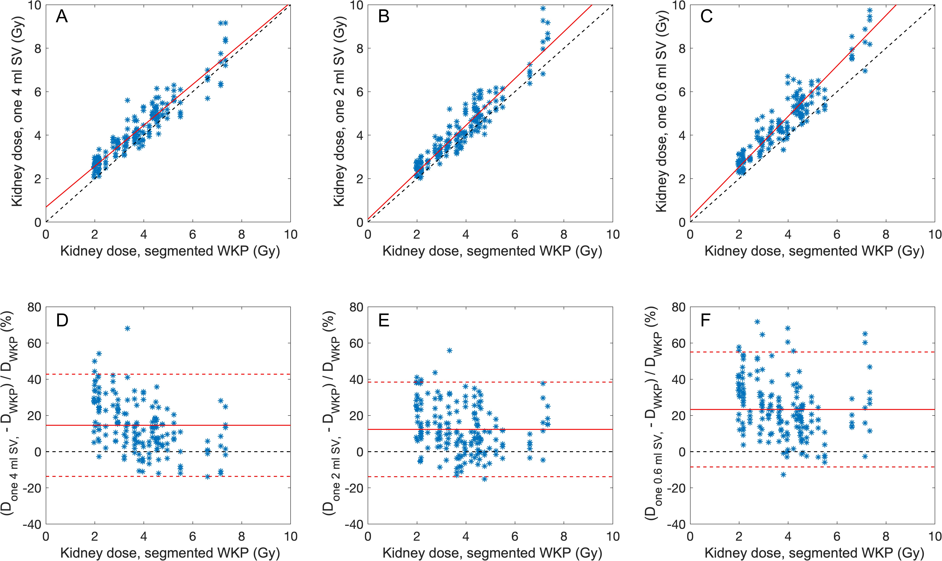
FIGURE S1. Bland-Altman and Pearson’s correlation plots of the kidney absorbed doses estimated from the whole-kidney parenchyma (WKP) and small volume of interest (SV) methods based on unfiltered ASCC-OSEM reconstructed images. (A–C) Pearson’s correlation plots of the kidney absorbed doses estimated using one SV₄ (A), one SV₂ (B), and one SV_{0.6} (C). (D–F) Bland-Altman plots of one SV₄ (D), one SV₂ (E), and one SV_{0.6} (F). Solid red lines indicate the best fit (A–C) and the mean of the differences (bias) value (D–F) between two methods. Dashed red lines indicate the upper and lower 95% limits of agreement (bias ± 1.96 × SD). The dashed black lines indicate the line of identity.

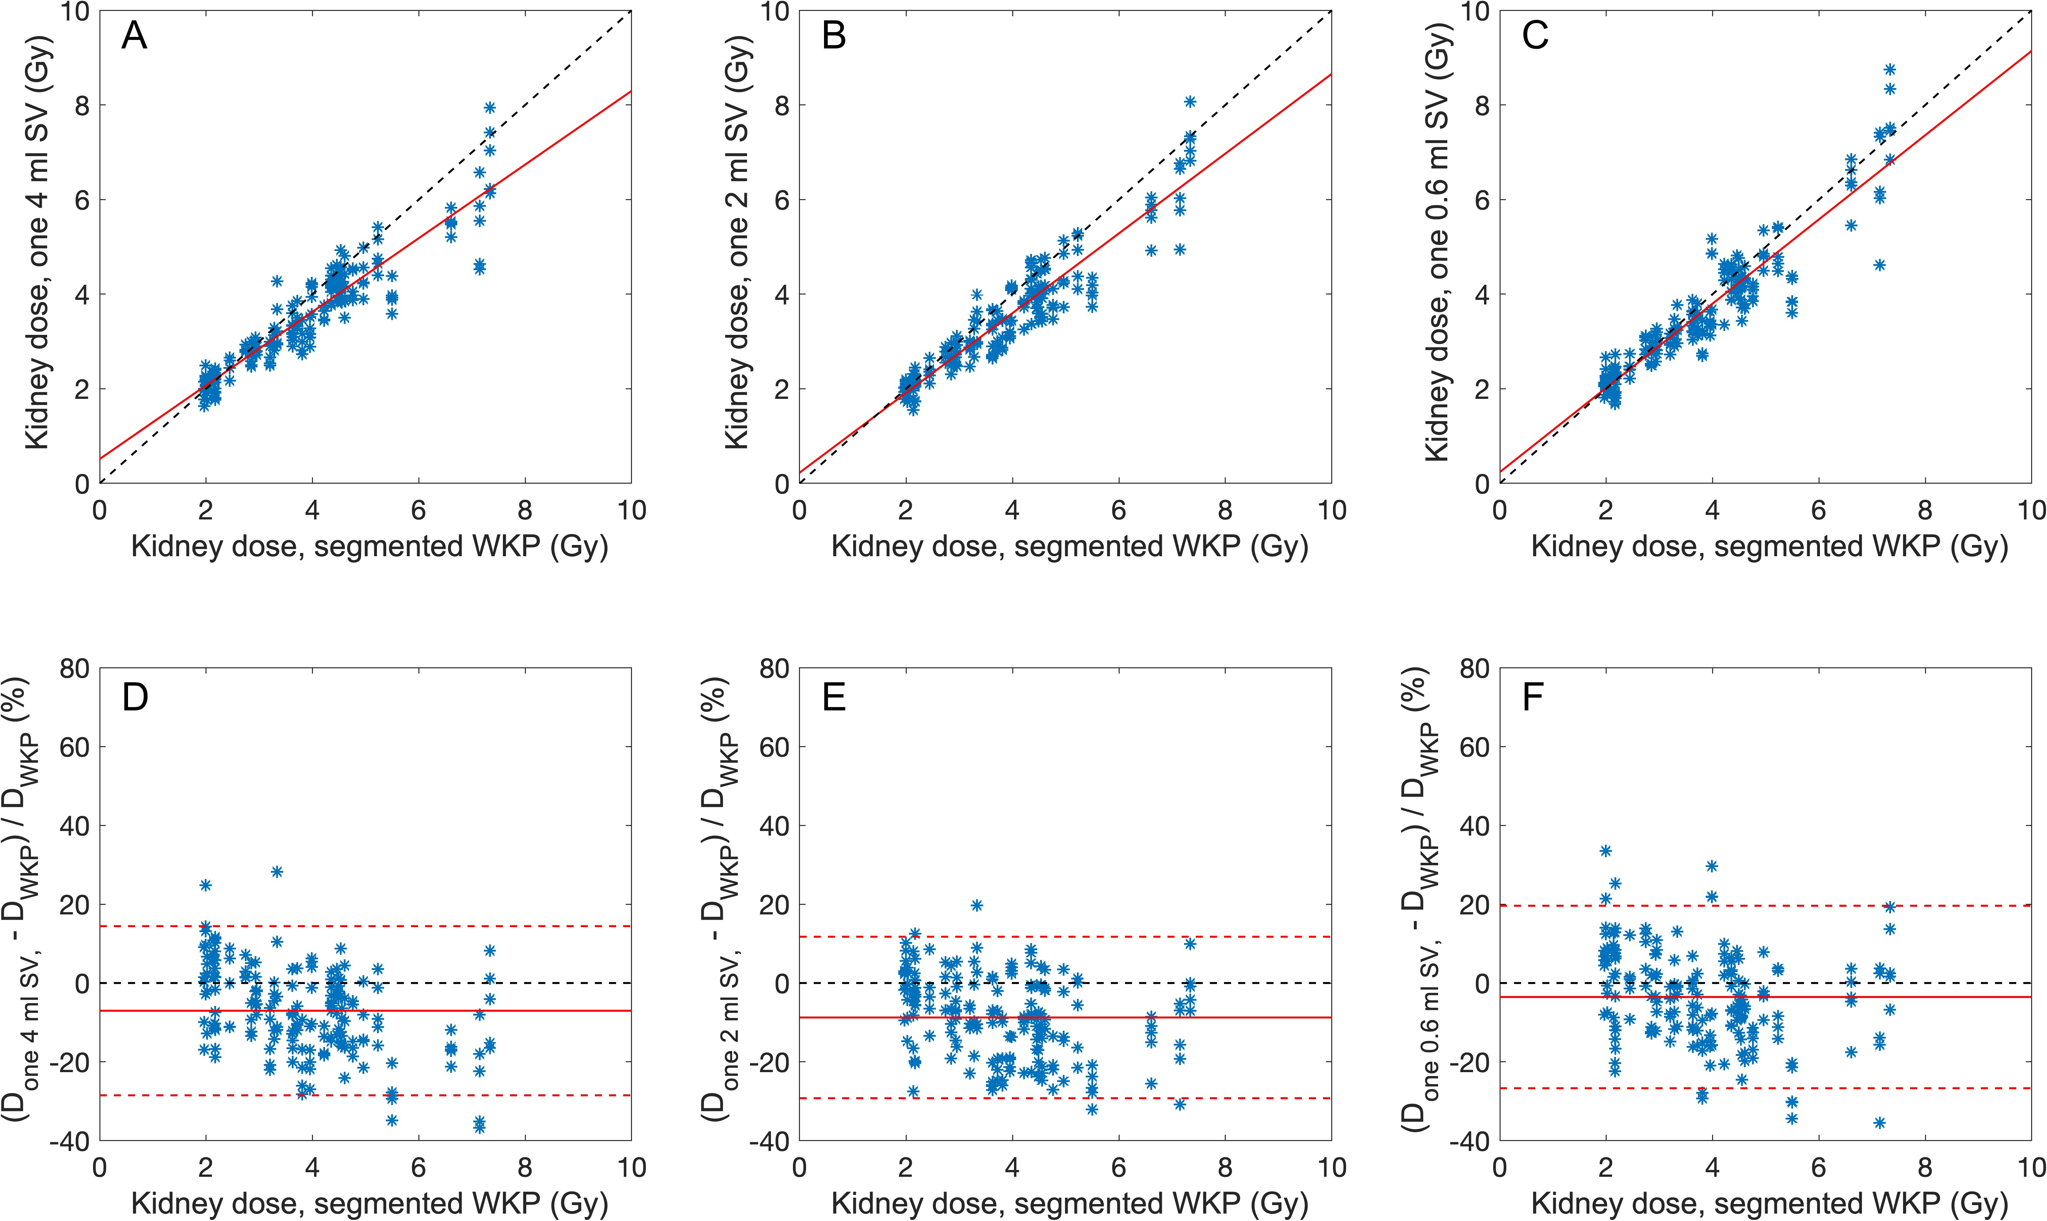
FIGURE S2. Bland-Altman and Pearson’s correlation plots of kidney absorbed doses estimated from the whole-kidney parenchyma (WKP) and small volume of interest (SV) methods in ASCC-OSEM reconstructed SPECTs and postfiltering by Gaussian filter (6 mm). (A–C) Pearson’s correlation plots of the kidney absorbed doses estimated using one SV₄ (A), one SV₂ (B), and one SV_{0.6} (C). (D–F) Bland-Altman plots of one SV₄ (D), one SV₂ (E), and one SV_{0.6} (F). Solid red lines indicate the best fit (A–C) and the mean of the differences (bias) value (D–F) between two methods. Dashed red lines indicate the upper and lower 95% limits of agreement (bias ± 1.96 × SD). The dashed black lines indicate the line of identity.

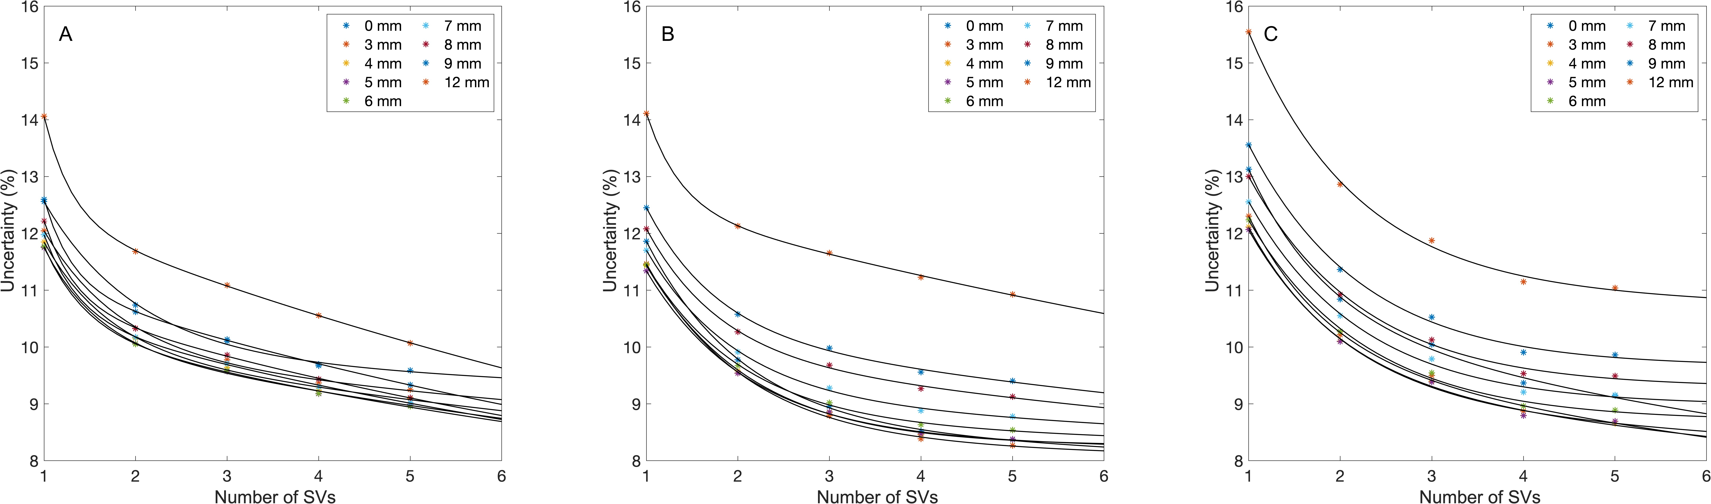
FIGURE S3. The uncertainties of the whole-kidney parenchyma (WKP) method versus the number of small volumes of interest (SVs) used in the determination of the mean activity concentration. Uncertainties are estimated by bi-exponential curve fit of total SV uncertainties (Eq. 6) for Gaussian filtering with nine different sigma values (0–12 mm). (A) SV₄. (B) SV₂. (C) SV_{0.6}.

