EXTENDED DATA

Extended Data Fig. 1 | Selected 2-D diffraction image of K₂Mg(CO₃)₂. Glass image collected at 1 bar at ID15b beamline, ESRF. The presence of diffuse scattering near the beamstop region (at the center) and the absence of powder diffraction rings and single crystal diffraction spots confirm the starting material to be completely glassy.

Extended Data Fig. 2 | Graphical representation of the procedure to derive the structure factor from experimental data. The background signal (in red) is subtracted from the sample signal (in black) and the difference is the structure factor S(Q) (in blue). The selected signal was acquired at 46 GPa, while the background was measured at 1 bar using the same gasket, thus same distance between the diamonds, after the sample has been decompressed, removed and the gasket cleaned in ultrasonic bath.

Extended Data Fig. 3 | Comparison between structure factors collected on different beamlines at similar pressures. The two S(Q) are identical within experimental error, i.e. induced by the use of different detectors in the experiments as well as a different DAC setup, i.e. diamonds of different thickness.

Extended Data Fig. 4 | Selected structure factors S(Q) for K₂Mg(CO₃)₂ glass in compression. Data have been collected at ID15a (A) and ID15b (B) at 60 keV and 30 keV photon energies respectively. The tiny spikes visible in some of the S(Q) in (B) are caused by the diffraction of micro-grains of dirt present on the table of the diamonds and appear sporadically based on the DAC-x-ray alignment.

Extended Data Fig. 5 | Pressure dependence of the first and second sharp diffraction peaks position of K₂Mg(CO₃)₂ glass. Acronym: first sharp diffraction peak, FSDP; second sharp diffraction peak, SSDF. Radial distribution function (RDF) calculations show that major contributions for FSDP and SSDP are K-O, O-O and Mg-O, O-O respectively. Values are compared between data acquired at beamlines ID15b (black) and ID15a (transparent). Colored regions reflect either compressional changes and/or structural transition in the glass. The flattening of the curves around 40 GPa reflects strong underlying changes in the carbonate ions. Note that structure factors obtained at ID15a and ID15b agree very well despite the different experimental conditions (Extended Data Fig. 3), thus for the purpose of this study both datasets complement each other and can be used together.

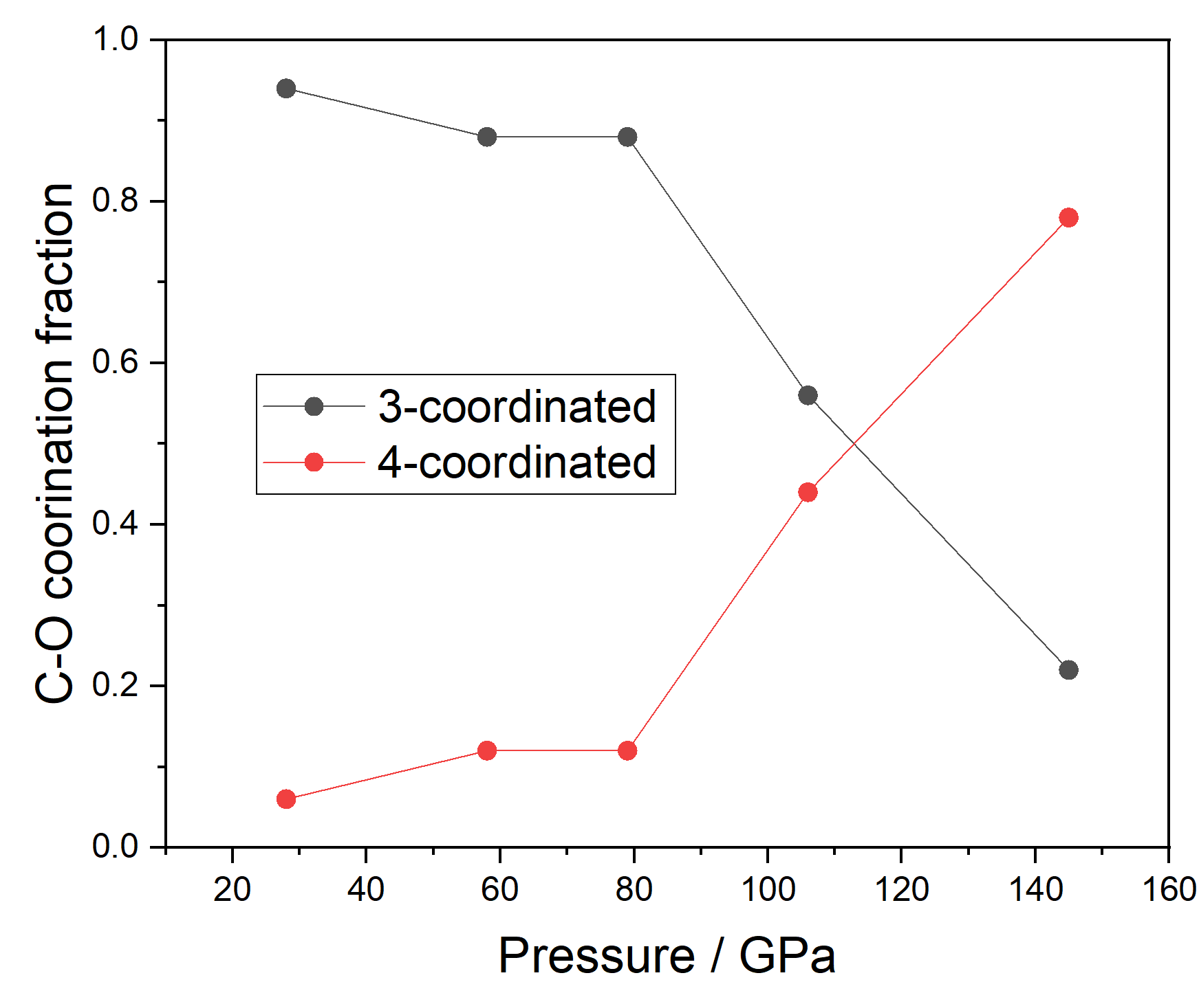
Extended Data Fig. 6 | Pressure dependence of the C-O coordination numbers from AIMD simulations. Calculations were performed with a cutoff separation of 1.7 Å.

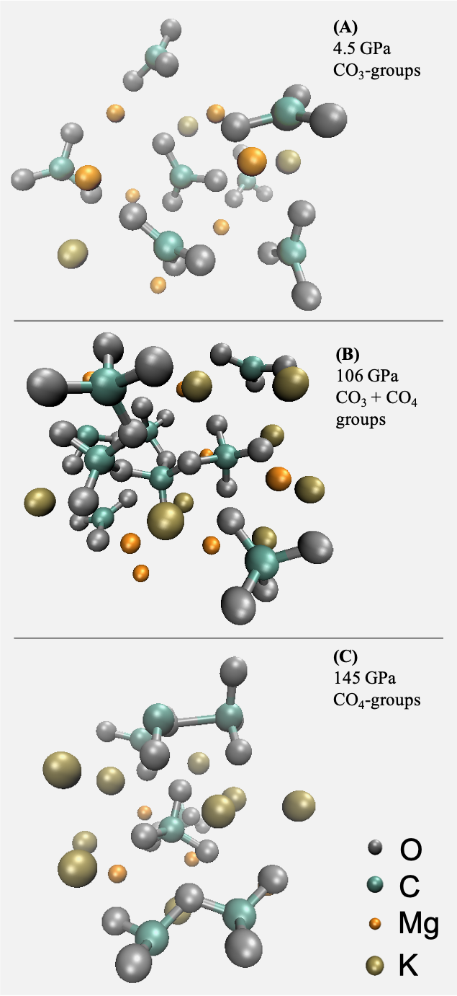
Extended Data Fig. 7 | Atomic structural snapshots from AIMD simulations of K₂Mg(CO₃)₂ at different pressures. The presence of (C₂O₇)⁶⁻ dimers is visible already at 106 GPa (79 GPa in the experimental spectrum, Fig. 1A).

Extended Data Fig. 8 | Main cation-anion distances plot as function of pressure. From the top: C-O, Mg-O and K-O average distances plotted as a function of pressure. Remarkably, C-O bonding distances display three different trends: 1) compression between ambient pressure and 33 GPa; 2) expansion, between 33 GPa and 85 GPa; 3) compression, above 85 GPa. Also Mg-O average distance follow a similar trend, even if the merging of Mg-O and K-O peaks at 85 GPa increases the uncertainty. K-O distance follows a more or less constant compression between ambient pressure and 46 GPa, where the compression slope changes to a lower compressional rate.

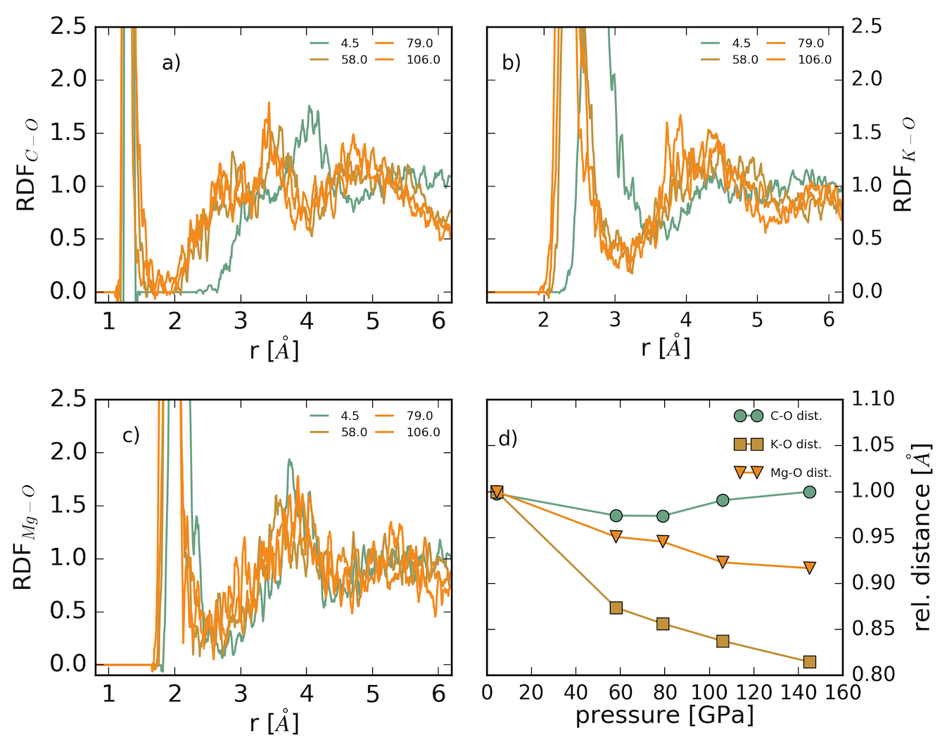
Extended Data Fig. 9 | Radial-distribution-function calculations on C-O (a), K-O (b) and Mg-O (c) performed at multiple pressures. Pressures are represented by distinctive colours as shown in the legend. Relative shift of the cation-oxygen distance as a function of pressure (d). C-O bonds do not show any evident contracture but rather an expansion towards higher lengths at high pressures. K-O bonds evidence a severe compaction between 4.5 and 58 GPa, followed by a smoother compressional path towards the highest simulated pressures. Mg-O bonds seem to be more compressible between 4.5-58 GPa and 79-106 GPa, possibly accommodating the expansion of C-O bonds with the formation of tetrahedral CO₄ units. Sharp increase of the coordination environment might explain the two regions where Mg-O bonds compression is more attenuated.

Extended Data Fig. 10 | Simulated pair distribution function of crystalline K₂Mg(CO₃)₂ at 1 bar. Structural data were taken from⁴⁶.

