New modified heterocyclic-magnetite chitosan nanocomposite for efficient alizarin red dye removal: adsorption analysis and antibacterial activity.
Asmaa Abuessawy,^{1,2} Amr Fouda ³, Adel A.-H. Abdel-Rahman¹, Mohamed A. Hawata¹ Nora A. Hamad^{*1}

¹Chemistry Department, Faculty of Science, Menofia University, Shebin El-Kom, 32511 Egypt
²Basic Science Department, Higher Institute of Engineering and Technology, Menoufia, Egypt
³ Botany and Microbiology Department, Faculty of Science, Al-Azhar University, Nasr City, Cairo 11884, Egypt

Name | Email | ORCID
Asmaa Abuessawy | a.abuessawy@science.menofia.edu.eg | 0000-0003-2264-3552
Amr Fouda | amr_fh83@azhar.edu.eg | 0000-0003-3840-7837
Adel A-H. Abdel-Rahman | adelnassar63@yahoo.com | 0000-0003-3319-8191
Mohamed A. Hawata | drmohamedhawata@gmail.com | 0000-0001-6859-5133
Nora A. Hamad | nhamad059@gmail.com | 0000-0002-4195-6215

*Corresponding author: Nora A. Hamad
https://orcid.org/0000-0002-4195-6215
E–mail address: nhamad059@gmail.com; Tel: +2-010-9587-6887

Scheme S1. The preparation steps of AOC.

Scheme S2. The preparation steps of MC-Cl.

Characterization of 4,6- di methyl-2-oxo-1,2- di hydropyridine-3-carbonitrile (1):

- IR (KBR) cm⁻¹ν_{max}: 3353 cm⁻¹ (ν NH), 2921, 2856 cm⁻¹ (ν CH-Aliphatic), 2218 cm⁻¹ (ν CN), 1641 cm⁻¹ (ν C=O, C=C Ar).
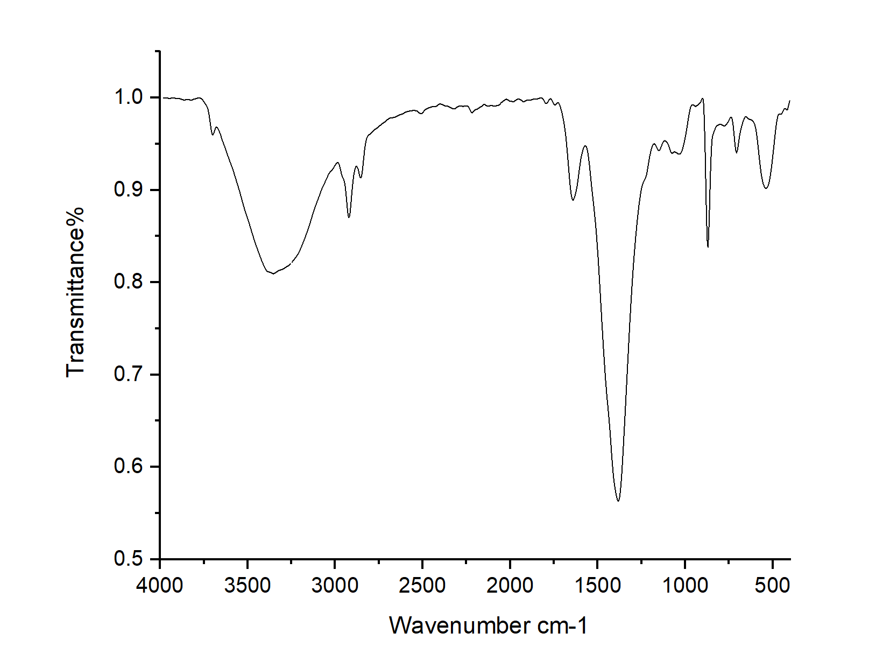
Fig.S1: FTIR spectrum of compound 1.

- ¹H-NMR (DMSO) δ: 2.107, 2.147 (s, 6H, 2CH), 4.326) Brs, 1H, NH), 5. 921 (s, 1H, C-H).
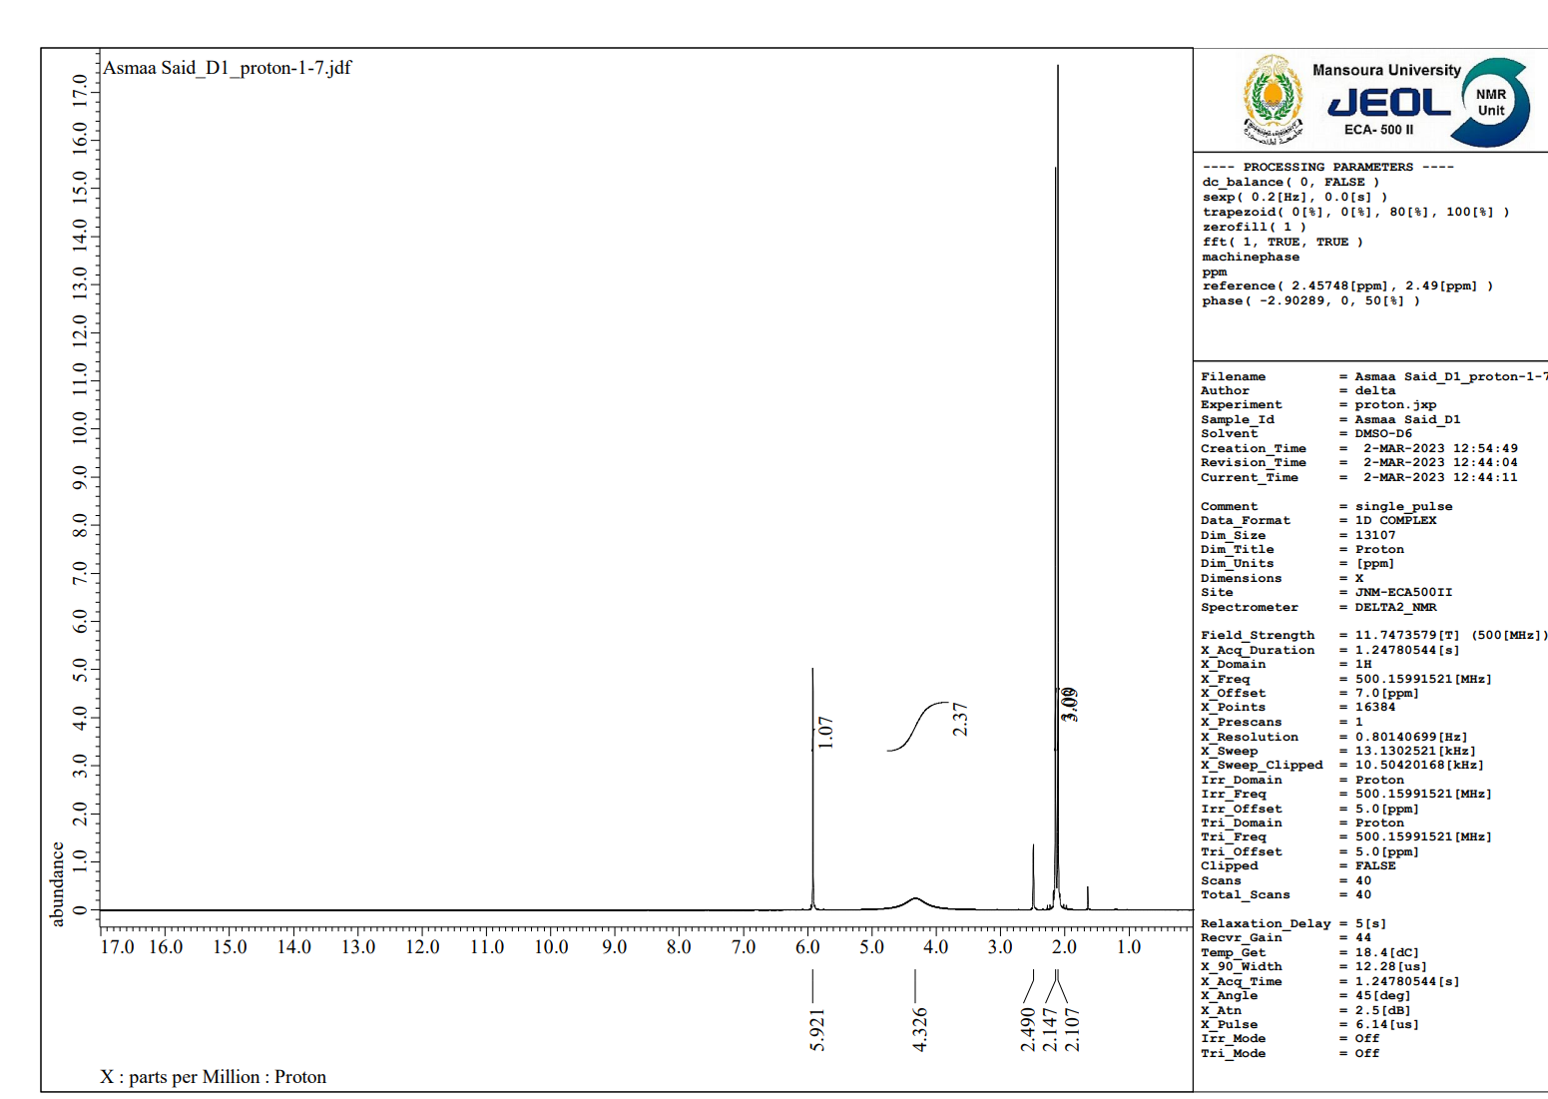
Fig.S2: ¹H -NMR spectrum of compound 1.

Characterization of Ethyl 2-(3-cyano-4,6-dimethyl -2- oxopyridine-1(2H)-yl)acetate (2):

- IR (KBR) cm⁻¹ν_{max}: 3022 cm⁻¹ (ν CH-Aromatic), 2967, 2917cm⁻¹ (ν CH-Aliphatic), 2218 cm⁻¹ (ν CN), 1732, 1638 cm⁻¹ (ν 2 C=O), 1605 cm⁻¹ (ν C=C Ar).
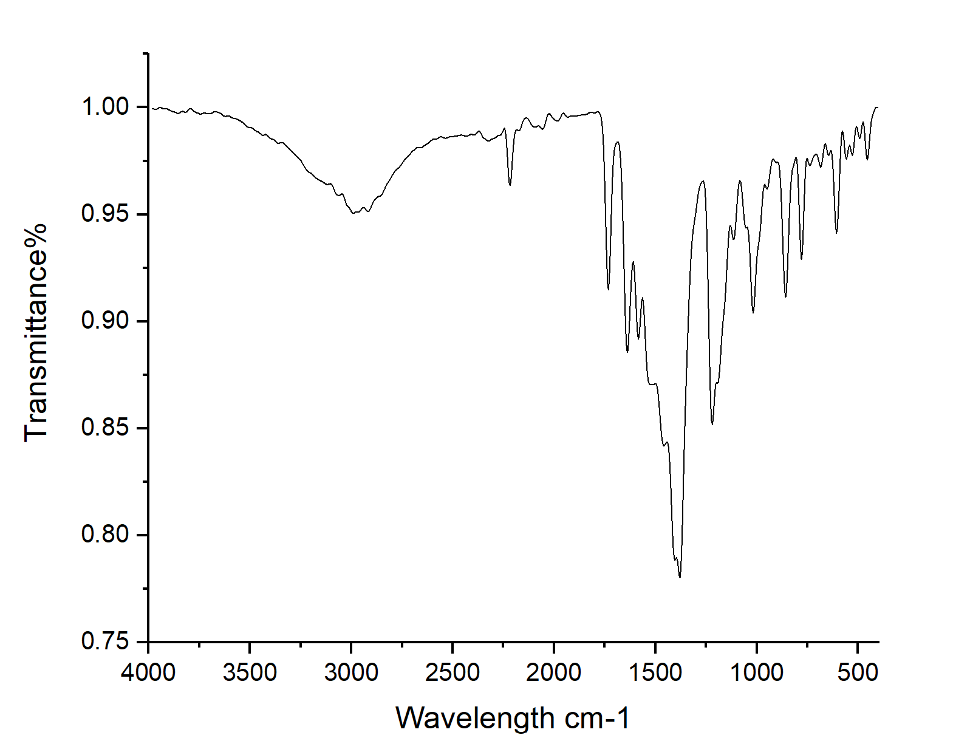
Fig.S2: FTIR spectrum of compound 2.
- ¹H-NMR (DMSO) δ: 1.213(t, 3H, CH), 2.218, 2.295 (d, 6H, 2CH), 4.156 (q, 2H, CH), 4.822(s, 2H, CH), 6.154(s, 1H, CH).

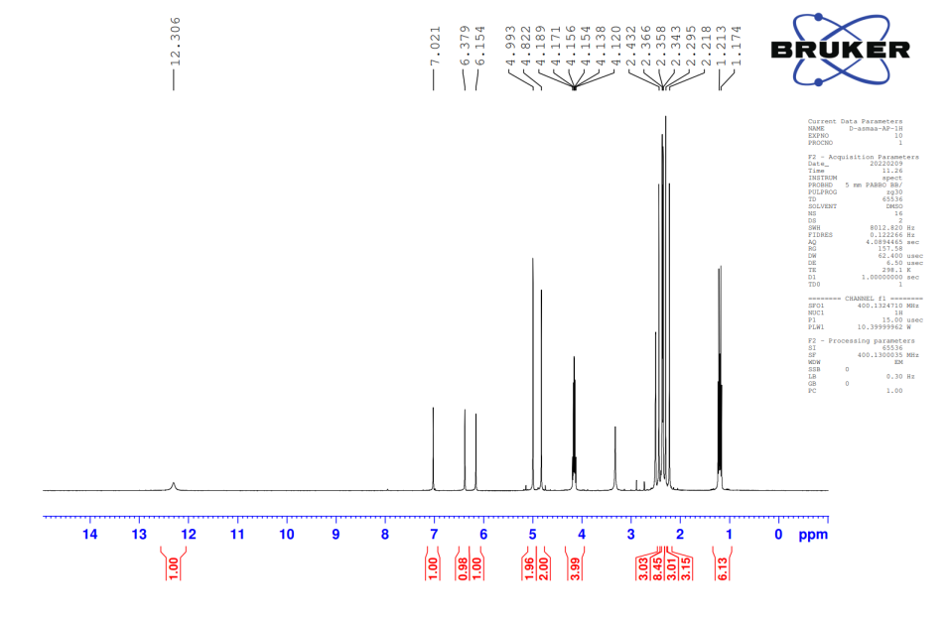
Fig.S4: ¹H -NMR spectrum of compound 2.

Characterization of 1-((4-amino-5-thioxo-4,5-dihydro-1H-1,2,4-triazole-3-yl)methyl)-4,6-dimethyl-2-oxo-1,2-dihydropyridine-3-carbonitrile (3) OAC:

- IR (KBR) cm⁻¹ν_{max}: 3425 cm⁻¹ (ν NH₂), 3071 cm⁻¹ (ν NH), 3026 cm⁻¹ (ν CH-Aromatic), 2924, 2854 cm⁻¹ (ν CH-Aliphatic), 2223 cm⁻¹ (ν CN), 1634 cm⁻¹ (ν C=O, C=C Ar), 1522 cm⁻¹ (ν C=N), 1309 cm⁻¹ (ν C=S).

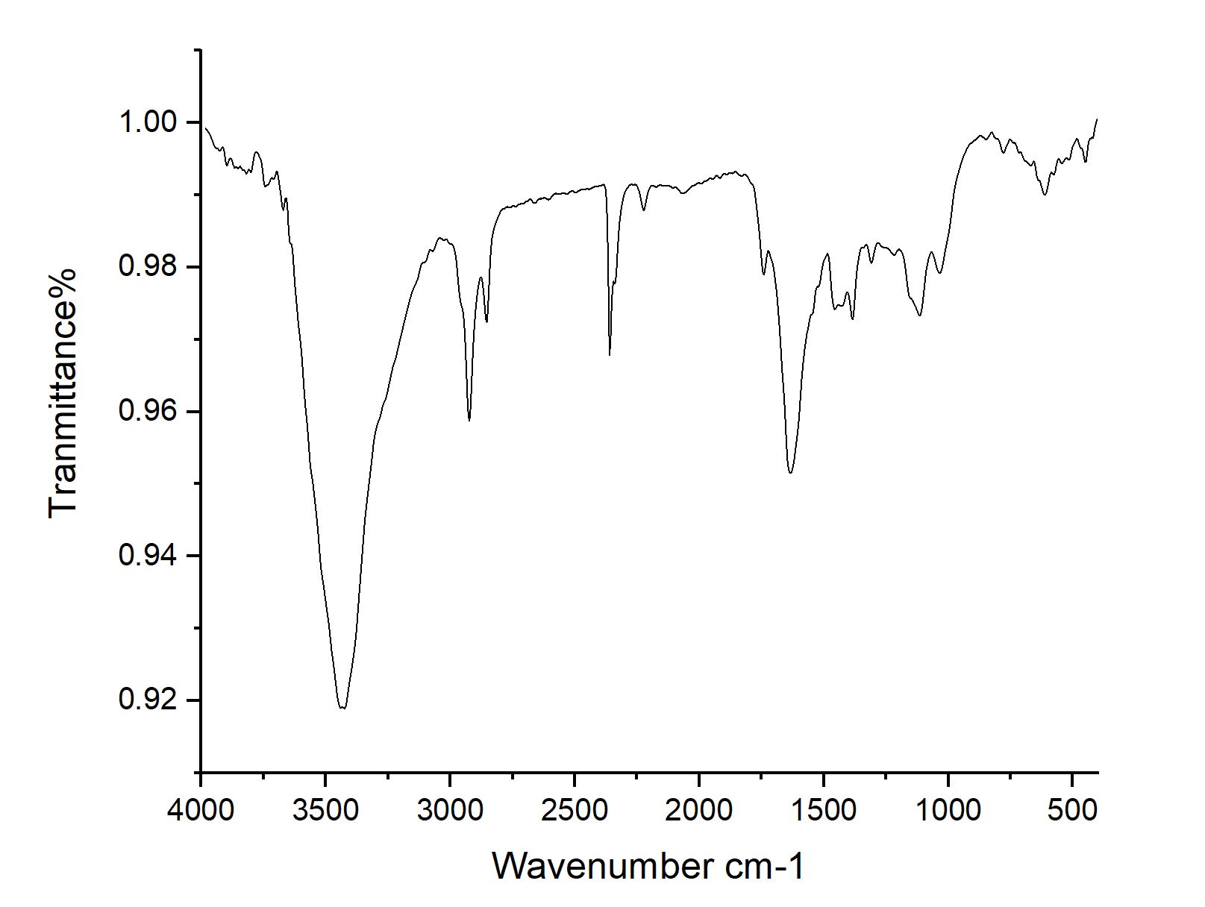
Fig.S5: FTIR spectrum of compound 3 (AOC).

- ¹H-NMR (DMSO) δ: 2.372, 2.434 (d, 6H, 2CH₃), 3.673(s, 2H, CH₂), 5.027(brs, 2H, NH₂), 10 (brs, 1H, NH).
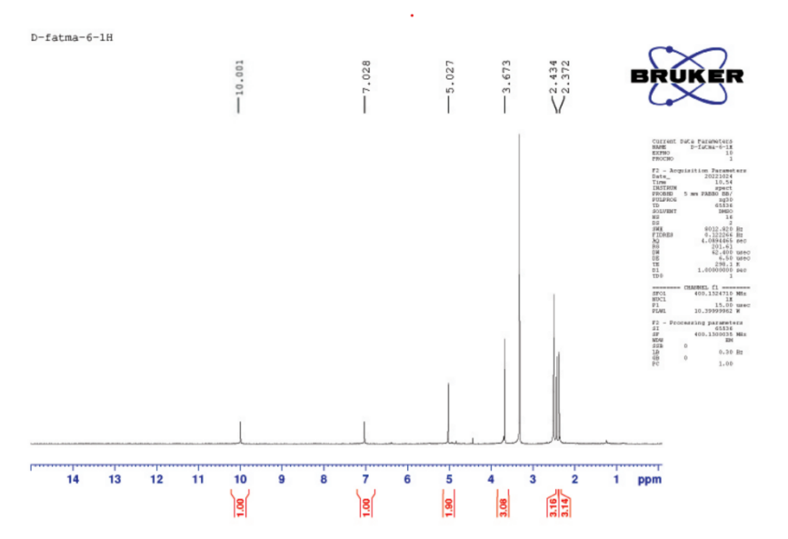

Fig.S6: ¹H -NMR spectrum of compound 3.

Characterization of MC-Cl (4):
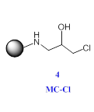
- IR (KBR) cm⁻¹ν_{max}: 3449cm⁻¹ (ν OH), 3385 cm⁻¹ (ν NH), 2856, 2925 cm⁻¹ (ν CH-Aliphatic), 1152 cm-1 (ν C-C), 1064 cm-1 (ν C-O), 800 cm-1 (ν C-CL), 581cm-1 (ν Fe-O).

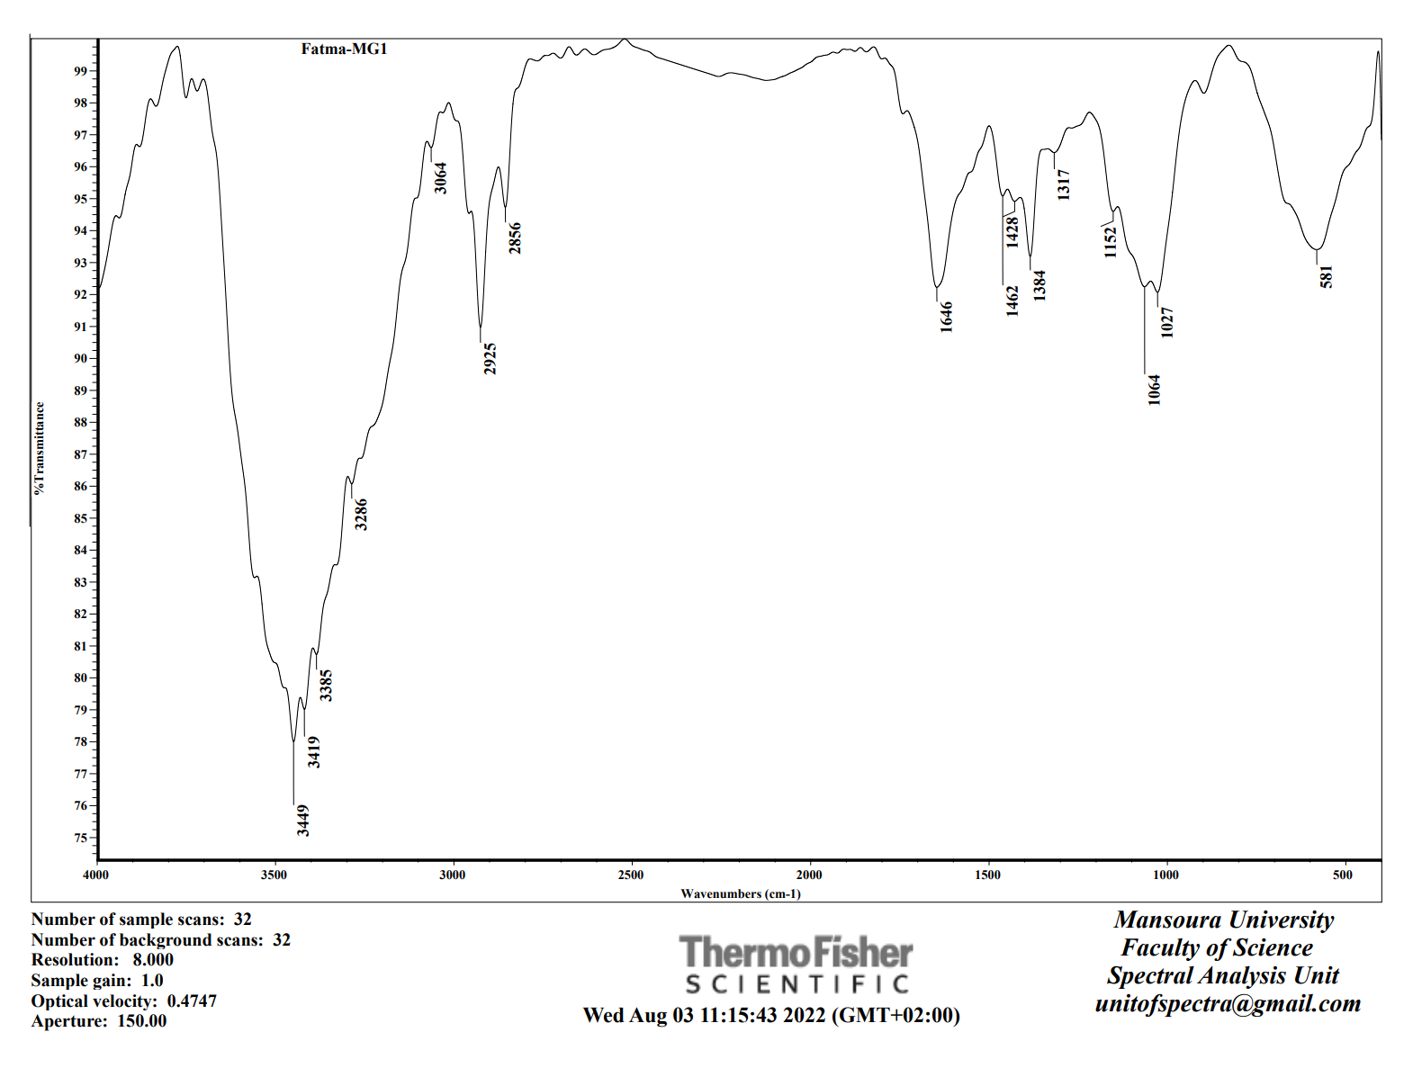

Fig.S7: FTIR spectrum of compound MC-Cl.

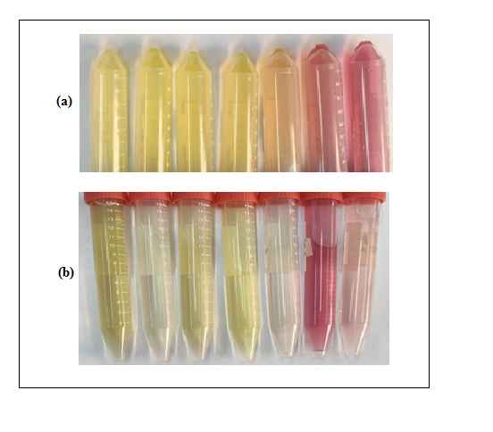

Fig.S8: Effect of AR concentration on sorption process at pH 1→7;
a) 100 ppm Befor adding sorbent and b) 100 ppm after adding sorbent.

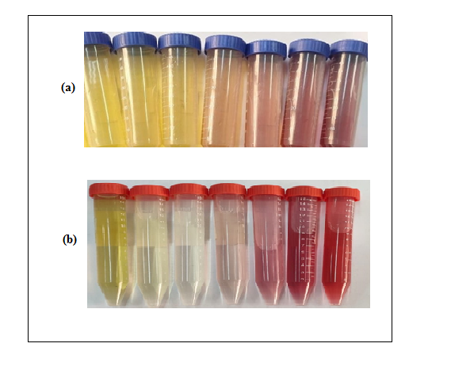
Fig.S9: Effect of AR concentration on sorption process at pH 1→7;
a) 200 ppm Befor adding sorbent and b) 200 ppm after adding sorbent.

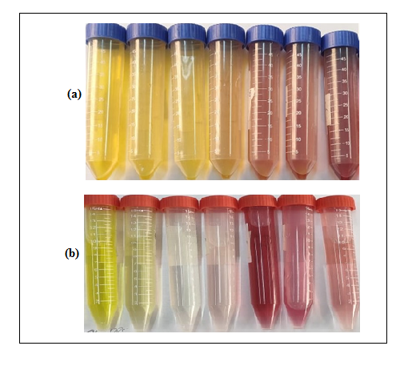

Fig.S10: Effect of AR concentration on sorption process at pH 1→7;
a) 300 ppm Befor adding sorbent and b) 300 ppm after adding sorbent.

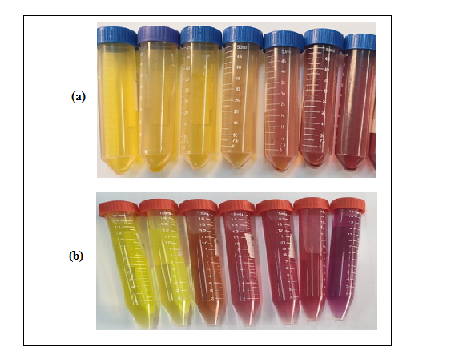

Fig.S11: Effect of AR concentration on sorption process at pH 1→7;
a) 400 ppm Befor adding sorbent and b) 400 ppm after adding sorbent.

