Supporting Information

Characterization and Antibacterial Properties of Metal Borates Vectorized As Ceramic Glaze Additives

Osman Aguş¹, Osman Arslan²,Yüksel Abalı*¹
corresponding author:yuksel.abali@cbu.edu.tr
¹ Departmant of Chemistry, Manisa Celal Bayar Universty,45140 Manisa,TURKEY
² Departmant of Food Engineering, Istanbul Sabahattin Zaim University, 34303, Istanbul, TURKEY

Keywords: Antibacterial compound, silver borate, copper borate, zinc borate, nanoparticles, ceramic glaze, ceramic nanocomposite

* Corresponding author. Tel.: +90 505 396 1797

E-mail address: yuksel.abali@cbu.edu.tr

Characterization and Antibacterial Properties of Metal Borates Vectorized As Ceramic Glaze Additives
Supporting Figure 1: Particle size distribution of the a) AgB13, b) CuB13 and c) ZnB13

Supporting Figure 2: EDX curves of synthesized a) AgB13 b) CuB13 c) ZnB13
Supporting Figure 3: FTIR curves of synthesized a) AgB13, b) CuB13 and c) ZnB13
Supporting Figure 4: UV – Visible spectra of the a) AgB13, b) CuB13 and b) ZnB13 structures
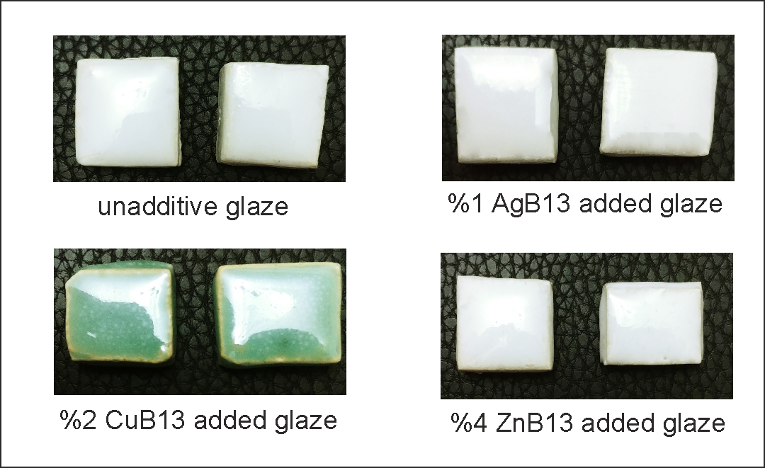
Supporting Figure 5 : Visual observation of the normal, Silverborate, Cupperborate and Zincborate added antibacterial ceramic materials

