STUDY CHARACTERISTICS

Meta-Analysis (Continuous Outcome)

Auth | Year | Country | Measure | Type | N | DV | Cohen’s d | Direction | Diagnosis | Hofstede
Bassitt | 2007 | Brazil | SUMD | Clinician | 50 | Age | -0.10 | Younger age | Schizophrenia | 38
Beland | 2017 | Canada | SAI-E | Clinician | 139 | Age | 0.01 | Older age | Schizophrenia | 80
Bivona | 2008 | Italy | AQ-D | Discrepancy | 37 | Age | 0.28 | Older age | Brain injury | 76
Chapman, Beschin | 2019 | UK | VATAmem | Discrepancy | 51 | Age | -0.02 | Younger age | Brain injury | 89
Chesnel | 2018 | France | BICoQ | Discrepancy | 90 | Age | -0.63 | Younger age | Brain injury | 71
Cines | 2015 | USA | ARS | Clinician | 103 | Age | -0.56 | Younger age | Alzheimer's | 91
Ciurli | 2010 | Italy | PCRS | Discrepancy | 52 | Age | 0.02 | Older age | Brain injury | 76
Clare, Whitaker | 2010 | UK | MARS | SRAny | 80 | Age | -0.13 | Younger age | Alzheimer's | 89
Cuffel | 1996 | USA | AII | Clinician | 89 | Age | -0.16 | Younger age | Schizophrenia | 91
Danki | 2007 | Turkey | SATCI | Clinician | 66 | Age | -0.18 | Younger age | Schizophrenia | 37
DeFeis | 2019 | USA | Complaint interview | Discrepancy | 192 | Age | -0.19 | Younger age | Alzheimer’s | 91
Depp | 2014 | USA | MDIS | SRClinical | 106 | Age | 0.02 | Older age | Bipolar disorder | 91
Derouesne | 1999 | France | CDS | Discrepancy | 88 | Age | -0.45 | Younger age | Alzheimer's | 71
Diez-Martin | 2014 | Spain | SUMD | Clinician | 161 | Age | -0.13 | Younger age | Schizophrenia | 51
Donohoe, Donnell | 2004 | Ireland | SAI | Clinician | 38 | Age | -0.32 | Younger age | Schizophrenia | 70
Dourado, Laks | 2019 | Brazil | ASPIDD | Discrepancy | 201 | Age | 0.30 | Younger age | Alzheimer’s | 38
Dourado, Marinho | 2007 | Brazil | ASPIDD | Discrepancy | 52 | Age | -0.71 | Younger age | Alzheimer's | 38
Elvish | 2010 | UK | OVIS | SRClinical | 94 | Age | 0.24 | Older age | OCD | 89
Feher | 1991 | USA | MAC-S | Discrepancy | 38 | Age | -0.14 | Younger age | Alzheimer's | 91
Fujimoto | 2017 | Japan | SRSMF | Discrepancy | 49 | Age | -0.44 | Younger age | Alzheimer's | 46
Gerretsen, Chakravarty | 2013 | Canada | PANSS G12 | Clinician | 52 | Age | -0.24 | Younger age | Schizophrenia | 80
Gerretsen, Chung | 2017 | Various | Ecog | SRAny | 191 | Age | -0.26 | Younger age | Alzheimer's
Gerretsen, Chung | 2017 | Various | Ecog | SRAny | 398 | Age | -0.20 | Younger age | MCI
Gerretsen, Chung | 2017 | Various | Ecog | SRAny | 101 | Age | 0.18 | Older age | MCI
Ghaemi, Stoll | 1995 | USA | ITAQ | Clinician | 28 | Age | 0.37 | Older age | Bipolar disorder | 91
Gilleen | 2012 | UK | Multiple |  | 27 | Age | -0.58 | Younger age | Schizophrenia | 89
Hamann | 2010 | Germany | BIS | SRClinical | 300 | Age | -0.07 | Younger age | Schizophrenia | 67
Hannesdottir | 2007 | Iceland | BAS | Clinician | 92 | Age | -0.08 | Younger age | Alzheimer's | 60
Kalbe | 2005 | Germany | Complaint interview | Discrepancy | 79 | Age | -0.52 | Younger age | MCI | 67
Kalbe | 2005 | Germany | Complaint interview | Discrepancy | 82 | Age | -0.30 | Younger age | Alzheimer's | 67
Kao | 2010 | Taiwan | SAIQ | SRClinical | 104 | Age | -0.40 | Younger age | Schizophrenia | 17
Kashyap | 2012 | India | BABS | SRClinical | 150 | Age | -0.02 | Younger age | OCD | 48
Kazui | 2006 | Japan | EMC | SRAny | 103 | Age | -0.39 | Younger age | Alzheimer's | 46
Kelly | 2004 | Ireland | PANSS G12 | Clinician | 78 | Age | -0.41 | Younger age | Schizophrenia | 70
Kleim | 2008 | Various | ITAQ | Clinician | 127 | Age | -0.10 | Younger age | Schizophrenia
Konstantakopoulos, Ploumpidis | 2013 | Greece | SAI-E | Clinician | 72 | Age | -0.30 | Younger age | Schizophrenia | 35
Lacerda, Belfort | 2018 | Brazil | ASPIDD | Discrepancy | 54 | Age | -0.43 | Younger age | Alzheimer's | 38
Lacerda, Belfort | 2018 | Brazil | ASPIDD | Discrepancy | 74 | Age | -0.30 | Younger age | Alzheimer's | 38
Lacerda, Neto | 2017 | Brazil | ASPIDD | Discrepancy | 89 | Age | -0.28 | Younger age | Alzheimer's | 38
Macpherson | 1996 | UK | SAI | Clinician | 64 | Age | -0.39 | Younger age | Schizophrenia | 89
Martyr, Nelis | 2014 | UK | FAQ | Discrepancy | 100 | Age | -0.48 | Younger age | Mixed (AD+ Other Dementia) | 89
Mayelle | 1996 | France | ASDA | SRClinical | 28 | Age | .10 | Older age | Alzheimer’s | 71
McEvoy | 2006 | USA | ITAQ | Clinician | 251 | Age | 0.32 | Older age | Schizophrenia | 91
Michel | 2013 | France | SUMD | Clinician | 531 | Age | -0.31 | Younger age | Schizophrenia | 71
Mohamed | 2009 | USA | ITAQ | Clinician | 1432 | Age | 0.14 | Older age | Schizophrenia | 91
Molina-Andreu | 2014 | Brazil | SUMD | Clinician | 64 | Age | -0.71 | Younger age | Schizophrenia | 38
Orfei, Varsi | 2010 | Italy | AQ-D | Discrepancy | 38 | Age | -1.01 | Younger age | Alzheimer's | 76
Ozzoude | 2019 | Canada | PANSS G12 | Clinician | 373 | Age | 0.12 | Older age | Schizophrenia | 80
Schennach | 2012 | Germany | PANSS G12 | Clinician | 399 | Age | -0.03 | Younger age | Schizophrenia | 67
Silva | 2016 | Austria | FAI | Discrepancy | 34 | Age | -0.24 | Younger age | Mixed (MCI + AD) | 55
Sitman | 2012 | Israel | PANSS G12 | Clinician | 66 | Age | -0.68 | Younger age | Mixed (Scz + Bipolar) | 54
Sousa | 2015 | Brazil | ASPIDD | Discrepancy | 69 | Age | -0.19 | Younger age | Alzheimer's | 38
Spalletta | 2012 | Italy | AQ-D | Discrepancy | 103 | Age | -0.60 | Younger age | Alzheimer's | 76
Spalletta | 2012 | Italy | AQ-D | Discrepancy | 54 | Age | -0.16 | Younger age | MCI | 76
Spalletta | 2012 | Italy | AQ-D | Discrepancy | 52 | Age | -0.12 | Younger age | MCI | 76
Szepietowska | 2019 | Poland | DEX | Discrepancy | 41 | Age | -0.50 | Younger age | Mixed (Dementia)
Tolin | 2010 | USA | Y-BOCS | SRClinical | 558 | Age | -0.37 | Younger age | OCD | 91
Tumkaya | 2018 | Turkey | SAI | Clinician | 48 | Age | -0.08 | Younger age | Schizophrenia | 37
Turksoy | 2002 | Turkey | Unspecified Clinical interview |  | 94 | Age | -0.32 | Younger age | OCD | 37
Vallat-Azouvi | 2017 | France | BICoQ | Discrepancy | 286 | Age | -0.14 | Younger age | Brain injury | 71
Vasterling, Seltzer, Carpenter | 1997 | USA | PCRS | Discrepancy | 55 | Age | -0.75 | Younger age | Alzheimer’s | 91
Vasterling, Seltzer, Carpenter | 1997 | USA | PCRS | Discrepancy | 55 | Education | 0.65 | Better educated | Alzheimer’s | 91
Vasterling, Seltzer, Foss | 1995 | USA | EMQ | Discrepancy | 43 | Age | -0.26 | Younger age | Alzheimer's | 91
Verhey | 1993 | Netherlands | Unspecified Clinical interview |  | 170 | Age | -0.70 | Younger age |  | 80
Verhulsdonk | 2013 | Germany | AQ-D | Discrepancy | 47 | Age | 0.10 | Older age | Alzheimer's | 67
Weiler | 2000 | USA | ITAQ | Clinician | 40 | Age | -0.75 | Younger age | Bipolar disorder | 91
Xiang | 2012 | China | ITAQ | Clinician | 139 | Age | -0.02 | Younger age | Schizophrenia | 20
Yen, Cheng | 2008 | Taiwan | SAI-E | Clinician | 96 | Age | -0.07 | Younger age | Bipolar disorder | 17
Bassitt | 2007 | Brazil | SUMD | Clinician | 50 | Education | -0.02 | Less educated | Schizophrenia | 38
Bladzinski | 2019 | Poland | MTAF | SRClinical | 51 | Education | -0.47 | Less educated | Schizophrenia | 60
Cernovsky | 2004 | Canada | Unspecified Clinical interview | Clinician | 111 | Education | 0.70 | Better educated | Schizophrenia | 80
Chapman, Beschin | 2019 | UK | VATAmem | Discrepancy | 51 | Education | -0.06 | Less educated | Brain injury | 89
Danki | 2007 | Turkey | SATCI | Clinician | 66 | Education | 0.66 | Better educated | Schizophrenia | 37
DeFeis | 2019 | USA | Complaint interview | Discrepancy | 192 | Education | -0.05 | Less educated | Alzheimer’s | 91
Depp | 2014 | USA | MDIS | SRClinical | 106 | Education | 0.30 | Better educated | Bipolar disorder | 91
Diez-Martin | 2014 | Spain | SUMD | Clinician | 161 | Education | 0.42 | Better educated | Schizophrenia | 51
Dourado, Laks | 2019 | Brazil | ASPIDD | Discrepancy | 201 | Education | 0.26 | Less educated | Alzheimer’s | 38
Elvish | 2010 | UK | OVIS | SRClinical | 94 | Education | 0.33 | Better educated | OCD | 89
Feher | 1991 | USA | MAC-S | Discrepancy | 38 | Education | 0.39 | Better educated | Alzheimer's | 91
Fujimoto | 2017 | Japan | SRSMF | Discrepancy | 49 | Education | 0.34 | Better educated | Alzheimer's | 46
Gerretsen, Chung | 2017 | Various | Ecog | SRAny | 101 | Education | -0.22 | Less educated | MCI
Gerretsen, Chung | 2017 | Various | Ecog | SRAny | 398 | Education | 0.14 | Better educated | MCI
Gerretsen, Chung | 2017 | Various | Ecog | SRAny | 191 | Education | 0.49 | Better educated | Alzheimer's
Gilleen | 2012 | UK | Multiple |  | 27 | Education | 0.30 | Better educated | Schizophrenia | 89
Hamann | 2010 | Germany | BIS | SRClinical | 300 | Education | 0.01 | Better educated | Schizophrenia | 67
Kalbe | 2005 | Germany | Complaint interview | Discrepancy | 79 | Education | 0.20 | Better educated | MCI | 67
Kalbe | 2005 | Germany | Complaint interview | Discrepancy | 82 | Education | -0.26 | Better educated | Alzheimer's | 67
Kao | 2010 | Taiwan | SAIQ | SRClinical | 104 | Education | 0.04 | Better educated | Schizophrenia | 17
Kashyap | 2012 | India | BABS | SRClinical | 147 | Education | -0.03 | Less educated | OCD | 48
Kazui | 2006 | Japan | EMC | SRAny | 103 | Education | 0.22 | Better educated | Alzheimer's | 46
Konstantakopoulos, Ploumpidis | 2013 | Greece | SAI-E | Clinician | 72 | Education | 0.43 | Better educated | Schizophrenia | 35
Lacerda, Belfort | 2018 | Brazil | ASPIDD | Discrepancy | 74 | Education | -0.30 | Less educated | Alzheimer's | 38
Lacerda, Belfort | 2018 | Brazil | ASPIDD | Discrepancy | 54 | Education | 0.62 | Better educated | Alzheimer's | 38
Lacerda, Neto | 2017 | Brazil | ASPIDD | Discrepancy | 89 | Education | 0.14 | Better educated | Alzheimer's | 38
Macpherson | 1996 | UK | SAI | Clinician | 64 | Education | 0.75 | Better educated | Schizophrenia | 89
Mohamed | 2009 | USA | ITAQ | Clinician | 1432 | Education | 0.08 | Better educated | Schizophrenia | 91
Ozzoude | 2019 | Canada | PANSS G12 | Clinician | 373 | Education | 0.22 | Better educated | Schizophrenia | 80
Rossell | 2003 | UK | SAI-E | Clinician | 78 | Education | 0.63 | Better educated | Schizophrenia | 89
Silva | 2016 | Austria | FAI | Discrepancy | 34 | Education | -0.16 | Less educated | Mixed (MCI + AD) | 55
Sousa | 2015 | Brazil | ASPIDD | Discrepancy | 69 | Education | 0.14 | Better educated | Alzheimer's | 38
Spalletta | 2012 | Italy | AQ-D | Discrepancy | 54 | Education | -0.51 | Less educated | MCI | 76
Spalletta | 2012 | Italy | AQ-D | Discrepancy | 103 | Education | -0.05 | Less educated | Alzheimer's | 76
Spalletta | 2012 | Italy | AQ-D | Discrepancy | 52 | Education | 0.01 | Better educated | MCI | 76
Tumkaya | 2018 | Turkey | SAI | Clinician | 48 | Education | -.40 | Less educated | Schizophrenia | 37
Vallat-Azouvi | 2017 | France | BICoQ | Discrepancy | 286 | Education | 0.16 | Better educated | Brain injury | 71
Vasterling, Seltzer, Foss | 1995 | USA | EMQ | Discrepancy | 43 | Education | 0.37 | Better educated | Alzheimer's | 91
Verhulsdonk | 2013 | Germany | AQ-D | Discrepancy | 47 | Education | 0.61 | Better educated | Alzheimer's | 67
Xiang | 2012 | China | ITAQ | Clinician | 139 | Education | -0.06 | Less educated | Schizophrenia | 20
Yeh | 2014 | Taiwan | DDS | Discrepancy | 36 | Education | 0.43 | Better educated | Alzheimer's | 17
Yen, Cheng | 2008 | Taiwan | SAI-E | Clinician | 96 | Education | 0.42 | Better educated | Bipolar disorder | 17
Bellino | 2005 | Italy | OVIS | SRClinical | 74 | Employment | 0.62 | Employed | OCD | 76
Bladzinski | 2019 | Poland | Multiple |  | 51 | Employment | 0.71 | Employed | Schizophrenia | 60
Elvish | 2010 | UK | OVIS | SRClinical | 94 | Employment | 0.28 | Employed | OCD | 89
Ghaemi, Stoll | 1995 | USA | ITAQ | Clinician | 28 | Employment | 0.04 | Employed | Bipolar disorder | 91
Othman, Huri | 2017 | Malaysia | ITAQ | Clinician | 42 | Employment | -0.25 | Unemployed | Schizophrenia | 46
Schennach | 2012 | Germany | PANSS G12 | Clinician | 399 | Employment | 0.15 | Employed | Schizophrenia | 67
Xiang | 2012 | China | ITAQ | Clinician | 139 | Employment | 0.12 | Employed | Schizophrenia | 20
Elvish | 2010 | UK | OVIS | SRClinical | 94 | Ethnicity | 0.23 | White British | OCD | 89
McEvoy | 2006 | USA | ITAQ | Clinician | 226 | Ethnicity | 0.27 | White ethnicity (vs. black) | Schizophrenia | 91
Rathod | 2005 | UK | SAI | Clinician | 42 | Ethnicity | 0.20 | White (vs. African-Caribbean) | Schizophrenia | 89
Bellino | 2005 | Italy | OVIS | SRClinical | 74 | Marital Status | 0.22 | Married | OCD | 76
Depp | 2014 | USA | MDIS | SRClinical | 106 | Marital Status | -0.68 | Unmarried | Bipolar disorder | 91
Elvish | 2010 | UK | OVIS | SRClinical | 94 | Marital Status | 0.03 | Married/Partnership | OCD | 89
Garg | 2018 | India | IP | SRClinical | 53 | Marital Status | -0.48 | Single | Schizophrenia | 48
Karow | 2008 | Germany | SUMD | Clinician | 59 | Marital Status | 0.68 | Married/Relationship | Schizophrenia | 67
Kelly | 2004 | Ireland | PANSS G12 | Clinician | 78 | Marital Status | 0.61 | Married | Schizophrenia | 70
Mohamed | 2009 | USA | ITAQ | Clinician | 1432 | Marital Status | 0.17 | Married/Partnership | Schizophrenia | 91
Othman, Huri | 2017 | Malaysia | ITAQ | Clinician | 57 | Marital Status | 0.27 | Married | Schizophrenia | 26
Rathod | 2005 | UK | SAI | Clinician | 358 | Marital Status | 0.12 | Married | Schizophrenia | 89
Schennach | 2012 | Germany | PANSS G12 | Clinician | 399 | Marital Status | -0.09 | Unmarried | Schizophrenia | 67
Shimshoni | 2011 | Israel | DSM-IV Scale |  | 60 | Marital Status | 0.79 | Married/Relationship | OCD | 54
Xiang | 2012 | China | ITAQ | Clinician | 139 | Marital Status | 0.28 | Married | Schizophrenia | 20
Ampalam | 2012 | India | SAI | Clinician | 60 | Sex | 0.12 | Males | Schizophrenia | 48
Bassitt | 2007 | Brazil | SUMD | Clinician | 50 | Sex | -0.05 | Females | Schizophrenia | 38
Bellino | 2005 | Italy | OVIS | SRClinical | 74 | Sex | 0.12 | Males | OCD | 76
Chapman, Cosentino | 2020 | UK | VATAmem | Discrepancy | 35 | Sex | -0.67 | Females | Stroke | 89
Chesnel | 2018 | France | BICoQ | Discrepancy | 90 | Sex | -0.40 | Females | Brain injury | 71
Cobo | 2020 | Spain | SUMD | Clinician | 516 | Sex | 0.14 | Males | Schizophrenia | 51
Cuffel | 1996 | USA | AII | Clinician | 89 | Sex | 0.63 | Males | Schizophrenia | 91
Derouesne | 1999 | France | CDS | Discrepancy | 88 | Sex | -0.17 | Females | Alzheimer's | 71
Elvish | 2010 | UK | OVIS | SRClinical | 94 | Sex | -0.28 | Married/Partnership | OCD | 89
Fujimoto | 2017 | Japan | SRSMF | Discrepancy | 49 | Sex | 0.08 | Males | Alzheimer's | 46
Garg | 2018 | India | IP | SRClinical | 53 | Sex | 0.34 | Males | Schizophrenia | 48
Gerretsen, Chakravarty | 2013 | Canada | PANSS G12 | Clinician | 52 | Sex | 0.30 | Males | Schizophrenia | 80
Ghaemi, Stoll | 1995 | USA | ITAQ | Clinician | 28 | Sex | -0.35 | Females | Bipolar disorder | 91
Hamann | 2010 | Germany | BIS | SRClinical | 300 | Sex | -0.02 | Females | Schizophrenia | 67
Jeong | 2017 | South Korea | PANSS G12 | Clinician | 41 | Sex | -0.57 | Females | Schizophrenia | 18
Kao | 2010 | Taiwan | SAIQ | SRClinical | 104 | Sex | -0.30 | Females | Schizophrenia | 17
Kelly | 2004 | Ireland | PANSS G12 | Clinician | 78 | Sex | -0.25 | Females | Schizophrenia | 70
McEvoy | 2006 | USA | ITAQ | Clinician | 251 | Sex | -0.34 | Females | Schizophrenia | 91
Michel | 2013 | France | SUMD | Clinician | 531 | Sex | -0.07 | Females | Schizophrenia | 71
Othman, Huri | 2017 | Malaysia | ITAQ | Clinician | 70 | Sex | 0.39 | Males | Schizophrenia | 26
Ozzoude | 2019 | Canada | PANSS G12 | Clinician | 373 | Sex | 0.20 | Males | Schizophrenia | 80
Prus | 2012 | Germany | SUMD | Clinician | 111 | Sex | -0.56 | Females | Schizophrenia | 67
Rathod | 2005 | UK | SAI | Clinician | 422 | Sex | 0.04 | Males | Schizophrenia | 89
Schennach | 2012 | Germany | PANSS G12 | Clinician | 399 | Sex | 0.05 | Males | Schizophrenia | 67
Shimshoni | 2011 | Israel | DSM-IV Scale | Clinician | 60 | Sex | -0.67 | Females | OCD | 54
Xiang | 2012 | China | ITAQ | Clinician | 139 | Sex | 0.14 | Males | Schizophrenia | 20
Yen, Cheng | 2008 | Taiwan | SAI-E | Clinician | 96 | Sex | 0.20 | Males | Bipolar disorder | 17

Table A.1. Study characteristics of all continuous effect sizes included in the meta-analysis

Meta-Analysis (Dichotomous Outcome)

Auth | Year | Country | Measure | Type | N | DV | Cohen’s d | Variance | Odds | Hofstede | Direction | Diagnosis
Amanzio | 2011 | Italy | AQ-D | Discrepancy | 29 | Age | -0.35 | 0.38 | -0.63 | 76 | Younger age | Alzheimer's
Ayesa-Arriola | 2014 | Spain | SUMD | Clinician | 224 | Age | -0.19 | 0.05 | -0.35 | 51 | Younger age | Schizophrenia
Chapman, Colvin | 2018 | USA | CRA | Clinician | 35 | Age | -0.93 | 0.33 | -1.68 | 91 | Younger age | Alzheimer's
Cherian | 2012 | India | Y-BOCS | SRClinical | 545 | Age | 0.12 | 0.06 | 0.23 | 48 | Older age | OCD
Conde-Sala | 2013 | Spain | AQ-D | Discrepancy | 164 | Age | -0.63 | 0.07 | -1.15 | 51 | Younger age | Alzheimer's
Contador | 2020 | Spain | FAQ | Discrepancy | 325 | Age | 0.07 | 0.04 | 0.13 | 51 | Older age | Mixed (AD + Other Dementia)
Cosentino | 2007 | USA | ARS | Clinician | 24 | Age | -0.05 | 0.48 | -0.10 | 91 | Younger age | Alzheimer's
Cosentino | 2011 | USA | ARS | Clinician | 42 | Age | -0.26 | 0.26 | -0.46 | 91 | Younger age | Alzheimer's
De Berardis | 2005 | Italy | Y-BOCS | SRClinical | 112 | Age | 0.28 | 0.12 | 0.51 | 76 | Older age | OCD
De Berardis | 2008 | Italy | Y-BOCS | SRClinical | 75 | Age | 0.02 | 0.17 | 0.05 | 76 | Older age | OCD
Dias, Brissos, Carita | 2007 | Portugal | SUMD | Clinician | 50 | Age | -0.54 | 0.23 | -0.98 | 27 | Younger age | Bipolar disorder
Dias, Brissos, Frey | 2008 | Portugal | SUMD | Clinician | 70 | Age | -0.40 | 0.17 | -0.72 | 27 | Younger age | Bipolar disorder
Emami | 2016 | Canada | SAI-E | Clinician | 66 | Age | -0.25 | 0.17 | -0.46 | 80 | Younger age | Schizophrenia
Faget | 2012 | France | SUMD | Clinician | 27 | Age | 0.17 | 0.40 | 0.31 | 71 | Older age | Schizophrenia
Fu | 2017 | China | ITAQ | Clinician | 278 | Age | -0.42 | 0.06 | -0.76 | 20 | Younger age | Mixed (Psychiatric)
Gambina | 2014 | Italy | AQ-D | Discrepancy | 79 | Age | -0.71 | 0.16 | -1.29 | 76 | Younger age | Alzheimer's
Hanyu | 2008 | Japan | EMC | SRAny | 38 | Age | -0.13 | 0.29 | -0.23 | 46 | Younger age | Alzheimer's
Himle | 2006 | USA | Y-BOCS | SRClinical | 69 | Age | -0.10 | 0.20 | -0.18 | 91 | Younger age | OCD
Jacob | 2014 | USA | Y-BOCS | SRClinical | 130 | Age | -0.26 | 0.14 | -0.47 | 91 | Younger age | OCD
Karadag | 2011 | Turkey | OVIS | SRClinical | 64 | Age | -0.20 | 0.18 | -0.36 | 37 | Younger age | OCD
Kishore | 2004 | India | BABS | SRClinical | 100 | Age | 0.19 | 0.15 | 0.34 | 48 | Older age | OCD
Kortte | 2015 | USA | BAS | Clinician | 35 | Age | -2.63 | 0.54 | -4.76 | 91 | Younger age | Stroke
Lamar | 2002 | USA | AQ-D | Discrepancy | 32 | Age | -0.42 | 0.35 | -0.76 | 91 | Younger age | Mixed (AD + Other Dementia)
Loebel | 1990 | USA | Unspecified Clinical interview | NA | 32 | Age | -0.43 | 0.34 | -0.79 | 91 | Younger age | Alzheimer's
Lopez, Becker | 1994 | USA | Unspecified Clinical interview | NA | 177 | Age | -0.36 | 0.08 | -0.65 | 91 | Younger age | Alzheimer's
Lysaker, Bryson | 1998 | USA | SUMD | Clinician | 101 | Age | -0.27 | 0.11 | -0.50 | 91 | Younger age | Schizophrenia
Maeshima | 1997 | Japan | Unspecified Clinical interview | NA | 50 | Age | 0.75 | 0.30 | 1.36 | 46 | Older age | Brain injury
Moro | 2016 | Various | BAS | Clinician | 63 | Age | -0.55 | 0.21 | -0.99 | NA | Younger age | Stroke
Noe | 2005 | Spain | PCRS | Discrepancy | 62 | Age | 0.00 | 0.18 | 0.00 | 51 | Equal | Brain injury
Onen | 2013 | Turkey | Y-BOCS | SRClinical | 100 | Age | 0.36 | 0.11 | 0.66 | 37 | Older age | OCD
Ozkiris | 2015 | Turkey | OVIS | SRClinical | 63 | Age | -0.23 | 0.20 | -0.41 | 37 | Younger age | OCD
Sedaghat | 2010 | Greece | Unspecified Clinical interview | NA | 21 | Age | 0.27 | 0.53 | 0.50 | 35 | Older age | Alzheimer's
Sedaghat | 2010 | Greece | Unspecified Clinical interview | NA | 21 | Age | -0.71 | 0.56 | -1.29 | 35 | Younger age | Alzheimer's
Senturk | 2017 | Turkey | CIRS | Clinician | 26 | Age | -1.70 | 0.48 | -3.08 | 37 | Younger age | MCI
Senturk | 2017 | Turkey | CIRS | Clinician | 21 | Age | -0.26 | 0.52 | -0.48 | 37 | Younger age | Alzheimer's
Shad | 2004 | USA | BPRS | Clinician | 35 | Age | -.017 | 0.31 | -0.32 | 91 | Younger age | Schizophrenia
Starkstein, Brockman | 2010 | Argentina | AQ-D | Discrepancy | 77 | Age | 0.02 | 0.15 | 0.04 | 46 | Older age | Alzheimer's
Starkstein, Jorge | 2006 | Argentina | AQ-D | Discrepancy | 173 | Age | 0.02 | 0.19 | 0.04 | 46 | Older age | Alzheimer's
Therriault | 2018 | Various | Ecog | SRAny | 468 | Age | -0.34 | 0.02 | -0.61 | NA | Younger age | MCI
Tordesillas | 2018 | Spain | SUMD | Clinician | 108 | Age | 0.27 | 0.11 | 0.49 | 51 | Older age | Schizophrenia
Tremont | 2011 | USA | Unspecified Clinical interview | NA | 65 | Age | -0.51 | 0.17 | -0.93 | 91 | Younger age | MCI
Turro-Garriga | 2013 | Spain | ERS | Clinician | 124 | Age | 0.09 | 0.12 | 0.17 | 51 | Older age | Alzheimer's
Turro-Garriga | 2016 | Spain | AQ-D | Discrepancy | 177 | Age | -0.64 | 0.07 | -1.16 | 51 | Younger age | Alzheimer's
Valiente | 2011 | Spain | PANSS G12 | Clinician | 40 | Age | -0.33 | 0.27 | -0.60 | 51 | Younger age | Schizophrenia
Wang | 2011 | China | ITAQ | Clinician | 139 | Age | -0.14 | 0.11 | -0.24 | 20 | Younger age | Schizophrenia
Woon | 2020 | India | MDIS | SRClinical | 99 | Age | -0.55 | 0.22 | -1.00 | 48 | Younger age | Depression
Yoon | 2017 | South Korea | Unspecified Clinical interview | NA | 616 | Age | -0.24 | 0.04 | -0.43 | 18 | Younger age | Alzheimer's
Zhang | 2016 | China | PANSS G12 | Clinician | 56 | Age | -1.48 | 0.21 | -2.69 | 20 | Younger age | Schizophrenia
Amanzio | 2011 | Italy | AQ-D | Discrepancy | 29 | Education | 0.51 | 0.38 | 0.93 | 76 | Better educated | Alzheimer's
Ayesa-Arriola | 2014 | Spain | SUMD | Clinician | 198 | Education | 0.23 | 0.06 | 0.41 | 51 | Better educated | Schizophrenia
Bota | 2006 | USA | SUMD | Clinician | 24 | Education | 1.14 | 0.49 | 2.07 | 91 | Better educated | Schizophrenia
Chapman, Colvin | 2018 | USA | CRA | Clinician | 35 | Education | 0.42 | 0.32 | 0.76 | 91 | Better educated | Alzheimer's
Cosentino | 2007 | USA | ARS | Clinician | 24 | Education | -1.07 | 0.51 | -1.95 | 91 | Less educated | Alzheimer's
Cosentino | 2011 | USA | ARS | Clinician | 42 | Education | 1.07 | 0.28 | 1.93 | 91 | Better educated | Alzheimer's
Dias, Brissos, Carita | 2007 | Portugal | SUMD | Clinician | 50 | Education | 0.66 | 0.23 | 1.20 | 27 | Better educated | Bipolar disorder
Dias, Brissos, Frey | 2008 | Portugal | SUMD | Clinician | 70 | Education | 0.44 | 0.17 | 0.79 | 27 | Better educated | Bipolar disorder
Emami | 2016 | Canada | SAI-E | Clinician | 66 | Education | 0.06 | 0.17 | 0.10 | 80 | Better educated | Schizophrenia
Fu | 2017 | China | ITAQ | Clinician | 278 | Education | 0.19 | 0.06 | 0.35 | 20 | Better educated | Mixed (Psychiatric)
Hanyu | 2008 | Japan | EMC | SRAny | 38 | Education | 0.42 | 0.29 | 0.76 | 46 | Better educated | Alzheimer's
Karadag | 2011 | Turkey | OVIS | SRClinical | 64 | Education | -0.33 | 0.18 | -0.60 | 37 | Less educated | OCD
Kishore | 2004 | India | BABS | SRClinical | 100 | Education | -0.05 | 0.15 | -0.10 | 48 | Less educated | OCD
Kortte | 2015 | USA | BAS | Clinician | 31 | Education | 0.04 | 0.44 | 0.07 | 91 | Better educated | Stroke
Lamar | 2002 | USA | AQ-D | Discrepancy | 32 | Education | 0.63 | 0.35 | 1.14 | 91 | Better educated | Mixed (AD + Other Dementia)
Loebel | 1990 | USA | Unspecified Clinical interview | NA | 32 | Education | 0.81 | 0.35 | 1.47 | 91 | Better educated | Alzheimer's
Lopez, Becker | 1994 | USA | Unspecified Clinical interview | NA | 177 | Education | 0.57 | 0.09 | 1.03 | 91 | Better educated | Alzheimer's
Lysaker, Bryson | 1998 | USA | SUMD | Clinician | 101 | Education | -0.09 | 0.11 | -0.16 | 91 | Less educated | Schizophrenia
Noe | 2005 | Spain | PCRS | Discrepancy | 62 | Education | 0.04 | 0.18 | 0.08 | 51 | Better educated | Brain injury
Ozkiris | 2015 | Turkey | OVIS | SRClinical | 63 | Education | -0.36 | 0.20 | -0.66 | 37 | Less educated | OCD
Senturk | 2017 | Turkey | CIRS | Clinician | 26 | Education | 0.23 | 0.42 | 0.42 | 37 | Better educated | MCI
Senturk | 2017 | Turkey | CIRS | Clinician | 21 | Education | 0.57 | 0.53 | 1.03 | 37 | Better educated | Alzheimer's
Starkstein, Brockman | 2010 | Argentina | AQ-D | Discrepancy | 77 | Education | 0.05 | 0.15 | 0.10 | 46 | Better educated | Alzheimer's
Starkstein, Jorge | 2006 | Argentina | AQ-D | Discrepancy | 173 | Education | 0.11 | 0.19 | 0.21 | 46 | Better educated | Alzheimer's
Therriault | 2018 | Various | Ecog | SRAny | 468 | Education | 0.04 | 0.02 | 0.08 | NA | Better educated | MCI
Tordesillas | 2018 | Spain | SUMD | Clinician | 108 | Education | 0.59 | 0.11 | 1.07 | 51 | Better educated | Schizophrenia
Tremont | 2011 | USA | Unspecified Clinical interview | NA | 65 | Education | -0.25 | 0.17 | -0.46 | 91 | Less educated | MCI
Wang | 2011 | China | ITAQ | Clinician | 139 | Education | -0.30 | 0.11 | -0.55 | 20 | Less educated | Schizophrenia
Yoon | 2017 | South Korea | Unspecified Clinical interview | NA | 616 | Education | 0.33 | 0.04 | 0.59 | 18 | Better educated | Alzheimer's
Zhang | 2016 | China | PANSS G12 | Clinician | 56 | Education | -0.48 | 0.20 | -0.88 | 20 | Less educated | Schizophrenia
Visser | 2017 | Netherlands | OVIS | SRClinical | 140 | Employment | 0.55 | 0.09 | 1.00 | 80 | Employed | OCD
Wang | 2011 | China | ITAQ | Clinician | 139 | Employment | 0.23 | 0.10 | 0.41 | 20 | Employed | Schizophrenia
Woon | 2020 | India | MDIS | SRClinical | 99 | Employment | -0.38 | 0.26 | -0.69 | 48 | Unemployed | Depression
Heinrichs | 1985 | USA | Clinical judgement | NA | 37 | Ethnicity | 0.66 | 0.42 | 1.19 | 81 | White | Schizophrenia
Kortte | 2015 | USA | BAS | Clinician | 35 | Ethnicity | -0.65 | 0.45 | -1.17 | 81 | African American | Stroke
Lysaker, Bryson | 1998 | USA | SUMD | Clinician | 96 | Ethnicity | 0.29 | 0.11 | 0.52 | 81 | White | Schizophrenia
Cherian | 2012 | India | Y-BOCS (item 11) | SRClinical | 536 | Marital Status | 0.02 | 0.05 | 0.04 | 48 | Married | OCD
Fennig | 1996 | USA | HDS | Clinician | 229 | Marital Status | 0.86 | 0.08 | 1.56 | 81 | Married | Schizophrenia (+ other psychoses)
Fu | 2017 | China | ITAQ | Clinician | 278 | Marital Status | 0.43 | 0.06 | 0.78 | 20 | Married | Mixed (Psychiatric)
Karadag | 2011 | Turkey | OVIS | SRClinical | 62 | Marital Status | 0.24 | 0.15 | 0.43 | 37 | Married | OCD
Kishore | 2004 | India | BABS | Clinician | 100 | Marital Status | -0.48 | 0.14 | -0.86 | 48 | Unmarried | OCD
Turksoy | 2002 | Turkey | DSM-IV | NA | 88 | Marital Status | 0.01 | 0.13 | 0.02 | 37 | Married | OCD
Woon | 2020 | India | MDIS | SRClinical | 99 | Marital Status | -0.61 | 0.26 | -1.10 | 48 | Unmarried | Depression
Amanzio | 2011 | Italy | AQ-D | Discrepancy | 29 | Sex | -0.01 | 0.31 | -0.01 | 76 | Female | Alzheimer's
Ayesa-Arriola | 2014 | Spain | SUMD | Clinician | 224 | Sex | -0.22 | 0.04 | -0.40 | 51 | Female | Schizophrenia
Baier | 2005 | Germany | BAS | Clinician | 128 | Sex | 0.06 | 0.10 | 0.11 | 67 | Male | Stroke
Castrillo Sanz | 2016 | Spain | CIR | Clinician | 127 | Sex | -0.36 | 0.13 | -0.66 | 51 | Female | Alzheimer's
Chapman | 2018 | USA | CRA | Clinician | 35 | Sex | 0.08 | 0.30 | 0.15 | 81 | Male | Alzheimer's
Cherian | 2012 | India | Y-BOCS | SRClinical | 545 | Sex | 0.14 | 0.05 | 0.25 | 48 | Male | OCD
Conde-Sala | 2013 | Spain | AQ-D | Discrepancy | 164 | Sex | 0.02 | 0.06 | 0.04 | 51 | Male | Alzheimer's
Contador | 2020 | Spain | FAQ | Discrepancy | 325 | Sex | -0.26 | 0.03 | -0.47 | 51 | Female | Mixed (AD + Other Dementia)
Cosentino | 2007 | USA | ARS | Clinician | 24 | Sex | -0.61 | 0.43 | -1.10 | 81 | Female | Alzheimer's
Cosentino | 2011 | USA | CRA | Clinician | 42 | Sex | -0.01 | 0.21 | -0.02 | 91 | Female | Alzheimer's
De Berardis | 2005 | Italy | Y-BOCS (item 11) | Clinician | 123 | Sex | 0.03 | 0.10 | 0.06 | 76 | Male | OCD
De Berardis | 2008 | Italy | Y-BOCS (item 11) | Clinician | 75 | Sex | 0.06 | 0.14 | 0.11 | 76 | Male | OCD
De Carolis | 2015 | Italy | CIRS | Clinician | 108 | Sex | 0.01 | 0.13 | 0.03 | 76 | Male | MCI
Dias, Brissos, Frey | 2008 | Portugal | SUMD | Clinician | 70 | Sex | -0.51 | 0.17 | -0.93 | 27 | Female | Bipolar disorder
Emami | 2016 | Canada | SAI-E | Clinician | 66 | Sex | 0.18 | 0.18 | 0.33 | 80 | Male | Schizophrenia
Faget | 2012 | France | SUMD | Clinician | 31 | Sex | -0.94 | 0.72 | -1.71 | 71 | Female | Schizophrenia
Fu | 2017 | China | ITAQ | Clinician | 278 | Sex | 0.09 | 0.05 | 0.16 | 20 | Male | Mixed (Psychiatric)
Hanyu | 2008 | Japan | EMC | SRAny | 38 | Sex | 0.23 | 0.24 | 0.42 | 46 | Male | Alzheimer's
Heinrichs | 1985 | USA | Clinical judgement | NA | 38 | Sex | -0.07 | 0.25 | -0.12 | 81 | Female | Schizophrenia
Himle | 2006 | USA | Y-BOCS (item 11) | Clinician | 69 | Sex | -0.31 | 0.16 | -0.56 | 91 | Female | OCD
Jacob | 2014 | USA | Y-BOCS | SRClinical | 129 | Sex | -0.23 | 0.12 | -0.42 | 81 | Female | OCD
Karadag | 2011 | Turkey | OVIS | SRClinical | 64 | Sex | -0.50 | 0.16 | -0.90 | 37 | Female | OCD
Kishore | 2004 | India | BABS | Clinician | 100 | Sex | 0.28 | 0.12 | 0.51 | 48 | Male | OCD
Kortte | 2015 | USA | BAS | Clinician | 35 | Sex | -0.04 | 0.36 | -0.07 | 81 | Female | Stroke
Lamar | 2002 | USA | AQ-D | Discrepancy | 32 | Sex | -0.09 | 0.29 | -0.16 | 91 | Female | Mixed (AD + Other Dementia)
Loebel | 1990 | USA | Clinical interview | NA | 32 | Sex | 0.38 | 0.50 | 0.69 | 81 | Male | Alzheimer's
Lopez, Becker | 1994 | USA | Clinical judgement | NA | 181 | Sex | 0.07 | 0.08 | 0.13 | 81 | Male | Alzheimer's
Lysaker, Bryson | 1998 | USA | SUMD | Clinician | 101 | Sex | -0.39 | 0.48 | -0.70 | 81 | Female | Schizophrenia
Maeshima | 1997 | Japan | Clinical judgement | NA | 50 | Sex | -0.18 | 0.31 | -0.33 | 46 | Female | Brain injury
Moro | 2016 | Various | Structured interview (Berti, Ladavas & Della Corte, 1996) | NA | 63 | Sex | 0.36 | 0.19 | 0.65 | NA | Male | Stroke
Noe | 2005 | Spain | PCRS | Discrepancy | 62 | Sex | 0.30 | 0.18 | 0.54 | 51 | Male | Brain injury
Onen | 2013 | Turkey | Y-BOCS | SRClinical | 100 | Sex | -0.21 | 0.09 | -0.38 | 37 | Female | OCD
Ozkiris | 2015 | Turkey | OVIS | SRClinical | 63 | Sex | 0.07 | 0.19 | 0.12 | 37 | Male | OCD
Senturk | 2017 | Turkey | CIRS | Clinician | 47 | Sex | 0.05 | 0.19 | 0.09 | 37 | Male | Alzheimer's
Starkstein, Brockman | 2010 | Argentina | AQ-D | Discrepancy | 77 | Sex | 0.12 | 0.13 | 0.22 | 46 | Male | Alzheimer's
Starkstein, Sabe | 1996 | Argentina | AQ-D | Discrepancy | 55 | Sex | -0.14 | 0.20 | -0.26 | 46 | Female | Alzheimer's
Therriault | 2018 | Various | Ecog | SRAny | 468 | Sex | -0.30 | 0.02 | -0.55 | NA | Female | MCI
Tordesillas | 2018 | Spain | SUMD | Clinician | 108 | Sex | 0.06 | 0.10 | 0.11 | 51 | Male | Schizophrenia
Tremont | 2011 | USA | Clinical Judgement | NA | 65 | Sex | 0.01 | 0.14 | 0.02 | 81 | Male | MCI
Turksoy | 2002 | Turkey | DSM-IV | NA | 94 | Sex | -0.41 | 0.11 | -0.74 | 37 | Female | OCD
Turro-Garriga | 2013 | Spain | ERS | Discrepancy | 124 | Sex | 0.32 | 0.13 | 0.58 | 51 | Male | Alzheimer's
Turro-Garriga | 2016 | Spain | AQ-D | Clinician | 177 | Sex | -0.30 | 0.06 | -0.55 | 51 | Female | Alzheimer's
Valiente | 2011 | Spain | PANSS G12 | Clinician | 40 | Sex | -0.22 | 0.22 | -0.39 | 51 | Female | Schizophrenia
Visser | 2017 | Netherlands | OVIS | SRClinical | 140 | Sex | 0.21 | 0.08 | 0.37 | 80 | Male | OCD
Wang | 2011 | China | ITAQ | Clinician | 139 | Sex | -0.13 | 0.09 | -0.23 | 20 | Female | Schizophrenia
Wibawa | 2019 | Australia | AS | Discrepancy | 38 | Sex | 0.06 | 0.31 | 0.12 | 90 | Male | Huntington's
Woon | 2020 | India | MDIS | SRClinical | 99 | Sex | -0.10 | 0.18 | -0.18 | 48 | Female | Depression
Yoon | 2017 | South Korea | Clinician semi-structured interview | NA | 617 | Sex | -0.33 | 0.03 | -0.60 | 18 | Female | Alzheimer's
Zhang | 2016 | China | PANSS G12 | Clinician | 56 | Sex | 0.32 | 0.16 | 0.57 | 20 | Male | Schizophrenia
Table A.2. Study characteristics of all dichotomous effect sizes that were included in the meta-analysis.

Qualitative Only Studies

First Author | Year | Country | Insight Measure | Study Design | Participant No. | Sociodemographic variable | Journal | Reason for exclusion | Participant Group | Significant outcomes?
Aalten | 2006 | Netherlands | GRAD | Prospective Cohort | 199 | Age, education, sex, socioeconomic status | International Psychogeriatrics | Ineligible analyses | Dementia | Yes (age, education, socioeconomic status, sex)
Almeida | 1996 | Brazil | SAI | Cross Sectional | 40 | Age, | International Journal of Geriatric Psychiatry | Absent statistics | Paraphrenia | No
Amador | 1994 | USA | SUMD | Cross Sectional | 412 | Age, education, sex | Archives of General Psychiatry | Absent statistics | Psychosis and Mood Disorder | No
Arbel | 2013 | Israel | SUMD | Cross Sectional | 25 | Age, , education | Psychiatry Research | Few population samples | Anorexia | No
Berg | 2018 | Norway | BIS | Cross Sectional | 80 | Immigration Status | Early Intervention in Psychiatry | Ineligible insight variable/demographic | Psychosis | Yes (immigration status)
Bianchini | 2014 | Italy | SAI | Prospective Cohort | 55 | Age, sex | Psychiatry Research | Absent statistics | Schizophrenia | No
Buchy | 2010 | Canada | SUMD | Prospective cohort | 165 | Age, education, sex | Early Intervention in Psychiatry | Longitudinal only | FEP | No
Burton | 2016 | USA | MIC-SR vs. neuropsychological test | Cross Sectional | 168 | Age, education, employment, ethnicity, marital status, sex | Schizophrenia Research | Neuropsychological test discrepancy | Schizophrenia Spectrum Disorders | No
Chan | 2014 | Hong Kong | SUMD | Prospective cohort | 71 | Age, education | Psychiatry Research | Longitudinal only | First Episode Schizophrenia | No
Chan | 2016 | Hong Kong | SUMD | Cross Sectional | 95 | Age, , education, employment, marital status, sex | Comprehensive Psychiatry | Absent statistics | Schizophrenia Spectrum Disorder | No
Chen | 2001 | Hong Kong | SUMD | Prospective Cohort | 70 | Age, education | The Journal of Nervous and Mental Disease | Longitudinal only | Psychiatric Inpatients | No
Chen | 2018 | Taiwan | PRMQ | Cross Sectional | 90 | Age, education, sex | Psychiatry Research | Ineligible analysis | Alcohol dependence | Yes (age, education)
Collins | 1997 | Canada | SAI | Cross Sectional | 58 | Age | Schizophrenia Research | Ineligible analysis | Schizophrenia | No
Comacchio | 2020 | Italy | SAI-E | Prospective cohort | 185 | Sex | Archives of Women’s Mental Health | Longitudinal only | FEP | Yes (gender)
Cuesta | 1994 | Spain | Lack of Insight Index | Cross Sectional | 40 | Age, education, sex | Schizophrenia Bulletin | Absent statistics | Schizophrenia | No
David | 1992 | UK | SAI | Cross Sectional | 91 | Age | British Journal of Psychiatry | Absent statistics | Psychosis | No
David | 1995 | UK | PSE Insight Item | Prospective Cohort | 150 | Age, , socioeconomic status, ethnicity, immigration, sex | British Journal of Psychiatry | Absent statistics | Psychosis | Yes (socioeconomic status)
De Assis | 2015 | Brazil | HAM-D & YMRS | Cross Sectional | 48 | Age | Psychiatric Quarterly | Ineligible insight variable/demographic | Bipolar disorder | Yes (age, sex)
de Castro Zilli | 2007 | Brazil | DIS | Cross Sectional | 21 | Age, education | Dementia & Neuropsychologia | Absent statistics | Alzheimer's disease | No
Duarte Gigante | 2004 | Brazil | SAI | Cross Sectional | 40 | Age, , education, sex | Sao Paulo Medical Journal | Absent statistics | Schizophrenia | No
Farias | 2005 | USA | DFQ | Cross Sectional | 111 | Age, education, ethnicity, sex | International Journal of Geriatric Psychiatry | Absent statistics | Older adults | No
Gilleen | 2011 | UK | DEX, MARS, PCRS, SUMD, SAI-E | Cross Sectional | 31 | Age, education | Schizophrenia Bulletin | Absent statistics | Schizophrenia | No
Goldberg | 2001 | USA | PANSS G12 | Cross Sectional | 211 | Age, education, ethnicity, sex | The Journal of Nervous and Mental Disease | Ineligible analysis | SMI | Yes (ethnicity)
Gomez-de-Regil | 2015 | Mexico | SUMD | Cross Sectional | 61 | Age, , marital status, sex | Schizophrenia Research: Cognition | Absent statistics | Psychosis | No
Greenfeld | 1990 | USA | Schedule for the Assessment of Insight in Illness (Greenfeld et al, 1989) | Prospective cohort | 40 | BMI | International Journal of Eating Disorders | Longitudinal only | Anorexia | No
Hanseeuw | 2020 | Various | ECog | Prospective cohort | 1070 | Age, education, sex | Annals of Neurology | Longitudinal only | Older adults (including MCI and AD) | Yes (age)
Hoth | 2007 | USA | PCRS | Cross Sectional | 66 | Age, education | Journal of Clinical and Experimental Neuropsychology | Absent statistics | Huntington's disease | No
Jong | 2007 | Korea | HAIS | Cross Sectional | 123 | Age, education, religion, occupation | Journal of Korean Medical Sciences | Few population samples | Alcohol use disorder | Yes (age)
Kemp, Lambert | 1995 | UK | SUMD | Cross Sectional | 29 | Age, marital status | Schizophrenia Research | Absent statistics | Schizophrenia | No
Keshavan | 2004 | USA | PANSS G12 | Cross Sectional | 535 | Age, , education, sex | Schizophrenia Research | Ineligible analysis | Schizophrenia Spectrum Disorder | No
Kim, Ozzoude | 2020 | Canada | PANSS G12 | Randomised Controlled Trial | 1447 | Age, education, ethnicity, sex | Neuropsychopharmacology | Ineligible analysis | Schizophrenia | Yes (sex)
Klaas | 2017 | Switzerland | Clinical Judgement | Prospective Cohort | 240 | Education, migration status, sex | Psychological Medicine | Absent statistics | EIP | No
Kumar | 2013 | India | SUMD | Cross Sectional | 44 | Marital Status, sex | Journal of Postgraduate Medicine | Absent statistics | Mania | No
Liu | 2017 | Singapore | Subjective vs. Cognitive testing discrepancy | Cross Sectional | 751 | Marital Status, sex | Psychogeriatrics | Neuropsychological test discrepancy | Memory Impairment in older adults | Yes (marital status, sex)
Lysaker, Bell | 1995 | USA | PANSS G12 | Case Control | 44 | Age, education, employment | The Journal of Nervous and Mental Disease | Longitudinal only | Schizophrenia | No
Lysaker, Dimaggio | 2011 | USA | SUMD | Cross Sectional | 65 | Age, education, sex | Comprehensive Psychiatry | Absent statistics | Schizophrenia Spectrum Disorder | No
Lysaker, Gagen | 2018 | USA | PANSS G12 | Cross Sectional | 324 | Sex | Schizophrenia Bulletin | Ineligible analysis | Schizophrenia or Schizoaffective disorder | Yes (sex)
Lysaker, Whitney | 2006 | USA | SUMD | Cross Sectional | 53 | Age, education | Journal of Neuropsychiatry and Clinical Neurosciences | Absent statistics | Schizophrenia or Schizoaffective disorder | No
Marazziti | 2002 | Italy | Y-BOCS (item 11) | Cross Sectional | 117 | Age, | European Psychiatry | Absent statistics | OCD | No
Maremmani | 2012 | Italy | DAH-RS item 7 | Cross Sectional | 1066 | Age, employment, income, marital status, sex | Frontiers in Psychiatry | Absent statistics | Substance misuse | No
Martyr, Clare | 2012 | UK | FAD | Cross Sectional | 96 | Age | The Clinical Neuropsychologist | Ineligible analysis | Dementia | Yes (age)
McCabe | 2002 | NR | SAI | Cross Sectional | 89 | Sociodemographic (unspecified) | Journal of Nervous and Mental Disease | Ineligible insight variable/demographic | Schizophrenia | No
Mintz | 2004 | USA | BIS | Cross Sectional | 91 | Age | Israel Journal of Psychiatry and Related Sciences | Ineligible analysis | Psychiatric inpatients | No
Mograbi | 2012 | Various | Self report vs. Neuropsychological test | Cross Sectional | 683 | Education, marital status, sex | International Psychogeriatrics | Neuropsychological test discrepancy | Dementia | Yes (education)
Moore | 1999 | Ireland | SUMD | Cross Sectional | 46 | Age, socioeconomic status, sex | European Psychiatry | Absent statistics | Schizophrenia | No
Mullick | 2001 | USA | SAI | Cross Sectional | 44 | Education | Psychiatric Services | Absent statistics | SMI | No
Parellada | 2009 | Spain | SUMD | Prospective Cohort | 110 | Age, sex | Psychological Medicine | Absent statistics | FEP (adolescents) | No
Pijnenborg | 2015 | Various | PANSS G12 | Prospective Cohort | 455 | Age, country, sex | European Neuropsychopharmacology | Ineligible analysis | Schizophrenia and Schizoaffective | No
Pia | 2014 | Italy | Clinical Judgement | Cross Sectional | 27 | Age, education | Cortex | Ineligible analysis | Stroke | No
Pillai | 2018 | USA | AQ-D | Cross Sectional | 80 | Age, education | Movement Disorders and Clinical Practice | Absent statistics | Parkinson's disease | No
Reed | 1993 | USA | ARS | Cross Sectional | 57 | Age, education | Journal of Clinical and Experimental Neuropsychology | Ineligible analysis | Alzheimer's disease | No
Sanchez-Torres | 2015 | Spain | AMDP | Retrospective Cohort | 42 | Age, , education, sex | Schizophrenia Research | Longitudinal only | Schizophrenia | Yes (sex)
Sanz | 1998 | UK | ITAQ, Markova & Berrios (a), Markova & Berrios (b), PANSS G12 | Cross Sectional | 33 | Education | Psychological Medicine | Absent statistics | Psychosis | Yes (education)
Saravanan | 2007 | India | SAI-E | Cross Sectional | 131 | Age, education, sex | Social Psychiatry and Psychiatric Epidemiology | Absent statistics | Schizophrenia | No
Sasse | 2013 | Germany | PCRS | Cross Sectional | 141 | Age, education, employment | Journal of Head Trauma and Rehabilitation | Absent statistics | Traumatic Brain Injury | No
Schwartz | 1997 | USA | SUMD | Prospective Cohort | 23 | Age | Comprehensive Psychiatry | Absent statistics | Schizophrenia | No
Setkowski | 2016 | Netherlands | BIS | Prospective Cohort | 100 | Age, country, domestic situation, sex | International Journal of Social Psychiatry | Longitudinal only | Psychiatric Inpatients | No
Sherer | 2003 | USA | AQ-D | Cross Sectional | 129 | Age, education, sex | Archives of Physical Medicine Rehabilitation | Ineligible analysis | Traumatic Brain Injury | Yes (age)
Sherer | 2005 | USA | AQ(2) | Cross Sectional | 91 | Age | Journal of Head and Trauma Rehabilitation | Ineligible analysis | Traumatic brain injury | No
Smith | 1997 | USA | SUMD | Cross Sectional | 33 | Age, sex | Journal of Clinical Psychopharmacology | Absent statistics | Schizophrenia | No
Smith | 2014 | Australia | YMRS (item 11) | Cross Sectional | 41 | Age, sex | Journal of Affective Disorders | Ineligible insight variable/demographic | FEP | No
Tariku | 2019 | Ethiopia | SUMD | Cross Sectional | 455 | Employment, literacy, sex | Psychiatry Journal | Ineligible analysis | Schizophrenia | Yes (employment)
Turro-Garriga | 2014 | Spain | AQ-D | Cross Sectional | 352 | Age, marital status, sex | Journal of Geriatric Psychiatry and Neurology | Absent statistics | Alzheimer's disease | Yes (age)
van Vliet | 2013 | Netherlands | GRAD | Prospective Cohort | 268 | Sex | Alzheimer's Disease & Associated Disorders | Longitudinal | Alzheimer's disease | Yes (sex)
Vanderploeg | 2007 | USA | KBCI | Cross Sectional | 36 | Age, education | Journal of Rehabilitation and Research Development | Absent statistics | Traumatic brain injury (moderate to severe) | No
Vannini | 2017 | USA | Discrepancy between neuropsychological testing and MFQ subscale | Cross Sectional | 297 | Age, education, sex | Neuropsychologia | Neuropsychological test discrepancy | Mild cognitive impairment | Yes (sex)
Vasterling, Seltzer, Watrous | 1997 | USA | EMQ | Prospective Cohort | 28 | Age, , education | Neuropsychiatry, Neuropsychology and Behavioural Neurology | Longitudinal only | Alzheimer's disease | No
Vazmalaei, Jolfaei | 2012 | Iran | MDIS/SUMD | Cross Sectional | 145 | Age | Journal of Research in Medical Sciences | Absent statistics | Bipolar disorder (type 1) | No
Vigne | 2014 | Brazil | BABS | Cross Sectional | 37 | Age, employment, marital status, religion, socioeconomic status, sex | Psychiatry Research | Few population samples | Social anxiety disorder | Yes (marital status)
Welten | 2016 | Netherlands | YMRS (item 11) | Retrospective Cohort | 1904 | Age, BMI, sex | Journal of Clinical Psychopharmacology | Ineligible insight variable/demographic | Bipolar disorder (acute mania) | Yes (BMI)
Wiffen | 2010 | Various | SAI-E | Retrospective Cohort | 303 | Sex | Schizophrenia Research | Ineligible analysis | Schizophrenia or Schizoaffective disorder | No
Wilson | 2015 | USA | Discrepancy between episodic memory rating and neuropsychological battery performance | Retrospective Cohort | 2092 | Age, education, sex | Neurology | Neuropsychological test discrepancy | Dementia | Yes (age)
Yen, Chen.1 | 2002 | Taiwan | SAI-E | Cross Sectional | 109 | Sex | The Journal of Nervous and Mental Disease | Ineligible analysis | Psychosis | No
Yen, Hslao | 2008 | Taiwan | HAIS | Cross Sectional | 401 | Employment, ethnicity, sex | The American Journal of Drug and Alcohol Abuse | Ineligible analysis | Alcohol use disorder | Yes (ethnicity)
Yen, Chen.2 | 2003 | Taiwan | SAI-E | Prospective Cohort | 33 | Age, education | Comprehensive Psychiatry | Longitudinal only | Bipolar disorder | No
Young | 1993 | Canada | SUMD | Cross Sectional | 31 | Age, education | Schizophrenia Research | Absent statistics | Schizophrenia | No
Zimmerman | 2017 | Brazil | PCRS | Cross Sectional | 65 | Age | Cognitive Neuropsychiatry | Ineligible analysis | Traumatic brain injury | Yes (age)
Table A.3. Study characteristics of all records that were only included in the qualitative synthesis.

SENSITIVITY ANALYSES FOR INFLUENTIAL CASES

Overview of Potential Outliers: Meta-Analysis (Continuous Outcome)

Variable | k | Original I² | First Author | Cook’s Distance (Critical d) | Leave in/out Effect Size | I² Change | Effect Size Change
Age | 67 | 52% | McEvoy | .09 (.06) | -.22 | -5% | -.01
 |  |  | Mohamed | .09 (.06) | -.22 | -7% | -.01
 |  |  | Verhey | .12 (.06) | -.20 | -3% | +.01
Education | 44 | 62% | Cernovsky | .11 (.09) | .14 | -5% | .0
Marital Status | 13 | 93% | Ampalam | .47 (.31) | .04 | -11% | -.10
Sex | 27 | 59% | Prus | .17 (.15) | .03 | -7% | -.02
Table A.4. A summary of influential cases for each socio-demographic characteristic when insight was measured as a continuous variable. Excluded cases are highlighted in red.

Overview of Potential Outliers: Meta-Analysis 2 (Dichotomous Outcome)

Variable | k | First Author | Original I² | Cook’s Distance (Critical d) | Leave in/out Effect Size | I² Change | Effect Size Change
Age | 48 | De Carolis | 91% | 1.47 (.08) | .24 | -86% | -.22
Education | 31 | De Carolis | 63% | .43 (.13) | .18 | -63% | +.06
 | 30 | Therriault | 0% | .16 (.13) | .19 | 0% | + 02
Sex | 49 | Therriault | 13% | .15 (.08) | .13 | -6% | -.02
 |  | Yoon | 13% | .11 (.08) | .13 | -3% | -.02
Table A.5. A summary of influential cases for each socio-demographic characteristic when insight was measured as a dichotomous variable. Excluded cases are highlighted in red.

Overview of Meta-Analytic Decisions

Variable | First Author | Methodological Considerations | Considerations for Meta-Analysis | Study Author Comments | Decision to Exclude?
Age | De Carolis | Very low threshold for ‘anosognosia’ group (score >1). Large heterogeneity observed for other variables in study. Mean age = 72.5. | Large heterogeneity in age. Large number of studies looking at age. Study effect size is very large and significant, and the direction is comparable to other effect sizes in MCI groups. Cook’s d is minimally above threshold. Removal would substantially change the pooled effect size and substantially reduce heterogeneity. | None. | Yes.
 | McEvoy | Large schizophrenia sample (n= 251). Mean age= 40.52. Longitudinal, randomised trial for antipsychotics. | Moderate heterogeneity in age. Large number of studies looking at age. Study effect size is moderate and significant. In opposite direction, which may be expected, as the effect is weaker in schizophrenia samples. Cook’s d is minimally above threshold. Removal would not substantially change the pooled effect size or heterogeneity. Pooled effect would remain significant if removed. | Reported but not explained. | No.
 | Mohamed | Very large, chronic schizophrenia sample (n= 1432). Mean age = 40.5. Longitudinal, randomised trial for antipsychotics. | Moderate heterogeneity in age. Large number of studies looking at age. Study effect size is small and significant. In opposite direction, which may be expected, as the effect is weaker in schizophrenia samples. Cook’s d is minimally above threshold. Removal would not substantially change the pooled effect size or heterogeneity. Pooled effect would remain significant if removed. | None. | No.
 | Verhey | Dutch study. Large, mixed dementia sample. Awareness scored with dual raters and achieved reasonably good reliability. Mean age= 71.2. | Moderate heterogeneity in age. Large number of studies looking at age. Study effect size is large and significant. In expected direction, and is comparable to other effect sizes in dementia groups. Cook’s d is moderately above threshold. Removal would not substantially change the pooled effect size or heterogeneity. Pooled effect would remain significant if removed. | Reported but not explained. | No.
Education | Cernovsky | Canadian study. Moderate size schizophrenia sample (n= 111). Mean age= 38.10. Insight assessed using generic clinical interview and then dichotomised. | Moderate heterogeneity in education. Large number of studies looking at education. Study effect size large and significant and in the expected direction. Cook’s d is minimally above threshold. Removal would not change the pooled effect size to or substantially reduce heterogeneity. Pooled effect would remain significant if removed. | Reported but not explained. | No.
 | De Carolis | Very low threshold for ‘anosognosia’ group (score >1). Large heterogeneity observed for other variables in this study. Mean education = 9.3. All participants had at least five years of education so potentially biased. | Moderate heterogeneity in education. Large number of studies looking at education. Study effect size not large or significant but only one other study found an effect in this direction. Cook’s d very high. Removal would moderately change the pooled effect size and would substantially reduce heterogeneity. | None. | Yes.
 | Therriault | Amnestic MCI sample. Multiple countries. 46% female. 44% sample had insight. Cut-off determined statistically. Large sample (N= 467). Mean age= 71.29. | Zero heterogeneity in education. Large number of studies looking at education. Study level effect is minimal and non-significant. Cook’s d is minimally above threshold. Would not substantially change the effect size or heterogeneity to remove. Pooled effect would remain significant if removed. | Reported but not explained. | No.
Marital Status | Ampalam | Indian study. Small-to-moderate sample size (N= 60). Mean age not reported. 46% male sample overall. SAI scale used to assess insight. | Large heterogeneity in marital status. Relatively small number of studies looking at marital status. Study effect size is large and significant but in opposite direction to the pooled effect. Cook’s d moderately high. Would substantially change the pooled effect size and heterogeneity to remove. Pooled effect would remain non-significant if removed. | Reported and explanation offered (coping mechanisms and social support). | Yes.
Sex | Prus | German study. Moderate sample size (n= 111). Insight rated using SUMD scale and administered by graduate students. Mean age= 39. 53% male. | Moderate heterogeneity in sex. Moderate number of studies looking at education. Study effect size is large and significant. Cook’s d minimally above threshold. Would moderately change the pooled effect size to remove and would substantially reduce heterogeneity. Pooled effect would remain non-significant if removed. | Reported and explanations offered (gender differences in disclosure, verbal memory, adaptive behaviour, neurobiological differences) | No.
 | Therriault | Amnestic MCI sample. Multiple countries. 46% female. 62.6% sample had insight. Cut-off determined statistically. Large sample (N= 467). Mean age= 71.29. | Very little heterogeneity in sex. Large number of studies looking at sex. Study effect in same direction to pooled effect. Cook’s d moderately above threshold. Would not substantially change pooled effect size or heterogeneity to remove. However, pooled effect would become marginally non-significant if removed (p= .067) | Reported but not explained. | No.
 | Yoon | Very large sample (N= 616). South Korean study. Patients diagnosed with early onset Alzheimer’s disease. 87.6% of patients had insight. 37% male. | Very little heterogeneity in sex. Large number of studies looking at sex. Study effect in same direction to pooled effect. Cook’s d minimally above threshold. Would not substantially change pooled effect size or heterogeneity to remove. However, pooled effect would become marginally non-significant if removed (p= .062) | None. | No.
Table A.6. Study characteristics and inclusion decisions for potential outliers.

Data analysis procedure

All statistical results were converted into standardised effect sizes (cohen’s d and fisher’s z), to correct for potential violations of the normality assumption. The procedure for this is outlined below. All effects were ultimately reported as Cohen’s d, following standard research reporting procedures. 95% confidence intervals were also calculated for each effect size. 3x2 Chi Squared tests were excluded, unless they could be reasonably reduced to a two-by-two frequency matrix. This was done for marital status (single/unmarried vs. married/partnered), ethnicity (white/Caucasian ethnicity vs. black/African/Caribbean ethnicity) and insight (poor/low/impaired insight/present anosognosia vs. good/high/preserved insight/no anosognosia. We did, however, exclude data from the meta-synthesis if age or education was reported as a categorical variable. Where more than one insight measure was eligible for inclusion, the results were pooled so that the assumption of independence was maintained.

See here for the associated formulas [1].

Statistic | Conversion One | Final Conversion
Independent (t) | Cohen (d)/Pearson (r) | Fisher (z)/Cohen (d)
Pearson (r) | N/A | Fisher (z) /Cohen (d)
Cohen (d) | Cohen (d)/Pearson (r) | Fisher (z) /Cohen (d)
Spearman (rho) | N/A | Fisher (z) /Cohen (d)
Mann Whitney (U) | Rank Biserial Correlation | Fisher (z) /Cohen (d)

Table A.7. Conversion metrics for effect sizes included in the meta analyses.

SENSITIVITY ANALYSES FOR EFFECTS

Forest Plots
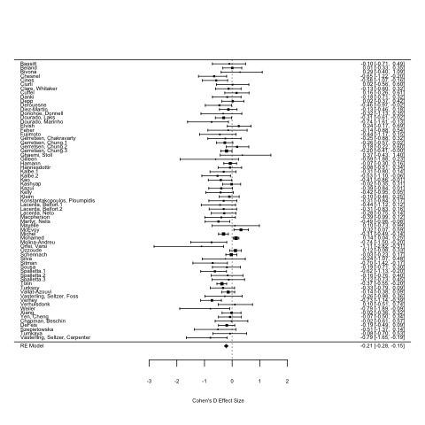
Figure A.1. Forest plot detailing the relationship between insight and age when insight was measured as a continuous variable (measured in Fisher’s Z units).
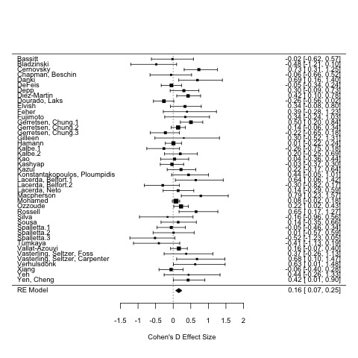
Figure A.2. Forest plot detailing the relationship between insight and education when insight was measured as a continuous variable (measured in Fisher’s Z units).
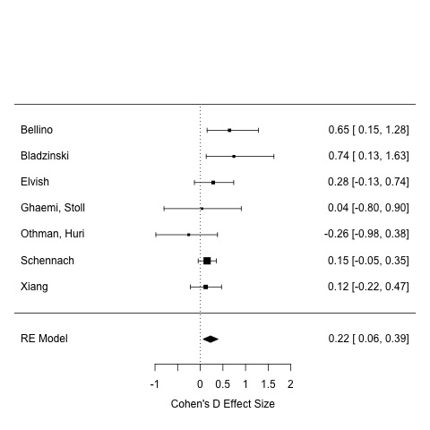

Figure A.3. Forest plot detailing the relationship between insight and employment when insight was measured as a continuous variable (measured in Fisher’s Z units).

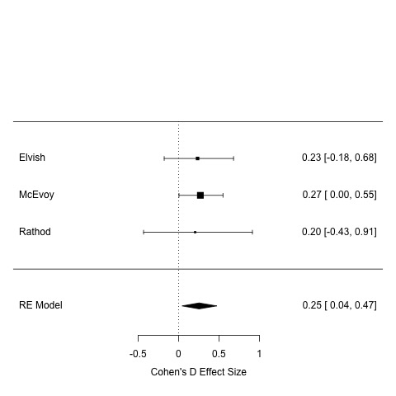

Figure A.4. Forest plot detailing the relationship between insight and ethnicity when insight was measured as a continuous variable (measured in Fisher’s Z units).

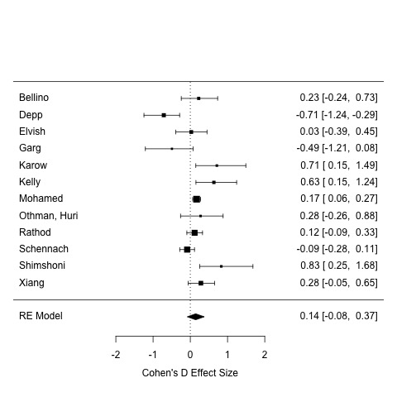

Figure A.5. Forest plot detailing the relationship between insight marital status when insight was measured as a continuous variable (measured in Fisher’s Z units).

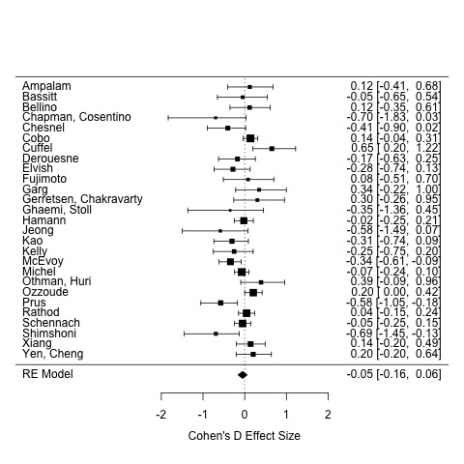

Figure A.6. Forest plot detailing the relationship between insight and sex when insight was measured as a continuous variable (measured in Fisher’s Z units; Male coded as positive).

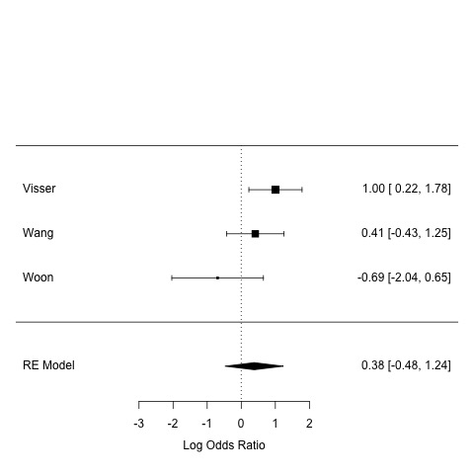
Figure A.7. Forest plot detailing the odds of an employed person being judged to have good insight, relative to an unemployed person.

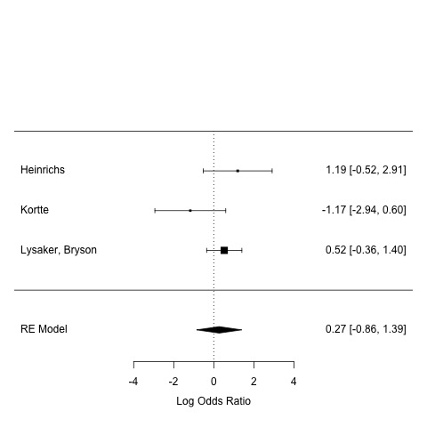
Figure A.8. Forest plot detailing the odds of a white person being judged to have good insight, relative to a black person.

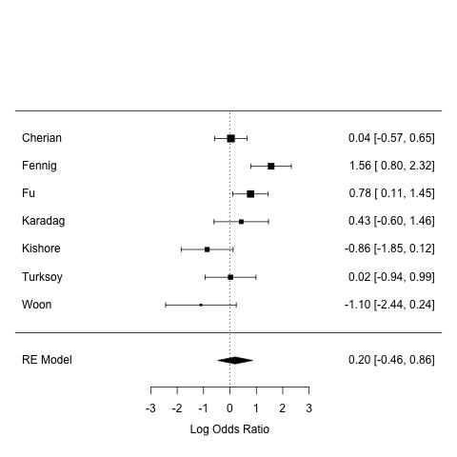
Figure A.9. Forest plot detailing the odds of a married person being judged to have good insight, relative to an unmarried person.

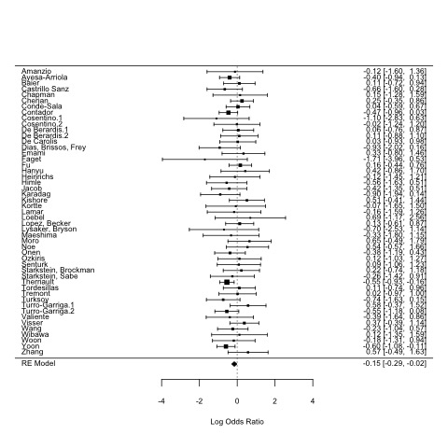
Figure A.10. Forest plot detailing the odds of females being judged to have good insight, relative to a males (males coded as positive).

Funnel Plots

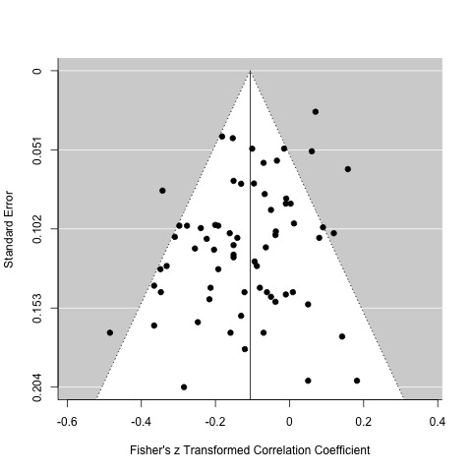
Figure A.11. Funnel plot of studies that investigated the relationship between insight and age when insight was measured as a continuous variable.

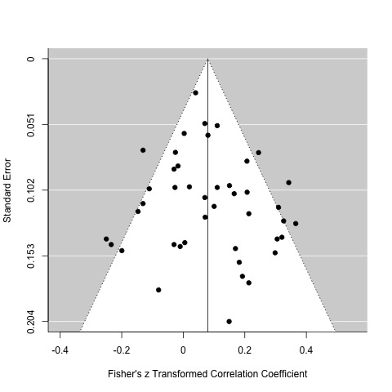
Figure A.12. Funnel plot of studies that investigated the relationship between insight and education when insight was measured as a continuous variable.

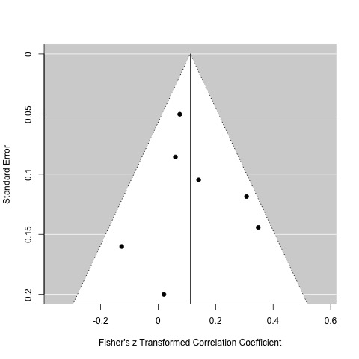
Figure A.13. Funnel plot of studies that investigated the relationship between insight and employment when insight was measured as a continuous variable.

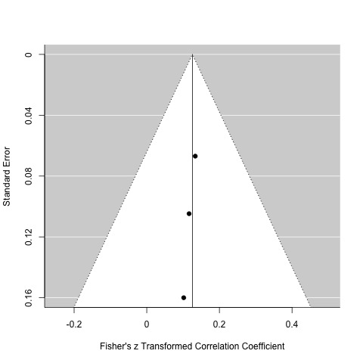
Figure A.14. Funnel plot of studies that investigated the relationship between insight and ethnicity when insight was measured as a continuous variable.

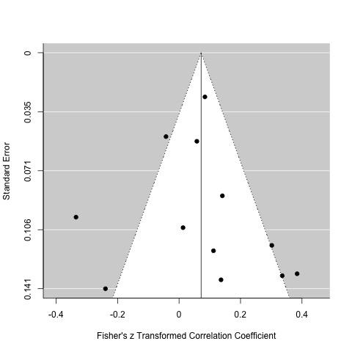
Figure A.15. Funnel plot of studies that investigated the relationship between insight and marital status when insight was measured as a continuous variable.

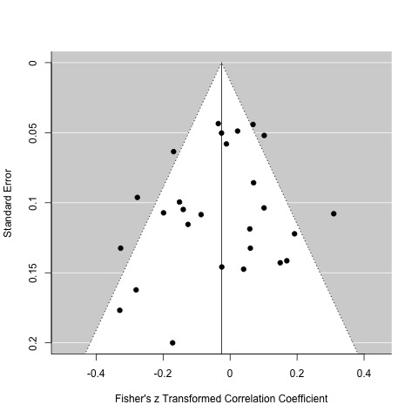

Figure A.16. Funnel plot of studies that investigated the relationship between insight and sex when insight was measured as a continuous variable.

Cook’s Distance Plots

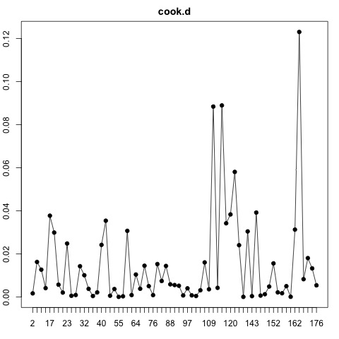
Figure A.17. Cook’s distance analysis investigating outliers from studies the relationship between insight and age when insight was measured as a continuous variable.

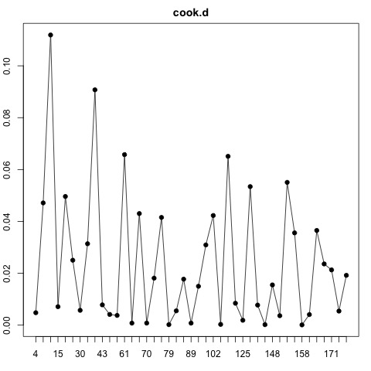
Figure A.18. Cook’s distance analysis investigating outliers from studies the relationship between insight and education when insight was measured as a continuous variable.

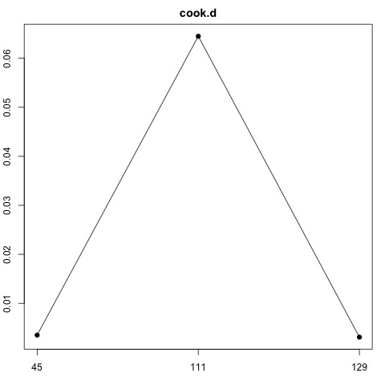
Figure A.19. Cook’s distance analysis investigating outliers from studies the relationship between insight and ethnicity when insight was measured as a continuous variable.

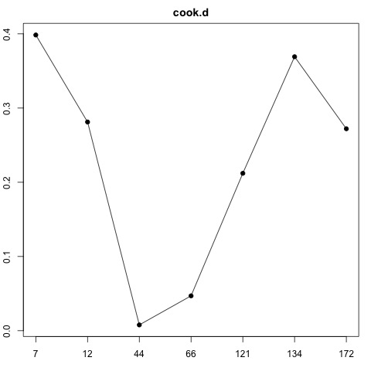
Figure A.20. Cook’s distance analysis investigating outliers from studies the relationship between insight and employment when insight was measured as a continuous variable.

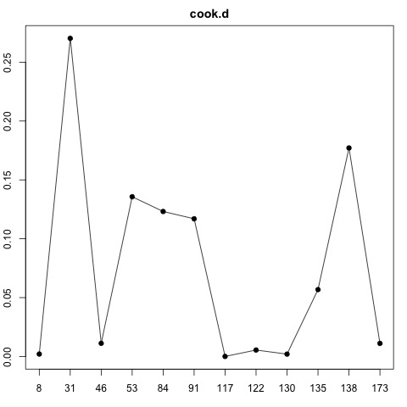
Figure A.21. Cook’s distance analysis investigating outliers from studies the relationship between insight and marital status when insight was measured as a continuous variable.

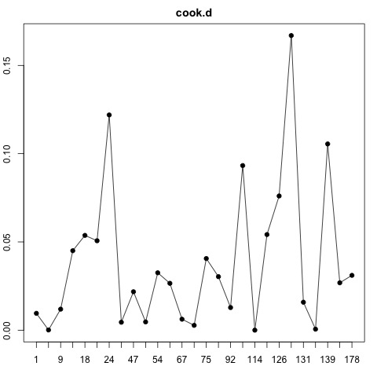
Figure A.22. Cook’s distance analysis investigating outliers from studies the relationship between insight and sex when insight was measured as a continuous variable.

SUPPLEMENTARY SUBGROUP ANALYSES

Age effect on insight in Psychiatric and Neurological samples
Figure A.23. The effect of age on insight between psychiatric and neurological sub-samples.

Age effect on insight between diagnoses

Figure A.24. The effect of age on insight, between different diagnoses.

Age effect on insight for different types of insight scales

Figure A.23. The effect of age on insight between different types of measurement scales.

SUPPLEMENTARY DATA FOR QUALITATIVE SYNTHESIS

Summary of Longitudinal Results

First Author | Year | Sociodemographic factors | Diagnostic group | Follow up period | Follow ups | Significant results (insight total scores only).
Aalten | 2006 | Age, education, SES, sex | Dementia | 18 months | 3 | Only better education predicted good insight at 6 months. Younger age, better education, male gender and higher socioeconomic status predicted good insight at 12 months. Better education and higher socioeconomic status predicted good insight at 16 months.
Chan | 2014 | Age, education | Schizophrenia | 1 year | 2 | Neither variable significantly predicted insight.
Chen | 2001 | Age, education | SMI inpatients | Variable | 1 | No variable predicted change in insight.
Comacchio | 2020 | Gender | Psychosis | 5 years | 3 | Female patients scored worse than males at baseline but improved more than males over time.
Derouesne | 1999 | Age, education, sex | Alzheimer’s disease | Variable (M= 21 months) | 1 | Only younger age predicted good insight at follow up.
Fennig | 1996 | Marital status | Psychosis | 6 months | 1 | Being married predicted good insight.
Gerretsen | 2017 | Age, education | Schizophrenia | 28 weeks | 1 | No variable predicted good insight at follow up.
Greenfeld | 1990 | BMI | Anorexia | Variable (1.2 to 10 years) |  | Increase in BMI between hospitalization and follow-up predicted better insight.
Hanseeuw | 2020 | Age | Alzheimer’s disease | Var (M= 3 years) | 3.3 | Older patients had faster decreases in awareness over time, than did younger patients.
Lysaker | 1995 | Age, education, employment | Schizophrenia | 26 weeks | 1 | No variable predicted change in insight.
Ozzoude | 2019 | Age, education, sex | Schizophrenia | Variable (1-3 months) | 1 | Only male gender predicted good insight at follow up.
Rathod | 2005 | Age, employment, ethnicity, marital status, sex | Schizophrenia | 12 months | 2 | Younger age, being in part time employment and white ethnicity predicted good insight at 5 months. Only white ethnicity predicted good insight at 12 months.
Sanchez-Torres | 2015 | Age, , education, sex | Schizophrenia | 10 years | 1 | Only female gender predicted good insight at follow up.
Schennach | 2012 | Age, employment, marital status, sex | Schizophrenia | 1 year | 1 | Only being employed predicted improvement in insight.
Setkowski | 2016 | Age, country, marital status, sex | SMI inpatients | 2 years | 1 | No variable predicted change in insight.
Silva | 2016 | Age, education, sex | MCI | 2 years | 1 | No variable predicted good insight at follow up.
Sousa | 2015 | Age, education, carer burden sex | Alzheimer’s disease | 12 months | 1 | No variable predicted good insight at follow up.
Van Vliet | 2013 | Sex | Alzheimer’s disease | 1 year | 2 | Male gender predicted good insight over the follow up period.
Vasterling | 1997 | Age, , education | Alzheimer’s disease | Variable (M= 16.4 months) | 1 | No variable predicted change in insight.
Wiffen | 2010 | Sex | Schizophrenia | 6 months | 3 | No variable predicted good insight at follow up.
Yen | 2003 | Age, education | Bipolar disorder | Variable (M= 32.8 days) | 1 | No variable predicted change in insight.
Table A.11. Sociodemographic associations with insight, when measured as a longitudinal variable.

Explanations of Results Provided by Authors

Predictor of Good Insight | Proposed Explanations
 | Clinical | Psychosocial | Methodological | Neurocognitive
Older age | Prolonged experience with disorder | Age-related psychological functions, coping mechanisms | Sampling bias (adolescent samples), interviewer bias
Younger age | Neurodegeneration, functional impairment, early diagnosis, illness onset, illness duration | Age-related beliefs, coping mechanisms, learning processes, upbringing styles | Sampling bias | Differences in premorbid functioning
Better education | NR | Compensatory mechanisms, access to support, illness knowledge, learning processes | NR | Cognitive reserve, intellectual functioning
Female gender | Disease onset, antipsychotic response | Gender norms, coping mechanisms, cultural norms |  | Gender differences in verbal memory
White ethnicity | NR | Cultural constructions of illness, client-patient interaction | Dropout rates, racial bias in evaluation | NR
Table A.12. A brief summary of possible explanations for the relationship between insight and sociodemographic variables, as outlined by study authors.

REVIEW PROTOCOL

Insight Review Protocol (Amended)

Included | Excluded
Design
Cross-sectional | Qualitative only studies
Epidemiological analyses | Non-systematic review
Case note analyses | Non-English language
Case control | Commentaries
Retrospective cohort | Case studies
Prospective cohort | Small N samples (<20 eligible participants)
Randomised controlled studies | Conference abstracts
Systematic review | Brief reports
Meta-analyses | Books
Unpublished dissertations of the above
Population
Cognitive impairment | Non-human participants
Dementia/stroke | Palliative care
Mental health diagnosis | Rare neuropsychiatric syndromes
Substance use disorder | Intellectual/Learning disability
All ages | Healthy populations
 | Physical health problems only
Focus
Clinical insight | Mental capacity focus only
Anosognosia | Non-clinical or non-cognitive focus
Neuroimaging of relevant populations (other eligibility criteria applies) | Methodological focus only
Neuropsychological testing of relevant populations (other eligibility criteria applies) | Interventions for medical professionals  Cognitive Insight
Metacognitive experiments of relevant populations (other eligibility criteria applies)
Data/Outcomes
Quantitative measure of insight via:  - Full validated insight assessment tool (and international adaptations)  - Subjective clinical judgment  - Awareness discrepancy measure | No quantitative measure of insight or measure can’t be linked to a protected characteristic
PANSS G12/OVIS item 11/Y-BOCS item 11 are the only eligible single item scales | No recorded protected characteristic (or insufficient data to merit a conclusion)
Self-reports vs. neuropsychological test discrepancies | Insight subscales or single item scales (except PANSS G12/OVIS item 11/Y-BOCS item 11)
 | Protected characteristic included as a covariate only

REVIEW SEARCH TERMS

MEDLINE

(("clinical insight"[All Fields] OR "cognitive insight"[All Fields] OR "anosognosia"[All Fields] OR ("insight"[All Fields] AND "self awareness"[All Fields]) OR ("insight"[All Fields] AND "awareness of deficit"[All Fields]) OR ("insight"[All Fields] AND "self certainty"[All Fields]) OR "patient's insight"[All Fields] OR "patient insight"[All Fields] OR "lack of insight"[All Fields] OR "loss of insight"[All Fields] OR "impaired insight"[All Fields] OR "poor insight"[All Fields] OR "lack of insight"[All Fields])) AND ((("age" OR "children" OR "younger" OR "older" OR "gender*" OR "sex" OR "male*" OR "female*" OR "rac*" OR "ethnic*" OR "minority" OR "Afro*" OR "African" OR "Caribbean" OR "Asian" OR "Indian" OR "Chinese" OR "sexual orient*" OR "homosexual" OR "bisexual" OR "trans*" OR "gender AND reassign*" OR "disab*" OR "plegic" OR "special AND needs" OR "religi*" OR "spiritu*" OR "pregnan*" OR "matern*" OR "natal")))

Cochrane Database for Systematic Reviews & Cochrane Controlled Register of Trials (CENTRAL)

#1 "clinical insight" OR "cognitive insight" OR "anosognosia"
#2 ("insight" AND "self awareness") OR ("insight" AND "awareness of deficit") OR ("insight" AND "self certainty")
#3 "patient's insight" OR "patient insight" OR "lack of insight" OR "loss of insight" OR "impaired insight" OR "poor insight" OR "lack of insight"
#4 "Beck Cognitive Insight Scale" OR "Birchwood Insight Scale" OR "Scale to assess unawareness of mental disorder" OR "Positive negative syndrome scale" OR "schedule for the assessment of insight" OR "self reflection insight scale" OR "self appraisal of illness questionnaire" OR "mood disorders insight scale"
#5 ("BCIS" AND "insight"):ti,ab,kw OR ("BIS" AND "insight"):ti,ab,kw OR ("SUMD" AND "insight"):ti,ab,kw OR ("PANSS" AND "insight"):ti,ab,kw OR ("SAI" AND "insight"):ti,ab,kw OR ("SRIS" AND "insight"):ti,ab,kw OR ("SAIQ" AND "insight"):ti,ab,kw OR ("MDIS" AND "insight"):ti,ab,kw
#6 "age" OR "children" OR "younger" OR "older" OR "gender*" OR "sex" OR "male*" OR "female*" OR "rac*" OR "ethnic*" OR "minority" OR "Afro*" OR "African" OR "Caribbean" OR "Asian" OR "Indian" OR "Chinese" OR "sexual orient*" OR "homosexual" OR "bisexual" OR "trans*" OR "gender AND reassign*" OR "disab*" OR "plegic" OR "special AND needs" OR "religi*" OR "spiritu*" OR "pregnan*" OR "matern*" OR "natal"
#7 (#1 or #2 or #3 or #4 or #5) = 257 (51 reviews, 206 trials.
#8 (#7 and #6) = 190 (51 reviews, 139 trials).

Web of Science

Indexes = SCI-EXPANDED, SSCI, CPCI-S, CPCI-SHH, ESCI. Languages = English, Document Type = Article, Timespan = All years (1900-2019)
#1 ALL= ("clinical insight" OR "cognitive insight" OR "anosognosia”)
#2 ALL= ("insight" AND "self awareness") OR ("insight" AND "awareness of deficit") OR ("insight" AND "self certainty")
#3 ALL= ("patient's insight" OR "patient insight" OR "lack of insight" OR "loss of insight" OR "impaired insight" OR "poor insight" OR "lack of insight")
#4 ALL= ("Beck Cognitive Insight Scale" OR "Birchwood Insight Scale" OR "Scale to assess unawareness of mental disorder" OR "Positive negative syndrome scale")
#5 ALL= ("schedule for the assessment of insight" OR "self reflection insight scale" OR "self appraisal of illness questionnaire" OR "mood disorders insight scale")
#6 TS= (("BCIS" NEAR/5 "insight") OR ("BIS" NEAR/5 "insight") OR ("SUMD" NEAR/5 "insight") OR ("PANSS" NEAR/5 "insight") OR ("SAI" NEAR/5 "insight") OR ("SRIS" NEAR/5 "insight") OR ("SAIQ" NEAR/5 "insight") OR ("MDIS" NEAR/5 "insight"))
#7 ALL= ("age" OR "children" OR "younger" OR "older" OR "gender*" OR "sex" OR "male*" OR "female*" OR "rac*" OR "ethnic*" OR "minority" OR "Afro*" OR "African" OR "Caribbean" OR "Asian" OR "Indian" OR "Chinese" OR "sexual orient*" OR "homosexual" OR "bisexual" OR "trans*" OR "gender AND reassign*" OR "disab*" OR "plegic" OR "special AND needs" OR "religi*" OR "spiritu*" OR "pregnan*" OR "matern*" OR "natal")
#8 ALL= ((#1 OR #2 OR #3 OR #4 OR #5 OR #6) AND #7) = 1043 Articles.

EMBASE (& EMBASE Classic)

Dates: 1947-2019, Limits: Human participants only, English language
#1 Text Word: "clinical insight" or "cognitive insight" or "anosognosia" or ("insight" and "self awareness") or ("insight" and "awareness of deficit") or ("insight" and "self certainty") or "patient's insight" or "patient insight" or "lack of insight" or "loss of insight" or "impaired insight" or "poor insight" or "lack of insight" or "Beck Cognitive Insight Scale" or "Birchwood Insight Scale" or "Scale to assess unawareness of mental disorder" or "Positive negative syndrome scale" or "schedule for the assessment of insight" or "self reflection insight scale" or "self appraisal of illness questionnaire" or "mood disorders insight scale"
#2 Text Word: ("BCIS" adj5 "insight") or ("BIS" adj5 "insight") or ("SUMD" adj5 "insight") or ("PANSS" adj5 "insight") or ("SAI" adj5 "insight") or ("SRIS" adj5 "insight") or ("SAIQ" adj5 "insight") or ("MDIS" adj5 "insight")
#3 Text Word: "age" or "children" or "younger" or "older" or "gender*" or "sex" or "male*" or "female*" or "rac*" or "ethnic*" or "minority" or "Afro*" or "African" or "Caribbean" or "Asian" or "Indian" or "Chinese" or "sexual orient*" or "homosexual" or "bisexual" or "trans*" or "gender AND reassign*" or "disab*" or "plegic" or "special AND needs" or "religi*" or "spiritu*" or "pregnan*" or "matern*" or "natal"
#4 All Fields: (#1 or #2) AND #3 = 1356 records.

CINAHL

Limits: English language only, Human participants,
#1 TX: "clinical insight" or "cognitive insight" or "anosognosia" or ("insight" and "self awareness") or ("insight" and "awareness of deficit") or ("insight" and "self certainty") or "patient's insight" or "patient insight" or "lack of insight" or "loss of insight" or "impaired insight" or "poor insight" or "lack of insight")
#2 TX: "Beck Cognitive Insight Scale" or "Birchwood Insight Scale" or "Scale to assess unawareness of mental disorder" or "Positive negative syndrome scale" or "schedule for the assessment of insight" or "self reflection insight scale" or "self appraisal of illness questionnaire" or "mood disorders insight scale"
#3 TX: ("BCIS" N5 "insight") or ("BIS" N5 "insight") or ("SUMD" N5 "insight") or ("PANSS" N5 "insight") or ("SAI" N5 "insight") or ("SRIS" N5 "insight") or ("SAIQ" N5 "insight")) or ("MDIS" N5 "insight")
#4 TX: "age" or "children" or "younger" or "older" or "gender*" or "sex" or "male*" or "female*" or "rac*" or "ethnic*" or "minority" or "Afro*" or "African" or "Caribbean" or "Asian" or "Indian" or "Chinese" or "sexual orient*" or "homosexual" or "bisexual" or "trans*" or "gender AND reassign*" or "disab*" or "plegic" or "special AND needs" or "religi*" or "spiritu*" or "pregnan*" or "matern*" or "natal"
#1 TX ( "clinical insight" or "cognitive insight" or "anosognosia" or ("insight" and "self awareness") or ("insight" and "awareness of deficit") or ("insight" and "self certainty") or "patient's insight" or "patient insight" or "lack of insight" or "loss of insight" or "impaired insight" or "poor insight" or "lack of insight") )
#2 TX ( "Beck Cognitive Insight Scale" or "Birchwood Insight Scale" or "Scale to assess unawareness of mental disorder" or "Positive negative syndrome scale" or "schedule for the assessment of insight" or "self reflection insight scale" or "self appraisal of illness questionnaire" or "mood disorders insight scale" )
#3 TX ( ( "BCIS" N5 "insight") or ("BIS" N5 "insight") or ("SUMD" N5 "insight") or ("PANSS" N5 "insight") or ("SAI" N5 "insight") or ("SRIS" N5 "insight") or ("SAIQ" N5 "insight")) or ("MDIS" N5 "insight") )
#4 ( "age" or "children" or "younger" or "older" or "gender*" or "sex" or "male*" or "female*" or "rac*" or "ethnic*" or "minority" or "Afro*" or "African" or "Caribbean" or "Asian" or "Indian" or "Chinese" or "sexual orient*" or "homosexual" or "bisexual" or "trans*" or "gender AND reassign*" or "disab*" or "plegic" or "special AND needs" or "religi*" or "spiritu*" or "pregnan*" or "matern*" or "natal" )
#5 TX: (#1 or #2 or #3) AND #4 = 943 records.

PsycINFO

Limits: No date filter (1806-2019), English language, Human participants
#1 Text Word: "clinical insight" or "cognitive insight" or "anosognosia" or ("insight" and "self awareness") or ("insight" and "awareness of deficit") or ("insight" and "self certainty") or "patient's insight" or "patient insight" or "lack of insight" or "loss of insight" or "impaired insight" or "poor insight" or "lack of insight" or "Beck Cognitive Insight Scale" or "Birchwood Insight Scale" or "Scale to assess unawareness of mental disorder" or "Positive negative syndrome scale" or "schedule for the assessment of insight" or "self reflection insight scale" or "self appraisal of illness questionnaire" or "mood disorders insight scale"
#2 Text Word: ("BCIS" w5 "insight") or ("BIS" w5 "insight") or ("SUMD" w5 "insight") or ("PANSS" w5 "insight") or ("SAI" w5 "insight") or ("SRIS" w5 "insight") or ("SAIQ" w5 "insight") or ("MDIS" w5 "insight")
#3 Text Word: "age" or "children" or "younger" or "older" or "gender*" or "sex" or "male*" or "female*" or "rac*" or "ethnic*" or "minority" or "Afro*" or "African" or "Caribbean" or "Asian" or "Indian" or "Chinese" or "sexual orient*" or "homosexual" or "bisexual" or "trans*" or "gender AND reassign*" or "disab*" or "plegic" or "special AND needs" or "religi*" or "spiritu*" or "pregnan*" or "matern*" or "natal"
#4 All Fields: (#1 or #2) AND #3 = 953 records

REFERENCES

Meta-Analysis
[2-131]

Qualitative Synthesis Only
[132-208]

Other References

[1]

1. Borenstein M, Hedges LV, Higgins JP, Rothstein HR: Converting among effect sizes. Introduction to meta-analysis 2009:45-49.
2. Yeh YC, Yen CF, Li CW, Kuo YT, Chen CH, Lee CC, Liu GC, Huang MF, Liu TL, Chen CS: Altered neurochemical metabolites in Alzheimer's disease patients with unawareness of deficits. Int Psychogeriatr 2014, 26(3):393-402.
3. Verhulsdonk S, Quack R, HÃ¶ft B, Lange-Asschenfeldt C, Supprian T: Anosognosia and depression in patients with Alzheimer's dementia. Archives of Gerontology & Geriatrics 2013, 57(3):282-287.
4. Yoon B, Shim YS, Hong YJ, Choi SH, Park HK, Park SA, Jeong JH, Yoon SJ, Yang D-W: Anosognosia and Its Relation to Psychiatric Symptoms in Early-Onset Alzheimer Disease. Journal of Geriatric Psychiatry & Neurology 2017, 30(3):170-177.
5. Spalletta G, Girardi P, Caltagirone C, Orfei MD: Anosognosia and neuropsychiatric symptoms and disorders in mild Alzheimer disease and mild cognitive impairment. J Alzheimers Dis 2012, 29(4):761-772.
6. Starkstein SE, Sabe L, Cuerva AG, Kuzis G, Leiguarda R: Anosognosia and procedural learning in Alzheimer's disease. Neuropsychiatry, neuropsychology, and behavioral neurology 1997, 10(2):96-101.
7. Kortte KB, McWhorter JW, Pawlak MA, Slentz J, Sur S, Hillis AE: Anosognosia for hemiplegia: The contributory role of right inferior frontal gyrus. Neuropsychology 2015, 29(3):421-432.
8. Chapman S, Beschin N, Cosentino S, Elkind MSV, Della Sala S, Cocchini G: Anosognosia for prospective and retrospective memory deficits: Assessment and theoretical considerations. Neuropsychology 2019, 33(7):1020-1031.
9. Castrillo Sanz A, Andres Calvo M, Repiso Gento I, Izquierdo Delgado E, Gutierrez Rios R, Rodriguez Herrero R, Rodriguez Sanz F, Tola-Arribas MA: Anosognosia in Alzheimer disease: Prevalence, associated factors, and influence on disease progression. Neurologia (Barcelona, Spain) 2016, 31(5):296-304.
10. Feher EP, Mahurin RK, Inbody SB, Crook TH, Pirozzolo FJ: Anosognosia in Alzheimer's disease. Neuropsychiatry, Neuropsychology and Behavioral Neurology 1991, 4(2):136-146.
11. Orfei MD, Varsi AE, Blundo C, Celia E, Casini AR, Caltagirone C, Spalletta G, Orfei MD, Varsi AE, Blundo C et al: Anosognosia in mild cognitive impairment and mild Alzheimer's disease: frequency and neuropsychological correlates. American Journal of Geriatric Psychiatry 2010, 18(12):1133-1140.
12. De Carolis A, Cipollini V, Corigliano V, Comparelli A, Sepe-Monti M, Orzi F, Ferracuti S, Giubilei F: Anosognosia in people with cognitive impairment: association with cognitive deficits and behavioral disturbances. Dement Geriatr Cogn Dis Extra 2015, 5(1):42-50.
13. Kalbe E, Salmon E, Perani D, Holthoff V, Sorbi S, Elsner A, Weisenbach S, Brand M, Lenz O, Kessler J et al: Anosognosia in very mild Alzheimer's disease but not in mild cognitive impairment. Dementia and geriatric cognitive disorders 2005, 19(5-6):349-356.
14. Starkstein SE, Brockman S, Bruce D, Petracca G: Anosognosia is a significant predictor of apathy in Alzheimer's disease. J Neuropsychiatry Clin Neurosci 2010, 22(4):378-383.
15. Gerretsen P, Chung JK, Shah P, Plitman E, Iwata Y, Caravaggio F, Nakajima S, Pollock BG, Graff-Guerrero A: Anosognosia Is an Independent Predictor of Conversion From Mild Cognitive Impairment to Alzheimer’s Disease and Is Associated With Reduced Brain Metabolism. Journal of Clinical Psychiatry 2017, 78(9):e1187-e1196.
16. Wibawa P, Zombor R, Dragovic M, Hayhow B, Lee J, Panegyres PK, Rock D, Starkstein SE: Anosognosia Is Associated With Greater Caregiver Burden and Poorer Executive Function in Huntington Disease. J Geriatr Psychiatry Neurol 2020, 33(1):52-58.
17. Therriault J, Ng KP, Pascoal TA, Mathotaarachchi S, Kang MS, Struyfs H, Shin M, Benedet AL, Walpola IC, Nair V et al: Anosognosia predicts default mode network hypometabolism and clinical progression to dementia. Neurology 2018, 90(11):E932-501.
18. Clare L, Whitaker CJ, Nelis SM: Appraisal of Memory Functioning and Memory Performance in Healthy Ageing and Early-Stage Alzheimer's Disease. Aging Neuropsychol Cogn 2010, 17(4):462-491.
19. Woon LS, Khoo SI, Baharudin A, Midin M: Association between insight and internalized stigma and other clinical factors among patients with depression: A cross-sectional study. Indian J Psychiatry 2020, 62(2):186-192.
20. Xiang YT, Wang Y, Wang CY, Chiu HF, Chen Q, Chan SS, Lai KY, Lee EH, Ungvari GS: Association of insight with sociodemographic and clinical factors, quality of life, and cognition in Chinese patients with schizophrenia. Compr Psychiatry 2012, 53(2):140-144.
21. Błądziński P, Kalisz A, Adamczyk P, Arciszewska A, Mętel D, Daren A, Cechnicki A: Associations of insight and treatment adherence with employment status of people with schizophrenia. Postępy Psychiatrii i Neurologii 2019, 28(1):21-33.
22. Dourado MCN, Laks J, Mograbi DC: Awareness in Dementia: Development and Evaluation of a Short Version of the Assessment Scale of Psychosocial Impact of the Diagnosis of Dementia (ASPIDD-s) in Brazil. Alzheimer Dis Assoc Dis 2019, 33(3):220-225.
23. Lopez OL, Becker JT, Somsak D, Dew MA, Dekosky ST: Awareness of Cognitive Deficits and Anosognosia in Probable Alzheimers-Disease. Eur Neurol 1994, 34(5):277-282.
24. Gambina G, Bonazzi A, Valbusa V, Condoleo M, Bortolami O, Broggio E, Sala F, Moretto G, Moro V: Awareness of cognitive deficits and clinical competence in mild to moderate Alzheimer's disease: their relevance in clinical practice. Neurological sciences : official journal of the Italian Neurological Society and of the Italian Society of Clinical Neurophysiology 2014, 35(3):385-390.
25. Dourado M, Marinho V, Soares C, Engelhardt E, Laks J: Awareness of disease in Alzheimer's dementia: description of a mild to moderate sample of patient and caregiver dyads in Brazil. Int Psychogeriatr 2007, 19(4):733-744.
26. Sousa MFB, Santos RL, Nogueira ML, Belfort T, Rosa RDL, Torres B, Simoes P, Mograbi DC, Laks J, Dourado MCN: Awareness of Disease is Different for Cognitive and Functional Aspects in Mild Alzheimer's Disease: A One-Year Observation Study. J Alzheimers Dis 2015, 43(3):905-913.
27. Molina-Andreu O, Gonzalez-Rodriguez A, Villanueva AP, Penades R, Catalan R, Bernardo M: Awareness of illness and suicidal behavior in delusional disorder patients. Revista de Psiquiatria Clinica 2014, 41(6):156-158.
28. Cuffel BJ, Alford J, Fischer EP, Owen RR: Awareness of illness in schizophrenia and outpatient treatment adherence. J Nerv Ment Dis 1996, 184(11):653-659.
29. Mayelle A, El Haj M, Antoine P: Awareness of Self and Disease Assessment: Development and Validation of a Subjective Measure in People with Alzheimer's Disease. J Alzheimers Dis 2019, 71(3):841-850.
30. Fujimoto H, Matsuoka T, Kato Y, Shibata K, Nakamura K, Yamada K, Narumoto J: Brain regions associated with anosognosia for memory disturbance in Alzheimer's disease: a magnetic resonance imaging study. Neuropsychiatric disease and treatment 2017, 13:1753-1759.
31. Sedaghat F, Dedousi E, Baloyannis I, Tegos T, Costa V, Dimitriadis AS, Baloyannis SJ, Sedaghat F, Dedousi E, Baloyannis I et al: Brain SPECT findings of anosognosia in Alzheimer's disease. Journal of Alzheimer's Disease 2010, 21(2):641-647.
32. Turro-Garriga O, Garre-Olmo J, Vilalta-Franch J, Conde-Sala JL, Gracia Blanco M, Lopez-Pousa S: Burden associated with the presence of anosognosia in Alzheimer's disease. International Journal of Geriatric Psychiatry 2013, 28(3):291-297.
33. Dias V, Brissos S, Carita A: Clinical and neurocognitive correlates of insight in patients with bipolar I disorder in remission. Acta Psychiatrica Scandinavica 2008, 117(1):28-34.
34. Kao Y-C, Liu Y-P: The clinical applicability of the Self-Appraisal of Illness Questionnaire (SAIQ) to chronic schizophrenic patients in Taiwan. Psychiatric Quarterly 2010, 81(3):215-225.
35. Kishore VR, Samar R, Reddy YCJ, Chandrasekhar CR, Thennarasu K: Clinical characteristics and treatment response in poor and good insight obsessive-compulsive disorder. European Psychiatry 2004, 19(4):202-208.
36. Cernovsky ZZ, Landmark JA, Merskey H, Husni M: Clinical correlates of insight in schizophrenia. Psychological reports 2004, 95(3 Pt 1):821-827.
37. Conde-Sala JL, Reñé-Ramírez R, Turró-Garriga O, Gascón-Bayarri J, Juncadella-Puig M, Moreno-Cordón L, Viñas-Diez V, Garre-Olmo J: Clinical differences in patients with Alzheimer's disease according to the presence or absence of anosognosia: implications for perceived quality of life. Journal of Alzheimer's Disease 2013, 33(1):1105-1116.
38. Bellino S, Patria L, Ziero S, Bogetto F: Clinical picture of obsessive-compulsive disorder with poor insight: a regression model. Psychiatry Res 2005, 136(2-3):223-231.
39. Kelly B, Clarke M, Browne S, McTigue O, Kamali M, Gervin M, Kinsella A, Lane A, Larkin C, O'Callaghan E: Clinical predictors of admission status in first episode schizophrenia. European Psychiatry 2004, 19(2):67-71.
40. Senturk G, Hanagasi H, Gurvit H, Emre M, Bilgic B, Bayram A, Arslan AB: Cognitive and anatomical correlates of anosognosia in amnestic mild cognitive impairment and early-stage Alzheimer's disease. Int Psychogeriatr 2017, 29(2):293-302.
41. Turksoy N, Tukel R, Ozdemir O, Karali A: Comparison of clinical characteristics in good and poor insight obsessive-compulsive disorder. Journal of anxiety disorders 2002, 16(4):413-423.
42. Jeong SH, Chung IW, Jung HY, Hwang SS, Kim SH, Youn T, Chung JK, Kim YS: Comparison of clinician-rated and self-report insight in Korean patients with schizophrenia using VAGUS insight scale. Psychiatry Res 2017, 258:93-100.
43. Sitman R, Sela T, Erez G, Bloch Y, Levkovitz Y: Comparison of insight among schizophrenia and bipolar disorder patients in remission of affective and positive symptoms: Analysis and critique. European Psychiatry 2012, 27(8):612-618.
44. Fu Y-N, Cao X-L, Hou C-L, Ng CH, Ungvari GS, Chiu HF, Lin Y-Q, Wang L, Zheng X, Jia F-J et al: Comparison of insight and clinical variables in homeless and non-homeless psychiatric inpatients in China. Psychiatry Research 2017, 255:13-16.
45. Contador I, Mograbi DC, Fernandez-Calvo B, Benito-Leon J, Bermejo-Pareja F: Comparison of mortality rate in older adults with and without functional awareness: the Neurological Disorders in Central Spain (NEDICES) population-based study. Public Health 2020, 183:146-152.
46. Emami S, Guimond S, Chakravarty MM, Lepage M: Cortical thickness and low insight into symptoms in enduring schizophrenia. Schizophrenia Research 2016, 170(1):66-72.
47. Turró-Garriga O, Garre-Olmo J, Calvó-Perxas L, Reñé-Ramírez R, Gascón-Bayarri J, Conde-Sala JL, Conde-Sala JL: Course and Determinants of Anosognosia in Alzheimer's Disease: A 12-Month Follow-up. Journal of Alzheimer's Disease 2016, 51(2):357-366.
48. Chapman S, Colvin LE, Vuorre M, Cocchini G, Metcalfe J, Huey ED, Cosentino S: Cross domain self-monitoring in anosognosia for memory loss in Alzheimer's disease. Cortex 2018, 101:221-233.
49. Mohamed S, Rosenheck R, McEvoy J, Swartz M, Stroup S, Lieberman JA: Cross-sectional and longitudinal relationships between insight and attitudes toward medication and clinical outcomes in chronic schizophrenia. Schizophr Bull 2009, 35(2):336-346.
50. Derouesne C, Thibault S, Lagha-Pierucci S, Baudouin-Madec V, Ancri D, Lacomblez L: Decreased awareness of cognitive deficits in patients with mild dementia of the Alzheimer type. International Journal of Geriatric Psychiatry 1999, 14(12):1019-1030.
51. Verhey FRJ, Rozendaal N, Ponds RWHM, Jolles J: Dementia, awareness and depression. International Journal of Geriatric Psychiatry 1993, 8(10):851-856.
52. Lamar M, Lasarev MR, Libon DJ: Determining levels of unawareness in dementia research. J Neuropsychiatry Clin Neurosci 2002, 14(4):430-437.
53. Starkstein SE, Jorge R, Mizrahi R, Robinson RG, Starkstein SE, Jorge R, Mizrahi R, Robinson RG: A diagnostic formulation for anosognosia in Alzheimer's disease. Journal of Neurology, Neurosurgery & Psychiatry 2006, 77(6):719-725.
54. Diez-Martin J, Moreno-Ortega M, Bagney A, Rodriguez-Jimenez R, Padilla-Torres D, Sanchez-Morla EM, Santos JL, Palomo T, Jimenez-Arriero MA: Differential relationships between set-shifting abilities and dimensions of insight in schizophrenia. Psychopathology 2014, 47(2):86-92.
55. Karow A, Pajonk FG, Reimer J, Hirdes F, Osterwald C, Naber D, Moritz S: The dilemma of insight into illness in schizophrenia: self- and expert-rated insight and quality of life. European archives of psychiatry and clinical neuroscience 2008, 258(3):152-159.
56. Cherian AV, Narayanaswamy JC, Srinivasaraju R, Viswanath B, Math SB, Kandavel T, Reddy YC: Does insight have specific correlation with symptom dimensions in OCD? J Affect Disorders 2012, 138(3):352-359.
57. Bota RG, Munro JS, Ricci WF, Bota DA: The dynamics of insight in the prodrome of schizophrenia. CNS Spectr 2006, 11(5):355-362.
58. Heinrichs DW, Cohen BP, Carpenter WT, Jr.: Early insight and the management of schizophrenic decompensation. J Nerv Ment Dis 1985, 173(3):133-138.
59. Ozzoude M, Nakajima S, Plitman E, Chung JK, Kim J, Iwata Y, Caravaggio F, Takeuchi H, Uchida H, Graff-Guerrero A et al: The effects of illness severity, cognition, and estimated antipsychotic dopamine receptor occupancy on insight into the illness in schizophrenia: An analysis of clinical antipsychotic trials of intervention effectiveness (CATIE) data. Prog Neuropsychopharmacol Biol Psychiatry 2019, 89:207-213.
60. Donohoe G, Donnell CO, Owens N, O'Callaghan E: Evidence that health attributions and symptom severity predict insight in schizophrenia. Journal of Nervous & Mental Disease 2004, 192(9):635-637.
61. Cines S, Farrell M, Steffener J, Sullo L, Huey E, Karlawish J, Cosentino S: Examining the Pathways Between Self-Awareness and Well-Being in Mild to Moderate Alzheimer Disease. Am J Geriatr Psychiatry 2015, 23(12):1297-1306.
62. Bivona U, Ciurli P, Barba C, Onder G, Azicnuda E, Silvestro D, Mangano R, Rigon J, Formisano R: Executive function and metacognitive self-awareness after severe traumatic brain injury. J Int Neuropsychol Soc 2008, 14(5):862-868.
63. Cobo J, Labad J, Pousa E, Nieto L, Ochoa S, Usall J, Garcia-Ribera C, Banos I, Gonzalez B, Massons C et al: Exploring the relationship of insight with psychopathology and gender in individuals with schizophrenia spectrum disorders with structural equation modelling. Arch Womens Ment Health 2020, 23(5):643-655.
64. Lacerda IB, Santos RL, Neto JPS, Dourado MCN: Factors Related to Different Objects of Awareness in Alzheimer Disease. Alzheimer Dis Assoc Dis 2017, 31(4):335-342.
65. Tolin DF, Fitch KE, Frost RO, Steketee G: Family Informants’ Perceptions of Insight in Compulsive Hoarding. Cognitive Ther Res 2008, 34(1):69-81.
66. Loebel J, Dager SR, Berg G, Hyde TS: Fluency of speech and self-awareness of memory deficit in Alzheimer's disease. International Journal of Geriatric Psychiatry 1990, 5(1):41-45.
67. Gerretsen P, Chakravarty M, Mamo D, Menon M, Pollock BG, Rajji TK, Graff-Guerrero A: Frontotemporoparietal asymmetry and lack of illness awareness in schizophrenia. Human Brain Mapping 2013, 34(5):1035-1043.
68. Visser H, Megen HV, Oppen PV, Hoogendoorn A, Glas G, Neziroglu F, Balkom AV: The impact of poor insight on the course of Obsessive-Compulsive Disorder in patients receiving naturalistic treatment. Journal of Obsessive-Compulsive and Related Disorders 2017, 13:42-48.
69. Baier B, Karnath H, Baier B, Karnath HO: Incidence and diagnosis of anosognosia for hemiparesis revisited. Journal of Neurology, Neurosurgery & Psychiatry 2005, 76(3):358-361.
70. De Berardis D, Campanella D, Gambi F, Sepede G, Salini G, Carano A, La Rovere R, Pelusi L, Penna L, Cicconetti A et al: Insight and alexithymia in adult outpatients with obsessive-compulsive disorder. European archives of psychiatry and clinical neuroscience 2005, 255(5):350-358.
71. Lysaker PH, Bell MD, Bryson GJ, Kaplan E: Insight and interpersonal function in schizophrenia. J Nerv Ment Dis 1998, 186(7):432-436.
72. De Berardis D, Campanella D, Serront N, Gambi F, Carano A, La Rovere R, Nardella E, Pizzorno AM, Cotellassa C, Salerno RM et al: Insight and perceived expressed emotion among adult outpatients with obsessive-compulsive disorder. J Psychiatr Pract 2008, 14(3):154-159.
73. Shad MU, Muddasani S, Prasad K, Sweeney JA, Keshavan MS: Insight and prefrontal cortex in first-episode Schizophrenia. Neuroimage 2004, 22(3):1315-1320.
74. Bassitt DP, Neto MR, de Castro CC, Busatto GF: Insight and regional brain volumes in schizophrenia. European archives of psychiatry and clinical neuroscience 2007, 257(1):58-62.
75. Weiler MA, Fleisher MH, McArthur-Campbell D: Insight and symptom change in schizophrenia and other disorders. Schizophr Res 2000, 45(1-2):29-36.
76. Himle JA, Van Etten ML, Janeck AS, Fischer DJ: Insight as a Predictor of Treatment Outcome in Behavioral Group Treatment for Obsessive–Compulsive Disorder. Cognitive Ther Res 2006, 30(5):661-666.
77. Jacob ML, Larson MJ, Storch EA: Insight in adults with obsessive-compulsive disorder. Compr Psychiatry 2014, 55(4):896-903.
78. Wang Y, Xiang YT, Wang CY, Chiu HF, Zhao JP, Chen Q, Chan SS, Lee EH, Tang WK, Ungvari GS: Insight in Chinese schizophrenia patients: a 12-month follow-up. Journal of psychiatric and mental health nursing 2011, 18(9):751-757.
79. Fennig S, Everett E, Bromet EJ, Jandorf L, Fennig SR, Tanenberg-Karant M, Craig TJ: Insight in first-admission psychotic patients. Schizophr Res 1996, 22(3):257-263.
80. McEvoy JP, Johnson J, Perkins D, Lieberman JA, Hamer RM, Keefe RS, Tohen M, Glick ID, Sharma T: Insight in first-episode psychosis. Psychological medicine 2006, 36(10):1385‐1393.
81. Shimshoni Ya, Reuven O, Dar R, Hermesh H: Insight in obsessive-compulsive disorder: A comparative study of insight measures in an israeli clinical sample. Journal of Behavior Therapy and Experimental Psychiatry 2011, 42(3):389-396.
82. Othman Z, Huri SZ: Insight in Offenders with Schizophrenia: Relationship to Psychopathology and Cognitive Function. International Medical Journal 2017, 24(1):18-20.
83. Schennach R, Meyer S, Seemuller F, Jager M, Schmauss M, Laux G, Pfeiffer H, Naber D, Schmidt LG, Gaebel W et al: Insight in schizophrenia-course and predictors during the acute treatment phase of patients suffering from a schizophrenia spectrum disorder. European psychiatry : the journal of the Association of European Psychiatrists 2012, 27(8):625-633.
84. Danki D, Dilbaz N, Okay IT, Telci S: [Insight in schizophrenia: relationship to family history, and positive and negative symptoms]. Turk Psikiyatri Derg 2007, 18(2):129-136.
85. Rathod S, Kingdon D, Smith P, Turkington D: Insight into schizophrenia: The effects of cognitive behavioural therapy on the components of insight and association with sociodemographics--data on a previously published randomised controlled trial. Schizophrenia Research 2005, 74(2-3):211-219.
86. Dias VV, Brissos S, Frey BN, Kapczinski F: Insight, quality of life and cognitive functioning in euthymic patients with bipolar disorder. J Affect Disorders 2008, 110(1-2):75-83.
87. Rossell SL, Coakes J, Shapleske J, Woodruff PWR, David AS: Insight: its relationship with cognitive function, brain volume and symptoms in schizophrenia. Psychological Medicine 2003, 33(1):111-119.
88. Tumkaya S, Hanci Yenigun E, Topak OZ, Sendur I, Ozturk Atkaya N, Ozdel O: [Is Clinical Insight Associated with Working Memory Components in Schizophrenia and Schizoaffective Disorder?]. Turk Psikiyatri Derg 2019, 30(1):1-8.
89. Konstantakopoulos G, Ploumpidis D, Oulis P, Soumani A, Nikitopoulou S, Pappa K, Papadimitriou GN, David AS: Is insight in schizophrenia multidimensional? Internal structure and associations of the Greek version of the Schedule for the Assessment of Insight-Expanded. Psychiatry Res 2013, 209(3):346-352.
90. Ayesa-Arriola R, Moríñigo JDL, David AS, Pérez-Iglesias R, Rodríguez-Sánchez JM, Crespo-Facorro B: Lack of insight 3 years after first-episode psychosis: an unchangeable illness trait determined from first presentation? Schizophrenia Research 2014, 157(1-3):271-277.
91. Ghaemi SN, Stoll AL, Pope HG, Jr.: Lack of insight in bipolar disorder. The acute manic episode. J Nerv Ment Dis 1995, 183(7):464-467.
92. Cosentino S, Metcalfe J, Cary MS, De Leon J, Karlawish J: Memory Awareness Influences Everyday Decision Making Capacity about Medication Management in Alzheimer's Disease. Int J Alzheimers Dis 2011, 2011:483897.
93. Ciurli P, Bivona U, Barba C, Onder G, Silvestro D, Azicnuda E, Rigon J, Formisano R: Metacognitive unawareness correlates with executive function impairment after severe traumatic brain injury. J Int Neuropsychol Soc 2010, 16(2):360-368.
94. Chapman S, Cosentino S, Igwe KC, Abdurahman A, Elkind MSV, Brickman AM, Charlton R, Cocchini G: Mnemonic monitoring in anosognosia for memory loss. Neuropsychology 2020, 34(6):675-685.
95. Moro V, Pernigo S, Tsakiris M, Avesani R, Edelstyn NM, Jenkinson PM, Fotopoulou A: Motor versus body awareness: Voxel-based lesion analysis in anosognosia for hemiplegia and somatoparaphrenia following right hemisphere stroke. Cortex 2016, 83:62-77.
96. Hanyu H, Sato T, Akai T, Shimizu S, Hirao K, Kanetaka H, Iwamoto T, Koizumi K: Neuroanatomical correlates of unawareness of memory deficits in early Alzheimer's disease. Dementia and geriatric cognitive disorders 2008, 25(4):347-353.
97. Karadag F, Tumkaya S, Kirtas D, Efe M, Alacam H, Oguzhanoglu NK: Neurological soft signs in obsessive compulsive disorder with good and poor insight. Prog Neuropsychopharmacol Biol Psychiatry 2011, 35(4):1074-1079.
98. Kashyap H, Kumar JK, Kandavel T, Reddy YCJ: Neuropsychological correlates of insight in obsessive-compulsive disorder. Acta Psychiatrica Scandinavica 2012, 126(2):106-114.
99. Cosentino S, Metcalfe J, Butterfield B, Stern Y, Cosentino S, Metcalfe J, Butterfield B, Stern Y: Objective metamemory testing captures awareness of deficit in Alzheimer's disease. Cortex: A Journal Devoted to the Study of the Nervous System & Behavior 2007, 43(7):1004-1019.
100. Hamann J, Kruse J, Schmitz FS, Kissling W, Pajonk FG: Patient participation in antipsychotic drug choice decisions. Psychiatry Res 2010, 178(1):63-67.
101. Lacerda IB, Santos RL, Belfort T, Neto JPS, Dourado MCN: Patterns of discrepancies in different objects of awareness in mild and moderate Alzheimer's disease. Aging Ment Health 2018:1-8.
102. Kleim B, Vauth R, Adam G, Stieglitz R-D, Hayward P, Corrigan P: Perceived stigma predicts low self-efficacy and poor coping in schizophrenia. J Ment Health 2009, 17(5):482-491.
103. Martyr A, Nelis SM, Clare L: Predictors of perceived functional ability in early-stage dementia: self-ratings, informant ratings and discrepancy scores. Int J Geriatr Psychiatry 2014, 29(8):852-862.
104. Valiente C, Provencio M, Espinosa R, Chaves C, Fuentenebro F: Predictors of subjective well-being in patients with paranoid symptoms: is insight necessarily advantageous? Psychiatry Res 2011, 189(2):190-194.
105. Hannesdottir K, Morris RG, Hannesdottir K, Morris RG: Primary and secondary anosognosia for memory impairment in patients with Alzheimer's disease. Cortex: A Journal Devoted to the Study of the Nervous System & Behavior 2007, 43(7):1020-1030.
106. Depp CA, Harmell AL, Savla GN, Mausbach BT, Jeste DV, Palmer BW: A prospective study of the trajectories of clinical insight, affective symptoms, and cognitive ability in bipolar disorder. Journal of Affective Disorders 2014, 152-154:250-255.
107. Michel P, Baumstarck K, Auquier P, Amador X, Dumas R, Fernandez J, Lancon C, Boyer L: Psychometric properties of the abbreviated version of the a scale to assess unawareness in mental disorder in schizophrenia. BMC Psychiatry Vol 13 2013, ArtID 229 2013, 13.
108. Garg R, Cheema SK, Raj R: Psychometric Properties of the Insight in Psychosis Questionnaire and its Correlation to Psychopathology in Indian Population. Indian journal of psychological medicine 2018, 40(2):113-120.
109. DeFeis B, Chapman S, Zhu C, Azar M, Sunderaraman P, Ornstein K, Gu Y, Cosentino S: Reduced Awareness of Memory Deficit is Associated With Increased Medicare Home Health Care Use in Dementia. Alzheimer Dis Assoc Dis 2019, 33(1):62-67.
110. Maeshima S, Dohi N, Funahashi K, Nakai K, Itakura T, Komai N: Rehabilitation of patients with anosognosia for hemiplegia due to intracerebral haemorrhage. Brain injury 1997, 11(9):691-697.
111. Tremont G, Alosco ML: Relationship between cognition and awareness of deficit in mild cognitive impairment. Int J Geriatr Psychiatry 2011, 26(3):299-306.
112. Yen CF, Cheng CP, Ko CH, Yen JY, Huang CF, Chen CS: Relationship between insight and neurocognition in patients with bipolar I disorder in remission. Compr Psychiatry 2008, 49(4):335-339.
113. Ozkiris A, Essizoglu A, Gulec G, Aksaray G: The relationship between insight and the level of expressed emotion in patients with obsessive-compulsive disorder. Nordic journal of psychiatry 2015, 69(3):204-209.
114. Macpherson R, Jerrom B, Hughes A: Relationship between insight, educational background and cognition in schizophrenia. Br J Psychiatry 1996, 168(6):718-722.
115. Onen S, Karakas Ugurlu G, Caykoylu A: The relationship between metacognitions and insight in obsessive-compulsive disorder. Compr Psychiatry 2013, 54(5):541-548.
116. Beland S, Lepage M: The relative contributions of social cognition and self-reflectiveness to clinical insight in enduring schizophrenia. Psychiatry Res 2017, 258:116-123.
117. Tordesillas-Gutierrez D, Ayesa-Arriola R, Delgado-Alvarado M, Robinson JL, Lopez-Morinigo J, Pujol J, Dominguez-Ballesteros ME, David AS, Crespo-Facorro B: The right occipital lobe and poor insight in first-episode psychosis. PloS one 2018, 13(6):e0197715.
118. Gilleen J, Greenwood K, Archer N, Lovestone S, David AS: The role of premorbid personality and cognitive factors in awareness of illness, memory, and behavioural functioning in Alzheimer's disease. Cogn Neuropsychiatry 2012, 17(3):227-245.
119. Ampalam P, Deepthi R, Vadaparty P: Schizophrenia - insight, depression: a correlation study. Indian journal of psychological medicine 2012, 34(1):44-48.
120. Faget-Agius C, Boyer L, Padovani R, Richieri Rl, Mundler O, LanÃ§on C, Guedj E: Schizophrenia with preserved insight is associated with increased perfusion of the precuneus. Journal of Psychiatry & Neuroscience 2012, 37(5):297-304.
121. Szepietowska EM, Kuzaka A: Self-assessment of executive function and lateralization of brain pathology: What does the DEX-S profile show? Psychiatr Pol 2019, 53(1):129-143.
122. Noe E, Ferri J, Caballero MC, Villodre R, Sanchez A, Chirivella J: Self-awareness after acquired brain injury--predictors and rehabilitation. J Neurol 2005, 252(2):168-175.
123. Chesnel C, Jourdan C, Bayen E, Ghout I, Darnoux E, Azerad S, Charanton J, Aegerter P, Pradat-Diehl P, Ruet A et al: Self-awareness four years after severe traumatic brain injury: discordance between the patient's and relative's complaints. Results from the PariS-TBI study. Clin Rehabil 2018, 32(5):692-704.
124. Silva MR, Moser D, Pfluger M, Pusswald G, Stogmann E, Dal-Bianco P, Auff E, Lehrner J: Self-reported and informant-reported memory functioning and awareness in patients with mild cognitive impairment and Alzheimer s disease. Neuropsychiatrie : Klinik, Diagnostik, Therapie und Rehabilitation : Organ der Gesellschaft Osterreichischer Nervenarzte und Psychiater 2016, 30(2):103-112.
125. Prus L, Wiedl KH, Waldorf M: Stigma as a predictor of insight in schizophrenia. Psychiatry Research 2012, 198(2):187-193.
126. Kazui H, Hirono N, Hashimoto M, Nakano Y, Matsumoto K, Takatsuki Y, Mori E, Ikejiri Y, Takeda M: Symptoms underlying unawareness of memory impairment in patients with mild Alzheimer's disease. J Geriatr Psychiatry Neurol 2006, 19(1):3-12.
127. Zhang Q, Li X, Parker GJ, Hong XH, Wang Y, Lui SSY, Neumann DL, Cheung EFC, Shum DHK, Chan RCK: Theory of mind correlates with clinical insight but not cognitive insight in patients with schizophrenia. Psychiatry Research 2016, 237:188-195.
128. Vasterling JJ, Seltzer B, Foss JW, Vanderbrook V: Unawareness of deficit in Alzheimer's disease: Domain-specific differences and disease correlates. Neuropsychiatry, Neuropsychology, & Behavioral Neurology 1995, 8(1):26-32.
129. Amanzio M, Torta DM, Sacco K, Cauda F, D'Agata F, Duca S, Leotta D, Palermo S, Geminiani GC: Unawareness of deficits in Alzheimer's disease: role of the cingulate cortex. Brain 2011, 134(Pt 4):1061-1076.
130. Vasterling JJ, Seltzer B, Carpenter BD, Thompson KA: Unawareness of social interaction and emotional control deficits in alzheimer's disease. Neuropsychol Dev Cogn B Aging Neuropsychol Cogn 1997, 4(4):280-289.
131. Elvish J, Simpson J, Ball LJ: Which clinical and demographic factors predict poor insight in individuals with obsessions and/or compulsions? Journal of anxiety disorders 2010, 24(2):231-237.
132. Buchy L, Bodnar M, Malla A, Joober R, Lepage M: A 12-month outcome study of insight and symptom change in first-episode psychosis. Early Interv Psychiatry 2010, 4(1):79-88.
133. Turró-Garriga O, Garre-Olmo J, López-Pousa S, Vilalta-Franch J, Reñé-Ramírez R, Conde-Sala JL: Abridged scale for the screening anosognosia in patients with dementia. Journal of Geriatric Psychiatry & Neurology 2014, 27(3):220-226.
134. Pia L, Spinazzola L, Garbarini F, Bellan G, Piedimonte A, Fossataro C, Livelli A, Burin D, Berti A: Anosognosia for hemianaesthesia: a voxel-based lesion-symptom mapping study. Cortex 2014, 61:158-166.
135. de Castro Zilli BBC, Damasceno BP: Anosognosia in Alzheimer's disease: A neuropsychological approach. Dementia & Neuropsychologia 2007, 1(1):81-88.
136. Reed BR, Jagust WJ, Coulter L: Anosognosia in Alzheimer's disease: relationships to depression, cognitive function, and cerebral perfusion. J Clin Exp Neuropsychol 1993, 15(2):231-244.
137. David A, Buchanan A, Reed A, Almeida O: The assessment of insight in psychosis. Br J Psychiatry 1992, 161(NOV.):599-602.
138. Sanchez-Torres AM, Zarzuela A, Peralta V, Cuesta MJ: The association of lifetime insight and cognition in psychosis. Schizophr Res 2015, 162(1-3):183-188.
139. Chan KK: Associations of symptoms, neurocognition, and metacognition with insight in schizophrenia spectrum disorders. Compr Psychiatry 2016, 65:63-69.
140. Aalten P, van Valen E, de Vugt ME, Lousberg R, Jolles J, Verhey FRJ: Awareness and behavioral problems in dementia patients: a prospective study. Int Psychogeriatr 2006, 18(1):3-17.
141. van Vliet D, de Vugt ME, Kohler S, Aalten P, Bakker C, Pijnenburg YA, Vernooij-Dassen MJ, Koopmans RT, Verhey FR: Awareness and its association with affective symptoms in young-onset and late-onset Alzheimer disease: a prospective study. Alzheimer Dis Assoc Dis 2013, 27(3):265-271.
142. Amador XF, Flaum M, Andreasen NC, Strauss DH, Yale SA, Clark SC, Gorman JM: Awareness of illness in schizophrenia and schizoaffective and mood disorders. Archives of general psychiatry 1994, 51(10):826-836.
143. Lysaker PH, Whitney KA, Davis LW: Awareness of illness in schizophrenia: associations with multiple assessments of executive function. J Neuropsychiatry Clin Neurosci 2006, 18(4):516-520.
144. Vanderploeg RD, Belanger HG, Duchnick JD, Curtiss G: Awareness problems following moderate to severe traumatic brain injury: prevalence, assessment methods, and injury correlates. Journal of Rehabilitation Research & Development 2007, 44(7):937-949.
145. Saravanan B, Jacob KS, Johnson S, Prince M, Bhugra D, David AS: Belief models in first episode schizophrenia in South India. Soc Psychiatry Psychiatr Epidemiol 2007, 42(6):446-451.
146. Yen CF, Chen CS, Yeh ML, Yang SJ, Ke JH, Yen JY: Changes of insight in manic episodes and influencing factors. Compr Psychiatry 2003, 44(5):404-408.
147. Setkowski K, van der Post LFM, Peen J, Dekker JJM: Changing patient perspectives after compulsory admission and the risk of re-admission during 5 years of follow-up: The Amsterdam Study of Acute Psychiatry IX. International Journal of Social Psychiatry 2016, 62(6):578-588.
148. Sanz M, Constable G, Lopez-Ibor I, Kemp R, David AS: A comparative study of insight scales and their relationship to psychopathological and clinical variables. Psychol Med 1998, 28(2):437-446.
149. Yen C-F, Chen C-S, Yeh M-L, Yen J-Y, Ker J-H, Yang S-J: Comparison of insight in patients with schizophrenia and bipolar disorder in remission. Journal of Nervous and Mental Disease 2002, 190(12):847-849.
150. Keshavan MS, Rabinowitz J, DeSmedt G, Harvey PD, Schooler N: Correlates of insight in first episode psychosis. Schizophr Res 2004, 70(2-3):187-194.
151. Goldberg RW, Green-Paden LD, Lehman AF, Gold JM: Correlates of insight in serious mental illness. J Nerv Ment Dis 2001, 189(3):137-145.
152. Chan SKW, Chan KKS, Hui CL, Wong GHY, Chang WC, Lee EHM, Tang JYM, Chen EYH: Correlates of insight with symptomatology and executive function in patients with first-episode schizophrenia-spectrum disorder: A longitudinal perspective. Psychiatry Research 2014, 216(2):177-184.
153. Wiffen BDR, Rabinowitz J, Lex A, David AS: Correlates, change and 'state or trait' properties of insight in schizophrenia. Schizophrenia Research 2010, 122(1-3):94-103.
154. Maremmani AG, Rovai L, Rugani F, Pacini M, Lamanna F, Bacciardi S, Perugi G, Deltito J, Dell'osso L, Maremmani I: Correlations between awareness of illness (insight) and history of addiction in heroin-addicted patients. Front Psychiatry 2012, 3(JUL):61.
155. Kumar A, Kumar S, Khan NM, Mishra S: Course of insight in manic episode. J Postgrad Med 2013, 59(3):186-189.
156. Farias ST, Mungas D, Jagust W: Degree of discrepancy between self and other-reported everyday functioning by cognitive status: dementia, mild cognitive impairment, and healthy elders. Int J Geriatr Psychiatry 2005, 20(9):827-834.
157. Pijnenborg GH, Timmerman ME, Derks EM, Fleischhacker WW, Kahn RS, Aleman A: Differential effects of antipsychotic drugs on insight in first episode schizophrenia: data from the European First-Episode Schizophrenia Trial (EUFEST). European neuropsychopharmacology 2015, 25(6):808‐816.
158. Schwartz RC, Cohen BN, Grubaugh A: Does insight affect long-term impatient treatment outcome in chronic schizophrenia? Compr Psychiatry 1997, 38(5):283-288.
159. Welten CC, Koeter MW, Wohlfarth TD, Storosum JG, van den Brink W, Gispen-de Wied CC, Leufkens HG, Denys DA: Does Insight Affect the Efficacy of Antipsychotics in Acute Mania?: An Individual Patient Data Regression Meta-Analysis. Journal of clinical psychopharmacology 2016, 36(1):71-76.
160. Gilleen J, Greenwood K, David AS: Domains of awareness of schizophrenia. Schizophrenia Bulletin 2011, 37(1):61-72.
161. Sherer M, Hart T, Nick TG, Whyte J, Thompson RN, Yablon SA: Early impaired self-awareness after traumatic brain injury. Arch Phys Med Rehabil 2003, 84(2):168-176.
162. Smith CM, Barzman D, Pristach CA: Effect of patient and family insight on compliance of schizophrenic patients. J Clin Pharmacol 1997, 37(2):147-154.
163. Bianchini O, Porcelli S, Nespeca C, Cannavo D, Trappoli A, Aguglia E, De Ronchi D, Serretti A: Effects of antipsychotic drugs on insight in schizophrenia. Psychiatry Res 2014, 218(1-2):20-24.
164. Chen YL, Yang CY, Chen SJ, Chen YC, Su CY: Everyday memory problems in alcohol abuse and dependence: Frequency, patterns and patient-proxy agreement. Psychiatry Res 2018, 261:488-497.
165. Hanseeuw BJ, Scott MR, Sikkes SAM, Properzi M, Gatchel JR, Salmon E, Marshall GA, Vannini P, Alzheimer's Disease Neuroimaging I: Evolution of anosognosia in alzheimer's disease and its relationship to amyloid. Ann Neurol 2020, 87(2):267-280.
166. Comacchio C, Lasalvia A, Bonetto C, Cristofalo D, Miglietta E, Petterlini S, De Santi K, Tosato S, Riolo R, Cremonese C et al: Gender and 5-years course of psychosis patients: focus on clinical and social variables. Arch Womens Ment Health 2020, 23(1):63-70.
167. Smith LT, Shelton CL, Berk M, Hasty MK, Cotton SM, Henry L, Daglas R, Gentle E, McGorry PD, Macneil CA et al: The impact of insight in a first-episode mania with psychosis population on outcome at 18 months. J Affect Disorders 2014, 167:74-79.
168. de Assis da Silva R, Mograbi DC, Silveira LA, Nunes AL, Novis FD, Landeira-Fernandez J, Cheniaux E: Insight Across the Different Mood States of Bipolar Disorder. Psychiatr Q 2015, 86(3):395-405.
169. Mintz E, Wise TN, Helmkamp C: Insight and alexithymia in hospitalized psychiatric patients. Isr J Psychiatry Relat Sci 2004, 41(2):111-117.
170. Tariku M, Demilew D, Fanta T, Mekonnen M, Abebaw Angaw D: Insight and Associated Factors among Patients with Schizophrenia in Mental Specialized Hospital, Ethiopia, 2018. Psychiatry J 2019, 2019:2453862.
171. Gomez-de-Regil L: Insight and illness perception in Mexican patients with psychosis. Schizophrenia Research: Cognition 2015, 2(1):33-38.
172. Kim J, Ozzoude M, Nakajima S, Shah P, Caravaggio F, Iwata Y, De Luca V, Graff-Guerrero A, Gerretsen P: Insight and medication adherence in schizophrenia: An analysis of the CATIE trial. Neuropharmacology 2020, 168:107634.
173. Almeida OP, Levy R, Howard RJ, David AS: Insight and paranoid disorders in late life (late paraphenia). International Journal of Geriatric Psychiatry 1996, 11(7):653-658.
174. David A, van Os J, Jones P, Harvey I, Foerster A, Fahy T: Insight and psychotic illness. Cross-sectional and longitudinal associations. Br J Psychiatry 1995, 167(5):621-628.
175. Klaas HS, Clemence A, Marion-Veyron R, Antonietti JP, Alameda L, Golay P, Conus P: Insight as a social identity process in the evolution of psychosocial functioning in the early phase of psychosis. Psychol Med 2017, 47(4):718-729.
176. Chen EYH, Kwok CL, Chen RYL, Kwong PPK: Insight changes in acute psychotic episodes: A prospective study of Hong Kong Chinese patients. Journal of Nervous and Mental Disease 2001, 189(1):24-30.
177. Parellada M, Fraguas D, Bombín I, Otero S, Castro-Fornieles J, Baeza I, Gonzalez-Pinto A, Graell M, Soutullo C, Paya B et al: Insight correlates in child- and adolescent-onset first episodes of psychosis: results from the CAFEPS study. Psychological Medicine 2009, 39(9):1433-1445.
178. Marazziti D, Dell'Osso L, Di Nasso E, Pfanner C, Presta S, Mungai F, Cassano GB: Insight in obsessive-compulsive disorder: a study of an Italian sample. European psychiatry : the journal of the Association of European Psychiatrists 2002, 17(7):407-410.
179. Kemp RA, Lambert TJ: Insight in schizophrenia and its relationship to psychopathology. Schizophr Res 1995, 18(1):21-28.
180. Yen C-F, Hsiao RC, Ries R, Liu S-C, Huang C-F, Chang Y-P, Yu M-L: Insight into alcohol-related problems and its associations with severity of alcohol consumption, mental health status, race, and level of acculturation in southern Taiwanese indigenous people with alcoholism. The American Journal of Drug and Alcohol Abuse 2008, 34(5):553-561.
181. Greenfeld DG, Anyan WR, Hobart M, Quinlan DM, Plantes M: Insight into illness and outcome in anorexia nervosa. International Journal of Eating Disorders 1991, 10(1):101-109.
182. Mullick M, Miller LJ, Jacobsen T: Insight into mental illness and child maltreatment risk among mothers with major psychiatric disorders. Psychiatr Serv 2001, 52(4):488-492.
183. Duarte Gigante A, Castel S: Insight into schizophrenia: A comparative study between pateints and family members. Sao Paulo Medical Journal 2004, 122(6):246-251.
184. McCabe R, Quayle E, Beirne AD, Duane MMA: Insight, global neuropsychological functioning, and symptomatology in chronic schizophrenia. Journal of Nervous & Mental Disease 2002, 190(8):519-525.
185. Collins AA, Remington GJ, Coulter K, Birkett K: Insight, neurocognitive function and symptom clusters in chronic schizophrenia. Schizophr Res 1997, 27(1):37-44.
186. Pillai JA, Bonner-Jackson A, Floden D, Fernandez H, Leverenz JB: Lack of Accurate Self-appraisal is Equally Likely in MCI from Parkinson's Disease and Alzheimer's Disease. Mov Disord Clin Pract 2018, 5(3):283-289.
187. Cuesta MJ, Peralta V: Lack of insight in schizophrenia. Schizophr Bull 1994, 20(2):359-366.
188. Vasterling JJ, Seltzer B, Watrous WE: Longitudinal assessment of deficit unawareness in Alzheimer's disease. Neuropsychiatr Neuropsychol Behav Neurol 1997, 10(3):197-202.
189. Zimmermann N, Mograbi DC, Hermes-Pereira A, Fonseca R, Prigatano GP: Memory and executive functions correlates of self-awareness in traumatic brain injury. Cogn Neuropsychiatry 2017, 22(4):346-360.
190. Vannini P, Arnariglio R, Hanseeuw B, Johnson KA, McLaren DG, Chhatwal J, Pascual-Leone A, Rentz D, Sperling RA: Memory self-awareness in the preclinical and prodromal stages of Alzheimer's disease. Neuropsychologia 2017, 99:343-349.
191. Lysaker PH, Gagen E, Wright A, Vohs JL, Kukla M, Yanos PT, Hasson-Ohayon I: Metacognitive Deficits Predict Impaired Insight in Schizophrenia Across Symptom Profiles: A Latent Class Analysis. Schizophrenia Bulletin 2019, 45(1):48-56.
192. Jolfaei AG, Shabani A: Mood disorders insight scale: Validation of Persian version. Journal of Research in Medical Sciences 2012, 17(2):186-189.
193. Sherer M, Hart T, Whyte J, Nick TG, Yablon SA: Neuroanatomic basis of impaired self-awareness after traumatic brain injury - Findings from early computed tomography. J Head Trauma Rehabil 2005, 20(4):287-300.
194. Arbel R, Koren D, Klein E, Latzer Y: The neurocognitive basis of insight into illness in anorexia nervosa: a pilot metacognitive study. Psychiatry Res 2013, 209(3):604-610.
195. Burton CZ, Harvey PD, Patterson TL, Twamley EW: Neurocognitive insight and objective cognitive functioning in schizophrenia. Schizophr Res 2016, 171(1-3):131-136.
196. Hoth KF, Paulsen JS, Moser DJ, Tranel D, Clark LA, Bechara A: Patients with Huntington's disease have impaired awareness of cognitive, emotional, and functional abilities. J Clin Exp Neuropsychol 2007, 29(4):365-376.
197. Lysaker PH, Dimaggio G, Buck KD, Callaway SS, Salvatore G, Carcione A, Nicolò G, Stanghellini G: Poor insight in schizophrenia: links between different forms of metacognition with awareness of symptoms, treatment need, and consequences of illness. Comprehensive psychiatry 2011, 52(3):253-260.
198. Berg AO, Barrett EA, Nerhus M, Buchman C, Simonsen C, Faerden A, Andreassen OA, Melle I: Psychosis: clinical insight and beliefs in immigrants in their first episode. Early Interv Psychiatry 2018, 12(2):185-192.
199. Liu JL, Abdin E, Vaingankar JA, Shafie SB, Jeyagurunathan A, Shahwan S, Magadi H, Ng LL, Chong SA, Subramaniam M: The relationship among unawareness of memory impairment, depression, and dementia in older adults with memory impairment in Singapore. Psychogeriatrics 2017, 17(6):430-438.
200. Jong SK, Byoung KP, Gap JK, Sung SK, Jin GJ, Mi KO, Jang KO: The role of alcoholics' insight in abstinence from alcohol in male Korean alcohol dependents. Journal of Korean Medical Science 2007, 22(1):132-137.
201. Sasse N, Gibbons H, Wilson L, Martinez-Olivera R, Schmidt H, Hasselhorn M, von Wild K, von Steinbuchel N: Self-awareness and health-related quality of life after traumatic brain injury. J Head Trauma Rehabil 2013, 28(6):464-472.
202. Vigne P, de Menezes GB, Harrison BJ, Fontenelle LE: A study of poor insight in social anxiety disorder. Psychiatry Research 2014, 219(3):556-561.
203. Wilson RS, Boyle PA, Yu L, Barnes LL, Sytsma J, Buchman AS, Bennett DA, Schneider JA: Temporal course and pathologic basis of unawareness of memory loss in dementia. Neurology 2015, 85(11):984-991.
204. Moore O, Cassidy E, Carr A, O'Callaghan E: Unawareness of illness and its relationship with depression and self-deception in schizophrenia. European psychiatry : the journal of the Association of European Psychiatrists 1999, 14(5):264-269.
205. Young DA, Davila R, Scher H: Unawareness of illness and neuropsychological performance in chronic schizophrenia. Schizophr Res 1993, 10(2):117-124.
206. Mograbi DC, Ferri CP, Sosa AL, Stewart R, Laks J, Brown R, Morris RG: Unawareness of memory impairment in dementia: a population-based study. Int Psychogeriatr 2012, 24(6):931-939.
207. Martyr A, Clare L, Nelis SM, Markova IS, Roth I, Woods RT, Whitaker CJ, Morris RG: Verbal fluency and awareness of functional deficits in early-stage dementia. Clin Neuropsychol 2012, 26(3):501-519.
208. Lysaker P, Bell M: Work rehabilitation and improvements in insight in schizophrenia. J Nerv Ment Dis 1995, 183(2):103-106.

