Supplementary Materials

Temperature-responsive crystal dynamic accelerates sieving of propane/propylene mixtures
Yuhang Huang,¹ Jingmeng Wan,¹ Zhiyong Lu,² Kai Ge,¹ Ting Pan,¹ Yanan Guo,¹ Jingui Duan,^{1,*} Junfeng Bai,² Wanqin, Jin,¹ Susumu Kitagawa³
Correspondence to: duanjingui@njtech.edu.cn

This PDF file includes:

Materials and Methods
Figs. S1 to S89
Tables S1 to S3
Full Reference List

Other Supplementary Material for this manuscript includes the following:

Crystal structure as separate CIF files
Materials and Methods
Materials
All reagents and solvents were commercially available and used as received: zeolite 5A (Aldrich), activated carbon (NORIT SX 1, SBET~1100 m²/g), 1,4-dibromobenzene (Alfa), imidazole (Sinopharm), N,N’-dimethylformamide (Nineding chem), 1,3,5-Benzenetricarboxylic acid (Sinopharm), Gallic acid (Nineding chem) and Copperhexafluorosilicate (Nineding chem).
NTU-68 was prepared by soaking the fully activated NTU-65 (10 mg) in water (2 mL) in a glass bottle (10 mL), which was then heated at 100ºC for 4 days. After cooling down, purple block crystals of NTU-68 were obtained after washing by ethanol/water (1/1, v/v). Yield of NTU-68 is higher than 90% based on NTU-65. Elemental analysis for activated NTU-68 [C₂₄H₂₀CuF₆N₈Si]: Calcd. C, 46.04; H, 3.22; N, 17.90; Found, C, 45.85; H, 363; N, 18.25 %.
NTU-65 was prepared according to our previous work.¹
NTU-67 was prepared according to our previous work.²
KAUST-7 was prepared according to reported work.³
Co-gallate was prepared according to reported work.⁴
HKUST-1 was prepared according to reported work.⁵
ZIF-8 was prepared according to reported work.⁶

Methods
Elemental analysis was carried out with a Perkin-Elmer 240C elemental analyzer.
Fourier-transform Infrared (FT-IR) spectra were recorded from KBr pellets in the range of 4000–600 cm⁻¹ on a VECTOR 22 spectrometer.
Thermogravimetric analyses (TGA) were performed using a STA 209 F1 (NETZSCH Instruments) thermo-microbalance, heating from room temperature to 650°C at a rate of 10°C min⁻¹ under nitrogen flow.
Powder x-ray diffraction (PXRD) patterns of related samples were tested with Rigaku SmartLab (test conditions: 40 kV, 40 mA, CuKα, λ = 1.5418 Å). In-situ PXRD measurement was performed by using a cell with double berylliums and a pressure controller (designed by Xuzhou North Gaorui Electronic Equipment Co., Ltd). Simulated powder patterns from single-crystal X-ray diffraction data were generated using Mercury 1.4.2 software.
Single-crystal X-ray diffraction measurements were performed on a Bruker Smart Apex CCD diffractometer at 298 K using graphite monochromator Mo/Kα radiation (λ = 0.71073 Å). Data reduction was made with the Bruker Saint program. The structures were solved by direct methods and refined with full-matrix least squares technique using the SHELXTL package.⁷ Organic hydrogen atoms were placed in calculated positions with isotropic displacement parameters set to 1.2 × Ueq of the attached atom. The NTU-68a is prepared by evacuation of a solvent exchanged NTU-68 crystal in a glass tube at 353 K for 20 h, where the cell was purged by highly pure N₂ (1 bar) after evacuation. CCDC 2259589-2259603 contains the supplementary crystallographic data for this paper. These data can be obtained free of charge from The Cambridge Crystallographic Data Centre via www.ccdc.cam.ac.uk/data_request/cif. Crystal data are summarized in Table S1.
Sample activation was performed by immersing the as-synthesized crystals in dry ethanol for 3 days to remove the nonvolatile solvents, and the extract was decanted every 8 h and fresh ethanol was replaced. The completely activated NTU-68 were obtained by heating the solvent-exchanged sample at 60°C for 6 h and then 120°C for 20 h under high vacuum. Other PCPs were activated according to corresponding reports. Activated carbon and Zeolite 5A were activated directly under 300°C for 24 h under high vacuum.
Single gas adsorption measurements were performed on a Belsorpvolumetric adsorption instrument (BEL Japan Corp.). In the sorption measurements, ultra-high-purity grade gases of N₂, C₂H₄, C₂H₆, C₃H₆, C₃H₈, and CO₂ were used throughout the adsorption experiments.
Estimation of the adsorption heats was calculated by using Clausius- Clapeyron equation. Three different adsorption isotherms (298, 308 and 323 K) that were measured at different temperatures $T_{1}$ and $T_{2}$ are needed for the analysis. This software enables analysis with two or three adsorption isotherms. $q_{st}$ at an adsorption amount can be calculated from the equation below with the difference between the 2 different pressures at the same adsorption amount (According to instruction of BEL master 7).
$q_{st}=\frac{RT_{1}T_{2}}{T_{2}-T_{1}}\left(\ln{P_{2}}-\ln{P_{1}}\right)$ (1)
Ideal adsorbed solution theory (IAST) was used to predict binary mixture adsorption from the experimental pure-gas isotherms. In order to perform the integrations required by IAST, the single-component isotherms should be fitted. There is no restriction on the choice of the model to fit the adsorption isotherm, but data over the pressure range under study should be fitted very precisely. The dual-site Langmuir-Freundlich equation were used to fit the experimental data:
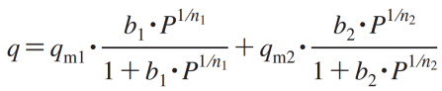 (2)
Here, P is the pressure of the bulk gas at equilibrium with the adsorbed phase (kPa), q is the adsorbed amount per mass of adsorbent (mol/kg), q_{m1} and q_{m2} are the saturation capacities of sites 1 and 2 (mol/kg), b₁ and b₂ are the affinity coefficients of sites 1 (1/kPa), and n₁ and n₂ represent the deviations from an ideal homogeneous surface. The R₂ values for all the fitted isotherms were over 0.99997. The adsorption selectivity for binary mixture
(3)
The separation performance in fixed bed adsorbers is dictated not only by selectivity, but also the uptake capacity. For this reason, a combined metric, called the separation potential, was introduced recently by Krishna.^{6, 7} This combined metric $Δq$, represents the maximum number of moles of pure component 2 (the less strongly adsdorbed species, C₂H₄ in this case) that can be recovered in the gas phase per kg of adsorbent in the fixed bed.
(4)
where $q_{1},q_{2}$ are the molar loadings (units: mol kg⁻¹) for mixture adsorption, calculated from the IAST.
Estimation of the adsorption heats was calculated by using Clausius- Clapeyron equation. Three different adsorption isotherms that were measured at different temperatures are needed for the analysis. This software enables analysis with two or three adsorption isotherms. $q_{st}$ at an adsorption amount can be calculated from the equation below with the difference between the 2 different pressures at the same adsorption amount (According to instruction of BEL master 7).
$q_{st}=\frac{RT_{1}T_{2}}{T_{2}-T_{1}}\left(\ln{P_{2}}-\ln{P_{1}}\right)$ (5)
Breakthrough measurements were collected on an automatic equipment that designed by Xuzhou North Gaorui Electronic Equipment Co., Ltd. The flow rates of all gases are regulated by mass flow controllers, and the effluent gas stream from the column is monitored by gas chromatography (GC) detector. The activated crystals (NTU-68a: 2.2189 g) were packed into a stainless-steel column (φ = 0.4 cm, L = 12 cm) tightly. Then, the column was swept with He flow until no other gases were detected in the effluent. Then, a mixture flow was dosed into the column. Breakpoints were determined when the first peak was detected. Breakthrough experiment of KAUST-7 (2.7112 g), Co-gallate (2.5999 g), ZIF-8 (0.4428 g), ZIF-67 (0.9174 g), NTU-65 (0.7723 g), HKUST-1 (0.5511 g), zeolite 5A (1.9545 g) and activated carbon (0.2841 g) were performed on the same column with same condition.
DFT Calculations. The diffusion properties of C₃H₆ and C₃H₈ in NTU67 were calculated using the CINEB method based on the spin polarized density functional theory (DFT).⁸ All calculations were performed through the Vienna Ab-initio Simulation Package (VASP).⁹ The projector augmented wavefunction (PAW) method¹⁰ was employed to describe the electron-core interactions. The Perdew-Burke-Ernzerhof (PBE) functional in a plane wave pseudopotential implementation within the generalized gradient approximation (GGA) was applied to detail with the electron exchange-correlation.¹¹ Grimme’s semi-empirical correction for the dispersion potential (DFT-D3) was applied to treat the long-range dispersion effect.¹² Plane wave cutoff energy of 600 eV was used for all the bulk cell models. The gamma point sampling in the Brillouin zone was used. The width of 0.1 eV was employed for Gaussian smearing. The convergence criteria for the norm of the force orthogonal to the path was less than 0.08 eV/Å for C₃H₆ and C₃H₈ for all the configurations.
The atomic positions and lattice parameters of NTU-68a primitive crystal cell were fully relaxed before CINEB calculation. The p(1×1×2) bulk cell including two cavities which can accommodate the gas molecules was used to study the diffuse of C₃H₆/C₃H₈. According to the single crystal structural analyses, several configurations of C₃H₆/C₃H₈ binding in NTU68 were built and geometrically optimized. The one whereas the C-C=C/C-C-C surface of C₃H₆/C₃H₈ molecule is parallel to the benzene ring shows the strongest binding of the gas molecule, and it was used as the starting point of the CINEB calculation.

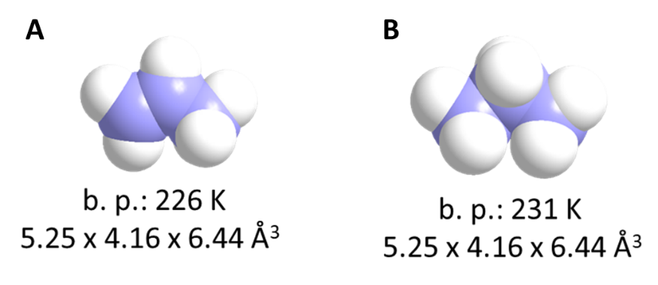

Fig. S1.
Molecular structures of (a) C₃H₆ and (b) C₃H₈.

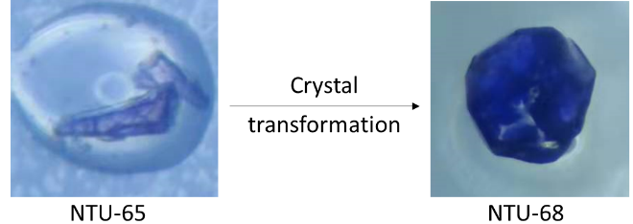

Fig. S2.
Optical photos of NTU-65 and NTU-68.

Fig. S3.
PXRD of as-synthesized and activated NTU-68.

Fig. S4.
IR spectra of ligand, NTU-65 and NTU-68.

Fig. S5.
TG plot of activated and as-synthesized NTU-68. The as-synthesized sample loses solvents between 30 to 130 °C followed by a platform from 135-270 °C. Then, the material decomposition starts above 280 °C.

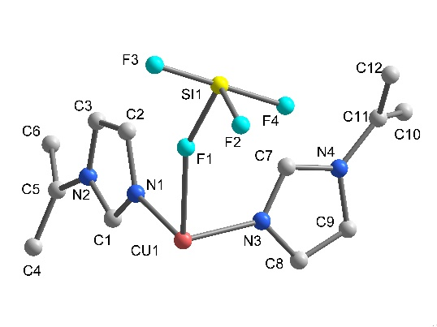

Fig. S6.
Asymmetric unit of NTU-68.

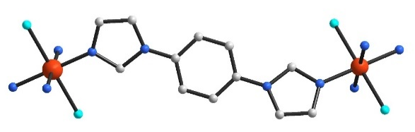

Fig. S7.
Ligand connection of NTU-68.

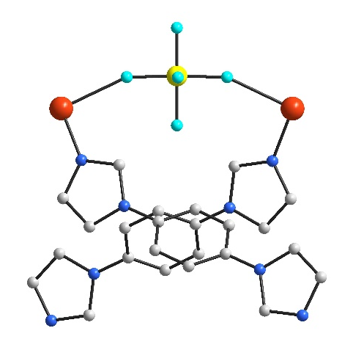

Fig. S8.
The connection of SiF6²⁻ in NTU-68.

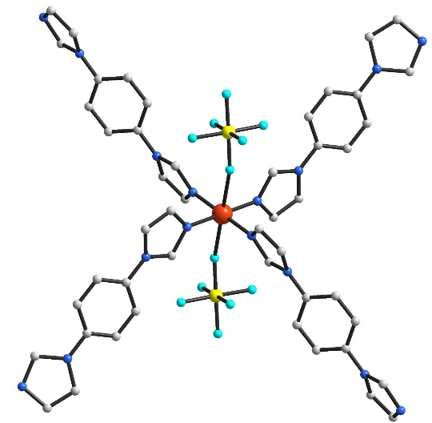

Fig. S9.
Coordination geometry of Cu²⁺ center of NTU-68.

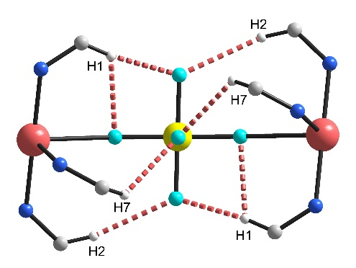

Fig. S10.
Involved hydrogen bonds around SiF6²⁻ in NTU-68.

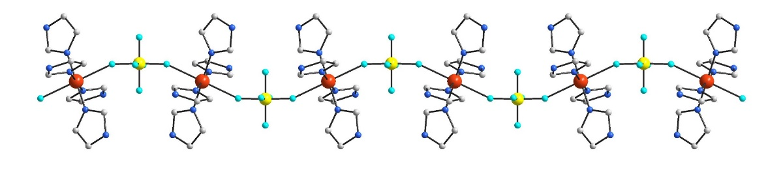

Fig. S11.
Rod packing of SiF6²⁻ and Cu²⁺ in NTU-68 along b-axis.

Fig. S12.
View of the formed rectangular motifs between L units and Cu atoms. This network corresponds to the typical cds topology.

Fig. S13.
View of the three interpenetrated cds networks.

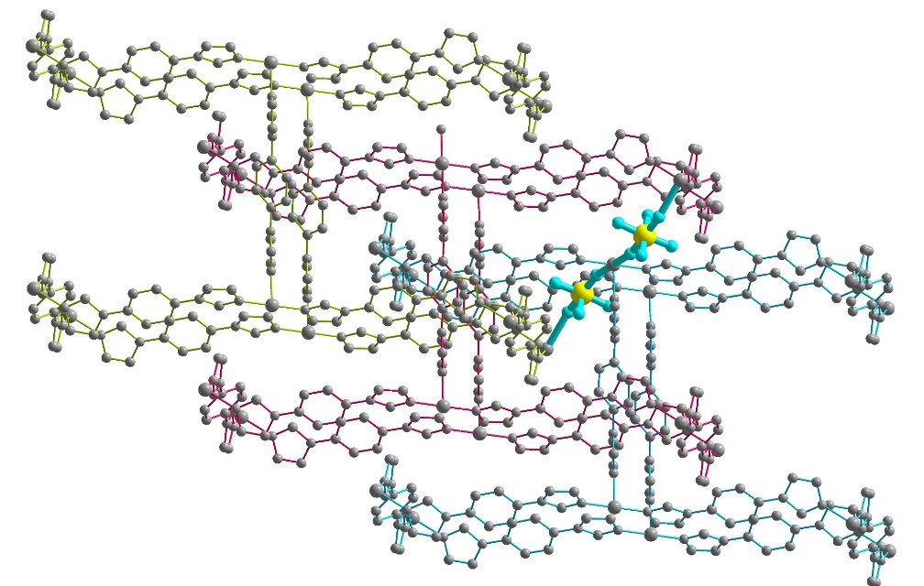

Fig. S14.
View of the three interpenetrated networks that connected by two coordinated SiF₆²⁻ ions.

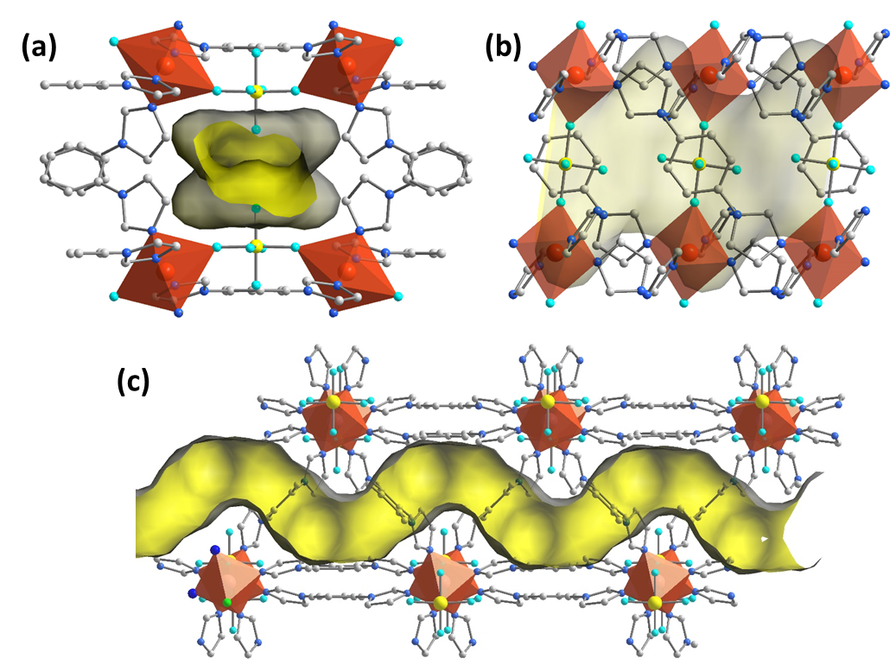

Fig. S15.
One dimensional accessible channel of NTU-68 along different directions (a-c), highlighted by yellow color.

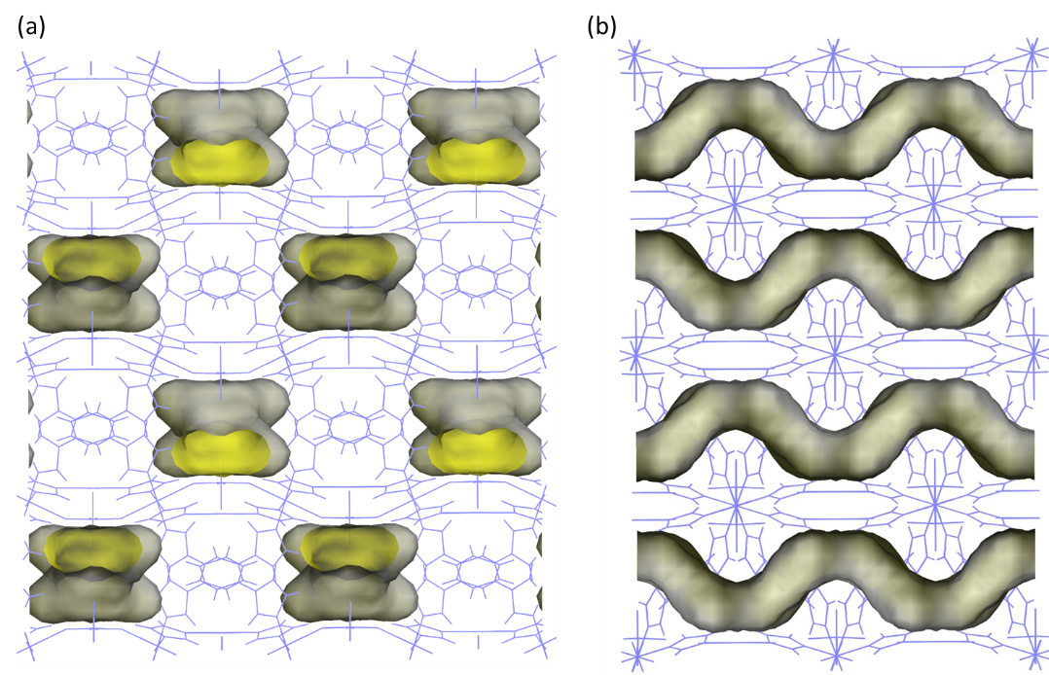

Fig. S16.
Packing viewing of the one dimensional accessible channel in NTU-68 along c- (a) and b-axis (b).
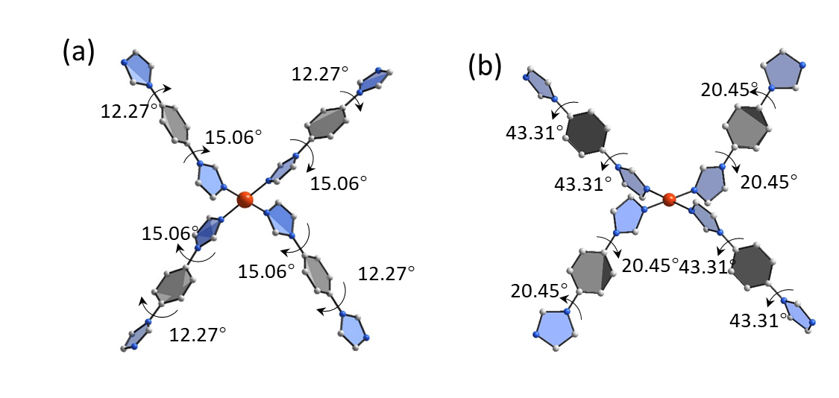

Fig. S17.
Ligand distortion of in NTU-65 (a) and NTU-68 (b). The four coordinated ligands around Cu center adopt same configuration in NTU-65, while the four ligands can be divided into two groups in NTU-68. Two ligands in para-position adopt trans-configurations and the other two adopt the cis-configuration. The torsion of dihedral angle between benzene ring and imidazole units become larger from 12.27-15.06° to 20.45-43.31°.
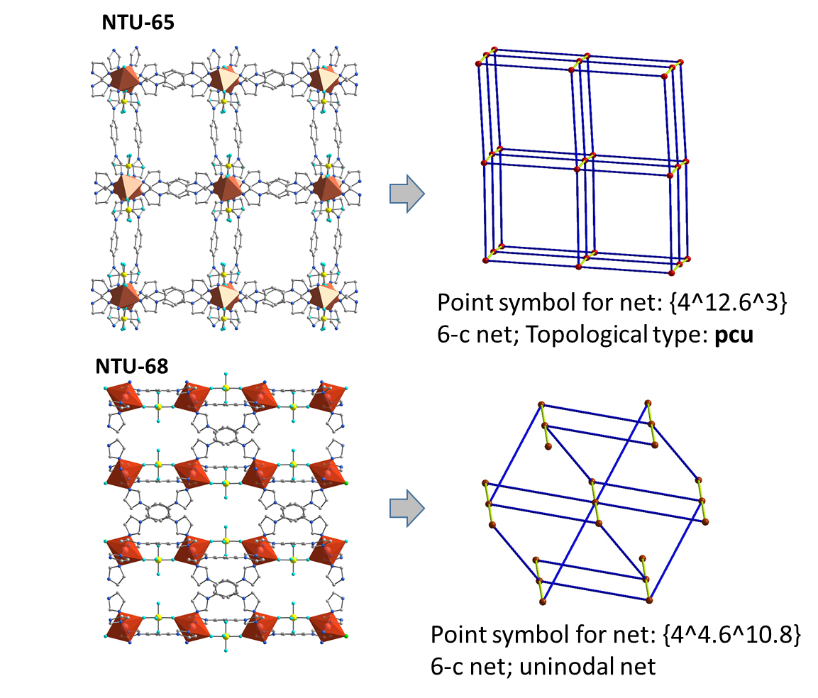

Fig. S18.
Structural and topological comparison of NTU-65 and NTU-68. A straight one-dimensional channel was observed in NTU-65, while a one-dimensional Zigzag channel was observed in NTU-68. The original pcu network transformed into a new topology with point symbol of {4⁴•6¹⁰•8}.

Fig. S19.
Cell length of NTU-68a at different temperatures. The b- and a-axes change linearly by +0.8% and -0.3% in the temperature range of 200-340 K, however, the c-axes shows an increase of +0.1% in the temperature range of 200-318 K and then a decrease of -0.1% in the temperature range of 318-340 K. In addition, the cell change is revisable once the temperature decrease to 200 K.

Fig. S20.
Angle β of the unit cell of NTU-68a at different temperatures.

Fig. S21.
The volume of the unit cell of NTU-68a at different temperatures.

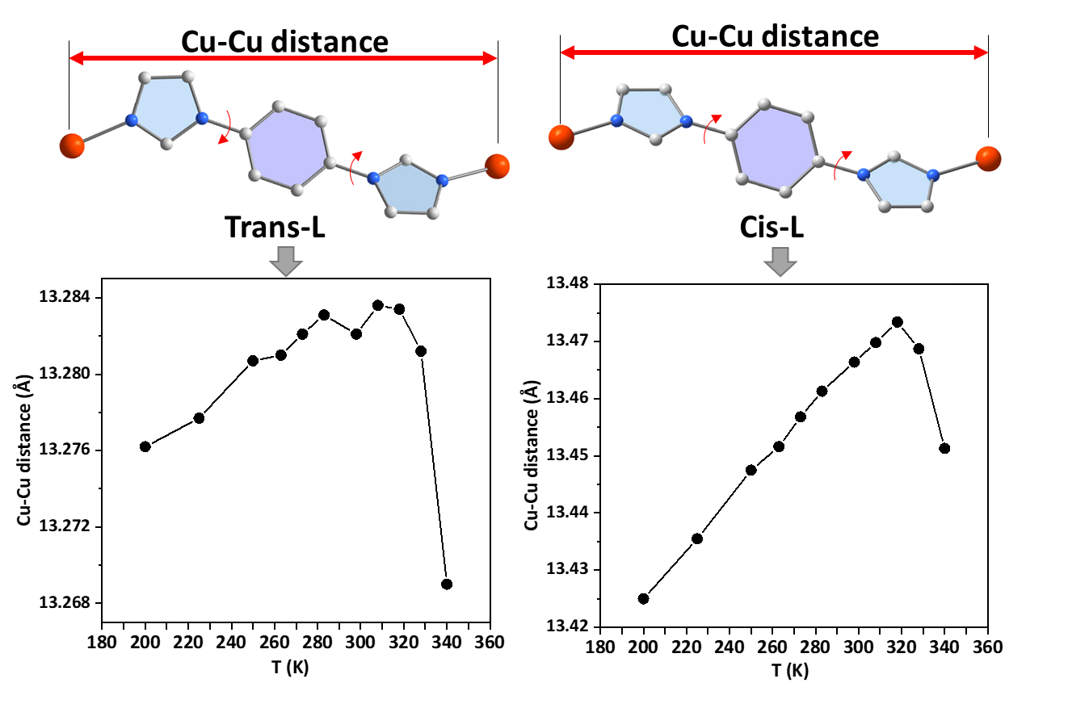

Fig. S22.
The varied Cu-Cu distance of NTU-68a at different temperatures.

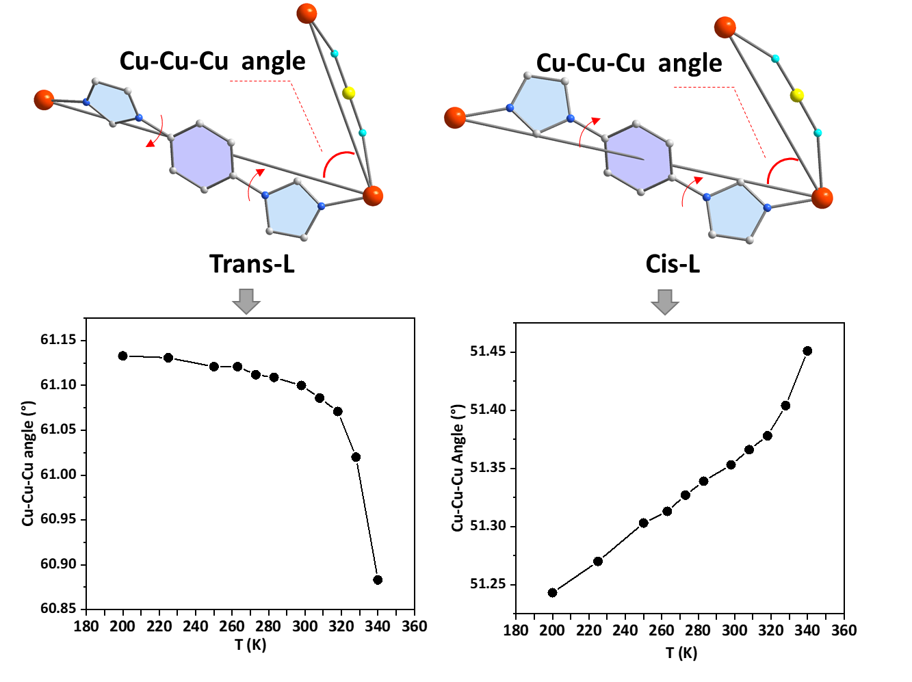

Fig. S23.
The varied Cu-Cu-Cu angle of NTU-68a at different temperatures.

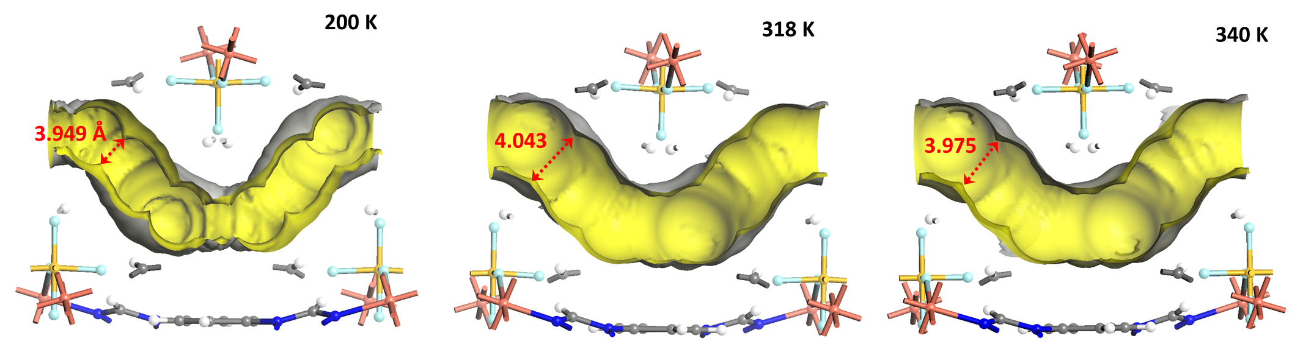

Fig. S24.
Comparison of the accessible inner surface the 1D channel and distance of face-to-face packed F-F atoms of NTU-68a at 200, 318 and 340 K.

Fig. S25.
In-situ PXRD NTU-68a at different temperature under vacuum. The [0 2 0] peak shifts to lower angle when the temperature raised from 200 to 318 K, showing pore expansion. However, the position of this peak turns back once the temperature reaching to 328 K or even higher (340 K).

Fig. S26.
N₂ and CO₂ adsorption isotherms of NTU-68a, plotted using a logarithmic scale.

Fig. S27.
CO₂ adsorption isotherms of NTU-68a at 298 K.

Fig. S28.
Fitting plot for BET calculation in NTU-68a, based on CO₂ isotherm at 298 K.

Fig. S29.
C₃H₆ adsorption-desorption isotherms of NTU-68a at different temperatures. Desorption hysteresis at 273 K is clear and which becomes smaller following the increased temperature.

Fig. S30.
C₃H₈ adsorption-desorption isotherms of NTU-68a at different temperatures. Desorption hysteresis can always be observed within these temperature ranges.

Fig. S31.
C₃H₆ adsorption-desorption isotherms of NTU-65 at different temperatures. Desorption hysteresis can always be observed within these temperature ranges.

Fig. S32.
C₃H₈ adsorption-desorption isotherms of NTU-65 at different temperatures. Desorption hysteresis is always observed at these temperature range.

Fig. S33.
C₃H₆ adsorption-desorption isotherms of Zeolite 5A at different temperatures.

Fig. S34.
C₃H₈ adsorption-desorption isotherms of Zeolite 5A at different temperatures.

Fig. S35.
C₃H₆ adsorption of KAUST-7 at different temperatures.

Fig. S36.
C₃H₈ adsorption of KAUST-7 at different temperatures.

Fig. S37.
C₃H₆ adsorption of Co-gallate at different temperatures.

Fig. S38.
C₃H₈ adsorption of Co-gallate at different temperatures.

Fig. S39.
C₃H₆ adsorption of ZIF-8 at different temperatures.

Fig. S40.
C₃H₈ adsorption of ZIF-8 at different temperatures.

Fig. S41.
C₃H₆ adsorption of ZIF-67 at different temperatures.

Fig. S42.
C₃H₈ adsorption of ZIF-67 at different temperatures.

Fig. S43.
C₃H₆ adsorption of HKUST-1 at different temperatures.

Fig. S44.
C₃H₈ adsorption of HKUST-1 at different temperatures.

Fig. S45.
C₃H₆ adsorption of Carbon at different temperatures.

Fig. S46.
C₃H₈ adsorption of Carbon at different temperatures.

Fig. S46.
Curves fitting of C₃H₆ and C₃H₈ gas adsorption isotherms for NTU-68a at 273 K.

Fig. S48.
Curves fitting of C₃H₆ and C₃H₈ gas adsorption isotherms for NTU-68a at 283 K.

Fig. S49.
Curves fitting of C₃H₆ and C₃H₈ gas adsorption isotherms for NTU-68a at 298 K.

Fig. S50.
Curves fitting of C₃H₆ and C₃H₈ gas adsorption isotherms for NTU-68a at 308 K.

Fig. S51.
IAST selectivity of C₃H₆ and C₃H₈ for NTU-68a at different temperatures. They are all sensitive to pressure. The higher pressure, the higher selectivity. Basically, the selectivity calculation based on the type-I isotherms is rational, however, the diffusional effect of C₃H₈ over-rides the influence of mixture adsorption equilibrium. Therefore, the values at 273 and 283 K cannot evaluate the selectivity in precise manner, but they deliver the sieving potential.

Fig. S52.
Curves fitting of C₃H₆ and C₃H₈ gas adsorption isotherms for NTU-65 at 298 K.

Fig. S53.
IAST selectivity of C₃H₆ and C₃H₈ for NTU-65 at 298 K.

Fig. S54.
Curves fitting of C₃H₆ and C₃H₈ gas adsorption isotherms for Zeolite 5A at 298 K.

Fig. S55.
IAST selectivity of C₃H₆ and C₃H₈ for Zeolite 5A at 298 K.

Fig. S56.
C₂H₄ adsorption-desorption isotherms of NTU-68a at different temperatures.

Fig. S57.
C₂H₆ adsorption-desorption isotherms of NTU-68a at different temperatures, plotted by linear (a) and logarithmic (b) scale. Due to relative smaller molecular size (vs C₃H₈), the lower pressure C₂H₆ adsorptions show a thermodynamic regulated behavior, whereas the kinetic dominated adsorption was observed at higher pressure.

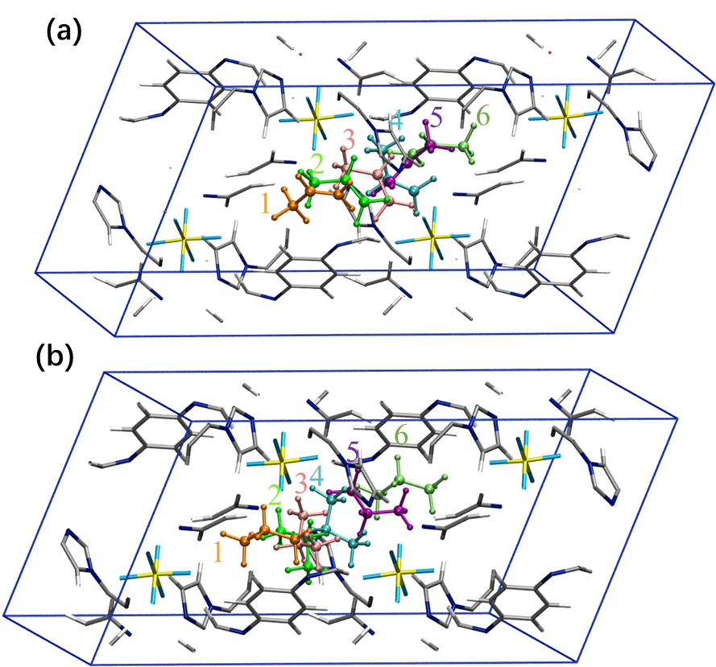

Fig. S58.
C₃H₆ (a) and C₃H₈ (b) diffusion pathways calculated using the CINEB method. The gas molecules at different diffusion positions are represented using the ball and stick style with orange, green, pink, cyan, purple and lime colors, respectively. NTU-68a crystal is represented using the stick style: the grey, white, blue, light cyan, yellow and red stand for C, H, N, F, Si and Cu, respectively.

Fig. S59.
Isosteric enthalpy of C₃H₆ in NTU-68a.

Fig. S60.
The R² value for isotherms fitting with experimental data (298, 308 and 323 K) during adsorption heat calculation of NTU-68a.

Fig. S61.
Local view of the gas-loaded structures that collected at 298 K: NTU-68a⊃C₃H₆ (a) and NTU-68a⊃C₃H₈ (b). Four hydrogen bonds with distance of 2.368-2.991 Å was observed for C₃H₆, while, six hydrogen bonds with relative shorter distance of 1.597-2.812 Å was observed for C₃H₈. The high number and short distance reflect much stronger host-C₃H₈ interaction than that of host-C₃H_{6.} For clearly, the CuL framework was omitted. Color code: light cyan: F, yellow: Si. C₃H₆ and C₃H₈ was highlighted by pink and green, respectively.

.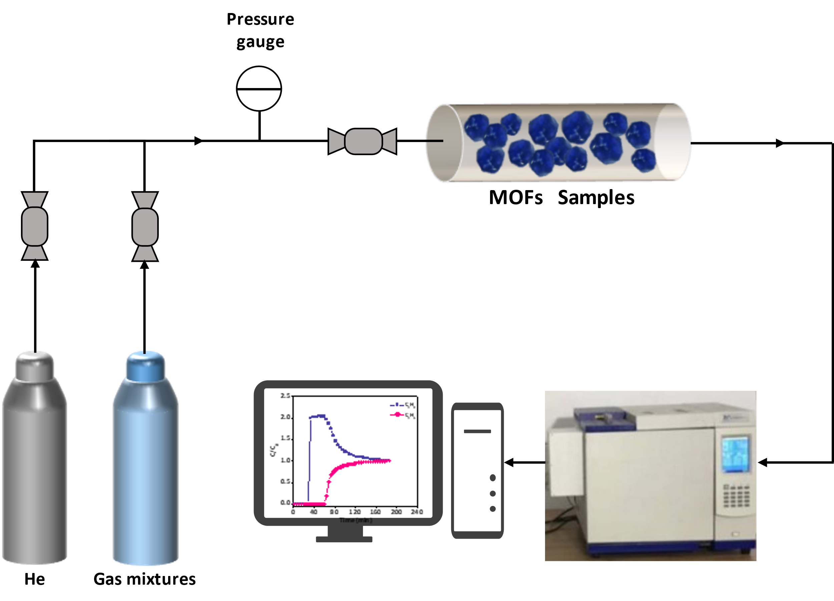

Fig. S62.
Schematic illustration of the apparatus for the breakthrough experiments.

Fig. S63.
Experimental breakthrough of NTU-68a (2.2189 g) for the separation of C₃H₆/C₃H₈ (1/1, v/v) at different temperatures and 1 bar, and the total gas velocity is 1 mL·min⁻¹. Desorption was performed at 393 K under high vacuum, and continued for 2 h.

Fig. S64.
Experimental breakthrough of NTU-65 (0.7723 g) for the separation of C₃H₆/C₃H₈ (1/1, v/v) at different temperatures and 1 bar, and the total gas velocity is 1 mL·min⁻¹. Desorption was performed at 393 K under high vacuum, and continued for 2h.

Fig. S65.
Experimental breakthrough of KAUST-7 (2.7112 g) for the separation of C₃H₆/C₃H₈ (1/1, v/v) at different temperatures and 1 bar, and the total gas velocity is 1 mL·min⁻¹. Desorption was performed at 418 K under high vacuum, and continued for 3 h.

Fig. S66.
Experimental breakthrough of Co-gallate (2.5999 g) for the separation of C₃H₆/C₃H₈ (1/1, v/v) at different temperatures and 1 bar, and the total gas velocity is 1 mL·min⁻¹. Desorption was performed at 393 K under high vacuum, and continued for 2 h.

Fig. S67.
Experimental breakthrough of ZIF-8 (0.4428 g) for the separation of C₃H₆/C₃H₈ (1/1, v/v) at different temperatures and 1 bar, and the total gas velocity is 1 mL·min⁻¹. Desorption was performed at 423 K under high vacuum, and continued for 3h.

Fig. S68.
Experimental breakthrough of ZIF-67 (0.9174 g) for the separation of C₃H₆/C₃H₈ (1/1, v/v) at different temperatures and 1 bar, and the total gas velocity is 1 mL·min⁻¹. Desorption was performed at 393 K under high vacuum, and continued for 2 h.

Fig. S69.
Experimental breakthrough of HKUST-1 (0.5511 g) for the separation of C₃H₆/C₃H₈ (1/1, v/v) at different temperatures and 1 bar, and the total gas velocity is 1 mL·min⁻¹. Desorption was performed at 423 K under high vacuum, and continued for 3 h.

Fig. S70.
Experimental breakthrough of 5A-Zeolite (1.9545 g) for the separation of C₃H₆/C₃H₈ (1/1, v/v) at different temperatures and 1 bar, and the total gas velocity is 1 mL·min⁻¹. Desorption was performed at 573 K under high vacuum, and continued for 3 h. Although slightly longer separation time was observed here, the significant high temperature for sample regeneration indicates much higher energy consumption.

Fig. S71.
Experimental breakthrough of Carbon (0.2841 g) for the separation of C₃H₆/C₃H₈ (1/1, v/v) at different temperatures and 1 bar, and the total gas velocity is 1 mL·min⁻¹. Desorption was performed at 473 K under high vacuum, and continued for 3 h.

Fig. S72.
Summary of the C₃H₆/C₃H₈ separation for various PCPs, zeolite and activated carbon at different temperatures. The retain time was normalized to 1g according to corresponding sample weight. The unit of the retain time is min·g⁻¹.

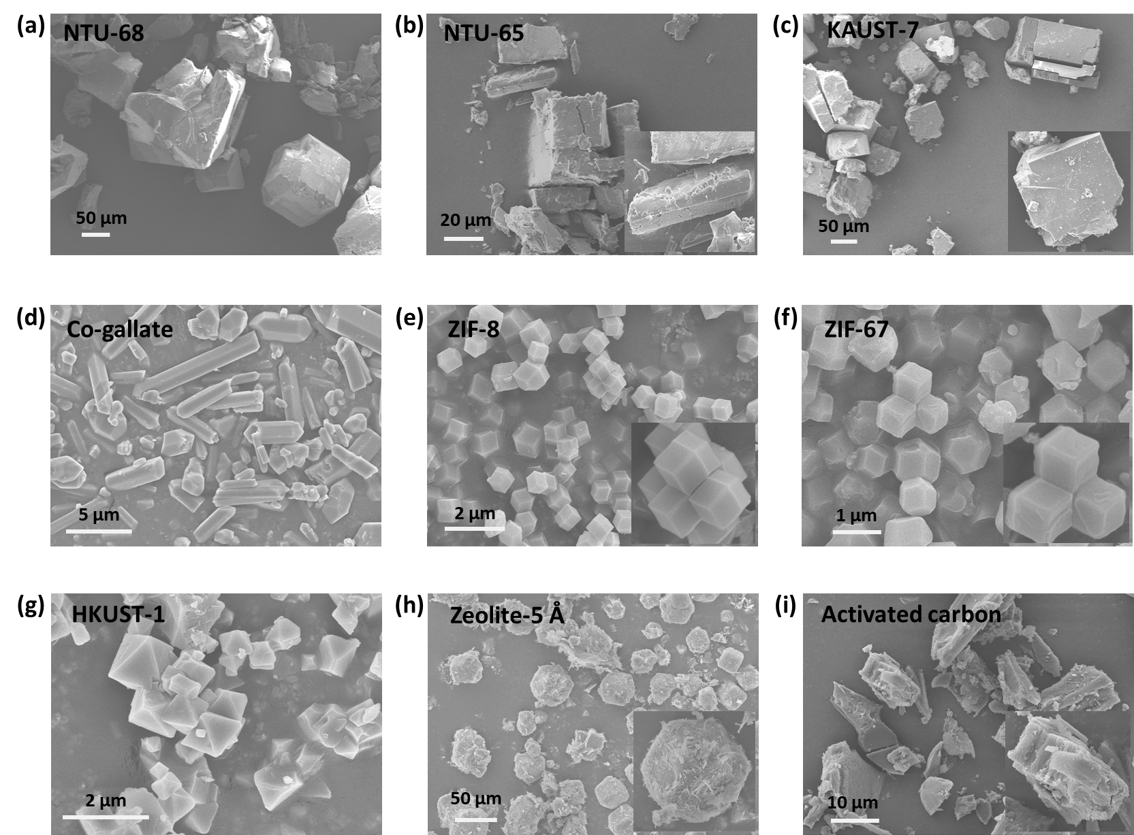

Fig. S73.
SEM images of the porous materials.

Fig. S74.
In-situ PXRD NTU-68a under the C₃H₆ atmosphere (1 bar) at different temperatures.

Fig. S75.
In-situ PXRD NTU-68a under the C₃H₈ atmosphere (1 bar) at different temperatures.

Fig. S76.
The [-1 1 1] face of NTU-68. Shifting of this face corresponds to the distortion of the ligand, highlight by blue.

Fig. S77.
The [0 2 0] face of NTU-68. Shifting of this face corresponds to the expansion or contraction of this channel.

Fig. S78.
The desorption curves of NTU-68a obtained by He purging of C₃H₆/C₃H₈ (1/1, v/v) at 298 K.

Fig. S79.
The outlet concentration of C₃H₆ of NTU-68a at 298 K.

Fig. S80.
Ten cycling breakthrough curves of C₃H₆/C₃H₈ (1/1, v/v, 1 mL min⁻¹) on NTU-68a at 298 K, 1 bar.

Fig. S81.
Breakthrough curves of wet C₃H₆/C₃H₈ (1/1, v/v, 1 mL min⁻¹) on NTU-68a at 298 K, 1 bar.

Fig. S82.
PXRD patterns of water and moisture treated NTU-68.

Fig. S83.
CO₂ adsorption and desorption isotherms at 298K of water and moisture treated NTU-68.

Fig. S84.
PXRD of NTU-65.

Fig. S85.
PXRD of KAUST-7.

Fig. S86.
PXRD of Co-gallate.

Fig. S87.
PXRD of ZIF-8.

Fig. S88.
PXRD of ZIF-67.

Fig. S89.
PXRD of HKUST-1.

Table S1.
Crystal data and structure refinement of NTU-68 structures.
 | As-synthesized | NTU-68a with C₃H₆ | NTU-68a with C₃H₈ | NTU-68a under varied temperature
T (K) | 298 | 298 | 298 | 200 | 225 | 250 | 260 | 273 | 283 | 298 | 308 | 318 | 328 | 340
Formula | C₂₄H₂₀CuF₆N₈Si | C₂₄H₂₀CuF₆N₈Si, 2(C₃H₆) | C₂₄H₂₀CuF₆N₈Si, 0.666(C₃H₈) | C₂₄H₂₀CuF₆N₈Si | C₂₄H₂₀CuF₆N₈Si | C₂₄H₂₀CuF₆N₈Si | C₂₄H₂₀CuF₆N₈Si | C₂₄H₂₀CuF₆N₈Si | C₂₄H₂₀CuF₆N₈Si | C₂₄H₂₀CuF₆N₈Si | C₂₄H₂₀CuF₆N₈Si | C₂₄H₂₀CuF₆N₈Si | C₂₄H₂₀CuF₆N₈Si | C₂₄H₂₀CuF₆N₈Si
Formula weight | 626.12 | 710.26 | 655.49 | 626.12 | 626.12 | 626.12 | 626.12 | 626.12 | 626.12 | 626.12 | 626.12 | 626.12 | 626.12 | 626.12
Crystal system | Monoclinic | Monoclinic | Monoclinic | Monoclinic | Monoclinic | Monoclinic | Monoclinic | Monoclinic | Monoclinic | Monoclinic | Monoclinic | Monoclinic | Monoclinic | Monoclinic
Space group | I2/c | I2/c | I2/c | I2/c | I2/c | I2/c | I2/c | I2/c | I2/c | I2/c | I2/c | I2/c | I2/c | I2/c
a (Å) | 11.6595(13) | 11.6267(7) | 11.6259(7) | 11.7023(10) | 11.7034(9) | 11.7048(8) | 11.7051(8) | 11.7049(8) | 11.7055(8) | 11.7035(8) | 11.7029(8) | 11.7010(8) | 11.6920(9) | 11.6631(10)
b (Å) | 17.5270(2) | 17.5415(11) | 17.5398(10) | 17.4132(14) | 17.4417(14) | 17.4746(12) | 17.4858(12) | 17.5006(12) | 17.5127(13) | 17.5285(13) | 17.5396(13) | 17.5516(13) | 17.5555(14) | 17.5583(14)
c (Å) | 15.5516(16) | 15.5668(10) | 15.5802(9) | 15.4786(18) | 15.4816(12) | 15.4861(15) | 15.4870(15) | 15.4895(15) | 15.4910(15) | 15.4927(15) | 15.4949(16) | 15.4968(16) | 15.4921(17) | 15.4813(18)
β(°) | 96.416(7) | 96.244(4) | 96.327(4) | 96.525(2) | 96.526(5) | 96.519(2) | 96.521(2) | 96.515(2) | 96.514(2) | 96.512(2) | 96.500(2) | 96.492(2) | 96.439(2) | 96.321(2)
V (Å³) | 3158.2(6) | 3156.0(3) | 3165.0(4) | 3133.7(5) | 3139.7(4) | 3147.0(4) | 3149.3(4) | 3152.4(4) | 3155.1(4) | 3157.7(4) | 3160.1(5) | 3162.2(5) | 3159.8(5) | 3151.1(5)
Z | 4 | 4 | 4 | 4 | 4 | 4 | 4 | 4 | 4 | 4 | 4 | 4 | 4 | 4
Density (g/cm³) | 1.317 | 1.495 | 1.376 | 1.327 | 1.325 | 1.321 | 1.321 | 1.319 | 1.318 | 1.317 | 1.316 | 1.315 | 1.316 | 1.320
Mu (mm⁻¹) | 0.791 | 0.801 | 0.792 | 0.797 | 0.796 | 0.794 | 0.793 | 0.792 | 0.792 | 0.791 | 0.790 | 0.790 | 0.790 | 0.793
F ₍₀₀₀₎ | 1268 | 1460 | 1337 | 1268 | 1268 | 1268 | 1268 | 1268 | 1268 | 1268 | 1268 | 1268 | 1268 | 1268
Index ranges | -13 ≤ h ≤ 13 | -13≤ h ≤ 13 | -13 ≤ h ≤ 13 | 13 ≤ h ≤ 13 | 15 ≤ h ≤ 15 | 13 ≤ h ≤ 13 | 13 ≤ h ≤ 13 | 15 ≤ h ≤ 15 | 13 ≤ h ≤ 13 | 13 ≤ h ≤ 13 | 13 ≤ h ≤ 13 | 13 ≤ h ≤ 13 | 13 ≤ h ≤ 13 | 13 ≤ h ≤ 13
Index ranges | -20 ≤ k ≤ 20 | -20 ≤ k ≤ 20 | -20 ≤ k ≤ 19 | 20 ≤ k ≤ 20 | 22 ≤ k ≤ 22 | 20 ≤ k ≤ 20 | 20 ≤ k ≤ 20 | 22 ≤ k ≤ 22 | 20 ≤ k ≤ 20 | 20 ≤ k ≤ 20 | 20 ≤ k ≤ 20 | 20 ≤ k ≤ 20 | 20 ≤ k ≤ 20 | 20 ≤ k ≤ 20
Index ranges | -18 ≤ l ≤ 16 | -17 ≤ l ≤ 18 | -18 ≤ l ≤ 17 | 18 ≤ l ≤ 18 | 20 ≤ l ≤ 20 | 18 ≤ l ≤ 18 | 18 ≤ l ≤ 18 | 20 ≤ l ≤ 20 | 18 ≤ l ≤ 18 | 18 ≤ l ≤ 18 | 18 ≤ l ≤ 18 | 18 ≤ l ≤ 18 | 18 ≤ l ≤ 18 | 18 ≤ l ≤ 18
Tot, Uniq Data, R(int) | 11184, 2786,  0.041 | 11176, 2771,  0.022 | 11058, 2727,  0.081 | 27157,  2773,  0.083 | 32689,  3631,  0.091 | 34934,  2658,  0.078 | 36376,  2793,  0.080 | 43947,  3641,  0.091 | 35047,  2665,  0.078 | 36571,  2802,  0.081 | 36503,  2793,  0.084 | 36302,  2807,  0.082 | 39437,  2807,  0.081 | 39514,  2799,  0.082
Observed data [I > 2σ (I)] | 2139 | 2431 | 2297 | 2389 | 2903 | 2295 | 2399 | 2935 | 2301 | 2393 | 2369 | 2379 | 2379 | 2372
Nref, Npar | 2786, 184 | 2771, 235 | 2727, 215 | 2773, 184 | 3631, 184 | 2658, 184 | 2793, 184 | 3641, 184 | 2665, 184 | 2802, 184 | 2793, 184 | 2807, 184 | 2807, 184 | 2799, 184
R₁, | 0.0596 | 0.0523 | 0.0661 | 0.0876 | 0.0707 | 0.0729 | 0.0867 | 0.0757 | 0.0927 | 0.0742 | 0.0766 | 0.0935 | 0.0624 | 0.0893
wR_{2a} [I>2σ(I)] | 0.1640 | 0.1430 | 0.2120 | 0.2264 | 0.2643 | 0.2497 | 0.2278 | 0.2710 | 0.2320 | 0.1960 | 0.2060 | 0.2334 | 0.1809 | 0.2475
GOOF | 1.08 | 1.01 | 1.07 | 1.06 | 1.07 | 1.09 | 1.07 | 1.09 | 1.09 | 1.01 | 1.06 | 1.02 | 1.08 | 1.07

R₁ = Σ||Fo| − |Fc||/|Fo|; wR₂ = [Σw(ΣFo² − Fc²)²/Σw(Fo²)²]^{1/2}

Table S2.
Uptake ratio of C₃H₆ and C₃H₈ at 1 bar of series of porous materials.

Materials | 273 K | 283 K | 298 K | 308 K
NTU-68 | 58.52 | 7.78 | 4.00 | 3.36
Co-gallate | 9.57 | 10.98 | 8.99 | 10.81
KAUST-7 | 1.77 | 2.03 | 3.47 | 4.16
NTU-65 | 1.52 | 1.58 | 2.79 | 1.02
ZIF-8 | 1.08 | 1.07 | 1.03 | 1.04
ZIF-67 | 1.08 | 1.08 | 1.04 | 1.08
HKUST-1 | 1.10 | 1.07 | 1.11 | 1.06
Activated carbon | 1.07 | 1.06 | 1.09 | 1.04
Zeolite 5A | 1.14 | 1.15 | 1.18 | 1.21
Note: All values were calculated based on the isotherms that collected in this work.

Table S3.
Summary of the C₃H₆/C₃H₈ uptake ratio, selectivities and Q_{st} for C₃H₆, in various porous materials.
Materials | T  (K) | P  (bar) | IAST  selectivity  (50/50) | Q_{st} of  C₃H₆  (kJ·mol⁻¹) | References
NTU-65 | 298 | 1 | 1.9 | 32 | ¹
KAUST-7 | 298 | 1 | 594 | 57.4 | ³
Co-gallate | 298 | 1 | 333 | 41 | ⁴
ZIF-8 | 303 | 1 | 125 | / | ⁶
JNU-3a | 303 | 1 | 513 | 29.3 | ¹³
NTU-85-WNT | 298 | 1 | 1570.3 | 49.9 | ¹⁴
HIAM-301 | 298 | 1 | 150 | 27.0 | ¹⁵
HIAM-402 | 298 | 1 | 1.43 | 31.2 | ¹⁶
Fe₂(m-dobdc) | 298 | 1 | > 55 | 65 | ¹⁷
ITQ-12 | 303 | 1 | 15 | / | ¹⁸
MAF-23-O | 298 | 1 | 8.8 | 78.0 | ¹⁹
NJU-Bai8 | 298 | 1 | 4.6 | / | ²⁰
ZJU-75a | 296 | 1 | 54.2 | 65.9 | ²¹
HOF-FJU-1 | 298 | 1 | 14.4 | 32.4 | ²²
SIFSIX-2-Cu-i | 298 | 1 | 4.5 | 35.82 | ²³
GeFSIX-2-Cu-i | 298 | 1 | 4.0 | 36.25 | ²³
NTU-68a | 298 | 1 | 2030 | 42.8 | This work

References
1. Dong Q, Zhang X, Liu S, Lin RB, Guo Y, Ma Y, et al. Tuning Gate-Opening of a Flexible Metal-Organic Framework for Ternary Gas Sieving Separation. Angew Chem Int Ed 2020, 59(50): 22756-22762.
2. Dong QB, Huang YH, Hyeon-Deuk K, Chang IY, Wan JM, Chen CL, et al. Shape- and Size-Dependent Kinetic Ethylene Sieving from a Ternary Mixture by a Trap-and-Flow Channel Crystal. Adv Funct Mater 2022, 32: 2203745-2203755.
3. Cadiau A, Adil K, Bhatt PM, Belmabkhout Y, Eddaoudi M. A metal-organic framework-based splitter for separating propylene from propane. Science 2016, 353(6295): 137-140.
4. Liang B, Zhang X, Xie Y, Lin RB, Krishna R, Cui H, et al. An Ultramicroporous Metal-Organic Framework for High Sieving Separation of Propylene from Propane. J Am Chem Soc 2020, 142(41): 17795-17801.
5. Du HQ, Bai JF, Zuo CY, Xin ZF, Hu JB. A hierarchical supra-nanostructure of HKUST-1 featuring enhanced H(2) adsorption enthalpy and higher mesoporosity. CrystEngComm 2011, 13(10): 3314-3316.
6. Wang B, Cote AP, Furukawa H, O'Keeffe M, Yaghi OM. Colossal cages in zeolitic imidazolate frameworks as selective carbon dioxide reservoirs. Nature 2008, 453(7192): 207-U206.
7. Sheldrick GM. A short history of SHELX. Acta Crystallogr Sec A 2008, 64: 112-122.
8. Henkelman G, Uberuaga BP, Jonsson H. A climbing image nudged elastic band method for finding saddle points and minimum energy paths. J Chem Phys 2000, 113(22): 9901-9904.
9. Kresse G, Furthmuller J. Efficient iterative schemes for ab initio total-energy calculations using a plane-wave basis set. Phys Rev B 1996, 54(16): 11169-11186.
10. Kresse G, Joubert D. From ultrasoft pseudopotentials to the projector augmented-wave method. Phys Rev B 1999, 59(3): 1758-1775.
11. Perdew JP, Burke K, Ernzerhof M. Generalized gradient approximation made simple. Phys Rev Lett 1996, 77(18): 3865-3868.
12. Grimme S, Ehrlich S, Goerigk L. Effect of the Damping Function in Dispersion Corrected Density Functional Theory. J Comput Chem 2011, 32(7): 1456-1465.
13. Zeng H, Xie M, Wang T, Wei R-J, Xie X-J, Zhao Y, et al. Orthogonal-array dynamic molecular sieving of propylene/propane mixtures. Nature 2021, 595(7868): 542-548.
14. Dong Q, Huang Y, Wan J, Lu Z, Wang Z, Gu C, et al. Confining Water Nanotubes in a Cu(10)O(13)-Based Metal-Organic Framework for Propylene/Propane Separation with Record-High Selectivity. J Am Chem Soc 2023, 145(14): 8043-8051.
15. Yu L, Han X, Wang H, Ullah S, Xia Q, Li W, et al. Pore Distortion in a Metal–Organic Framework for Regulated Separation of Propane and Propylene. J Am Chem Soc 2021, 143(46): 19300-19305.
16. Li X, Liu J, Zhou K, Ullah S, Wang H, Zou J, et al. Tuning Metal–Organic Framework (MOF) Topology by Regulating Ligand and Secondary Building Unit (SBU) Geometry: Structures Built on 8-Connected M6 (M = Zr, Y) Clusters and a Flexible Tetracarboxylate for Propane-Selective Propane/Propylene Separation. J Am Chem Soc 2022, 144(47): 21702-21709.
17. Bachman JE, Kapelewski MT, Reed DA, Gonzalez MI, Long JR. M₂(m-dobdc) (M = Mn, Fe, Co, Ni) Metal–Organic Frameworks as Highly Selective, High-Capacity Adsorbents for Olefin/Paraffin Separations. J Am Chem Soc 2017, 139(43): 15363-15370.

18. Gutiérrez-Sevillano JJ, Dubbeldam D, Rey F, Valencia S, Palomino M, Martín-Calvo A, et al. Analysis of the ITQ-12 Zeolite Performance in Propane−Propylene Separations Using a Combination of Experiments and Molecular Simulations. J Phy Chem C 2010, 114(35): 14907-14914.
19. Wang Y, Huang N-Y, Zhang X-W, He H, Huang R-K, Ye Z-M, et al. Selective Aerobic Oxidation of a Metal–Organic Framework Boosts Thermodynamic and Kinetic Propylene/Propane Selectivity. Angew Chem Int Ed 2019, 58(23): 7692-7696.
20. Wang X, Krishna R, Li L, Wang B, He T, Zhang Y-Z, et al. Guest-dependent pressure induced gate-opening effect enables effective separation of propene and propane in a flexible MOF. Chem Eng J 2018, 346: 489-496.
21. Liu D, Pei J, Zhang X, Gu X-W, Wen H-M, Chen B, et al. Scalable Green Synthesis of Robust Ultra-Microporous Hofmann Clathrate Material with Record C3H6 Storage Density for Efficient C3H6/C3H8 Separation. Angew Chem Int Ed 2023, 62(12): e202218590.
22. Chen Y, Yang Y, Wang Y, Xiong Q, Yang J, Xiang S, et al. Ultramicroporous Hydrogen-Bonded Organic Framework Material with a Thermoregulatory Gating Effect for Record Propylene Separation. J Am Chem Soc 2022, 144(37): 17033-17040.
23. Wang X, Zhang P, Zhang Z, Yang L, Ding Q, Cui X, et al. Efficient Separation of Propene and Propane Using Anion-Pillared Metal–Organic Frameworks. Indus Eng Chem Res 2020, 59(8): 3531-3537.

