Supplementary Material

Decreased interleukin-17RA expression is associated with good prognosis in patients with colorectal cancer and inhibits tumor growth and vascularity in mice
Jeng-Kai Jiang, Chi-Hung Lin, Ting-An Chang, Liang-Chuan Lo, Chien-Ping Lin, Ruey-Hwa Lu, Chih-Yung Yang

Supplementary Figure 1: Characterization of IL-17RA knockdown CT-26 cells. (A) IL-17RA expression was examined using qRT-PCR in IL-17RA knockdown and control CT-26 cells. (B) MTT assay showed that IL-17RA knockdown suppressed tumor cell growth in vitro. (C) IL-17RA knockdown had no significant effect on cell cycle compared to control CT-26 cells.

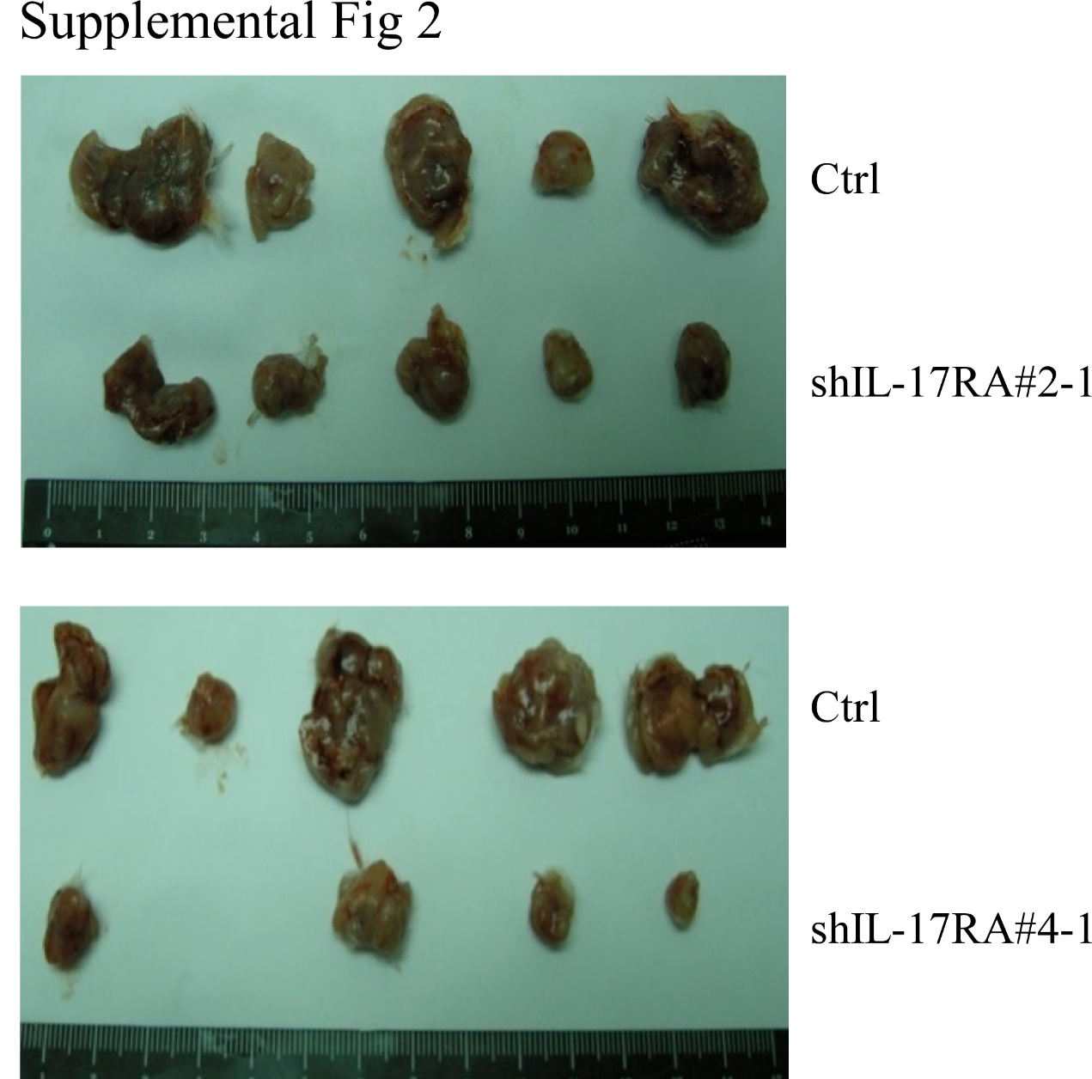

Supplementary Figure 2: Tumor masses from control shGFP tumors and shIL-17RA tumors.

