Supplementary Material: Vairo et al. Temporal and small-scale spatial variation in distribution, abundance, and reproduction of Australian hijiki analogues in southwest Victoria.

Supp. Table 1 Mean ± SEM values of environmental parameters for a) Oigles and b) Pea Soup study sites in Port Fairy, Victoria, Australia. Superscript letters represent the results of one-way ANOVAs and Tukey’s HSD pairwise comparisons for each dependent variables over time at each site, where significant differences (P < 0.05) are indicated by different letters.
Season | Salinity  (ppt) | Water Temperature (°C) | Dissolved Oxygen  (%) | Air Temperature* (°C) | Solar Exposure* (MJ·m⁻²)
a) Oigles |  |  |  | Port Fairy station 090175
Spring | 34.95 ± 0.05ª | 17.43 ± 0.18^{b} | 121.88 ± 4.19ª | 17.80 ± 0.71^{c} | 17.67 ± 2.26^{bc}
Summer | 35.03 ± 0.03ª | 19.98 ± 0.36^{b} | 122.75 ± 8.11ª | 21.57 ± 0.67^{b} | 22.70 ± 1.42^{b}
Autumn | 34.95 ± 0.05ª | 15.6 ± 0.30ª | 107.70 ± 19.20ª | 19.33 ± 1.19^{bc} | 11.10 ± 1.85^{c}
Winter | n.d. | n.d. | n.d. | 14.53 ± 0.39^{ac} | 8.47 ± 1.01^{ac}
b) Pea Soup
Spring | 32.37 ± 0.19ª | 17.33 ± 0.60^{b} | 103.67 ± 1.76^{bc}
Summer | 33.77 ± 0.39^{ac} | 21.90 ± 1.05^{cd} | 131.33 ± 6.39^{c}
Autumn | 35.27 ± 0.12^{bc} | 19.43 ± 0.28^{bd} | 157.67 ± 10.90ª
Winter | 34.37 ± 0.49^{bc} | 13.23 ± 0.20ª | 117.33 ± 7.22^{b}
*Air Temperature and Solar Exposure data are means ± SE of monthly averages derived from BOM weather station 090175 in Port Fairy, Victoria (http://www.bom.gov.au/climate/data/) for spring 2021 to winter 2022.

Supp. Table 2 Summary results of linear regression analyses between standing stock phenology and reproduction of Cystophora torulosa and Caulocystis uvifera with environmental parameters at Oigles and Peas Soup, respectively. Bold text indicates significant p-values and associated r- and r²-values.
 |  | Cystophora torulosa |  |  |  |  |  | Caulocystis uvifera
Dependent variable | Predictor variable | df | F | P | r | r² |  | df | F | P | r | r²
Length | Salinity | 1,33 | 0.616 | 0.438 | 0.135 | 0.018 |  | 1, 56 | 76.848 | <0.001 | -0.761 | 0.578
Length | Water temperature | 1,33 | 1.029 | 0.318 | 0.174 | 0.03 |  | 1, 56 | <0.001 | 0.984 | 0.003 | <0.001
Length | Dissolved oxygen | 1,33 | 0.972 | 0.331 | 0.169 | 0.029 |  | 1, 56 | 32.887 | <0.001 | -0.608 | 0.37
Length | Air temperature | 1,44 | 5.683 | 0.022 | -0.338 | 0.114 |  | 1, 56 | 0.004 | 0.949 | 0.009 | <0.001
Length | Solar Exposure | 1,44 | 1.589 | 0.214 | -0.187 | 0.035 |  | 1, 56 | 13.496 | 0.001 | 0.441 | 0.194
Abundance | Salinity | 1, 33 | 0.411 | 0.526 | 0.111 | 0.012 |  | 1,70 | 0.001 | 0.976 | <0.001 | <0.001
Abundance | Water temperature | 1, 33 | 1.03 | 0.317 | 0.174 | 0.03 |  | 1,70 | 5.249 | 0.025 | -0.264 | 0.07
Abundance | Dissolved oxygen | 1, 33 | 1.043 | 0.315 | 0.175 | 0.031 |  | 1,70 | 0.812 | 0.371 | -0.107 | 0.011
Abundance | Air temperature | 1,44 | 0.068 | 0.796 | 0.039 | 0.002 |  | 1,70 | 5.333 | 0.024 | -0.266 | 0.071
Abundance | Solar Exposure | 1,44 | 0.801 | 0.376 | 0.134 | 0.018 |  | 1,70 | 3.684 | 0.059 | -0.224 | 0.05
Biofouling | Salinity | 1, 33 | 0.479 | 0.494 | -0.12 | 0.014 |  | 1, 56 | 0.003 | 0.957 | 0.007 | <0.001
Biofouling | Water temperature | 1, 33 | 0.097 | 0.758 | 0.054 | 0.003 |  | 1, 56 | 6.359 | 0.015 | 0.319 | 0.102
Biofouling | Dissolved oxygen | 1, 33 | 0.273 | 0.605 | 0.091 | 0.008 |  | 1, 56 | 0.685 | 0.411 | 0.11 | 0.012
Biofouling | Air temperature | 1,44 | 0.078 | 0.781 | 0.002 | <0.001 |  | 1, 56 | 6.634 | 0.013 | 0.325 | 0.106
Biofouling | Solar Exposure | 1,44 | 0.551 | 0.462 | 0.111 | 0.012 |  | 1, 56 | 5.446 | 0.023 | 0.298 | 0.089
% branches reproductive | Salinity | 1, 32 | 0.603 | 0.443 | 0.136 | 0.018 |  | 1, 55 | 8.129 | 0.006 | -0.359 | 0.129
% branches reproductive | Water temperature | 1, 32 | 0.003 | 0.956 | 0.01 | <0.001 |  | 1, 55 | 16.955 | <0.001 | -0.485 | 0.236
% branches reproductive | Dissolved oxygen | 1, 32 | 0.062 | 0.805 | 0.044 | 0.002 |  | 1, 55 | 16.496 | <0.001 | -0.480 | 0.231
% branches reproductive | Air temperature | 1, 43 | 3.351 | 0.074 | -0.269 | 0.072 |  | 1, 55 | 17.093 | <0.001 | -0.487 | 0.237
% branches reproductive | Solar Exposure | 1, 43 | 1.241 | 0.272 | -0.167 | 0.028 |  | 1, 55 | 2.749 | 0.103 | -0.218 | 0.048
% branches reproductive | Length | 1, 43 | 11.368 | 0.002 | 0.457 | 0.209 |  | 1, 55 | 6.057 | 0.017 | 0.315 | 0.099
% branches reproductive | Abundance | 1, 43 | 2.382 | 0.13 | 0.229 | 0.052 |  | 1, 55 | 2.39 | 0.128 | 0.204 | 0.042
% branches reproductive | Biofouling | 1, 43 | 0.46 | 0.501 | 0.103 | 0.011 |  | 1, 55 | 0.968 | 0.329 | -0.132 | 0.017
No. conceptacles | Salinity | 1, 32 | 1.666 | 0.206 | -0.222 | 0.049
No. conceptacles | Water temperature | 1, 32 | 0.976 | 0.331 | -0.172 | 0.03
No. conceptacles | Dissolved oxygen | 1, 32 | 0.694 | 0.411 | -0.146 | 0.021
No. conceptacles | Air temperature | 1, 43 | 0.78 | 0.382 | -0.134 | 0.018
No. conceptacles | Solar Exposure | 1, 43 | 1.213 | 0.277 | -0.166 | 0.027
No. conceptacles | Length | 1, 43 | 2.009 | 0.164 | 0.211 | 0.045
No. conceptacles | Abundance | 1, 43 | 0.608 | 0.44 | 0.118 | 0.014
No. conceptacles | Biofouling | 1, 43 | 0.802 | 0.37 | 0.137 | 0.019

Supp. Table 3 Summary results of a) two-way Analyses of Variances comparing temporal (seasons) and small-scale spatial (position on shore) for Cystophora torulosa and Caulocystis uvifera; b) P-values from Tukey’s HSD Pairwise comparisons of seasons after significant main effect of season for length of both species and biofouling for C. uvifera and c) Simple Main Effects of percentag of branches reproductive for Caulocystis uvifera after significant season × distance from shore interaction. Significant P-values (at α = 0.05) are indicated in bold text.

a) Analyses of Variance
Cystophora torulosa
 | Abundance |  |  |  | Length |  |  |  | Biofouling |  |  |  | % Branches Reproductive |  |  |  | No. Conceptacles
Source | df | MS | F | P | df | MS | F | P | df | MS | F | P | df | MS | F | P | df | MS | F | P
Season | 3 | 268.424 | 0.414 | 0.744 | 3 | 317.527 | 3.295 | 0.031 | 3 | 0.213 | 1.464 | 0.24 | 3 | 1,046.64 | 1.522 | 0.225 | 3 | 0.1 | 0.779 | 0.513
Position on Shore | 1 | 58.398 | 0.09 | 0.766 | 1 | 83.291 | 0.864 | 0.358 | 1 | 0.089 | 0.615 | 0.438 | 1 | 2,250.31 | 3.271 | 0.079 | 1 | 0 | 0 | 0.999
Season* Position | 3 | 191.434 | 0.295 | 0.829 | 3 | 60.495 | 0.628 | 0.602 | 3 | 0.118 | 0.812 | 0.495 | 3 | 1,587.00 | 2.307 | 0.093 | 3 | 0.14 | 1.094 | 0.364
Error | 38 | 648.622 |  |  | 38 | 96.374 |  |  | 38 | 0.145 |  |  | 37 | 687.87 |  |  | 37 | 0.128
Caulocystis uvifera
 | Abundance |  |  |  | Length |  |  |  | Biofouling |  |  |  | % Branches Reproductive
Source | df | MS | F | P | df | MS | F | P | df | MS | F | P | df | MS | F | P
Season | 3 | 0.919 | 1.837 | 0.15 | 3 | 4,221.85 | 29.945 | <0.001 | 3 | 3.018 | 3.623 | 0.02 | 3 | 15,254.86 | 17.272 | <0.001
Position on Shore | 2 | 0.61 | 1.22 | 0.303 | 2 | 378.409 | 2.684 | 0.079 | 2 | 0.091 | 0.109 | 0.897 | 2 | 2,384.29 | 2.7 | 0.078
Season* Position | 6 | 0.54 | 1.079 | 0.386 | 6 | 161.802 | 1.148 | 0.351 | 6 | 0.798 | 0.958 | 0.464 | 6 | 2,345.15 | 2.655 | 0.027
Error | 60 | 0.5 |  |  | 46 | 140.985 |  |  | 46 | 0.833 |  |  | 45 | 883.222

b) Tukey's HSD Pairwise comparisons P-values
Season 1 | Season 2 | Length | Length | Biofouling
Season 1 | Season 2 | C. torulosa | C. uvifera | C. uvifera
Autumn | Spring | 0.846 | <0.001 | 0.993
Autumn | Summer | 0.780 | 0.149 | 0.080
Autumn | Winter | 0.021 | 0.432 | 0.813
Spring | Summer | 1.000 | <0.001 | 0.058
Spring | Winter | 0.180 | <0.001 | 0.940
Summer | Winter | 0.150 | 0.81 | 0.013
c) Simple Main Effects: % Branches Reproductive C. uvifera
 | 5-10 m |  |  |  |  | 15-20m |  |  |  |  | 25-30 m
Source | df | MS | F | P |  | df | MS | F | P |  | df | MS | F | P
Season | 3 | 11,163.92 | 12.64 | <0.001 |  | 3 | 5,170.56 | 5.854 | 0.002 |  | 3 | 3,551.11 | 4.021 | 0.013
Error | 45 | 883.222 |  |  |  | 45 | 883.222 |  |  |  | 45 | 883.222
Tukey's HSD Pairwise comparisons
Season 1 | Season 2 | 5-10 m | 15-20 m | 25-30 m
Season 1 | Season 2 | P | P | P
Autumn | Spring | <0.001 | 0.375 | 0.525
Autumn | Summer | 0.94 | 0.279 | 0.315
Autumn | Winter | <0.001 | 0.763 | 0.988
Spring | Summer | <0.001 | 0.016 | 0.047
Spring | Winter | 0.981 | 0.873 | 0.367
Summer | Winter | <0.001 | 0.050 | 0.463

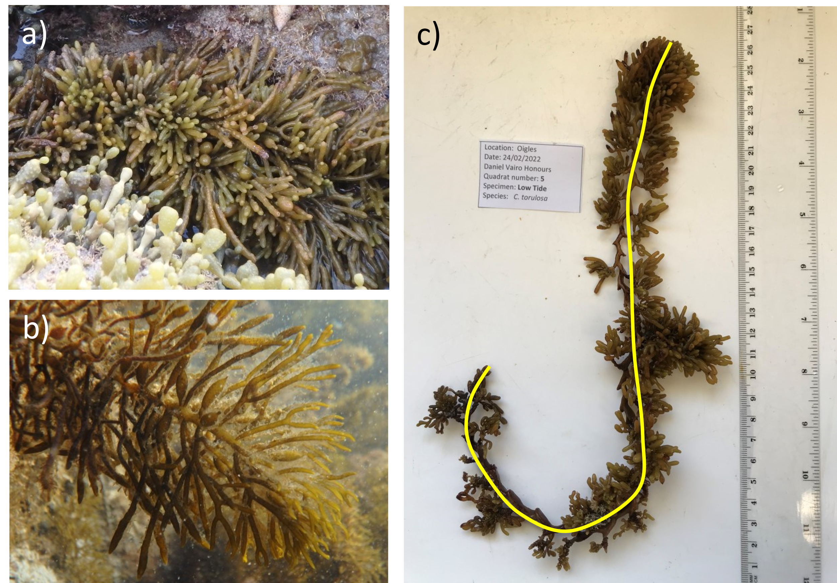
Supp. Fig. 1 a) Cystophora torulosa, b) Caulocystis uvifera, c) length of samples were measured in ImageJ software by tracing the length of the thallus after setting a scale to a known distance (1cm on ruler).

