Extended Data Figures
European rural regions supporting and hindering the Sustainable Development Goals
Kimberly A. Nicholas and Murray Scown
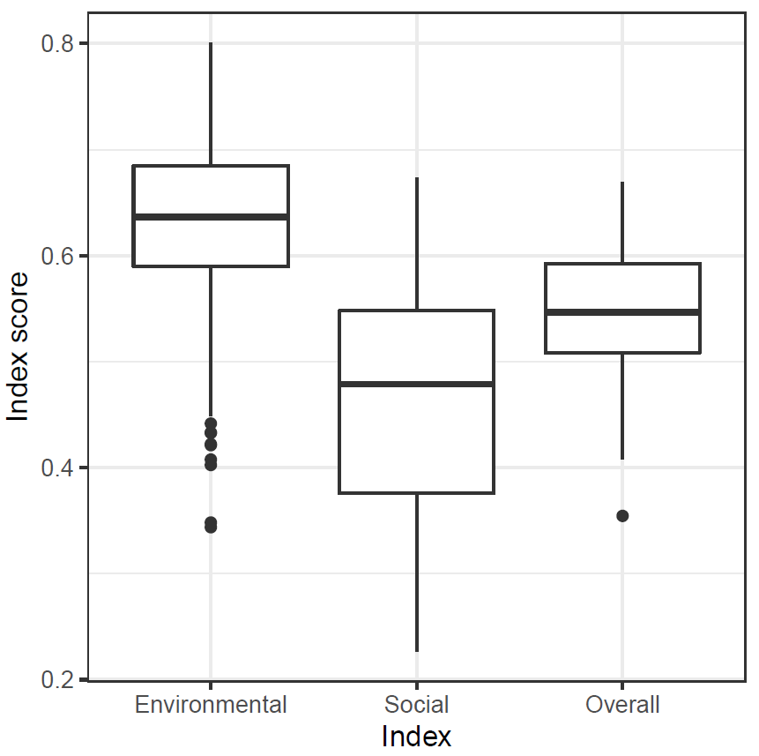
Extended Data Fig. 1. Distribution of environmental, social, and overall index scores of agricultural sustainability across all 283 European NUTS regions analysed, based on indicators normalised from 0 – 1 with 1 being the “best”. The environmental index contains 15 sustainability indicators; the social index contains 9 indicators; and the overall sustainability index equally weights their combination. Box indicates median and interquartile range, dots represent outliers more than 1.5 times the interquartile range above or below said range, whiskers represent range (excluding any outliers).

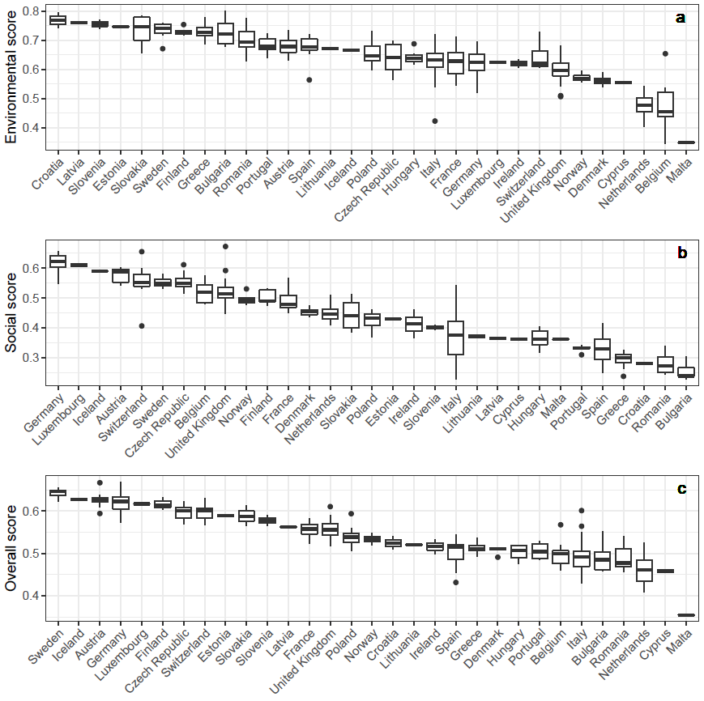
Extended Data Fig. 2. Distribution of environmental, social, and overall index scores for sustainable agriculture within each country. Indices are calculated from 15 environmental and 9 social indicators relevant for sustainable agriculture in Europe (listed in Table 1), each range-standardised to between zero and one. The indices are subsequently used for the hotspot analysis (please see Methods for full details).

Extended Data Fig. 3. Original neighbour matrix from the original Sphere of Influence calculation (A), which was manually adjusted for Iceland’s neighbours to the version used in our hotspot analysis (B).

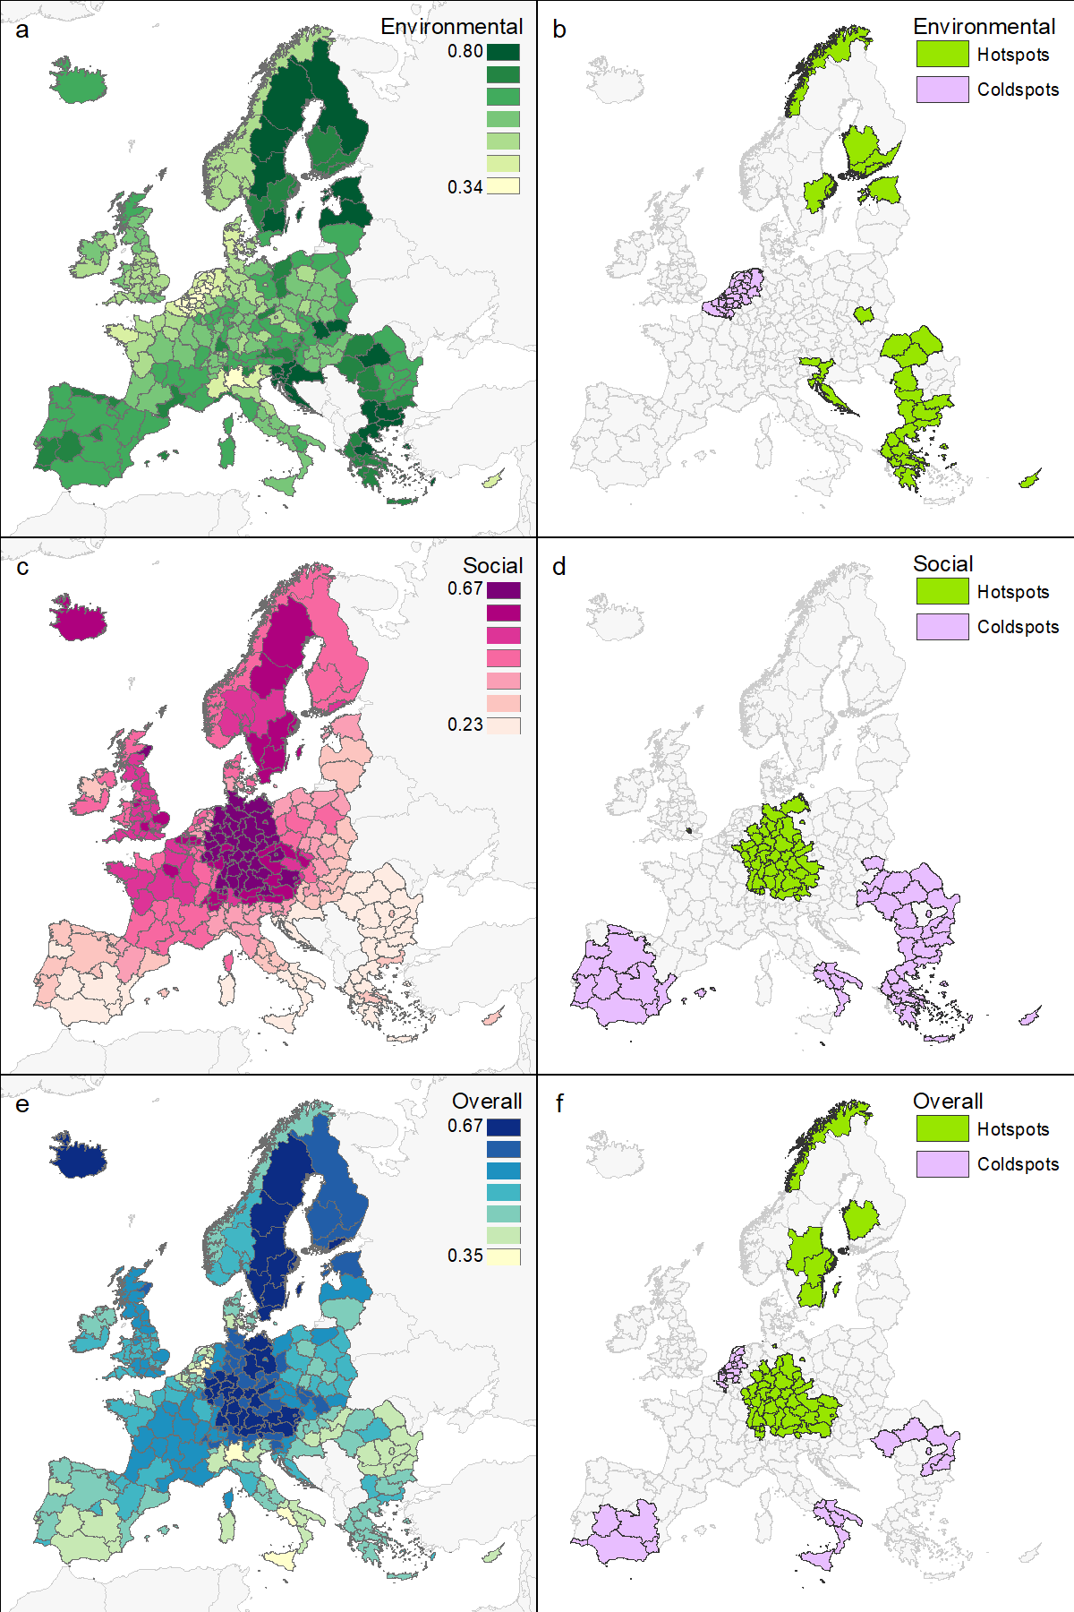
Extended Data Fig. 4. Maps of index scores (left column) and significant Getis-Ord Gi* hotspots and coldspots (right column) for the environmental (a and b), social (c and d), and overall (e and f) indices. Index scores are coloured according to Jenks natural breaks to optimise visualisation and only the maximum and minimum scores for each index are shown on the legend.

