Supplementary Information for the Scientific Reports Manuscript:
Immunoassay-based quantification of full-length peptidylglycine alpha-amidating monooxygenase in human plasma
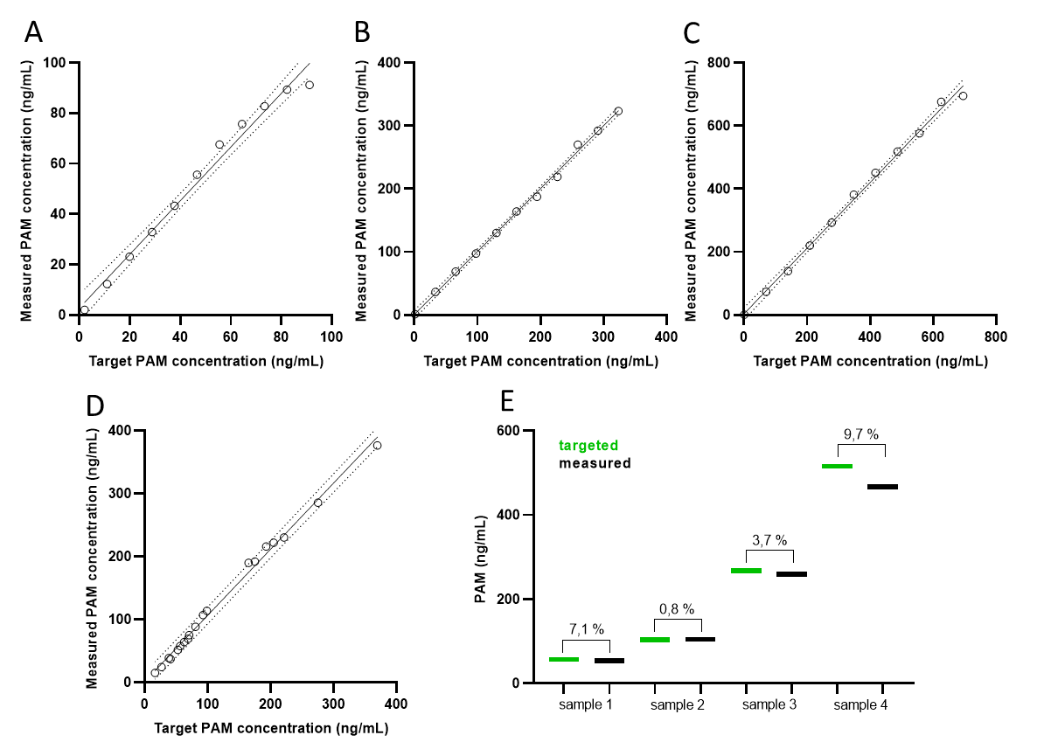
Supplemental Figure S1: (A-C) Assay linearity accessed by dilutional recovery with starting PAM concentration of 91.2 ng/mL (A), 323.5 ng/mL (B) and 674.7 ng/mL (C); (D) Mixing recovery of n=19 total sample pools with PAM concentrations ranging from 1.7 ng/mL to 481.1 ng/mL. The 95% confidence interval is shown as dotted lines; (E) The accuracy of PAM-LIA (spiking recovery), measured in four analyte-depleted samples, spiked with 50 ng/mL (sample 1), 100 ng/mL (sample 2), 250 ng/mL (sample 3), and 500 ng/mL (sample 4). The deviation between the targeted and measured PAM concentration are shown in % (CV).

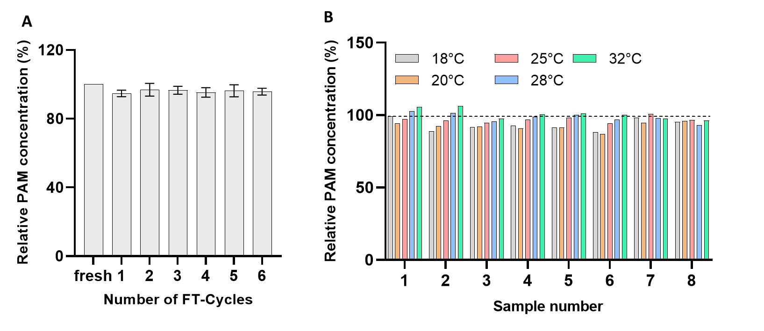
Supplemental Figure S2: (A) Freeze-thaw stability of the native PAM. Each bar represents the relative concentration of PAM, averaged over 6 measurements. The concentration of the unfrozen sample was set as 100%. (B) Operative temperature range of PAM-LIA assay. Each bar represents a relative PAM concentration determined in duplicate in eight EDTA plasma samples with increasing PAM concentration, ranging between 1.8 ng/mL to 466.4 ng/mL. The PAM concentration determined at 22°C was set as 100%.

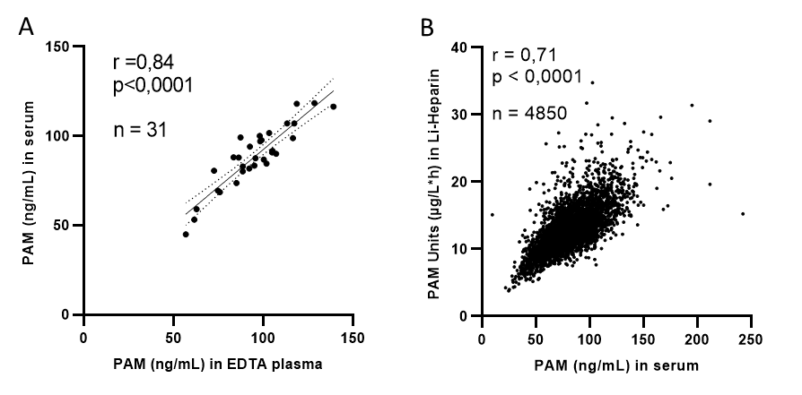
Supplemental Figure S3: Non-parametric Spearman correlation of PAM concentration, measured between matched EDTA plasma and serum samples in PAM-LIA assay (A). The correlation was also determined between PAM concentration (in ng/mL) and PAM amidating activity (in µg/L*h) in large population-based cohort, measured as described in Kaufmann et al. 2021. PAM concentration and activity was determined in matched serum and Li-Heparin samples, respectively. n being the number of matched pairs, r representing the correlation coefficient and p-value for statistical significance. The 95% confidence interval is shown as dotted lines.

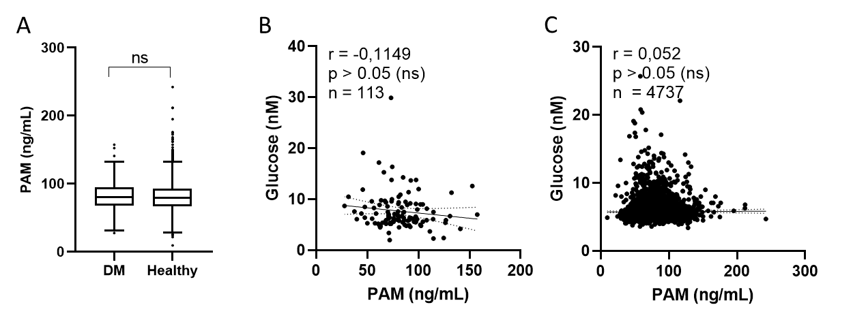
Supplemental Figure S4: PAM concentration and correlation with glucose levels in subjects with prevalent diabetes (DM) and healthy individuals. (A) A box plot of PAM concentration (PAM-LIA) in the study cohort, with 113 subjects with prevalent diabetes and 4737 healthy individuals. The non-parametric Mann-Whitney test was used to test for significance, with n being the number of pairs. Spearman rank correlations between PAM-LIA and glucose levels in subjects with prevalent diabetes (B) and healthy individuals (C), respectively, with r being the correlation coefficients and p indicating the statistical significance.

Supplemental Figure S5: Spearman rank correlations between PAM-LIA and bioactive adrenomedullin levels, measured in MPP subcohort of 4530 individuals, with r being the correlation coefficients and p indicating the statistical significance.

Supplemental Table S1: Substance interference study
 | Final concentration | Low pool |  | High pool
 | Final concentration | PAM (ng/mL) | Recovery (%) | PAM (ng/mL) | Recovery (%)
no supplemented |  | 54.7 |  | 364.6
H₂O |  | 51.6 | 100.0 | 347.5 | 100
Epinephrine | 12 µg/mL | 51.0 | 98.7 | 340.2 | 97.9
Trisodium Citrate | 165 mg/mL | 51.1 | 99.0 | 340.0 | 97.8
Phenylephrine | 6 µg/mL | 50.3 | 97.5 | 339.5 | 97.7
L-Ascorbic Acid | 1.05 mg/mL | 50.7 | 98.3 | 325.5 | 93.7
Thiotropium | 0.96 pg/mL | 50.8 | 98.4 | 334.0 | 96.1
Capropril | 58 µg/mL | 49.7 | 96.2 | 331.2 | 95.3
Gentamicin Sulfate | 0.6 mg/mL | 49.4 | 95.6 | 335.4 | 96.5
Hemoglobin | 200 mg/mL | 52.0 | 100.7 | 311.5 | 89.6
Fentanyl | 6 µg/mL | 49.4 | 95.8 | 327.5 | 94.2
Furosimide | 0.32 mg/mL | 48.7 | 94.4 | 326.9 | 94.1
Salicylic acid | 572 µg/mL | 46.1 | 89.3 | 315.4 | 90.8
Acetyl salicylic acid | 0.6 mg/mL | 46.8 | 90.6 | 319.7 | 92.0
Acetamiophen | 3.12 mg/mL | 46.0 | 89.1 | 318.6 | 91.7
Ibuprofen | 4.38 mg/mL | 46.1 | 89.4 | 323.1 | 93.0
Dexamethasone | 0.24 mg/mL | 46.4 | 89.9 | 317.4 | 91.3
Dextrometrophan | 3.12 µg/mL | 49.2 | 95.3 | 338.7 | 97.5
Dobutamine | 24.2 µg/mL | 45.7 | 88.5 | 338.2 | 97.3
Loratadine | 1.74 µg/mL | 46.4 | 89.9 | 337.0 | 97.0
Nicardipine | 0.93 µg/mL | 46.7 | 90.4 | 337.0 | 97.0
Valsatran | 0.234 mg/mL | 47.5 | 92.1 | 337.7 | 97.2
Wasfarin | 1.5 mg/mL | 45.5 | 88.2 | 337.1 | 97.0
Ionexol | 20 mg/mL | 48.9 | 94.7 | 346.9 | 99.8
Sacubitril | 0.183 mg/mL | 49.2 | 95.4 | 343.6 | 98.9
Sacubitrilat | 0.183 mg/mL | 49.3 | 95.6 | 344.4 | 99.1
Vancomycin | 2 mg/mL | 48.2 | 93.4 | 332.1 | 95.6
D-Glucose | 200 mg/mL | 49.3 | 95.5 | 344.5 | 99.1
Bilirubin conjugated | 8 mg/mL | 47.9 | 92.7 | 326.1 | 93.8
Bilirubin | 8 mg/mL | 47.6 | 92.2 | 331.6 | 95.4
MeOH | 4.5 % (v/v) | 48.2 | 93.4 | 339.9 | 97.8
DMSO | 4.5 % (v/v) | 47.7 | 92.5 | 338.3 | 97.4
EtOH | 4.5 % (v/v) | 50.6 | 98.0 | 341.6 | 98.3

