Supplementary information

Loss of ELAVL2 is associated with aggressive mesenchymal transition in glioblastoma

Yona Kim, Ji Hyeon You, Yeonjoo Ryu, Gyuri Park, Urim Lee, Hyo Eun Moon, Hye Ran Park, Chang Won Song, Ja-Lok Ku, Sung-Hye Park and Sun Ha Paek

Contents
1. Supplementary Figures ----------------------------------------------------------------------------------------- 2
2. Supplementary Tables ----------------------------------------------------------------------------------------- 12

Supplementary Fig. 1
Supplementary Fig. 1 ELAVL2 is most deleted in GBM and its expression level is associated with distinct transcriptomic signature. a Copy number alteration status of ELAVL family members (ELAVL1-4) in GBM is shown. The dataset was obtained from TCGA GBM cohort (TCGA, Firehose Legacy) in cBioPortal platform. b-c PN subtype was found to be significantly enriched in ELAVL2-high GBM patients b, whereas MES subtype was enriched in ELAVL2-low GBM patients c. TCGA, The Cancer Genome Atlas; GI, Glioma-intrinsic. Years next to each gene set indicate the year in which the corresponding gene sets were established. Normalized enrichment score (NES), as well as p value, are shown. Details regarding the gene sets are provided in Materials and Methods.

Supplementary Fig. 2
Supplementary Fig. 2 An inverse expression pattern of ELAVL2 and MES molecules in commercial GBM cell lines. a-b RT-qPCR a and immunoblotting b of ELAVL2 and MES markers were performed on GBM cell lines (T98G, U87MG, U373MG, U251MG). All data represent the mean ± SD (n = 3). *p < 0.05, **p < 0.01, ***p <0.001 between ELAVL2-high GBM (U87MG) and each of ELAVL2-low GBMs (T98G or U251MG). NS indicates statistically non-significant, ●p < 0.05, ●●p < 0.01, ●●●p <0.001 between ELAVL2-high GBM (U373MG) and each of ELAVL2-low GBMs (T98G or U251MG).

Supplementary Fig. 3

Supplementary Fig. 3 Inhibition of ELAVL2 increases MES traits in GBM cell lines. a Immunoblotting of ELAVL2 in GBM14 after ELAVL2 genetic silencing using 3 siRNA candidates. b mRNA levels of ELAVL2 and MES markers in U87MG and U373MG transfected with scr or siELAVL2. All data represent the mean ± SD (n = 3). **p < 0.01, ***p <0.001 between U87MG with scr transfected and U87MG with siELAVL2 transfected. ●p < 0.05, ●●p < 0.01, ●●●p <0.001 between U373MG with scr transfected and U373MG with siELAVL2 transfected. c Protein levels of ELAVL2 and MES-related molecules in U87MG and U373MG control (ctr) and transfected with scr or siELAVL2. d-f Invasion (original magnification, × 100. Scale bar, 100 μm) d, wound healing (original magnification, × 40. Scale bar, 250 μm) e, and proliferation assays f in U87MG and U373MG transfected with scr or siELAVL2. Representative images and bar graphs of relative wound closure d and invasion e are shown. All data represent the mean ± SD (n = 3). *p < 0.05, **p < 0.01, ***p <0.001 between U87MG with scr transfected and U87MG with siELAVL2 transfected. ●p < 0.05, ●●p < 0.01, ●●●p <0.001 between U373MG with scr transfected and U373MG with siELAVL2 transfected.

Supplementary Fig. 4
Supplementary Fig. 4 ELAVL2 down-regulation induces TMZ resistance in GBM cell lines. a Cell death assay of GBM14 transfected with scr or siELAVL2 and treated with DMSO or 2 mM TMZ for 24 h. Original magnification, × 100. Scale bar, 100 μm. NS indicates statistically non-significant, ***p <0.001 versus the scr group. b, c Cell viability assay b and cell death assay c of U87MG (left panel) and U373MG (right panel) transfected with scr or siELAVL2 and treated with indicated doses of TMZ for 24 h. TMZ-treated cells were normalized to DMSO control. Original magnification, × 100. Scale bar, 100 μm. All data represent the mean ± SD (n = 3). NS indicates statistically non-significant, ***p <0.001 between U87MG with scr transfected and U87MG with siELAVL2 transfected. ●●●p <0.001 between U373MG with scr transfected and U373MG with siELAVL2 transfected.

Supplementary Fig. 5

Supplementary Fig. 5 Positive correlations of ELAVL2 with SH3GL3 and DNM3, which are associated with favorable prognostic factors. a mRNA levels of ELAVL2 and 13 candidate target genes in GBM cell lines (T98G, U87MG, U373MG, and U251MG). All data represent the mean ± SD (n = 3). *p < 0.05, **p < 0.01, ***p <0.001 between ELAVL2-high GBM (U87MG) and each of ELAVL2-low GBMs (T98G or U251MG). ●●p < 0.01, ●●●p <0.001 between ELAVL2-high GBM (U373MG) and each of ELAVL2-low GBMs (T98G or U251MG). b RT-qPCR of ELAVL2 and 13 candidate target genes in U373MG treated with scr or siELAVL2. All data represent the mean ± SD (n = 3). NS indicates statistically non-significant, ●p < 0.05, ●●p < 0.01, ●●●p <0.001 versus the scr group. c, d GSEA graphs of the indicated gene sets comparing DNM3-high versus DNM3-low GBM patients c and SH3GL3-high versus SH3GL3-low GBM patients d from TCGA GBM U133a microarray dataset. Normalized enrichment score (NES), as well as p value, are shown. e Kaplan-Meier survival curves of GBM patients from TCGA GBM U133a microarray dataset based on their SH3GL3 (upper panel) or DNM3 (lower panel) mRNA expression levels. p, log-rank test.

Supplementary Fig. 6

Supplementary Fig. 6 Suppression of SH3GL3 or DNM3 increases MES characteristics in GBM cells. a-c Invasion (original magnification, × 100. Scale bar, 100 μm) a, proliferation b and wound healing assays (original magnification, × 40. Scale bar, 250 μm) c in U373MG treated with scr or siSH3GL3 or siDNM3. Representative images and bar graphs of relative cell invasion a and wound closure c are displayed. All data represent the mean ± SD (n = 3). ●●p < 0.01, ●●●p <0.001 versus the scr group. d, e mRNA levels of SH3GL3, DNM3, ELAVL2 d and MES markers e in U373MG transfected with the following conditions: scr, siSH3GL3, siSH3GL3 + siELAVL2, siDNM3, and siDNM3 + siELAVL2. All cells were normalized to scr. Data are presented as the mean ± SD (n = 3). NS indicates statistically non-significant, *p < 0.05, **p < 0.01, ***p <0.001 versus the scr group. #p < 0.05, ##p < 0.01, ###p <0.001 between siSH3GL3 and siSH3GL3 + siELAVL2 group. ●p < 0.05, ●●p < 0.01, ●●●p <0.001 between siDNM3 and siDNM3 + siELAVL2 group.

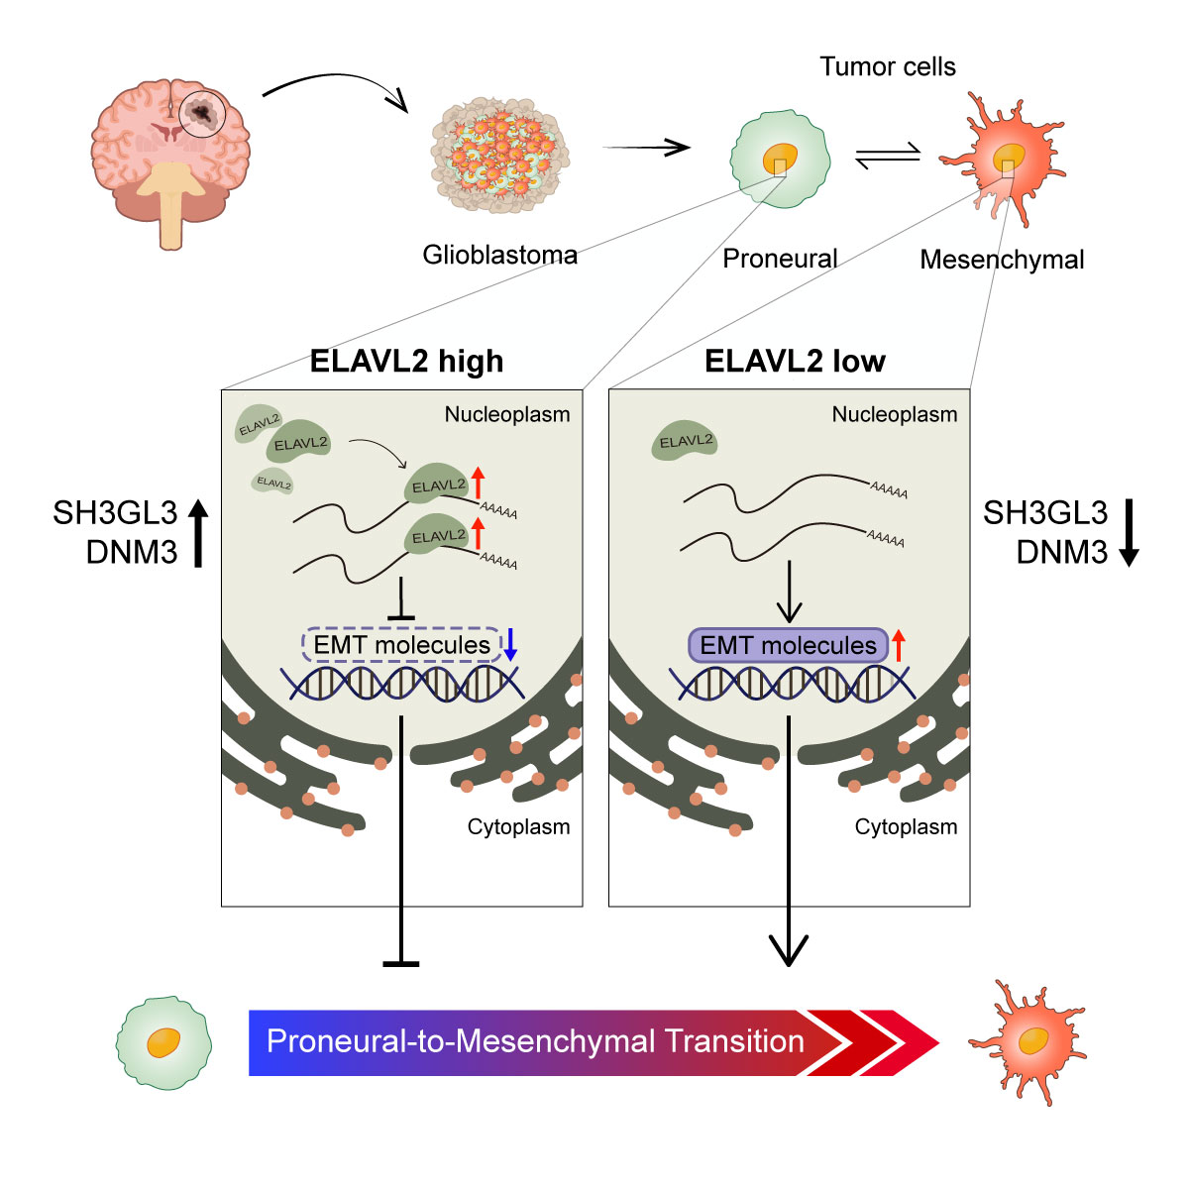
Supplementary Fig. 7
Supplementary Fig. 7 Proposed mechanism of ELAVL2 in regulating MES transition. In PN GBM cells without the deletion of ELAVL2 gene, ELAVL2 is highly expressed and regulates the expressions of SH3GL3 and DNM3 and together represses the PMT in GBM. On the other hand, in MES GBM cells where ELAVL2 is frequently deleted as a result of the copy number deletion of chromosome 9p21 loci, ELAVL2 is lowly expressed which leads to the downregulation of SH3GL3 and DNM3. Consequently, EMT molecules are highly expressed to promote PMT, or aggressive MES transition, in GBM.

Supplementary Table 1. List of primers used in RT-qPCR.

Gene | Direction | Sequence (5'-3')
GAPDH | Forward | GTCTCCTCTGACTTCAACAGCG
GAPDH | Reverse | ACCACCCTGTTGCTGTAGCCAA
ELAVL2 | Forward | GCGAATTGAGGCAGAAGAAG
ELAVL2 | Reverse | CTGGTACAGCTGGGAAAGGA
Vimentin | Forward | GAGAACTTTGCCGTTGAAGC
Vimentin | Reverse | CTCAATGTCAAGGGCCATCT
CDH2 | Forward | AGGATCAACCCCATACACCA
CDH2 | Reverse | TGGTTTGACCACGGTGACTA
ZEB1 | Forward | GCACAACCAAGTGCAGAAGA
ZEB1 | Reverse | ACTTTGCCTGGTTCAGGAGA
ZEB2 | Forward | AATGCACAGAGTGTGGCAAGGC
ZEB2 | Reverse | CTGCTGATGTGCGAACTGTAGG
CD44 | Forward | AGGAACAGTGGTTTGGCAAC
CD44 | Reverse | GGTGTTGTCCTTCCTTGCAT
MMP3 | Forward | TGCTTTGTCCTTTGATGCTG
MMP3 | Reverse | GGAAGAGATGGCCAAAATGA
MMP9 | Forward | CATCGTCATCCAGTTTGGTG
MMP9 | Reverse | AGGGACCACAACTCGTCATC
TWIST1 | Forward | ATCAAACTGGCCTGCAAAAC
TWIST1 | Reverse | TGCATTTTACCATGGGTCCT
TWIST2 | Forward | TTTCACGCCGCTATTCTTTT
TWIST2 | Reverse | GAGCAGGATACACAGCCACA
SNAI1 | Forward | TGCCCTCAAGATGCACATCCGA
SNAI1 | Reverse | GGGACAGGAGAAGGGCTTCTC
SNAI2 | Forward | ATCTGCGGCAAGGCGTTTTCCA
SNAI2 | Reverse | GAGCCCTCAGATTTGACCTGTC
SERPINE1 | Forward | TCATGGACAGACCCTTCCTC
SERPINE1 | Reverse | ATGGCAATGTGACTGGAACA
VIPR2 | Forward | TGCACCAGGAATTACATCCA
VIPR2 | Reverse | ACCAGCACTGAGATGGCTCT
SLC8A2 | Forward | GGAGATCACCATCACCAAGG
SLC8A2 | Reverse | GAGGTTGGACACCGTCTCAT
RPRM | Forward | CCCTCTGAAAGTCCTCATGC
RPRM | Reverse | CCCCGCATTCCAAGTAAGTA
CDH18 | Forward | CGGAGAGGAAGACACAGAGG
CDH18 | Reverse | TCCTCAGCAGCAGAAGGATT
HMP19 | Forward | TACGGTCACCATCCTTGTCA
HMP19 | Reverse | GGCTTTGTAAACCACCAGGA
PLCL1 | Forward | TTTTGGAATTGTGGCTGTCA
PLCL1 | Reverse | CGTGTGAAGGTCCATCATTG
CRTAC1 | Forward | AGGGCTTCAACAACAACTGG
CRTAC1 | Reverse | GCCCCACTCTTCTTGGTGTA
JPH3 | Forward | AATCCTTGCCTGTCGCTCTA
JPH3 | Reverse | TTGAGCTCATCCCCATTCTC
DUSP26 | Forward | GGCAGCTAGGCTGTAGATGG
DUSP26 | Reverse | GGTGAGGGAGAGAGGGAAAC
SH3GL3 | Forward | TTTGAGCCAGAAAACCAAGG
SH3GL3 | Reverse | GAATCCCGATTCTCCGTGTA
DNM3 | Forward | AAATCAGGTGATTCGCAAGG
DNM3 | Reverse | AGGACAAGCTTTCCGCAGTA
BASP1 | Forward | CAATGCCAATCCTCCATTCT
BASP1 | Reverse | AACTACAGGTGCACCCAACC
REPS2 | Forward | ACATGGCTGACCTTCCTGTC
REPS2 | Reverse | CCTCAGACACGTCCTTTGGT

Supplementary Table 2. List of siRNAs.

siRNA | Duplex Sequence (5'-3')
Negative Control | Sense | CCUCGUGCCGUUCCAUCAGGUAGUU
Negative Control | Antisense | CUACCUGAUGGAACGGCACGAGGUU
ELAVL2 #1 | Sense | GACAGAGUACUGCAGGUCU
ELAVL2 #1 | Antisense | AGACCUGCAGUACUCUGUC
ELAVL2 #2 | Sense | CUGUCUAAUGGGCCAACUU
ELAVL2 #2 | Antisense | AAGUUGGCCCAUUAGACAG
ELAVL2 #3 | Sense | GAGGAACUAAAGAGUCUCU
ELAVL2 #3 | Antisense | AGAGACUCUUUAGUUCCUC
SH3GL3 #1 | Sense | CUGAACACUGUGUCGAAGA
SH3GL3 #1 | Antisense | UCUUCGACACAGUGUUCAG
SH3GL3 #2 | Sense | GUAAGAUACCAGACGAAGA
SH3GL3 #2 | Antisense | UCUUCGUCUGGUAUCUUAC
DNM3 #1 | Sense | GUCUGAGAACCAUUGGAGU
DNM3 #1 | Antisense | ACUCCAAUGGUUCUCAGAC
DNM3 #2 | Sense | GAUUGUUGCUAACCACAUU
DNM3 #2 | Antisense | AAUGUGGUUAGCAACAAUC

Supplementary Table 3. Clinical information of glioma patients in TMA slides (TMA1573, 2248, 2249, 2758).
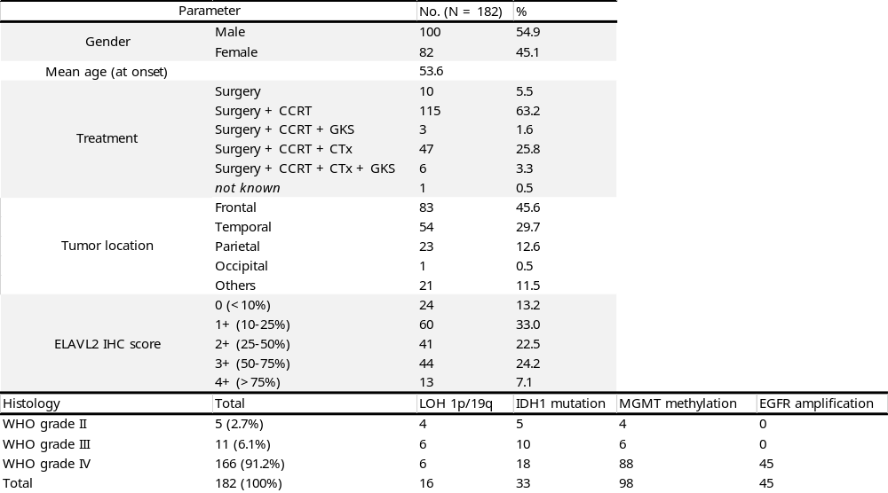

Supplementary Table 4. List of DEGs between ELAVL2-high and -low TCGA GBM patients.
Supplementary Table 5. List of positively correlated genes with ELAVL2 in TCGA, GSE16011, and GSE53733 datasets (R correlation p-value <= 0.0001, FDR applied).

*Supplementary Tables 4 and 5 are provided as Excel files.

