Supplementary Material

Supplementary Figures and Tables

Supplementary Figures
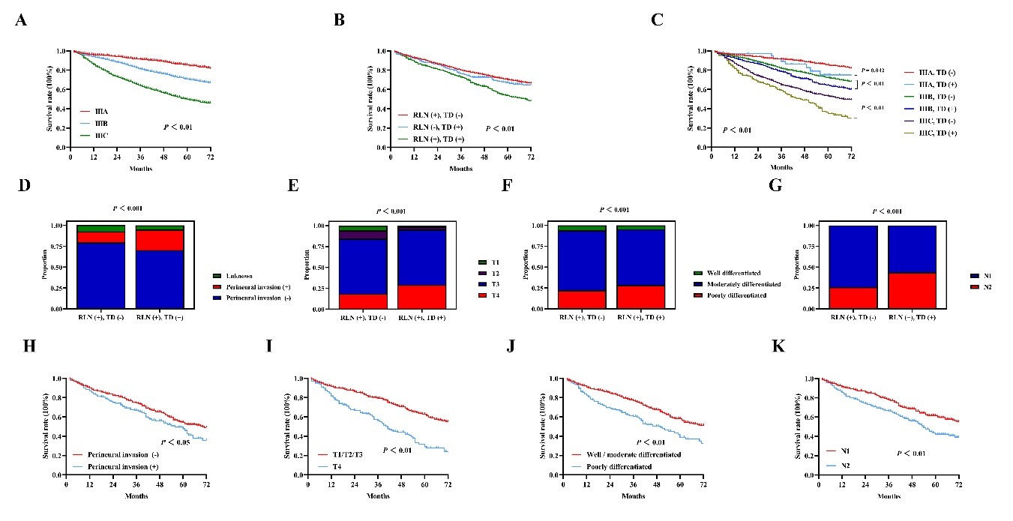
Fig. S1 Kaplan–Meier survival curves for patients in stage IIIA, IIIB and IIIC. A Patients in the internal validation cohort. Kaplan–Meier survival curves for patients with the presence or absence of TD and RLN. B Patients in the internal validation cohort. Kaplan–Meier survival curves for patients with and without TD in stage IIIA, IIIB and IIIC. C Patients in the internal validation cohort. The difference in the proportion of perineural invasion, T4 stage, poorly differentiated and N2 stage between RLN (+), TD (-) and RLN (+), TD (+) patients. D-G Patients in the internal validation cohort. Kaplan–Meier survival curves for RLN (+), TD (+) patients with and without perineural invasion, T4 stage, poorly differentiated and N2 stage. H-K Patients in the internal validation cohort.
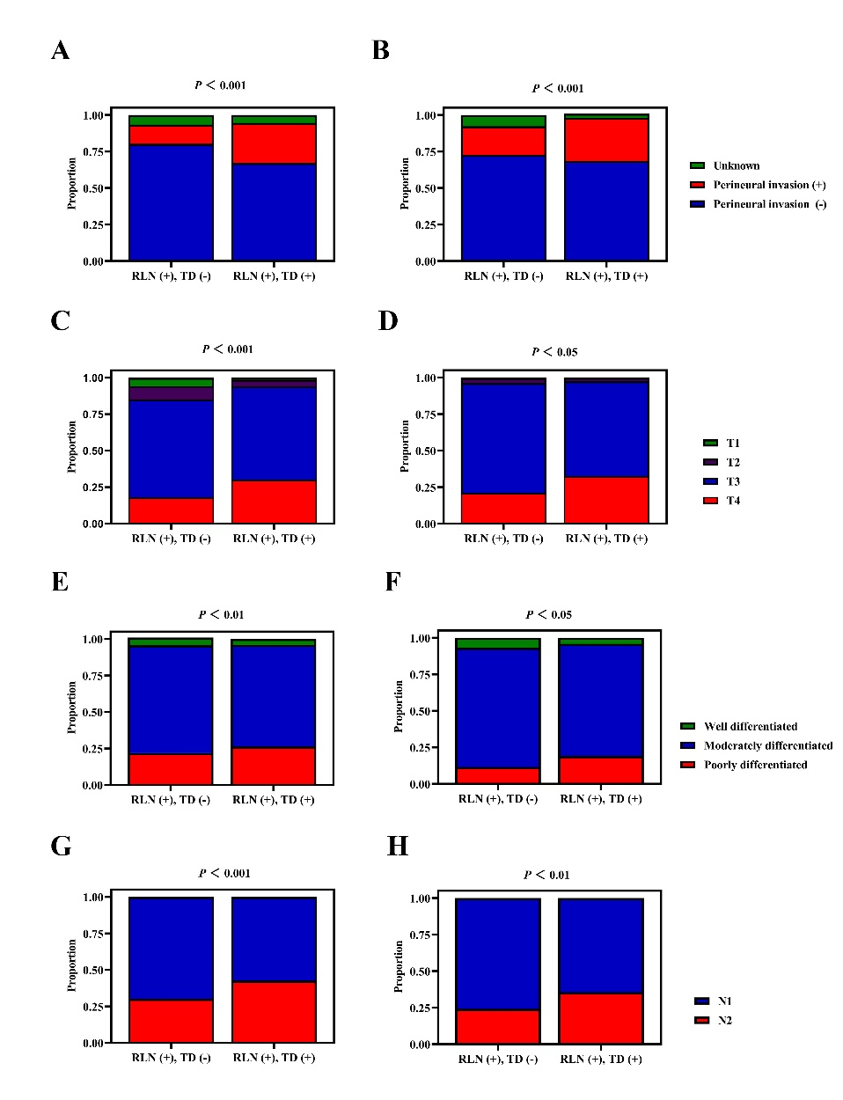
Fig. S2 The difference in the proportion of perineural invasion between RLN (+), TD (-) and RLN (+), TD (+) patients. A Patients in the training cohort; B Patients in the external validation cohort. The difference in the proportion of T4 stage between RLN (+), TD (-) and RLN (+), TD (+) patients. C Patients in the training cohort; D Patients in the external validation cohort. The difference in the proportion of poorly differentiated between RLN (+), TD (-) and RLN (+), TD (+) patients. E Patients in the training cohort; F Patients in the external validation cohort. The difference in the proportion of N2 stage between RLN (+), TD (-) and RLN (+), TD (+) patients. G Patients in the training cohort; H Patients in the external validation cohort.
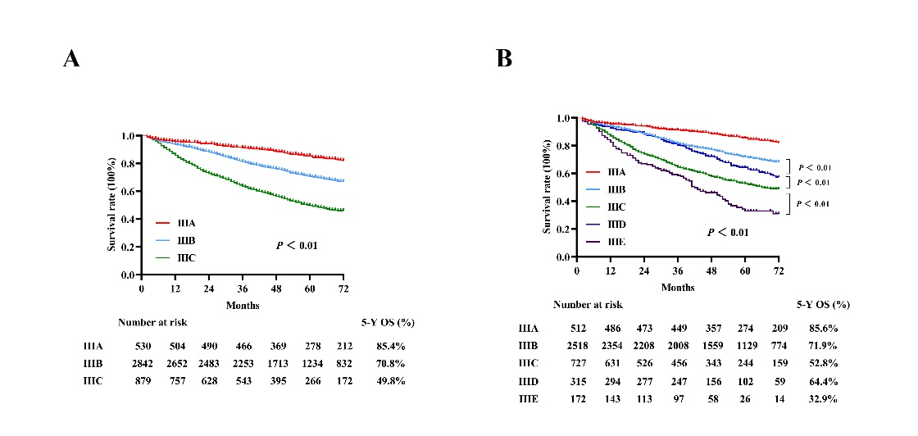
Fig. S3 Kaplan–Meier survival curves and 5-year OS rates for patients in stage IIIA, IIIB and IIIC. A Patients in the internal validation cohort. Kaplan–Meier survival curves and 5-year OS rates for patients in stage IIIA, IIIB, IIIC, IIID and IIIE. B Patients in the internal validation cohort.

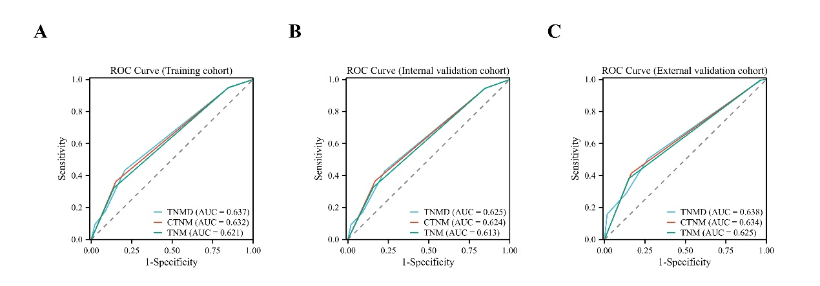
Fig. S4 ROC (receiver operating characteristic) curves in prediction of 5-year OS rates from the TNMD (tumor-node-metastasis-deposits), CTNM (combined tumor-node-metastasis) and TNM (tumor-node-metastasis) staging system. A Patients in the training cohort; B Patients in the internal validation cohort; C Patients in the external validation cohort.

Supplementary Tables
Table. S1 Univariate and multivariate survival analysis results of clinical characteristics in training and validation cohorts.
Variables |  | Univariate analysis |  |  |  |  |  | Multivariable analysis
 |  | HR 95% CI |  |  | P value |  | HR 95% CI |  |  | P value
Training cohort  Gender |  | 0.916 (0.855-0.981) |  |  | 0.013 |  |  |  | 0.879 (0.820-0.942) | 0.001
Age |  | 1.960 (1.950-2.071) |  |  | ＜0.001 |  |  |  | 2.049 (1.921-2.186) | ＜0.001
T stage |  | 1.617 (1.550-1.686) |  |  | ＜0.001 |  |  |  | 1.499 (1.432-1.568) | ＜0.001
N stage |  | 1.218 (1.189-1.247) |  |  | ＜0.001 |  |  |  | 1.186 (1.157-1.216) | ＜0.001
Tumor deposits |  | 1.487 (1.367-1.618) |  |  | ＜0.001 |  |  |  | 1.208 (1.108-1.316) | ＜0.001
Perineural invasion |  | 1.122 (1.079-1.167) |  |  | ＜0.001 |  |  |  | 1.068 (1.025-1.113) | 0.002
Examined lymph nodes |  | 0.725 (0.656-0.801) |  |  | ＜0.001 |  |  |  | 0.633 (0.571-0.703) | ＜0.001
Tumor size  Differentiation |  | 1.319 (1.229-1.416)  1.390 (1.314-1.471) |  |  | ＜0.001  ＜0.001 |  |  |  | 1.136 (1.055-1.223)  1.216 (1.147-1.289) | 0.001  ＜0.001
Internal validation cohort
Gender  Age  T stage  N stage  Tumor deposits  Perineural invasion  Examined lymph nodes  Tumor size  Differentiation |  | 0.896 (0.808-0.995)  1.937 (1.757-2.137)  1.585 (1.487-1.688)  1.195 (1.153-1.238)  1.490 (1.131-1.693)  1.412 (1.231-1.320)  0.792 (0.677-0.927)  1.294 (1.163-1.438)  1.423 (1.311-1.544) |  |  | 0.040  ＜0.001  ＜0.001  ＜0.001  ＜0.001  ＜0.001  0.003  ＜0.001  ＜0.001 |  |  |  | 0.858 (0.767-0.958)  1.973 (1.780-2.187)  1.448 (1.347-1.557)  1.154 (1.109-1.200)  1.229 (1.073-1.407)  1.184 (1.028-1.364)  0.682 (0.577-0.806)  1.095 (0.975-1.230)  1.293 (1.184-1.412) | 0.007  ＜0.001  ＜0.001  ＜0.001  0.003  0.019  ＜0.001  0.125  ＜0.001
External validation cohort
Gender  Age  T stage  N stage  Tumor deposits  Perineural invasion  Examined lymph nodes  Tumor size  Differentiation |  | 0.753 (0.596-0.950)  1.853 (1.453-2.364)  1.370 (1.190-1.577)  1.333 (1.233-1.441)  1.442 (1.129-1.840)  2.030 (1.581-2.607)  0.955 (0.737-1.237)  1.399 (1.091-1.795)  1.365 (1.136-1.641) |  |  | 0.016  ＜0.001  ＜0.001  ＜0.001  0.003  ＜0.001  0.727  0.007  0.001 |  |  |  | 0.834 (0.654-1.064)  2.081 (1.620-2.672)  1.315 (1.183-1.401)  1.288 (1.124-1.216)  1.263 (0.976-1.636)  1.922 (1.490-2.479)  0.961 (0.725-1.273)  1.086 (0.828-1.425)  1.182 (1.050-1.470) | 0.145  ＜0.001  ＜0.001  ＜0.001  0.026  ＜0.001  0.780  0.551  0.033
HR hazard ratios | CI confidence interval

Table. S2 Clinical and pathological characteristics between patients with RLN (+), TD (-) and RLN (+), TD (+) in training cohort.
Clinical characteristics |  | RLN (+), TD (-)  (N = 8192) |  | RLN (+), TD (+)  (N = 1136) | P value
 | Gender |  |  |  | P = 0.15
 | Male | 4129 (50.4%) | 596 (52.4%)
 | Female | 4093 (49.6%) | 540 (47.8%)
 | Age |  |  |  | P = 0.98
 | ≤40 | 458 (5.5%) | 65 (5.8%)
 | 40-70 | 5249 (64.2%) | 728 (64.0%)
 | ＞70 | 2485 (30.3%) | 343 (30.2%)
 | Race
 | White | 6046 (73.8%) | 832 (73.2%) |  | P = 0.80
 | Black | 1121 (13.6%) | 158 (13.9%)
 | Asian | 917 (11.2%) | 127 (11.8%)
 | Other | 108 (1.4%) | 19 (1.1%)
 | T stage |  |  |  | P＜0.001
 | T1 | 491 (5.9%) | 20 (1.7%)
 | T2 | 749 (9.1%) | 51 (4.4%)
 | T3 | 5502 (67.1%) | 726 (63.9%)
 | T4 | 1450 (17.9%) | 339 (30.0%)
 | N stage |  |  |  | P＜0.001
 | N1 | 5722 (69.8%) | 651 (57.3%)
 | N2 | 2470 (30.2%) | 484 (42.7%)
 | TNM stage |  |  |  | P＜0.001
 | IIIA | 1112 (13.5%) | 51 (4.4%)
 | IIIB | 5594 (68.2%) | 746 (65.6%)
 | IIIC | 1486 (18.3%) | 339 (30.0%)
 | Tumor size (cm) |  |  |  | P = 0.68
 | ≤ 5 | 5169 (63.0%) | 734 (64.6%)
 | ＞5 | 2799 (34.1%) | 387 (34.0%)
 | Unknown | 224 (2.9%) | 15 (1.4%)
 | Perineural invasion |  |  |  | P＜0.001
 | Negative | 6582 (80.3%) | 764 (67.2%)
 | Positive | 1081 (13.1%) | 310 (27.4%)
 | Unknown | 529 (6.6%) | 62 (5.4%)
 | Examined lymph nodes |  |  |  | P = 0.08
 | ＜12 | 842 (10.3%) | 136 (11.9%)
 | ≥ 12 | 7350 (89.7%) | 1000 (88.1%)
 | Differentiation |  |  |  | P＜0.01
 | Well differentiated | 437 (5.3%) | 46 (4.0%)
 | Moderately differentiated | 5923 (72.3%) | 789 (69.6%)
 | Poorly differentiated | 1832 (22.4%) | 300 (26.4%)
TNM tumor node metastasis; RLN regional lymph nodes; TD tumor deposits
Table. S3 Clinical and pathological characteristics between patients with RLN (+), TD (-) and RLN (+), TD (+) in internal validation cohort.
Clinical characteristics | RLN (+), TD (-)  (N = 3511) | RLN (+), TD (+)  (N = 494) | P value
Gender |  |  | P = 0.20
Male | 1790 (50.9%) | 267 (54.0%)
Female | 1721 (49.1%) | 227 (46.0%)
Age |  |  | P = 0.99
≤40 | 173 (4.9%) | 24 (4.8%)
40-70 | 2271 (64.6%) | 319 (64.5%)
＞70 | 1067 (30.5%) | 151 (30.7%)
Race
White | 2603 (74.1%) | 359 (72.6%) | P = 0.92
Black | 494 (14.0%) | 73 (14.7%)
Asian | 373 (10.7%) | 56 (11.5%)
Other | 41 (1.2%) | 6 (1.2%)
T stage |  |  | P＜0.001
T1 | 204 (5.8%) | 4 (0.8%)
T2 | 344 (9.7%) | 18 (3.6%)
T3 | 2318 (66.0%) | 329 (66.5%)
T4 | 635 (18.5%) | 143 (29.1%)
N stage |  |  | P＜0.001
N1 | 2589 (73.8%) | 278 (56.3%)
N2 | 922 (26.2%) | 216 (43.7%)
TNM stage |  |  | P＜0.001
IIIA | 493 (14.0%) | 18 (3.6%)
IIIB | 2326 (66.2%) | 324 (65.5%)
IIIC | 692 (19.8%) | 152 (30.9%)
Tumor size (cm) |  |  | P = 0.49
≤5 | 1968 (56.0%) | 290 (58.7%)
＞5 | 1444 (41.1%) | 199 (40.2%)
Unknown | 99 (2.8%) | 5 (1.0%)
Perineural invasion |  |  | P＜0.001
Negative | 2796 (79.6%) | 348 (70.4%)
Positive | 465 (13.2%) | 122 (24.8%)
Unknown | 250 (7.2%) | 24 (4.8%)
Examined lymph nodes |  |  | P = 0.38
＜12 | 360 (10.2%) | 54 (10.9%)
≥12 | 3151 (89.8%) | 440 (89.1%)
Differentiation |  |  | P＜0.001
Well differentiated | 206 (5.8%) | 23 (4.6%)
Moderately differentiated | 2526 (71.9%) | 329 (66.7%)
Poorly differentiated | 779 (22.3%) | 142 (28.7%)
TNM tumor node metastasis; RLN regional lymph nodes; TD tumor deposits
Table. S4 Clinical and pathological characteristics between patients with RLN (+), TD (-) and RLN (+), TD (+) in external validation cohort.
Clinical characteristics | RLN (+), TD (-)  (N = 715) |  | RLN (+), TD (+)  (N = 169) | P value
Gender |  |  |  | P = 0.98
Male | 394 (55.1%) |  | 93 (55.1%)
Female | 321 (44.9%) |  | 76 (44.9%)
Age |  |  |  | P = 0.29
≤40 | 35 (4.8%) |  | 10 (5.9%)
40-70 | 565 (79.0%) |  | 123 (72.7%)
＞70 | 121 (16.2%) |  | 36 (21.4%)
T stage |  |  |  | P = 0.018
T1 | 3 (0.4%) |  | 0 (0%)
T2 | 23 (3.2%) |  | 4 (2.4%)
T3 | 539 (75.4%) |  | 110 (65.1%)
T4 | 150 (21.0%) |  | 55 (32.5%)
N stage |  |  |  | P＜0.01
N1 | 542 (75.8%) |  | 109 (64.4%)
N2 | 173 (24.2%) |  | 60 (35.6%)
TNM stage |  |  |  | P＜0.01
IIIA | 21 (2.9%) |  | 3 (1.7%)
IIIB | 552 (77.2%) |  | 111 (65.6%)
IIIC | 142 (19.9%) |  | 55 (32.7%)
Tumor size (cm) |  |  |  | P = 0.13
≤5 | 246 (34.5%) |  | 48 (28.5%)
＞5 | 469 (65.5%) |  | 121 (71.5%)
Perineural invasion |  |  |  | P＜0.01
Negative | 520 (72.7%) |  | 116 (68.6%)
Positive | 141 (19.7%) |  | 50 (29.6%)
Unknown | 54 (7.6%) |  | 3 (2.8%)
Examined lymph nodes |  |  |  | P = 0.20
＜12 | 155 (21.6%) |  | 45 (26.6%)
≥12 | 560 (78.4%) |  | 124 (73.4%)
Differentiation |  |  |  | P = 0.035
Well differentiated | 49 (6.8%) |  | 7 (4.1%)
Moderately differentiated | 584 (81.6%) |  | 130 (76.9%)
Poorly differentiated | 82 (11.6%) |  | 32 (19.0%)
TNM tumor node metastasis; RLN regional lymph nodes; TD tumor deposits

Table. S5 Prognostic abilities of different amendments in the training and validation cohorts.
Cohorts |  | AUC AIC BIC | C-index
Training cohort
TNMD |  | 0.637 12556.38 12599.57 | 0.619
CTNM |  | 0.632 12615.47 12652.76 | 0.617
TNM |  | 0.621 12817.88 12846.68 | 0.608
Internal validation cohort
TNMD |  | 0.625 5436.62 5476.52 | 0.608
CTNM |  | 0.624 5508.18 5534.16 | 0.607
TNM |  | 0.613 5762.09 5787.74 | 0.599
External validation cohort  TNMD  CTNM  TNM |  | 0.638 1217.21 1236.38  0.634 1269.57 1278.42  0.625 1321.46 1340.91 | 0.604  0.602  0.594
AUC Areas under the receiver-operating characteristic curve;
AIC Akaike information criterion; BIC Bayesian information criterion;
TNMD tumor-node- metastasis-deposit; CTNM Combined- tumor-node-metastasis’
TNM tumor-node-metastasis.

