Supplementary Information
Legends
Figure. S1
Figure. S1 Cell apoptosis increased in NDHG-cultured huvecs. (A) Representative brightfield images of huvecs cultured in ECM containing various concentrations of D-glucose. (B) Quantification of cell viability based on the results of trypan blue staining in different groups. (C) Representative brightfield images of huvecs were cultured in EBM with only 2% fetal bovine serum and different concentrations of D-glucose (50mM, 70mM, 100mM) for three days. Data are represented as mean ± SEM. **p < 0.01, ***P < 0.001, and three independent experiments were analyzed. Scale bars represent 50 µm. Nutrients deprivation, deprivation of endothelial growth supplements; ECM, endothelial complete medium; EBM, endothelial basal medium.

Figure. S2
Figure. S2 Activation of TGF-β signal in NDHG-cultured huvecs. (A) huvecs were cultured in NDHG condition for three days, the mRNA levels of TGFB1, TGFB2 and ALK5 were detected by qRT-PCR. (B) The protein levels of total Smad2/3 and phospho-Smad2/3 were tested by western blot. Data are represented as mean ± SEM. *P < 0.05, **p < 0.01, ***P < 0.001, and three independent experiments were analyzed. npECs, non-preconditioned huvecs; NDHG-ECs, NDHG-cultured huvecs; pECs, preconditioned huvecs.

Figure. S3
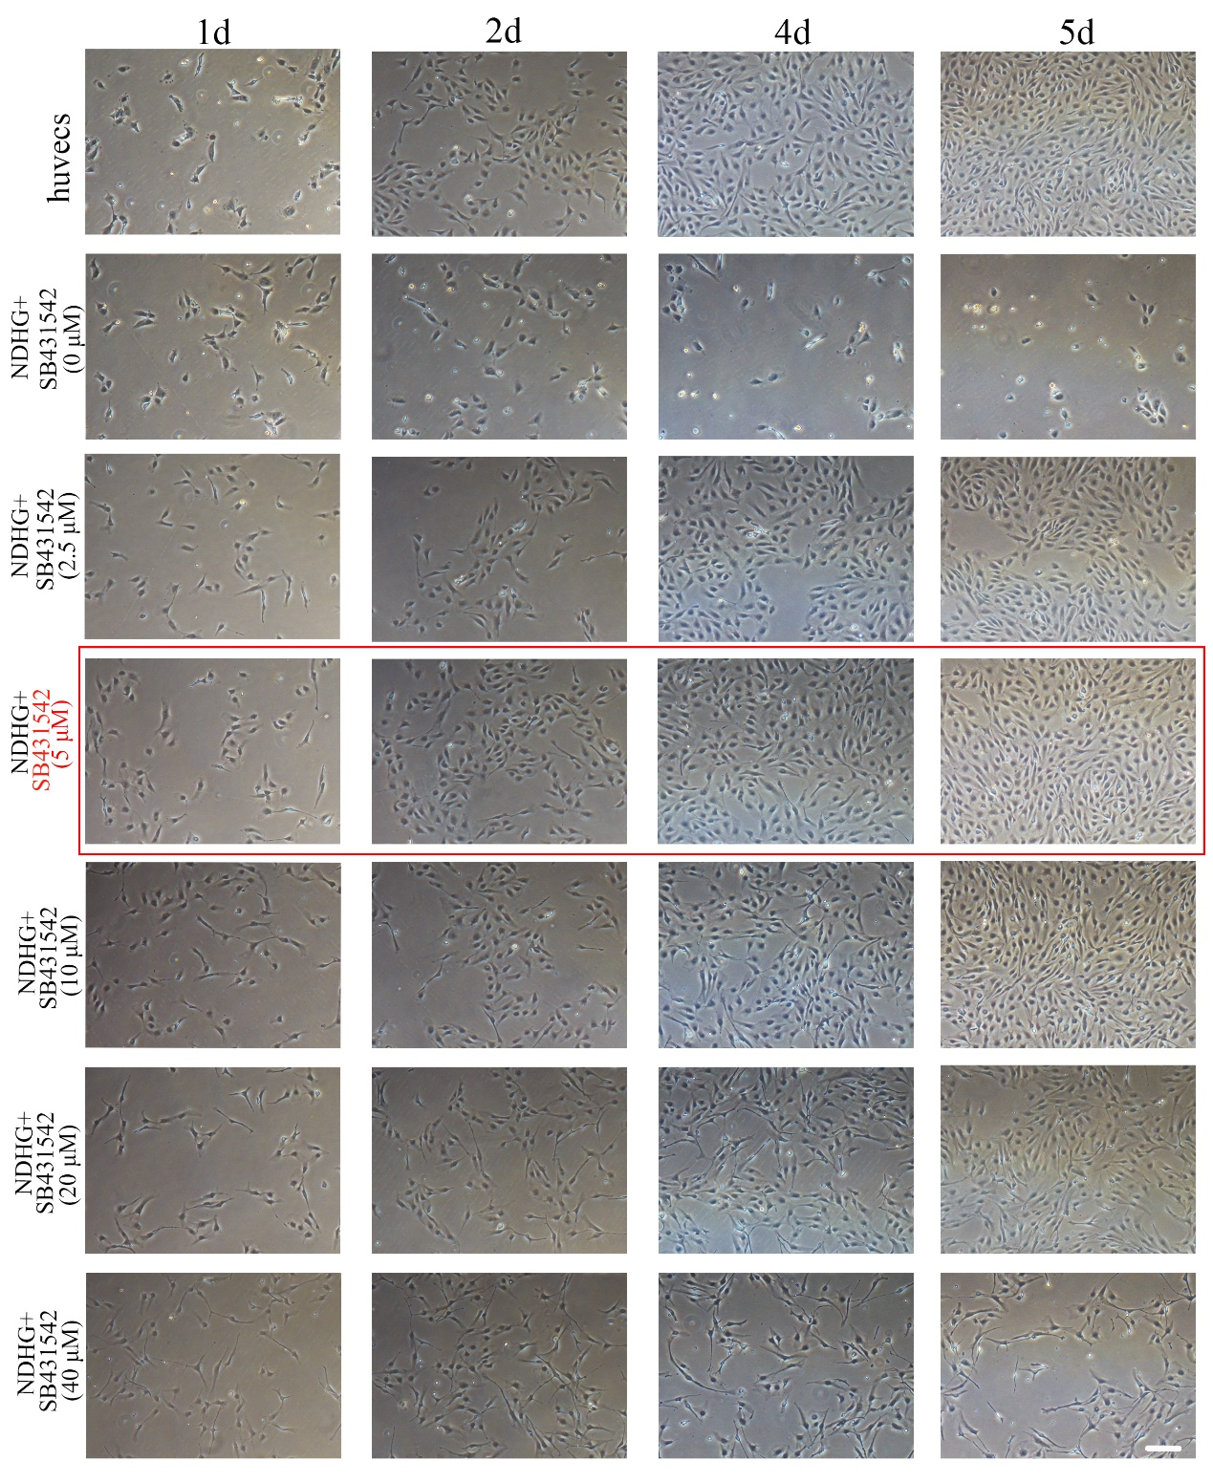

Figure. S3 The optimum working concentration of sb431542. Huvecs were cultured in NDHG containing various concentrations of SB431542. Representative brightfield images of cells cultured in different conditions at different times. Scale bars represent 50 µm. Three independent experiments were analyzed.

Figure. S4

Figure. S4 Inhibitors targeting TGF-β pathway can effectively reduce cell apoptosis.
(A) Representative bright-field images of huvecs cultured in NDHG containing SB 431542, SB 525334 or A-83-01 for three days. (B) Cell viability was evaluated with live/dead fluorescence staining. (C) Quantification of cell viability based on the results of live/dead fluorescent staining. Scale bars represent 50 µm. Data are represented as mean ± SEM, ***P < 0.001. Three independent experiments were analyzed.

Figure. S5
Figure. S5 Candidate small molecule compounds have limited effects in reduction of cell apoptosis. (A) Huvecs were cultured in NDHG with SB431542, SRT-1460, MDL-28170 and Lovastatin for five days. Representative brightfield images of cells exposed to different conditions. (B) Cell viability was evaluated by live/dead fluorescence staining. (C) Quantification of cell viability by counting the numbers of cell during five days. (D) Cell apoptosis was tested by flow cytometry. (E) Quantification of cell apoptosis based on the results of flow cytometry analysis. Data are represented as mean ± SEM. **p < 0.01, ***P < 0.001, and three independent experiments were analyzed. Scale bars represent 50 µm.

Figure. S6
Figure. S6 Long-term preconditioning improves the stability of tube-like structure in pECs.
Preconditioned ECs at passage 1, 2 and 3 were harvested and then plated on Matrigel-coated plates in ECM medium. (A) Representative brightfield images of tube-like structure after cell seeding for 6 hours and for 44 hours. (B) Tube lengths were measured 6 hours and 44 hours after seeding in Matrigel-coated plates. Data are represented as mean ± SEM. *P < 0.05, **P < 0.01, ***P < 0.001. Three independent experiments were analyzed. Scale bars represent 50 µm.

Figure. S7

Figure. S7 Hierarchical clustering and KEGG pathway enrichment analysis of the RNA-seq data for DEGs in the indicated cells. (A) Heat map for the DEGs was created with cut-offs of p<0.05 and fold change >2. (B) KEGG pathway enrichment analysis of the RNA-seq data for DEGs between NDHG-ECs and pEPCs.

Supplementary Table 1:

Product | Source | Catalog# | Target/ Signaling | The final working concentration
SB431542 | Selleck | S1067 | TGF-β | 5 μM
A-83-01 | Selleck | S7692 | TGF-β | 2.5 μM
SB525334 | Selleck | S1476 | TGF-β | 5 μM
LY294002 | Selleck | S1105 | PI3K-AKT | 10 μM
Lovastatin | Apexbio | A4365 | GTP-Cyclohydrolase 1 | 10 μM
SRT-1460 | Selleck | S6880 | SIRT1 activator | 2.5 μM
MDL-28170 | Apexbio | A4412 | Calpain inhibitor | 2.5 μM

Supplementary Table 2:

Antibody | Source | Catalog# | Pur-pose | Host Specied & Reactivity | Concentration
DAPI | Roche | 10236276 | IF | Nucleus | 1:1000
CD31 | Abcam | Ab222783 | IF | Mouse anti-human | 1:200
CD31 | Abcam | ab281583 | IF | Rabbit anti-human and mouse | 1:100
VE-cad | Abcam | ab33168 | IF | Rabbit anti-human and mouse | 1:200
vWF | Abcam | ab154193 | IF | Rabbit anti-human | 1:250
CD34 | Abcam | ab81289 | IF | Rabbit anti-human and mouse | 1:200
Tunel | Beyotime | C1088 | IF | Nucleus
CD31 | Biolegend | 303105 | FC | Mouse anti-human | 1x10⁶ cells/ 1.0 μg
CD34 | Biolegend | 343605 | FC | Mouse anti-human | 1x10⁶ cells/ 1.0 μg
KDR | Biolegend | 359916 | FC | Mouse anti-human | 1x10⁶ cells/ 1.0 μg
NRP1 | Biolegend | 354508 | FC | Mouse anti-human | 1x10⁶ cells/ 1.0 μg
VE-cad | Biolegend | 348506 | FC | Mouse anti-human | 1x10⁶ cells/ 1.0 μg
CD133 | Biolegend | 393903 | FC | Mouse anti-human | 1x10⁶ cells/ 1.0 μg
Annexin V-FITC Apoptosis Detection Kit | Beyotime | C1062M | FC | Cytomembrane
Nrf2 | CST | 33649 | WB | Rabbit anti-human and mouse | 1:1000
SOD | CST | 4266 | WB | Mouse anti-human | 1:1000
HIF-1α | CST | 79233 | WB | Mouse anti-human | 1:1000
Smad2 | HUA  BIO | SP06-05 | WB | Rabbit anti- Human/Mouse/Rat | 1:1000
P-Smad2 | CST | 3104 | WB | Rabbit anti- Human/Mous | 1:1000
Smad3 | HUA  BIO | SY25-01 | WB | Rabbit anti- Human/Mouse/Rat | 1:1000
P-Smad3 | CST | 9520 | WB | Rabbit anti- Human/Mouse | 1:1000
PI3K | HUA  BIO | SU04-07 | WB | Rabbit anti- Human/Mouse/Rat | 1:1000
P-PI3K | Abcam | ab278545 | WB | Rabbit anti- Human/Mouse | 1:1000
AKT | CST | 9272 | WB | Rabbit anti- Human/Mouse | 1:1000
P-AKT | CST | 4058 | WB | Rabbit anti- Human/Mouse | 1:1000
GAPDH | HUA  BIO | R1210-1 | WB | Rabbit anti- Human/Mouse | 1:1000

Antibodies used in the study. IF= immunofluorescence; FC= flow cytometry; WB=Western Blot

Supplementary Table 3:

Gene | Sequence
TGFB1 | Forward | CAGCAACAATTCCTGGCGATAC
TGFB1 | Reverse | GCTAAGGCGAAAGCCCTCAAT
TGFB2 | Forward | CATCCCGCCCACTTTCTAC
TGFB2 | Reverse | TCCGTTGTTCAGGCACTCT
ALK5 | Forward | CGTTCGTGGTTCCGTGAG
ALK5 | Reverse | TCGCCGTGGACAGAGCA
ZEB | Forward | GCTGAGGATGACGGTATTGCCAA
ZEB | Reverse | GACTGCATGACCATCGCGTTCCT
Snail | Forward | ACTGCAACAAGGAATACCTCAG
Snail | Reverse | GCACTGGTACTTCTTGACATCTG
Slug | Forward | CGAACTGGACACACATACAGTG
Slug | Reverse | CTGAGGATCTCTGGTTGTGGT
COLL-1 | Forward | GCTCTGGGAATGACACGA
COLL-1 | Reverse | CTTTCCACTAAGCAGCAAC
a-SMA | Forward | ACCATAACACGACCTGAGACC
a-SMA | Reverse | GACCCAGATTATGTTTGAGACC
Nrf2 | Forward | CAGCGACGGAAAGAGTATGA
Nrf2 | Reverse | GTGGGCAACCTGGGAGTAG
SOD1 | Forward | AGGTCCTCACTTTAATCCTCTATC
SOD1 | Reverse | CCAGCGTTTCCTGTCTTTGTAC
HIF-1α | Forward | GTCTGAGGGGACAGGAGGAT
HIF-1α | Reverse | CTCCTCAGGTGGCTTGTCAG
VEGF | Forward | TGGTTCCGGTCGTGTATCCTC
VEGF | Reverse | GGGCTGCTGCAATGACGA
b-FGF | Forward | CACAATGCCTACTCACAAAGAAA
b-FGF | Reverse | AAGAGCGACCCTCACATCA
ANG1 | Forward | CTGGGTCCATGATTTAGTTTG
ANG1 | Reverse | TATGAAGTCGGAGATGGC
HGF | Forward | AATGTGGTAGGGCATTATAGA
HGF | Reverse | TCCGAGTTGGCTACTGCT

