Supplementary Information

Virological analysis of bronchoalveolar lavage fluid in patients with respiratory disease in Wuhan
Clinical and Experimental Medicine

Liangyu Li†, Haiyue Zhang†, Pei Xiong, Chan Liu, Lu Wan, Mengling Liu, Ruiyun Li, Ming Shang, Hailing Liu, Jing Ying, Yuchuan Luo, Xiaojun Wu*, Jianjun Chen*

Department of Pulmonary and Critical Care Medicine, Renmin Hospital of Wuhan University, Wuhan, Hubei, China

† These authors contributed equally to this work

* Corresponding authors:
wuxiaojunrmyy@126.com (XY)
chenjj@wh.iov.cn (JC)

Supplementary Table 1. Demographic and clinical characteristics of the study participants
Variable | Viral group (118) | Non-viral group (217) | Total (335) | P-value
General condition
Age, years | 52.84 (39,65) | 55.38 (49.25,65) | 55.69 (50, 65) | 0.136
Sampling day | 3.61 (2,4.5) | 4.28 (2,5) | 4.07 (2, 5) | 0.137
Length of hospital stay | 15.34 (7,18) | 15.52 (9,19) | 16.36 (9, 20) | 0.935
Sick day | 64.7 (7,30) | 69.22 (7,30) | 62.69 (7, 60) | 0.87
Body temperature (℃) | 36.5 (36.3,36.6) | 36.49 (36.3,36.6) | 36.45 (36.3, 36.5) | 0.783
Pulse (per min) | 83.69 (75,90) | 85.11 (77,94) | 83.95 (77, 91) | 0.413
Breath (per min) | 19.81 (18,20) | 19.84 (19,20) | 20.12 (18, 20) | 0.97
Systolic pressure (mmHg) | 129.99 (118,141) | 127.28 (114,140) | 128.4 (116, 141) | 0.321
Diastolic pressure (mmHg) | 78.02 (72,85) | 77.15 (70,85) | 78.17 (72.25, 85) | 0.434
Laboratory values
WBC 10⁹ cells/L | 6.75 (4.83,7.87) | 6.64 (4.87,7.64) | 6.58 (4.93, 7.55) | 0.81
Neutrophils % | 63.39 (53,72.98) | 60.78 (51.93,69.63) | 61.47 (53.3, 68.6) | 0.121
Lymphocyte % | 25.47 (17.35,33.4) | 26.38 (18.7,35) | 26.48 (18.95, 34.2) | 0.546
Monocyte % | 12.27 (6.7,9.7) | 8.48 (6.9,10) | 10.34 (7, 9.9) | 0.199
Eosinophil % | 2.46 (1.25,3.2) | 2.68 (1,3.2) | 2.49 (1.2, 3.2) | 0.539
Basophil % | 0.65 (0.4,0.9) | 0.7 (0.5,0.9) | 0.69 (0.5, 0.9) | 0.294
Neutrophils 10⁹ cells/L | 4.39 (2.58,5.69) | 4.46 (2.65,5.04) | 4.35 (2.65, 5) | 0.831
Lymphocyte 10⁹ cells/L | 1.58 (1.05,2.03) | 2.16 (1.2,1.98) | 1.86 (1.19, 2) | 0.336
Monocyte 10⁹ cells/L | 0.55 (0.37,0.65) | 0.55 (0.39,0.64) | 0.55 (0.38, 0.64) | 0.967
Eosinophil 10⁹ cells/L | 0.17 (0.07,0.19) | 0.27 (0.06,0.18) | 0.19 (0.07, 0.18) | 0.555
Basophil 10⁹ cells/L | 0.04 (0.02,0.06) | 0.05 (0.03,0.06) | 0.05 (0.03, 0.06) | 0.315
CRP mg/L | 38.83 (0.5,79.65) | 31.56 (0.5,58.85) | 36.88 (0.5, 75.8) | 0.45
PCT ng/mL | 0.46 (0.04,0.52) | 3.16 (0.04,0.24) | 1.61 (0.04, 0.22) | 0.471
Department |  |  |  | 0.02
Respiratory medicine | 76 | 105 | 181
Thoracic surgery | 33 | 83 | 116
Others | 9 | 29 | 38
Sex |  |  |  | 0.66
Male | 65 | 125 | 190
Female | 53 | 92 | 145
Antibiotic |  |  |  | 0.02
Used | 64 | 88 | 152
Others | 54 | 129 | 183
Disease |  |  |  | 0.05
LRTI | 52 | 99 | 151
Tuberculosis | 24 | 20 | 44
Lung cancer | 34 | 85 | 119
Healthy | 0 | 2 | 2
Lung nodules | 8 | 11 | 19
Clinical feature
Cough | 59 | 99 | 158 | 0.44
Sputum | 45 | 71 | 116 | 0.32
Fever | 17 | 27 | 44 | 0.61
Pharynx discomfort | 7 | 10 | 17 | 0.60
Chest pain | 13 | 18 | 31 | 0.41
Chest tightness | 15 | 34 | 49 | 0.47
Nodular shadow | 36 | 77 | 113 | 0.36
Shortness of breath | 4 | 6 | 10 | 0.75
Wheezing | 12 | 29 | 41 | 0.39
Hemoptysis | 14 | 25 | 39 | 0.93
Lung auscultation | 26 | 54 | 80 | 0.56
Smoking (past or current) | 12 | 25 | 37 | 0.71
Drinking alcohol (past or current) | 9 | 14 | 23 | 0.68
Hypertension | 25 | 53 | 78 | 0.50
Diabetes | 9 | 20 | 29 | 0.62
Hyperlipidemia | 7 | 12 | 19 | 0.88
Chronic heart disease | 10 | 18 | 28 | 0.96
Chronic lung disease | 14 | 32 | 46 | 0.46
Chronic liver disease | 13 | 21 | 34 | 0.69
Chronic kidney disease | 6 | 8 | 14 | 0.57
Cerebrovascular accident | 4 | 12 | 16 | 0.38
Digestive disease | 15 | 29 | 44 | 0.87
Neurological disease | 6 | 8 | 14 | 0.57
Endocrine or metabolic disease | 5 | 3 | 8 | 0.14
Immune disease | 4 | 4 | 8 | 0.46

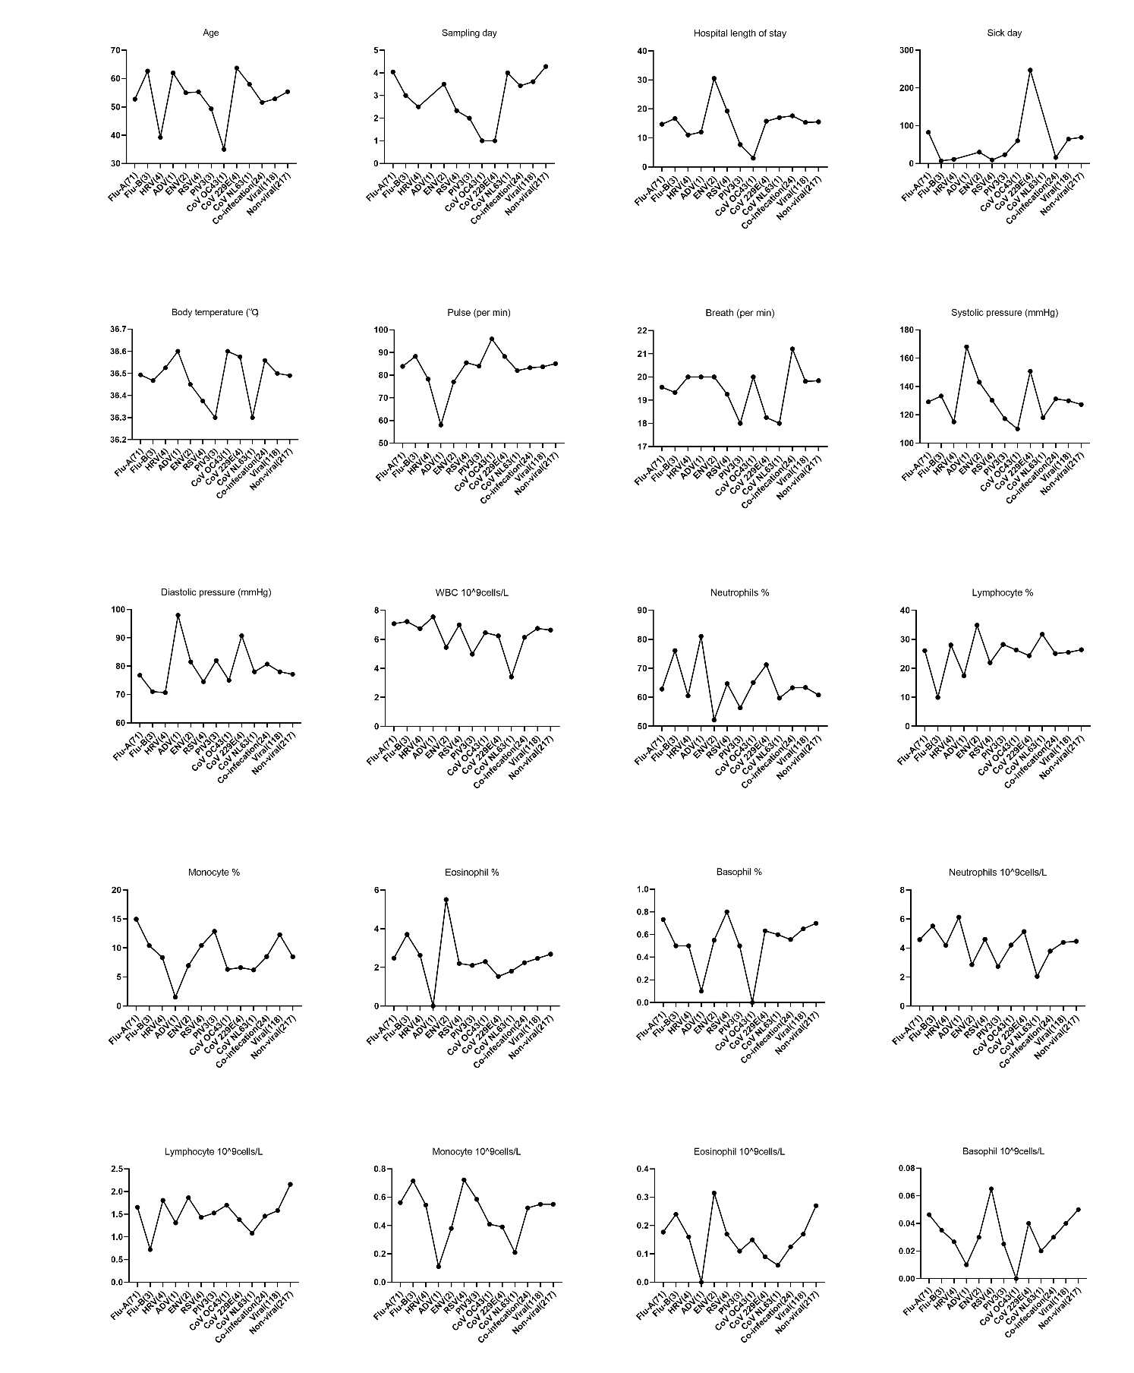
Supplementary Figure 1. Clinical characteristics of the different virus groups

