Supplementary information for
Ultrasensitive broadband photodetectors based on
two-dimensional Bi₂O₂Te films

Authors: Pin Tian^{1,2}, Hongbo Wu³, Libin Tang^{1,2*}, Jinzhong Xiang^{2,4}, Rongbin Ji¹, Shu-Ping Lau^{5*}, Kar Seng Teng^{6*}, Wei Guo^{3*}, Yugui Yao^{3*} and Lain-Jong Li⁷

Address:

¹Kunming Institute of Physics, Kunming 650223, P.R. China.

²Yunnan Key Laboratory of Advanced Photoelectric Materials & Devices, Kunming 650223, P.R. China.

³Beijing Key Laboratory of Nanophotonics and Ultrafine Optoelectronic Systems and Micro-nano Centre, School of Physics, Beijing Institute of Technology, Beijing 100081, China.

⁴School of Physics and Astronomy, Yunnan University, Kunming 650091, P.R. China.

⁵Department of Applied Physics, The Hong Kong Polytechnic University, Hong Kong SAP, P.R. China.

⁶College of Engineering, Swansea University, Bay Campus, Fabian Way, Swansea SA1 8EN, United Kingdom.

⁷School of Materials Science and Engineering, University of New South Wales, Sydney 2052, Australia. *email: scitang@163.com

Table of Contents
S1. Band structures of 2D Bi₂O₂Te film as a function of thickness by theoretical calculation.
S2. Study of transition from Bi₂Te₃ to Bi₂O₂Te.
S3. Characterization of photodetector based on 2D Bi₂O₂Te and Si substrate.
S4. Discussion on the variation of bandgap with film thickness.
S5. Discussion on calculation of indirect and direct bandgap semiconductor.
S6. Discussion on lattice distance and crystal orientation of Bi₂O₂Te.
S7. Discussion on transient response time of photodetector based on 2D Bi₂O₂Te.
S8. Discussion on relevant parameters of photodetector based on 2D Bi₂O₂Te.
S9. Table on a list of Hall measurements on sputtered Bi₂Te₃ (Supplementary Table 2).

S1. Band structures of 2D Bi₂O₂Te film as a function of thickness by theoretical calculation.
Supplementary Fig. 1 | Electronic structures of 2D layered Bi₂O₂Te. a, The atomic structures of 2D layered Bi₂O₂Te film with four-layer thickness. b-g, Evolution of the band structures of 2D layered Bi₂O₂Te ranging from monolayer to six layers. The pink, dark-yellow, and orange circles represent contributions of Bi-6p, Te-5p, and O-2p orbitals, respectively. The Fermi level is shifted to zero.
Supplementary Fig. 2 | Evolution of the indirect bandgaps of Bi₂O₂Te as a function of film thickness. Left panel: PBE vs PBE+SOC. Right panel: HSE vs HSE+SOC.
S2. Study of transition from Bi₂Te₃ to Bi₂O₂Te.
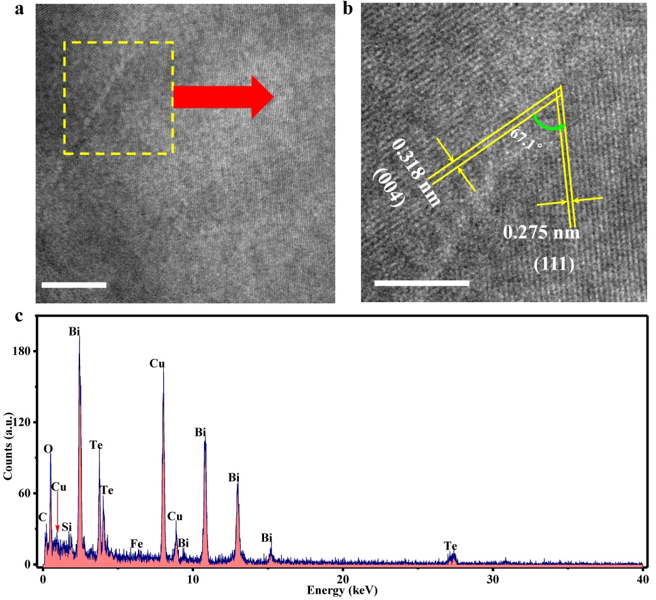
Supplementary Fig. 3 | The structure characterization of Bi₂O₂Te thin film. a, Transmission electron microscope (TEM) images of as-prepared Bi2O2Te film. b, High-resolution TEM (HRTEM) image of highlighted area in (a) showing crystal spacing of 0.318 and 0.275 nm along (004) and (111), respectively and grain boundary angle of 67.1°. h, The energy disperse spectroscopy (EDS) analysis. Scale bars, 10 nm, (a), 5 nm, (b).

Supplementary Fig. 4 | HRTEM characterization of Bi₂O₂Te thin film. a-b, HRTEM images of Bi₂O₂Te thin film prepared by transition of Bi₂Te₃ (a). HRTEM image showing lattice fringes with separation of 0.281 nm along (110) (b), enlarged from Fig. 6a. c, The fast fourier transform (FFT) image of Fig. 6a, and the patterns indicate that the crystal is of square structure. d, Energy dispersive spectroscopy (EDS) of Bi₂O₂Te thin film showing the presence of Bi, O and Te elements. Si and Cu peaks were also appeared in the spectrum due to Si substrate and Cu gird, respectively. Scale bars, 5 nm (a), 2 nm (b), 5 nm⁻¹ (c).

Supplementary Fig. 5 | TEM characterization of Bi₂Te₃ thin film prepared by sputtering. a-b, Morphology of Bi₂Te₃ thin film prepared by sputtering. The film was prepared by sputtering (a), and some dark spots observed in Fig. 4(b) on the thin film due to the direction of deposition, which the substrate was directly below to target. c-d, HRTEM image of Bi₂Te₃ thin film. The thin film was dense and composed of single crystal snowflake-like structures (c). The inset of Fig. 4c indicates that the thin film is of polycrystalline structure. The lattice fringes of the polycrystalline structure were evident (d). Scale bars, 2 μm (a), 500 nm (b), 20 nm (c), 5 nm (d).

Supplementary Fig. 6 | HRTEM characterization of Bi₂Te₃ thin film prepared by sputtering. a-b, HRTEM images of Bi₂Te₃ thin film prepared by sputtering. HRTEM image of uniform film (a), and image showing lattice fringes with separation of 0.31 and 0.328 nm along (015) (b), which was enlarged from the green circle in Fig. 5a. c-d, HRTEM images showing dark spots on the uniform film (c), and HRTEM image showing lattice fringes in Fig. 5(d), enlarged from cyan circle in Fig. 5(c). Scale bars, 5 nm (a), 2 nm (b), 50 nm (c), 10 nm (d).

Supplementary Fig. 7 | AFM measurements on the thickness of Bi₂Te₃ and Bi₂O₂Te films prepared under various conditions. a-c, The thickness of Bi₂Te₃ prepared with sputtering duration of 5 s (a), 10 s (b) and 15 s (c) while keeping other parameters constant. d-f, The thickness of Bi₂O₂Te prepared with Bi₂Te₃ sputtering duration of 5 s (d), 10 s (e) and 15 s (f) followed by rapid annealing at 400℃ for 10 min. Scale bars, 5 μm (a-f).

Supplementary Fig. 8 | Optical characterization of sputtered Bi₂Te₃ thin film. a, UV-visible near infrared absorption spectrum of Bi₂Te₃ thin film with different sputtering duration of 10, 15, 20, 30, 45 and 60 s. Inset shows optical images of Bi₂Te₃ grown on quartz (top panel) and Si/SiO₂ (bottom panel) substrates by sputtering for 1, 5, 10, 15, 20, 30, 45 and 60 s from left to right. The size of substrates was about 2 cm x 2 cm. b, The Fourier transform-infrared attenuated total reflection (FTIR-ATR) spectra of the Bi₂Te₃ with different sputtering durations of 10, 15, 20, 30, 45 and 60 s. c,d, Change in absorption density for various thickness film was similar to the UV-visible near infrared absorption below 9.8 μm (c), the variation trend was contrasted beyond 9.8 μm (d), which attributed to the absorption of quartz substrate.
Supplementary Fig. 9 | Optical characterization of Bi₂O₂Te thin film and optical bandgap of Bi₂Te₃ film. a, UV-visible near infrared absorption spectrum of Bi₂O₂Te thin film by transition of Bi₂Te₃ with sputtering duration of 1 s. Inset shows the enlarged absorption spectrum ranged from 1000 to 2600 nm. b, The schematic optical bandgap of Bi₂Te₃ thin film based on the calculation of FTIR-ATR absorption spectrum (see Supplementary Discussion for detailed calculation). Bi₂Te₃ has bulk states (bandgap ≈ 0.14 eV) and gapless surface states due to topological characterization.¹ Furthermore, the Fermi energy is above the conduction band due to the n-type nature of Bi₂Te₃ semiconductor according to the Hall measurement results (see Supplementary Table 2).

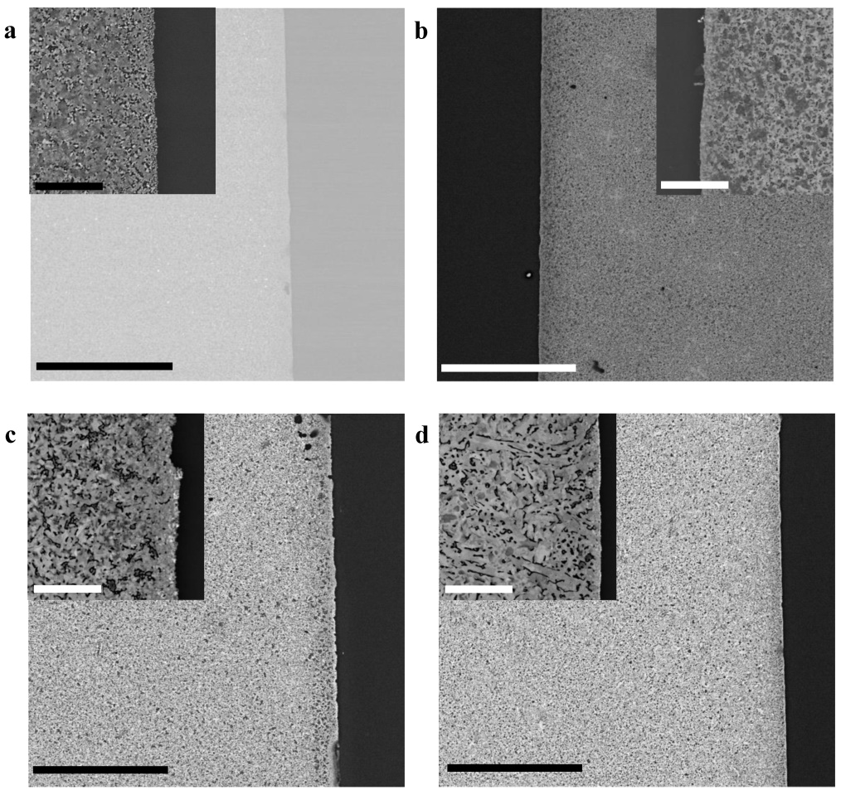
Supplementary Fig. 10 | SEM images of 2D Bi₂O₂Te at various sputtering conditions. a-d, SEM images of 2D Bi₂O₂Te by transition of Bi₂Te₃ prepared by sputtering for 1 (a), 5 (b), 10(c) and 15 s(d) followed by annealing at 400 ℃ under air atmosphere. All insets show enlarged images revealing uniform and dense films. Besides, the surface texture become denser and the microstructures grown larger in size with increasing sputtering time. Scale bars, 20 μm (a-d), 2 μm (inset in a-d).

S3. Characterization of photodetector based on 2D Bi₂O₂Te and Si substrate.
Supplementary Fig. 11 | Rectification characteristics and J-V measurements of photodetector based on 2D Bi₂O₂Te. a, Rectification characteristics of photodetector based on 2D Bi₂O₂Te by transition of Bi₂Te₃ prepared by sputtering for 1, 5, 10 and 15s followed by annealing at 400 ℃ under air atmosphere. The results indicate small rectification for increasing sputtering duration. b, The J-V results of photodetector based on the thinnest 2D Bi₂O₂Te under weak light illumination. Two insets show the increase of current density under weak light illumination ranged from 210 to 2400 nm, which indicate that this device has a good response to weak lights.

Supplementary Fig. 12 | Performance characterization of photodetector based on 2D Bi₂O₂Te. a and b, The J-V curves of photodetector based on the thinnest 2D Bi₂O₂Te under strong light illumination using LEDs (a). An increase in current density was evident as compared to dark current density (b). c and d, show the R and D* vs voltage curves, respectively.

Supplementary Fig. 13 | The transient response characteristics of photodetector based on 2D Bi₂O₂Te. a-j, The transient response curves of photodetector based on the thinnest 2D Bi₂O₂Te under strong light illumination using LEDs with wavelength of 365 (a), 400 (b), 500 (c), 520 (d), 555 (e), 590 (f), 660 (g), 740 (h), 850 (i) and 940 nm (j). The response time for each wavelength was calculated. Please see Supplementary Discussion 7 for the detailed calculation.

Supplementary Fig. 14 | The power density vs wavelength of weak light sources. Red line represents the power density curves measured using bolometer and black line represents the power density curves obtained from the light source system.

Supplementary Fig. 15 | Comparison on performances of photodetectors based on different 2D materials. a and b, Comparison on responsivity (a) and detectivity (b) of photodetectors based on different 2D materials and 2D Bi₂O₂Te (in this work) as well as traditional Si and GaAs photodetectors. c and d, Comparison on responsivity (c) and detectivity (d) of photodetectors based on Si hybrid with different 2D materials and 2D Bi₂O₂Te (in this work) as well as traditional Si and GaAs photodetectors. Data are extracted from ref. 2-43.
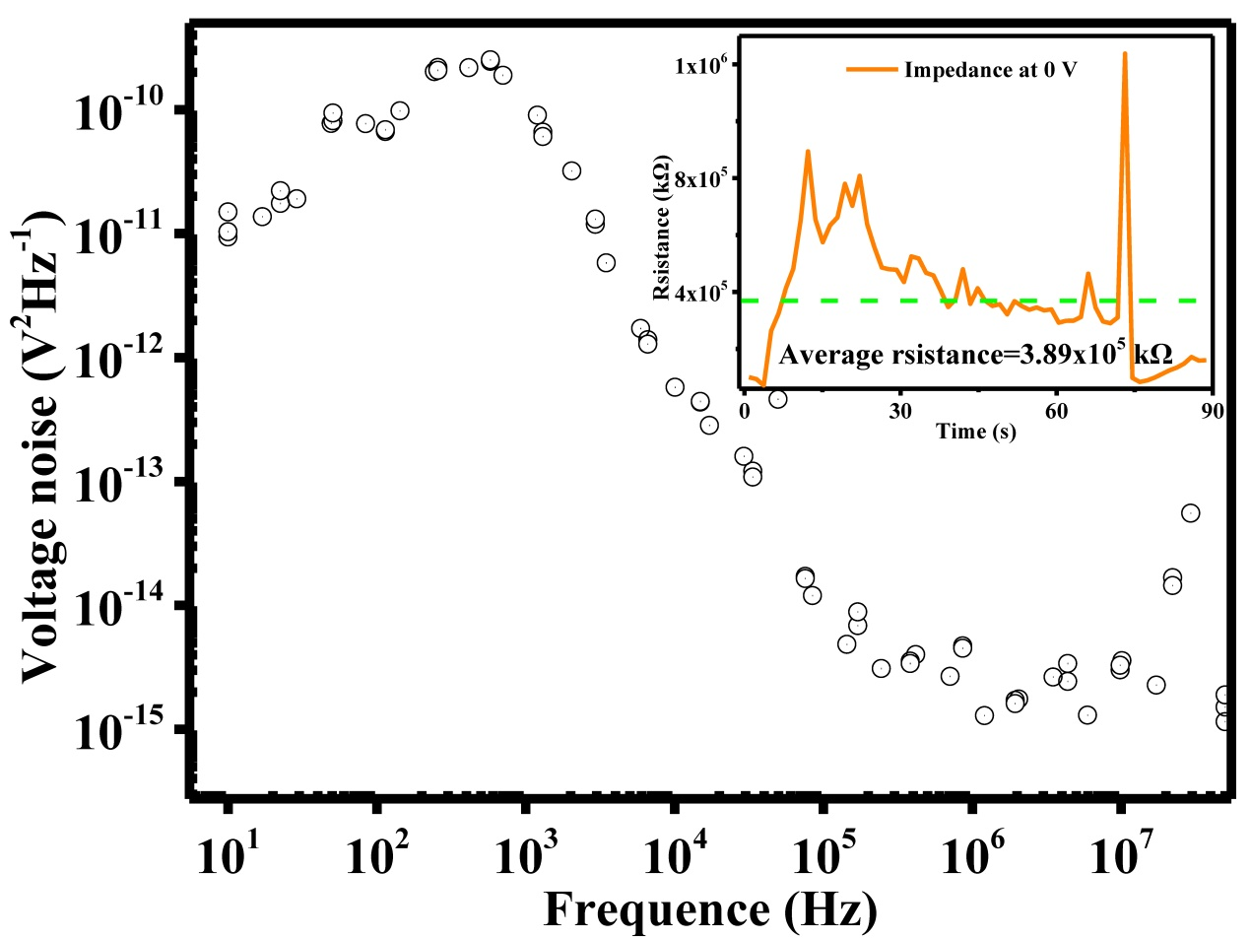
Supplementary Fig. 16 | Spectra of voltage noise power density at 0 V. Inset shows the resistance curve of device at 0 V, which the average resistance of the photodetector is about 3.89x10⁸ Ω.
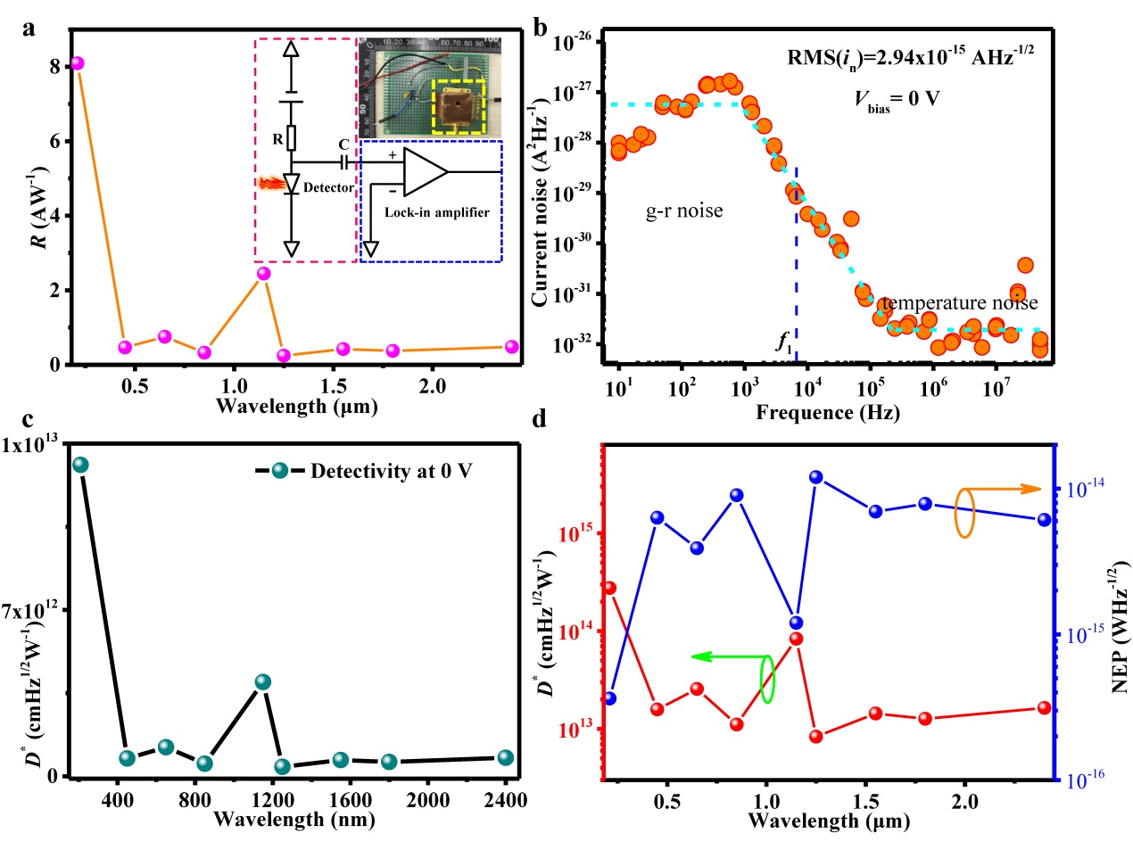
Supplementary Fig. 17 | Relevant parameters of photodetector based on 2D Bi₂O₂Te. a, Responsivity spectrum of photodetector based on 2D Bi₂O₂Te at 0 V according to the calculation of J-V curves under direct current (DC) mode. Inset shows the circuit diagram and optical image of the device, which operated in alternating current (AC) mode. b, Spectra of current noise power density at 0 V. c, A plot of detectivity against light wavelengths for the 2D Bi₂O₂Te based photodetector at 0 V according to the calculation of J-V curves under direct current (DC) mode. d, Graphs showing the detectivity (red dash-dotted line) and noise equivalent power density (blue dash-dotted line) against light wavelengths for the 2D Bi₂O₂Te based photodetector at 0 V according to the calculation of noise spectrum and responsivity under AC mode. Please see Supplementary Discussion 8 for the detailed calculations.
S4. Discussion on the variation of bandgap with film thickness.
Supplementary Fig. 1 summarizes the evolution of the band structures of 2D Bi₂O₂Te film as a function of thickness. Here, for computation efficiency, the calculations were performed at GGA+SOC level, focusing on the orbital contribution and evolution tendency to provide qualitative physics insight. The CBMs and VBMs of Bi₂O₂Te thin film are located at Γ and X, respectively. Close to the Fermi level, the CBM states at Γ and VMB states at X mainly originate from Bi 6p-orbital states and the Te 5p-orbital states, respectively. Similar to the layer-dependent band structure evolution feature of few-layer black phosphorus⁴⁴, an increasing 2D Bi₂O₂Te films thickness will lead to stronger interlayer interaction, hence resulting in stronger dispersions of CBMs and VBMs and tunable bandgap with varying film thickness. However, due to the underestimation of the bandgap from PBE (about ~0.5 eV in this case), the closing bandgap is re-opened after using the hybrid functional, which is discussed in the next paragraph.
In Supplementary Fig. 2, both PBE-GGA and HSE bandgap results are shown for comparison. The standard hybrid functional (e.g. 25% Hartree-Fock and 75% PBE-GGA) calculations employ a screened Coulomb potential for the exchange interaction, which will enhance the bandgap. Although the HSE method opens the bandgap of ~0.5 eV, it is almost a constant correction and the trends of dependence of bandgap on thickness are in good agreement with PBE-GGA values⁴⁵. Because of the strong SOC effect of Bi and Te atoms, the bandgap is decreased by ~0.15 eV. Due to the well-known quantum confinement effect, the bandgaps of 2D Bi₂O₂Te thin film show classic thickness-dependence for all the calculations shown in Supplementary Fig. 2. The hydrogen passivation effect at the outer most layers of the 2D Bi₂O₂Te structures has caused a dramatic decrease in the bandgap from monolayer to 2 layers. Then, the bandgap gradually decreases and reaches convergence at about ~6 layers (e.g. thickness ~ 40Å), in consistent with the experimental observation.
S5. Discussion on calculation of indirect and direct bandgap semiconductor.
The optical absorption is mainly attributed to lattice absorption of crystal. However, the semiconductors can be divided into indirect and direct bandgap semiconductor dependent on the alignment of its VBM and CBM. Thus, the optical bandgap of different semiconductor materials can be calculated using different equations. For indirect semiconductors, the optical bandgap can be obtained according to Tauc equation⁴⁶:
α(hν)=A(hν-E_{g})² (1)
where α(hν) is absorption coefficient (cm⁻¹), hν is photon energy, A is constant, and E_{g} is optical bandgap of semiconductor. For direct semiconductor, the optical bandgap can be calculated using the following expression due to the absence of phonons in the process of photon excitation:
α(hν)=A(hν-E_{g})^{1/2} (2)
According to the above equations, we can obtain the optical bandgap of indirect semiconductor Bi₂O₂Te and direct semiconductor Bi₂Te₃.
S6. Discussion on lattice distance and crystal orientation of Bi₂O₂Te.
According to Bragg formula, lattice distance can be calculated from the angle at XRD pattern:
2dsinθ=nλ (3)
where d is lattice distance, θ is diffraction half angle, n is diffraction series (n=1, 2, 3, 4……), and λ is wavelength of target (e.g. Cu target, λ=1.54056 Å). Besides, lattice distance can be calculated from the FFT pattern by the formula:
d=1/r (4)
where d is lattice distance, and r is between bright dot and central dot (unit: nm⁻¹).
According to the tetragonal structure of Bi₂O₂Te, we can obtain the crystal orientation responding to lattice distance through the expression:
d= [(h/a)²+(k/b)²+(l/c)²]^{-1/2} (5)
where d is lattice distance, h, k, l represent the crystal orientation along x, y, z axis respectively, and a, b and c are the crystal parameters. Thus, we can obtain the crystal orientation responding distance according the crystal parameters of Bi₂O₂Te, and part parameters are listed in Supplementary Table 1, as following:
h | k | l | D
1 | 0 | 0 | 0.398
0 | 0 | 1 | 1.27
1 | 1 | 0 | 0.281
1 | 0 | 1 | 0.38
1 | 1 | 1 | 0.275
2 | 0 | 0 | 0.199
0 | 0 | 2 | 0.635
2 | 1 | 0 | 0.178
1 | 0 | 2 | 0.337
2 | 0 | 1 | 0.197
2 | 2 | 0 | 0.141
2 | 0 | 2 | 0.19
1 | 1 | 2 | 0.257
2 | 1 | 1 | 0.176
2 | 2 | 1 | 0.14
2 | 1 | 2 | 0.171
2 | 2 | 2 | 0.137
3 | 0 | 0 | 0.133
0 | 0 | 3 | 0.423
3 | 1 | 0 | 0.126
3 | 0 | 1 | 0.132
1 | 0 | 3 | 0.29
3 | 2 | 0 | 0.11
3 | 0 | 2 | 0.13
2 | 0 | 3 | 0.18
3 | 3 | 0 | 0.094
3 | 0 | 3 | 0.127
3 | 2 | 1 | 0.11
2 | 1 | 2 | 0.171
3 | 3 | 1 | 0.094
3 | 1 | 3 | 0.121
3 | 2 | 2 | 0.109
2 | 2 | 3 | 0.134
3 | 3 | 2 | 0.093
3 | 2 | 3 | 0.107
3 | 3 | 3 | 0.092
4 | 0 | 0 | 0.1
0 | 0 | 4 | 0.318
4 | 1 | 0 | 0.097
4 | 0 | 1 | 0.099
1 | 0 | 4 | 0.248
4 | 1 | 1 | 0.096
1 | 1 | 4 | 0.211
4 | 2 | 0 | 0.089
4 | 0 | 2 | 0.098
2 | 0 | 4 | 0.169
4 | 2 | 1 | 0.089
4 | 1 | 2 | 0.095
2 | 1 | 4 | 0.155
4 | 2 | 2 | 0.088
2 | 2 | 4 | 0.129
4 | 3 | 0 | 0.08
3 | 0 | 4 | 0.122
4 | 0 | 3 | 0.097
4 | 3 | 1 | 0.079
4 | 1 | 3 | 0.094
3 | 1 | 4 | 0.117
4 | 3 | 2 | 0.079
4 | 2 | 3 | 0.087
3 | 2 | 4 | 0.104
4 | 3 | 3 | 0.078
3 | 3 | 4 | 0.09
4 | 4 | 4 | 0.069
5 | 0 | 0 | 0.08
0 | 0 | 5 | 0.254
6 | 0 | 0 | 0.066
0 | 0 | 6 | 0.212
7 | 0 | 0 | 0.057
0 | 0 | 7 | 0.181
8 | 0 | 0 | 0.05
0 | 0 | 8 | 0.159
9 | 0 | 0 | 0.044
0 | 0 | 9 | 0.141
0 | 1 | 0 | 0.398
S7. Discussion on transient response time of photodetector based on 2D Bi₂O₂Te.
Due to the internal electric field at the device, photogenerated carriers are swept to the corresponding regions of the device resulting in an increase in the mobile carriers and hence a decrease in resistance at the device. The population and the characteristic time of these carries are denoted as n_{s} and τ_{s}, respectively. As the holes and the electrons are accumulating at the junction region, the net field at the depletion region is reduced resulting in the diffusion of electrons from one semiconductor and recombining with holes in the adjacent semiconductor. The population and the characteristic time of these diffusing electrons are denoted as n_{d} and τ_{d}, respectively. So the net increasing mobile carriers are ∆n = ∆n_{s}e^{-t/τs} -∆n_{d}e^{-t/τd}. Normally, τ_{d} is much longer than τ_{s}, because the holes injected into Bi₂O₂Te is assisted by the built-in field. However, according to the above discussion, we can fit the experimental data to obtain the rise (τ_{r}) and fall (τ_{d}) response time using the expressions⁴⁷:
J_{r}=J_{r0}+Ae^{t/τr} (6)
J_{d}=J_{d0}+Ae^{t/τd} (7)
where J_{r} and J_{d} represent the rise and fall current density respectively, J_{r0} and J_{d0} are the maximum and minimum current density respectively, A is constant, t is time, and τ_{r} and τ_{d} are the rise and fall response time respectively.
S8. Discussion on relevant parameters of photodetector based on 2D Bi₂O₂Te.
As shown in Supplementary Fig. 16, the spectra of voltage noise power density and impedance curve of the photodetector at 0 V was characterized. The current noise spectrum is shown in Supplementary Fig. 17a according to the following equation:
i_{n}=V_{n}/R (8)
where R is resistance of device at 0 V, i_{n} and V_{n} are current and voltage noise, respectively. As shown in Supplementary Fig. 17b, the generation-recombination (g-r) noise dominated at low frequency, while current noise decreased and temperature noise became dominant at high frequency. The characteristic frequency (f₁) can be deduced from the spectra of current noise power density. As presented in Supplementary Fig. 17b, the f₁ is about 6500 Hz. Furthermore, the performance of the photodetector was independent on frequency when it was below f₁. The bandwidth frequency (Δf) was that of the lock-in amplifier at 1 Hz. Since g-r noise dominated the photodetector, the current noise should be selected from the plateau region when evaluating the performances of the photodetector, such as noise equivalent power density (NEP) and detectivity (D*) using the following equations⁴⁸⁻⁵¹:
NEP=i_{n}/R_{i} (9)
D*=(A_{D}Δf)^{1/2}/NEP (10)
where i_{n} and R_{i} are current noise and responsivity without bias voltage, respectively. A_{D} and Δf are active area and bandwidth of the photodetector, respectively. Due to the independent relationship between responsivity and frequency, the responsivity spectrum at 0 V was shown in Supplementary Fig. 17a according to Fig. 4d. The plot of detectivity of the photodetector at 0V in Supplementary Fig. 17c was obtained through measurement at DC mode. Besides, the detectivity and NEP were also characterized in AC mode by measuring current noise using a lock-in amplifier (HF2LI). On basis of equation (9) and (10), the current noise at 6500 Hz was selected (as shown in Supplementary Fig. 17b). Both NEP and detectivity spectra are shown in Supplementary Fig. 17d. When comparing the detectivity spectra under AC and DC modes, it can be concluded that the current noise of the 2D Bi₂O₂Te based photodetector was dominated by g-r noise and the photodetector exhibited equivalent performances under AC and DC modes of operation.
S9. Table on a list of Hall measurements on sputtered Bi₂Te₃ (Supplementary Table 2).
Sputtering time (Seconds) | Resistivity  (Ω·cm) | Hall coefficient (cm³C⁻¹) | Carrier concentration (cm⁻³) | Mobility (cm²V⁻¹s⁻¹) | Conduction type(N/P)
1 | 6.07x10⁻³ | -1.1x10⁻² | 5.69x10²⁰ | 1.81 | N
5 | 2.81x10⁻³ | -5.13x10⁻³ | 1.22x10²¹ | 1.82 | N
10 | 6.2x10⁻³ | -1.47x10⁻² | 4.23x10²⁰ | 2.38 | N
15 | 3.6x10⁻³ | -1.42x10⁻² | 4.41x10²⁰ | 3.93 | N
20 | 4.3x10⁻³ | -7.22x10⁻³ | 8.65x10²⁰ | 1.67 | N
30 | 3.1x10⁻³ | -8.75x10⁻³ | 7.13x10²⁰ | 2.83 | N
45 | 9.0x10⁻³ | -1.29x10⁻² | 4.84x10²⁰ | 1.43 | N
60 | 2.1x10⁻³ | -2.94x10⁻² | 2.12x10²⁰ | 1.40 | N
Supplementary References
1. Chen, Y. L. et al. Experimental realization of a three-dimensional topological insulator, Bi₂Te₃. Science 325, 178-180 (2009).
2. Song, J. et al. Monolayer and few-layer all-inorganic perovskites as a new family of two-dimensional semiconductors for printable optoelectronic devices. Adv. Mater. 28, 4861-4869 (2016).
3. Wang, X. et al. Ultrasensitive and broadband MoS₂ photodetector driven by ferroelectrics. Adv. Mater. 27, 6575-6581 (2015).
4. Xie, C., Mak, C., Tao, X. & Yan, F. Photodetectors based on two-dimensional layered materials beyond graphene. Adv. Funct. Mater. 27, 1603886 (2017).
5. Huang, M. et al. Broadband black-phosphorus photodetectors with high responsivity. Adv. Mater. 28, 3481-3485 (2016).
6. Zhang, Q. et al. 2D semiconductors towards high-performance ultraviolet photodetection. J. Phys. D: Appl. Phys. 52, 303002 (2019).
7. Hao, L. et al. 2D SnSe/Si heterojunction for self-driven broadband photodetectors. 2D Mater. 6, 034004 (2019).
8. Hu, Z. et al. Recent progress in 2D group IV-IV monochalcogenides: synthesis, properties and applications. Nanotechnol. 30, 252001 (2019).
9. Zhang, S. et al. Ultrasensitive hybrid MoS₂-ZnCdSe quantum dot photodetectors with high gain. ACS Appl. Mater. & Interfaces 11, 23667-23672 (2019).
10. Wang, B. et al. Broadband photodetectors based on 2D group IVA metal chalcogenides semiconductors. Appl. Mater. Today 15, 115-138 (2019).
11. Yin, Y. et al. High-speed and high-responsivity hybrid silicon/black-phosphorus waveguide photodetectors at 2 µm. Laser & Photon. Rev. 13, 1900032 (2019).
12. Zhang, X. et al. Edge-state-enhanced ultrahigh photoresponsivity of graphene nanosheet-embedded carbon film/silicon heterojunction. Adv. Mater. Interfaces 1802062 (2019).
13. Wang, F. et al. 2D metal chalcogenides for IR photodetection. Small 15, 1901347 (2019).
14. Long, M., Wang, P., Fang, H. & Hu, W. Progress, challenges, and opportunities for 2D material based photodetectors. Adv. Funct. Mater. 29, 1803807 (2018).
15. Zeng, W. et al. Synthesis of large-area atomically thin BiOI crystals with highly sensitive and controllable photodetection. Adv. Funct. Mater. 29, 1900129 (2019).
16. Zheng, Y. et al. Self-integrated hybrid ultraviolet photodetectors based on the vertically aligned InGaN nanorod array assembly on graphene. ACS Appl. Mater. & Interfaces 11, 13589-13597 (2019).
17. Alsaif, M. et al. 2D SnO/In₂O₃ van der Waals heterostructure photodetector based on printed oxide skin of liquid metals. Adv. Mater. Interfaces 6, 1900007 (2019).
18. Khan, U. et al. Controlled vapor-solid deposition of millimeter-size single crystal 2D Bi₂O₂Se for high-performance phototransistors. Adv. Funct. Mater. 29, 1807979 (2019).
19. Kim, Y., Bark, H., Kang, B. & Lee, C. Wafer-scale substitutional doping of monolayer MoS₂ films for high-performance optoelectronic devices. ACS Appl. Mater. & Interfaces 11, 12613-12621 (2019).
20. Hu, A. et al. Graphene on self-assembled InGaN quantum dots enabling ultrahighly sensitive photodetectors. Adv. Opt. Mater. 7, 1801792 (2019).
21. Zhang, K. et al. A substrate-enhanced MoS₂ photodetector through a dual-photogating effect. Mater. Horiz. 6, 826-833 (2019).
22. You, C. et al. Cascade-type energy band design of a black phosphorus photodetector with high performance. J. Mater. Chem. C 7, 2232-2239 (2019).
23. Chen, D. R. et al. Lateral two-dimensional material heterojunction photodetectors with ultrahigh speed and detectivity. ACS Appl. Mater. & Interfaces 11, 6384-6388 (2019).
24. Li, A. et al. Ultrahigh-sensitive broadband photodetectors based on dielectric shielded MoTe₂/Graphene/SnS₂ p-g-n junctions. Adv. Mater. 31, 1805656 (2019).
25. Ulaganathan, R. K., Yadav, K., Sankar, R., Chou, F.C. & Chen Y.-T. Hybrid InSe nanosheets and MoS₂ quantum dots for high-performance broadband photodetectors and photovoltaic cells. Adv. Mater. Interfaces 1801336 (2018).
26. Zeng, L.-H. et al. Controlled synthesis of 2D palladium diselenide for sensitive photodetector applications. Adv. Funct. Mater. 29, 1806878 (2019).
27. Fu, Q. et al. Ultrasensitive 2D Bi₂O₂Se phototransistors on silicon substrates. Adv. Mater. 31, 1804945 (2019).
28. Liu, T., Tong, L., Huang, X. & Ye, L. Room-temperature infrared photodetectors with hybrid structure based on two-dimensional materials. Chin. Phys. B 28, 017302 (2019).
29. Wang, F. et al. Liquid-alloy-assisted growth of 2D ternary Ga₂In₄S₉ toward high-performance UV photodetection. Adv. Mater. 31, 1806306 (2019).
30. Yu, M. et al. Synthesis of two-dimensional alloy Ga_{0.84}In_{0.16}Se nanosheets for high-performance photodetector. ACS Appl. Mater. & Interfaces 10, 43299-43304 (2018).
31. Peng, M. et al. PbS quantum dots/2D nonlayered CdS_{x}Se_{1-x} nanosheet hybrid nanostructure for high-performance broadband photodetectors. ACS Appl. Mater. & Interfaces 10, 43887-43895 (2018).
32. Lu, J. et al. Graphene/In₂S₃ van der Waals heterostructure for ultrasensitive photodetection. ACS Photon. 5, 4912-4919 (2018).
33. Qin, J. K. et al. Epitaxial growth of 1D atomic chain based Se nanoplates on monolayer ReS₂ for high-performance photodetectors. Adv. Funct. Mater. 28, 1806254 (2018).
34. Hu, X. et al. Halide-induced self-limited growth of ultrathin nonlayered Ge flakes for high-performance phototransistors. J. Am. Chem. Soc. 140, 12909-12914 (2018).
35. Patel, M., Kim, J. & Kim, Y. K. Growth of large-area SnS films with oriented 2D SnS layers for energy-efficient broadband optoelectronics. Adv. Funct. Mater. 28, 1804737 (2018).
36. Cao, S. et al. Ultrahigh-photoresponsive UV photodetector based on a BP/ReS₂ heterostructure p-n diode. Nanoscale 10, 16805-16811 (2018).
37. Deng, W. et al. High detectivity from a lateral graphene-MoS₂ schottky photodetector grown by chemical vapor deposition. Adv. Electron. Mater. 4, 1800069 (2018).
38. Wu, D. et al. Design of 2D layered PtSe₂ heterojunction for the high-performance, room-temperature, broadband, infrared photodetector. ACS Photon. 5, 3820-3827 (2018).
39. Wang, F. et al. 2D library beyond graphene and transition metal dichalcogenides: a focus on photodetection. Chem. Soc. Rev. 47, 6296-6341 (2018).
40. Wang, F. et al. Submillimeter 2D Bi₂Se₃ flakes toward high-performance infrared photodetection at optical communication wavelength. Adv. Funct. Mater. 28, 1802707 (2018).
41. Yang, M. et al. Enhanced performance of wideband room temperature photodetector based on Cd₃As₂ thin film/pentacene heterojunction. ACS Photon. 5, 3438-3445 (2018).
42. Amani, M. et al. Solution-synthesized high-mobility tellurium nanoflakes for short-wave infrared photodetectors. ACS Nano 12, 7253-7263 (2018).
43. Gao, Y. et al. Bias-switchable negative and positive photoconductivity in 2D FePS₃ ultraviolet photodetectors. Nanotechnol. 29, 244001 (2018).
44. Qiao, J., Kong, X., Hu, Z.-X., Yang, F. & Ji, W. High-mobility transport anisotropy and linear dichroism in few-layer black phosphorus. Nat. Comm. 5, 4475 (2014).
45. Duan, Y., Qin, L., Shi, L., Tang, G. & Shi, H. Hybrid density functional theory study of band gap tuning in AlN and GaN through equibiaxial strains. Appl. Phys. Lett. 100, 022104 (2012).
46. Wang, W. et al. Crystal field splitting and optical bandgap of hexagonal LuFeO₃ films. Appl. Phys. Lett. 101, 241907 (2012).
47. Cai, Y. et al. High performance ultraviolet photodetectors based on ZnO nanoflakes/PVK heterojunction. Appl. Phys. Lett. 109, 073103 (2016).
48. Maiti, R. et al. Strain-engineered high-responsivity MoTe₂ photodetector for silicon photonic integrated circuits. Nat. Photon. https://doi.org/10.1038/s41566-020-0647-4 1749-4893 (2020).
49. Yin, C. et al. Ultrabroadband photodetectors up to 10.6 µm based on 2D Fe₃O₄ nanosheets. Adv. Mater. 32, 2002237 (2020).
50. Huang, J. et al. A high-performance solution-processed organic photodetector for near-infrared sensing. Adv. Mater. 32, 1906027 (2019).
51. Li, C. et al. Ultrafast and broadband photodetectors based on a perovskite/organic bulk heterojunction for large-dynamic-range imaging. Light: Sci. & Appl. 9, 31 (2020).

