Supplemental Materials for
Ultra-broadband illusion acoustics for space and time camouflages
Chenkai Liu^{1,2†}, Chu Ma^{3†},Yun Lai^{1,*} and Nicholas X. Fang^{2,4,*}
¹ MOE Key Laboratory of Modern Acoustics, National Laboratory of Solid State Microstructures, School of Physics, and Collaborative Innovation Center of Advanced Microstructures, Nanjing University, Nanjing 210093, China
² Department of Mechanical Engineering, Massachusetts Institute of Technology, 77 Massachusetts Avenue, Cambridge, MA 02139, USA
³ Department of Electrical and Computer Engineering, University of Wisconsin-Madison, WI 53706, USA
⁴Department of Mechanical Engineering, University of Hong Kong, Pokfulam Road, Hong Kong

† C. L. and C. M. contributed equally to this work.
* Corresponding author. Emails: laiyun@nju.edu.cn (Y. L.), nicxfang@hku.hk (N. X. F.),

- Influence of some factors to the transmittance.
- The case of Gaussian wave incidence.
- The case of multiple-point-source radiation.
- Illusion of “time shift”.
- Pulse radiation containing five wave packets.
- A particular illusion metamaterial for a random collection of obstacles.

- Influence of some factors to the transmittance.

To investigate the robustness of the illusion metamaterials, we choose some factors, including the incident angles of the sound waves, the bending angle of the tunnels, as well as the variation of the tunnel width. By using COMSOL Multiphysics, the simulated results of transmittance as a function of these factors and the frequency are plotted in Fig. S1. The corresponding models are respectively shown in the insets. We note that the transmission phase is not affected by these factors, but dominated by the protrusion structures and the frequency discussed in the main text.
From Fig. S1a, it is clearly seen that almost total transmission is realized in a range of $θ_{i}∈[{0 }^{°},{45 }^{°}]$, and is independent to the frequency. Under the large angle incidence, there are some peaks of high transmittance versus the frequency, which is induced by Fabry-Pérot resonances. From the overall domain in Fig. S1a, the average transmittance can approach 80 %. Here, the average transmittance is obtained by $\overline{T}=(\sum{T})/N$, where $T$ presents the transmittance at a particular incident angle and a particular frequency, and $N$ denotes the total number of the data. From Figs. S1b-c, almost total transmission is achieved in a large range of the bending angle, the compression ratio, and the frequency. Further, an example of transmittance versus the tunnel bending angle and the ratio $h/w$ is performed. It is observed that the transmittance is more than 90 % over a large bending-angle range from ${0 }^{°}$ to ${160 }^{°}$, and becomes a little bit smaller when $h/w>0.3$. Here, normal incidence is applied in Figs. S1b-d. For simplicity, the positions of bending and compression are both set at the center of the tunnel.
Thus, the functionality of high transmission for the tunnels is valid against these factors and the frequency.

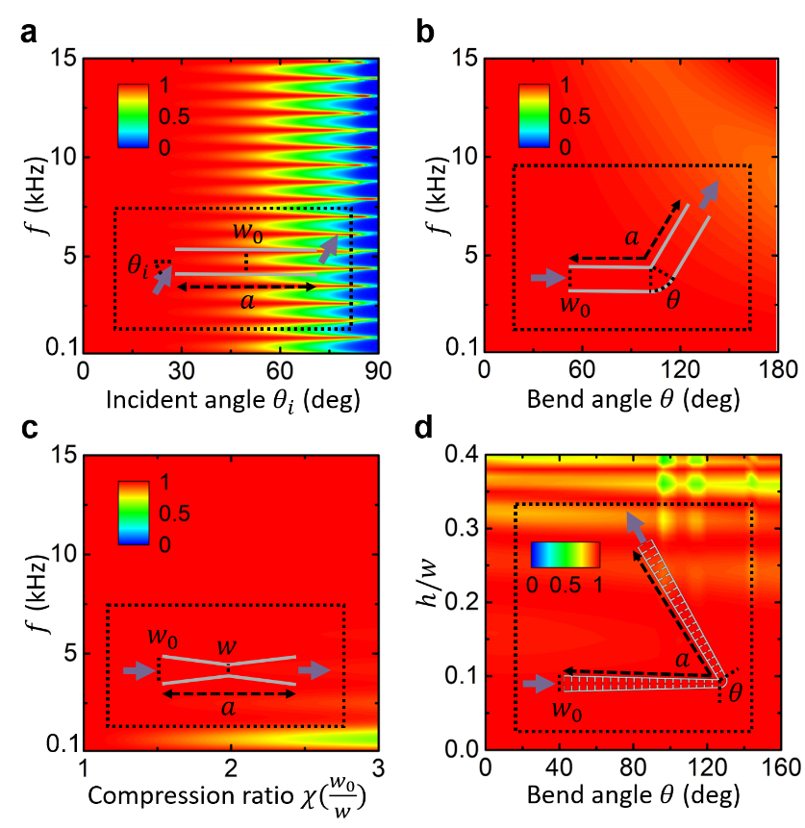
Fig. S1. a Transmittance as a function of the incident angle and the frequency. b Transmittance as a function of the bending angle and the frequency. c Transmittance as a function of the compression ratio and the frequency. Schematic diagrams of the calculated model are respectively shown in insets. The geometric parameters are set as $a=20 cm$ and $w_{0}=8.95 mm$. d Transmittance as a function of the bending angle and the ratio $h/w$. The geometric parameters are set as the same as the tunnels in Fig. 3 in the main text. Compression ratio is $χ=2$ and frequency is $f=6860 Hz$.

- The case of Gaussian wave incidence.

An example of Gaussian wave propagating through a collection of obstacles with and without the illusion metamaterial is performed, as shown in Fig. S2. Different frequencies of $4860 Hz, 6860 Hz, 8860 Hz$ and different incident angles of ${0 }^{°}, {45 }^{°}$ are applied. The design of the metamaterial and the obstacles are the same as Fig. 3 in the main text. Comparing to the huge scattering in the case of bare obstacles in Fig. S2a, perfect Gaussian wave is reproduced in the forward region by the metamaterial in Fig. S2b, as well as negligible reflection in the backward region.

Fig. S2. Simulated acoustic pressure field distributions of Gaussian wave propagating through a collection of obstacles for a, covered by the metamaterial for b at different frequencies and different incidences.

- The case of multiple-point-source radiation.

An example of multiple-point-source radiation propagating through a collection of obstacles is performed in Fig. S3. Three-point sources and three frequencies of $4860 Hz, 6860 Hz, 8860 Hz$ are applied. The design of the metamaterial and the obstacles are the same as Fig. 3 in the main text. For the case of empty field in Fig. S3a, each of three nearby point sources excites a cylindrical wave, leading to a redistribution of sound field. Multiple scattering occurs by a collection of obstacles in Fig, S3b. But when the obstacles covered by the metamaterial in Fig. S3c, the field in the forward region is reproduced, and is accordance with that of empty field, accompanied with an illusion of disappearing space and time shift, as well as negligible reflection in the backward region. Such unique phenomenon is valid at different frequencies, which may be beneficial for identifying and rebuilding complex sound fields.

Fig. S3. Simulated acoustic pressure field distributions of multiple-point-source radiation with different frequencies for a empty field, b bare obstacles, and c obstacles covered with metamaterial.

- Illusion of “time shift”.

To better exhibit the illusion of time shift, the comparison between the field with the metamaterial and the empty field is plotted in Fig. S4. It should be noted that, due to the illusion of disappearing space resulted from the metamaterial, the source position in empty field is set to be shifted. All the other setup is the same as the main text. It is clearly observed that, two transmitted fields (blue dotted box) fit perfectly well with each other in a time difference of $0.66 ms$, and the pulse for the metamaterial arrives slowly than that for the empty field. Such a time shift is consistent with the calculated results from the main text, further demonstrating the illusionary effect of time shift.

Fig. S4. a Snapshots of a sound pulse propagating through a collection of obstacles covered by the metamaterial. b Empty field with a space-offset pulse. Different snapshot denotes field pattern at different moment, where $∆t=0.1 ms$.

- Pulse radiation containing five wave packets.

An example of a sound pulse containing five wave packets propagating through a collection of obstacles is performed as shown in Fig. S5. It is clearly observed that, large scattering appears in the case of bare obstacles in Fig. S5a, while due to the presence of the metamaterial in Fig. S5b, the large scattering is obviously suppressed, and there is an illusionary effect of time shift for transmitted waves.

Fig. S5. a Snapshots of a sound pulse containing five wave packets propagating through a collection of obstacles. b Results for obstacles covered by the metamaterial. The numbers denote the frame order of the snapshots, where $∆t=0.1 ms$.

- A particular illusion metamaterial for a random collection of obstacles.

Here, we show the detailed design and more results of scattering suppression from a random collection of obstacles, shown in Fig. S6. For the random arrangement of three rhombic obstacles, 46 tunnels are designed in the particular metamaterial. The maximum width of the tunnel is set as $8.95 mm$. And the corresponding geometric parameters of $h/w$ are presented in Fig. S6a. Thanks to the protrusion structures, these tunnels possess the same acoustic path distance. The simulated acoustic pressure field distributions at different frequencies for the case of obstacles covered with the metamaterial and its comparison are plotted in Figs. S6b-c, demonstrating the ultra-broadband sound scattering suppression effect.

Fig. S6. a Geometry of $h/w$ for 46 illusion metamaterial tunnels. Wall thickness is $t=1mm$ and lattice constant of protrusion structure is $d=5 mm$. b-c Simulated acoustic pressure field distributions for the case of a random collection of obstacles, and obstacles covered by the metamaterial under a point source radiation with different frequencies of $f=4860 Hz, 8860 Hz$.

