Supplementary tables and figures
Supplementary figure 1: Relationships between AMF biomass (pmol NLFA g⁻¹ soil) and arbuscular mycorrhizal fungi (AMF) colonisation (%) (A), arbuscular colonisation (%) (B), and vesicular colonisation (%) (C) of the grassland plant community (GPC) roots collected in the topsoil (0 – 20 cm) of pasture (P) and silvopasture (SP) plots. Green dots represent samples from pastures (P); orange dots represent samples from silvopastures (SP). The lines are linear relationships fitted to the data with the p-values showing the significance of the correlations. Significance levels: ‘***’: p < 0.001, ‘**’: p < 0.01, ‘*’: p < 0.05, ‘.’; p < 0.1.
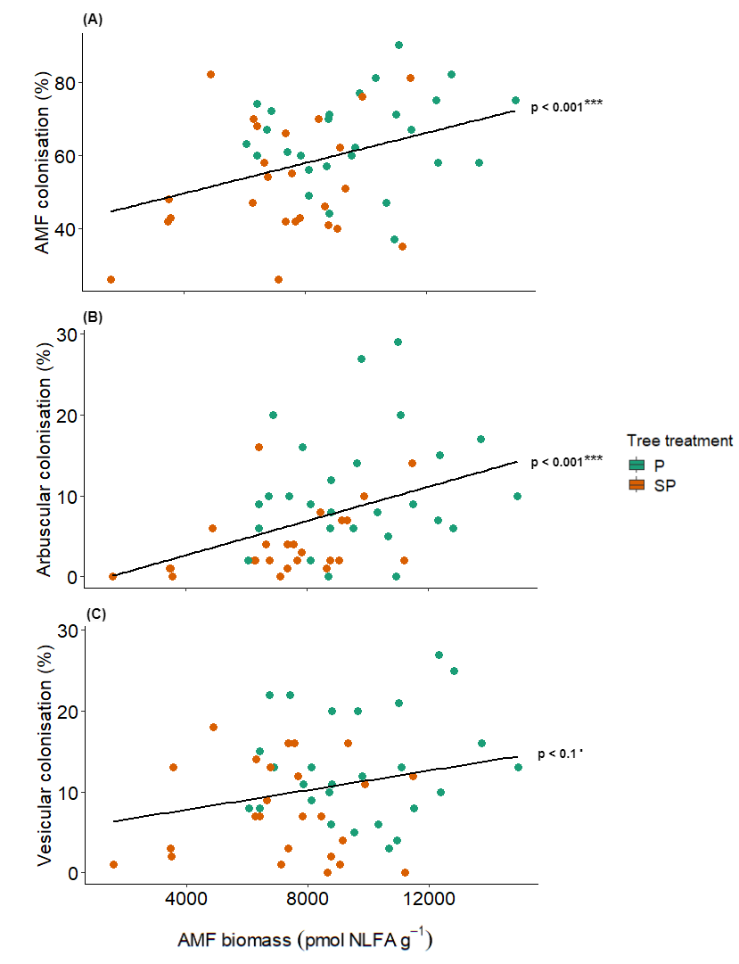
Supplementary figure 2: Total arbuscular mycorrhizal fungi (AMF) colonisation (%) (A), arbuscular colonisation (%) (B), and vesicular colonisation (%) (C) of the grassland plant community (GPC) in the topsoil (0 – 20 cm) in pasture (P) and silvopasture (SP) plots, at sites 1, 2, and 3. Solid lines indicate differences between P and SP and dotted lines indicate differences between sites. Significance levels: ‘***’: p < 0.001, ‘**’: p < 0.01, ‘*’: p < 0.05, ‘.’; p < 0.1.
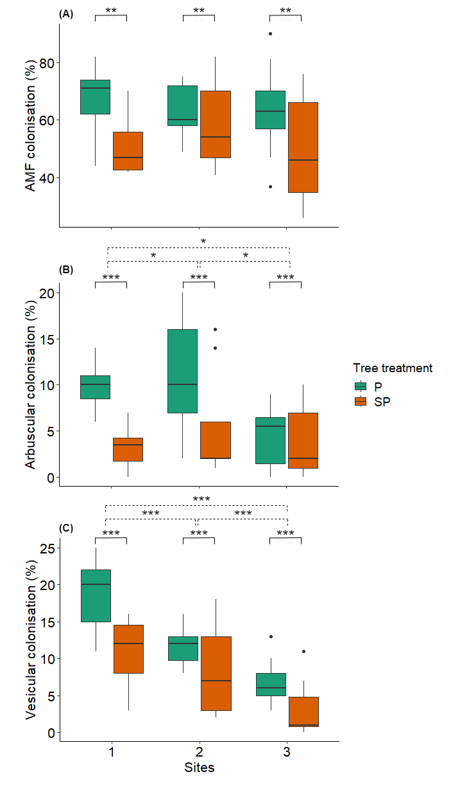
Supplementary figure 3: Nitrogen (N) uptake (log (g m⁻³)) (A) and Phosphorus (P) uptake (log (g m⁻³)) (B) by the grassland plant community (GPC) roots collected in the topsoil (0 – 20 cm) of pasture (P) and silvopasture (SP) plots, at sites 1, 2, and 3. Solid lines indicate differences between P and SP and dotted lines indicate differences between sites. Significance levels: ‘***’: p < 0.001, ‘**’: p < 0.01, ‘*’: p < 0.05, ‘.’; p < 0.1.
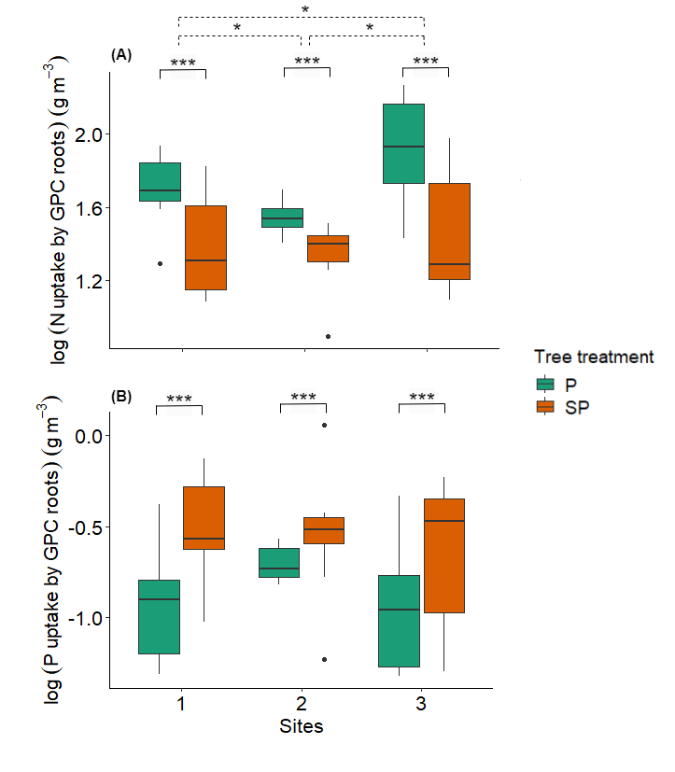
Supplementary figure 4: Relationships between arbuscular mycorrhizal fungi (AMF) biomass (pmol NLFA g⁻¹ soil) and grassland plant community (GPC) root biomass (log(kg m⁻³)) in the topsoil (0 – 20 cm) (A) and subsoil (20 – 60 cm) (B) of pasture (P) and silvopasture (SP) plots. Green dots represent samples from pastures (P); orange dots represent samples from silvopastures (SP). The lines are linear relationships fitted to the data with the p-values showing the significance of the correlations. Significance levels: ‘***’: p < 0.001, ‘**’: p < 0.01, ‘*’: p < 0.05, ‘.’; p < 0.1.
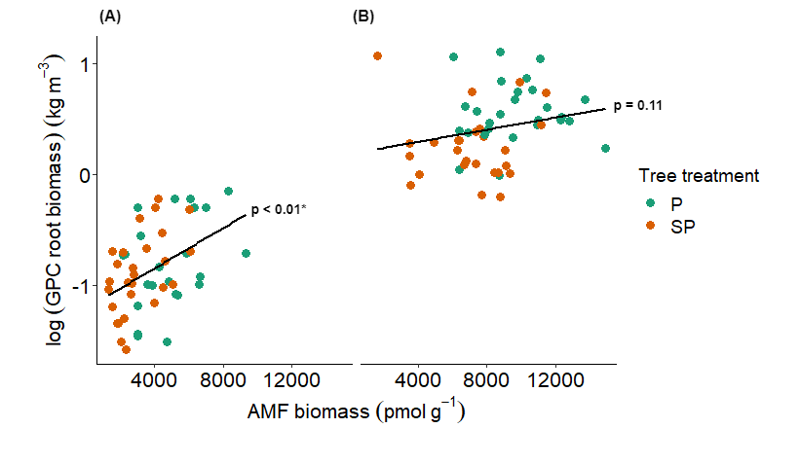
Supplementary figure 5: Relationships between arbuscular mycorrhizal fungi (AMF) biomass (pmol NLFA g⁻¹ soil) and grassland plant community (GPC) nitrogen (N) uptake (log(g m⁻³)) (A) and phosphorus (P) uptake (log(g m⁻³)) (B) in the topsoil (0 – 20 cm) of pasture (P) and silvopasture (SP) plots. Green dots represent samples from pastures (P); orange dots represent samples from silvopastures (SP). The lines are linear relationships fitted to the data with the p-values showing the significance of the correlations. Significance levels: ‘***’: p < 0.001, ‘**’: p < 0.01, ‘*’: p < 0.05, ‘.’; p < 0.1.
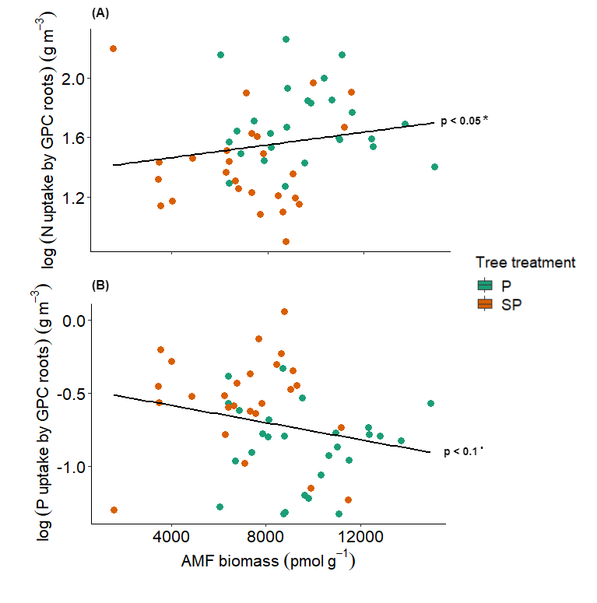
Supplementary table 1: A correlation matrix relating the AMF biomass, AMF arbuscular colonisation, and grassland plant community (GPC) root biomass to Olsen P, organic C, mineral N, pH, and water content measured in the topsoil (0 – 20 cm depth) at three sites including paired pasture and silvopasture plots. AMF biomass [pmol g-1], GPC root biomass [log(kg m⁻³)], Arbuscular colonisation [%], Mineral N [mg N-(NO₃ and NO₂),N-NH₄ L⁻¹soil extract], Olsen-P [mg P-PO₄ L⁻¹ extract], Organic C [%], pH [-], Water content [water weight g.(g soil)⁻¹]. (n = 46)
Statistical significance of correlations is as follows: *** = p < 0.001, ** = p < 0.01, * = p < 0.05 and • = p < 0.07
 | AMF biomass | Arbuscular colonisation | GPC root biomass | Olsen P | Organic C | Mineral N | pH | Water content
AMF biomass | - | 0.35* | 0.22 | -0.11 | 0.04 | 0.06 | 0.35* | -0.02
Arbuscular col. |  | - | 0.34* | 0.20 | -0.27• | -0.33* | -0.25 | 0.14
GPC root biomass |  |  | - | -0.15 | 0.24 | 0.09 | 0.20 | -0.07
Olsen P |  |  |  | - | -0.47* | -0.54*** | -0.58*** | 0.24
Organic C |  |  |  |  | - | 0.72*** | 0.53*** | 0.07
Mineral N |  |  |  |  |  | - | 0.58*** | -0.16
pH |  |  |  |  |  |  | - | -0.50***
Water content |  |  |  |  |  |  |  | -

