Supplementary Material for
The influence of Group Heterogeneity on Mask-Wearing and Epidemic Coevolution: a Coupled Disease-Behavior Model
Yan Song¹ Qian Yang^{1,*}
School of Business and Management, Shanghai international Studies University，Shanghai 201620，China
*E-mail: yangqian_fight@163.com
In the Supplementary document, we provide (1) Details of coupled disease-behavior models, including group heterogeneity distribution of social contagion, social contagion, and disease spread models. (2) Robustness results for critical transitions; (3) Disease spread trajectories for heterogeneous mutations; and (4) Data on mask-wearing and disease spread.
The Network Model of Coupled Disease-behavior Spread
Let $N=\left\{a,b\right\}$ is a two-layer network, where $a=(V,E_{1})$ is the social layer, and $b=(V,E_{2})$ is the biological layer. Layers $a$ and $b$ are defined as synthetic population with the same vertex V and different edges sets E. Structural of each layer is as follows:
- The upper layer of two-layer network uses a modular structure. The modular structure is constructed using our proposed extended model of small-world networks with the following rules: (a) Start with $M$ modules, each with $N/M$ nodes, for a total network of $N$ nodes. Each node in a module is connected to its first neighbors. (b) Randomly disconnect each edge of each module with probability $p_{intra}$. (c) Randomly connect to any vertex of the other modules with probability $p_{inter}$. We use relative modularity $Q$to quantify the modularity of the network (1).
- The lower layer of two-layer network employs a Watts-Strogatz model (2) to capture the spread of disease in the public. The detailed rules are as follows: starting from a ring lattice with $N$ vertices and $k$ edges per vertex, we rewire each edge at random with probability $p$. The average degree can show the characteristics of the network structure.
Group heterogeneity in social contagion
Wearing a mask in public has become a social norm, but its prevalence varies across populations. To illustrate this fact, wearing masks in public has become a social norm, but its prevalence varies across different populations. We Initially set the same threshold interval $\left[τ_{U}^{i}, τ_{L}^{i}\right]$ for each subgroup to denote the group's initial preference, Where $τ_{U}^{i}$and $τ_{L}^{i}$are the up-threshold and down-threshold of the original preference threshold interval. Then, a portion of the group would be compliant after the policy intervention, showing a strong bias in favor of wearing masks (this portion of the group is of the prosocial type). We randomly select several subgroups and change their threshold intervals to$\left[τ_{U}^{i^{'}}, τ_{L}^{i^{'}}\right]$. Finally, the thresholds for the members of each subgroup are chosen uniformly at random in the corresponding threshold interval. In order to quantitatively describe the degree of group heterogeneity of mask-wearing behavior preference, we calculated the difference between the two parts of the threshold means $d={\overline{τ}}^{i}−{\overline{τ}}^{i^{'}}$, $i^{'}$is the selected group, $i$ is the remaining group.
There are two key threshold intervals in the dynamics of coupled spread of mask behavior and disease, namely the peer pressure threshold $τ_{1}$and the fear threshold $τ_{2}$. $τ_{1}$can reflect subgroup preferences for mask-wearing behaviors. For groups that support and prefer to wear masks, members of that group have lower peer pressure thresholds. Conversely, members of groups that dislike or resist wearing masks have higher peer pressure thresholds. In addition, $τ_{2}$covers the effect of global information on disease prevalence on individual mask-wearing behavior. According to Trevas et al. (3), Asian populations have higher odds of wearing masks than white populations. Additionally, Haischer et al. (4) found that shoppers in urban or suburban areas are four times as likely to wear masks compared to those in rural areas. Furthermore, the distribution of fear thresholds was uneven, with people in areas with more cases of COVID-19 and urban areas having a higher level of fear of the disease (5). Huynh (6) stated that the more fear of COVID-19, the more likely one is to wear a mask. Moreover, Bokemper et al. (7) suggested that mask-wearing behavior is self-reinforcing, whereby more people wearing masks in a group will encourage others in the group to wear them (8). Therefore, a reasonable hypothesis is that subgroups with low fear thresholds also have low peer pressure thresholds.
When $τ_{1}^{i}∈\left[τ_{1L}^{i},τ_{1U}^{i}\right], τ_{1}^{i^{'}}∈\left[τ_{1L}^{i^{'}},τ_{1U}^{i^{'}}\right]; τ_{2}^{i}∈\left[τ_{2L}^{i},τ_{2U}^{i}\right], τ_{2}^{i^{'}}∈\left[τ_{2L}^{i^{'}},τ_{2U}^{i^{'}}\right]$
$if τ_{1L}^{i}>τ_{1U}^{i^{'}}, then if τ_{2L}^{i}>τ_{2U}^{i^{'}}$.
Update rules for the social contagion.
individual $v$ wears a mask when one of the following conditions is true.
- Let the peer pressure $φ_{1}(v)$ be the fraction of the neighbors of individual $v$ in $a=(V,E_{1})$ who wear masks at time $t−1$. And $v$ chooses to mask at time $t$ if $φ_{1}(v)≥τ_{1}(v)$ , where $τ_{1}(v)∈\left[τ_{1U}^{i}, τ_{1L}^{i}\right]$ V $\left[τ_{1U}^{i^{'}}, τ_{1L}^{i^{'}}\right]$.
- Let the fear $φ_{2}(v)$ be the fraction of infected individuals by the disease at time $t−1$. And $v$ chooses to mask at time $t$ if $φ_{2}(v)≥τ_{2}(v)$, where $τ_{2}(v)∈\left[τ_{2U}^{i}, τ_{2L}^{i}\right]$ V $\left[τ_{2U}^{i^{'}}, τ_{2L}^{i^{'}}\right]$.
However, if none of the above conditions are met at time $t−1$, $v$ chooses not to wear a mask at time $t$.
SIRS model
The disease is assumed to be divided into three stages: susceptible (S), infected (I) and refractory (R), and the state of the individual is represented by dynamic variables $π_{i}$. An individual in stage S can only be infected after contact with an individual in stage I. Once infected then they become immune after staying in the infected phase for$T_{I}$time. After that maintaining immunity for $T_{R}$ time will revert back to the susceptible state waiting to be infected again (9). Each element is characterized by a time counters${ T}_{i}=0, 1, ...,T_{I}, T_{R}$, as follows:
$$π_{i}(t) = S if T(t)=0$$
$π_{i}(t) = I if T_{i}(t)∈[1,T_{I}]$
$π_{i}(t) = R if T_{i}(t)∈(T_{I}, {T_{I}+T}_{R}]$
The state of an individual at the next moment is related to its state at this moment and the presence or absence of an infected person in its neighborhood. The evolutionary rule is as follows:
$$T_{i}(t+1)=0 if T_{i}(t)=0 and no infection occurs$$
$$T_{i}(t+1)=1 if T_{i}(t)=0 and i becomes infected$$
$$T_{i}(t+1)=T_{i}(t)+1 if 1≤T_{i}(t)≤T_{I}$$
$T_{i}(t+1)=T_{i}(t)+1 if T_{I}<T_{i}(t)≤T_{I}+T_{R}$
$T_{i}(t+1)=0 if T_{i}(t)>T_{I}+T_{R}$
In the above rule of evolution, if there are more infected individuals in the neighborhood, the more susceptible an individual is to be infected. Assuming that the probability of a susceptible individual being infected by an infected neighbor is $q$, then the probability of a susceptible individual becoming infected is $[1−{(1−q)}^{k_{inf}}]$, $k_{inf}$is the number of infected individuals in the neighborhood (Kuperman & Abramson, 2001). since the behavior of wearing masks inhibits the transmission of disease, individuals in the susceptible or infected state wearing masks will have differentially decreased rates of disease transmission. Specifically,
- If only the susceptible vertex wears a mask at time $t$, $q$ is decreased to $αq$, where $α∈\left[0,1\right]$ is a discounting factor.
- If only the infected vertex wears a mask at time $t$, $q$ is decreased to $βq$, where $β∈\left[0,1\right]$ is a discounting factor.
- If both susceptible vertex and infected vertex wear masks at time $t$, the transmission probability becomes $αβq$, where both discounting factors are applied.
Where parameters $α$ and $β$ are responses to the effectiveness of masks.
Basis for parameter selection.
This section describes the selection of the base parameters, as shown in Table (S1). Given that the purpose of wearing masks is to mitigate the risk of disease infection, we assume that no one wears a mask on the first day of the outbreak. The society is also assumed to be at a low prosocial level and set 1 subgroup out of 20 subgroups of the same size within which members show a strong pro-masking bias. In subsequent analyses, we vary the number of subgroups exhibiting a strong pro-masking bias to simulate different societies. The upper and lower limits of peer stress thresholds and fear thresholds are given in the study of Qiu et al (10). and we will set the threshold intervals within this range. In addition, parameters related to the epidemic model have been given in a wide range of studies. We will use various parameter settings to test the stability of the results in later simulations.
Parameter | Description | Baseline | Ref
$$p_{j}$$ | Fraction of population wearing masks on day 1 | 0.00 | Assumed
$$p_{i^{'}}$$ | Number of subgroups with a strong pro-mask bias | 1 | Assumed
$$τ_{1l}$$ | A lower bound of the threshold for peer pressure | 0.01 | (11,12)
$$τ_{1u}$$ | An upper bound of the threshold for peer pressure | 1.0 | (13)
$$τ_{2l}$$ | A lower bound of the threshold for fear | 0.001 | (10)
$$τ_{2u}$$ | An upper bound of the threshold for fear | 0.19 | (10)
$$q$$ | transition probability | 0.1 | (10)
$$α$$ | Discounting factor for a susceptible individual wearing a mask | 0.3 | (10,14)
$$β$$ | Discounting factor for an infected wearing a mask | 0.1 | (10,14)
$$T_{I}$$ | infectious time | 8 | (9)
$$T_{R}$$ | immunity time | 24 | (9)
Table S1. Basis for parameter selection.
In this section, we demonstrate the robustness of the critical transition. Specifically, we study its persistence under various parameter settings, network structures, and model extensions.
Robustness with respect to model parameters. We explored the effect of the fear threshold distribution and the number of subgroups with a strong pro-mask bias on the critical transitions in joint dynamics.
Figure S1 depicts the coupling dynamics of disease-behavior under different heterogeneous degrees of fear threshold. We observe that the critical point shifts back as the degree of group fear threshold heterogeneity increases, and the disease attack rate increases significantly under low fear heterogeneity. Not surprisingly, increasing group fear of disease drives more people to wear masks, thereby inhibiting the spread of disease more effectively.
Figure S2 illustrates the impact of the number of subgroups strongly biased towards wearing masks on the disease-behavior coupling dynamics. We observe that as the number of pro-social type groups increases, there is a significant reduction in disease incidence under highly heterogeneous settings. Thus, improving overall societal acceptance of mask-wearing behavior can help alleviate the losses caused by diseases. Overall, the system exhibits a critical transition in diverse testing scenarios.
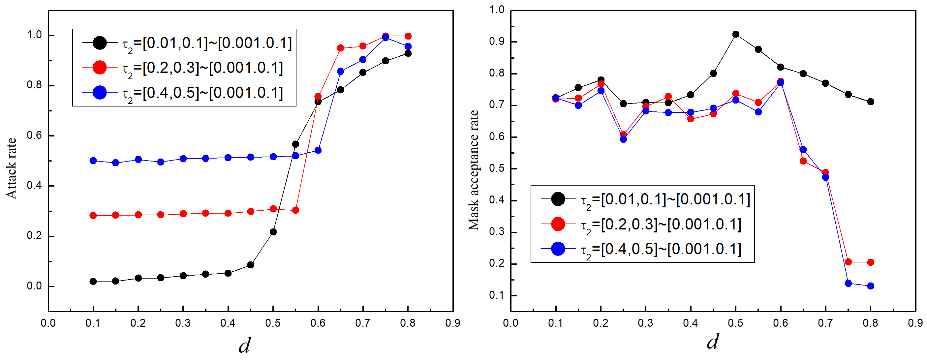
Fig. S1 The coupling dynamics of disease-behavior under different heterogeneous degrees of fear threshold.
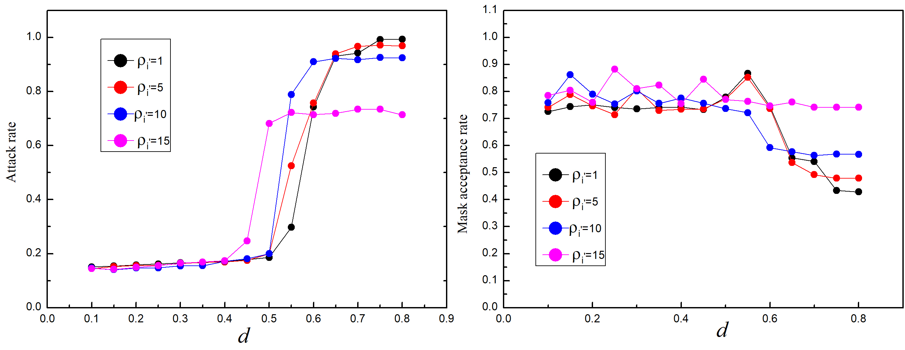
Fig. S2 The impact of the number of subgroups strongly biased towards wearing masks on the disease-behavior coupling dynamics.
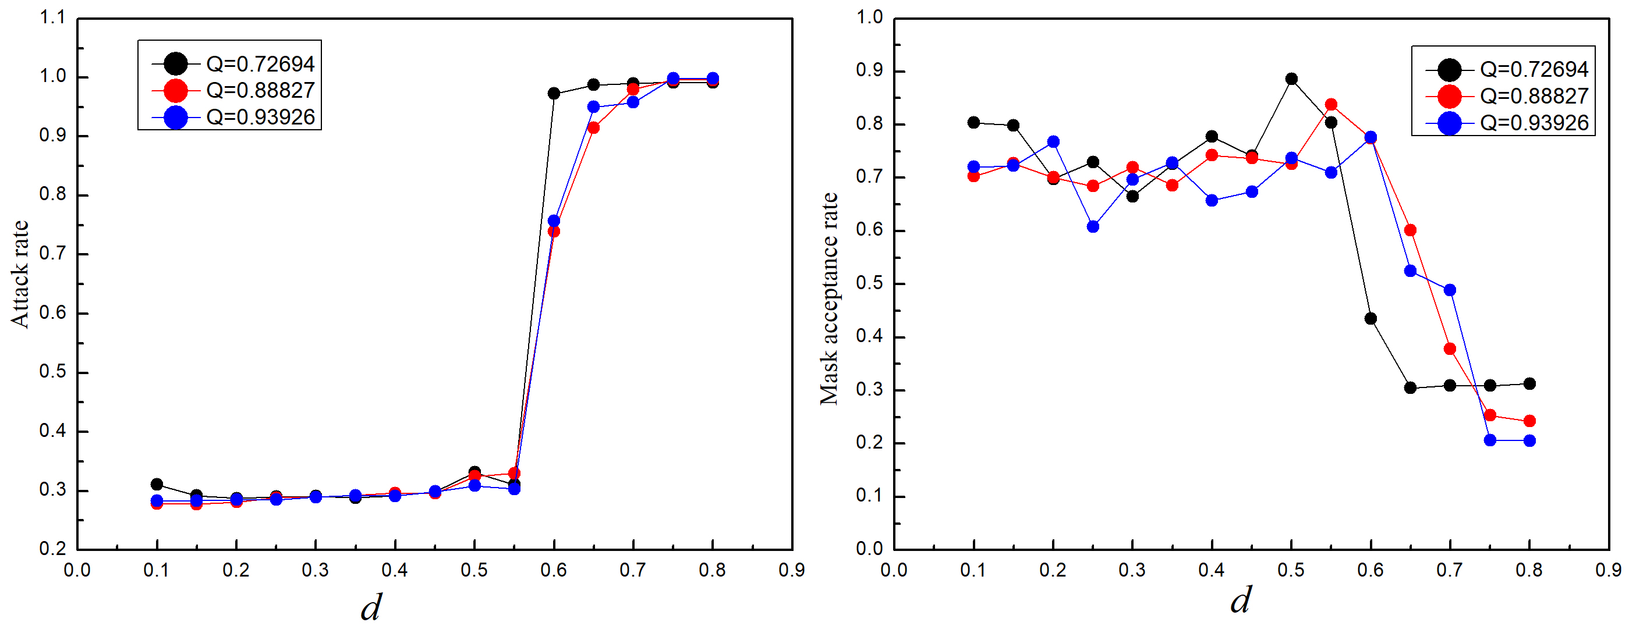
Robustness with respected to network structures. We analyzed the effect of the upper and lower network structure on the critical dynamics of the two-layer network separately. Figure S3 depicts the critical transition phenomenon of the system under different network modularity in the social contagion layer. Figure S4 depicts the critical transition phenomena of the system under different network average degrees in the disease transmission layer. In general, the critical transition phenomena can be observed under various parameter settings, except when the average degree of disease transmission network is high. In such case, the peak of the disease epidemic exceeds the fear threshold of all groups, leading to the collective mask-wearing and making the attack rate of the disease low.
Fig. S3 The critical transition phenomenon of the system under different network modularity in the social contagion layer.
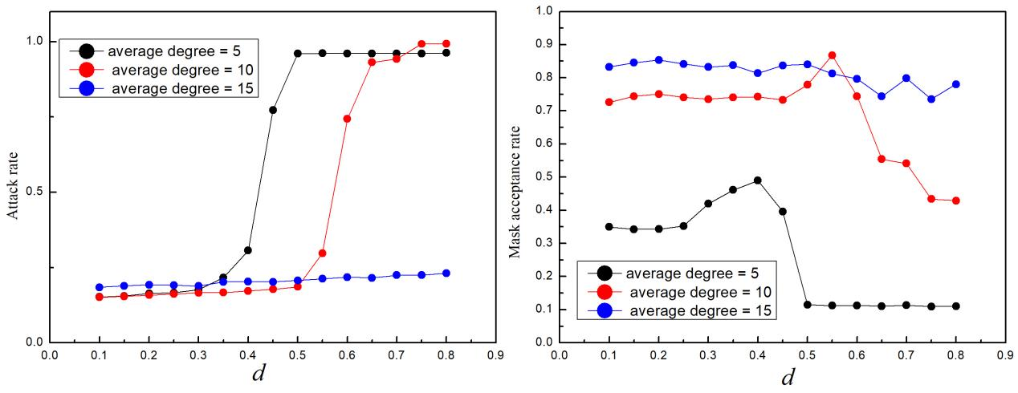
Fig. S4 The critical transition phenomena of the system under different network average degrees in the disease transmission layer.
Results for Model extensions. We also analyzed the simulation results for the case where mask-wearing behavioral preferences are uniformly distributed among individuals, at which time the upper layer network structure is a small-world network. In contrast to considering group heterogeneity in mask-wearing behavior preferences, we can still observe the critical transition phenomenon, as shown in Figure S5. The difference is that only two states emerge for disease dynamics and mask behavior. High mask wear rates and disease extinction after a peak, and low mask wear rates and continued disease transmission, ignoring the important oscillatory phenomenon. In reality, people's attitudes and habits toward mask-wearing vary, and such differences can affect the effectiveness of community-wide epidemic control. Therefore, consideration of group heterogeneity is important for predicting epidemic spread and developing control strategies.
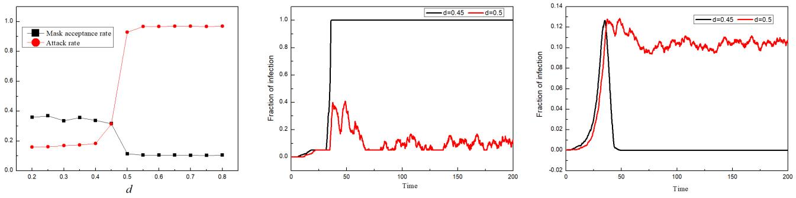
Fig. S5 The simulation results for the case where mask-wearing behavioral preferences are uniformly distributed among individuals.
Disease spread trajectories for heterogeneous mutations
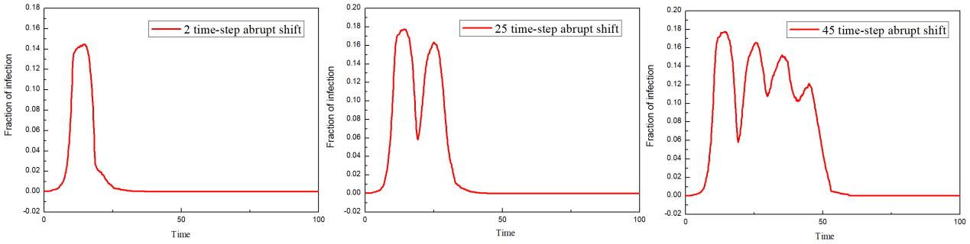
In this section, we show the disease spread trajectory of two dynamic processes of heterogeneity from high to low abrupt shift and from low to high abrupt shift. As shown in Figure S6, when the degree of social heterogeneity in mask-wearing shifts to low levels at a later time, the duration of disease will be longer and multiple waves of infection may occur, similar to the oscillations that actually occur in countries such as Singapore. In contrast, a shift at 2-time steps when the adherence of the group shifts from high to low will produce periodic oscillations in the epidemic. Once the critical point is exceeded, the prevalence peak and duration of the disease are almost independent of the timing of the abrupt shift, the result is shown in Fig S7.
Fig. S6 Disease spread trajectories for dynamic processes of heterogeneity from high to low abrupt shift.
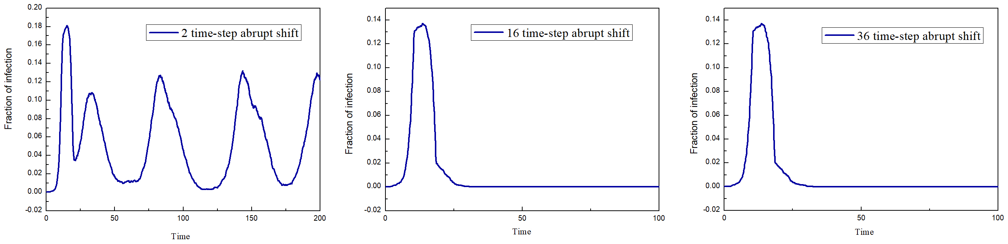
Fig. S7 Disease spread trajectories for dynamic processes of heterogeneity from low to high abrupt shift.
Real-world data on mask wearing and disease spread
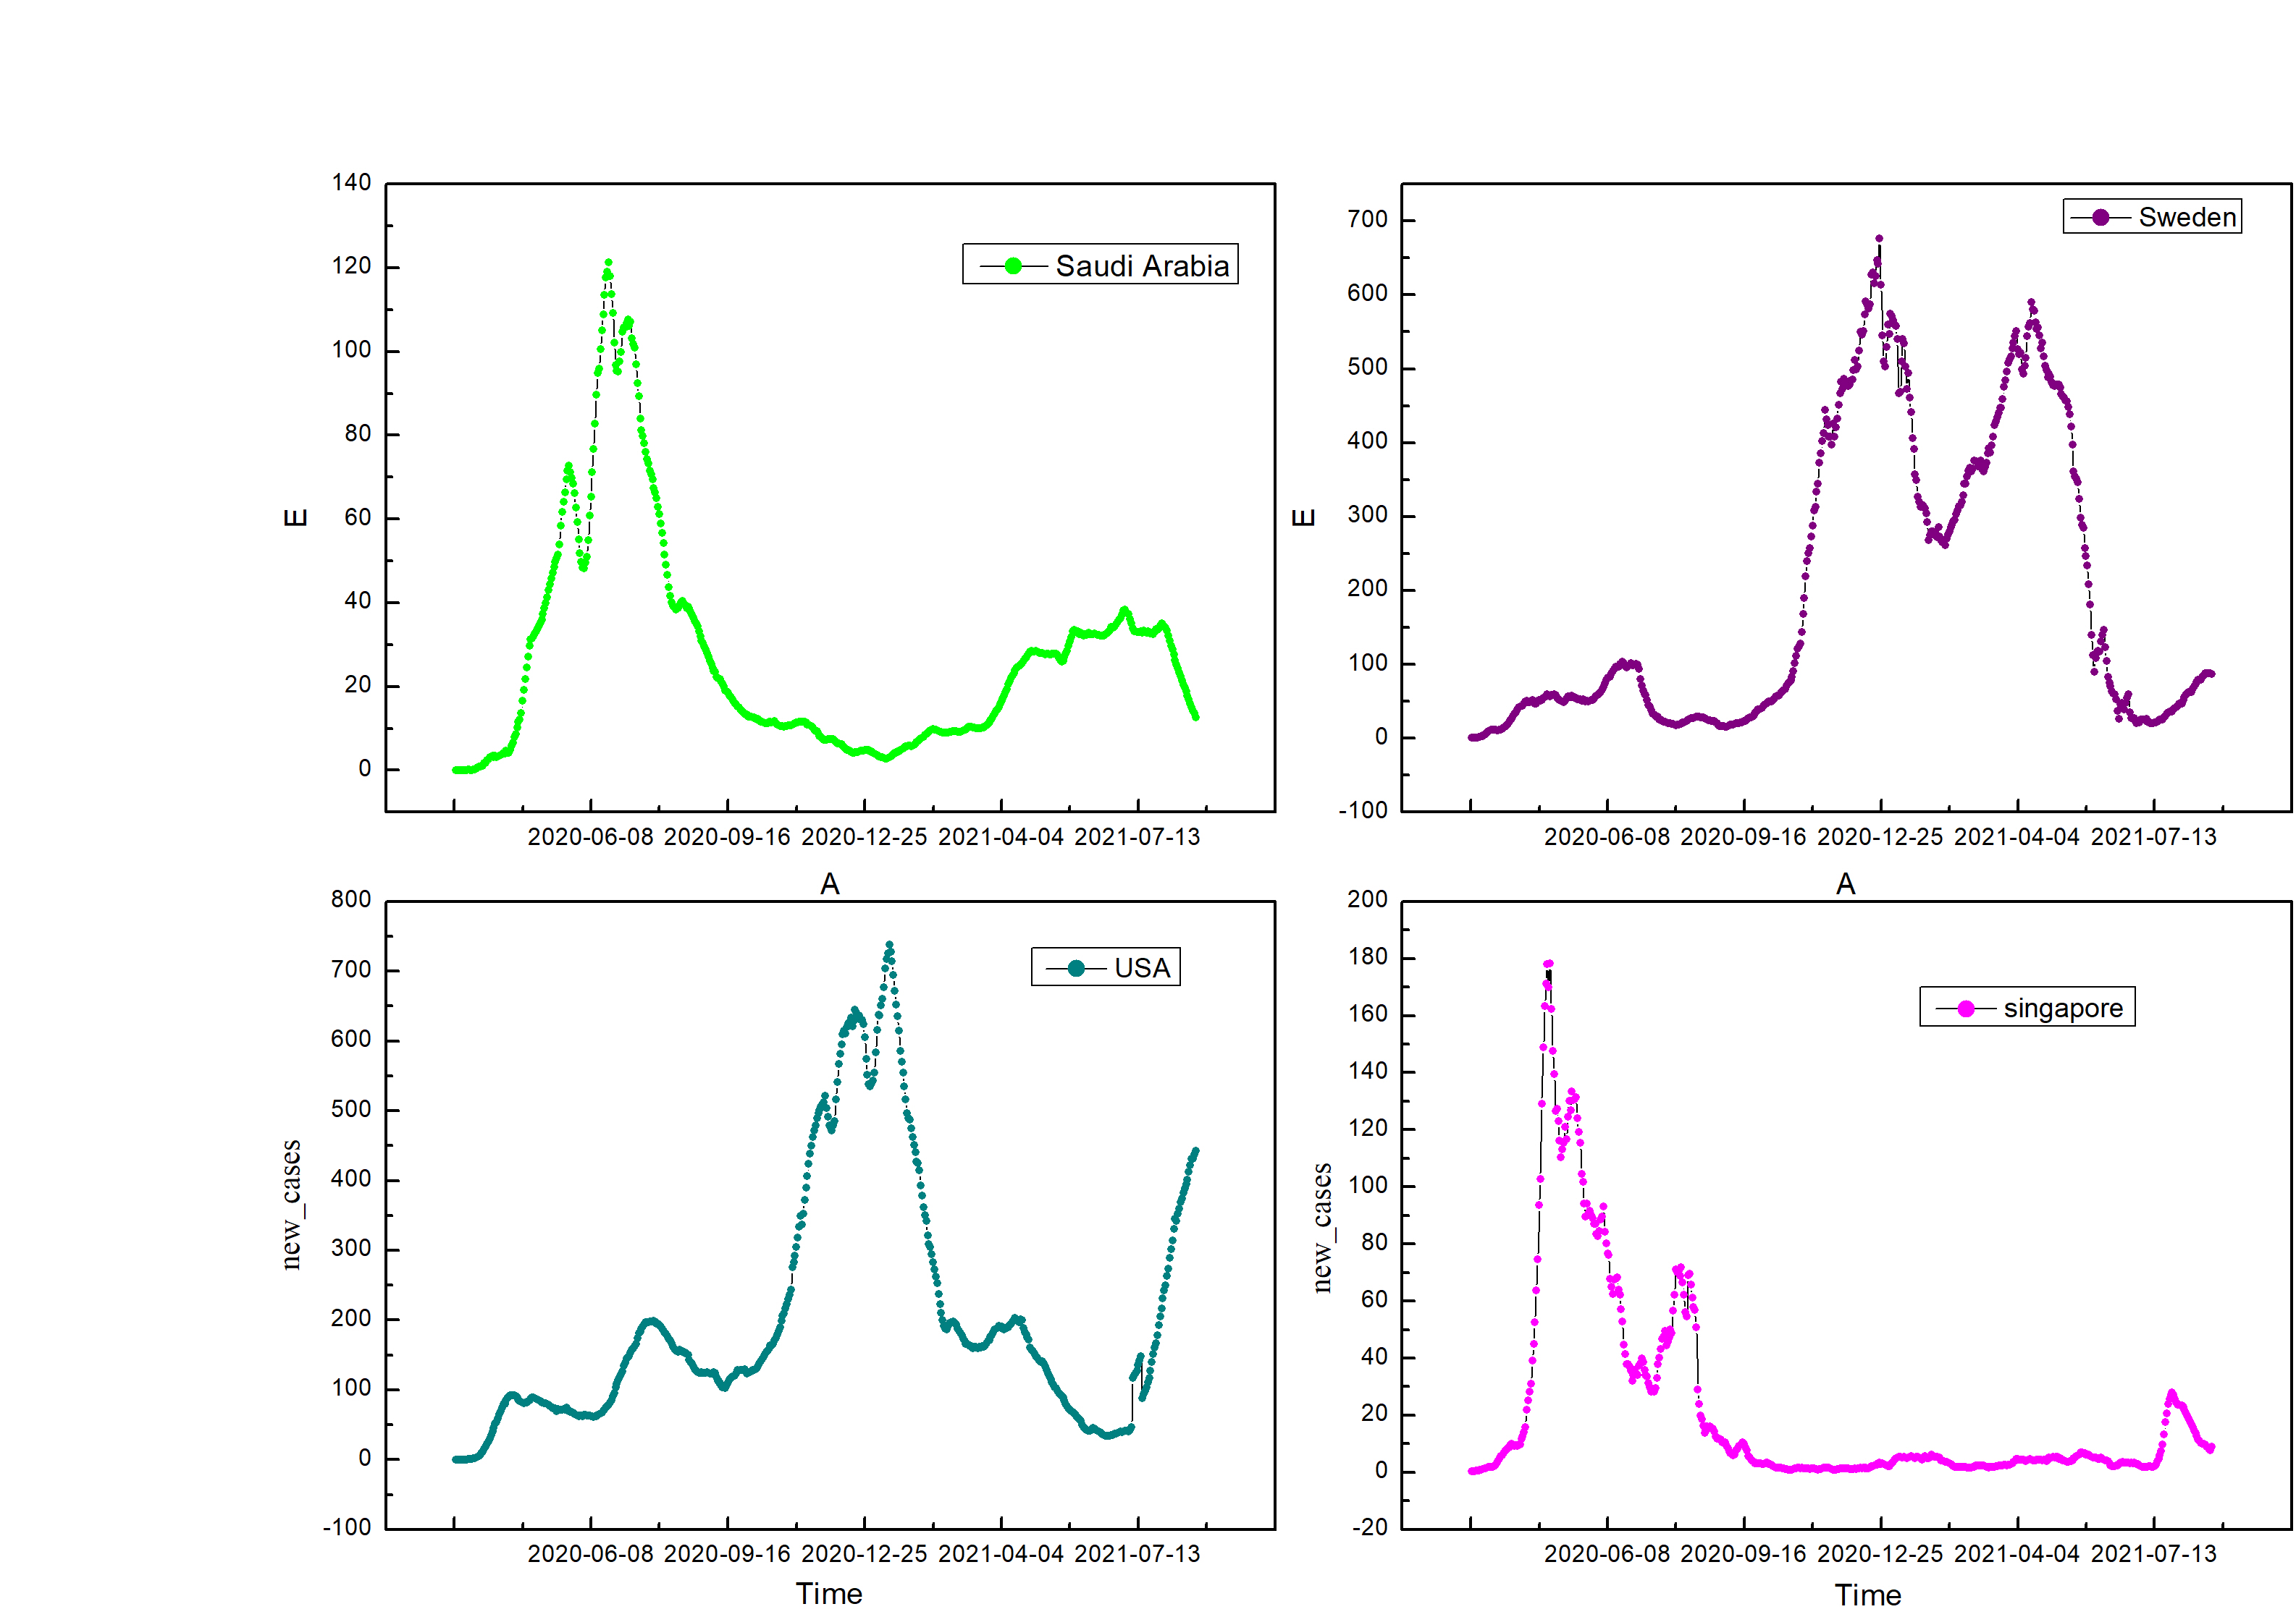
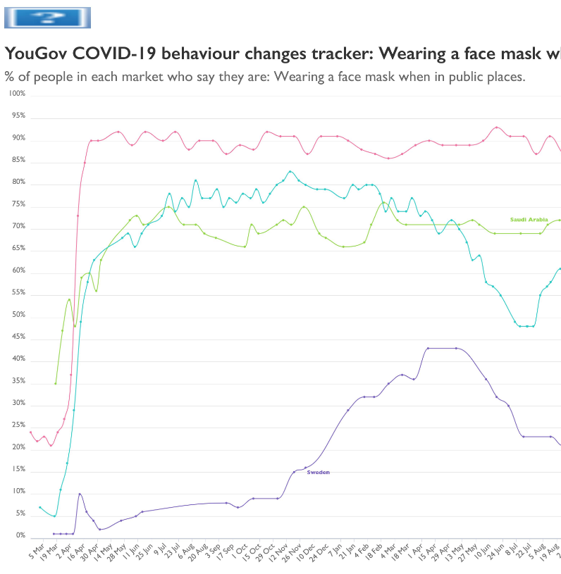
Fig. S8 Global mask-wearing behavior and disease spread dynamics during the COVID-19 pandemic and model diagram.
Figure S8 depicts Proportion of people reporting wearing masks in public and daily reports of confirmed cases summed (per million, smoothed) from February 2020 to August 2021 by country, including Saudi Arabia (green), Sweden (purple), USA (dark oyan), and Singapore (magenta), respectively. Overall, we observed a variety of mask adoption and infection trajectories. Cross-country self-reported mask-wearing rates are from YouGov survey data and the COVID-19 Public Monitor (https://today.yougov.com/covid-19). Epidemiological data are from Our World in Data (https://ourworldindata.org/covid-deaths).
References
- Sah, P., Leu, S. T., Cross, P. C., Hudson, P. J. & Bansal, S. (2017). Unraveling the Disease Consequences and Mechanisms of Modular Structure in Animal Social Networks. Proc Natl Acad Sci USA, 114(16), 4165–70.
- Watts, D. J., & Strogatz, S. H. (1998). Collective dynamics of small-world networks. Nature Publishing Group (6684).
- Trevas, S., Manuel, K., Malkani, R., & Hoelscher, D.M. (2023). Mask Adherence and Social Distancing in Houston, TX from January to April 2021. International Journal of Environmental Research and Public Health, 20.
- Haischer, M. H., Beilfuss, R., Hart, M. R., Opielinski, L., Wrucke, D., Zirgaitis, G., Uhrich, T. D., Hunter, S. K. (2020). Who is wearing a mask? Gender-, age-, and location-related differences during the COVID-19 pandemic. PLoS One, 15(10), e0240785.
- Fitzpatrick, K. M., Harris, C., & Drawve, G. (2020). Fear of COVID-19 and the Mental Health Consequences in America. Psychological Trauma: Theory, Research, Practice, and Policy 12(S1), S17-S21.
- Huynh, T. (2020). The more I fear about COVID-19, the more I wear medical masks: A survey on risk perception and medical masks uses. Health communication 37(13), 1563-1572.
- Bokemper, S. E., Cucciniello, M., Rotesi, T. E., Pin, P., Malik, A. A., Willebrand, K., Paintsil, E. E., & Omer, S. B., et al. (2021). Beliefs about Mask Efficacy and the Effect of Social Norms on Mask Wearing Intentions for COVID-19 Risk Reduction. medRxiv.
- Barceló, J., & Sheen, G. C. (2020). Voluntary adoption of social welfare-enhancing behavior: Mask-wearing in Spain during the COVID-19 outbreak. PLoS One 15(12), e0242764.
- Gonçalves, S., Abramson, G. & Gomes, M. F. C. (2011). Oscillations in SIRS model with distributed delays. Eur. Phys. J. B, 81, 363-371.
- Qiu, Z., Espinoza, B., Vasconcelos, V. V., Chen, C., Constantino, S. M., Crabtree, S, A., Yang, L., Vullikanti, A., et al. (2022). Understanding the Coevolution of Mask Wearing and Epidemics: A Network Perspective. Proceedings of the National Academy of Sciences 119(26), E2123355119.
- M Wolf, RH Kurvers, AJ Ward, S Krause, J Krause, Accurate decisions in an uncertain world: collective cognition increases true positives while decreasing false positives. Proc. Royal Soc. B: Biol. Sci. 280, 20122777 (2013).
- DK Ahorsu, et al., The fear of covid-19 scale: development and initial validation. Int. journal mental health addiction pp. 1–9 (2020).
- LH Kahane, Politicizing the mask: Political, economic and demographic factors affecting mask wearing behavior in the usa. East. economic journal 47, 163–183 (2021).
- SE Eikenberry, et al., To mask or not to mask: Modeling the potential for face mask use by the general public to curtail the covid-19 pandemic. Infect. Dis. Model. 5, 293–308 (2020).

