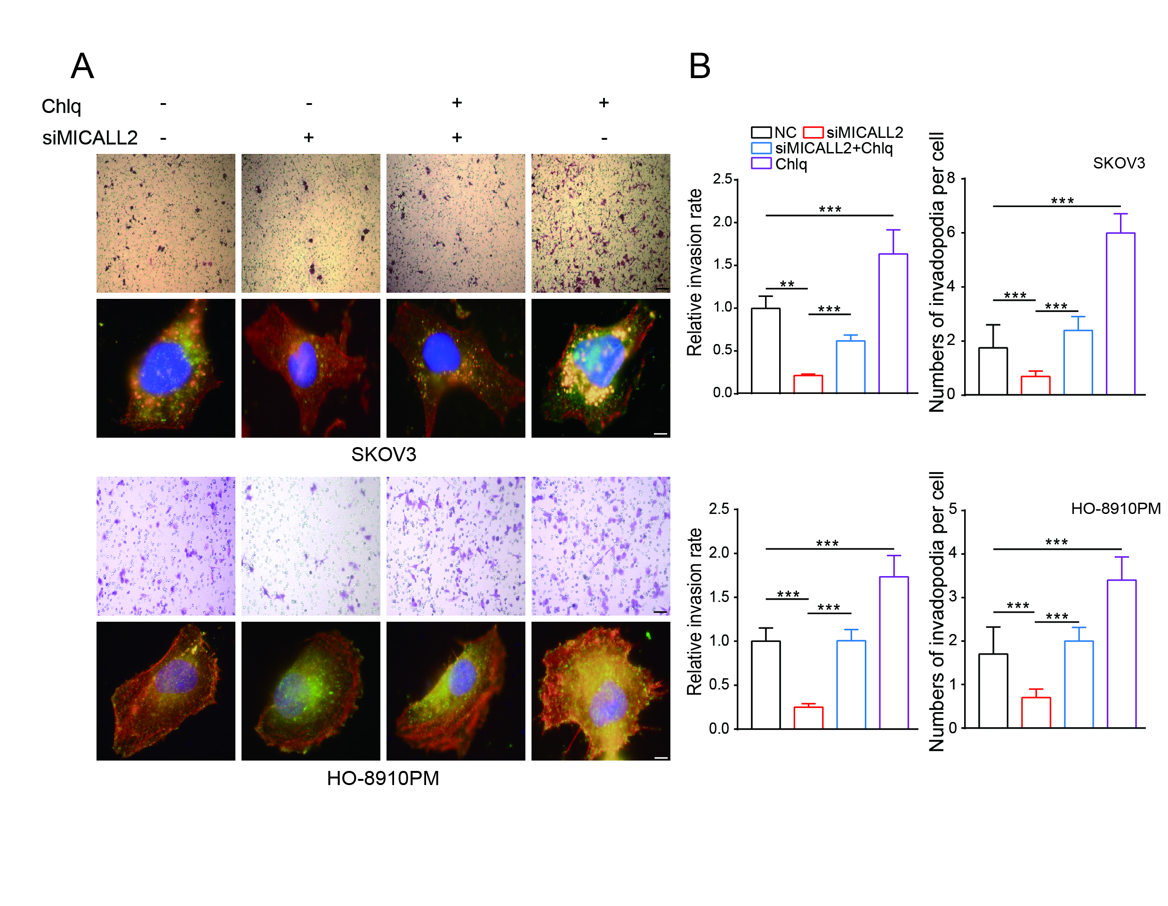
Fig. S1 Effect of autophagy on the invasive ability of ovarian cancer cells.
After the silencing of MICALL2, SKOV3 (a) and HO-8910PM cells (b) were pre-treated with Chlq (autophagy inhibitor). Subsequently, the invasive ability of cells and the number of invadopodia extensions in cells were determined. ***P<0.001.

