Supplementary Information accompanying the manuscript

Land use predicts proportion of West Nile Virus vector-competent mosquitoes

Amely M. Bauer^{1,*}, Robert P. Guralnick², Shelley A. Whitehead³, Narayani Barve⁴, Julie M. Allen⁵, Lindsay P. Campbell¹

Affiliations:
¹Florida Medical Entomology Laboratory, Department of Entomology and Nematology, IFAS, University of Florida, Vero Beach, FL, USA
²Florida Museum of Natural History, Department of Natural History, University of Florida, Gainesville, FL, US
³Whitehead Entomology Consulting, Gainesville, FL, USA
⁴Department of Ecology & Evolutionary Biology, University of Tennessee, Knoxville, TN, USA
⁵Department of Biology, University of Nevada, Reno, NV, USA

*Corresponding author, amely.bauer@ufl.edu

Table S1. List of all species included in the analysis.
Retrieved species list | Adjusted species list
Aedes aegypti | Aedes aegypti
Aedes albopictus | Aedes albopictus
Aedes atlanticus | Aedes atlanticus/tormentor
Aedes atlanticus-tormentor morph. group | Aedes atlanticus/tormentor
Aedes atropalpus | Aedes atropalpus
Aedes canadensis | Aedes canadensis
Aedes dupreei | Aedes dupreei
Aedes fulvus | Aedes fulvus
Aedes fulvus pallens | Aedes fulvus
Aedes infirmatus | Aedes infirmatus
Aedes mathesoni | Aedes canadensis
Aedes mathesoni complex | Aedes canadensis
Aedes sollicitans | Aedes sollicitans
Aedes taeniorhynchus | Aedes taeniorhynchus
Aedes tormentor | Aedes atlanticus/tormentor
Aedes tortilis | Aedes tortilis
Aedes triseriatus | Aedes triseriatus
Aedes vexans sensu lato | Aedes vexans sensu lato
Anopheles atropos | Anopheles atropos
Anopheles barberi | Anopheles barberi
Anopheles bradleyi | Anopheles crucians complex
Anopheles crucians | Anopheles crucians complex
Anopheles crucians complex | Anopheles crucians complex
Anopheles georgianus | Anopheles crucians complex
Anopheles perplexens | Anopheles perplexens
Anopheles punctipennis | Anopheles punctipennis
Anopheles quadrimaculatus | Anopheles quadrimaculatus
Coquillettidia perturbans | Coquillettidia perturbans
Culex coronator | Culex coronator
Culex erraticus | Culex erraticus
Culex iolambdis | Culex iolambdis
Culex nigripalpus | Culex nigripalpus
Culex quinquefasciatus | Culex quinquefasciatus
Culex restuans | Culex restuans
Culex salinarius | Culex salinarius
Culex tarsalis | Culex tarsalis
Culex territans | Culex territans
Culiseta inornata | Culiseta inornata
Culiseta melanura | Culiseta melanura
Mansonia dyari | Mansonia dyari
Mansonia titillans | Mansonia titillans
Orthopodomyia alba | Orthopodomyia alba
Psorophora ciliata | Psorophora ciliata
Psorophora columbiae | Psorophora columbiae
Psorophora cyanescens | Psorophora cyanescens
Psorophora ferox | Psorophora ferox
Psorophora horrida | Psorophora horrida
Psorophora howardii | Psorophora howardii
Uranotaenia lowii | Uranotaenia lowii
Uranotaenia sapphirina | Uranotaenia sapphirina
Wyeomyia mitchellii | Wyeomyia mitchellii
Wyeomyia vanduzeei | Wyeomyia vanduzeei
Records based on CO2-baited CDC light trap collections in Manatee County, FL, between May and November of 2016, 2017, 2019, and 2020 (VectorBase 2022). Species that have been regrouped for analysis are highlighted in bold.

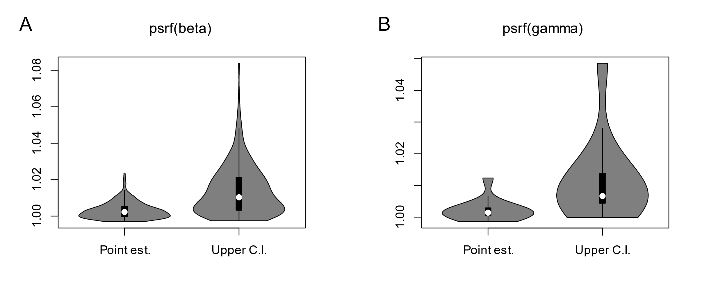
Figure S1. Model MCMC chain convergence diagnostics via potential scale reduction factors (psrf) of A beta-parameters (species-environment, mean point estimates (est.) = 1.003 [mean upper credible interval (CI) = 1.014]) B gamma parameters (trait-environment, mean point est. = 1.00 [mean upper CI = 1.01].

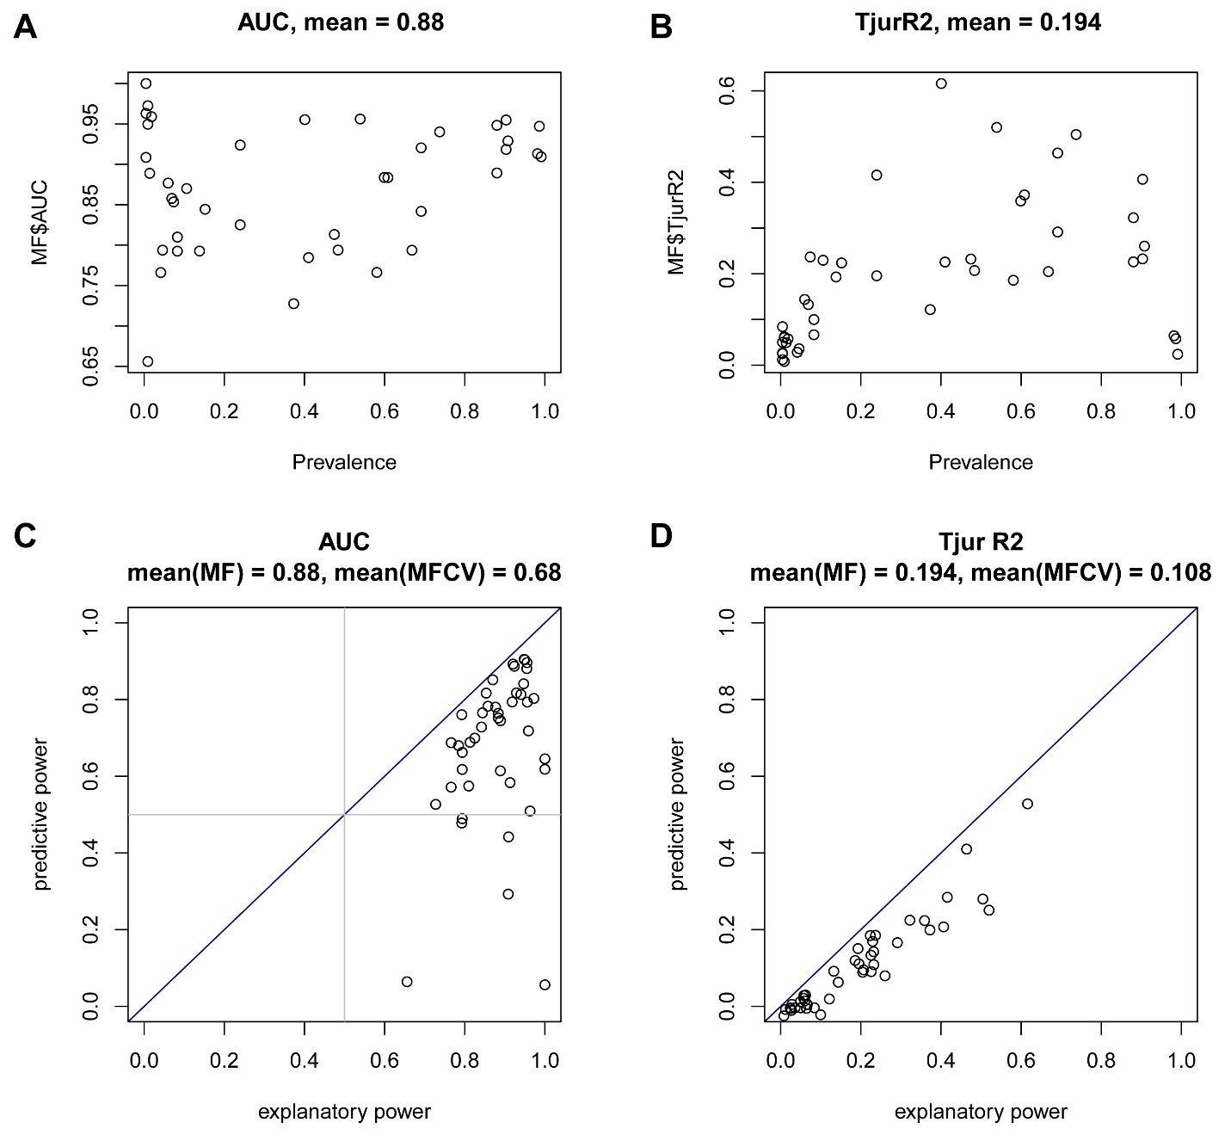
Figure S2. Model fit as measured by AUC (A, C) and Tjur R² (B, D). Species-specific model fit over species prevalence (A, B) and predictive over explanatory power of the model for each species included in the model (C, D). Each point per plot represents a species, identity line (blue) visualizes equal predictive and explanatory power.

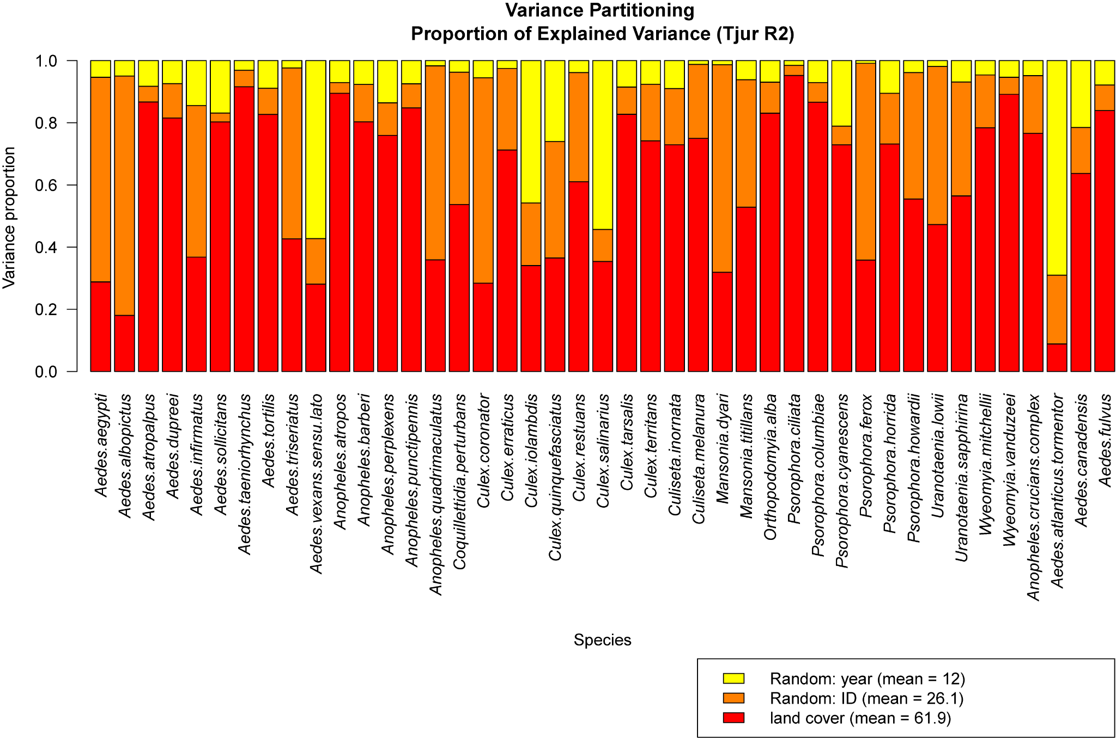

Figure S3. Partitioning of the proportion of variance explained for each species between random effects and land cover covariates.

Table S2. Marginal effects of land cover classes on predicted community-level responses in Manatee County, FL.
Land cover class | Species richness | Proportion of WNV  vector-competent species
Water | + (0.94) | - (0.68)
Developed | + (0.96) | - (0.91)
Cropland | + (1) | - (1)
Herbaceous wetland | + (0.87) | - (1)
Woody wetland | + (0.93) | - (0.95)

Effects of individual landscape variables calculated by holding all other variables at their mean values over the data.The numbers in parentheses indicate the posterior probability that the community-weighted mean response at the smallest and the largest percent values of each land cover class differ (posterior probabilities rounded to two decimals). Correlations with ≧ 0.95 posterior support are highlighted. Correlation: + positive, - negative.

