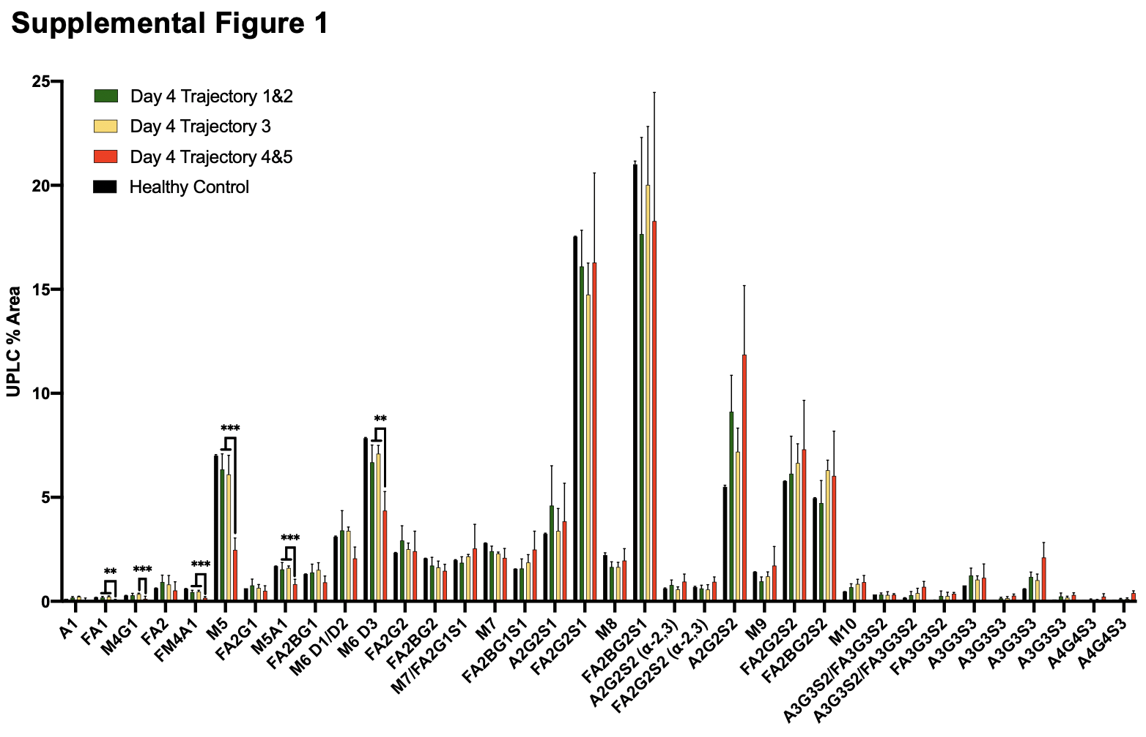
Supplemental Figure 1. IgM N-glycans labeled with Waters RapiFluor (RFMS) were profiled with UPLC-FLR-ESI-MS. Healthy Control (n=2), Day 4: Trajectory 1&2 (n=6), Trajectory 3 (n=6), and Trajectory 4&5 (n=10) COVID-19 hospitalized cohorts are presented by N-glycan. Statistical significance was determined using unpaired t-tests, graphed with mean +/- S.D.

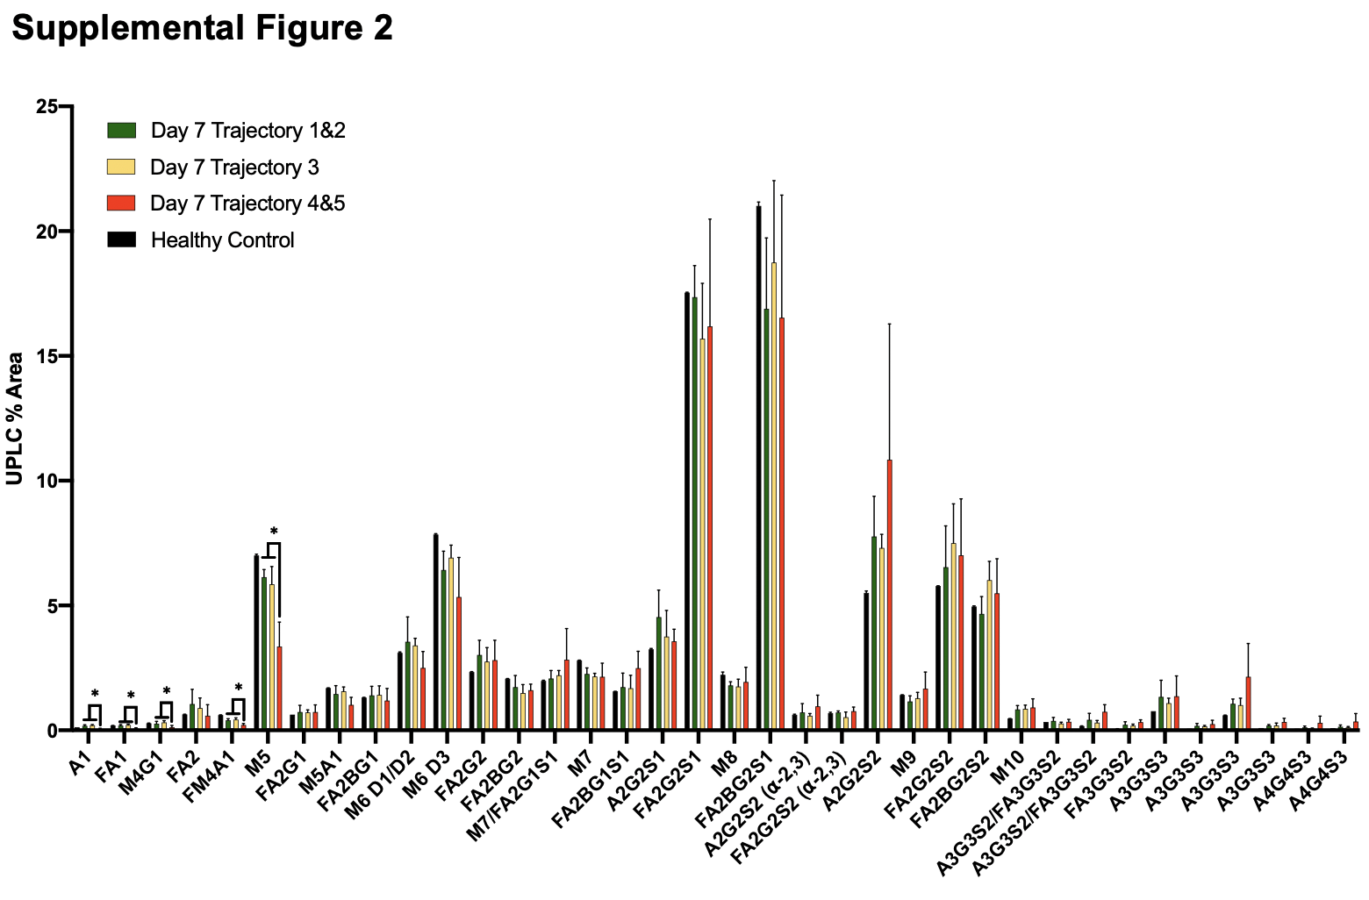
Supplemental Figure 2. IgM N-glycans labeled with Waters RapiFluor (RFMS) were profiled with UPLC-FLR-ESI-MS. Healthy Control (n=2), Day 7: Trajectory 1&2 (n=5), Trajectory 3 (n=5), and Trajectory 4&5 (n=5) COVID-19 hospitalized cohorts are presented by N-glycan Mean +/- S.D. Statistical significance determined using unpaired t-tests *p <0.05

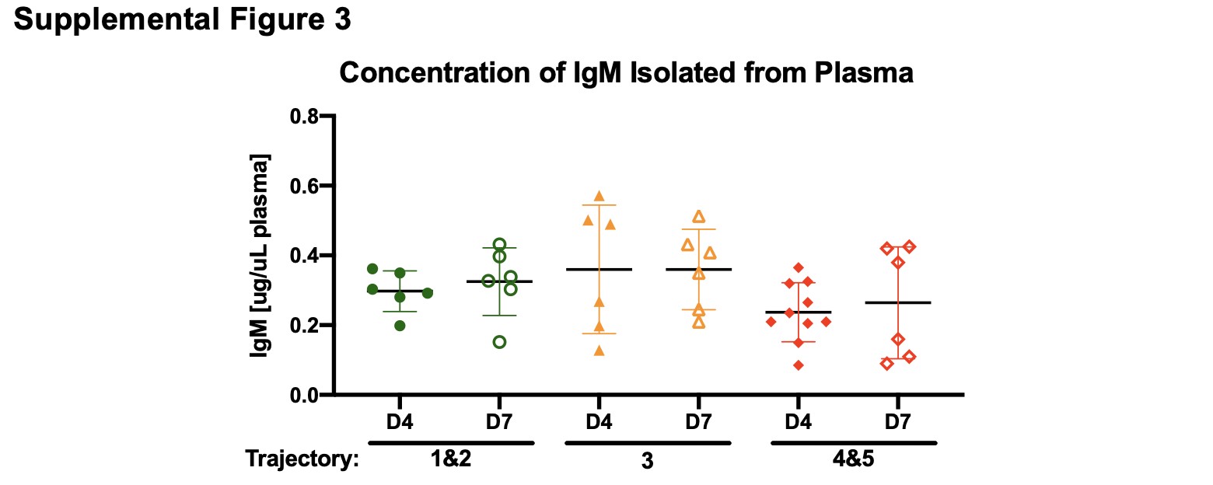
Supplemental Figure 3. The concentration of total IgM isolated from hospitalized COVID-19-infected patient cohort plasma across trajectory from day 4 (D4) and day 7 (D7) is reported in units of µg IgM per µL plasma. A nonparametric T-test determined no statistically significant differences between trajectory cohorts or days of infection.

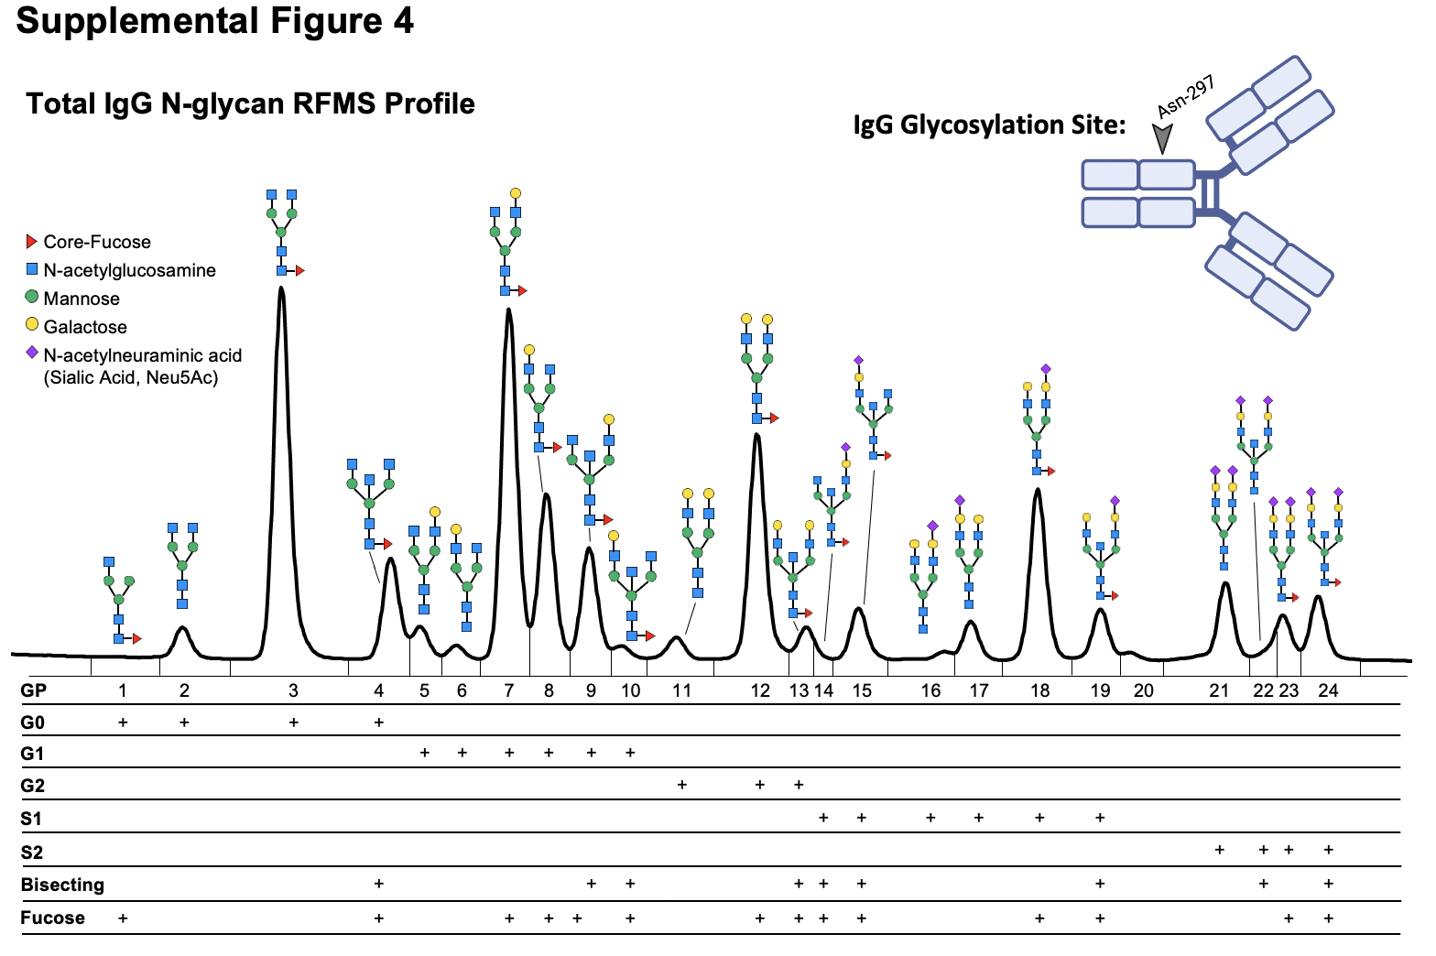
Supplemental Figure 4 IgG N-glycans labeled with RapiFluor MS detected with UPLC-FLR-ESI-MS. IgG N-glycans are grouped by class: G0 refers to core diantennary N-glycans lacking galactose, G1 refers to core diantennary N-glycans with a single galactose, G2 refers to core diantennary N-glycans with two galactoses, S1 refers to diantennary N-glycans with a single sialic acid, S2 refers to diantennary N-glycans with two sialic acids, Bisecting refers to any N-glycan with a bisecting GlcNAc moiety, Fucose refers N-glycans with a core-fucose. Induvial glycan moieties are labeled on the upper left of the figure, with the conversed glycosylation site Asn-297 on IgG glycosylation site depicted in the upper right of the figure.

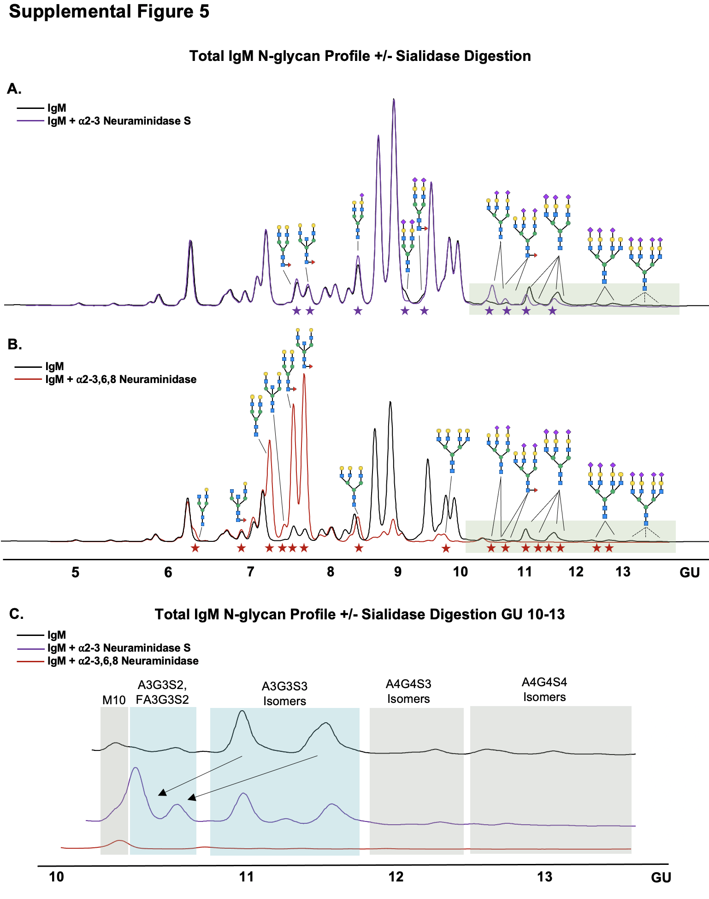
Supplemental Figure 5: IgM N-glycans digested with ⍺2-3 linkage-specific neuraminidase reveal alpha-2,3 linked sialic acid on IgM. A) Neuraminidase S digested IgM N-glycan profile (purple) is overlaid with the un-digested IgM N-glycan profile (black). Purple stars indicate peak abundance shifts due to neuraminidase digestion. B) A non-linkage-specific neuraminidase digested IgM N-glycan profile (red) is overlaid with the un-digested IgM N-glycan profile (black). Red stars indicate peak abundance shifts due to non-specific neuraminidase digestion. C) GU 10-13 IgM neuraminidase digestions are stacked to demonstrate the shifts observed following linkage-specific sialidase digestions on the A3G3S3 and A4G4S4 species.

Supplemental Table 1. IgM N-glycans identified using mass spectrometry and retention time are listed in the table below. n.d. = not detected due to mass scan range of 500 to 1250 m/z.

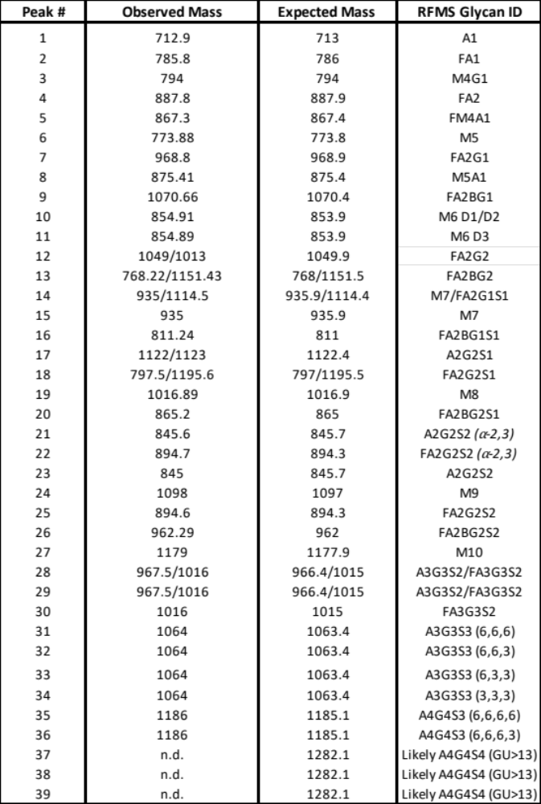

Supplemental Table 2. Linear regression results sorted by statistical significance total di-sialylated (S2) content detected from total plasma IgM N-glycan profiles were correlated to the transcriptomic expression of glycosyltransferases in PBMCs collected on day 0 of hospitalization, clinical data, the relative abundance of anti-nucleocapsid antibodies at visit 1 (day 0 hospitalization) and visit 2 (day 4 of hospitalization), viral RT-qPCR titers, and Luminex data from plasma samples. Data sorted by P-value, with p<0.05 highlighted in pink.
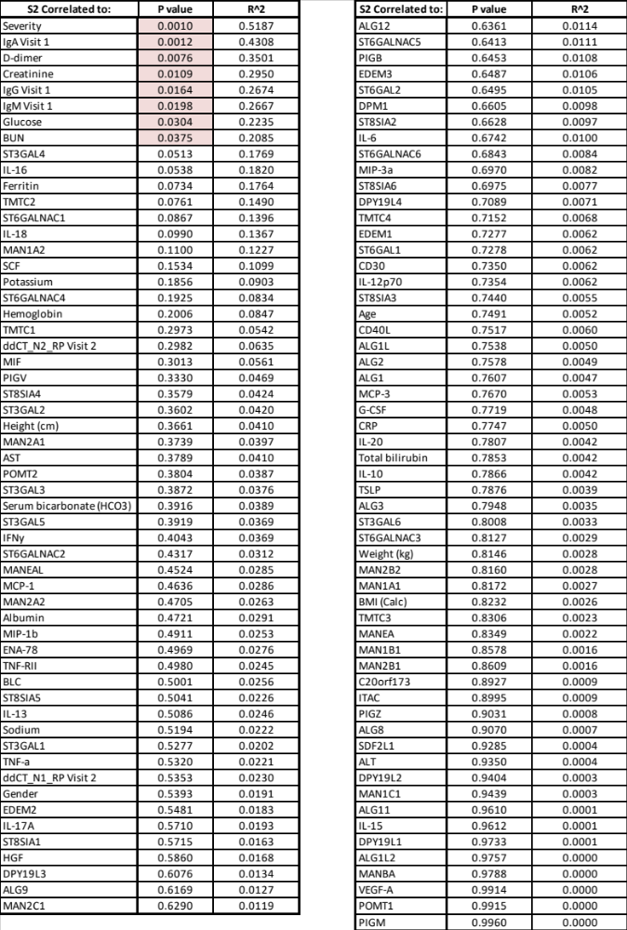

Supplemental Table 3. Linear regression results sorted by statistical significance total mannose (Mann) content detected from total plasma IgM N-glycan profiles were correlated to the transcriptomic expression of glycosyltransferases in PBMCs collected on day 0 of hospitalization, clinical data, the relative abundance of anti-nucleocapsid antibodies at visit 1 (day 0 hospitalization) and visit 2 (day 4 of hospitalization), viral RT-qPCR titers, and Luminex data from plasma samples. Data sorted by P-value, with p<0.05 highlighted in pink.
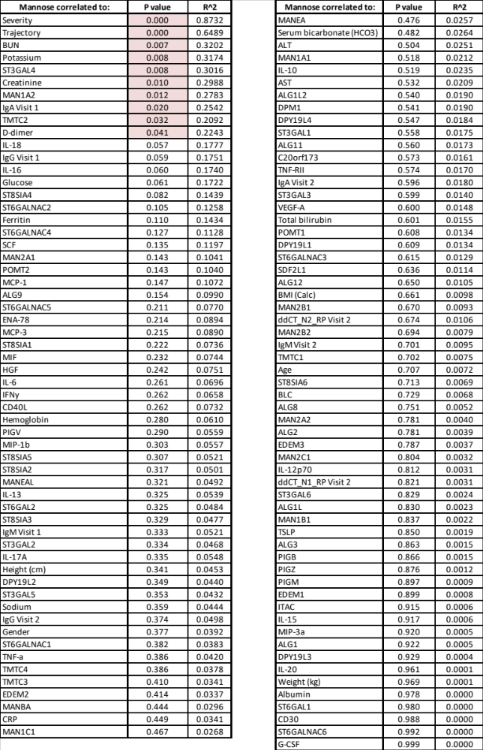

Supplemental Table 4. COVID cohort trajectories 1-3 (nonsevere) data was compared to trajectories 4 and 5 (severe). Transcriptomic expression of glycosyltransferases in PBMCs collected on day 0 of hospitalization, clinical data, relative abundance of anti-nucleocapsid antibodies at visit 1 (day 0 hospitalization) and visit 2 (day 4 of hospitalization), viral RT-qPCR titers, and Luminex data are presented below. Data sorted by P-value, with p<0.05 highlighted in pink.

