Supplementary Materials
Manuscript title: Core competencies for dermatology physician assistants: knowledge recommendations from a national survey of dermatologists and physician assistants
Contents (listed by manuscript’s referenced order)
- Table 1e: Survey participant characteristics
- Figure 1e: Conditions with weaker recommendations from dermatologists
- Table 2e: Conditions with larger response discrepancies between cohorts
- Figure 2e: Discrepancy between each cohort vs answer variability within
- Appendix 1e: Unabridged free-typed responses of survey participants
Supplementary Table 1e: Of 97 PAs and 142 dermatologists who received the survey, 172 (72%) completed it. Fourteen of these were excluded, yielding 79 PAs and 79 dermatologists from 36 US states to be included in analysis.
Supplementary Table 1e: Survey participant characteristics
 | Physician assistants (%) | Dermatologists (%) | Overall (%) | P value
Received survey | 97 | 142 | 239 | -
No response | 14 (14.4) | 51 (35.9) | 65 (27.2) | -
Withdrew | 0 | 2 (1.4) | 2 (0.8) | -
Withdrawal reasons | - | One: questions too vague;  one: anonymity concern | - | -
Response rate | 83 (85.6) | 89 (62.7) | 172 (72) | 0.254
Excluded | 4 (4.8) | 10 (11.2) | 14 (8.1) | -
Exclusion reasons | Four: less than 2 years of experience | Nine: less than 2 years experience supervising PAs;  one: incomplete survey | - | -
Included in analysis | 79 | 79 | 158 | -
Years experience:  min - max, mean | 2 - 42, 11.1 | 2- 60, 17.7 | 2 - 60, 14.4 | 7.9 × 10⁻⁵
Western region | 38 (24.1) | 53 (33.5) | 91 (57.6) | 0.396
Midwest | 5 (3.2) | 4 (2.5) | 9 (5.7) | 0.497
Southern | 39 (18.4) | 13 (8.2) | 42 (26.6) | 0.387
Northeast | 7 (4.4) | 9 (5.7) | 16 (10.1) | 0.493
Unique states | 27 | 21 | 36 | -

Supplementary Figure 1e: Converging bar chart of dermatologist and PA responses to diagnosis questions, separated by cohort and ranked according to percent of dermatologists recommending “start treatment for some” and “diagnose and manage most comprehensively.” Only the 35 conditions which elicited this response from fewer than 50% of dermatologists are shown. See Figure 1 for responses to the preceding 67 conditions. [to editors: high-resolution version available on request]
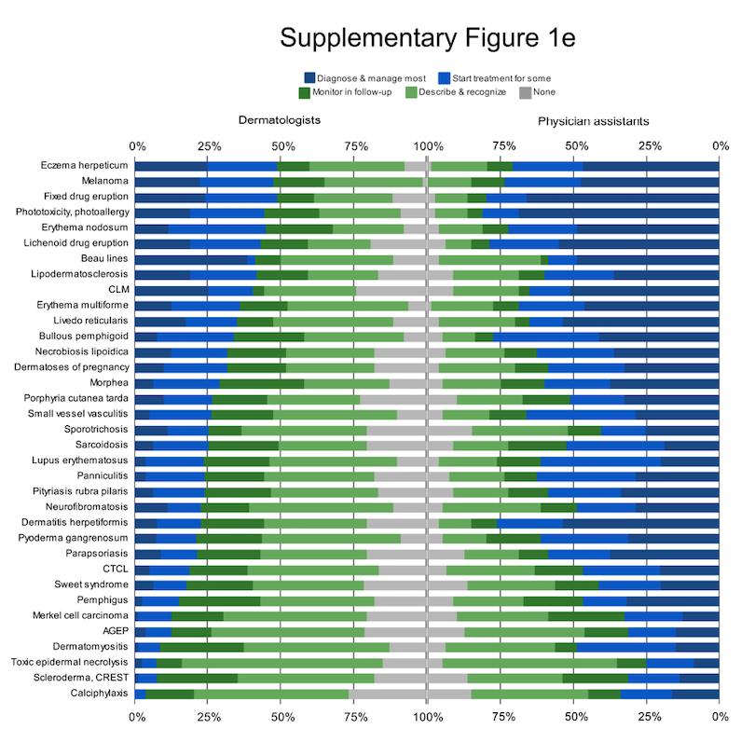

Supplementary Table 2e: Conditions with larger discrepancies between cohort responses.
Supplementary. Table 2e: Conditions with 15% or greater discrepancy between cohorts
(difference between each cohort's sum of "treat some" and "manage most").
Averages for each category are bolded; asterisks denote diagnoses potentially involving pediatrics.
Diseases by category | Discrepancy | Diseases by category | Discrepancy
Connective tissue & complex | 31% | Inflammatory | 26%
Small vessel vasculitis | 40% | Pyoderma gangrenosum | 40%
Dermatomyositis | 40% | Phototoxicity/photoallergy | 38%
Panniculitis | 39% | Lichenoid drug eruption | 36%
Parapsoriasis | 38% | Necrobiosis lipoidica | 31%
Lupus erythematosus | 38% | Hidradenitis suppurativa | 25%
Pityriasis rubra pilaris | 35% | Morbilliform drug rash | 24%
Morphea | 31% | Sweet syndrome | 24%
Livedo reticularis | 30% | Lichen planus | 23%
Calciphylaxis | 30% | PMLE | 21%
Erythema nodosum | 29% | Factitial dermatitis | 19%
Sarcoidosis | 28% | Beau lines | 18%
CTCL | 28% | Stasis dermatitis, ulcers | 18%
*Neurofibromatosis | 26% | Benign lesions | 24%
Lichen sclerosus | 25% | *Hemangioma | 36%
Scleroderma / CREST | 24% | *Nevus sebaceous | 29%
Lipodermatosclerosis | 19% | Blue nevus | 26%
Vesiculobullous | 29% | Nevus spilus | 21%
Dermatitis herpetiformis | 54% | Atypical nevi | 21%
Bullous pemphigoid | 44% | Porokeratosis | 20%
Erythema multiforme | 33% | Becker nevus | 18%
Fixed drug eruption | 33% | Malignancies & related | 21%
Pemphigus | 31% | Melanoma | 26%
*Dermatoses of pregnancy | 28% | Merkel cell carcinoma | 20%
*Varicella | 26% | Poikiloderma of Civatte | 18%
Porphyria cutanea tarda | 25% | Infections | 20%
*Eczema herpeticum | 21% | Cutaneous larva migrans | 25%
AGEP | 19% | Sporotrichosis | 15%
Toxic epidermal necrolysis | 18%
*Hand-foot-mouth disease | 16%
Supplementary Figure 2e: For conditions eliciting higher inter-cohort discrepancies, variability of individual responses within each was also increased, indicating significant differences between individual clinicians’ views on controversial items, not just between cohorts.
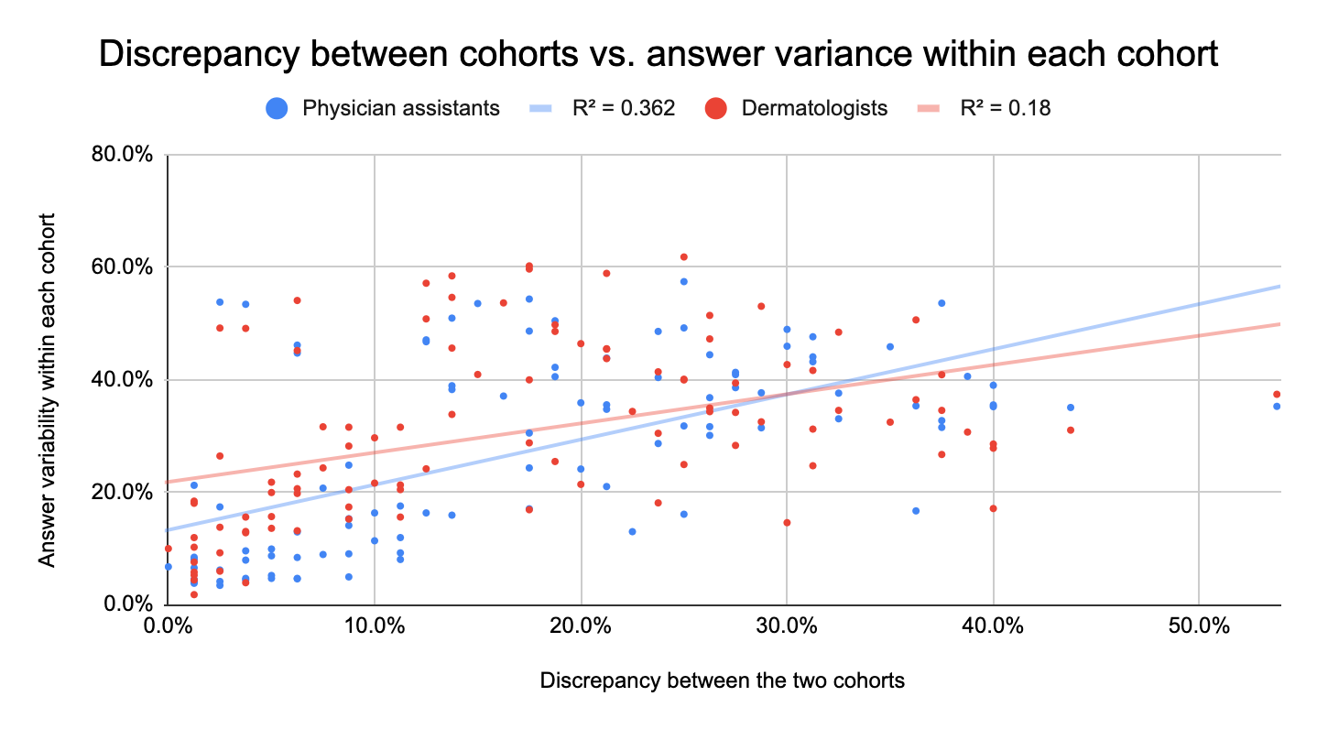

Supplementary Appendix 1e: Unabridged comments of survey respondents, from free-text fields in electronic survey. Comments are grouped by related themes and lightly edited for clarity.
Dermatologist comments
- Survey instrument
  - This is a very comprehensive survey.
  - Choices are not mutually exclusive.
  - One of the challenges of only having multiple choice answers is that they don't completely reflect the nuances in each disease. For example, for morbilliform drug eruption, what does initiate treatment really mean?
  - Benign lesions are only needed to be described and recognized without any additional treatments/follow up.
- Disease variation
  - Answers are somewhat qualified by extent and severity of condition
  - Obviously there is a range of severity in many of the diseases listed so a PA should not be expected to manage extreme outliers.
  - For some of these my answer would be "it depends." For example, metastatic melanoma is very different than MIS
  - Can mean newborn or adult, for newborn would want monitor treatment response
  - Unsure if this was including infantile, which I think would not be appropriate for PA.
- Diagnosis
  - Answers are assuming that correct diagnosis is made to comprehensively manage most cases
  - Diagnosis is the main issue. We are a referrals only practice, so a primary care MD has already seen our patients. Many of our patients need a diagnosis and most dermatology lesions need a dermatologist to diagnose if a primary care [doctor] could not diagnose it.
  - My main concern would be a MLP's ability to recognize DRESS/DIHS/SKIRT or early EMM. Or for CTCL, the main concern would be missing the diagnosis and treating it indefinitely as "dermatitis" but I'm not worried about a MLP using topical steroids or phototherapy which are appropriate treatments for CTCL. Or livedo reticularis? Sure, they should be able to know what physiologic/normal LR should be what about Sneddon syndrome or a livedoid vasculopathy?
  - In general our PAs do skin checks, acne, warts, keloids, AA, rosacea. We do not have them diagnose or manage any other rashes.
  - I presume that one [who can] describe and recognize an entity will be able to initiate a work-up, do a biopsy to make the diagnosis or know that an appropriate referral is necessary
  - There needs to be alot of training to safely manage most of these conditions in follow up. Diagnosis can be difficult, so mostly diagnosis should be done by an MD, with the exception of acne.
  - Consider using PAs to biopsy unknowns previously evaluated via teledermatology. Mostly for rule out skin cancer and not for rash recognition and tx except common (TV, tinea, PR, mild eczema, mild pso, etc)
- Supervision
  - This assumes PA working with MD (same practice) and not practicing independently
  - "4" with the understanding there is MD/DO board certified dermatologist overseeing this
  - Many of these [medications] require a high level of initial training and immediately available supervision.
  - Any systemic management with high risk medication should be reviewed with supervising staff
  - With higher risk conditions (high risk meds, complicated conditions, lab work, biopsies), I like that the PA has to sign all these notes to physician and serious cases get transferred to physician
  - With exposure and following protocols written by MDs, most meds could be started and monitored.
- Medications
  - It is presumed that one has the understanding of the mechanism of action if one is monitoring , starting therapy, and or, managing a medication
  - The challenge is that [medications are] practice specific. 90% of dermatologists don't know how to use cyclosporine, for example, so I don't expect PAs to know, but mine does.
  - 2 years should understand basic biologics (etanercept, adalimumab), but recommend newer and more targeted therapies which much greater cost, as well as more complicated systemic medications (MMF, CSA) be reserved for MD.
  - They should be aware of what to check and what symptoms to monitor
  - I feel like some of these meds we often don't use
- Individual variability
  - PAs can be proficient and their level of training. This varies widely based upon PA, training, and experience.
  - Please note that there is a major gap between some PAs abilities and others.
  - Most of these responses will depend on the individual. After decades of experience, I have observed that people, no matter their general training, either have an aptitude for dermatology or they do not. My current PA, who came to me without prior derm experience, learned dermatology more rapidly than some residents I have known. She has been with me for > 15 years and requires very little supervision.
- Rare and autoimmune conditions
  - Autoimmune conditions may need input from the supervising physician, depending on the skill of the PA.
  - The main concern would be a MLP to properly recognize and triage some of these conditions to other non-derm specialisits (ie rheum or GI). I don't expect MLPs (or myself) to be able to "comprehensively manage" many of these condition.
  - Of the rare diagnoses, a physicians assistant is unlikely to see those in two years of outpatient practice
- Practice setting
  - 2 years is not much time for having significant fund of knowledge and this will vary depending on patient population of the clinic. For example, in some clinics focus would be skin cancer recognition and biopsy. If this is vast majority of practice, will be more challenging to diagnosis and understand treatment algorithm for complex medical conditions and systemic medications. On the other hand, PAs could be trained in a complex medical derm environment and be the go to for new and established complex med derm prescriptions (biologics); in this case its unlikely in two years they'll have enough experience to learn and manage these conditions as well as be proficient in recognizing and managing other conditions. Therefore, a training program will need to determine whether to provide broad overview of all dermatologic conditions and expect PA to have lower overall fund of knowledge of all conditions, or focus on more select conditions and treatments depending on patient population for which one is caring.
  - 2 years of training and clinical work should be aimed at understanding and recognizing common dermatologic conditions. unlikely that someone with 2 years training only will be able to have strong fund of knowledge and mgmt of common dermatologic conditions and also recognize and describe uncommon conditions such as those found on page 2 unless a very rigorous full time clinical and training program.

Physician assistant comments

- Practice setting
  - I have practiced for the last five years in a skin cancer focused Mohs clinic and just started general dermatology, so I am personally still training in many of these areas but believe after two years in a general dermatology setting I will be capable of the above.
  - Some of these "less common" conditions is something I have been seeing on a daily basis since starting as a Derm PA.
  - This [medications prescribed] will be greatly determined by the type of practice where the PA is practicing
- Surgical management
  - I didn’t know how to answer regarding squamous cell carcinoma and basal cell carcinoma where some of the management is surgical and I would not consider this to be in the wheelhouse of a general Dermatology PA.
  - SCC & BCC are surgical in nature, not all PA's are trained for excisions
  - Surgical diagnoses (melanoma, BCC) saying comprehensive treatment is confusing because ein not sure if you are asking if we are referring for the treatment or if we are doing the surgery etc. I think that will vary widely amongst PAs and what surgical experience they have and the location and severity of the cancer.
  - BCC and SCC are the most difficult to quantify based on the choices; I answered from more of a medical practice perspective; for more surgically-focused practices-diagnosing and managing most cases would be more appropriate
  - For Melanoma, SCC, and BCC did not select comprehensively manage most cases since I do not participate in Mohs or excise melanomas.
- Disease variability
  - I had to really think about my responses for some of the questions - like CTCL is such a heterogenous disease process, I answered "start initial therapy in some cases" because I would start NBUVB for patch stage MF.. Ultimately I answered these questions from the perspective of a medical dermatology PA that has access to supervising dermatologists/surgeons & referral sources like rheumatology for complex cases. Ultimately I don't think there's anything on this list besides TEN that I think we shouldn't be able to at least start initial therapy. I found it interesting that epidermal cysts, lipomas, dermatitis herpetiformis, pemphigus, morphea, LSetA, sarcoid, telogen effluvium, androgenetic alopecia, traction alopecia CCCA, dissecting cellulitis, melasma were missing from this "common conditions" list as these are all things I treat within any given week/month/year. I found it concerning that atopic dermatitis was missing - this is a "top ten."
  - Again in some of these conditions the extensiveness of disease (scar sarcoid vs systemic sarcoid) and severity of patients illness depends of level of involvement from collaborating physician.
  - Depends a lot on the unique situation of the cases.
  - Lupus for example I might fully manage DLE and SCLE, but not SLE. Same with CTCL- I might fully manage patch stage, but not more advanced.
- Compex, systemic, and rare conditions
  - Learning about these diagnoses and knowing where to find the info when you do see it again is important.
  - All of these are conditions that a trained Derm PA should be able to recognize and treat, although some listed will be determined by the frequency seen.
  - There could have been some room between start therapy for some cases and manage most cases.
  - For some of these conditions (e.g. scleroderma, PCT, sarcoid, PRP, acanthosis nigricans, CTCL, vasculitides) comprehensive management beyond the dermatologic aspect of the condition may include specialist referral and/or co-monitoring with rheumatology, OB/GYN, and/or primary care to address underlying issues (4).
- Individual variability
  - I tried to answer these questions as a PA of only 2 years experience. There is a vast difference between 2, 5, and 10 or more years of practice as well as the mentorship a PA has received.
  - The knowledge and comfort level of prescribing medications varies on experience.
- Survey instrument
  - Another condition should’ve been included (atopic dermatitis- 1, angiosarcoma- 1).
  - For benign lesions I answer “describe and recognize,” since treatment isn’t required.
  - Unclear if answer options are mutually exclusive or represent a sliding scale of proficiency (3).
  - Unclear if medication question was regarding oral or topical formulation (ruxolitinib- 2, dapsone- 1).
  - I would love to see a survey to gauge what PAs think would be the best advanced degree (i.e., stopping at master’s vs earning their doctorate vs having a transition program to earn an MD, perhaps with a requirement of 5 years minimum clinical practice as a PA).
  - I would have the CAQ reflect competency at 5-10 years, not two years.
- Supervision
  - It would be helpful to have an answer of “consult with supervising physician.”
  - Some of the answer options for these conditions should include “need to consult attending physician‚” as sometimes appearance/ diagnosis/ management of these conditions may not be straightforward, especially if a PA has only practiced for 2 years in dermatology. The implication here is that more experience for the PA is needed.
  - In some instances where I indicated “diagnose and comprehensively manage,” that might include discussion of diagnosis and treatment with my collaborating/supervising physician, although they might not need to see the patient depending on the severity.
  - For TEN and CTCL, PAs should be able to recognize quickly and initiate referral (even to supervising physician) or start treatment, vs know where to find the appropriate information to do so.
  - My supervising physician is there to discuss cases I manage, and refer my cases if needed.
  - It is important for PAs to be able diagnose many of these, and to know when it is appropriate to follow personally vs MDs.
  - For the rheumatoid, vasculitides, and cutaneous lymphoma patients, our PAs collaborate with dermatologists but do not manage long-term.
  - Even some common conditions may not be presented to a Derm PA, due to the patients scheduled with you (i.e., limitations provided by supervising physician).
- Medications
  - Some of these I have never used or needed to use. (Stanozolol, Pentoxyfilline, Danazol)
  - Ruxolitinib topically can be comprehensively managed by PA, oral would require further consideration (2).
  - When I checked off "2" this answer represents that the MOA is known.
  - I don't use some of these medications so I put "0."

