Supplemental Information – Table of Contents
- Supplemental Tables

Table S1, related to Figure 3: Summary of different thermal assays with control and ablated Split^{Cre}-Aβ TauDTR mice.

Table S2, related to Figure 4: Summary of peripheral light-evoked behavioral responses of Split^{Cre}-Aβ ReaChR mice.

Table S3, related to Figure 6: Summary of spinal light-evoked spontaneous behavioral responses of Split^{Cre}-Aβ ReaChR mice.

- Supplemental Figures

Figure S1, related to Figure 1: Histological characterizations of Split^{Cre}-Aβ ReaChR mice.

Figure S2, related to Figure 2: Histological characterization of Split^{Cre}-Aβ TauDTR mice.

Figure S3, related to Figure 3: Ablation of Split^{Cre}-Aβ-LTMRs did not alter general locomotion and thermal sensation.

Figure S4, related to Figure 3: Ablation of Split^{Cre}-Aβ-LTMRs altered the gentle touch and nociception in the hairy skin.

Figure S5, related to Figure 4: Local optogenetic activation of Split^{Cre}-Aβ-LTMRs at different skin areas, and CFA-induced inflammation altered the GFP⁺ fiber innervation in plantar skin.

Figure S6, related to Figure 6: Dorsal column activation of Split^{Cre}- ReaChR⁺ Aβ-LTMRs evoked spinal cord dorsal horn neurons.

- Supplemental Tables

Table S1. Summary of different thermal assays in Split^{Cre}-Aβ TauDTR mice, related to Figure 3.

Hargreaves
Vehicle | 9.89 ± 0.47 s
DTA | 10.29 ± 0.75 s
Dry-ice
Vehicle | 2.77 ± 0.05 s
DTA | 2.65 ± 0.08 s
Dynamic hotplate
Vehicle | 49.4 ± 0.24℃
DTA | 49.73 ± 0.30℃
Static hotplate
 | Flick | Lick | Jump
Vehicle | 10.33 ± 0.81 s | 22.01 ± 2.23 s | 29.33 ± 0.58 s
DTA | 9.79 ± 0.77 s | 21.34 ± 2.47 s | 29.83 ± 0.17 s
Tail-immersion
 | 48℃ | 50℃ | 55℃
Vehicle | 1.91 ± 0.07 s | 1.26 ± 0.03 s | 0.71 ± 0.02 s
DTA | 1.83 ± 0.05 s | 1.33 ± 0.04 s | 0.72 ± 0.02 s

Table S2. Summary of peripheral light-evoked behavioral response in Split^{Cre}-Aβ ReaChR mice, related to Figure 4.

Baseline
 | 5 mW |  | 10 mW |  | 20 mW
 | Response (%) | Latency (s) | Response (%) | Latency (s) | Response (%) | Latency (s)
Hind paw | 37.5 ± 13.27 | 4.01 ± 0.38 | 83.33 ± 8.9 | 2.76 ± 0.38 | 95.83 ± 4.17 | 1.88 ± 0.22
Tail | 83.33 ± 8.9 | 2.82 ± 0.42 | 91.67 ± 5.45 | 1.78 ± 0.24 | 95.83 ± 4.17 | 0.78 ± 0.16
CFA-induced chronic inflammatory pain condition
5 mW
Time post-CFA | Paw withdrawal  frequency (%) |  | Latency (s) |  | Pain-score
Baseline | 37.03 ± 11.71 |  | 4.01 ± 0.38 |  | 0.04 ± 0.04
2h | 74.07 ± 10.80 |  | 3.09 ± 0.31 |  | 1.11 ± 0.26
D1 | 88.89 ± 7.86 |  | 2.73 ± 0.33 |  | 1.79 ± 0.30
D3 | 81.48 ± 8.07 |  | 2.20 ± 0.19 |  | 1.33 ± 0.34
D7 | 88.89 ± 7.86 |  | 2.07 ± 0.21 |  | 2.41 ± 0.40
D14 | 96.30 ± 3.70 |  | 1.72 ± 0.27 |  | 1.96 ± 0.39
D21 | 88.89 ± 7.86 |  | 2.80 ± 0.19 |  | 1.18 ± 0.27
D28 | 92.59 ± 4.90 |  | 3.00 ± 0.39 |  | 1.15 ± 0.18
MPNL-induced chronic neuropathic pain condition
5 mW
Time post-MPNL | Paw withdrawal  frequency (%) |  | Latency (s) |  | Pain-score
Baseline | 33.17 ± 12.57 |  | 3.44 ± 0.58 |  | 0
D1 | 70.83 ± 11.68 |  | 2.83 ± 0.35 |  | 0.95 ± 0.20
D3 | 91.67 ± 5.46 |  | 2.33 ± 0.29 |  | 1.62 ± 0.22
D7 | 95.83 ± 4.17 |  | 1.87 ± 0.29 |  | 1.54 ± 0.21
D14 | 100 ± 0 |  | 1.54 ± 0.27 |  | 1.59 ± 0.27
D21 | 95.83 ± 4.17 |  | 1.50 ± 0.18 |  | 1.79 ± 0.26
D28 | 95.83 ± 4.17 |  | 1.48 ± 0.14 |  | 1.54 ± 0.14

Table S3. Summary of spinal light-evoked behavioral responses in Split^{Cre}-Aβ ReaChR mice, related to Figure 6.

50% Paw withdrawal threshold (g)
Intensity (mW) | Pre-stim. | 5 min. | 30 min. | 90 min. | 120 min.
0.5 | 0.985 ± 0.007 | 0.924 ± 0.017 | 0.953 ± 0.018 | 0.989 ± 0.007 | 0.986 ± 0.004
10 | 0.98 ± 0.009 | 0.405 ± 0.13 | 0.657 ± 0.064 | 0.88 ±  0.04 | 0.92 ± 0.02

 | Behaviors during light stimuli (15-minute period)
Intensity (mW) | Back attending episodes |  | Hind paw licking episodes |  | Back scratching bouts
 | Pre-stim. | Stim. | Pre-stim. | Stim. | Pre-stim. | Stim.
0.5 | 12.01 ± 4.35 | 38.0 ± 9.05 | 1.14 ± 0.40 | 1.87 ± 0.55 | 7.14 ± 1.72 | 12.71 ± 3.67

- Supplemental Figures

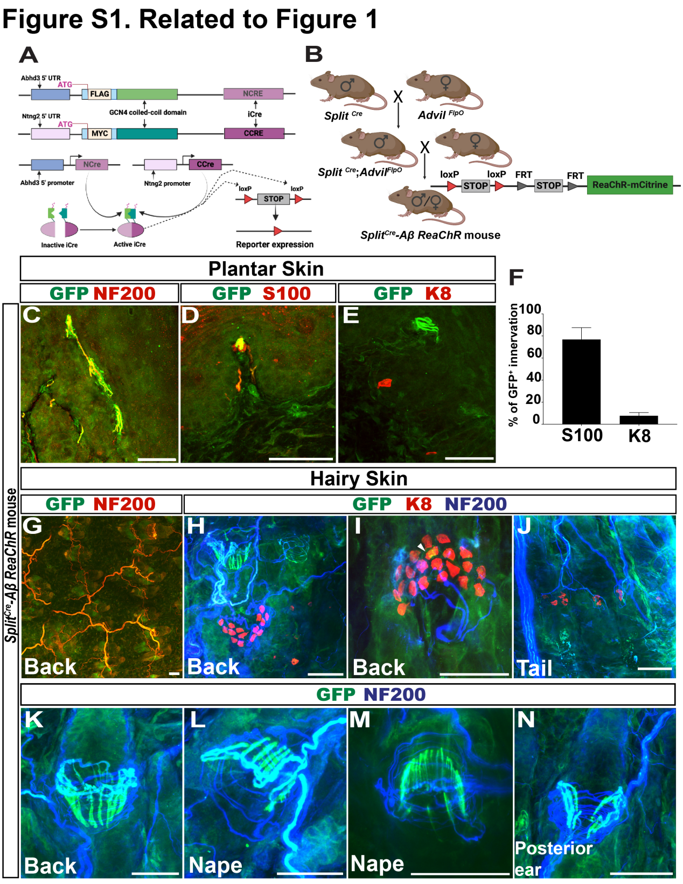

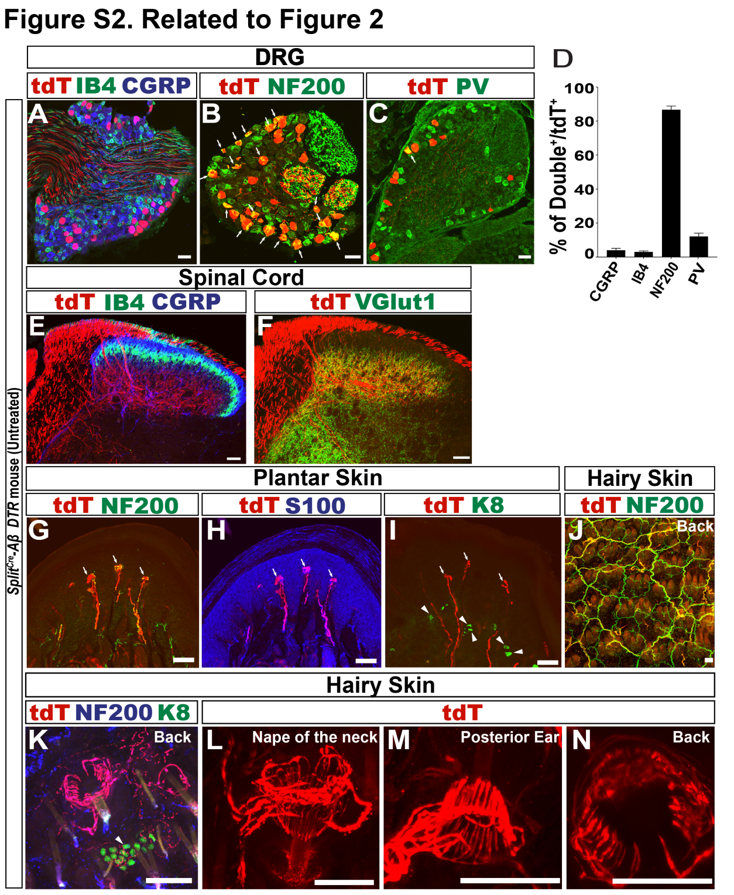
O

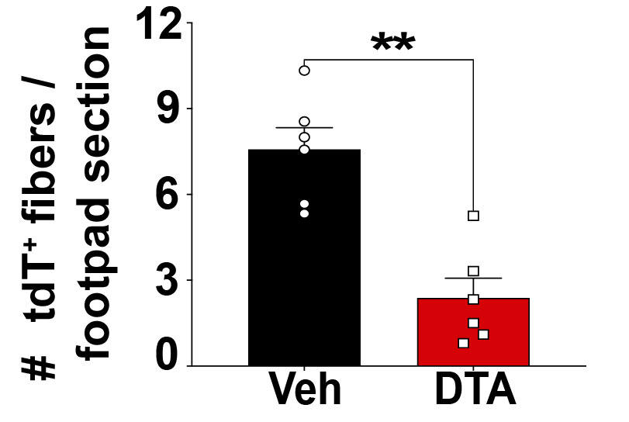

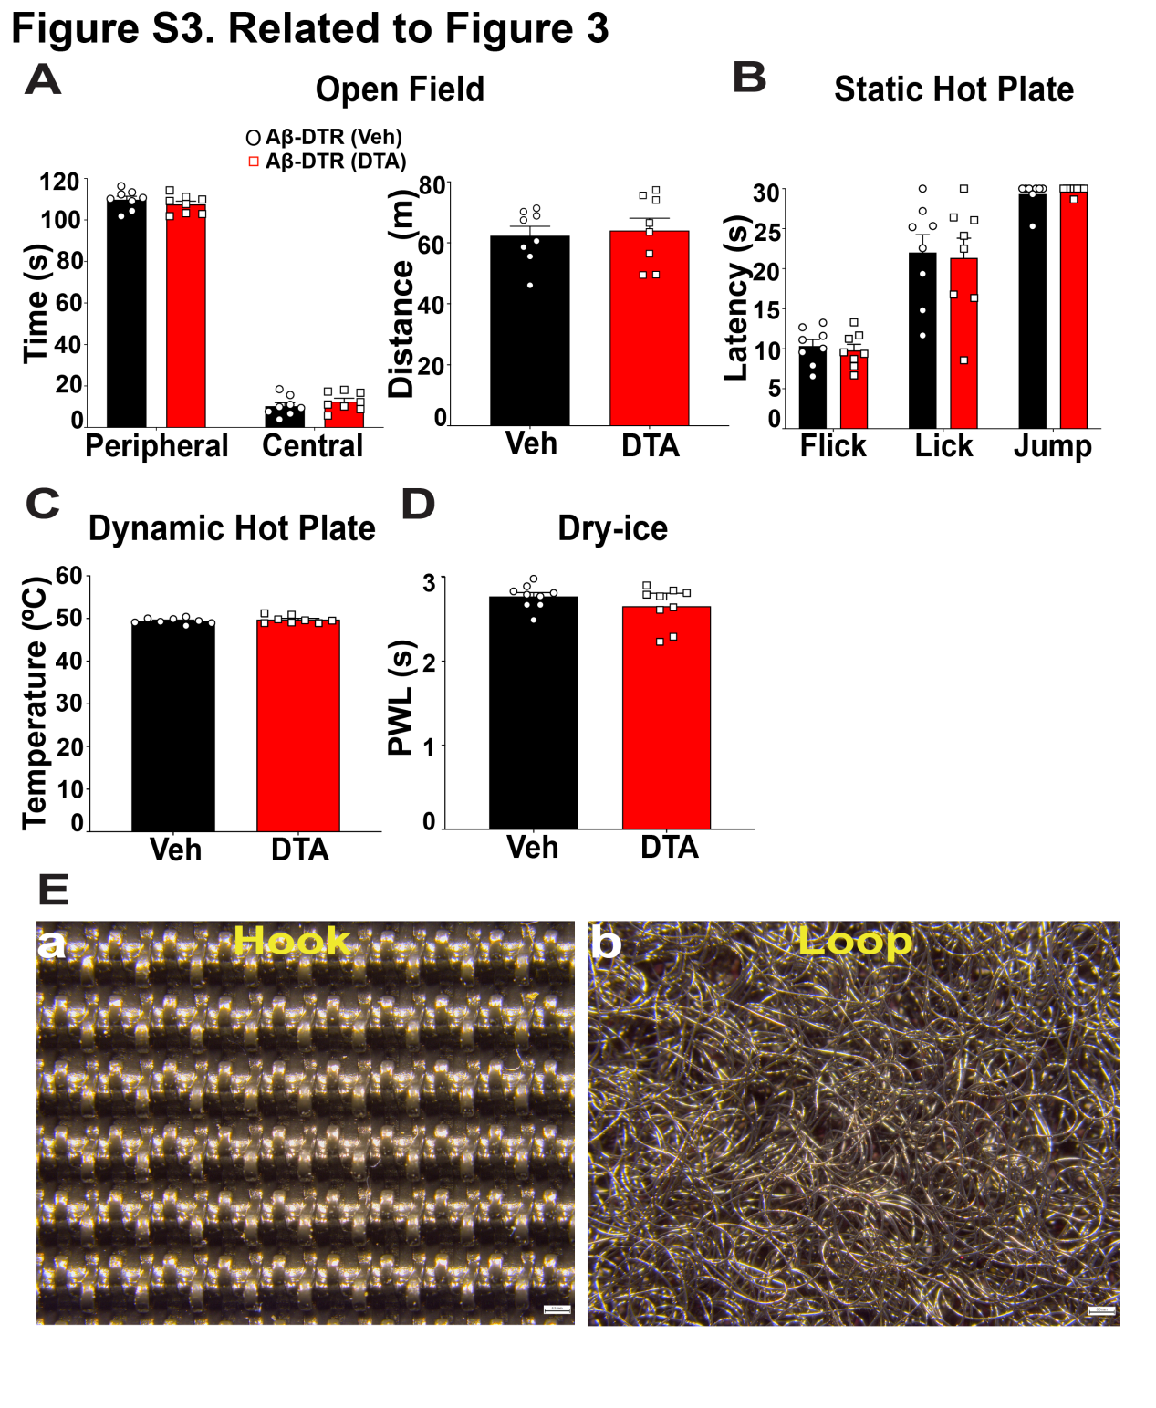

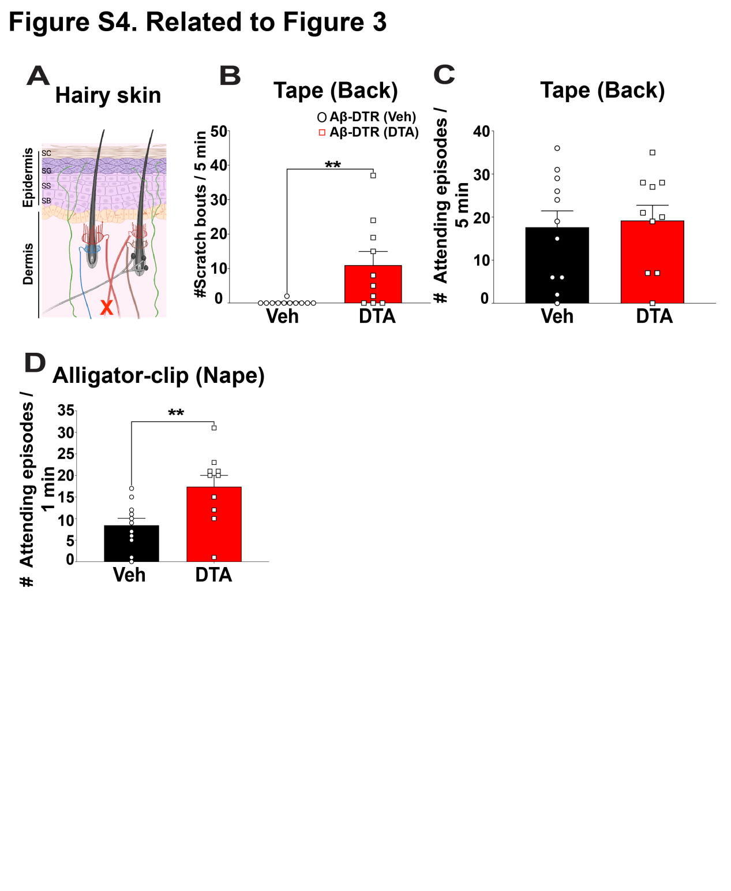

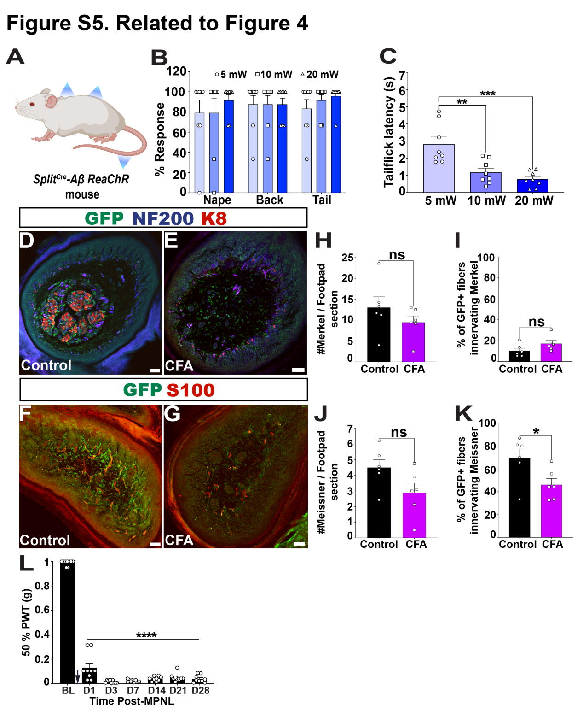

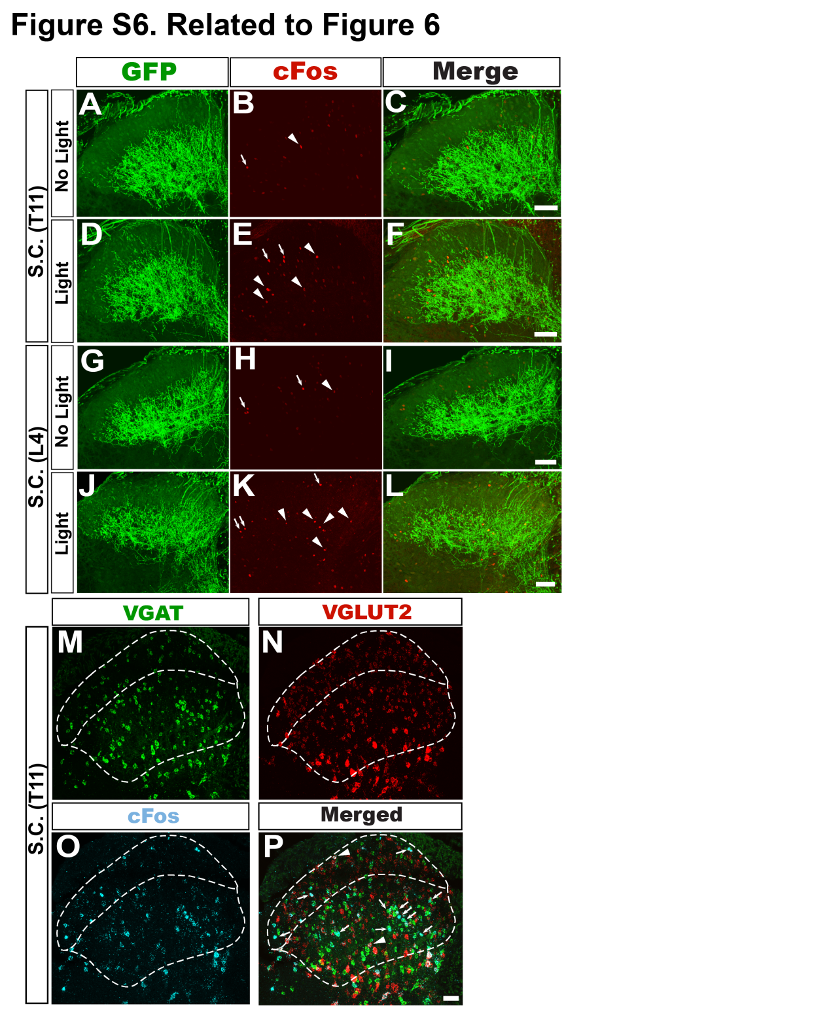

- Supplementary Figure Legends

Supplementary Figure 1. Histological characterizations of Split^{Cre}-Aβ ReaChR mice, related to Figure 1.
- Schematic depicting the genetic configuration of the Split^{Cre} mouse line. (B) Schematic depicting the breeding strategy to generate Split^{Cre};Advil^{FlpO};Rosa^{ReaChRf/+} triple mice. (C-E) Images of dermal papilla sections of the plantar skin showing GFP⁺ nerves are NF200⁺ and innervate S100⁺ Meissner’s corpuscles. GFP⁺ fibers rarely innervate the K8⁺ Merkel cell at the base of papilla. (F) Quantification of the percentage of GFP⁺ peripheral axons innervating Meissner’s corpuscles. Data are presented as Mean ± SEM. 6-8 sections/mouse, n = 4-6 mice. (G) Whole-mount immunostaining of the hairy back skin showing that GFP⁺ peripheral axons are NF200⁺. (H-J) Whole-mount immunostaining of the hairy back and tail skin showing that GFP⁺ peripheral axons are NF200⁺. A few GFP⁺ fibers innervate Merkel cells in the hairy skin (an example indicated by a white arrowhead). n = 4-6 mice. (K-N) Whole-mount immunostaining of the hairy back, nape and posterior ear skin showing that GFP⁺ peripheral axons are NF200⁺ and form lanceolate ending structures around hair follicles.

Supplementary Figure 2. Histological characterization of Split^{Cre}-Aβ TauDTR mice, related to Figure 2.
- Immunostaining of a lumbar DRG section showed a little overlap between tdTomato⁺ DRG neurons and nociceptor markers CGRP or IB4. (B) Immunostaining of DRG sections showing high overlaps between tdTomato⁺ DRG neurons and a large-diameter neuron marker NF200. White arrows indicate some overlapped neurons. (C) Immunostaining of DRG sections showed some overlap between tdTomato⁺ DRG neurons and a proprioceptive marker PV. (D) Quantification of the percentage of tdTomato⁺ neurons expressing different markers. 6-8 sections/mouse, n = 4-6 mice. Error bars represent Mean ± S.E.M. (E) Immunostaining of a lumbar spinal cord section showing laminar segregation of tdTomato⁺ central terminals and CGRP⁺ or IB4⁺ nociceptor terminals. (F) Immunostaining of a lumbar spinal cord section showing tdTomato⁺ central terminals innervate deeper dorsal horn lamina (III-V), indicated by VGLUT1⁺ staining. (G-I) Immunostaining of plantar skin sections showed that tdTomato⁺ peripheral axons are NF200⁺ and innervate Meissner’s corpuscles (revealed by S100 staining) but rarely innervate K8⁺ Merkel cells. White arrows indicate some Meissner’s corpuscles, while white arrowheads indicate some Merkel cells. 6-8 sections/mouse, n = 4-6 mice. (J) Whole-mount immunostaining of the hairy back skin shows that tdTomato⁺ peripheral axons are NF200⁺. (K) Whole-mount immunostaining of the hairy back skin showed that most of tdTomato⁺ peripheral axons are NF200⁺, and a few tdTomato⁺ fibers also innervate Merkel cells (One example indicated by a white arrowhead). (L-N) Whole-mount immunostaining of the nape, posterior ear and back skin showing that tdTomato⁺ peripheral axons form lanceolate endings around the hair follicles of different hairy skin regions. (O) Quantification of total tdTomato⁺ fibers innervating dermal papilla per footpad section showed a significant decrease with DTA-treatment (p = 0.0022), 5-7 sections per mouse, n = 6 mice. Error bars represent Mean ± S.E.M. Unpaired, two-tailed Mann-Whitney test. **p < 0.01

Supplementary Figure 3. Ablation of Split^{Cre}-Aβ-LTMRs did not alter general locomotion, and thermal sensation, related to Figure 3.
- Ablation of Split^{Cre}-Aβ-LTMRs did not alter the time spent in peripheral (p = 0.38) and central zones (p = 0.328) in vehicle vs DTA treated mice. There was also no difference in total distance travelled between the two groups (p = 0.72). (B) No difference in baseline heat nociception sensitivity, indicated by the latency of hind paw flick (p = 0.64), hind paw lick (p = 0.904), or jump (p = 0.733), in the DTA vs vehicle treated groups in static hotplate test. (C) No difference in baseline heat nociception sensitivity, indicated by the heat pain temperature threshold (p = 0.702) between the DTA vs vehicle treated using the dynamic hotplate test, n = 8 mice in each group in (A-C). (D) No difference in baseline cold nociception sensitivity, indicated by the paw-withdrawal latency (p = 0.395) to dry ice, between the DTA vs vehicle treated groups, n = 9 mice in each group. (E) Representative images of hook (a) and loop (b) material of the Velcro surface. Scale bar = 0.5 mm. Error bars represent Mean ± S.E.M. Unpaired, two-tailed Mann-Whitney test. *p < 0.05, **p < 0.01; ***p < 0.001, ns = non significance, BL = baseline.

Supplementary Figure 4. Ablation of Split^{Cre}-Aβ-LTMRs altered the gentle touch and nociception in the hairy skin, related to Figure 3.
- Illustration showing cutaneous sensory afferents of the ablated hairy skin; green fibers represent nociceptive C/Aδ fibers; red fibers represent RA Aβ-LTMRs encircling the hair follicles; black fibers represent SA Aβ-LTMRs innervating Merkel cells (black bead-like structures); blue and brown colored fibers represent the C- and Aδ-LTMRs respectively; ‘X’ symbol represents the DTA-induced selective ablation of Split^{Cre}-Aβ-LTMRs. (B) The ablated mice showed significantly increased scratching behaviors in response to a tape attached to the back (p = 0.0027). (C) In response to a tape attached to the back, no difference in licking behaviors between the vehicle and DTA groups (p = 0.743) was observed. (D) The ablated mice displayed significantly increased number of licking episodes (p = 0.0074) in response to the application of an alligator clip at the nape of the neck. n = 11 and 10 mice in vehicle and DTA groups respectively in (B-D). Also see the supplementary video 3. Error bars represent Mean ± S.E.M. Unpaired, two-tailed Mann-Whitney test. **p < 0.01.

Supplementary Figure 5. Local optogenetic activation of Split^{Cre}-Aβ-LTMRs at different skin areas, and CFA-induced inflammation alter the GFP⁺ fiber innervation in plantar skin, related to Figure 4.
- Schematic showing how blue laser was shined to stimulate different skin areas of the Split^{Cre}-Aβ ReaChR mouse. (B) Split^{Cre}-Aβ ReaChR mice showed high responsive rates to different intensities (5, 10 and 20 mW) of blue laser stimuli on different hairy skin (Nape of the neck, back and tail) regions. (C) The tail-flick latency decreased significantly in an intensity dependent manner (5 mW vs 10 mW, p = 0.005); (5 mW vs 20 mW, p = 0.0008); (10 mW vs 20 mW, p = 0.68). n = 8 mice in (B-C). Error bars represent Mean ± S.E.M. One way ANOVA followed by Tukey’s multiple comparison. *p < 0.05, **p < 0.01, ***p < 0.001, ****p < 0.0001. (D-E) Triple staining of GFP, NF200 and K8 with plantar footpad sections of control and CFA-treated Split^{Cre}-Aβ ReaChR mice at post-CFA Day 7. (F-G) Double staining of GFP and S100 with footpad sections of control and CFA-treated Split^{Cre}-Aβ ReaChR mouse at post-CFA Day 7. (H) Quantification of Merkel cell numbers per foot pad skin section showed no significant difference between the control and CFA treated mice (p = 0.179) at post-CFA Day 7. (I) Quantification of the percentage of GFP⁺ fibers innervating Merkel cells per foot pad section showed a non-significant increase trend in CFA treated mice, compared to the control (p = 0.088). (J) Quantification of the number of Meissner’s corpuscles per foot pad section showed non-significant decrease trend in control and CFA-treated mice (p = 0.0931). (K) Quantification of the percentage of GFP⁺ fibers innervating Meissner’s corpuscles per foot pad section showed a significant decrease in CFA treated mice compared to the control (p = 0.041), n = 6 mice in each group (5-7 sections per mouse. (L) Results showing the effect and time course of the neuropathic medial plantar nerve ligation (MPNL) model. Control mice undergone MPNL showed a significant decrease in the 50% PWT (p < 0.0001), which didn’t recover as the experiment lasted up to D28, n = 9 mice. Error bars represent Mean ± S.E.M. Mann-Whitney test in H-K & One way ANOVA followed by Bonferroni’s test in L and M. *p < 0.05, **p < 0.01, ****p < 0.0001.

Supplementary Figure 6. Dorsal column activation of Split^{Cre}-ReaChR⁺ Aβ-LTMRs evoked spontaneous behaviors and c-Fos expression in deep dorsal horn neurons, related to Figure 6.
(A-C) Double immunostaining of c-Fos and GFP with a T11 spinal cord section of an unstimulated Split^{Cre}-Aβ ReaChR mouse showing innervation of ReaChR-EFYP⁺ central terminals in the layer III-V and baseline c-Fos expression. (D-F) Double immunostaining of c-Fos and GFP with a T11 spinal cord section of a light-stimulated Split^{Cre}-Aβ ReaChR mouse showing innervation of ReaChR-EFYP⁺ central terminals in the layer III-V and increased c-Fos expression. (G-I) Double immunostaining of c-Fos and GFP with a L4 spinal cord section of an unstimulated Split^{Cre}-Aβ ReaChR mouse showing innervation of ReaChR-EFYP⁺ central terminals in the layer III-V and baseline c-Fos expression. (J-L) Double immunostaining of c-Fos and GFP with a L4 spinal cord section of a light-stimulated Split^{Cre}-Aβ ReaChR mouse showing innervation of ReaChR-EFYP⁺ central terminals in the layer III-V and increased c-Fos expression. White arrowheads indicate some examples of c-Fos immunoreactivity in deeper laminae. White arrows point to some c-Fos⁺ cells in superficial laminae of the dorsal horn. n = 3 mice in each group (5-7 sections per mouse for statistical comparison). (M-P) Representative images of RNAScope in situ hybridization for Vgat, Vglut2 and c-Fos with a T11 spinal cord section of a spinal light-stimulated Split^{Cre}-Aβ ReaChR mouse. White arrowheads indicate some examples of co-localized VGLUT2⁺ and c-Fos⁺ neurons. White arrows indicate some co-localized VGAT⁺ with c-Fos⁺ neurons. n = 3 mice (3-4 sections per mouse). Error bars represent Mean ± S.E.M. Mann-Whitney test. *p < 0.05, **p < 0.01, ***p < 0.001.

