Impact of Early Corticosteroids on 60-day Mortality in Critically Ill Patients With COVID-19: A Multicenter Cohort Study of the OUTCOMEREA Network

Additional file 1
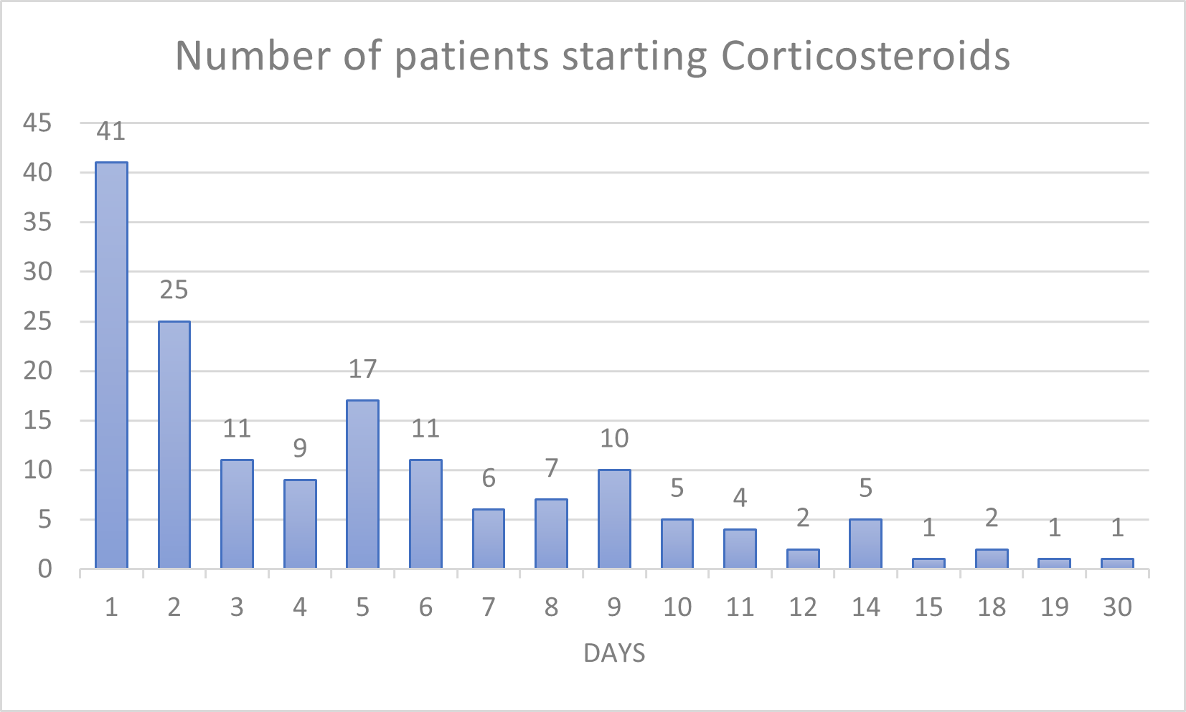
Figure S 1: Distribution of the start of steroids in the studied population

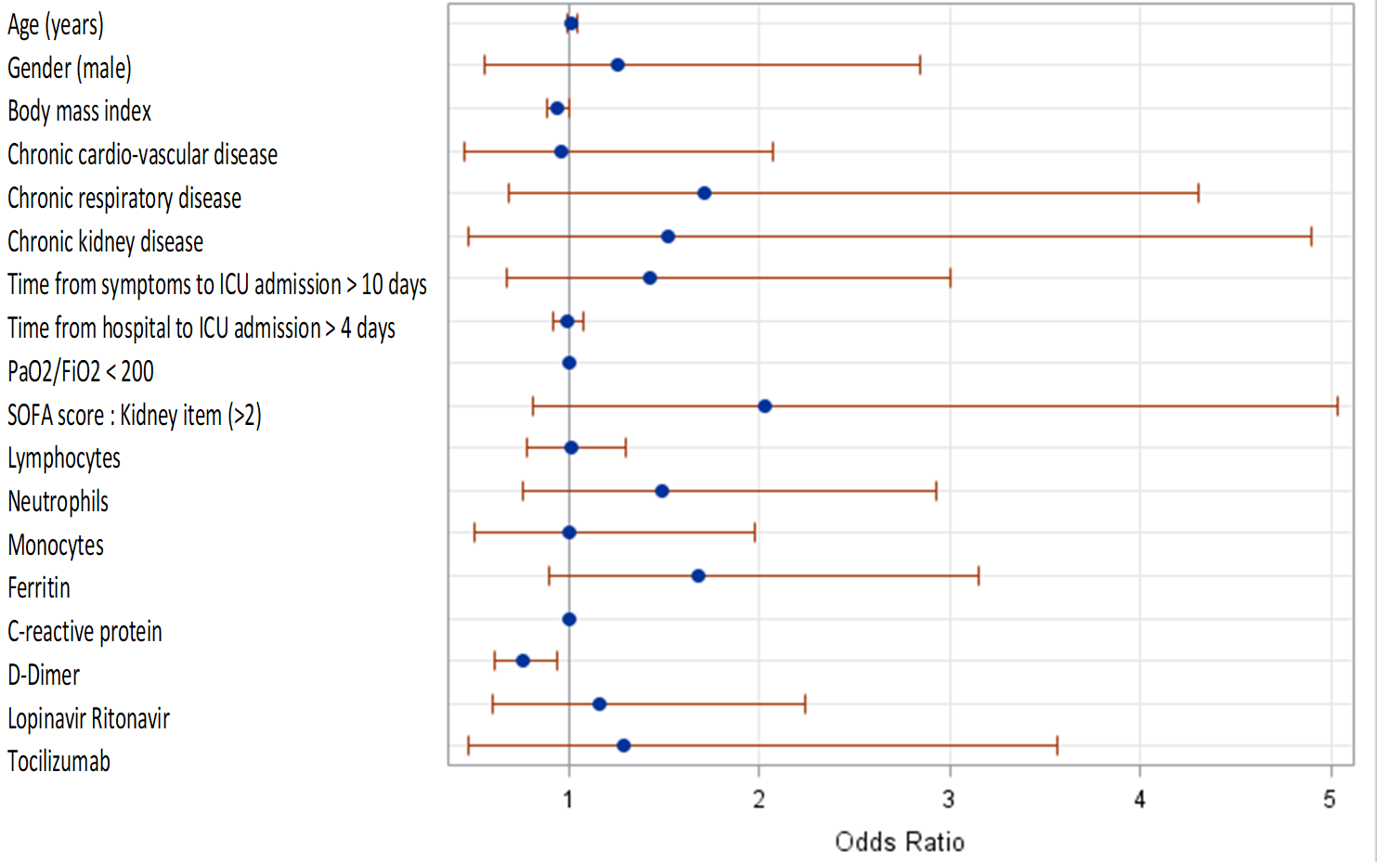
Figure S 2 Propensity score: multivariate regression logistic analysis for the factors associated with receiving early Corticosteroids.
ICU: Intensive care unit; SOFA: Sequential Organ Failure Assessment
AUC=0.76
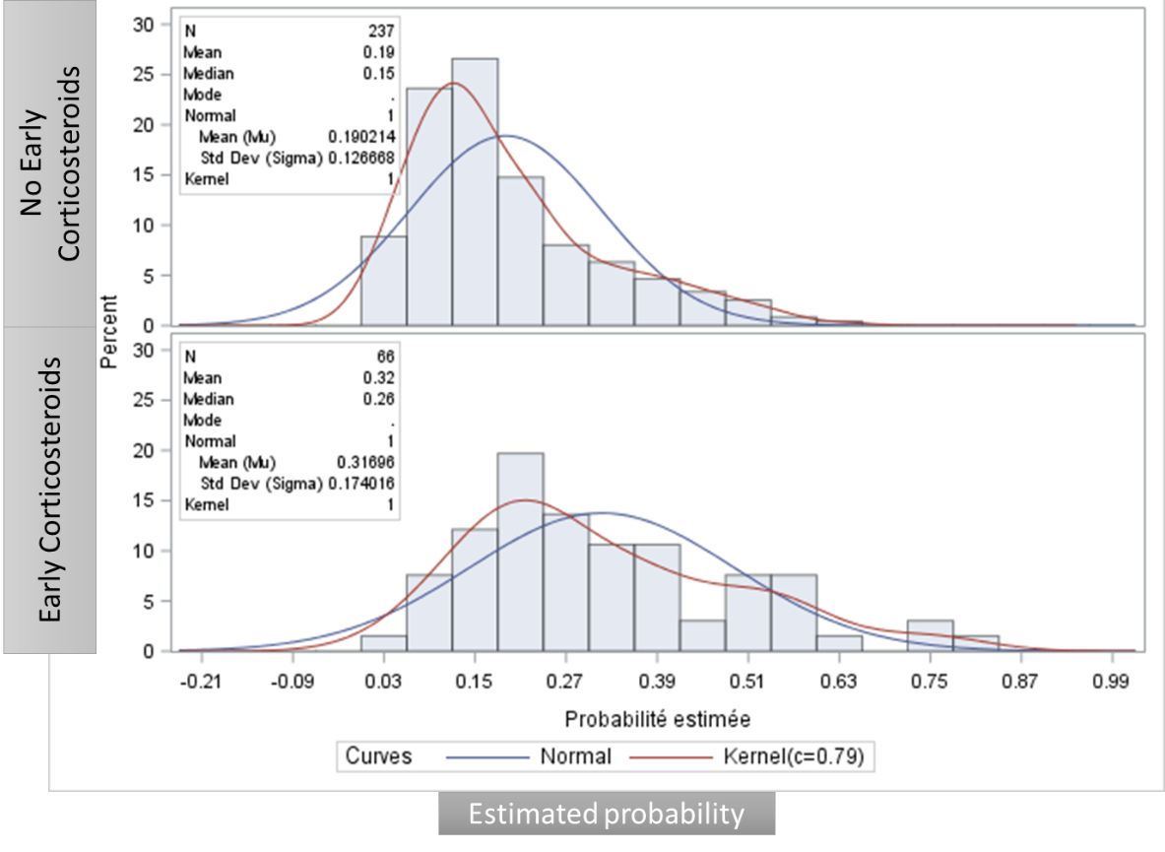
Figure S 3: Histograms of propensity score by treatment group: Early Steroids and Non-early Corticosteroids

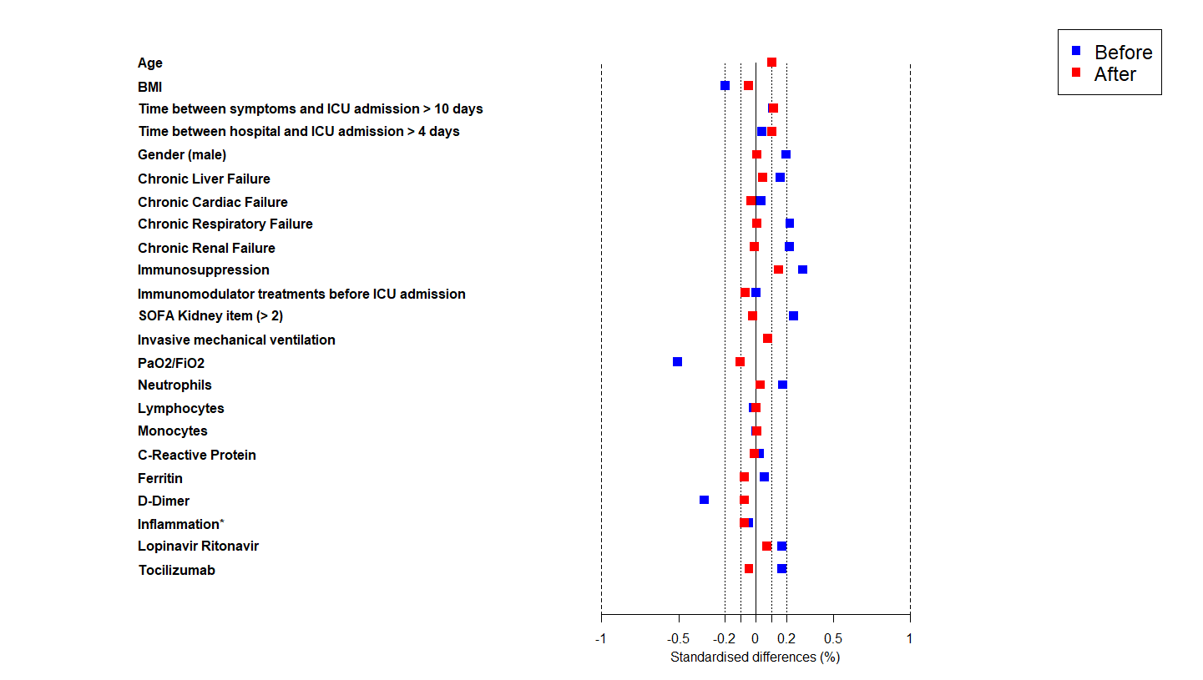
Figure S 4: Standardized differences of the covariates included in the propensity score, before (in blue) and after (in red) weighting.
* a Ferritin > 1000 µg/l or D-Dimers > 1000 µg/l or C-Reactive Protein > 100 mg/dL.

Table S 1: Cox model for 60-day mortality with ponderation on IPTW for the impact of early corticosteroids
Truncation | Estimated weight |  | Early Corticosteroids effect
Percentiles | Mean(SD) | Minimum/maxium | HR | CI 95% | P-value
0,1 | 1/1.235 | 0.505/16.879 | 0.80 | [0.5 ; 1.28] | 0.35
1,99 | 0.999/1.235 | 0.505/16.879 | 0.81 | [0.5 ; 1.29] | 0.37
5 ,95 | 0.959/0.861 | 0.519/5.618 | 0.88 | [0.55 ; 1.39] | 0.58
10,9 | 0.928/0.734 | 0.532/3.805 | 0.93 | [0.58 ; 1.48] | 0.75
25,75 | 0.877/0.584 | 0.552/2.534 | 0.96 | [0.6 ; 1.55] | 0.88
50,5 | 0.875/0.542 | 0.589/1.9 | 1.04 | [0.65 ; 1.68] | 0.86
IPTW: Inverse Probability of treatment weight; HR: Hazard Ratio

Table S 2: Multivariate survival analyses of the factors associated with 60-day mortality
Variables | HR | HRIC | Pr > Khi-2
Early Corticosteroids | 1.10 | [0.63 ; 1.92] | 0.74
Time between symptom and ICU admission | 0.66 | [0.41 ; 1.07] | 0.09
Chronic cardiac disease | 1.93 | [1.19 ; 3.12] | 0.01
Chronic respiratory disease | 2.11 | [1.14 ; 3.89] | 0.02
PaO2/FiO2 < 200 mmHg | 1.93 | [1.15 ; 3.23] | 0.01
Vasopressors | 1.65 | [1.08 ; 2.54] | 0.02
Age | 1.06 | [1.04 ; 1.09] | <0.01
Renal SOFA > 2 | 1.76 | [0.95 ; 3.25] | 0.07
Leucocytes > 10 G/L | 1.44 | [0.92 ; 2.25] | 0.11
Monocytes > 1 G/L | 0.66 | [0.42 ; 1.03] | 0.07
T° > 39 °C | 2.06 | [1.24 ; 3.45] | <0.01
HR: Hazard Ratio; SOFA: Sequential Organ Failure Assessment; HR: Hazard Ration

Table S 3: Occurrence of HAP-VAP: Competing risk models with death or leaving alive as competing risks.
Truncation | Estimated weight |  | Early Corticosteroids effect
Percentiles | Mean(SD) | Minimum/maxium | SubHR | CI 95% | P-value
0,1 | 1/1.235 | 0.505/16.879 | 1.11 | [0.68 ; 1.81] | 0.66
1,99 | 0.999/1.235 | 0.505/16.879 | 1.13 | [0.69 ; 1.83] | 0.63
5 ,95 | 0.959/0.861 | 0.519/5.618 | 1.19 | [0.74 ; 1.92] | 0.47
10,9 | 0.928/0.734 | 0.532/3.805 | 1.22 | [0.76 ; 1.95] | 0.41
25,75 | 0.877/0.584 | 0.552/2.534 | 1.20 | [0.75 ; 1.93] | 0.45
50,5 | 0.875/0.542 | 0.589/1.9 | 1.15 | [0.72 ; 1.85] | 0.56
HAP-VAP: Ventilator associated pneumoniae; SubHR: Sub hazard ratio
Table S 4: Occurrence of ICU-BSI: Competing risk models with death or leaving alive as competing risks
Truncation | Estimated weight |  | Early Corticosteroids effect
Percentiles | Mean(SD) | Minimum/maxium | SubHR | CI 95% | P-value
0,1 | 1/1.005 | 0.514/8.467 | 0.95 | [0.51 ; 1.76] | 0.87
1,99 | 0.998/1.005 | 0.517/8.467 | 0.94 | [0.51 ; 1.75] | 0.85
5 ,95 | 0.979/0.888 | 0.528/5.942 | 1.01 | [0.55 ; 1.85] | 0.97
10,9 | 0.952/0.767 | 0.533/4.208 | 1.01 | [0.55 ; 1.86] | 0.97
25,75 | 0.907/0.602 | 0.555/2.706 | 0.99 | [0.54 ; 1.82] | 0.98
50,5 | 0.863/0.476 | 0.612/1.763 | 1.07 | [0.59 ; 1.93] | 0.83
ICU BSI: Intensive care unit blood stream infection; SubHR: Sub Hazard Ratio

Table S 5: Comparison between older and younger patients and between patients with and without inflammation
 | Age < 60 y.o. | Age > 60 y.o. | pvalue | No inflammation | Inflammation | pvalue
Number of patients | 142 | 161 |  | 49 | 254
Baseline characteristics
Age | 52 [46 ; 57] | 70 [65 ; 74] | <0.01 | 61 [52 ; 73] | 61.5 [54 ; 70] | 0.99
Body-mass index, kg/cm² * (miss=14) | 29.1 [25.9 ; 33.1] | 27.7 [25.2 ; 30.7] | <0.01 | 28.4 [25.2 ; 31.9] | 28.4 [25.7 ; 31.6] | 0.50
Body-mass index ≥ 30 | 63 (44.4) | 45 (28) | <0.01 | 18 (36.7) | 90 (35.4) | 0.86
Comorbidities
At least one comorbidity | 67 (47.2) | 109 (67.7) | <0.01 | 28 (57.1) | 148 (58.3) | 0.88
Chronic liver failure | 3 (2.1) | 1 (0.6) | 0.26 | 1 (2) | 3 (1.2) | 0.63
Chronic cardiovascular disease | 27 (19) | 52 (32.3) | <0.01 | 14 (28.6) | 65 (25.6) | 0.66
Chronic respiratory failure | 16 (11.3) | 17 (10.6) | 0.84 | 3 (6.1) | 30 (11.8) | 0.24
Chronic kidney disease | 8 (5.6) | 14 (8.7) | 0.31 | 5 (10.2) | 17 (6.7) | 0.39
Immunosuppression§ | 6 (4.2) | 5 (3.1) | 0.60 | 2 (4.1) | 9 (3.5) | 0.85
Time between symptoms and ICU admission | 10 [8 ; 12] | 10 [7 ; 12] | 0.45 | 10 [8 ; 11] | 10 [7 ; 12] | 0.53
Treatment before admission
Angiotensin converting enzyme inhibitor | 18 (12.7) | 41 (25.5) | <0.01 | 8 (16.3) | 51 (20.1) | 0.54
Immunomodulatory treatments | 7 (4.9) | 2 (1.2) | 0.06 | 4 (8.2) | 5 (2) | 0.02
Characteristics on admission
SAPS II score | 28 [22 ; 36] | 36 [30 ; 47] | <0.01 | 32.5 [18.5 ; 43] | 33 [25 ; 44] | 0.26
SOFA score | 4 [2 ; 6] | 4 [3 ; 7] | 0.07 | 4 [2 ; 5] | 4 [3 ; 7] | 0.25
Neurological failure (GCS < 15) | 21 (14.8) | 19 (11.8) | 0.44 | 7 (14.3) | 33 (13) | 0.81
Body temperature > 39°C | 58 (40.8) | 38 (23.6) | <0.01 | 9 (18.4) | 87 (34.3) | 0.03
Severity of ARDS
No ARDS PaO2/FiO2 > 300 | 16 (11.3) | 21 (13) | 0.54 | 12 (24.5) | 25 (9.8) | 0.01
Mild: PaO2/FiO2 200-300 | 18 (12.7) | 26 (16.1) | . | 3 (6.1) | 41 (16.1) | .
Moderate: PaO2/FiO2 100-200 | 61 (43) | 72 (44.7) | . | 22 (44.9) | 111 (43.7) | .
Severe: PaO2/FiO2 < 100 | 47 (33.1) | 42 (26.1) | . | 12 (24.5) | 77 (30.3) | .
Ventilatory support on admission
No mechanical ventilation | 59 (41.5) | 65 (40.4) | 0.20 | 15 (30.6) | 109 (42.9) | 0.01
Non-invasive mechanical ventilation | 28 (19.7) | 45 (28) | . | 20 (40.8) | 53 (20.9) | .
Mechanical ventilation | 55 (38.7) | 51 (31.7) | . | 14 (28.6) | 92 (36.2) | .
Laboratory features on admission
Leucocytes (miss=10) | 7605 [5400 ; 10680] | 7900 [6000 ; 10500] | 1.00 | 7440 [4610 ; 9600] | 7915 [6000 ; 11200] | 0.09
Neutrophils (miss=36) | 6650 [4300 ; 9830] | 6710 [4980 ; 9239.5] | 0.96 | 6700 [4240 ; 9460] | 6705 [4700 ; 9446.3] | 0.44
Lymphocytes (miss=36) | 900 [630 ; 1210] | 700 [500 ; 1070.7] | <0.01 | 800 [503.3 ; 1110] | 800 [510 ; 1100] | 0.83
Monocytes(miss=36) | 340 [201.1 ; 500] | 390 [228.2 ; 600] | 0.53 | 330 [230 ; 500] | 385 [200 ; 600] | 0.92
CRP(miss=63) | 139.7 [84 ; 213] | 168 [83.5 ; 238] | 0.13 | 68.3 [35.1 ; 83.5] | 175 [120 ; 245] | <.01
Ferritin (miss=107) | 1135.5 [491 ; 1960.2] | 974 [622 ; 1801] | 0.76 | 562 [303 ; 730.9] | 1357.8 [705.5 ; 2031.1] | <.01
DDimers (miss=90) | 1626.5 [800 ; 3957.3] | 2349.4 [980 ; 6500] | 0.02 | 1390 [640 ; 3794.2] | 1915.7 [921 ; 5671] | 0.08
Inflammation* | 119 (83.8) | 135 (83.9) | 0.99
Treatments on admission
Lopinavir Ritonavir | 44 (31) | 65 (40.4) | 0.09 | 10 (20.4) | 99 (39) | 0.01
Tocilizumab | 13 (9.2) | 12 (7.5) | 0.59 | 8 (16.3) | 17 (6.7) | 0.02
Anakinra | 11 (7.7) | 11 (6.8) | 0.76 | 3 (6.1) | 19 (7.5) | 0.74
Hydroxychloroquine | 20 (14.1) | 13 (8.1) | 0.09 | 7 (14.3) | 26 (10.2) | 0.40
Corticosteroids | 27 (19) | 39 (24.2) | 0.27 | 11 (22.4) | 55 (21.7) | 0.90
High dose of corticosteroids | 25 (17.6) | 30 (18.6) | 0.82 | 9 (18.4) | 46 (18.1) | 0.97
First corticosteroids after Day 3 | 44 (31) | 50 (31.1) | 0.99 | 15 (30.6) | 79 (31.1) | 0.95
LOS and Mortality
ICU LOS | 12 [7 ; 20] | 11 [7 ; 20] | 0.84 | 9 [6 ; 16] | 12 [7 ; 21] | 0.07
ICU Death | 28 (19.7) | 58 (36) | <0.01 | 13 (26.5) | 73 (28.7) | 0.75
Death at day 60 | 28 (19.7) | 62 (38.5) | <0.01 | 14 (28.6) | 76 (29.9) | 0.85
Adverse events due to corticosteroids
VFD | 4 [1 ; 7] | 3 [1 ; 8] | 0.70 | 3 [1 ; 6] | 4 [1 ; 7] | 0.49
Hyperglycemia | 53 (37.3) | 52 (32.3) | 0.36 | 13 (26.5) | 92 (36.2) | 0.19
Mean daily dose of insulin | 8.5 [0 ; 38.8] | 9 [0 ; 49.9] | 0.45 | 11.6 [0 ; 35.3] | 7.4 [0 ; 46] | 0.93
BSI | 22 (15.5) | 21 (13) | 0.54 | 5 (10.2) | 38 (15) | 0.38
HCAP | 46 (32.4) | 49 (30.4) | 0.71 | 14 (28.6) | 81 (31.9) | 0.65
Inflammation* Ferritin >1000 µg/l or D-Dimers >1000 µg/l or C-Reactive Protein >100 mg/dL
VFD: Ventilatory free days; BSI: Blood stream infection, HAP-VAP: hospital-acquired pneumonia and ventilator-associated pneumonia. LOS: Length of stay; HSHC: Hydrocortisone hemisuccinate ICU: intensive care unit; SOFA: Sequential organ Failure assessment; SAPS II: simplified acute physiology score

