Tuning of the chiral nematic phase of cellulose nanocrystals by the adsorption of a short polymer on their surface

Hugo Voisin¹, Adèle Vasse¹, Estelle Bonnin¹, Fabrice Cousin², Isabelle Capron¹*

1. INRAE, UR BIA, F-44316, Nantes, France
2. Laboratoire Léon Brillouin, Université Paris-Saclay, CEA-CNRS, CEA-Saclay, Gif-sur-Yvette, France

 | XG20
M_{n} | 15 164 g/mol
M_{w} | 20 262 g/mol
M_{w}/M_{n} | 1.34
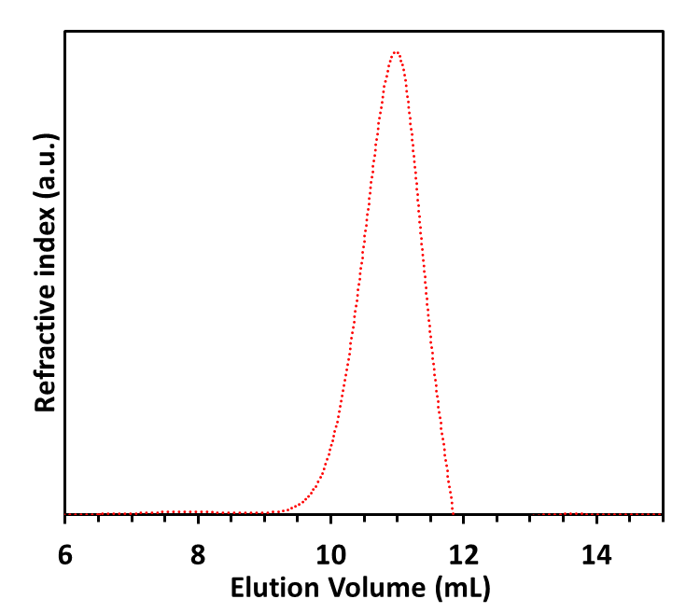
Fig. S1 HPSEC-MALLS with refractometric detection was used to characterize the average molar mass of the XG sample recovered after the optimized enzymatic hydrolysis. Here are the refractive index peak, and the corresponding M_{n}, M_{w} and polydispersity are given in the table

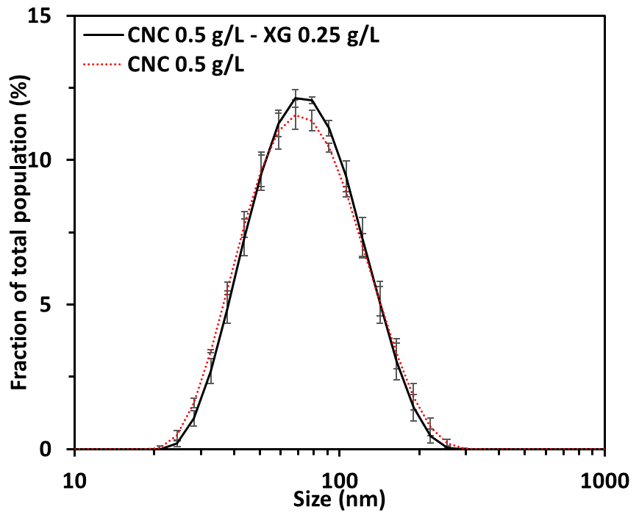
Fig. S2 Dynamic light scattering of diluted suspensions of CNC and CNC-XG mixtures. This dilution was necessary but the ratio CNC:XG of 1:0.5 is equivalent to 60:30, the larger amount of XG used

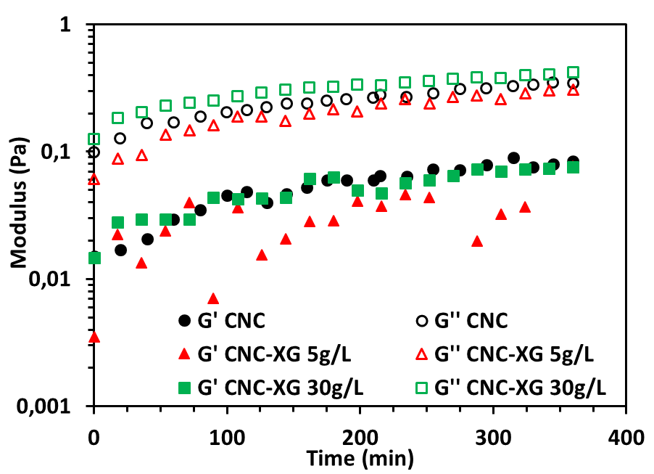
Fig. S3 Time evolution of the rheological moduli of CNC suspensions at 70 g/L without and with various concentration of XG after preparation
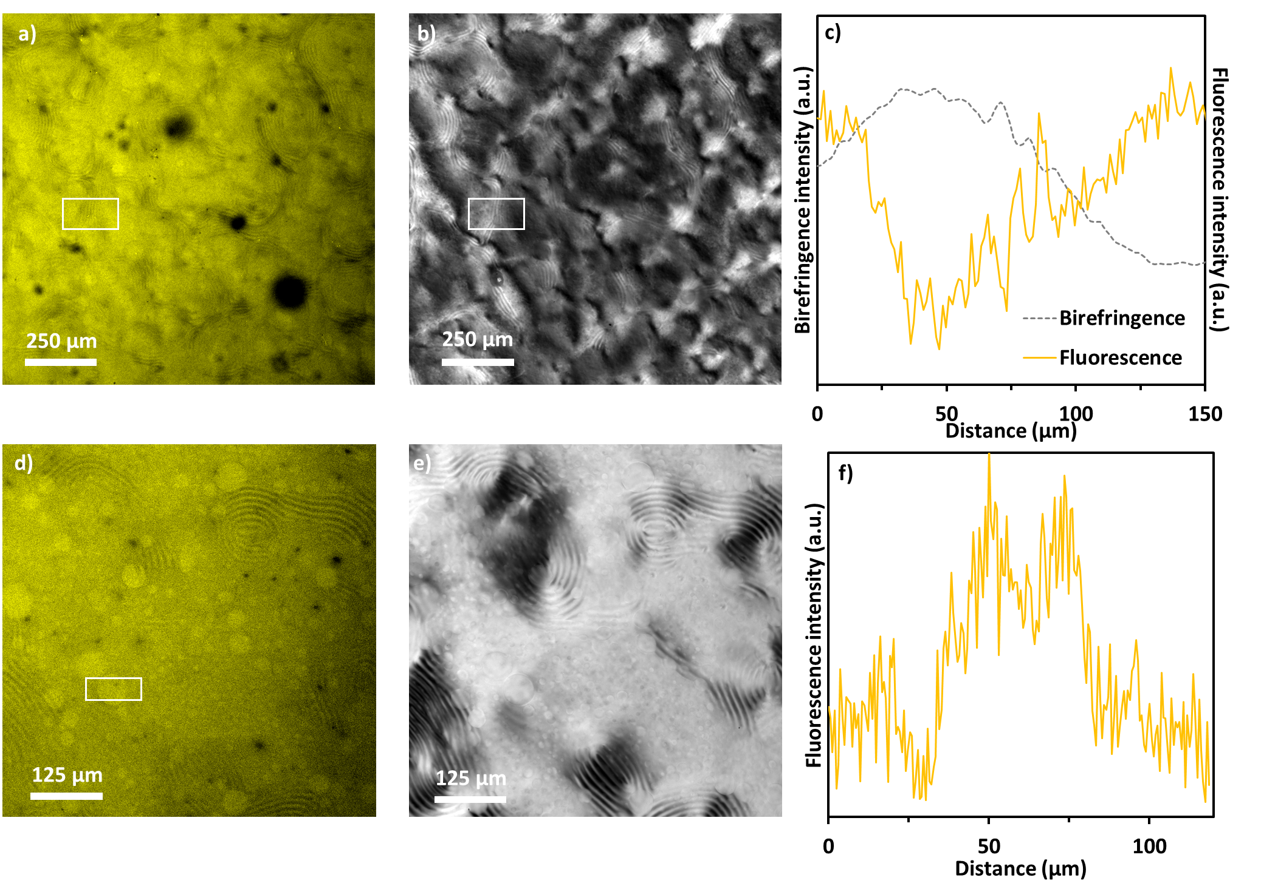
Fig. S4 Confocal fluorescence (a,d) and POM (b,e) microscopy of a 60 g/L CNC suspension with 30 g/L XG (a,b,c) and 10 g/L XG (d, e f). XG is labeled with FITC; intensity profiles of the birefringence (c,f) and fluorescence intensities from the white rectangle on (a,d) and (b), respectively, vertically integrated and from left to right

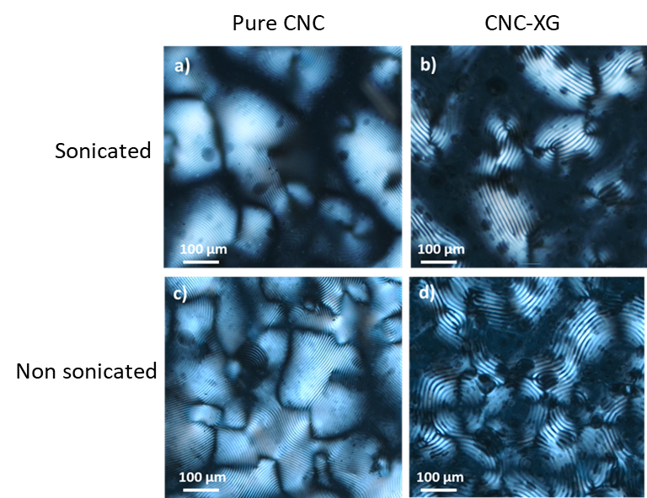
Fig. S5 POM pictures of a 60 g/L pure CNC suspension (a, c) and with 10 g/L XG (b,d). The samples were prepared with sonication (a,b) and without sonication (c,d) and visualized 3 days after mixing. The pitch of the non-sonicated samples is 13 µm for CNC (c) and 22.5 µm for CNC-XG (d) samples which gives the same result as for sonicated samples.

