Supporting Information

SnFe₂O₄ Nanocatalyst for the Synthesis of Arylbenzimidazoles from Aqueous Cascade Reaction and the Computational Study of the Mechanism and Application of the Products as Putative Human Transmembrane Protein Activators

Mohammad Taqi Jafari–Chermahini and Hossein Tavakol

*Department of Chemistry, Isfahan University of Technology, Isfahan 84156-83111, Iran.
Tell: +98-3133913241
Fax: +98-3133913241
Email: h_tavakol@cc.iut.ac.ir

Part A- Extra Figures and Tables
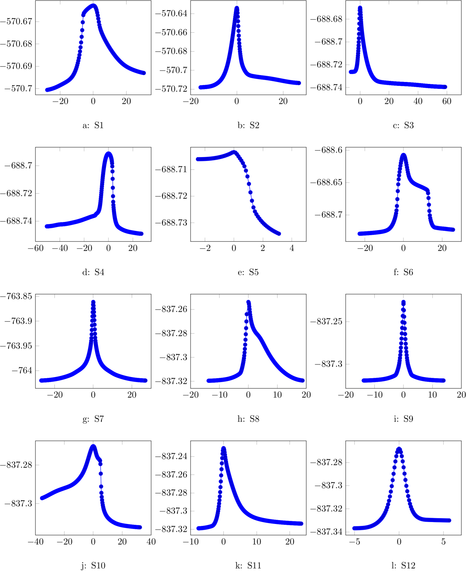
Figure S1. The IRC trajectories of the all TSs, related to the mechanism of the reaction.
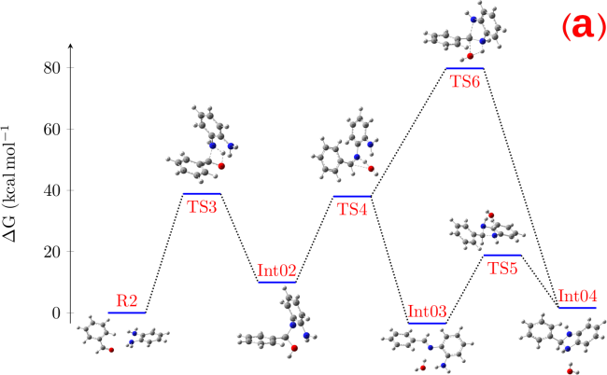 | 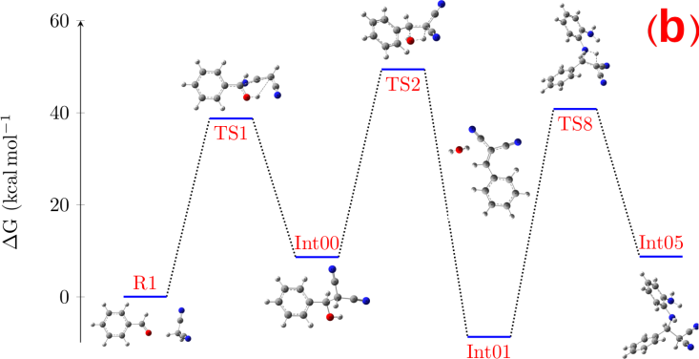
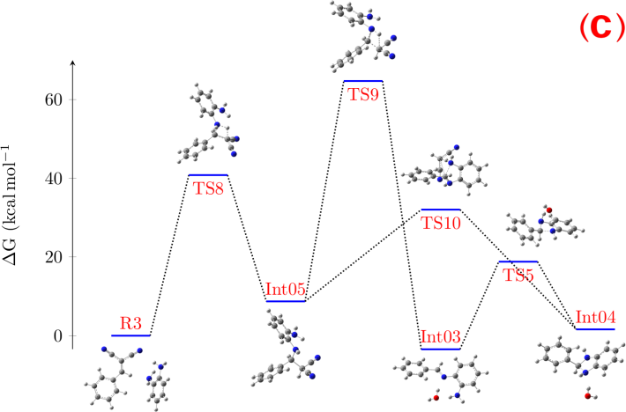 | 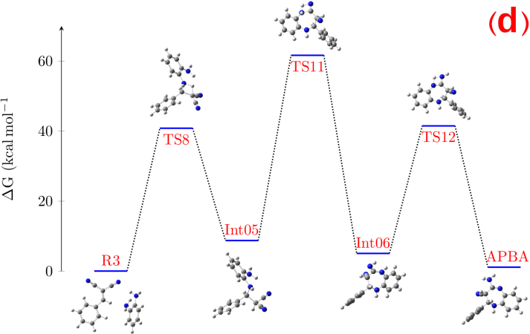
Figure S2. The calculated relative Gibbs free energy values for all involved molecules (reactants, products, intermediates and transition states) of all pathways using B3LYP/6-311+G(d,p) level of theory at 298.15 K and 1 atm; Path A: (a), Path B: (b), Path C: (c), and APBA formation pathway: (d).

Figure S3. The redox reaction (top) and the color change of the typical reactions in the presence of MB (0.01 M) under argon or oxygen atmosphere.

Figure S4. The calculated structural representation of supercell model of prepared SnFe₂O₄ (a and b) and corresponding electron localization function isosurface with an isovalue of 0.25 (c).
Table S1. Views of optimized structures and corresponding relative energies for reactant, intermediates, transitions states and products.
Name | ΔG (Kcal/mol) | PCM ΔG (Kcal/mol) | Geometry
R1 | 0 | 0 | 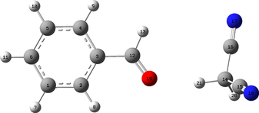
R2 | 0 | 0 | 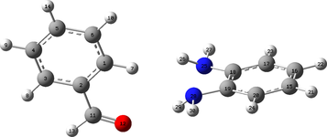
R3 | 0 | 0 | 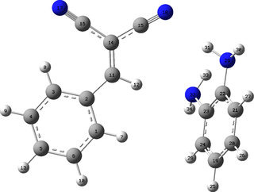
Int00 | 12.02119949 | 8.606292793 | 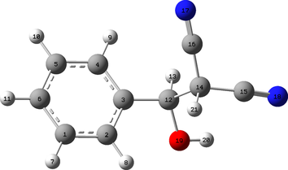
Int01 | -1.874998386 | -8.733049712 | 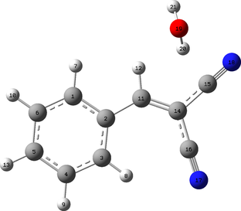
Int02 | 13.81273911 | 9.959830784 | 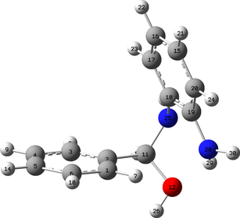
Int03 | 1.202308202 | -3.452557269 | 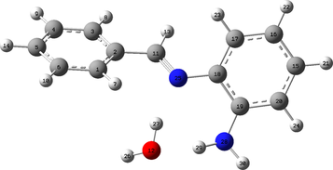
Int04 | 6.468995436 | 1.608934358 | 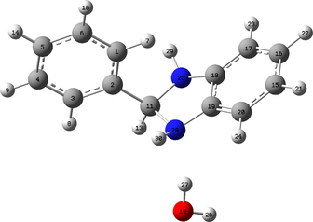
Int05 | 10.42732536 | 8.72238205 | 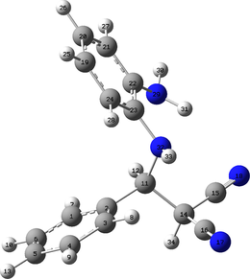
Int06 | 6.214854088 | 5.037646266 | 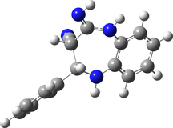
TS1 | 42.65433075 | 38.73114136 | 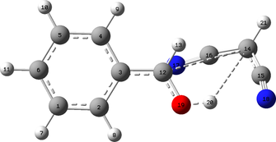
TS2 | 58.52718356 | 49.40947052 | 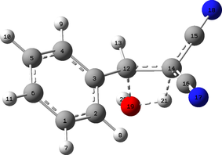
TS3 | 45.66072877 | 38.8591533 | 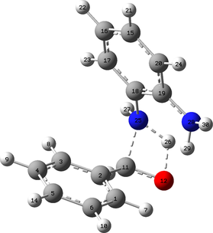
TS4 | 42.52569131 | 38.0007203 | 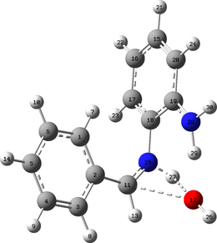
TS5 | 22.46609512 | 18.80081213 | 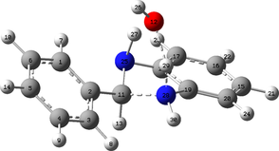
TS6 | 86.79146645 | 79.79348051 | 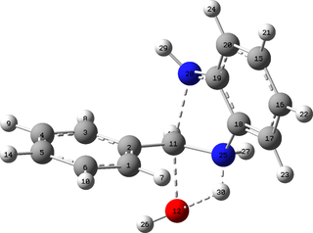
TS8 | 48.06220762 | 40.80255022 | 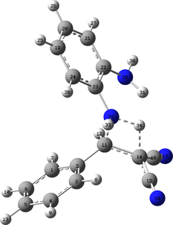
TS9 | 65.67514427 | 64.70438707 | 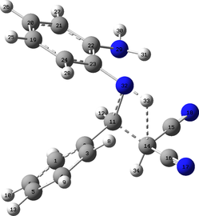
TS10 | 39.96168749 | 32.02745737 | 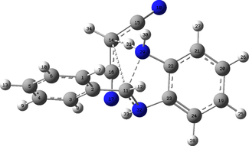
TS11 | 65.7234625 | 61.63147305 | 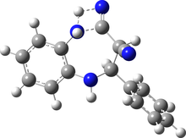
TS12 | 42.0500391 | 41.47398538 | 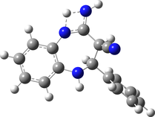
APBA | 1.810992417 | 1.113829363 | 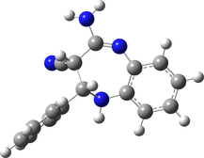
P | -182.6975084 | -194.0905709 | 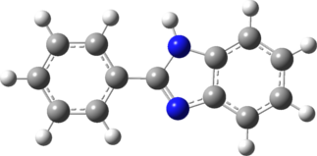

Table S2. Ribbon representation of the three-dimensional structure of 4KSY, 4KSY′ and 4LOH and corresponding representative docking poses with synthesized arylbenzimidazoles.
Ligand | 4KSY | 4KSY′ | 4LOH
- | 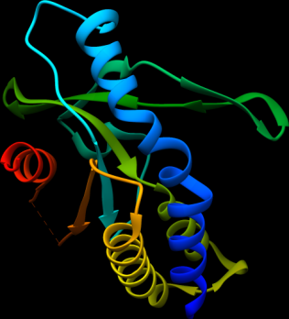 | 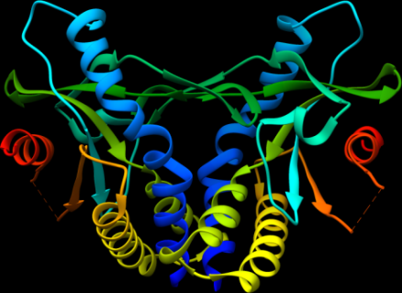 | 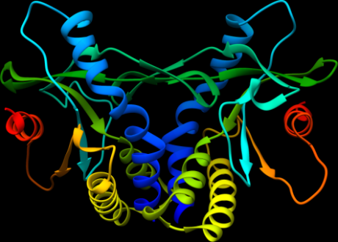
Pocket | 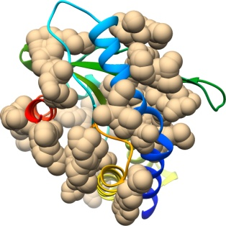 | 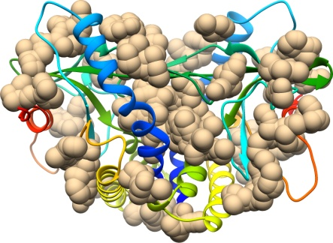 | 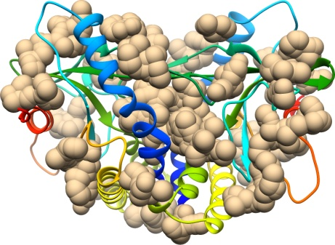
4a | 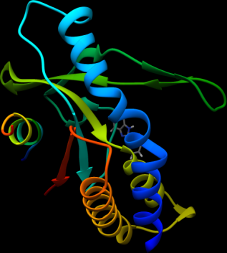 | 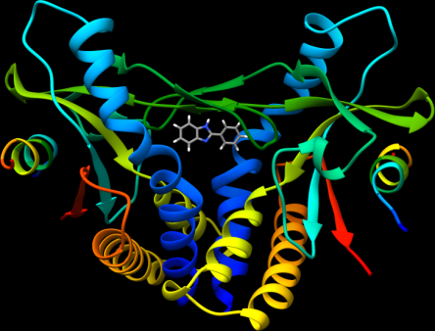 | 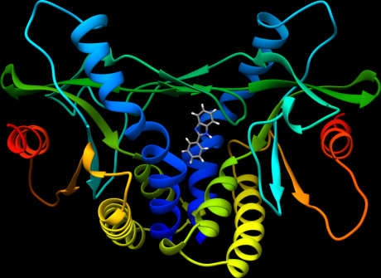
4b | 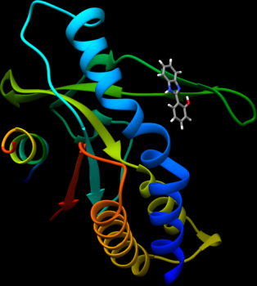 | 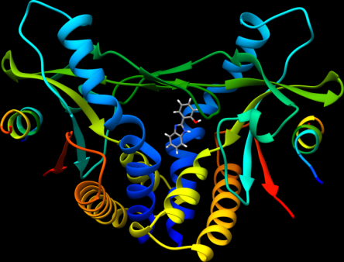 | 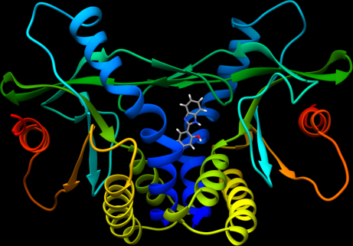
4c | 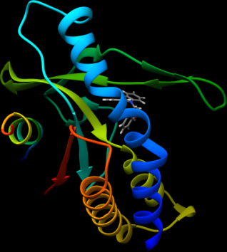 | 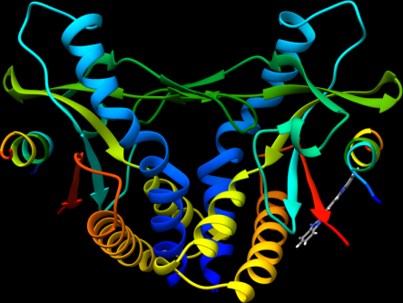 | 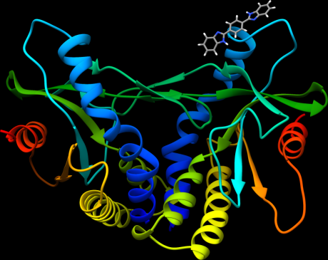
4d | 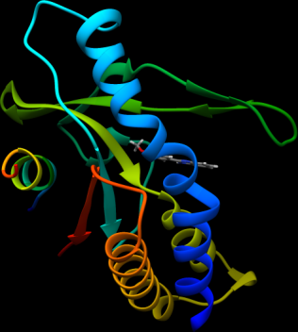 | 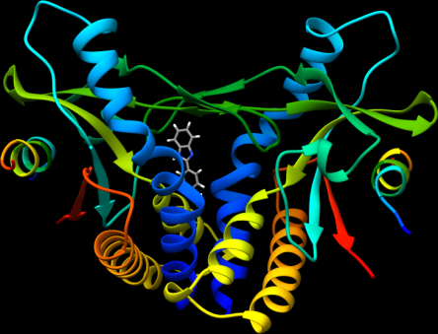 | 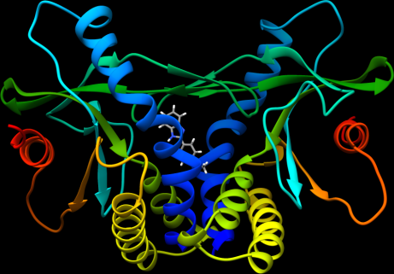
4e | 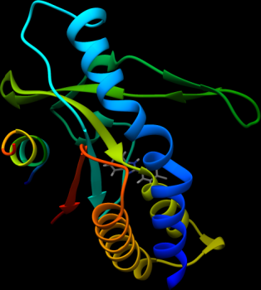 | 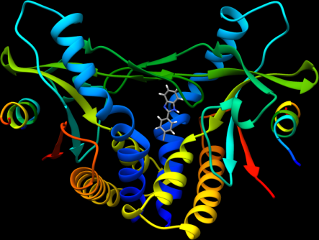 | 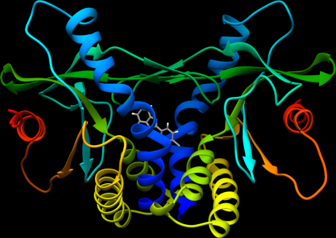
4f | 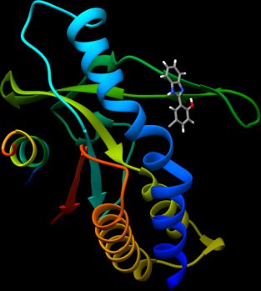 | 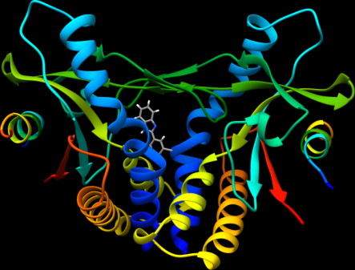 | 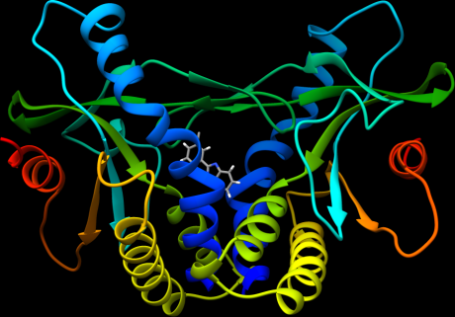
4g | 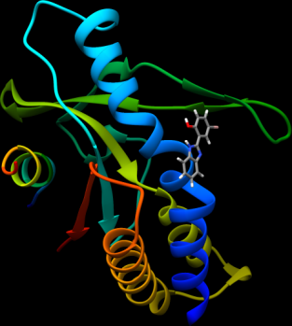 | 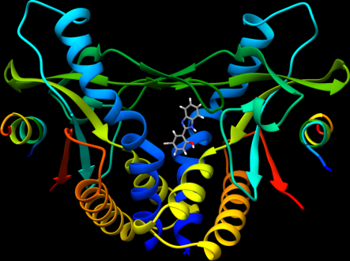 | 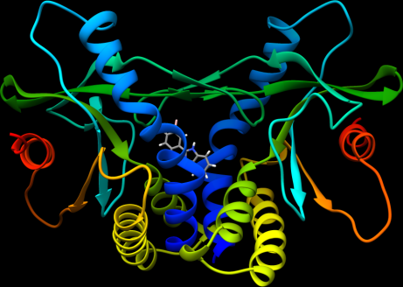
4h | 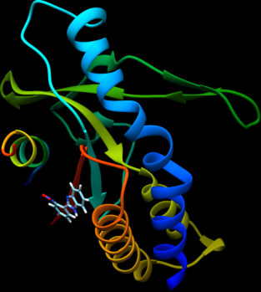 | 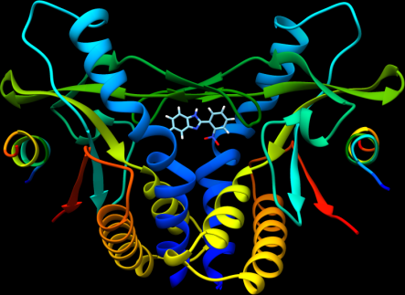 | 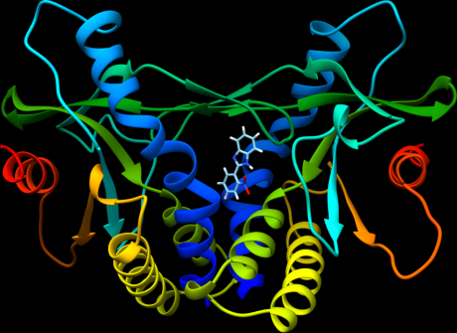
4i | 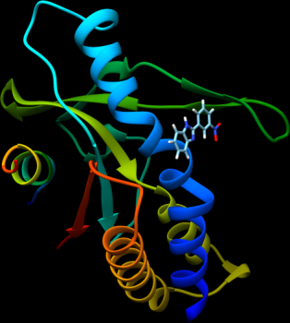 | 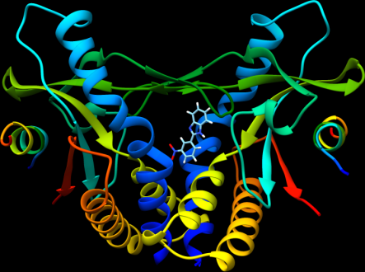 | 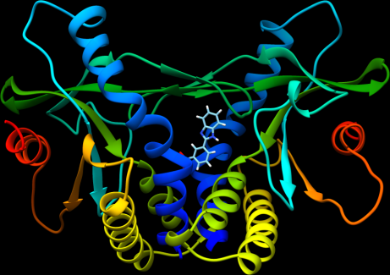
4j | 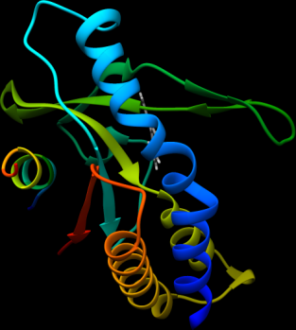 | 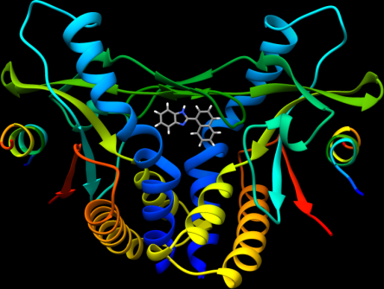 | 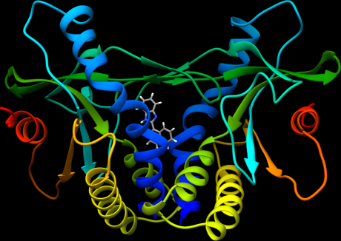

Part B- Original Spectra
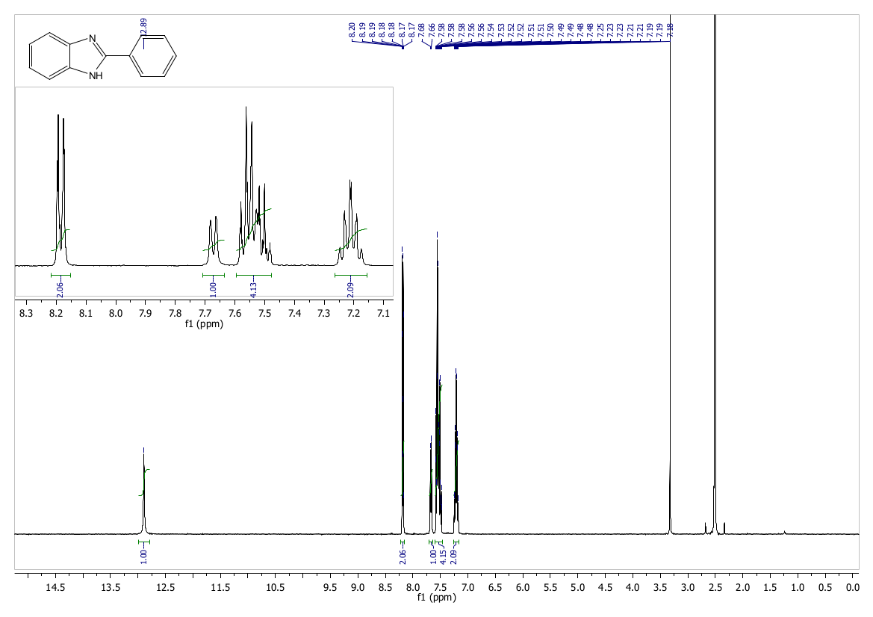
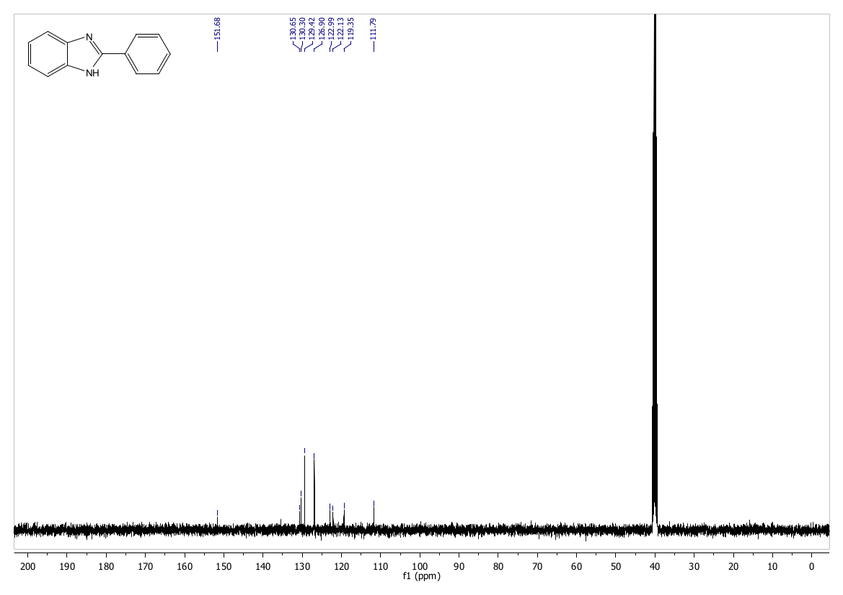
Figure S5. ¹H NMR and ¹³C NMR of 4a (CDCl₃).
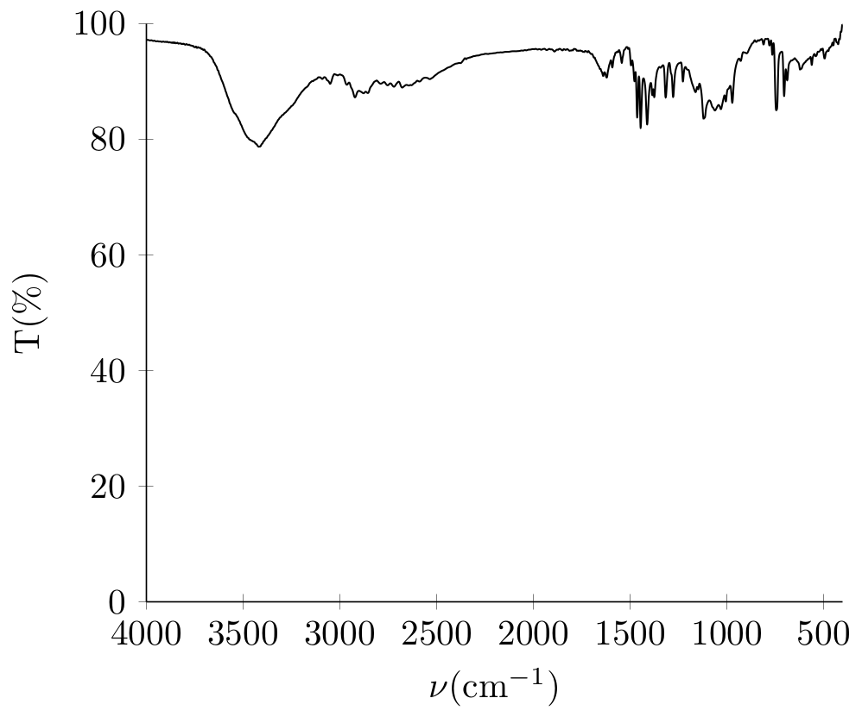
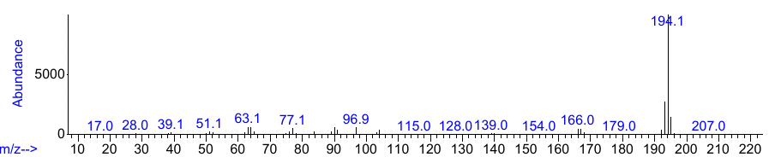
Figure S6. IR and Mass spectra of 4a.

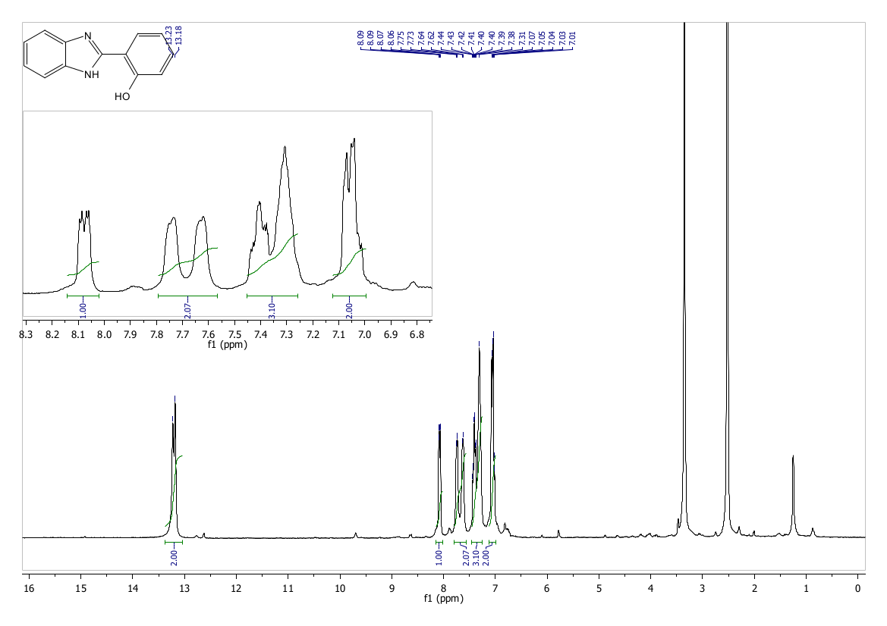
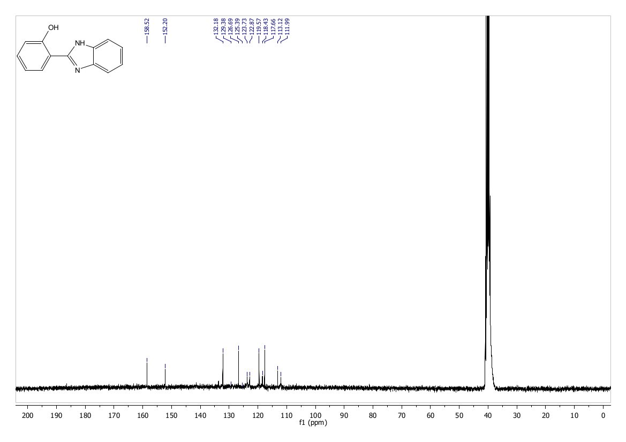
Figure S7. ¹H NMR and ¹³C NMR of 4b (DMSO-d6).
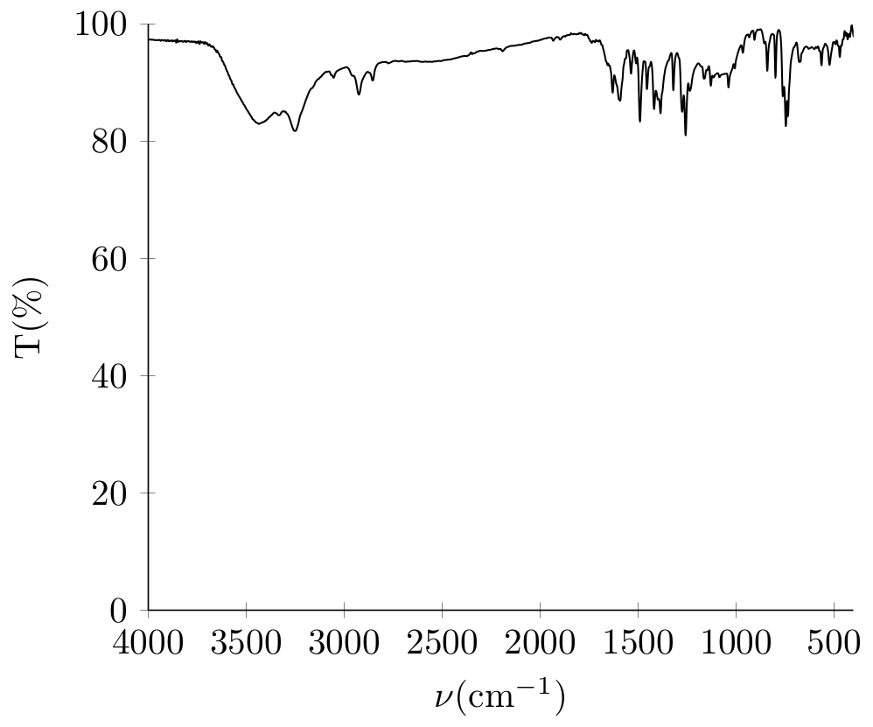
Figure S8. IR spectra of 4b (KBr).

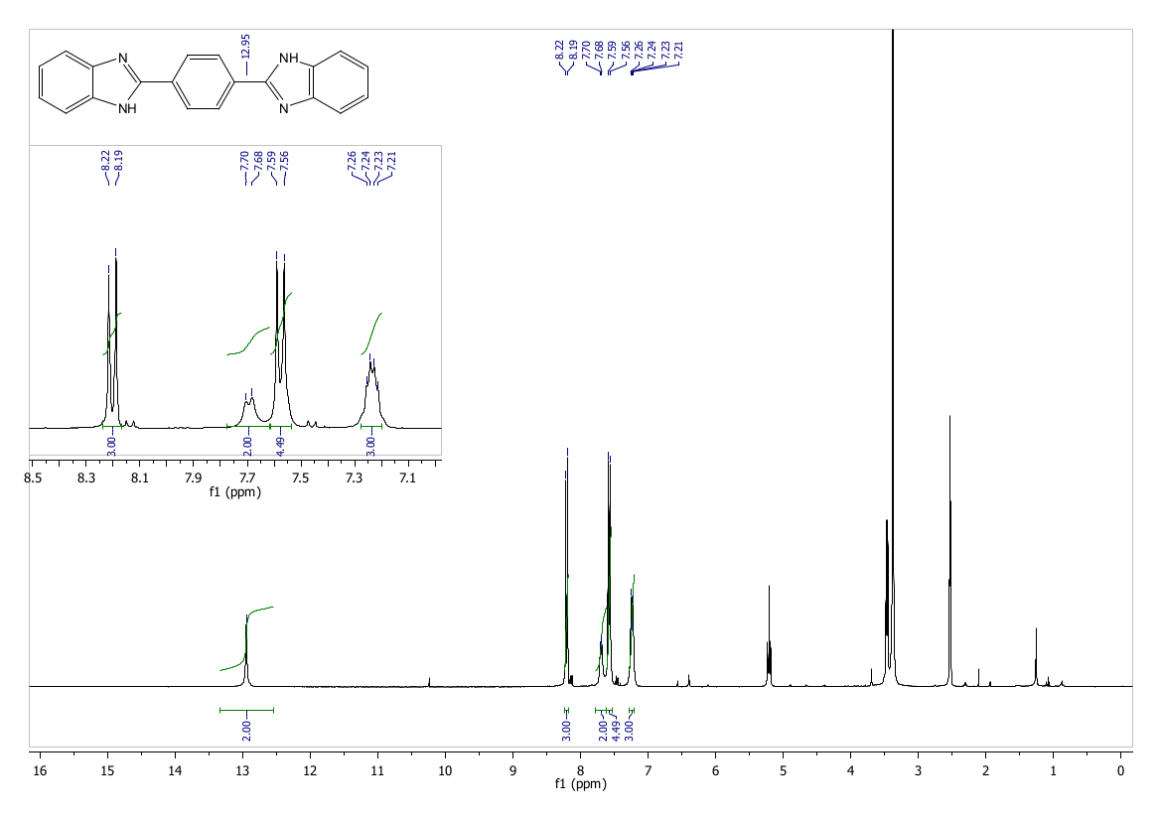
Figure S9. ¹H NMR of 4c (300 MHz, DMSO-d6).

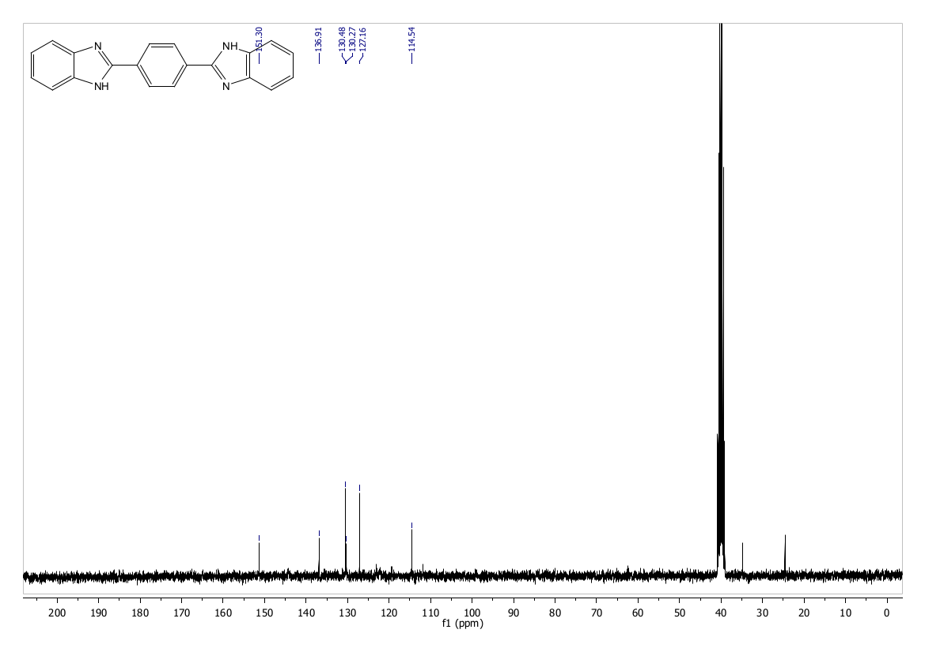
Figure S10. ¹³C NMR of 4c (DMSO-d6).
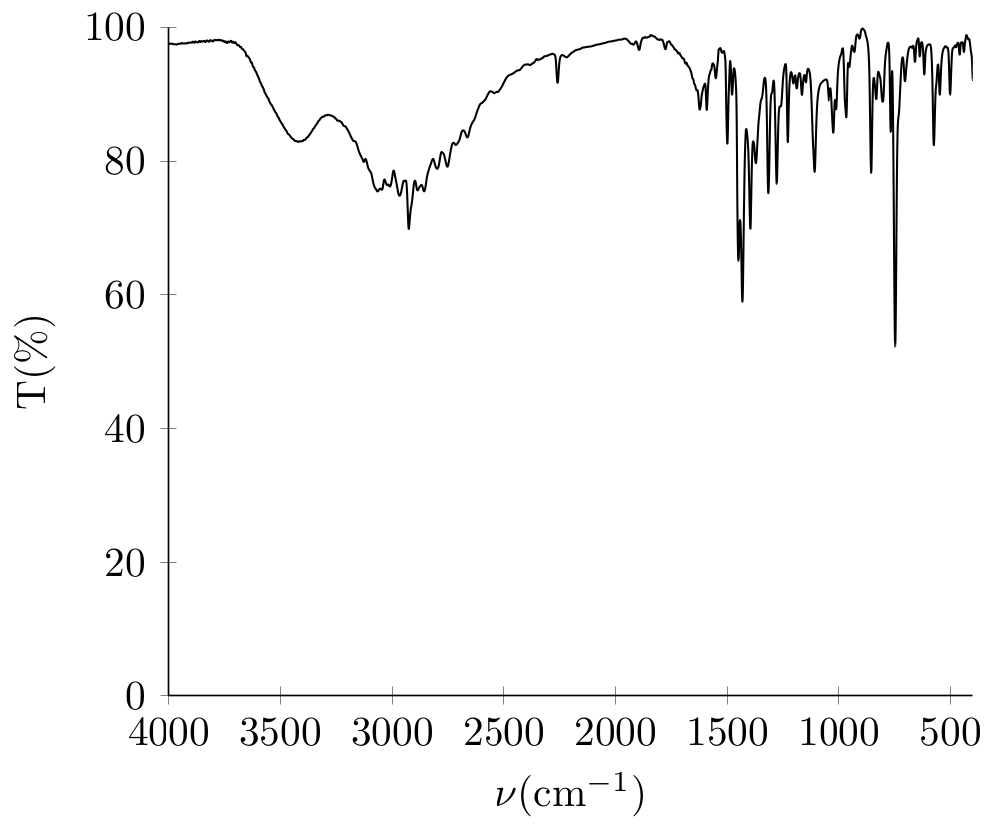
Figure S11. IR spectra of 4c (KBr).

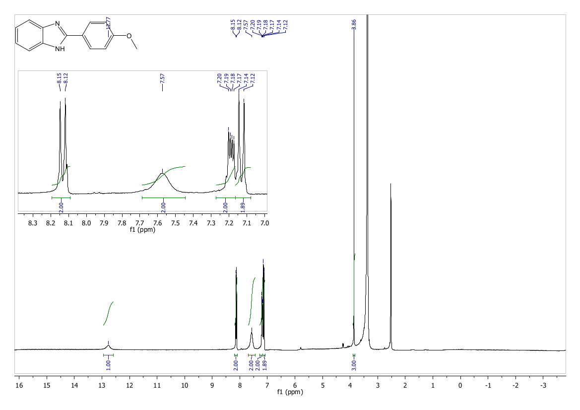
Figure S12. ¹H NMR of 4d (300 MHz, DMSO-d6).

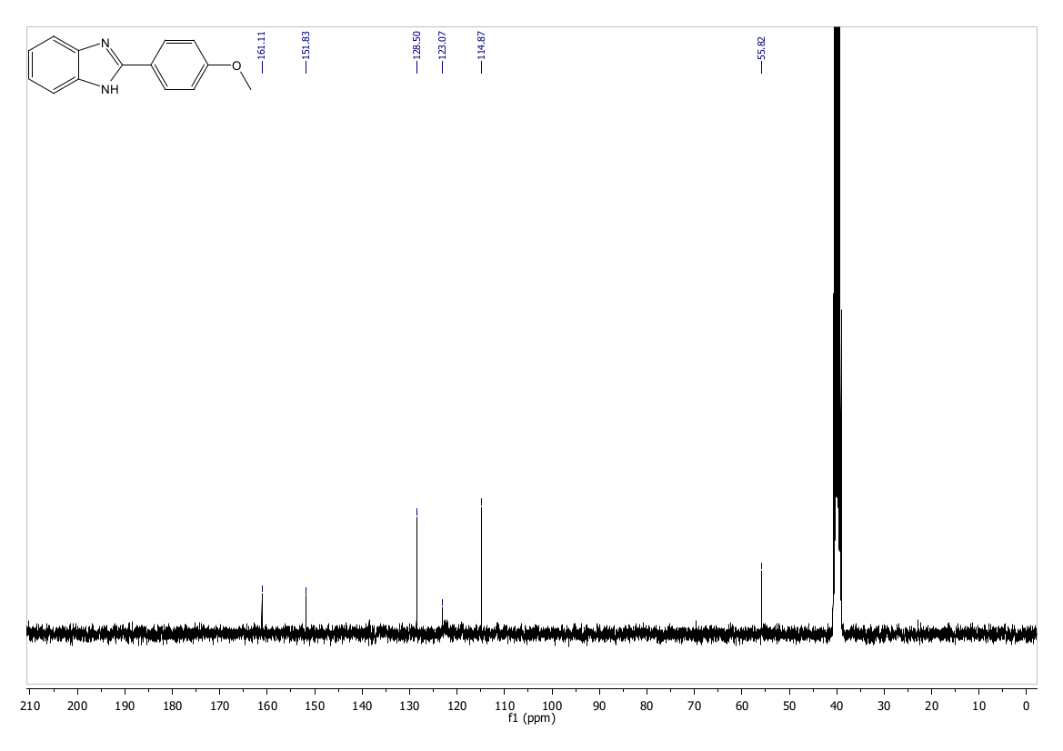
Figure S13. ¹³C NMR of 4d (DMSO-d6).
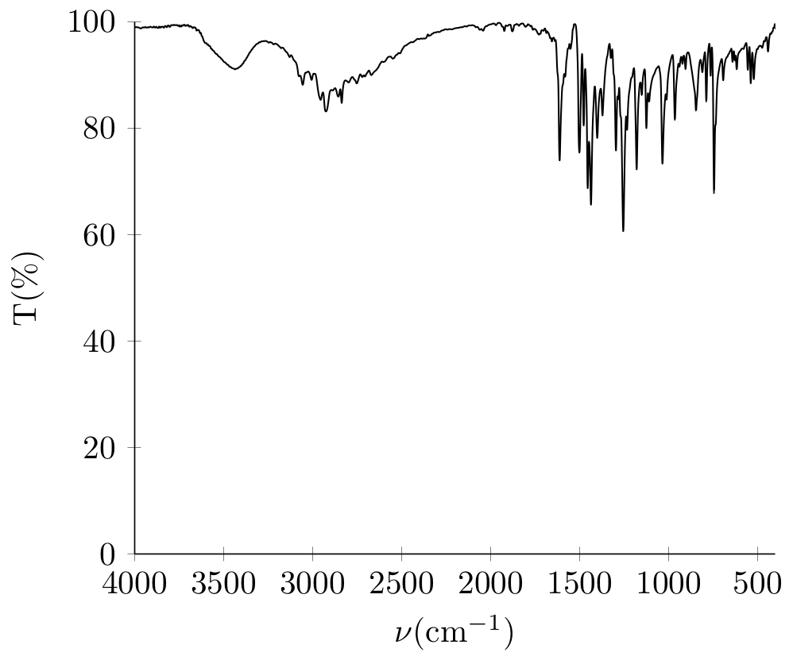
Figure S14. IR spectra of 4d (KBr).

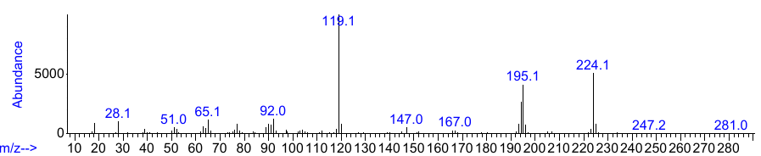
Figure S15. Mass spectra of 4d.

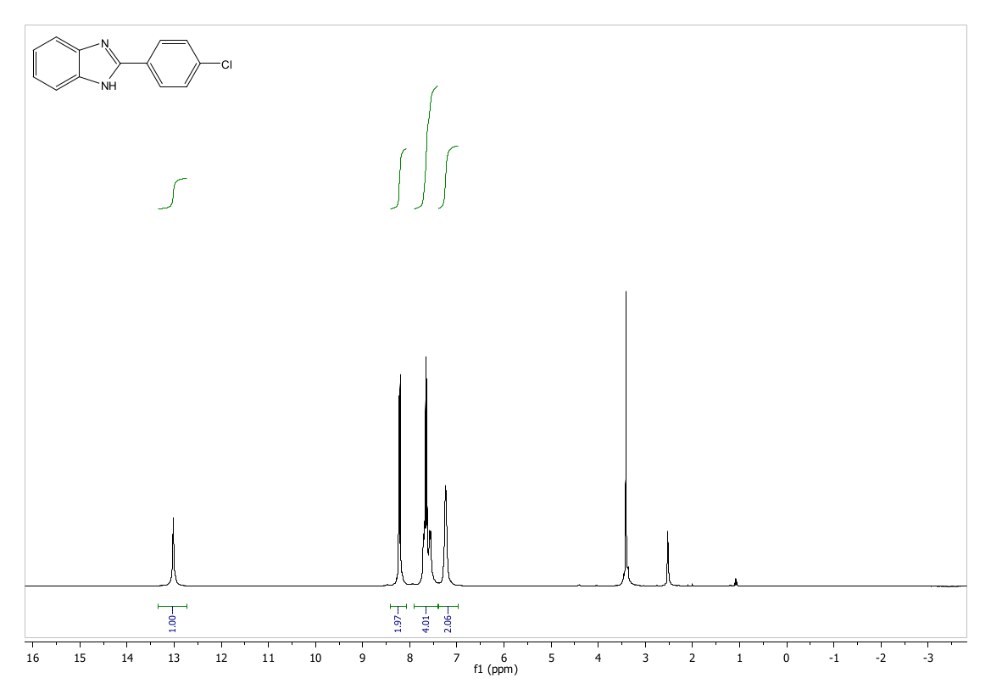
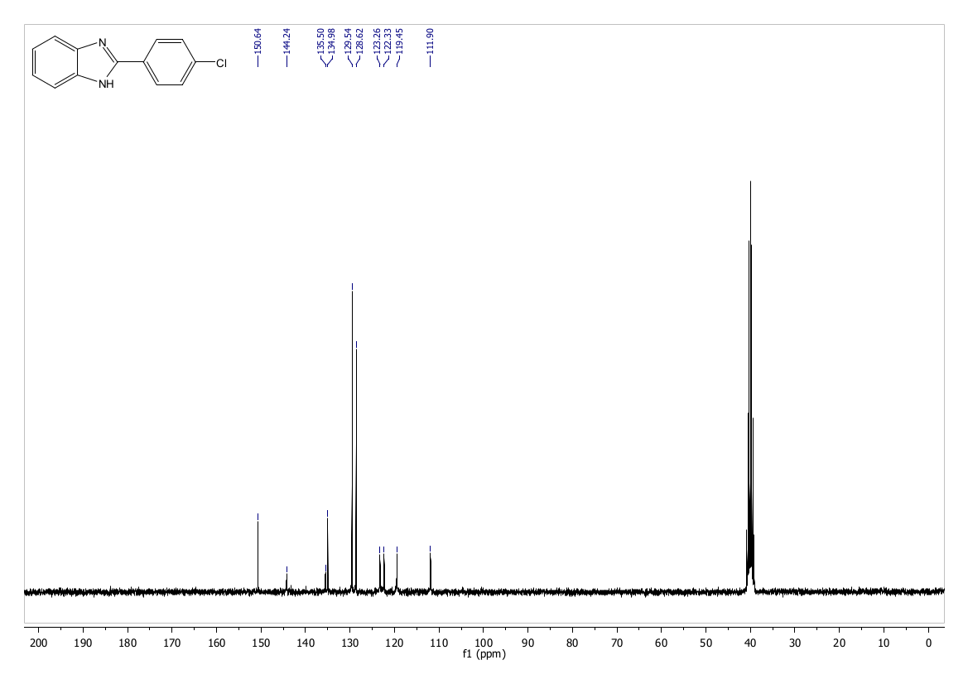
Figure S16. ¹H NMR and ¹³C NMR of 4e (DMSO-d6).
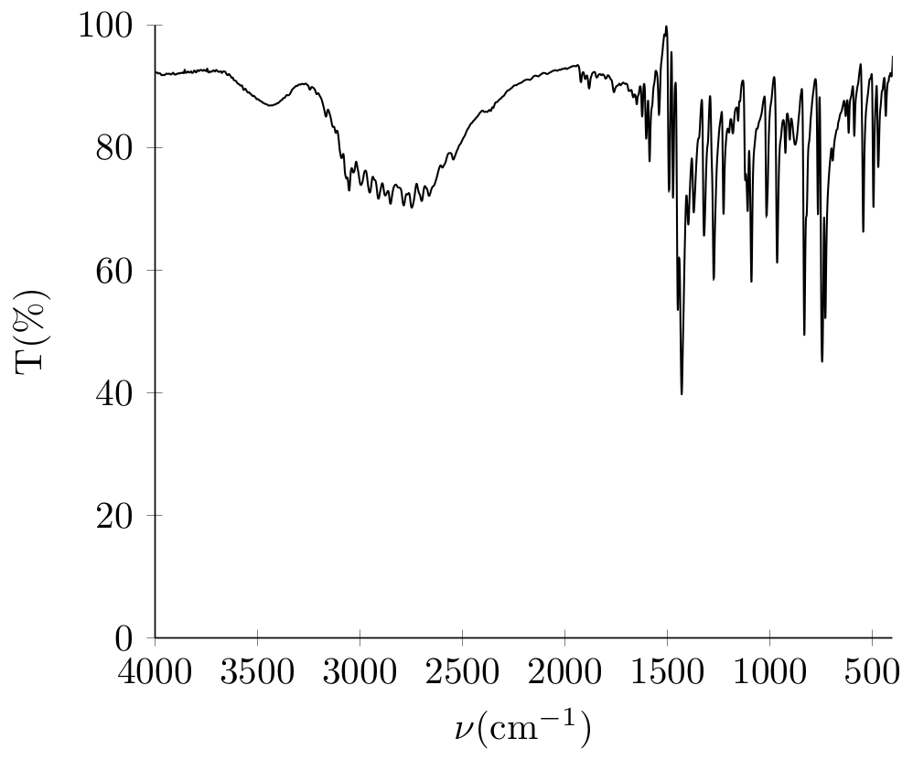

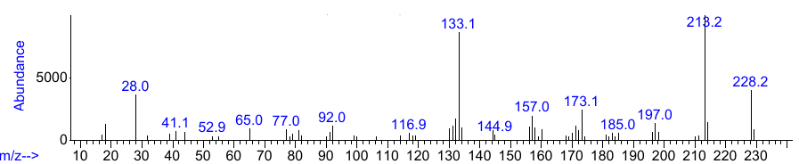
Figure S17. IR spectra and Mass spectra of 4e.

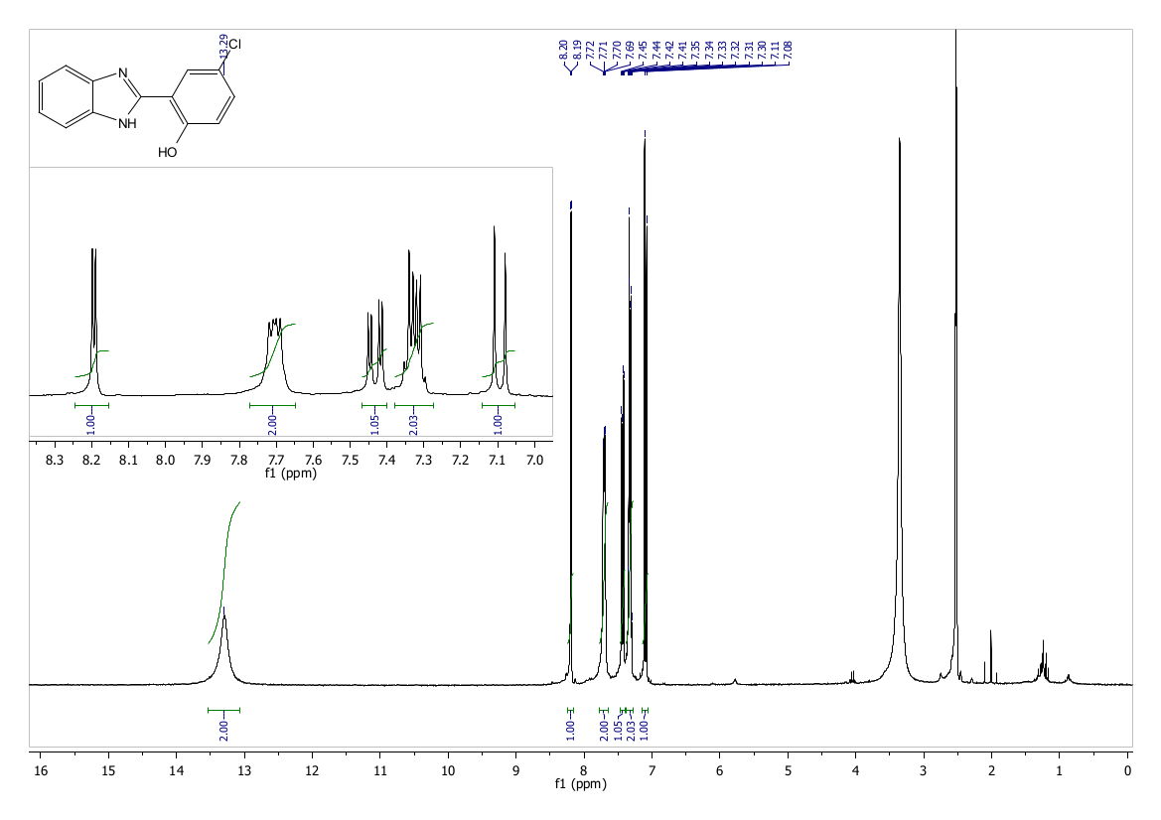
Figure S18. ¹H NMR of 4f (300 MHz, DMSO-d6).
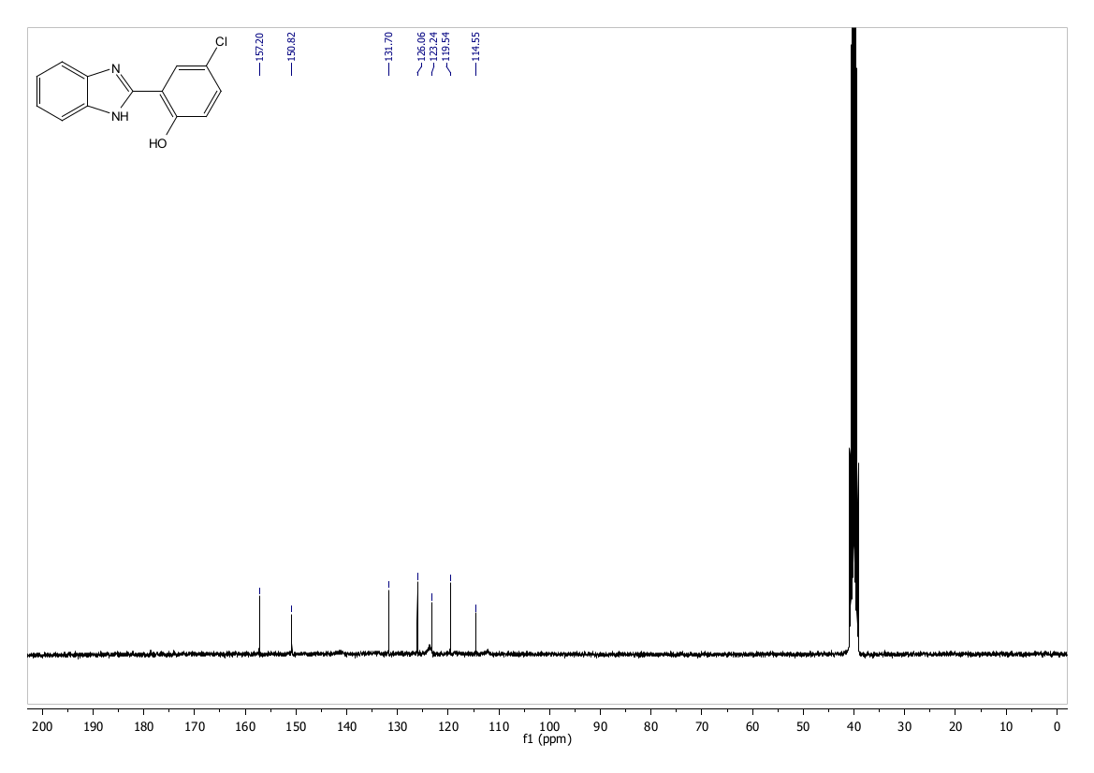
Figure S19. ¹³C NMR of 4f (DMSO-d6).
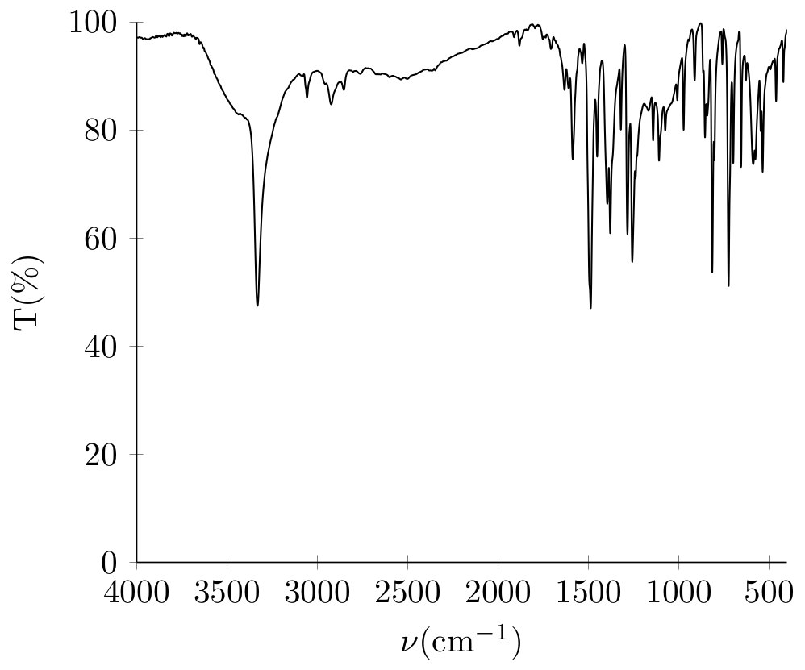
Figure S20. IR spectra of 4f (KBr).

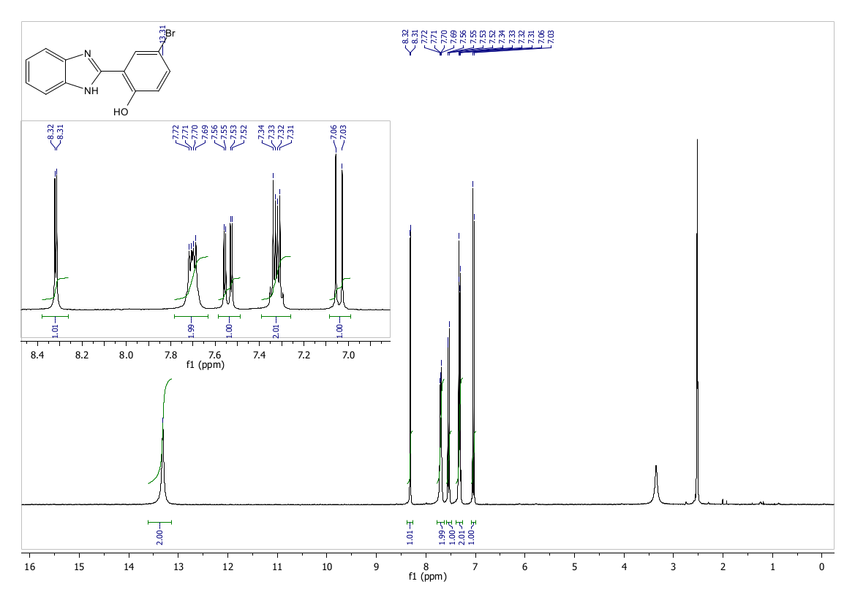
Figure S21. ¹H NMR of 4g (300 MHz, DMSO-d6).
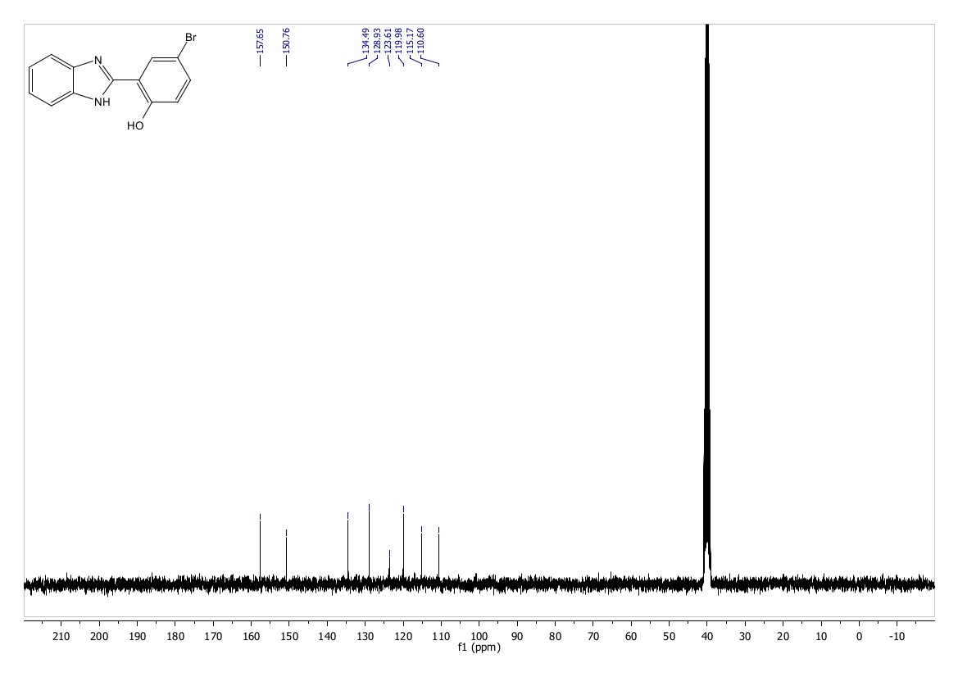
Figure S22. ¹³C NMR of 4g (DMSO-d6).
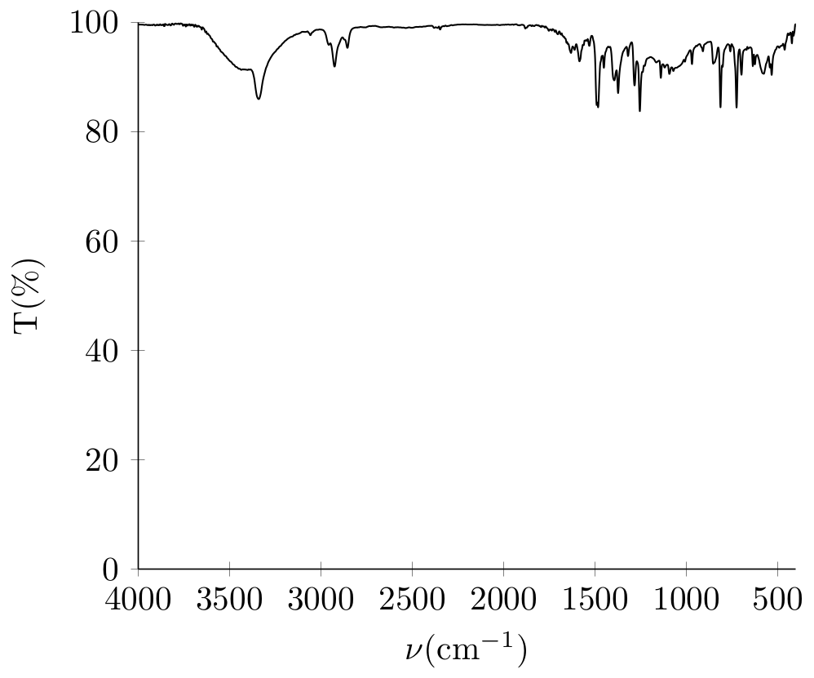
Figure S23. IR spectra of 4g (KBr).

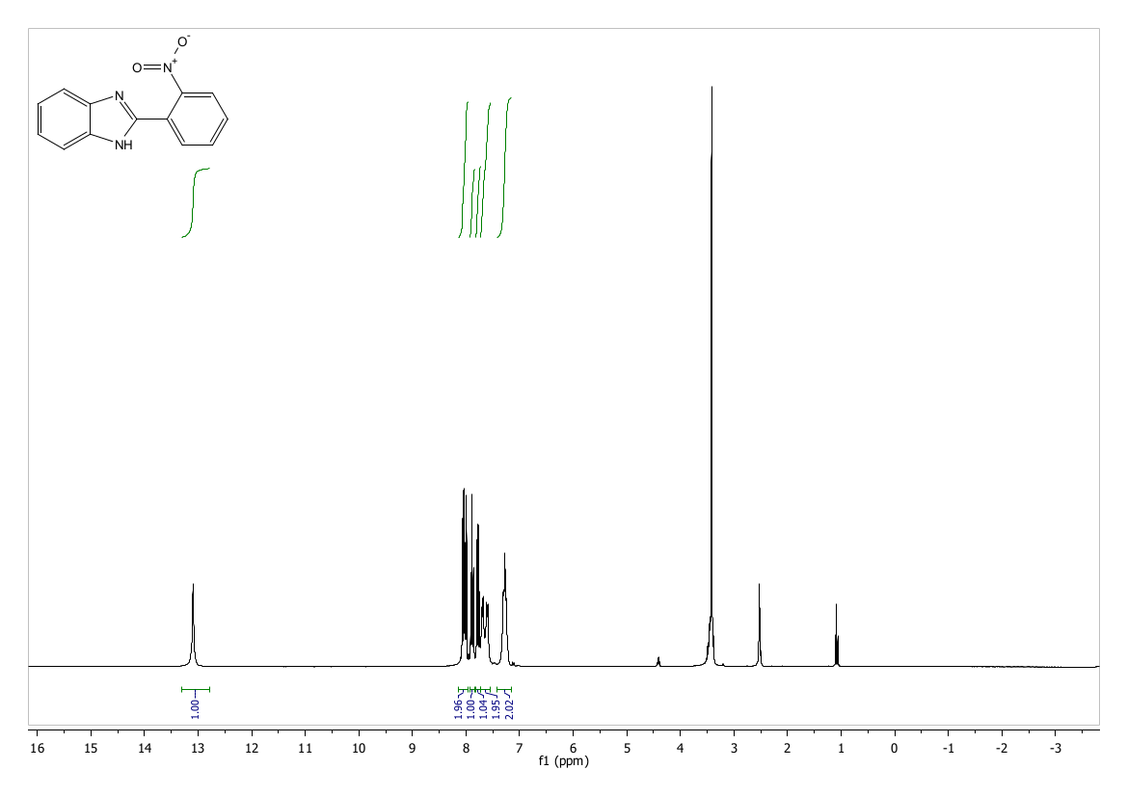
Figure S24. ¹H NMR of 4h (300 MHz, DMSO-d6).
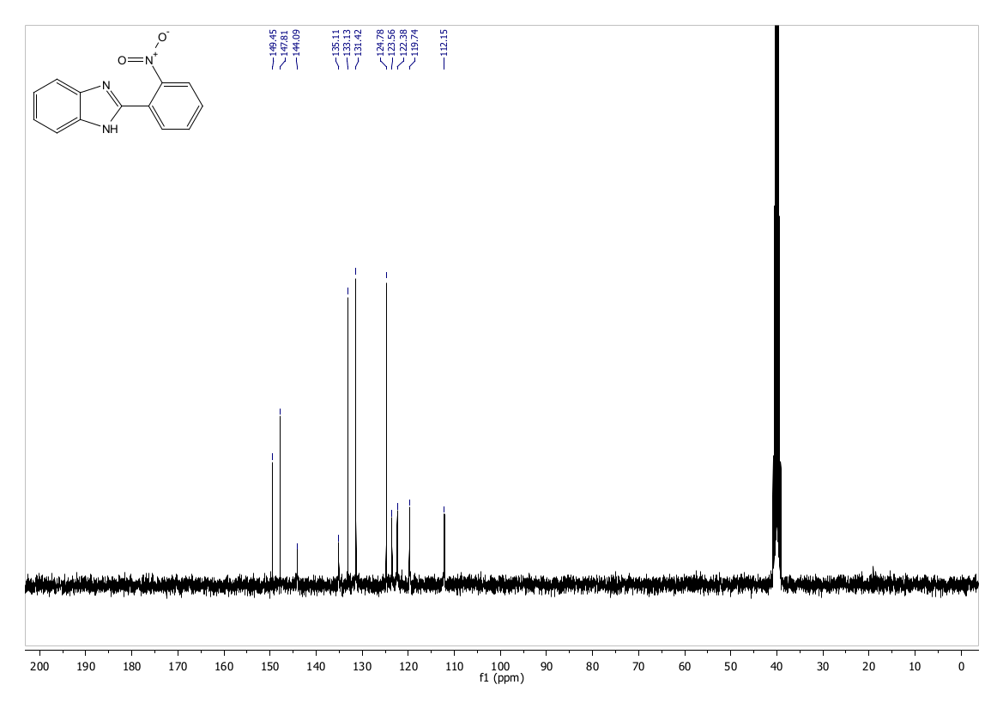
Figure S25. ¹³C NMR of 4h (DMSO-d6).
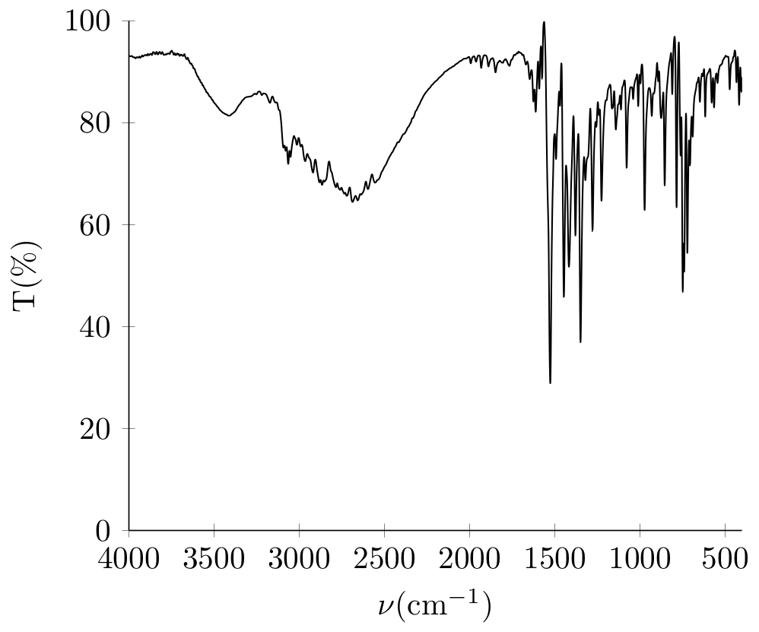
Figure S26. IR spectra of 4h (KBr).

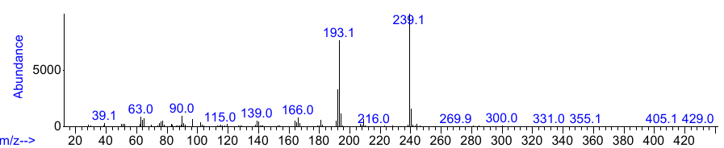
Figure S27. Mass spectra of 4h.

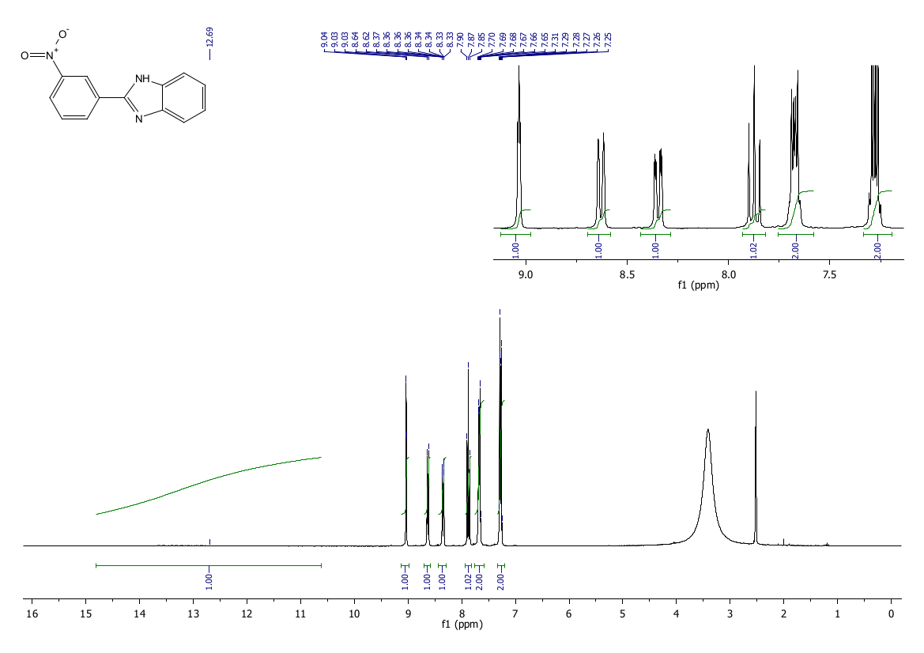
Figure S28. ¹H NMR of 4i (300 MHz, DMSO-d6).
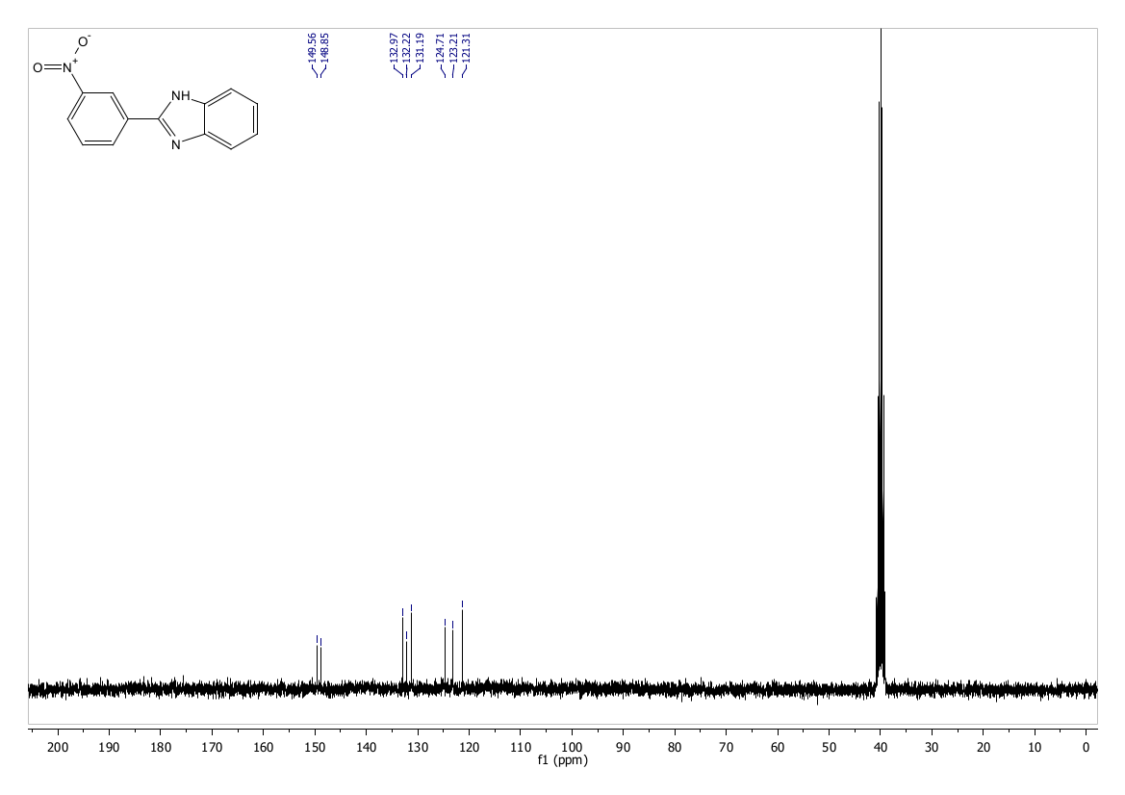
Figure S29. ¹³C NMR of 4i (DMSO-d6).
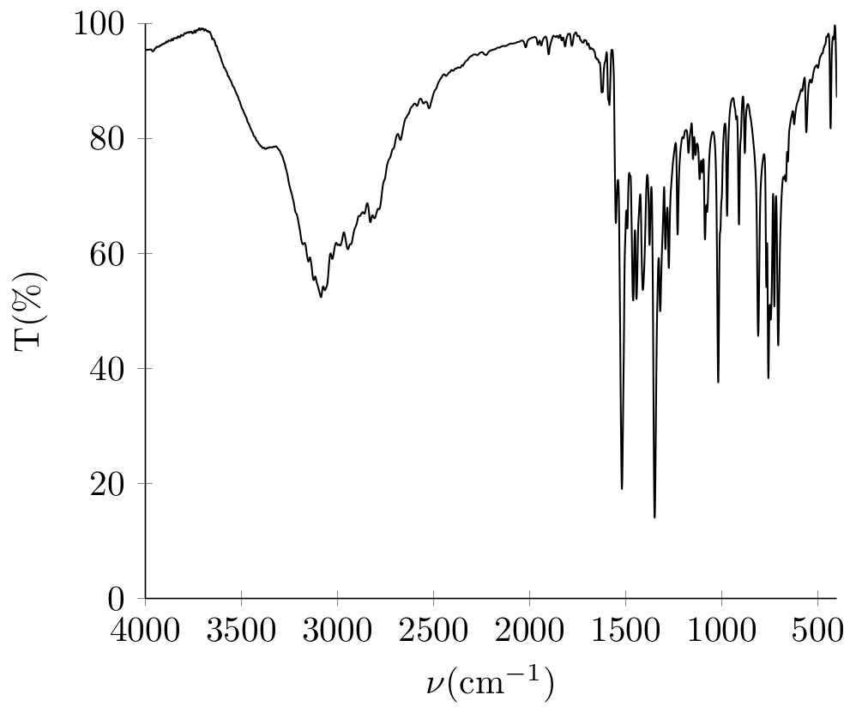
Figure S30. IR spectra of 4i (KBr).

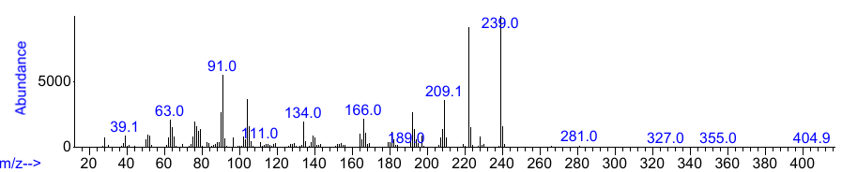
Figure S31. Mass spectra of 4i.

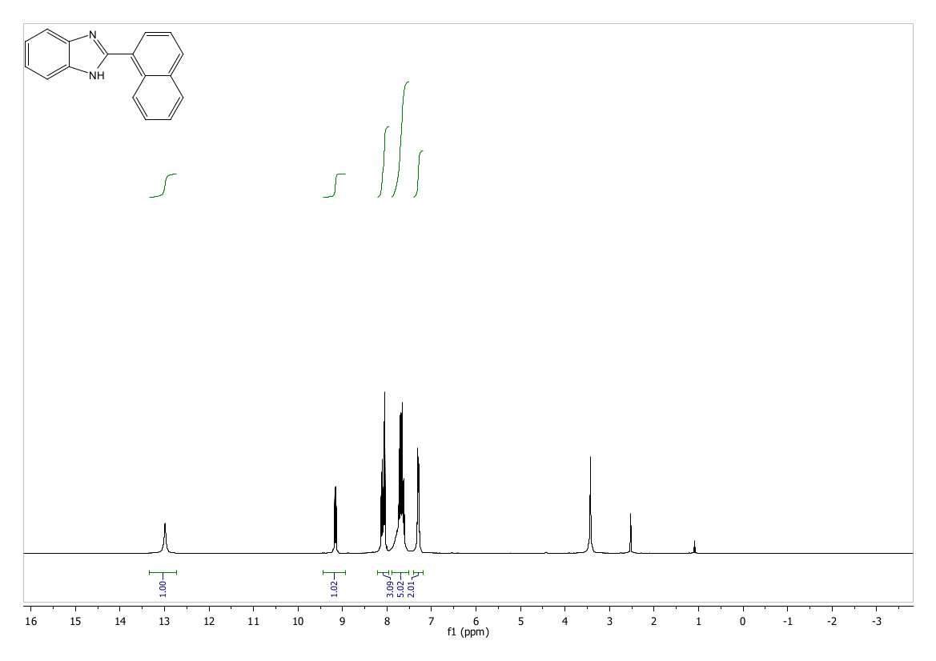
Figure S32. ¹H NMR of 4j (300 MHz, DMSO-d6).
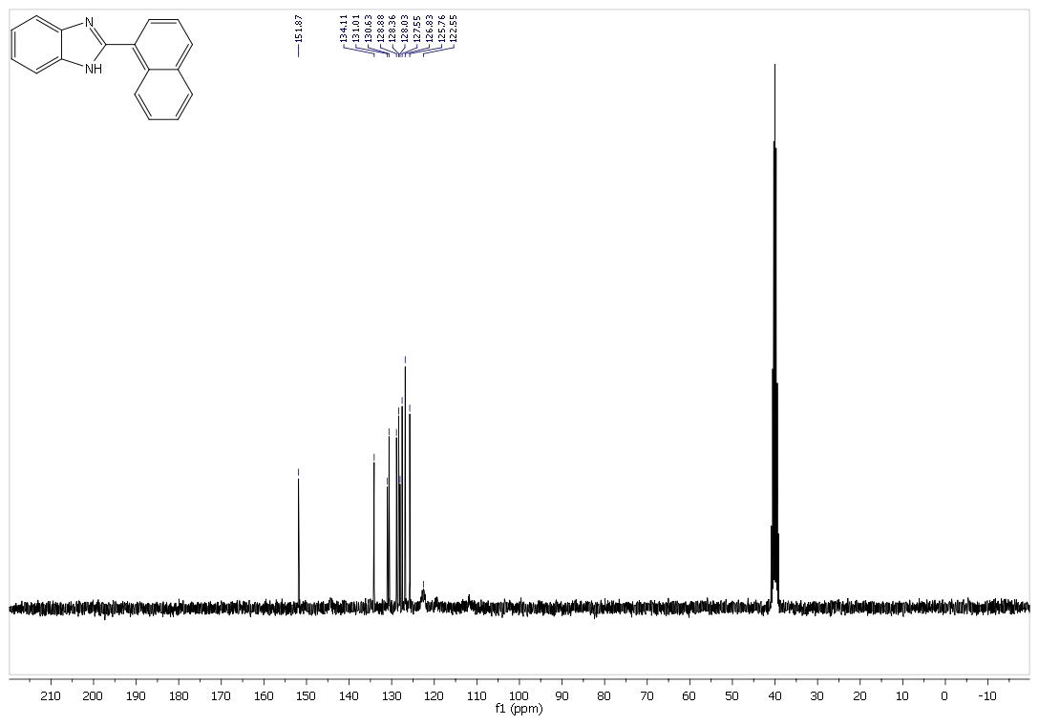
Figure S33. ¹³C NMR of 4j (DMSO-d6).
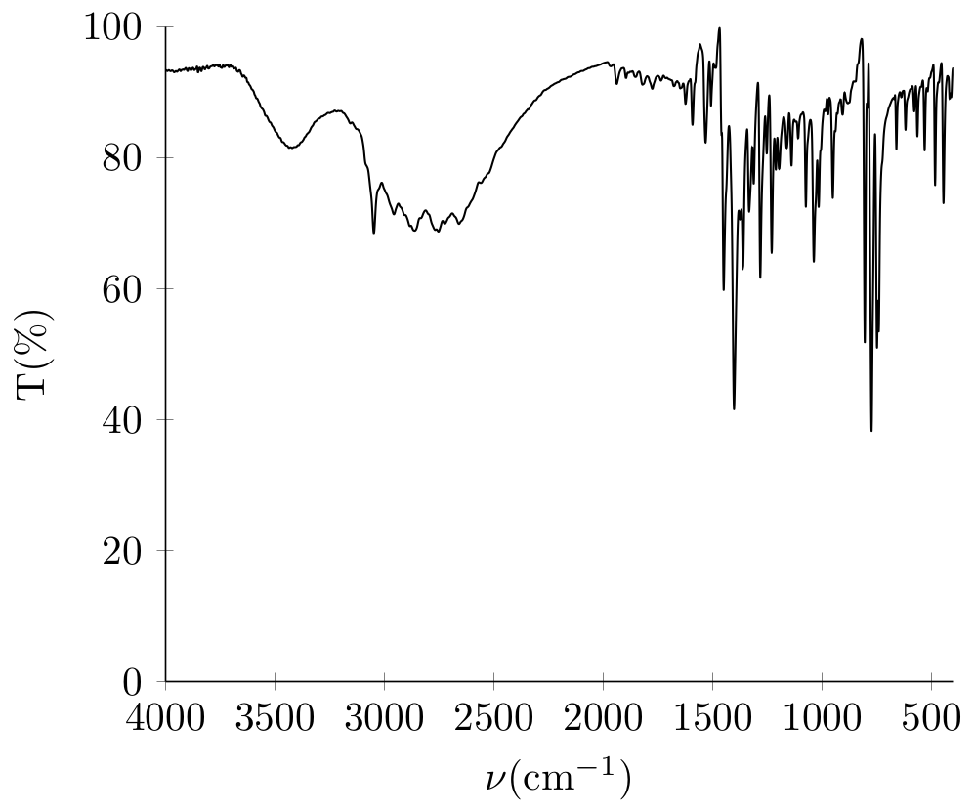
Figure S34. IR spectra of 4j (KBr).

