Supplementary Materials for

Non-invasive current collectors for improved current-density distribution during CO₂ electrolysis on super-hydrophobic electrodes

Hugo-Pieter Iglesias van Montfort¹, Mengran Li^{1,2}, Erdem Irtem¹, Maryam Abdinejad¹, Yuming Wu³, Santosh K. Pal¹, Mark Sassenburg¹, Davide Ripepi¹, Siddhartha Subramaniam¹, Jasper Biemolt¹, Thomas E. Rufford³, Thomas Burdyny¹*
¹ Department of Chemical Engineering, Delft University of Technology; 9 van der Maasweg, Delft, 2629HZ the Netherlands
² Department of Chemical Engineering, The University of Melbourne; Parkville, Victoria, 3010, Australia
³ School of Chemical Engineering, The University of Queensland; St. Lucia 4072, Australia
*Corresponding author. Email: t.e.burdyny@tudelft.nl

This PDF file includes:

Supplementary Text
Figs. S1 to S18
Tables S1 to S2
Supplementary References 1 to 11

Supplementary Text

Reaction-diffusion in a Finite Volume Partial-Differential Equation Solver

In wanting to calculate and represent the effect of the GDE architecture on local availability of CO2 in the catalyst layer, we constructed a 1-D reaction-diffusion model close to the gas-liquid interface of both ePTFE and carbon-based electrodes. To define and execute the solver, we used the FiPy solver package, in a Python environment.¹
This model is focused on the catalytic interface in a porous GDE and is defined by three domains: (i) the micro-porous layer (MPL), (ii) the catalyst layer and (iii) the electrolyte, simulating the behavior of CO₂ in an alkaline flow-electrolyzer. The domain of the model is 500 µm thick, the nodal distance of the mesh is 1 nm. For these regions, (i) can be modelled as a flooded (i.e. liquid-phase) domain or a gaseous one, whereas (ii) and (iii) are considered to be wetted throughout. The MPL is assumed to be 20 µm thick for the ePTFE simulation and 40 µm in the case of a carbon GDL.^{2,3} The catalyst layer is 500 nm thick in both cases and the rest of the modelled domain is liquid-phase electrolyte as used in the experiments (1M KOH).
In the gaseous phase (i), gas-species (CO2, CO and H2) are governed by simple diffusion equations, in the form of:
$$\begin{aligned}\frac{∂c_{i}}{∂t}=D_{i}\frac{∂^{2}c_{i}}{∂t^{2}} \end{aligned}S1$$
With a convective transport boundary on the left limit of the system and a phase-change (gas to liquid) on the right limit. In the catalyst layer, dissolved species (CO_{2,aq}, OH⁻, HCO₃⁻, CO₃²⁻ and H⁺) are governed by:
$$\begin{aligned}\frac{∂c_{i}}{∂t}=D_{i}\frac{∂^{2}c_{i}}{∂t^{2}}+R_{h}+R_{i} \#S2\end{aligned}$$
where R_{h} are the homogeneous CO₂-buffering reactions:
$$\begin{aligned}CO_{2}+OH^{-}⇌HCO_{3}^{-}\#S3\end{aligned}$$
$$\begin{aligned}HCO_{3}^{-}+OH^{-}⇌CO_{3}^{2-}\#S4\end{aligned}$$
and R_{i} are the electrochemical production and consumption rates of CO₂, OH⁻, CO and H₂:
$$\begin{aligned}R_{CO_{2}}=-\frac{j_{t}}{F}\left(\frac{s_{CO}}{z_{CO}}\right)\frac{ε_{cat}}{L_{cat}} \#S5\end{aligned}$$
$$\begin{aligned}R_{CO}=\frac{j_{t}}{F}\left(\frac{s_{CO}}{z_{CO}}\right)\frac{ε_{cat}}{L_{cat}} \#S6\end{aligned}$$
$$\begin{aligned}R_{OH}=\frac{j_{t}}{F}\frac{ε_{cat}}{L_{cat}} \#S7\end{aligned}$$
$$\begin{aligned}R_{H_{2}}=\frac{j_{t}}{F}\left(\frac{{1-s}_{CO}}{z_{H_{2}}}\right)\frac{ε_{cat}}{L_{cat}} \#S8\end{aligned}$$where s_{i} are the selectivities (faradaic efficiencies) towards every product (assumed to be 80% CO and 20% H₂), ε_{cat} is the porosity of the catalyst layer, L_{cat} its length, F the Faraday constant, z_{i} the stoichiometric number of electrons involved in each reduction reaction, and j_{t} the total applied current (a scalar in the model). In the liquid phase of the model, iii, only the homogeneous buffering reactions are involved.
A cornerstone of the modelled quantities lies in the amount of aqueous CO₂ at the gas-liquid interface. Solubility of CO₂ is heavily influenced by the presence of ions in the liquid phase.⁴ In order to set the calculated [CO_{2,aq}] at this interface, the Hessian of the model is disturbed at the nodes before and after the phase-change using a mask involving a large number (2⁶³). The CO_{2,aq} concentration is set using the Séchenov constants on the classical Henry model of carbon dioxide dissolution.^{5,6} First, the Henry equation for CO₂ as a function of temperature:⁷
$$\begin{aligned}\left[CO_{2,aq}\right]={P_{CO_{2}}·K}_{H}{· K}_{c}\#S9\end{aligned}$$
With:
$$\begin{aligned}\ln{K_{H}=93.4517\left(\frac{100}{T}\right)-60.2409+23.3585\ln\left(\frac{T}{100}\right)}\#S10\end{aligned}$$
The Henry equilibrium is corrected for the presence of ions in the solution, following:⁸
$$\begin{aligned}\log\left(\frac{\left[CO_{2,aq,0}\right]}{\left[CO_{2,aq}\right]}\right)=K_{c}C_{i} \#S11\end{aligned}$$
The correction factor for each ion, K_{c} is calculated using:
$$\begin{aligned}K_{c}= \sum{\left(h_{i}+h_{g}\right)} \#S12\end{aligned}$$
$$\begin{aligned}h_{g}=h_{g,0}+h_{T}\left(T-298.15\right)\#S13\end{aligned}$$
The constants used in this case for each ionic species are taken from earlier reports in literature. The concentration of K⁺ is calculated imposing electronic neutrality at the boundary each solving loop, bicarbonate anions are disregarded since their concentration is residual.
Table: Séchenov constants for involved ionic species.
Species | h_{i}
K⁺ | 0.0922
OH⁻ | 0.0839
CO₃²⁻ | 0.1423

Table: Correction factors for CO₂ dilution and temperature effects.
Magnitude | Value
h_{g,0} | -0.0172
h_{T} | -0.000338
The value of [CO_{2,aq}] is updated every computational loop of the model assuming a partial pressure of 1.1 bar for CO, and is the basis of the boundary value of the plots in Fig 1d and e.

Working principle of IR thermography on gas-diffusion electrodes for CO2RR

While we have detailed the working principles of infrared thermography for electrochemical activity mapping in previous works,⁹ the text below reproduces the rationale behind it in order to illustrate the design considerations for this case.
For infrared thermography to be a valid technique for this use case, we lay 3 main conditions that have to be met in order to couple temperature measurements to local electrochemical activity. These are:
- Heat production must be sufficient so that activity can be mapped at relevant current densities
Power consumed by an electrochemical system is defined as:
$$\begin{aligned}P=I·∆E\#S14\end{aligned}$$
Applying Ohm’s law, this translates to:
$$\begin{aligned}P=I^{2}·R \#S15\end{aligned}$$
At an electrode, a part of this power will be destined to driving the reaction, whereas parts of it will be translated into heating of the system’s surrounding. This heating, in electrolysis, is mainly due to either ohmic resistances or reaction overpotential. For the latter, the heat stream is proportional to the reaction overpotential, which in its turn is the difference between the required potential (E_{app}) and the thermoneutral potential of the reaction in question (E_{tn,0}), by:
$$\begin{aligned}Q_{cat}=\left(E_{app}-E_{tn.0}\right)·I \#S16\end{aligned}$$
$$\begin{aligned}q_{cat}^{''}=\frac{Q_{cat}}{A_{geo}}=\left(E_{app}-E_{tn.0}\right)·j \#S17\end{aligned}$$
If we take, for example, reduction of CO₂ to CO (simplified process of the reactions at a copper electrode, with E_{tn,0} = 0.264 V vs. RHE) and compare it to the operational, i·R corrected potential of the tested ePTFE electrodes at 50 mA cm⁻² (~ –0.65 V vs. RHE), the total heat generation will be:
$$\begin{aligned}q_{cat,Cu}^{''}=\left(E_{app}-E_{tn.0}\right)·j=\left(-0.65-0.264\right)·\left(-0.05\right)= 0.046 W cm^{-2}\#S18\end{aligned}$$
At the same current density, the contribution to heating of the other main source, ohmic resistance, is calculated by considering the measured resistance between the GDE and the RE (in this case, 0.48 Ω):
$$\begin{aligned}q_{ohm}^{''}=I^{2}R={\left(j·A\right)}^{2}·R={\left(-0.05·5\right)}^{2}·0.48=0.030 W cm^{2}\#S19\end{aligned}$$
which is lower than the heating resulting from the reaction overpotential, thus fulfilling requirement i.
- Heat generation must be translatable to temperature
The heat produced, will not translate itself to observational temperature increases if the specific heat of the GDE’s backbone is too high. The C_{p,m} value for ePTFE is around 1500 J kg⁻¹
K⁻¹.¹⁰Assuming an area weight for our electrodes similar to that of a thick sheet of paper (120 g m⁻², or 1.2·10⁻⁵ kg cm⁻²), we can calculate a theoretical heating rate by:
$$\begin{aligned}\frac{∆T}{t}=\frac{Q_{cat}}{m·C_{p,m}}=\frac{q_{cat}^{''}}{m^{''}·C_{p,m}}=\frac{0.046 W cm^{-2}}{\left(1.2·10^{-5} kg cm^{-2}\right)·(1500 J kg^{-1} K^{-1}}=2.55 K s^{-1} \#S20\end{aligned}$$
Which constitutes a heating rate even higher to the one we previously reported.⁹ This second requirement is thus also met.
- The temperature of the electrode’s backbone is representative of the catalyst’s temperature
The final topic to assess the viability of this technique is the representativity of the backbone’s temperature with respect to the catalyst’s temperature. In case not enough heat is transported through the GDE to its open back side and is otherwise advectively removed by the flowing electrolyte, the measured temperature is not representative of the activity at a certain location. To compare the two heat streams (towards the backbone of the GDE and towards the electrolyte layer), we can devise a simplified 1-D heat conduction problem based on Fourier’s law of heat conduction:
In evaluating the ratio between the heat fluxes, we can quantify how much heat ‘travels’ to the back of the GDE, that is filmed by the camera, and how much is lost to the advective effect of the electrolyte. For each heat flux, we approximate the value by:
$$\begin{aligned}q^{'}=k∇T ≈k\frac{∆T}{∆x}\#S21\end{aligned}$$
Applying this approximation to the problem described in the sketch above, we obtain:
$$\begin{aligned}Q_{gdl}= \frac{∆T}{R_{gde}}=k_{gde}\frac{∆T}{∆x}A=k_{gde}\frac{(T_{cat}-T_{back,gde})}{δ_{gde}}A\#S22\end{aligned}$$
$$\begin{aligned}Q_{el}= \frac{∆T}{R_{el}}=k_{el}\frac{∆T}{∆x}A =k_{el}\frac{(T_{cat}-T_{el})}{δ_{el}}A\#S23\end{aligned}$$
$$\begin{aligned}\frac{Q_{gdl}}{Q_{el}}=\frac{{q'}_{gde}}{{q'}_{el}}=\left|\frac{k_{gde}}{k_{el}}\frac{\left(T_{cat}-T_{back,gde}\right)}{\left(T_{cat}-T_{el}\right)}\frac{δ_{el}}{δ_{gde}}\right| \#S24\end{aligned}$$
Where δ is the thickness of each phase, T_{cat} the temperature of the catalyst layer, and k the heat-transfer constant of each phase.
For the solid, GDE-phase, the thermal conductivity can be taken as that of ePTFE, which is around 0.29 W m⁻¹ K⁻¹.¹⁰ The thickness of the GDE is around 220 µm total. For the electrolyte, on the other hand, thermal conductivity is assumed, for simplicity, to be equal to that of water (~ 0.6 W m⁻¹ K⁻¹), while the thermal diffusivity length requires further evaluation. If we assume the Prandtl number of the electrolyte to be close to that of water (~ 7.5), we know that:¹¹
$$\begin{aligned}δ_{elec}=5.0\sqrt{\frac{ν·x}{u_{0}}}{Pr}^{-1/3} \#S25\end{aligned}$$
where v represents the kinematic viscosity of water, x is the distance that the flow has travelled along the flat plate, and u₀ is the flow at the channel center.
For the system we discuss, typical flow rates of catholyte used where in the order of 5 sccm. For an electrolyte chamber of dimensions 22 x 22 x 3 mm, this results in an average fluid velocity (u₀) of 0.13 cm s⁻¹. After an average travel distance of 1.1 cm in the catholyte chamber, the thermal boundary between the GDE and the flowing catholyte is around 7400 µm. Filling then out equation S23, we obtain that, in equilibrium (∆T = 1), the ratio of heat fluxes is 16:1 in the direction of the GDE backbone, which confirms that this value of temperature is relevant and representative for the temperature of the catalyst layer.
For further and more intensive analysis of the rationale behind IR thermography for electrochemical activity mapping in electrolysis devices, we kindly refer the reader to our previous work, which includes an intensive analysis in its supporting information.⁹

References

1. Guyer, J. E., Wheeler, D. & Warren, J. A. FiPy: Partial Differential Equations with Python. Comput. Sci. Eng. 11, 6–15 (2009).
2. Tiwari, P., Tsekouras, G., Swiegers, G. F. & Wallace, G. G. Gortex-Based Gas Diffusion Electrodes with Unprecedented Resistance to Flooding and Leaking. ACS Appl. Mater. Interfaces 10, 28176–28186 (2018).
3. Samu, A. A., Szenti, I., Kukovecz, Á., Endrődi, B. & Janáky, C. Systematic screening of gas diffusion layers for high performance CO2 electrolysis. Commun. Chem. 6, 41 (2023).
4. Weisenberger, S. & Schumpe, A. Estimation of gas solubilities in salt solutions at temperatures from 273 K to 363 K. AIChE J. 42, 298–300 (1996).
5. Dinh, C. T. et al. CO2 electroreduction to ethylene via hydroxide-mediated copper catalysis at an abrupt interface. Science 360, 783–787 (2018).
6. García de Arquer, F. P. et al. CO2 electrolysis to multicarbon products at activities greater than 1 A cm−2. Science 367, 661–666 (2020).
7. Wiesenburg, D. A. & Guinasso, N. L. Equilibrium solubilities of methane, carbon monoxide, and hydrogen in water and sea water. J. Chem. Eng. Data 24, 356–360 (1979).
8. Blake, J. W., Padding, J. T. & Haverkort, J. W. Analytical modelling of CO 2 reduction in gas-diffusion electrode catalyst layers. Electrochimica Acta 393, 138987 (2021).
9. Iglesias van Montfort, H.-P. & Burdyny, T. Mapping Spatial and Temporal Electrochemical Activity of Water and CO2 Electrolysis on Gas-Diffusion Electrodes Using Infrared Thermography. ACS Energy Lett. 7, 2410–2419 (2022).
10. Overview of materials for Polytetrafluoroethylene (PTFE), Extruded. https://www.matweb.com/search/datasheet_print.aspx?matguid=4e0b2e88eeba4aaeb18e8820f1444cdb.
11. Deen, W. M. Analysis of transport phenomena. (1998).

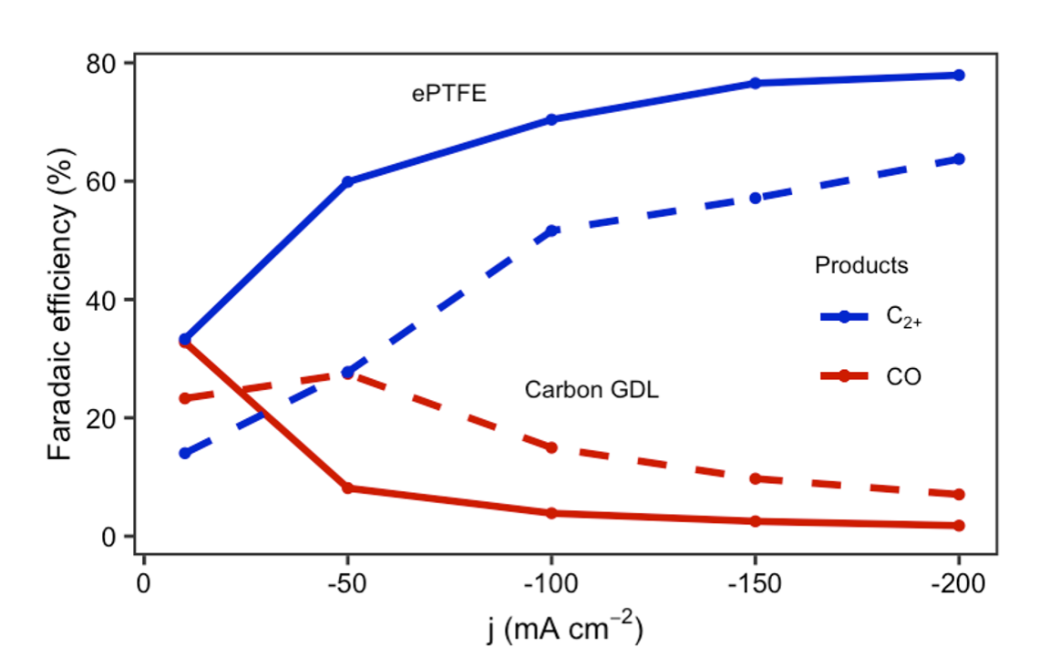

Fig. S1.
Product distribution at increasing current densities for a 200 nm Cu catalyst layers on a carbon GDL (Sigracet 38BB) and a 500 nm layer on an ePTFE electrode (Sterlitech Aspire QL822).

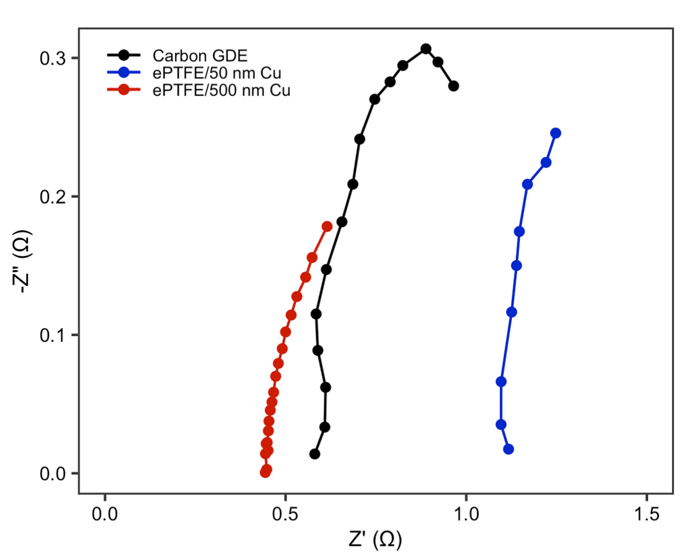

Fig. S2.
High-frequency segments of EIS measurements performed on the three compared electrodes, at a current density of –50 mA cm⁻² and 1M KOH as the electrolyte.
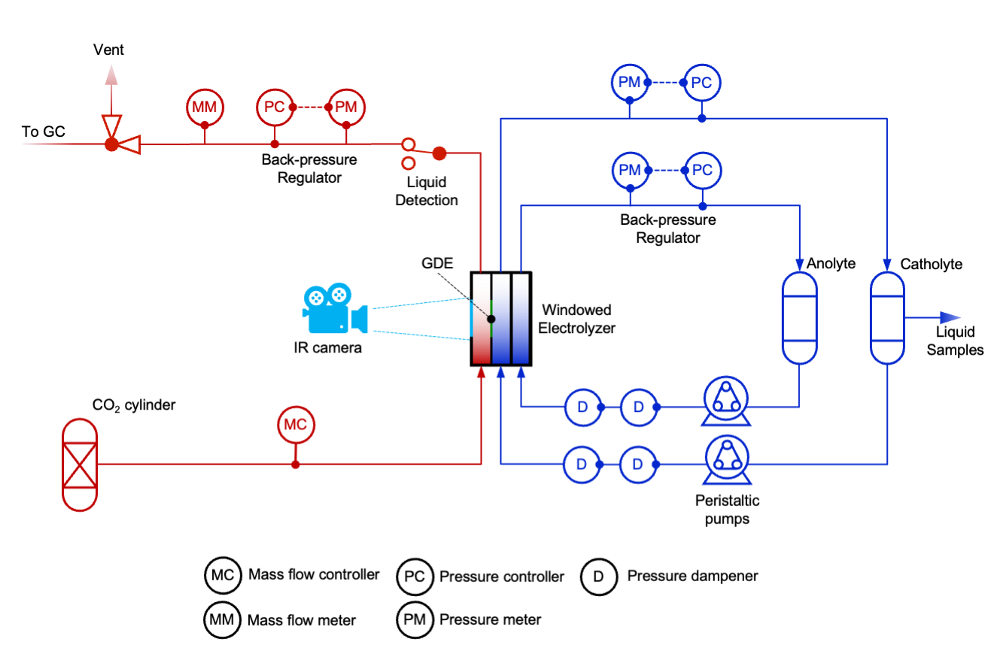

Fig. S3.
Process flow-diagram of the electrochemical testing setup used.

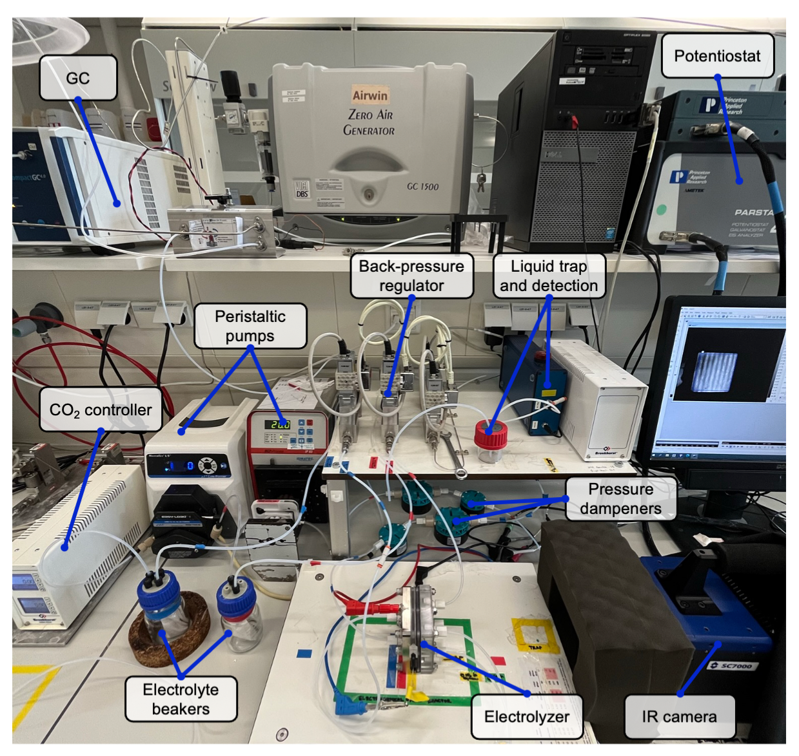

Fig. S4.
Picture of the electrochemical testing bench used.

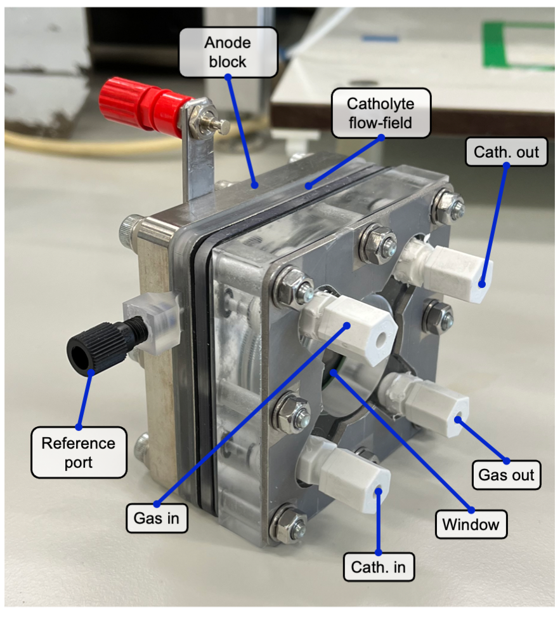

Fig. S5.
State-of-the-art windowed electrolyzer used in the electrochemical characterization of the different cathodes. The assembly consists of a titanium anode block (with integrated flow-field), a catholyte flow-field (3D-printed), a gas chamber (3D-printed) and a window end-block (milled, PMMA) with a stainless-steel pressing plate.

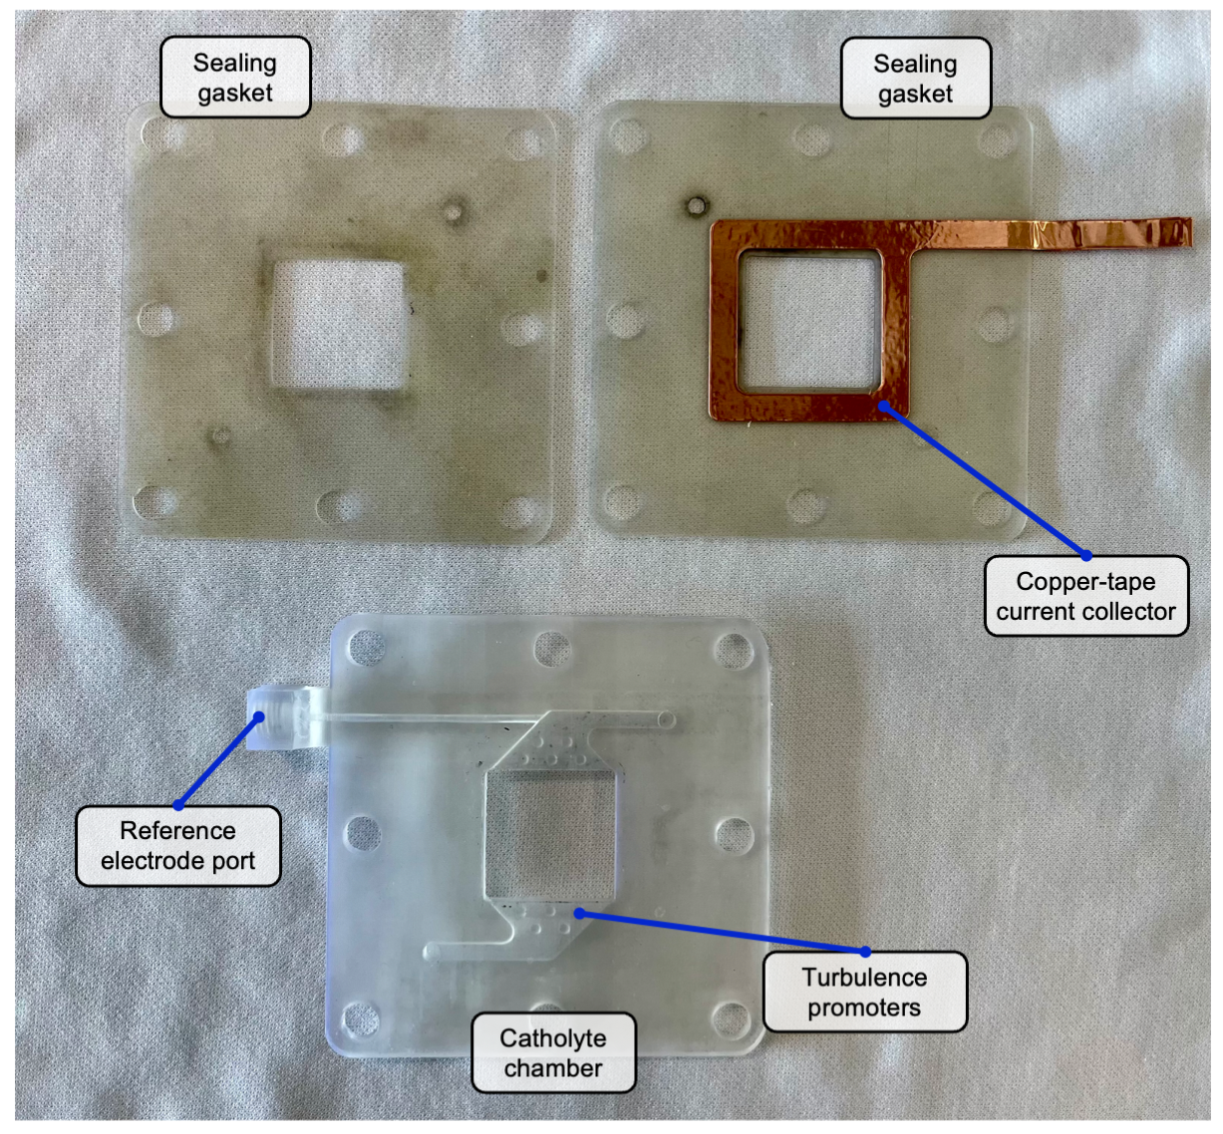

Fig. S6.
Assembly around the cathode, consisting of a 3D-printed catholyte chamber with reference-electrode port and turbulence promotors, a sealing gasket (δ = 500 µm, silicone) with an edge-current collector (pressed to the silicone at 10 bar) and a sealing gasket (δ = 250 µm, silicone)

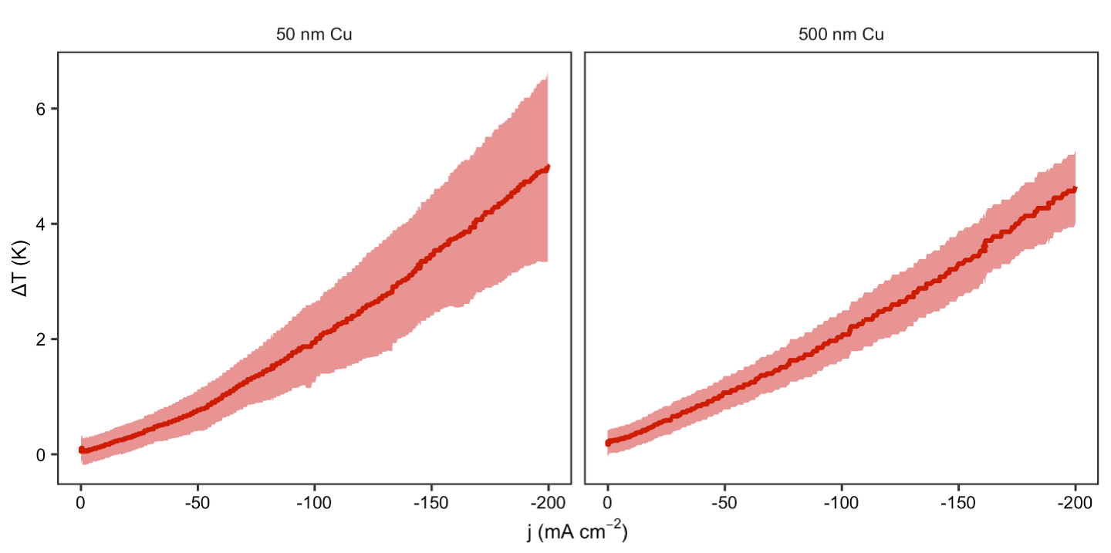

Fig. S7.
Average (bold) and standard-deviation (shaded) temperature increase on 50 nm and 500 nm Cu ePTFE electrodes under increasing cathodic polarization.

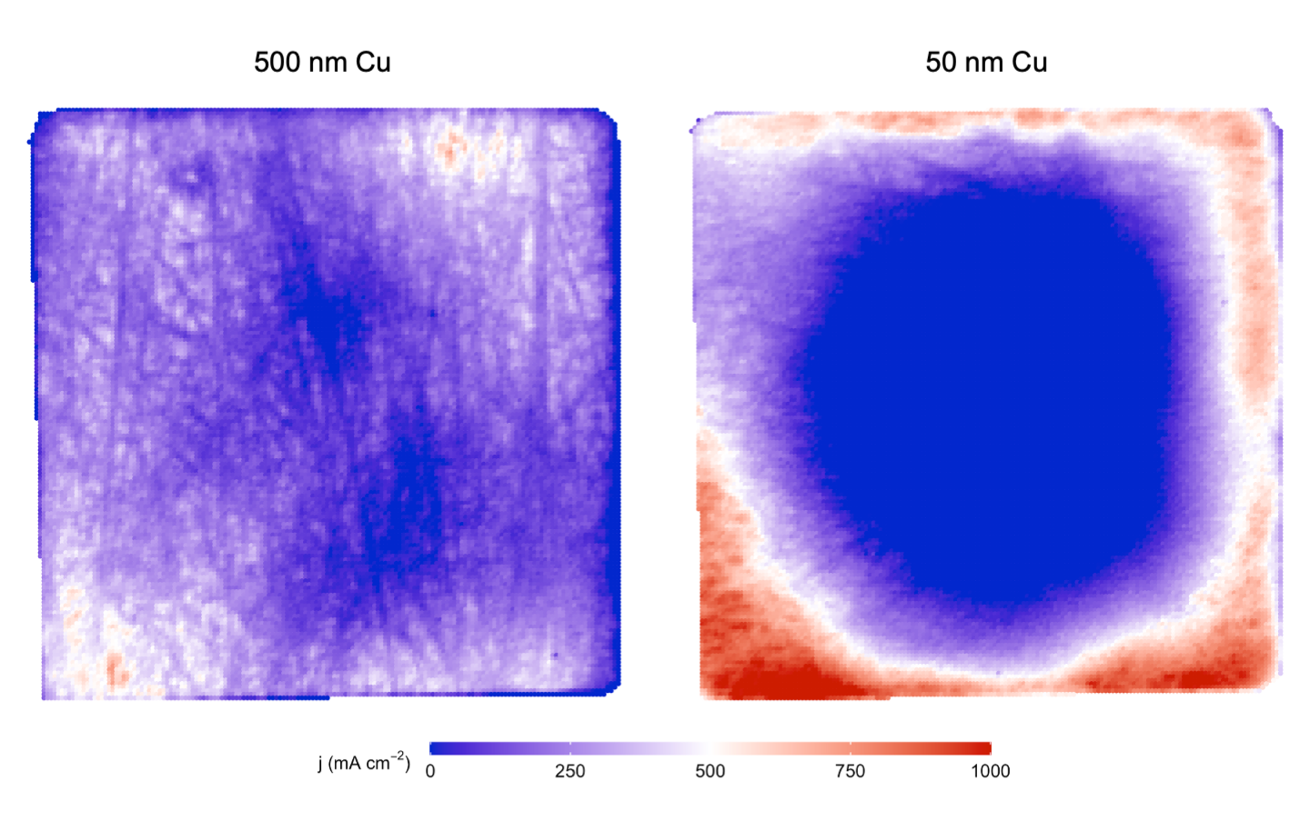

Fig. S8.
Corrected local current densities based on the relative temperature increase per pixel for a 50 nm and a 500 nm Cu ePTFE electrode at –200 mA cm⁻².

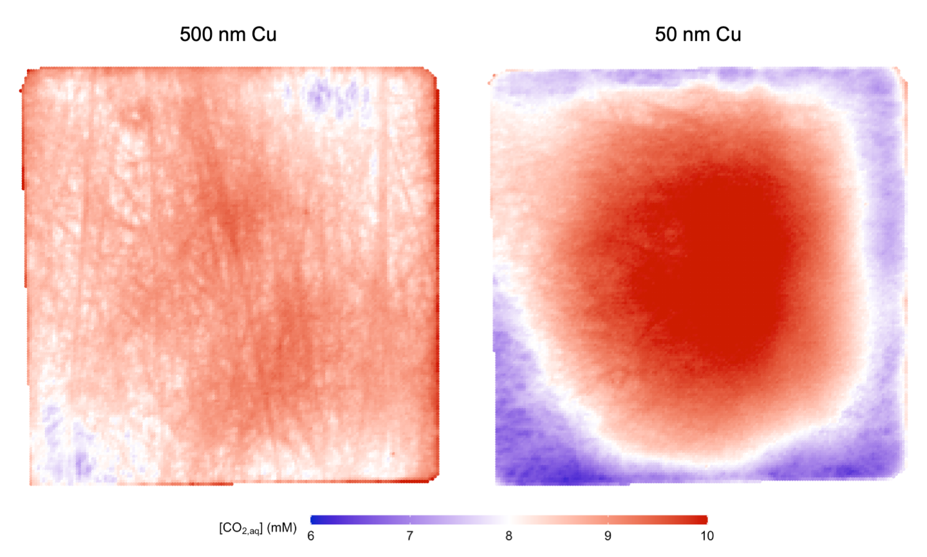

Fig. S9.
Corrected local concentration of dissolved CO₂ at the gas-liquid interface, based on the measured temperature per pixel for a 50 nm and a 500 nm Cu ePTFE electrode at an average j of –200 mA cm⁻². Salting-out effects were calculated using interpolated ion-concentrations resulting from the model described in the Supplementary Text.

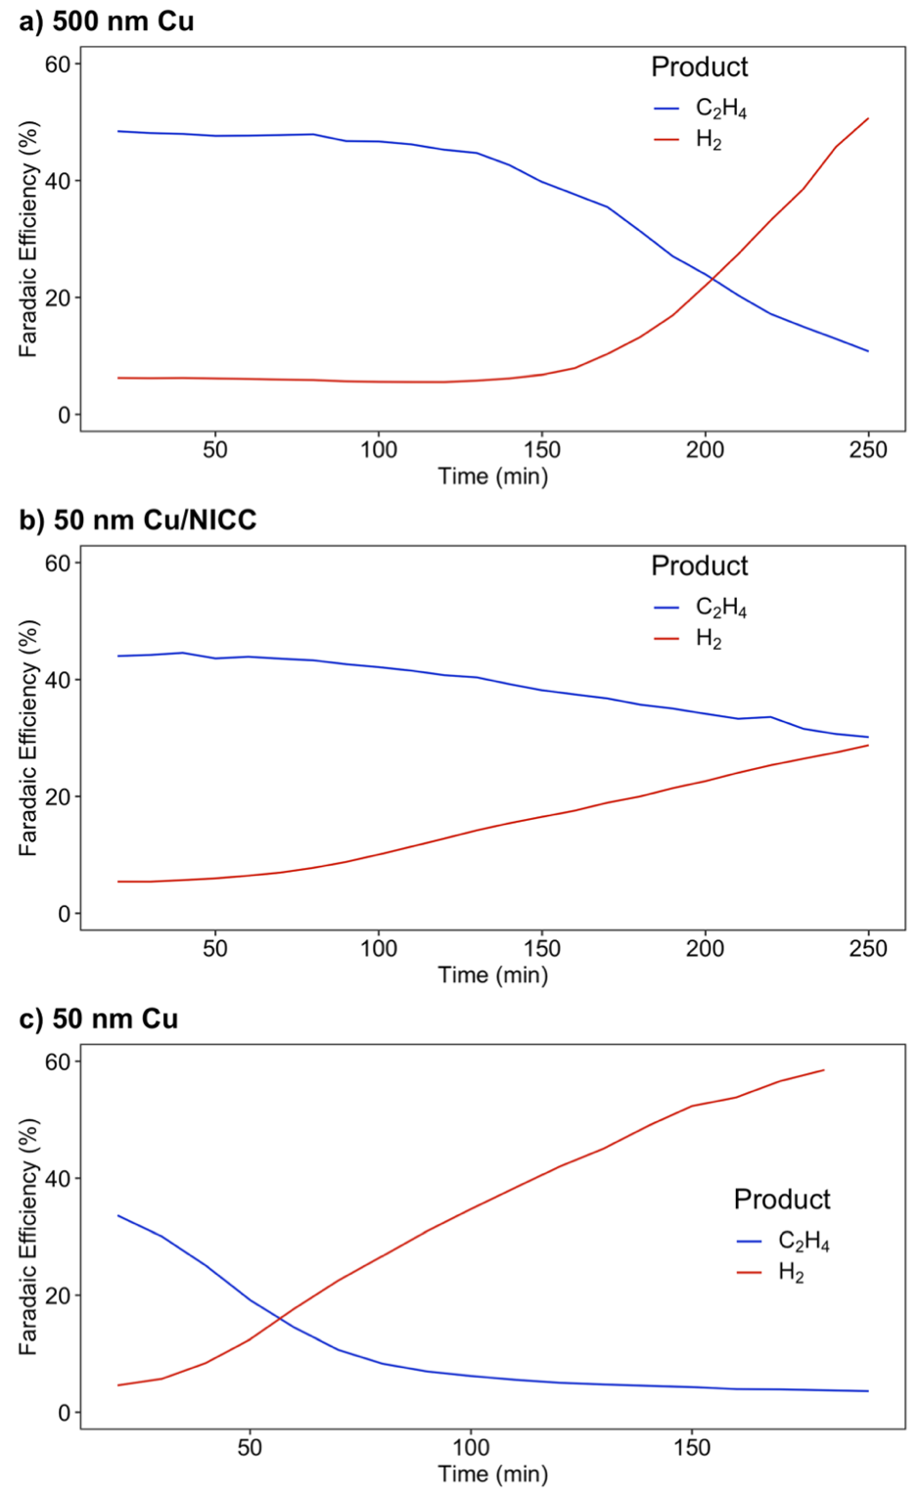

Fig. S10.
Long-term faradaic efficiencies towards ethylene and hydrogen of a 500 nm Cu ePTFE electrode, a 50 nm Cu/NICC and a 50 nm Cu design, at constant potential (~ - 0.55 V vs. RHE)

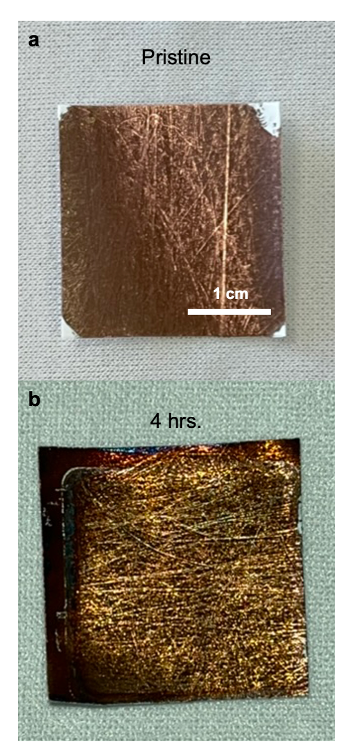

Fig. S11.
(a) As-prepared 500 nm Cu ePTFE electrode, and (b) state of a 500 nm Cu sample after 4 hrs. of electrolysis at ~-0.55 V vs. RHE

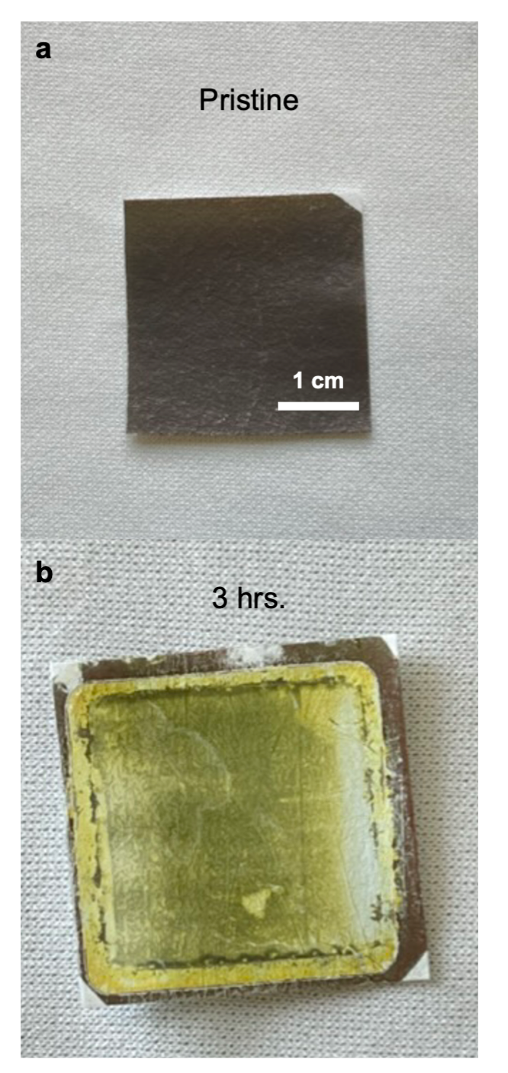

Fig. S12.
(a) As-prepared 50 nm Cu ePTFE electrode, and (b) state of a 50 nm Cu sample after 3 hrs. of electrolysis at ~-0.55 V vs. RHE

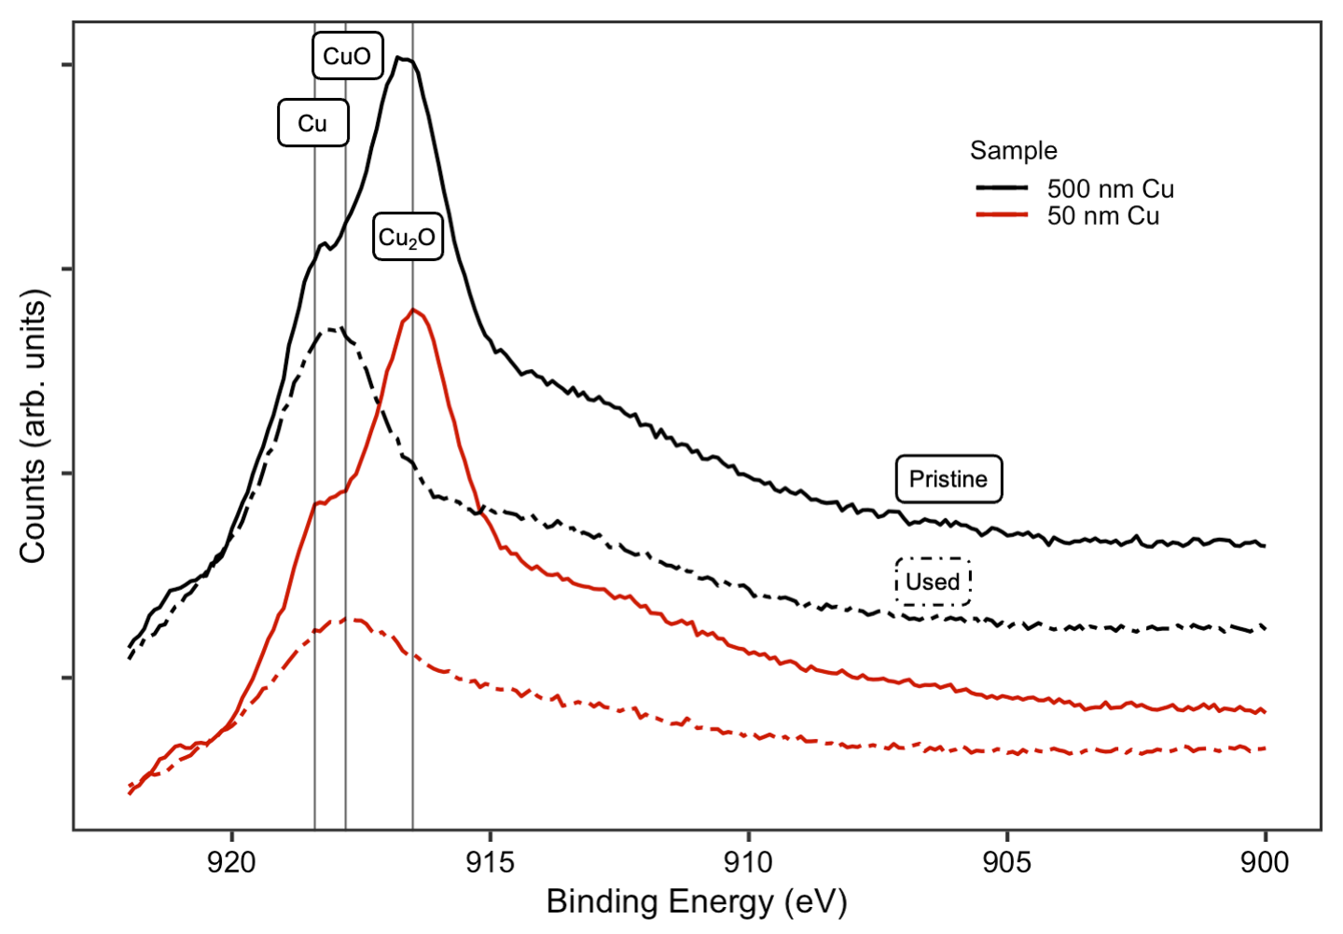

Fig. S13.
Cu-LMM XPS scans of pristine and used samples of each thickness. The used 500 nm Cu scan shows a convolution of Cu and CuO peaks, whereas that convolution is much weaker for the 50 nm Cu used sample. The metallic copper shoulder is evident for both pristine samples.

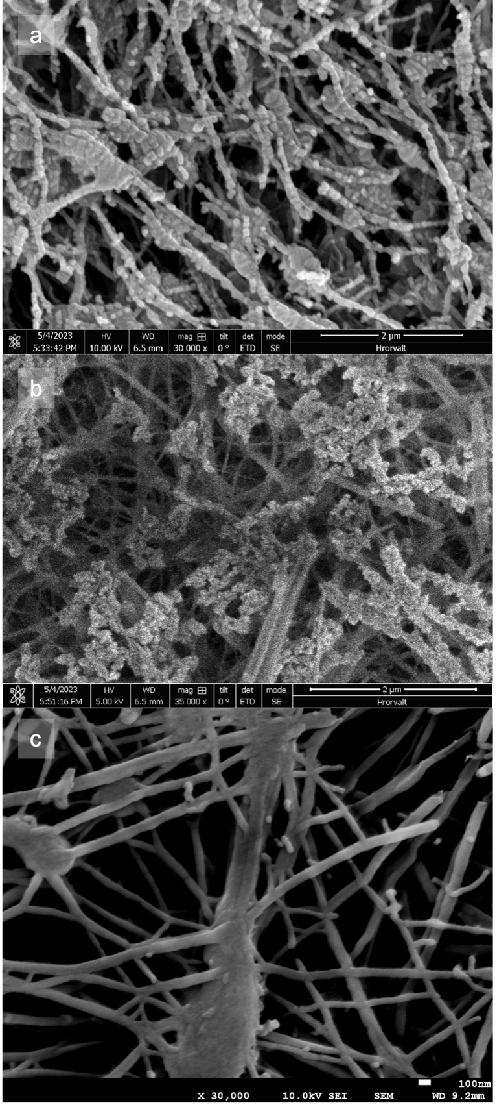

Fig. S14.
(a) SEM imaging of as-prepared 50 nm Cu ePTFE electrode, (b) state of a 50 nm Cu electrode after prolonged (~ 2h) electrolysis at increasing current densities and (c) state of a bare spot of ePTFE after prolonged (~ 2h) electrolysis.

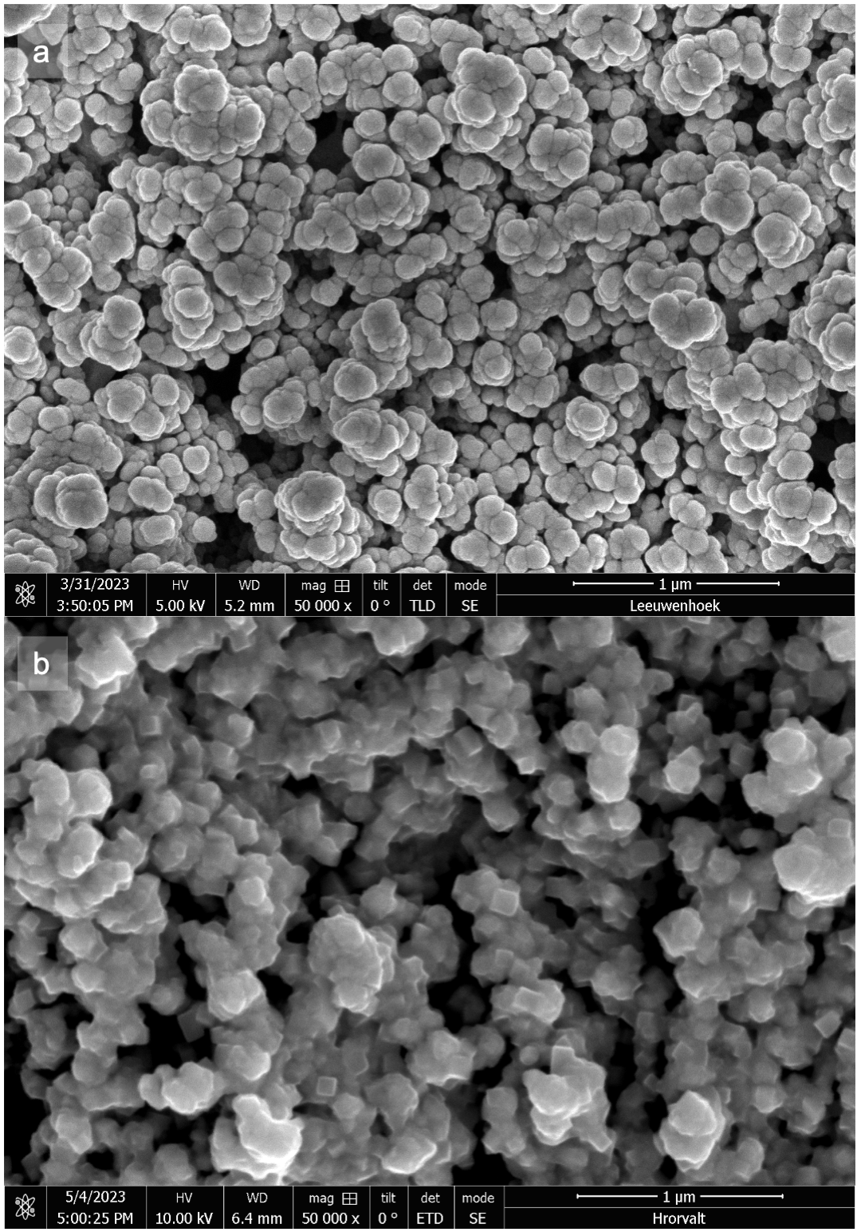

Fig. S15.
(a) SEM imaging of as-prepared 200 nm Cu + Sigracet 3BB electrode, and (b) state of a 200 nm Cu + Sigracet 3BB electrode after prolonged (~ 2h) electrolysis at increasing current densities.
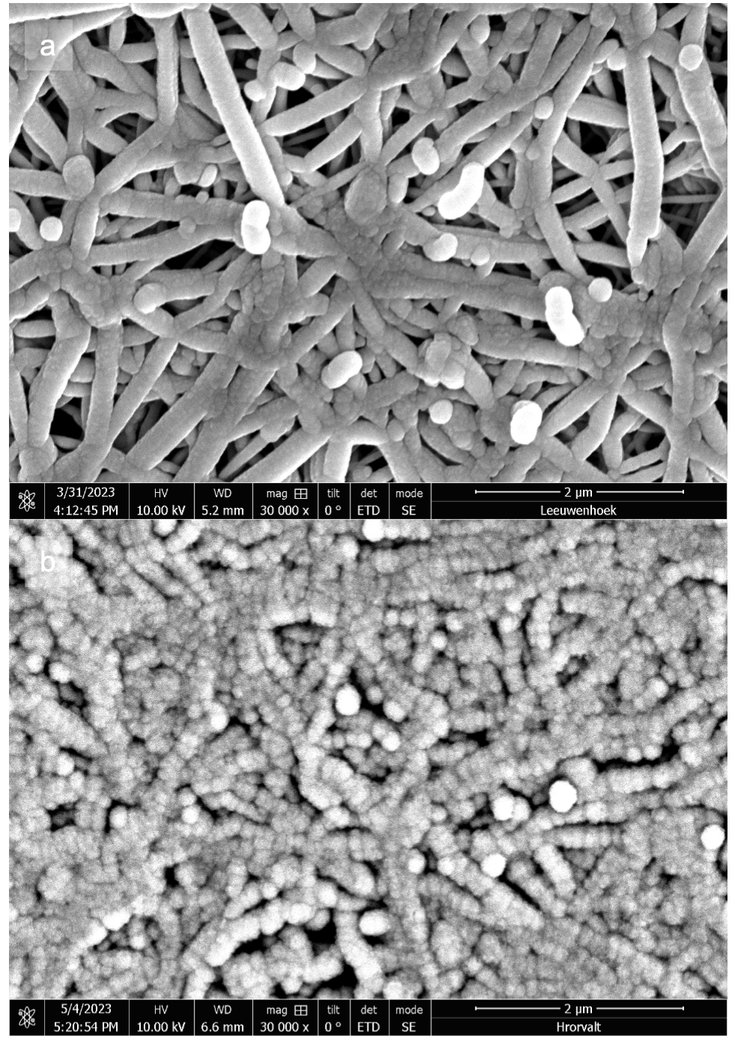

Fig. S16.
(a) SEM imaging of as-prepared 500 nm Cu ePTFE electrode, and (b) state of a 500 nm Cu electrode after prolonged (~ 2h) electrolysis at increasing current densities.

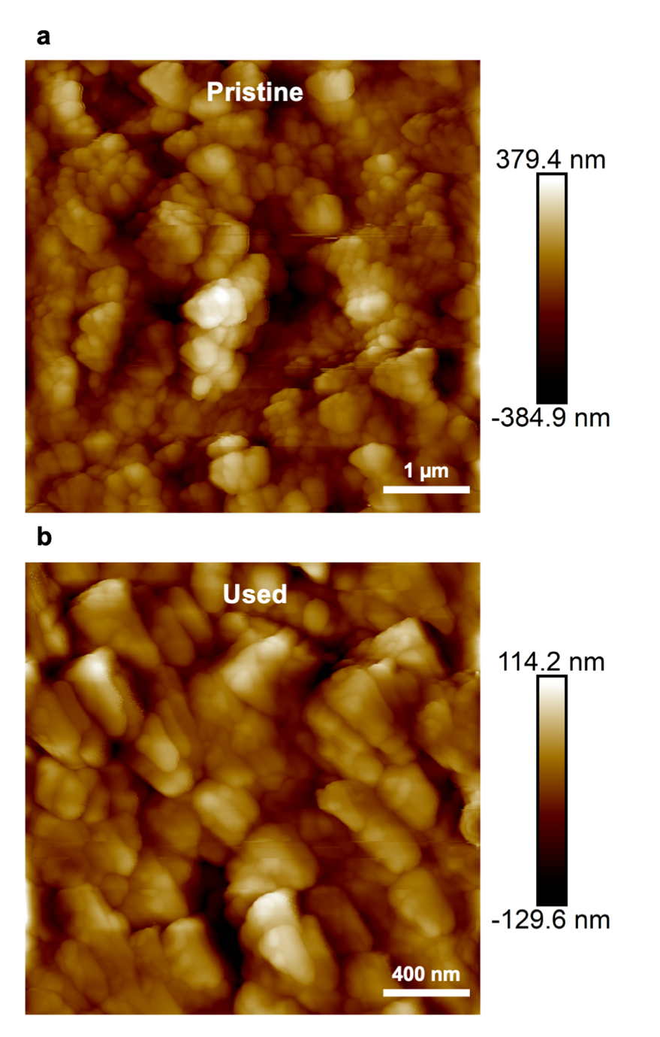

Fig. S17.
AFM surface imaging of (a) as-prepared 200 nm Cu on Sigracet 38BB, and (b) state of the 200 nm Cu layer after prolonged (~ 2h) electrolysis at increasing current densities.

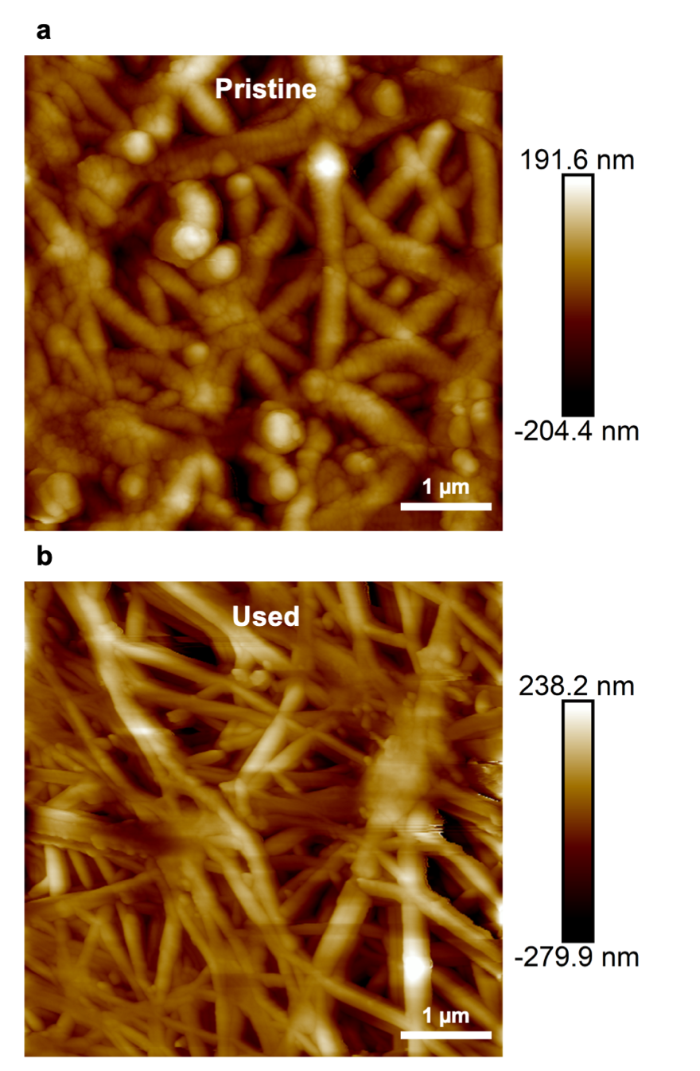

Fig. S18.
AFM surface imaging of (a) as-prepared 50 nm Cu on ePTFE, and (b) state of the same layer after prolonged (~ 2h) electrolysis at increasing current densities.
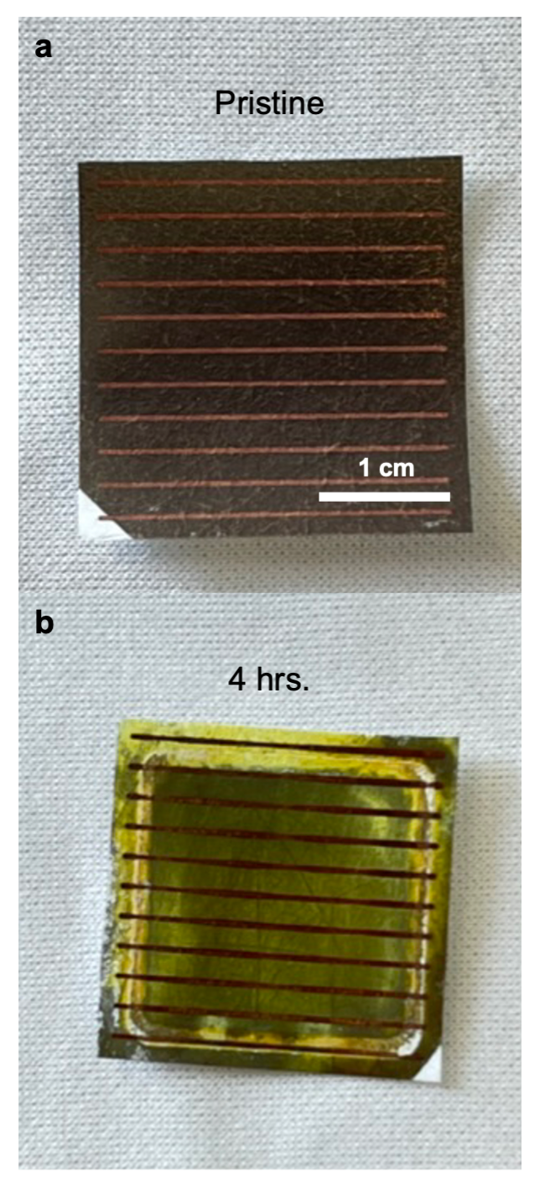

Fig. S19.
(a) As-prepared 50 nm Cu/NICC ePTFE electrode, and (b) state of a NICC electrode after 4 hrs. of electrolysis at ~-0.55 V vs. RHE

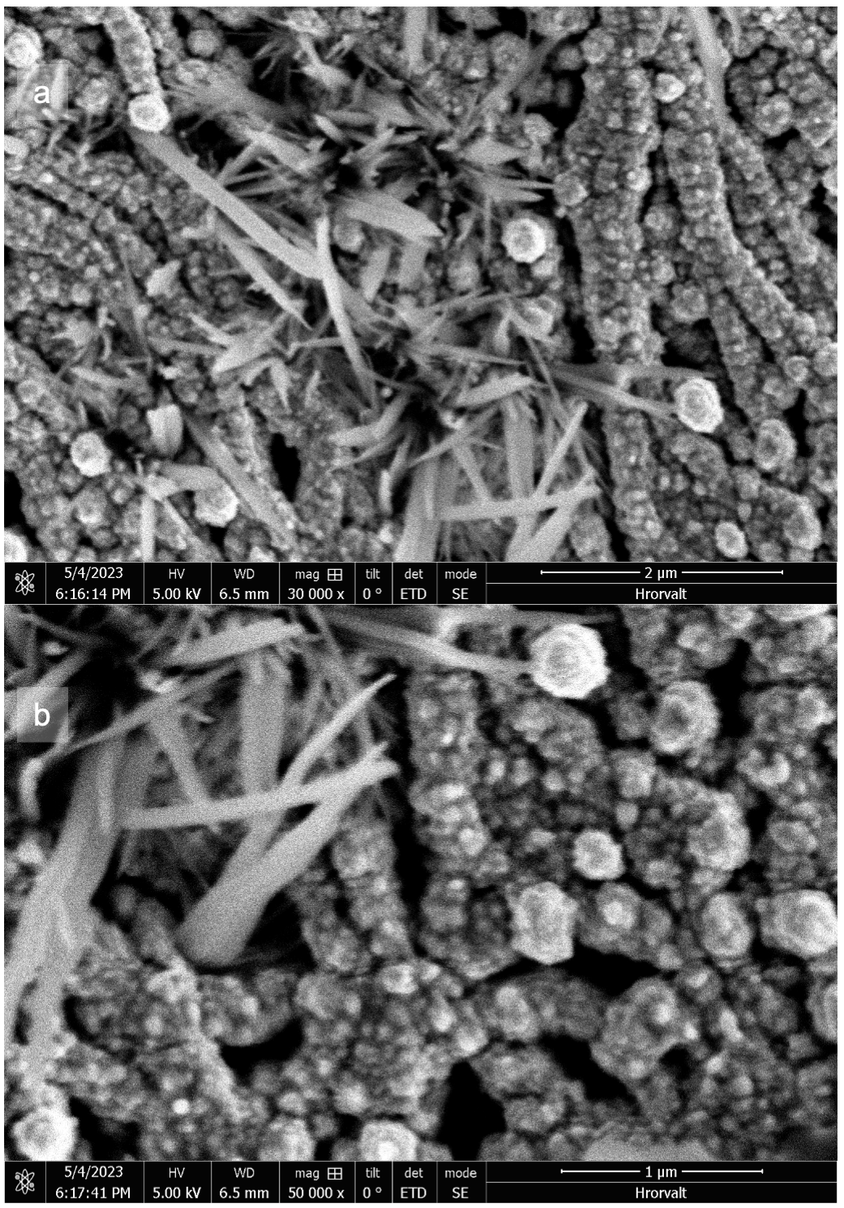

Fig. S20.
(a, b) SEM imaging of a 50 nm Cu/NICC electrode after prolonged (~ 2h) electrolysis at increasing current densities. The crystalline structures are due to insufficient rinsing of potassium carbonates after running.

Table S1.
Faradaic efficiencies towards ethylene and hydrogen of a thick (500 nm Cu) and thin (50 nm Cu) catalyst layers sputtered on ePTFE GDEs. Data taken at increased current densities. FE’s of liquid products are corrected and approximated to resting electrolyte volume at time of acquisition.

 |  | Faradaic Efficiency [%]
 | j  [mA cm⁻²] | Methane  [CH₄] | Formate  [HCOO⁻] | Ethylene  [C₂H₄] | Ethanol  [C₂H₅OH] | Acetate  [CH₃COO⁻] | Propanol  [CH₃H₇OH] | Acetaldehyde  [C₂H₄O] | C₁ |  | C₂₊
500 nm Cu | – 10 | 1.11 | 16.0 | 17.8 | 15.0 | 7.40 | 0.13 | 0.14 | 17.1 |  | 40.5
500 nm Cu | – 50 | 0.20 | 5.79 | 40.4 | 14.8 | 1.30 | 9.03 | 2.91 | 5.99 |  | 68.5
500 nm Cu | – 100 | 0.30 | 4.70 | 45.5 | 23.5 | 2.19 | 6.79 | 3.58 | 5.00 |  | 81.5
500 nm Cu | – 150 | 0.30 | 3.98 | 45.2 | 30.9 | 2.35 | 8.46 | 3.99 | 4.27 |  | 90.9
500 nm Cu | – 200 | 0.33 | 3.59 | 45.8 | 33.5 | 2.97 | 6.97 | 3.63 | 3.91 |  | 92.8
500 nm Cu | – 300 | 4.85 | 3.00 | 29.8 | 43.5 | 6.79 | 5.42 | 4.32 | 7.84 |  | 89.8
50 nm Cu | – 10 | 0.42 | 16.3 | 15.1 | 0.71 | 8.30 | 0.11 | 0.12 | 16.7 |  | 24.3
50 nm Cu | – 50 | 4.64 | 5.08 | 40.7 | 14.9 | 2.57 | 5.59 | 6.39 | 9.72 |  | 70.1
50 nm Cu | – 100 | 6.59 | 4.66 | 42.1 | 19.5 | 5.76 | 4.11 | 6.36 | 11.3 |  | 77.8
50 nm Cu | – 150 | 13.3 | 3.99 | 38.2 | 24.4 | 7.90 | 4.49 | 6.47 | 17.3 |  | 81.5
50 nm Cu | – 200 | 31.6 | 4.61 | 21.7 | 21.6 | 9.26 | 2.72 | 4.76 | 36.2 |  | 60.0
50 nm Cu | – 300 | 29.4 | 4.90 | 2.46 | 13.4 | 5.12 | 2.83 | 3.63 | 34.3 |  | 27.5

Table S2.
Faradaic efficiencies towards ethylene and hydrogen of the architectures compared in Figure 4. All data is taken at around –0.55 V vs. RHE using the setup described previously.

 | 500 nm Cu |  | 50 nm Cu/NICC |  | 50 nm Cu
t [min] | FE C₂H₄ [%] | FE H₂ [%] | FE C₂H₄ [%] | FE H₂ [%] | FE C₂H₄ [%] | FE H₂ [%]
10 | 48,42 | 6,26 | 44,03 | 5,42 | 33,62 | 4,62
20 | 48,11 | 6,21 | 44,21 | 5,41 | 30,06 | 5,72
30 | 47,97 | 6,25 | 44,57 | 5,67 | 25,08 | 8,43
40 | 47,64 | 6,17 | 43,62 | 5,97 | 19,18 | 12,47
50 | 47,67 | 6,09 | 43,90 | 6,44 | 14,49 | 17,70
60 | 47,77 | 5,98 | 43,58 | 6,98 | 10,68 | 22,53
70 | 47,89 | 5,90 | 43,30 | 7,78 | 8,31 | 26,72
80 | 46,73 | 5,68 | 42,62 | 8,79 | 7,00 | 30,94
90 | 46,67 | 5,60 | 42,12 | 10,06 | 6,22 | 34,73
100 | 46,17 | 5,57 | 41,52 | 11,42 | 5,56 | 38,37
110 | 45,26 | 5,56 | 40,75 | 12,79 | 5,06 | 41,98
120 | 44,70 | 5,80 | 40,38 | 14,20 | 4,77 | 45,07
130 | 42,63 | 6,17 | 39,20 | 15,43 | 4,54 | 48,92
140 | 39,75 | 6,78 | 38,16 | 16,51 | 4,32 | 52,33
150 | 37,60 | 7,90 | 37,44 | 17,58 | 3,98 | 53,81
160 | 35,46 | 10,34 | 36,78 | 18,94 | 3,92 | 56,62
170 | 31,33 | 13,21 | 35,71 | 20,00 | 3,77 | 58,51
180 | 27,03 | 16,93 | 35,05 | 21,41 | 3,62 | 60,50
190 | 23,94 | 22,04 | 34,14 | 22,62 | - | -
200 | 20,36 | 27,39 | 33,29 | 24,06 | - | -
210 | 17,16 | 33,20 | 33,59 | 25,33 | - | -
220 | 14,98 | 38,57 | 31,59 | 26,46 | - | -
230 | 12,90 | 45,76 | 30,68 | 27,53 | - | -
240 | 10,77 | 50,70 | 30,15 | 28,75 | - | -

