Supplementary material
Table S.1. Models used for the evaluation of adsorption of Ni(II) and Cd(II) ions in PAB.
Isotherm
Model | Equation | Parameters
Langmuir | $$q_{eq}=\frac{q_{max}K_{L}C_{eq}}{1+K_{L}C_{eq}}$$ | q_{eq} (mg/g): Sorption capacity at equilibrium  q_{max} (mg/g): Maximum sorption capacity
 | $$R_{L}=\frac{1}{(1+K_{L}C_{o})}$$ | K_{L} (L/mg): Langmuir’s constant  C_{eq} (mg/L): concentration at equilibrium R_{L}: separation factor  C_{o} (mg/L): higher initial concentration
Freundlich | $$q_{eq}=K_{F}C_{eq}^{\frac{1}{n}}$$ | K_{F} (mg/g)(L/mg)^{1/n}: Freundlich’s constant  n: heterogeneity factor
Kinetic
Model | Equation | Parameters
Pseudo first-order | $$lnln \left(q_{eq}-q_{t}\right) =lnln q_{eq}- k_{1}t$$ | q_{t} (mg/g): sorption capacity at time t  k₁ (1/min): pseudo first-order’s constant rate
Pseudo second-order | $$\frac{1}{q_{t}}=\frac{1}{k_{2}q_{eq}^{2}}+\frac{1}{q_{eq}}t$$ | k₂ (1/min): pseudo second-order’s constant rate
Intraparticle diffusion | $$q_{t}=k_{d}t^{0,5}+C$$ | k_{d} (mg/min^{1/2g}): instraparticle diffusion’s parameter  C (mg/g): intercept
Thermodinamyc
Equation |  | Parameters
$$∆G^{°}=∆H^{°}-T∆S^{°}$$ | Enthalpy change ($∆H^{°}$) and entropy change ($∆S^{°}$) can be obtained from the plot of log$(\frac{q_{e}}{c_{e}})$ vs. 1/T. | ΔG°: Gibbs free energy  T: Temperature (K)  $q_{e}=$ amount of metal adsorbed by unit mass of adsorbent (mg/g)  $c_{e}=$ Equilibrium metal concentration (mg/L)

Table S.2. Operational parameters for column biosorption studies
Column adsorption
Operational parameter | Equation/Description | Parameters
C/C₀ Máx | - | C = concentração final (mg/L);  C₀ = Initial concentration (mg/L)
t_{b} (min) | Time at C/C₀ = 0,05 | t_{b} = Breakthrough time (min)
t_{x} (min) | Time at C/C₀ = 0,95 | t_{x} = Exhaust time (min)
V_{b} (mg/L) | Volume at C/C₀ = 0,05 | V_{b} = Breakthrough volume (mg/L)
V_{x} (mg/L) | Volume at C/C₀ = 0,95 | V_{x} = Exhaust volume (mg/L)
δ (cm) | $$δ=\left(1-\frac{q_{u}}{q_{t}}\right)*h$$ | δ= Height of ZTM;  q_{u} = Amount of metal removed until the breakthrough point (mg);  q_{t} = Total amount of metal removed (mg);  h = Height of fixed bed adsorption (cm)
%sat | %S = $\left[ 1+\left(\frac{δ\left(f-1\right)}{h}\right)\right]*100$ | %S = Column saturation percentage;  δ = Height of ZTM (cm);  f = Adsorbent capacity fractional in the adsorption zone to continue removing solute after the breakthrough point;  h = Height of fixed bed adsorption (cm).

Table S.3. Analysis of variance for removed Ni(II) and Cd(II) using PAB
Metal ion |  | Source | Sum of squares (SS) | Degrees of freedom  (df) | Mean square (MS) | F | F_{tab}
Ni(II) |  | Regression (R) | 0,762858 | 3 | 0,254286 | 14,91 | 4,35
Ni(II) |  | Residual (r) | 0,119312 | 7 | 0,017045
Ni(II) |  | Lack of fit | 0,038192 | 2 | 0,019096
Ni(II) |  | Pure error | 0,000072 | 2 | 0,000036
Ni(II) |  | Total SS | 0,882170 | 10
Cd(II) |  | Regression (R) | 0,557341 | 3 | 0,185780 | 5,48 | 4,35
Cd(II) |  | Residual (r) | 0,237146 | 7 | 0,033878
Cd(II) |  | Lack of fit | 0,028471 | 2 | 0,014235
Cd(II) |  | Pure error | 0,000176 | 2 | 0,000088
Cd(II) |  | Total SS | 0,794487 | 10

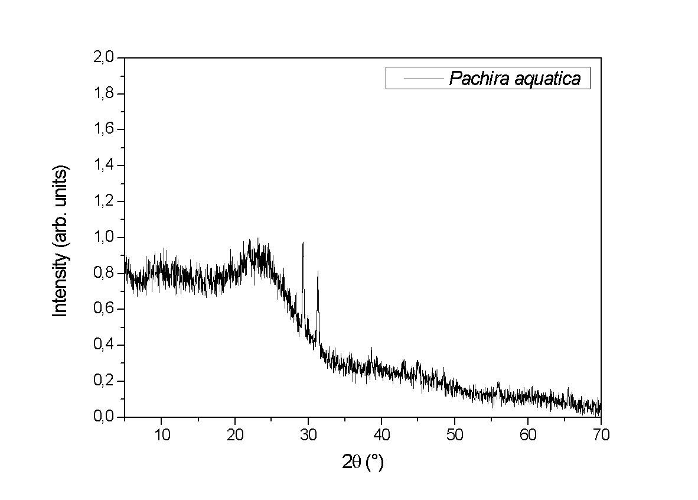
Fig. S.1. XRD pattern of the PAB

Fig S.2. Effects of factors on (a) Ni(II) (b) Cd(II) removal using PAB

