Supplementary Materials
AIEgen orthopalladated hybrid polymers for efficient inactivation of the total coliforms in urban wastewater

Lucia Sessa¹, Rosita Diana^{2*}, Francesco Silvio Gentile³, Fabio Mazzaglia⁴, and Barbara Panunzi²
¹ Department of Pharmacy, University of Salerno, Via Giovanni Paolo II, 132, Fisciano, 84084, SA, Italy
² Department of Agricultural Sciences, University of Naples Federico II, Portici, NA, Italy
³ Department of Chemical Sciences, University of Napoli Federico II, Strada Comunale Cinthia, 26, Napoli, 80126, Italy
⁴ C.R.A. s.r.l., Calle Giovanni Legrenzi, 2 – 30171, VE, Italy
* Correspondence: rosita.diana@unina.it

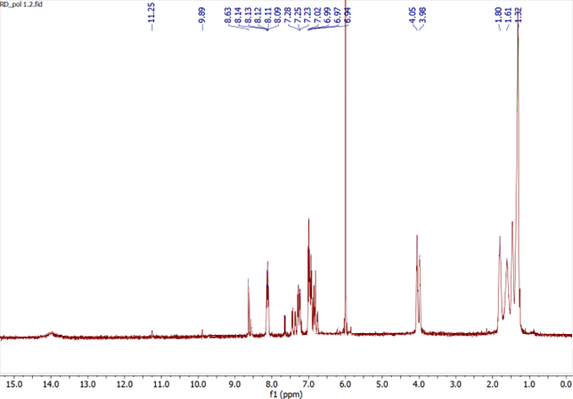
Figure S1. ¹H-NMR of P1 in CDCl₃
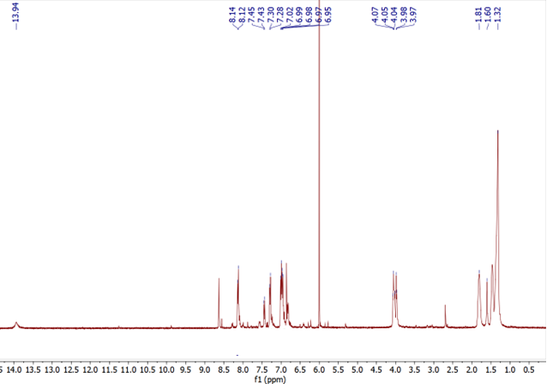
Figure S2. ¹H-NMR of P1-Pd(A) in CDCl₃

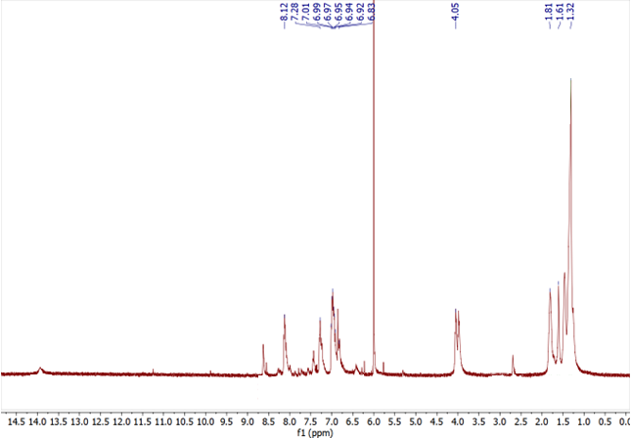
Figure S3. ¹H-NMR of P1-Pd(B) in CDCl₃
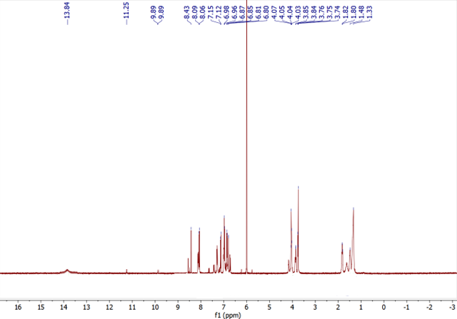
Figure S4. ¹H-NMR of P2 in CDCl₃

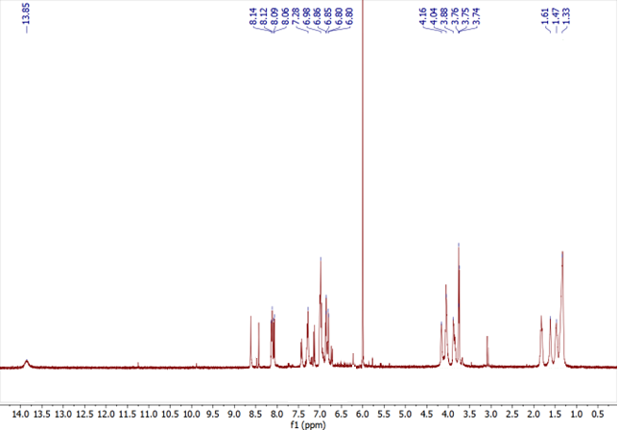
Figure S5. ¹H-NMR of P2-Pd(A) in CDCl₃
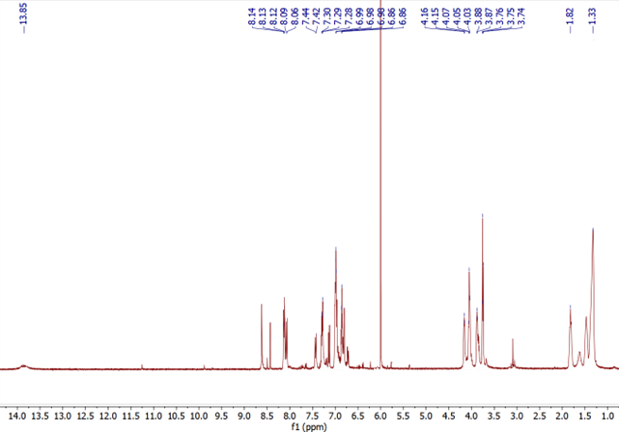
Figure S6. ¹H-NMR of P2-Pd(B) in CDCl₃

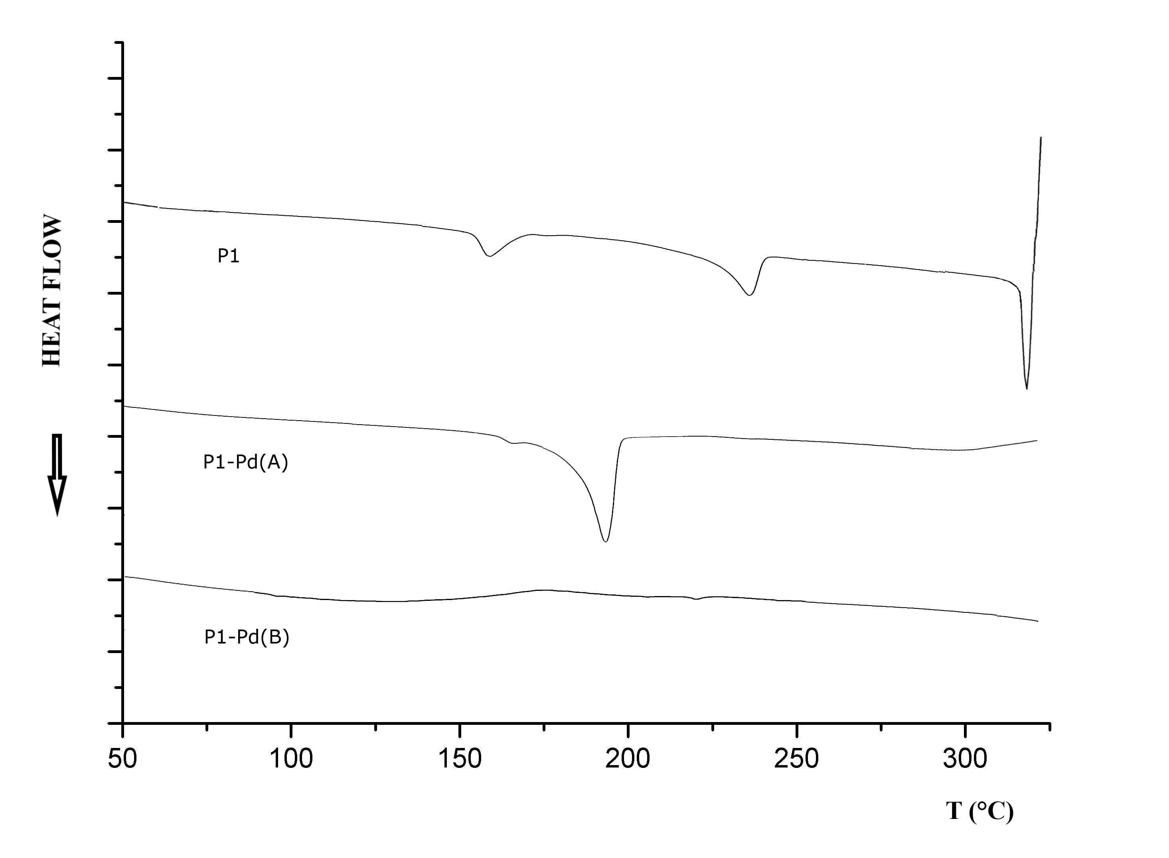
Figure S7. DSC curves of P1 and related grafted polymers
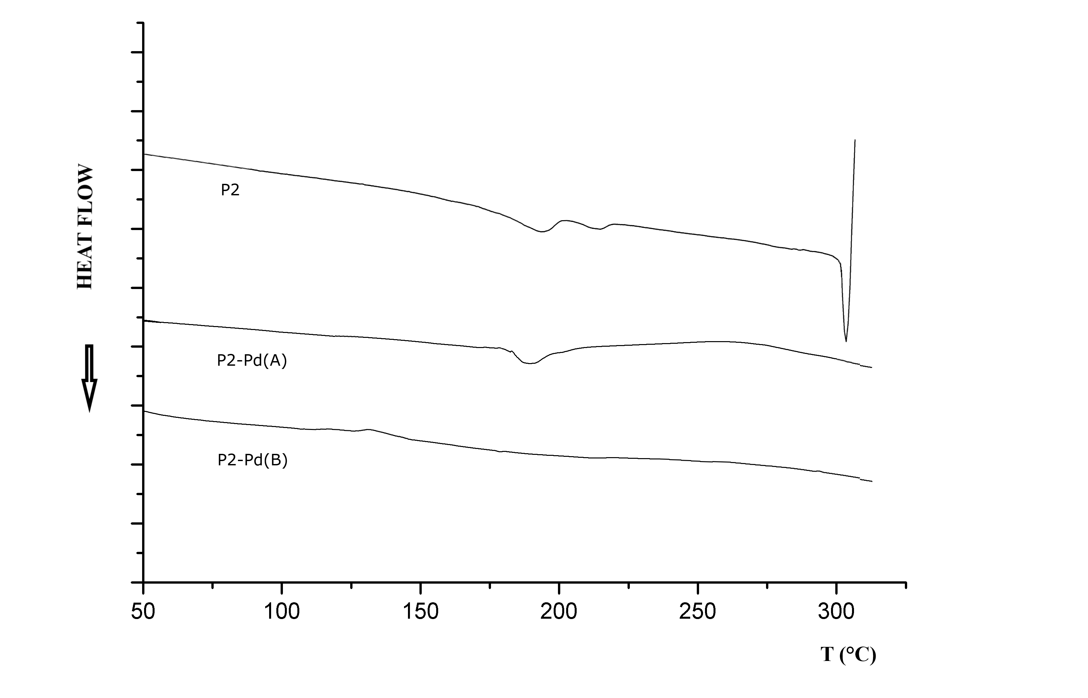
Figure S8. DSC curves of P2 and related grafted polymers

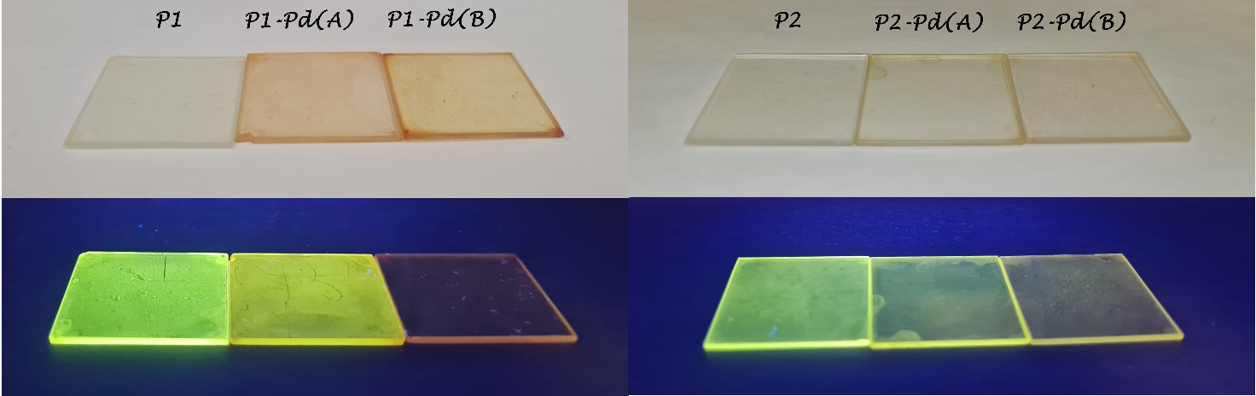

Figure S9. Polymeric thin films in natural light (above) and irradiated by a commercial UV-visible lamp at 365 nm (below).
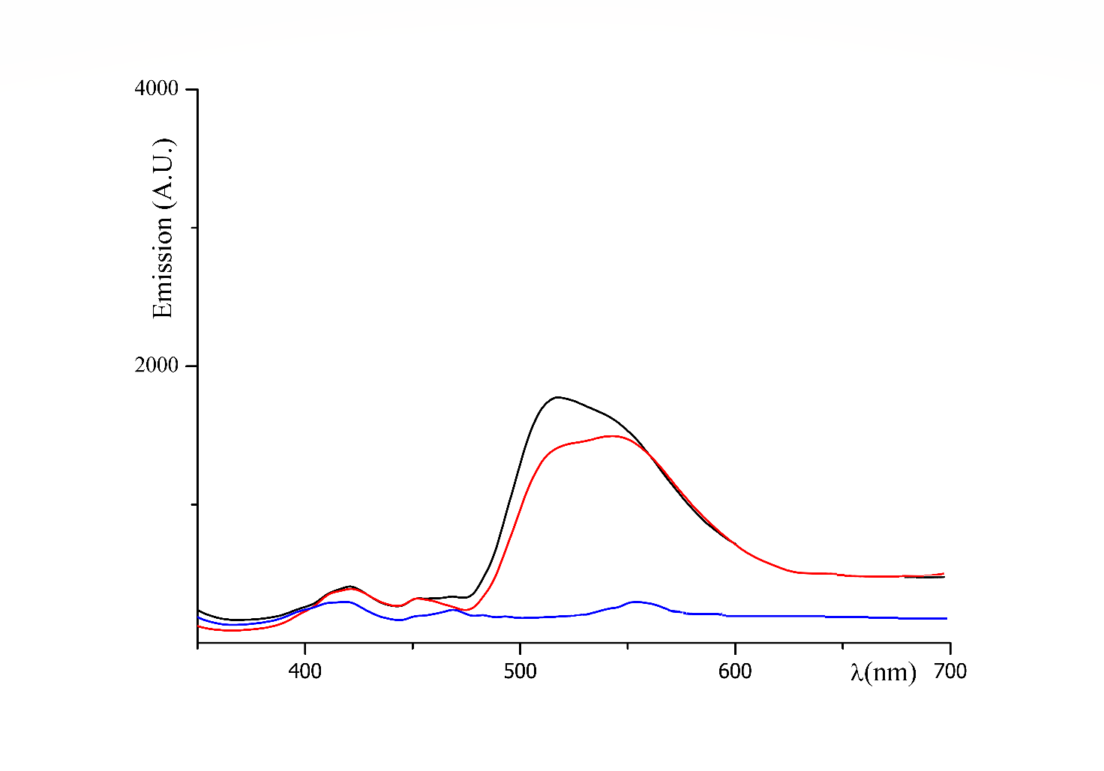
Figure S10. Emission spectra recorded on thin film of P1 (black curve), P1-Pd(A) (red curve), and P1-Pd(B) (blue curve).

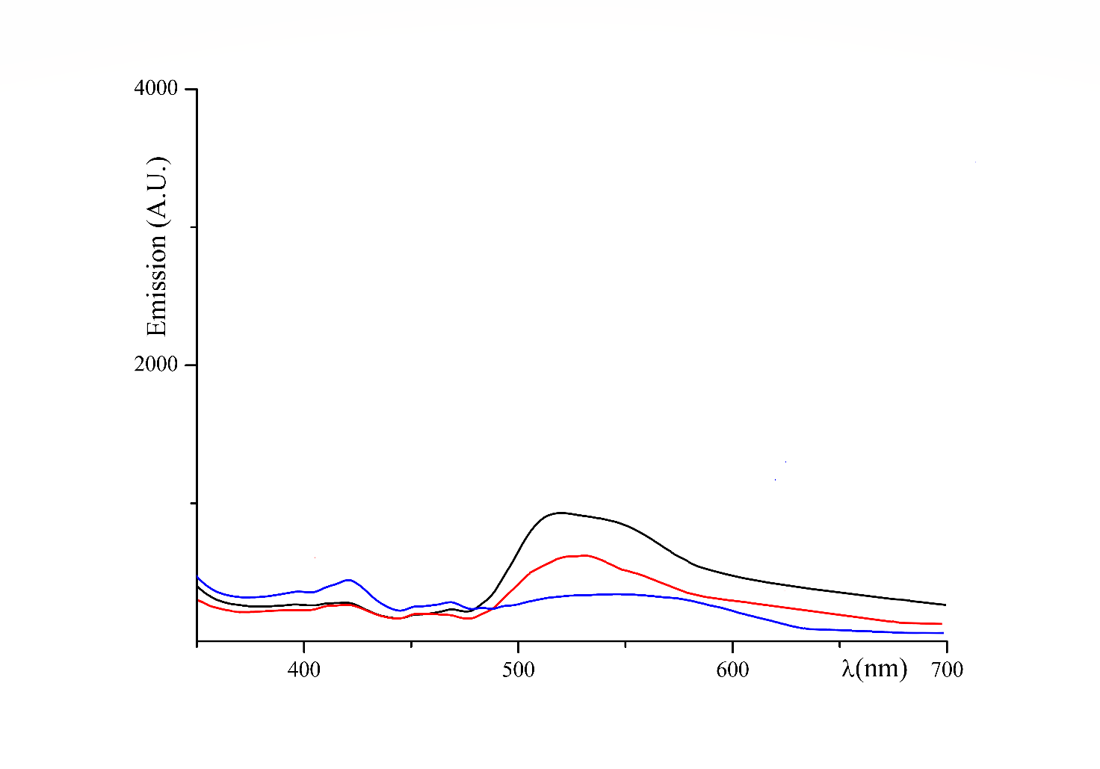
Figure S11. Emission spectra recorded on thin film of P2 (black curve), P2-Pd(A) (red curve), and P2-Pd(B) (blue curve).

