Figure S1：A forest plot showing the teaching satisfaction by continuous outcomes
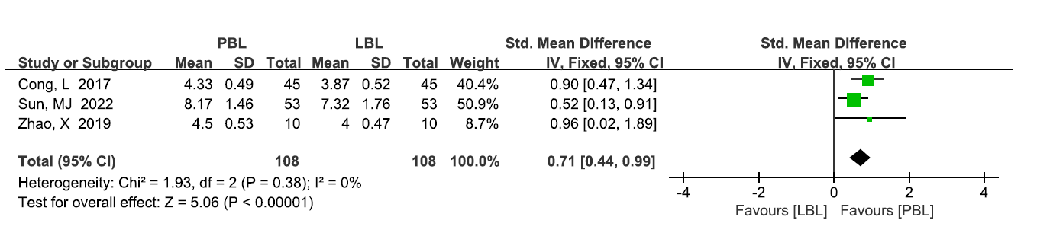

Figure S2：A forest plot showing the analyzing problem ability by continuous outcomes
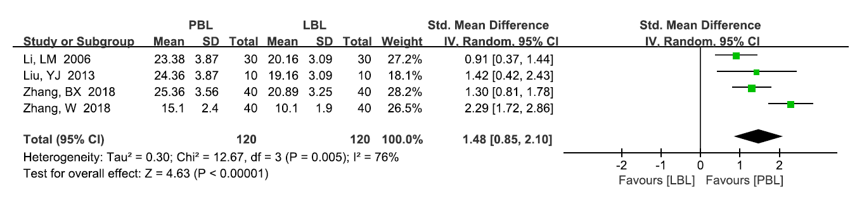

Figure S3：A forest plot showing the solving problem ability by continuous outcomes
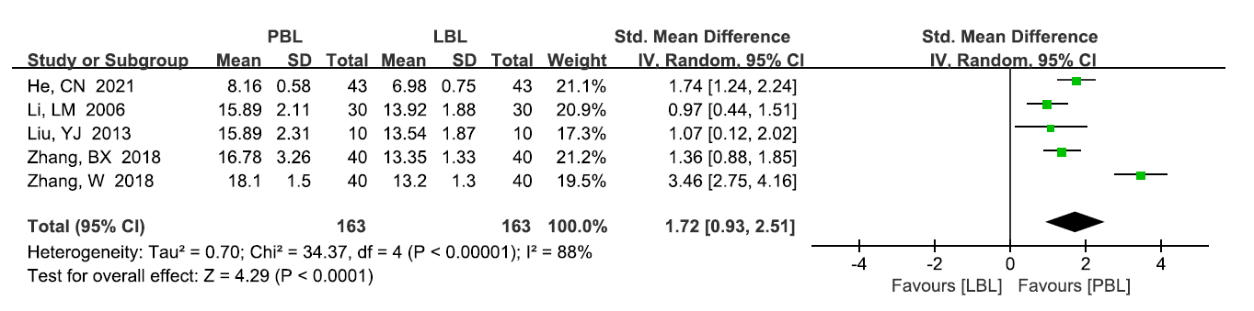

Figure S4：A forest plot showing the team assistance ability
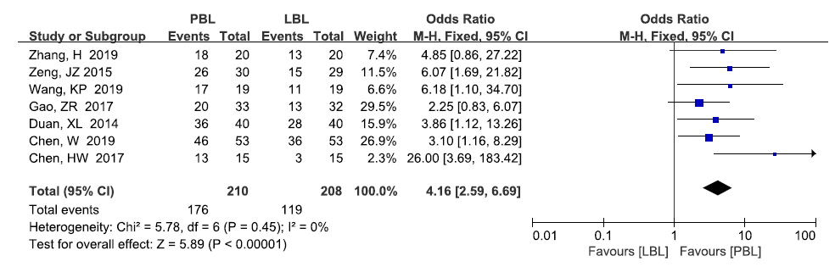

Figure S5：A forest plot showing the communication ability
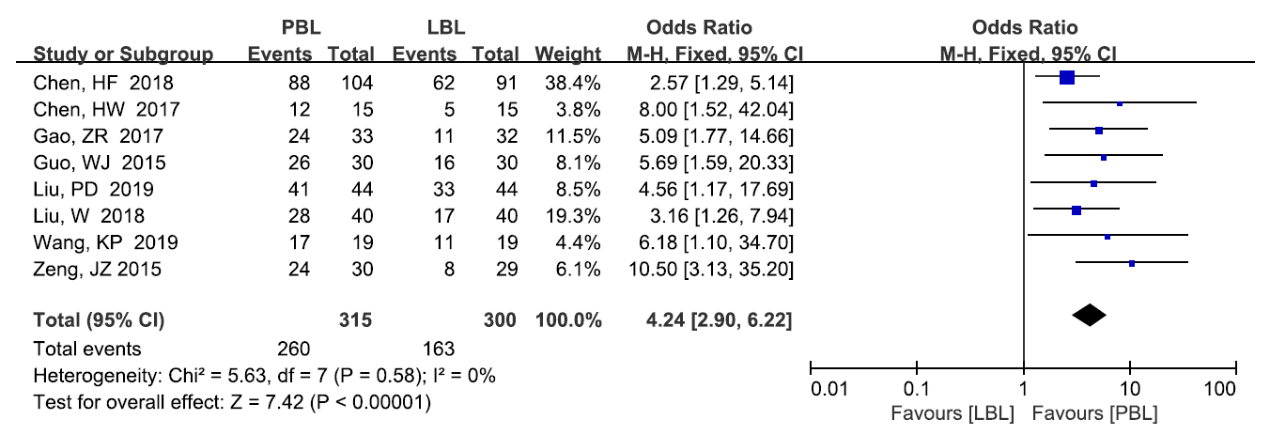

Figure S6：A forest plot showing the clinical think ability
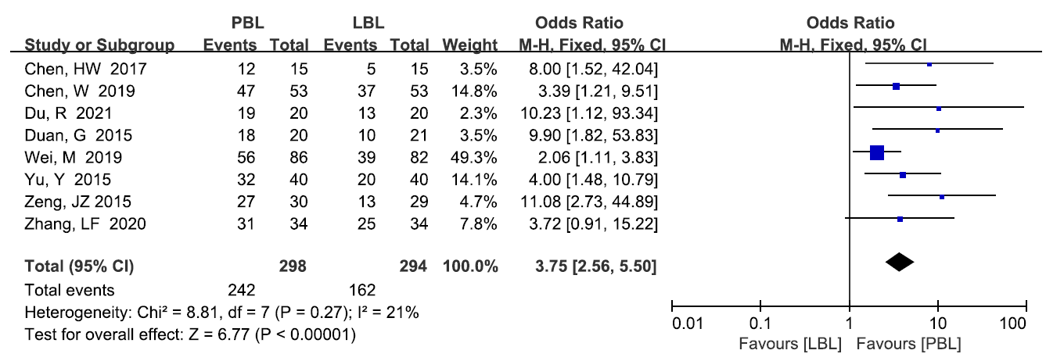

Figure S7：A funnel plot showing publication bias for operational score
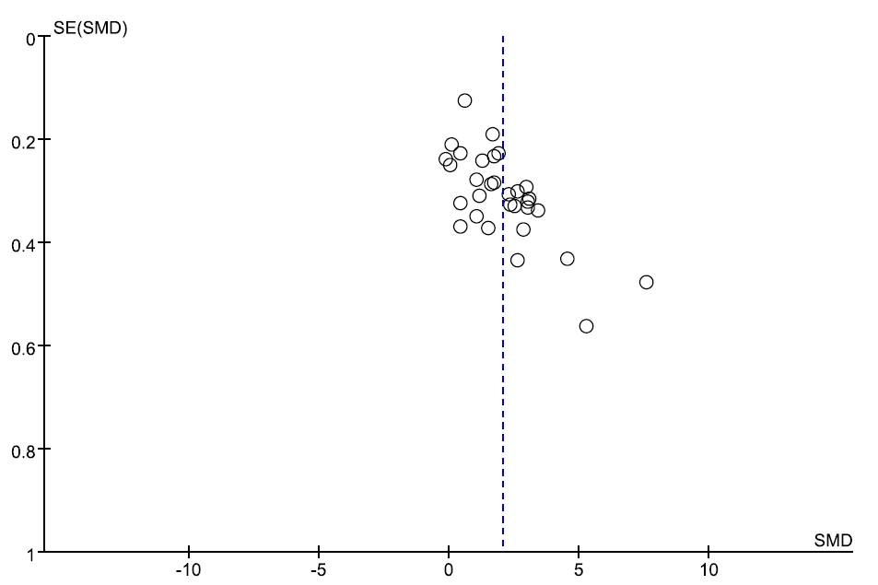

Figure S8：A funnel plot showing publication bias for case analysis score
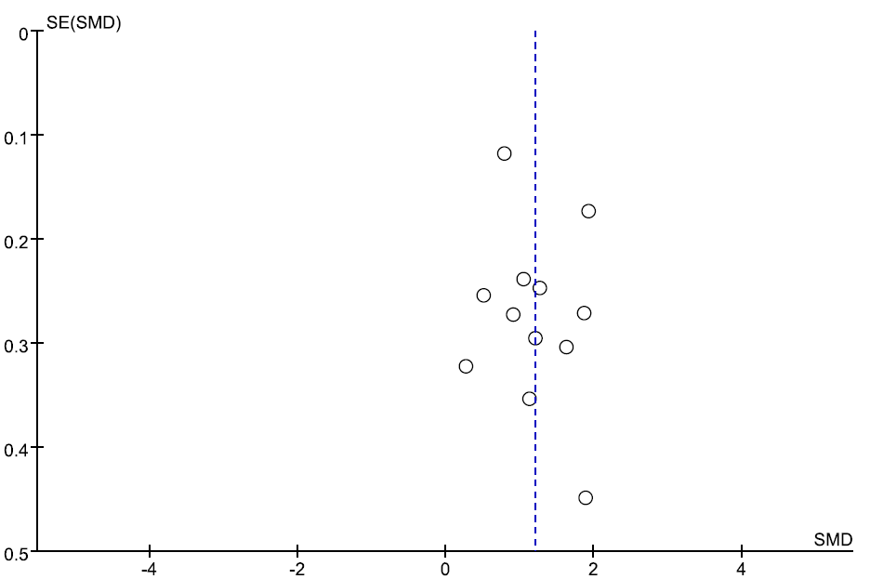

Figure S9：A funnel plot showing publication bias for total score
