Supplemental Materials
Genistein enhances NAD⁺ biosynthesis by binding to prohibitin 1 and upregulating nicotinamide phosphoribosyltransferase (NAMPT) in adipocytes
Shun Watanabeª, Riki Haruyama^{b}, Koji Umezawa^{c}, Ikuo Tomioka^{a,b}, Soichiro Nakamura^{b}, Shigeru Katayama^{c}, Takakazu Mitani^{a,b*}

ªGraduate School of Science and Technology, Shinshu University, 8304 Minami-minowa, Kamiina, Nagano, 3994598, Japan.
^{b}Department of Agricultural and Life Sciences, Faculty of Agriculture, Shinshu University, 8304 Minami-minowa, Kamiina, Nagano, 3994598, Japan.
^{c}Department of Biomolecular Innovation, Institute for Biomedical Sciences, Interdisciplinary Cluster for Cutting Edge Research, Shinshu University, Kamiina, 8304 Minami-minowa, Kamiina, Nagano, Japan.

*Corresponding author (mitani@shinshu-u.ac.jp)

Suppl. Fig. S1 Effect of genistein on intracellular NAD⁺ and NAMPT expression levels. qPCR analysis of NAD⁺ biosynthesis associated genes in 3T3-L1 adipocytes after induction of differentiation in the presence (green bars) or absence (blue bars) of genistein (Gen; 10 μM) for 7 days. Data are representative of triplicate independent experiments presented as the mean ± s.d. (n = 3).

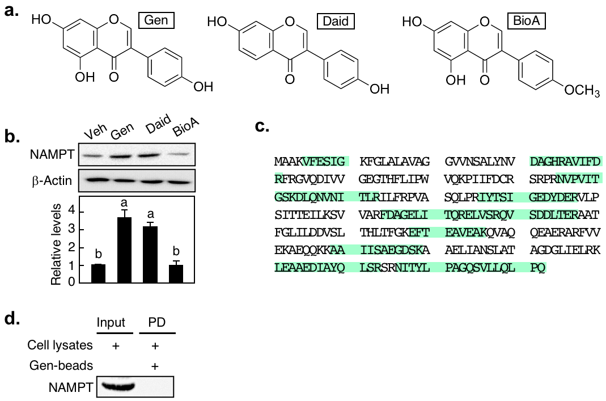
Suppl. Fig. S2 Identification of target protein for genistein-mediated regulation of NAMPT expression. a Chemical structure of isoflavones. b Western blotting of NAMPT in 3T3-L1 adipocytes after induction of differentiation with 10 μM isoflavones (genistein; Gen, daidzein; Daid, Biochanin A; BioA) for 7 days. c Amino acid sequences of PHB1. Obtained peptide fragments by nanoLC Q-TOF/MS and ProteinLynx Global server software are shown in green sheet. d Pulldown assay between Gen-bead and NAMPT. 3T3-L1 adipocyte lysates were incubated with Gen-bead, followed by western blotting with anti-NAMPT antibodies. Data are representative of triplicate independent experiments presented as the mean ± s.d. (n = 3). Different letters indicate statistically significant differences (p < 0.05).

Suppl. Fig. S3 Effect of genistein and PHB1 on C/EBPb-stimulated promoter activity of Nampt gene. a qPCR analysis of Cebpb in 3T3-L1 adipocytes after induction of differentiation in the presence (green bars) or absence (blue bars) of genistein (Gen; 10 μM). b Nampt promoter activity in 3T3-L1 adipocytes transiently transfected with pGL4-Nampt-Luc vector, and C/EBPβ and PHB1ΔNTD expression vectors, followed by incubation with Gen. Data are representative of triplicate independent experiments presented as the mean ± s.d. (n = 3). Statistically significant differences (p < 0.05) are indicated using different letters—a common letter between the groups indicated that the difference is not statistically significant.

Suppl. Fig. S4 Association of genistein-increased C/EBPβ protein levels and ERK signaling. a Phosphorylation levels of ERK in PHB1-specific siRNA (siPHB1)-treated ASCs treated with genistein (Gen; 10 μM). b Western blotting of C/EBPβ, p-ERK in ASCs treated with Gen and ERK inhibitor PD98059 (20 µM). All data shown are each representative of triplicate independent experiments.

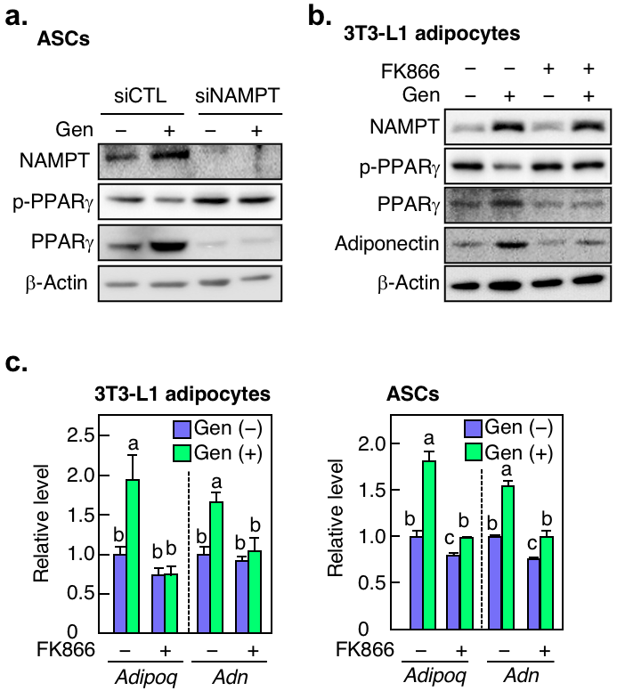
Suppl. Fig. S5 Effect of genistein on phosphorylation of PPARγ through the upregulation of NAMPT. a Western blotting in NAMPT-knocked down ASCs. The cells were transfected with siRNA for control (siCTL) or NAMPT specific (siNAMPT), followed by differentiation with genistein (Gen; 10 μM) for 7 days. b Protein expression of p-PPARγ, PPARg and adiponectin in 3T3-L1 adipocytes. The cells were induced into adipocyte differentiation with Gen and/or FK866 (10 nM) for 7 days. c qPCR analysis in 3T3-L1 adipocytes (left panel) or ASCs (right panel) treated with FK866 in the presence (green bars) or absence (blue bars) of Gen for 7 days. Data are representative of triplicate independent experiments presented as the mean ± s.d. (n = 3). Statistically significant differences (p < 0.05) are indicated using different letters—a common letter between the groups indicated that the difference is not statistically significant.

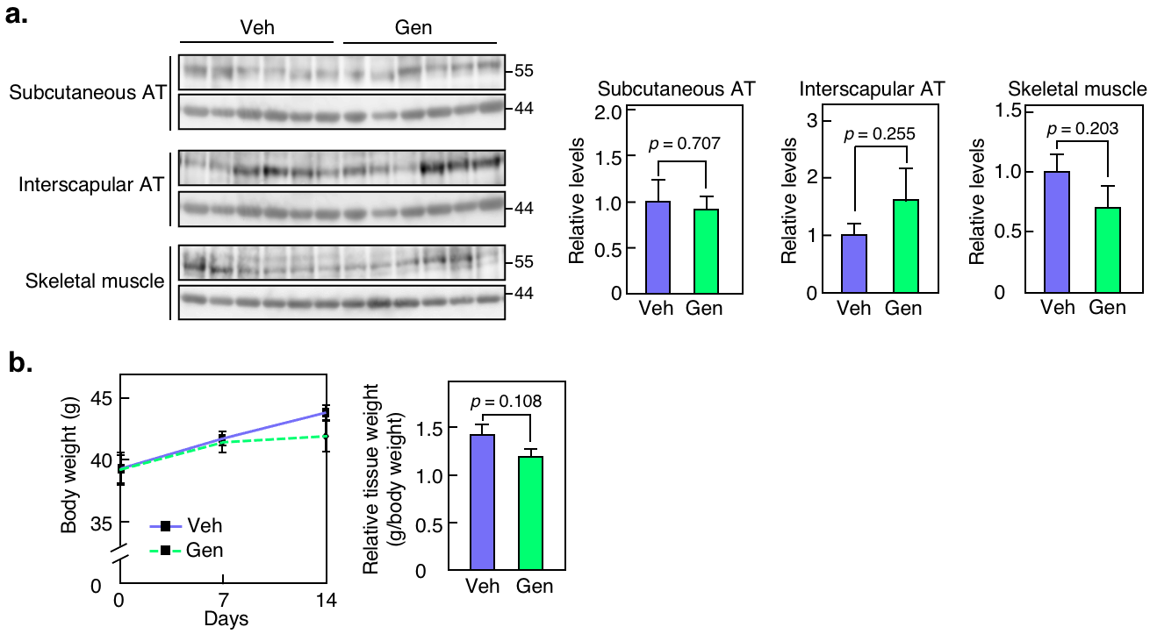
Suppl. Fig. S6 Effect of genistein administration on NAD⁺ levels and NAMPT expression in adipose tissues. a Western blotting of NAMPT in adipose tissues (AT) and skeletal muscle from mice following two weeks treatment with either vehicle (Veh) or genistein (Gen) (left panels). The ratio of each band was normalized to that of β-actin (right panels). b Body and visceral adipose tissue weight in Gen administered mice. In a and b, blue bars are Veh and green bars are Gen. Error bars represent the mean ± s.e.m. (n = 6), and all data did not show statistically significant differences between the Veh and Gen groups (p > 0.05).

