Supple. Table S1 Demographics of children by weight status
 | Primary Four Cohort (N₁ = 442,898) |  |  |  |  | Primary Six Cohort (N₂ = 344,186)
Variables | Normal Weight (n = 280,998) | Underweight (n = 53,100) | Overweight (n = 82,154) | Obese (n = 26,646) | p Value | Normal Weight (n = 225,294) | Underweight (n = 40,950) | Overweight (n = 63,697) | Obese (n = 14,245) |  | p Value
Male, n (%) | 135,421 (48.2) | 21,719 (40.9) | 48,395 (58.9) | 18,863 (70.8) | < 0.001‡ | 105,876 (47.0) | 17,709 (43.0) | 38,128 (59.9) | 10,055 (70.6) |  | < 0.001‡
Age, years, mean (SD) | 9.37 (0.55) | 9.45 (0.57) | 9.36 (0.54) | 9.29 (0.52) | < 0.001‡ | 11.35 (0.54) | 11.40 (0.56) | 11.29 (0.51) | 11.25 (0.50) |  | < 0.001‡
Weight, kg, mean (SD) | 31.12 (4.46) | 25.00 (2.64) | 41.32 (4.93) | 50.99 (6.89) | < 0.001‡ | 39.78 (5.89) | 30.59 (3.63) | 52.48 (6.21) | 65.16 (8.41) |  | < 0.001‡
Height, cm, mean (SD) | 136.75 (6.55) | 134.51 (6.19) | 140.10 (6.40) | 142.23 (6.42) | < 0.001‡ | 149.43 (7.40) | 145.44 (7.16) | 151.75 (7.04) | 153.71 (7.18) |  | < 0.001‡
Educational Level of Student's Father, n (%)
Missing value | 11,630 (4.1) | 2,085 (3.9) | 3,468 (4.2) | 1,295 (4.9) |  | 8,618 (3.8) | 1,447 (3.5) | 2,575 (4.0) | 681 (4.8)
No Schooling | 1,489 (0.5) | 297 (0.6) | 408 (0.5) | 168 (0.6) | < 0.001‡ | 1,085 (0.5) | 250 (0.6) | 312 (0.5) | 84 (0.6) |  | < 0.001‡
Kindergarten | 286 (0.1) | 52 (0.1) | 82 (0.1) | 30 (0.1) | < 0.001‡ | 204 (0.1) | 36 (0.1) | 59 (0.1) | 14 (0.1) |  | < 0.001‡
Primary | 39,717 (14.1) | 7,626 (14.4) | 11,372 (13.8) | 4,163 (15.6) | < 0.001‡ | 32,740 (14.5) | 6,245 (15.3) | 9,335 (14.7) | 2,307 (16.2) |  | < 0.001‡
Lower Secondary | 57,454 (20.4) | 10,672 (20.1) | 17,578 (21.4) | 6,043 (22.7) | < 0.001‡ | 46,363 (20.6) | 8,473 (20.7) | 13,497 (21.2) | 3,268 (22.9) |  | < 0.001‡
Upper Secondary | 110,253 (39.2) | 20,917 (39.4) | 33,409 (40.7) | 10,833 (40.7) | < 0.001‡ | 89,902 (39.9) | 16,197 (39.6) | 26,146 (41.0) | 5,846 (41.0) |  | < 0.001‡
Matriculation | 11,309 (4.0) | 2,199 (4.1) | 3,238 (3.9) | 937 (3.5) | < 0.001‡ | 9,360 (4.2) | 1,710 (4.2) | 2,547 (4.0) | 492 (3.5) |  | < 0.001‡
Tertiary (Non-  degree Course) | 11,830 (4.2) | 2,321 (4.4) | 3,193 (3.9) | 851 (3.2) | < 0.001‡ | 9,896 (4.4) | 1,812 (4.4) | 2,580 (4.1) | 440 (3.1) |  | < 0.001‡
Tertiary (Degree  Course) | 37,030 (13.2) | 6,931 (13.1) | 9,406 (11.4) | 2,326 (8.7) | < 0.001‡ | 27,126 (12.0) | 4,780 (11.7) | 6,646 (10.4) | 1,113 (7.8) |  | < 0.001‡
Educational Level of Student's Mother, n (%)
Missing value | 5,380 (1.9) | 937 (1.8) | 1,670 (2.0) | 666 (2.5) |  | 3,704 (1.6) | 681 (1.7) | 1,219 (1.9) | 332 (2.3)
No Schooling | 2,225 (0.8) | 462 (0.9) | 627 (0.8) | 218 (0.8) | < 0.001‡ | 1,761 (0.8) | 377 (0.9) | 512 (0.8) | 123 (0.9) |  | < 0.001‡
Kindergarten | 288 (0.1) | 50 (0.1) | 70 (0.1) | 38 (0.1) | < 0.001‡ | 251 (0.1) | 38 (0.1) | 61 (0.1) | 15 (0.1) |  | < 0.001‡
Primary | 39,758 (14.1) | 7,961 (15.0) | 11,403 (13.9) | 3,970 (14.9) | < 0.001‡ | 34,304 (15.2) | 6,816 (16.6) | 9,565 (15.0) | 2,249 (15.8) |  | < 0.001‡
Lower Secondary | 58,936 (21.0) | 10,807 (20.4) | 17,928 (21.8) | 6,130 (23.0) | < 0.001‡ | 46,711 (20.7) | 8,341 (20.4) | 13,391 (21.0) | 3,210 (22.5) |  | < 0.001‡
Upper Secondary | 129,205 (46.0) | 24,627 (46.4) | 38,367 (46.7) | 12,377 (46.4) | < 0.001‡ | 105,900 (47.0) | 19,033 (46.5) | 30,305 (47.6) | 6,806 (47.8) |  | < 0.001‡
Matriculation | 11,517 (4.1) | 2,066 (3.9) | 3,336 (4.1) | 960 (3.6) | < 0.001‡ | 9,022 (4.0) | 1,587 (3.9) | 2,558 (4.0) | 491 (3.4) |  | < 0.001‡
Tertiary (Non-  degree Course) | 10,218 (3.6) | 1,908 (3.6) | 2,761 (3.4) | 743 (2.8) | < 0.001‡ | 7,950 (3.5) | 1,380 (3.4) | 2,101 (3.3) | 342 (2.4) |  | < 0.001‡
Tertiary (Degree  Course) | 23,471 (8.4) | 4,282 (8.1) | 5,990 (7.3) | 1,544 (5.8) | < 0.001‡ | 15,691 (7.0) | 2,697 (6.6) | 3,985 (6.3) | 677 (4.8) |  | < 0.001‡
Occupation of Student's Father, n (%)
Missing value | 11,739 (4.2) | 2,140 (4.0) | 3,640 (4.2) | 1,185 (4.4) |  | 8,465 (3.8) | 1,460 (3.6) | 2,484 (3.9) | 621 (4.4)
Managers and  Administrators | 30,266 (10.8) | 5,265 (9.9) | 9,327 (11.4) | 2,758 (10.4) | < 0.001‡ | 25,307 (11.2) | 4,249 (10.4) | 7,487 (11.8) | 1,530 (10.7) |  | < 0.001‡
Professionals | 16,124 (5.7) | 3,143 (5.9) | 3,826 (4.7) | 972 (3.6) | < 0.001‡ | 12,653 (5.6) | 2,265 (5.5) | 2,865 (4.5) | 486 (3.4) |  | < 0.001‡
Associate  Professionals | 18,512 (6.6) | 3,625 (6.8) | 4,761 (5.8) | 1,263 (4.7) | < 0.001‡ | 15,273 (6.8) | 2,798 (6.8) | 3,856 (6.1) | 692 (4.9) |  | < 0.001‡
Clerks | 26,487 (9.4) | 5,348 (10.1) | 7,445 (9.1) | 2,283 (8.6) | < 0.001‡ | 21,824 (9.7) | 4,170 (10.2) | 5,930 (9.3) | 1,278 (9.0) |  | < 0.001‡
Service Workers  and Shop Sales  Workers | 52,208 (18.6) | 9,858 (18.6) | 15,778 (19.2) | 5,321 (20.0) | < 0.001‡ | 40,641 (18.0) | 7,371 (18.0) | 12,045 (18.9) | 2,755 (19.3) |  | < 0.001‡
Craft and Related  Workers | 41,986 (14.9) | 7,844 (14.8) | 12,407 (15.1) | 3,986 (15.0) | < 0.001‡ | 35,250 (15.6) | 6,664 (16.3) | 10,003 (15.7) | 2,256 (15.8) |  | < 0.001‡
Plant & Machine  Operators and  Assemblers | 41,211 (14.7) | 7,690 (14.5) | 12,577 (15.3) | 4,265 (16.0) | < 0.001‡ | 33,889 (15.0) | 5,955 (14.5) | 9,874 (15.5) | 2,331 (16.4) |  | < 0.001‡
Elementary  Occupations | 32,577 (11.6) | 6,235 (11.7) | 9,769 (11.9) | 3,600 (13.5) | < 0.001‡ | 25,115 (11.1) | 4,702 (11.5) | 7,151 (11.2) | 1,781 (12.5) |  | < 0.001‡
Unemployed | 9,888 (3.5) | 1,952 (3.7) | 2,804 (3.4) | 1,013 (3.8) | < 0.001‡ | 6,877 (3.1) | 1,316 (3.2) | 2,002 (3.1) | 515 (3.6) |  | < 0.001‡
Occupation of Student's Mother, n (%)
Missing value | 3,847 (1.4) | 724 (1.4) | 1,164 (1.4) | 423 (1.6) |  | 2,421 (1.1) | 501 (1.2) | 804 (1.3) | 205 (1.4)
Managers and  Administrators | 8,397 (3.0) | 1,391 (2.6) | 2,567 (3.1) | 882 (3.3) | < 0.001‡ | 6,334 (2.8) | 1,000 (2.4) | 1,979 (3.1) | 413 (2.9) |  | < 0.001‡
Professionals | 5,728 (2.0) | 1,073 (2.0) | 1,419 (1.7) | 332 (1.2) | < 0.001‡ | 4,130 (1.8) | 741 (1.8) | 976 (1.5) | 161 (1.1) |  | < 0.001‡
Associate  Professionals | 13,177 (4.7) | 2,491 (4.7) | 3,500 (4.3) | 960 (3.6) | < 0.001‡ | 10,447 (4.6) | 1,869 (4.6) | 2,657 (4.2) | 534 (3.7) |  | < 0.001‡
Clerks | 47,327 (16.8) | 8,932 (16.8) | 13,646 (16.6) | 4,416 (16.6) | < 0.001‡ | 39,418 (17.5) | 7,021 (17.1) | 11,299 (17.7) | 2,614 (18.4) |  | < 0.001‡
Service Workers  and Shop Sales  Workers | 32,190 (11.5) | 5,554 (10.5) | 10,720 (13.0) | 4,067 (15.3) | < 0.001‡ | 23,039 (10.2) | 3,624 (8.8) | 7,591 (11.9) | 1,989 (14.0) |  | < 0.001‡
Craft and Related  Workers | 2,718 (1.0) | 456 (0.9) | 916 (1.1) | 331 (1.2) | < 0.001‡ | 2,244 (1.0) | 385 (0.9) | 734 (1.2) | 195 (1.4) |  | < 0.001‡
Plant & Machine  Operators and  Assemblers | 950 (0.3) | 147 (0.3) | 342 (0.4) | 133 (0.5) | < 0.001‡ | 766 (0.3) | 122 (0.3) | 236 (0.4) | 75 (0.5) |  | < 0.001‡
Elementary  Occupations | 10,876 (3.9) | 1,939 (3.7) | 3,514 (4.3) | 1,425 (5.3) | < 0.001‡ | 7,999 (3.6) | 1,399 (3.4) | 2,559 (4.0) | 713 (5.0) |  | < 0.001‡
Unemployed | 155,788 (55.4) | 30,393 (57.2) | 44,366 (54.0) | 13,677 (51.3) | < 0.001‡ | 128,496 (57.0) | 24,288 (59.3) | 34,862 (54.7) | 7,346 (51.6) |  | < 0.001‡
Type of Housing, n (%)
Missing value | 4,846 (1.7) | 811 (1.5) | 1,376 (1.7) | 418 (1.6) |  | 3,781 (1.7) | 624 (1.5) | 1,103 (1.7) | 192 (1.3)
Block-Self-  contained | 116,760 (41.6) | 22,064 (41.6) | 33,712 (41.0) | 10,163 (38.1) | < 0.001‡ | 96,013 (42.6) | 17,220 (42.1) | 26,657 (41.8) | 5,469 (38.4) |  | < 0.001‡
Block-Non Self-  contained | 6,386 (2.3) | 1,162 (2.2) | 1,938 (2.4) | 683 (2.6) | < 0.001‡ | 4,187 (1.9) | 741 (1.8) | 1,210 (1.9) | 323 (2.3) |  | < 0.001‡
Housing Authority  Home Ownership  Estate | 44,400 (15.8) | 8,539 (16.1) | 12,885 (15.7) | 4,163 (15.6) | < 0.001‡ | 37,844 (16.8) | 6,926 (16.9) | 10,845 (17.0) | 2,379 (16.7) |  | < 0.001‡
Housing  Authority/Society  Blocks | 95,611 (34.0) | 17,950 (33.8) | 28,450 (34.6) | 9,942 (37.3) | < 0.001‡ | 73,485 (32.6) | 13,488 (32.9) | 21,096 (33.1) | 5,189 (36.4) |  | < 0.001‡
Village Houses | 10,243 (3.6) | 2,054 (3.9) | 3,041 (3.7) | 1,042 (3.9) | < 0.001‡ | 7,670 (3.4) | 1,481 (3.6) | 2,149 (3.4) | 547 (3.8) |  | < 0.001‡
Institution | 2,752 (1.0) | 520 (1.0) | 752 (0.9) | 235 (0.9) | < 0.001‡ | 2,314 (1.0) | 470 (1.1) | 637 (1.0) | 146 (1.0) |  | < 0.001‡
‡ Comparison among all groups with significance

Supple. Table S2 Personal lifestyles and psychological wellbeing of children by weight status
 | Primary Four Cohort (N1 = 442,898) |  |  |  |  | Primary Six Cohort (N2 = 344,186)
Variables | Normal Weight (n = 280998) | Underweight (n = 53100) | Overweight (n = 82154) | Obese (n = 26646) | p Value | Normal Weight (n = 225,294) | Underweight (n = 40,950) |  | Overweight (n = 63,697) |  | Obese (n = 14,245) |  | p Value
Breakfast Eating Habit, n (%)
Missing value | 283 (0.1) | 45 (0.1) | 69 (0.1) | 33 (0.1) |  | 177 (0.1) | 26 (0.1) |  | 76 (0.1) |  | 15 (0.1)
home | 247,611 (88.1) | 47,572 (89.6) | 69,413 (84.5) | 21,145 (79.4) | < 0.001‡ | 192,513 (85.4) | 35,991 (87.9) |  | 51,280 (80.5) |  | 10,735 (75.4) |  | < 0.001‡
rarely at home | 21,053 (7.5) | 3,635 (6.8) | 7,468 (9.1) | 3,165 (11.8) | < 0.001‡ | 19,323 (8.6) | 3,159 (7.7) |  | 6,748 (10.6) |  | 1,868 (13.1) |  | < 0.001‡
no breakfast | 12,051 (4.3) | 1,848 (3.5) | 5,204 (6.3) | 2,303 (8.6) | < 0.001‡ | 13,281 (5.9) | 1,774 (4.3) |  | 5,593 (8.8) |  | 1,627 (11.4) |  | < 0.001‡
Sweetness Preference during Past 7 days, n (%)
Missing value | 674 (0.2) | 129 (0.2) | 214 (0.3) | 81 (0.3) |  | 402 (0.2) | 66 (0.2) |  | 108 (0.2) |  | 30 (0.2)
0-3 times | 92,655 (33.0) | 18,533 (34.9) | 25,493 (31.0) | 8,464 (31.8) | < 0.001‡ | 69,450 (30.8) | 13,581 (33.2) |  | 17,169 (27.0) |  | 3,628 (25.5) |  | < 0.001‡
4-6 times | 160,588 (57.1) | 29,967 (56.4) | 47,400 (57.7) | 15,017 (56.4) | < 0.001‡ | 140,912 (62.5) | 24,944 (60.9) |  | 41,119 (64.6) |  | 9.202 (64.6) |  | < 0.001‡
once daily | 18,414 (6.6) | 3,078 (5.8) | 6,043 (7.4) | 2,010 (7.5) | < 0.001‡ | 10,256 (4.6) | 1,695 (4.1) |  | 3,699 (5.8) |  | 934 (6.6) |  | < 0.001‡
2 times or above  daily | 8,667 (3.1) | 1,393 (2.6) | 3,004 (3.7) | 1,070 (4.0) | < 0.001‡ | 4,274 (1.9) | 664 (1.6) |  | 1,602 (2.5) |  | 451 (3.2) |  | < 0.001‡
Junk Food Intake Habits, n (%)
Missing value | 705 (0.3) | 119 (0.2) | 223 (0.3) | 95 (0.4) |  | 441 (0.2) | 76 (0.2) |  | 141 (0.2) |  | 25 (0.2)
Everyday | 15,053 (5.4) | 3104 (5.8) | 3,933 (4.8) | 1,255 (4.7) | < 0.001‡ | 13,466 (6.0) | 2,792 (6.8) |  | 2,706 (4.2) |  | 526 (3.7) |  | < 0.001‡
Occasionally | 170,541 (60.7) | 33,405 (62.9) | 48,632 (59.2) | 15,284 (57.4) | < 0.001‡ | 145,487 (64.6) | 26,967 (65.9) |  | 39,423 (61.9) |  | 8,385 (58.9) |  | < 0.001‡
Rarely | 90,609 (32.2) | 15,838 (29.8) | 27,881 (33.9) | 9,424 (35.4) | < 0.001‡ | 63,656 (28.3) | 10,784 (26.3) |  | 20,539 (32.2) |  | 5,034 (35.3) |  | < 0.001‡
Never | 4,090 (1.5) | 634 (1.2) | 1,485 (1.8) | 588 (2.2) | < 0.001‡ | 2,244 (1.0) |  | 331 (0.8) |  | 888 (1.4) |  | 275 (1.9) | < 0.001‡
Fruit/ vegetable Intake, n (%)
Missing value | 11,229 (4.0) | 2105 (4.0) | 3627 (4.4) | 1,229 (4.6) |  | 10,593 (4.7) |  | 1,725 (4.2) |  | 3,263 (5.1) |  | 792 (5.6)
at least thrice a  day | 71,618 (25.5) | 12,680 (23.9) | 20,888 (25.4) | 6,454 (24.2) | < 0.001‡ | 48,730 (21.6) |  | 8,161 (19.9) |  | 14,119 (22.2) |  | 3,080 (21.6) | < 0.001‡
once or twice a  day | 152,555 (54.3) | 29,240 (55.1) | 44,003 (53.6) | 14,041 (52.7) | < 0.001‡ | 128,899 (57.2) |  | 23,626 (57.7) |  | 35,955 (56.4) |  | 7,868 (55.2) | < 0.001‡
once every few  days | 35,593 (12.7) | 7,228 (13.6) | 10,503 (12.8) | 3,676 (13.8) | < 0.001‡ | 31,280 (13.9) |  | 6,357 (15.5) |  | 8,639 (13.6) |  | 2,035 (14.3) | < 0.001‡
less than once a  week | 10,003 (3.6) | 1,847 (3.5) | 3,133 (3.8) | 1,246 (4.7) | < 0.001‡ | 5,792 (2.6) |  | 1,081 (2.6) |  | 1,721 (2.7) |  | 470 (3.3) | < 0.001‡
Milk Consumption Habit, n (%)
Missing value | 904 (0.3) | 171 (0.3) | 289 (0.4) | 95 (0.4) |  | 504 (0.2) |  | 91 (0.2) |  | 153 (0.2) |  | 47 (0.3)
at least once a  day | 93,499 (33.3) | 17,602 (33.1) | 22,408 (27.3) | 5,971 (22.4) | < 0.001‡ | 61,479 (27.3) |  | 11,701 (28.6) |  | 13,814 (21.7) |  | 2,470 (17.3) | < 0.001‡
once every few  days | 82,500 (29.4) | 15,780 (29.7) | 24,099 (29.3) | 7,632 (28.6) | < 0.001‡ | 67,828 (30.1) |  | 12,534 (30.6) |  | 18,790 (29.5) |  | 4,069 (28.6) | < 0.001‡
less than once a  week | 51,716 (18.4) | 9,689 (18.2) | 17,164 (20.9) | 6,906 (22.9) | < 0.001‡ | 50,745 (22.5) |  | 8,802 (21.5) |  | 15,917 (25.0) |  | 3,808 (26.7) | < 0.001‡
Never | 52,379 (18.6) | 9,858 (18.6) | 18,194 (22.1) | 6,852 (25.7) | < 0.001‡ | 44,738 (19.9) |  | 7,822 (19.1) |  | 15,023 (23.6) |  | 3,851 (27.0) | < 0.001‡
Frequency of Aerobic Exercise, n (%)
Missing value | 4,401 (1.6) | 824 (1.6) | 1,384 (1.7) | 487 (1.8) |  | 2,955 (0.3) |  | 527 (1.3) |  | 983 (1.5) |  | 227 (1.6)
at least thrice a  day | 89,566 (31.9) | 14,729 (27.7) | 22,508 (27.4) | 6,496 (24.4) | < 0.001‡ | 66,401 (29.5) |  | 10,213 (24.9) |  | 15,886 (24.9) |  | 3,165 (22.2) | < 0.001‡
once or twice a  day | 125,063 (44.5) | 24,244 (45.7) | 38,257 (46.6) | 12,063 (45.3) | < 0.001‡ | 104,915 (46.6) |  | 19,463 (47.5) |  | 31,025 (48.7) |  | 6,806 (47.8) | < 0.001‡
once every few  days | 44,152 (15.7) | 9,315 (17.5) | 14,530 (17.7) | 5,433 (20.4) | < 0.001‡ | 38,613 (17.1) |  | 8,031 (19.6) |  | 12,163 (19.1) |  | 3,077 (21.6) | < 0.001‡
less than once a  week | 17,816 (6.3) | 3,988 (7.5) | 5,475 (6.7) | 2,167 (8.1) | < 0.001‡ | 12,410 (5.5) |  | 2,716 (6.6) |  | 3,640 (5.7) |  | 970 (6.8) | < 0.001‡
Hours of Aerobic Exercise, n (%)
Missing value | 4,434 (1.6) | 1,413 (1.7) | 893 (1.7) | 478 (1.8) |  | 3,153 (1.4) |  | 616 (1.5) |  | 1,033 (1.6) |  | 245 (1.7)
more than an  hour | 92,537 (32.9) | 26,928 (32.8) | 14,695 (27.7) | 8,572 (32.2) | < 0.001‡ | 89,486 (39.7) |  | 13,746 (33.6) |  | 24,247 (38.1) |  | 5,109 (35.9) | < 0.001‡
half to one hour | 111,469 (39.7) | 32,151 (39.1) | 21,818 (41.1) | 9,963 (37.4) | < 0.001‡ | 81,092 (36.0) |  | 15,585 (38.1) |  | 23,278 (36.5) |  | 5,204 (36.5) | < 0.001‡
less than half an  hour | 51,992 (18.5) | 15,423 (18.8) | 11,128 (21.0) | 5,172 (19.4) | < 0.001‡ | 37,293 (16.6) |  | 7,933 (19.4) |  | 10,975 (17.2) |  | 2,590 (18.2) | < 0.001‡
zero | 20,566 (7.3) | 6,239 (7.6) | 4,566 (8.6) | 2,461 (9.2) | < 0.001‡ | 14,270 (6.3) |  | 3,070 (7.5) |  | 4,164 (6.5) |  | 1,097 (7.7) | < 0.001‡
Daily Hours of TV Viewing, n (%)
Missing value | 3,181 (1.1) | 553 (1.0) | 1,096 (1.3) | 368 (1.4) |  | 2,412 (1.1) |  | 436 (1.1) |  | 758 (1.2) |  | 202 (1.4)
less than an hour | 60,103 (21.4) | 11,073 (20.9) | 14,960 (18.2) | 3,814 (14.3) | < 0.001‡ | 33,894 (15.0) |  | 5,998 (14.6) |  | 8,150 (12.8) |  | 1,435 (10.1) | < 0.001‡
one or two hours | 112,788 (40.1) | 21,658 (40.8) | 31,807 (38.7) | 9,617 (36.1) | < 0.001‡ | 87,460 (38.8) |  | 16,049 (39.2) |  | 23,295 (36.6) |  | 4,690 (32.9) | < 0.001‡
two to four hours | 73,959 (26.3) | 14,271 (26.9) | 23,204 (28.2) | 8,254 (31.0) | < 0.001‡ | 73,813 (32.8) |  | 13,742 (33.6) |  | 22,087 (34.7) |  | 5,207 (36.6) | < 0.001‡
more than four  hours | 30,967 (11.0) | 5,454 (10.4) | 11,087 (13.5) | 4,593 (17.2) | < 0.001‡ | 27,715 (12.3) |  | 4,725 (11.5) |  | 9,407 (14.8) |  | 2,711 (19.0) | < 0.001‡
SEI Score a, mean (SD)
Total | 37.33 (6.82) | 37.26 (6.75) * | 36.67 (7.05) † | 35.59 (7.22) † | < 0.05‡ | 38.13 (6.84) |  | 38.06 (6.75) |  | 37.18 (7.26) † |  | 36.12 (7.41) † | < 0.001§
General | 15.00 (3.20) | 15.05 (3.19) * | 14.69 (3.31) † | 14.22 (3.39) † | < 0.05‡ | 15.43 (3.19) |  | 15.52 (3.16) |  | 14.97 (3.38) |  | 14.56 (3.43) | < 0.001‡
Social | 6.58 (1.80) | 6.35 (1.80) | 6.46 (1.83) | 6.22 (1.86) | < 0.001‡ | 6.97 (1.77) |  | 6.64 (1.77) |  | 6.77 (1.86) |  | 6.54 (1.87) | < 0.001‡
School-related | 7.14 (1.81) | 7.18 (1.78) | 7.02 (1.81) | 6.80 (1.89) | < 0.001‡ | 7.13 (1.88) |  | 7.19 (1.85) |  | 6.97 (1.94) |  | 6.71 (2.00) | < 0.001‡
Parent-related | 8.61 (1.84) | 8.68 (1.80) | 8.50 (1.90) | 8.35 (1.98) | < 0.001¶ | 8.61 (1.90) |  | 8.72 (1.82) |  | 8.48 (2.00) |  | 8.31 (2.10) | < 0.001‡
RBQ Score b, mean (SD)
Total | 9.30 (5.80) | 9.35 (5.82) | 9.34 (5.80) | 9.71 (5.90) † | < 0.001§ | 9.33 (5.44) |  | 9.57 (5.48) |  | 9.62 (5.56) |  | 9.98 (5.72) | < 0.001‡
Conduct | 1.51 (1.30) | 1.42 (1.27) † | 1.51 (1.30) | 1.56 (1.32) † | < 0.001§ | 1.39 (1.24) |  | 1.32 (1.21) |  | 1.45 (1.27) |  | 1.52 (1.32) | < 0.001‡
Emotion | 1.41 (1.26) | 1.53 (1.30) | 1.33 (1.23) | 1.30 (1.23) | < 0.001‡ | 1.42 (1.24) |  | 1.54 (1.28) |  | 1.33 (1.22) |  | 1.29 (1.23) | < 0.001‡
Hyperactivity | 1.76 (1.56) | 1.63 (1.54) † | 1.77 (1.55) * | 1.78 (1.54) * | < 0.05‡ | 1.34 (1.44) |  | 1.29 (1.43) |  | 1.41 (1.45) |  | 1.42 (1.46) | < 0.001‡
SD standard deviation, SEI Culture Free Self-Esteem Inventory for Children Questionnaire, RBQ Rutter Behaviour Questionnaire.
‡ Comparison among all groups with significance
§ Comparison between the groups with significance

* P < 0.05, when comparison with normal weight group
† P < 0.001, when comparison with normal weight group

Supple. Table S3 Accuracy of different multiclass machine learning models for every prediction window on test sets.
Prediction Model | LG | DT | RF | XG Boost | k-NN | SVM
 | Prediction for Primary Four Cohort
Primary Five | 0.814 | 0.866 | 0.909 | 0.924 | 0.887 | 0.875
Primary Six | 0.779 | 0.835 | 0.886 | 0.906 | 0.865 | 0.831
Secondary One | 0.722 | 0.847 | 0.899 | 0.923 | 0.895 | 0.771
Secondary Two | 0.717 | 0.805 | 0.870 | 0.899 | 0.840 | 0.760
Secondary Three | 0.694 | 0.795 | 0.866 | 0.899 | 0.831 | 0.734
Secondary Four | 0.671 | 0.790 | 0.864 | 0.898 | 0.824 | 0.711
Secondary Five | 0.649 | 0.781 | 0.862 | 0.899 | 0.815 | 0.688
Secondary Six | 0.639 | 0.769 | 0.854 | 0.890 | 0.801 | 0.671
 | Prediction for Primary Six Cohort
Secondary One | 0.824 | 0.875 | 0.919 | 0.933 | 0.903 | 0.872
Secondary Two | 0.780 | 0.847 | 0.900 | 0.921 | 0.878 | 0.820
Secondary Three | 0.750 | 0.830 | 0.889 | 0.914 | 0.862 | 0.785
Secondary Four | 0.720 | 0.817 | 0.883 | 0.910 | 0.848 | 0.758
Secondary Five | 0.698 | 0.804 | 0.876 | 0.906 | 0.837 | 0.733
Secondary Six | 0.676 | 0.793 | 0.872 | 0.902 | 0.826 | 0.705
LG logistic regression, DT decision tree, XG Boost eXtreme Gradient Boosting, SVM support vector machine, k-NN K-nearest
Neighbors, RF random forest.

Supple. Table S4 Accuracy of the multiclass XG Boost machine learning models.
Predictors | All predictors | Top six important predictors ª | Top three important predictors ^{b}
 | Prediction for the Primary Four Cohort
Primary Five | 0.924 | 0.906 | 0.897
Primary Six | 0.906 | 0.877 | 0.869
Secondary One | 0.923 | 0.858 | 0.836
Secondary Two | 0.899 | 0.842 | 0.829
Secondary Three | 0.899 | 0.825 | 0.809
Secondary Four | 0.898 | 0.817 | 0.794
Secondary Five | 0.899 | 0.808 | 0.773
Secondary Six | 0.890 | 0.797 | 0.743
 | Prediction for the Primary Six Cohort
Secondary One | 0.933 | 0.909 | 0.902
Secondary Two | 0.921 | 0.881 | 0.868
Secondary Three | 0.914 | 0.859 | 0.844
Secondary Four | 0.910 | 0.844 | 0.824
Secondary Five | 0.906 | 0.830 | 0.798
Secondary Six | 0.902 | 0.821 | 0.769
XG Boost eXtreme Gradient Boosting
ª top six important predictors by the Shapely values were: weight, height, sex, age, hours of aerobic exercise, and frequency of aerobic exercise
^{b} top three important predictors by the Shapely values were: weight, height, sex

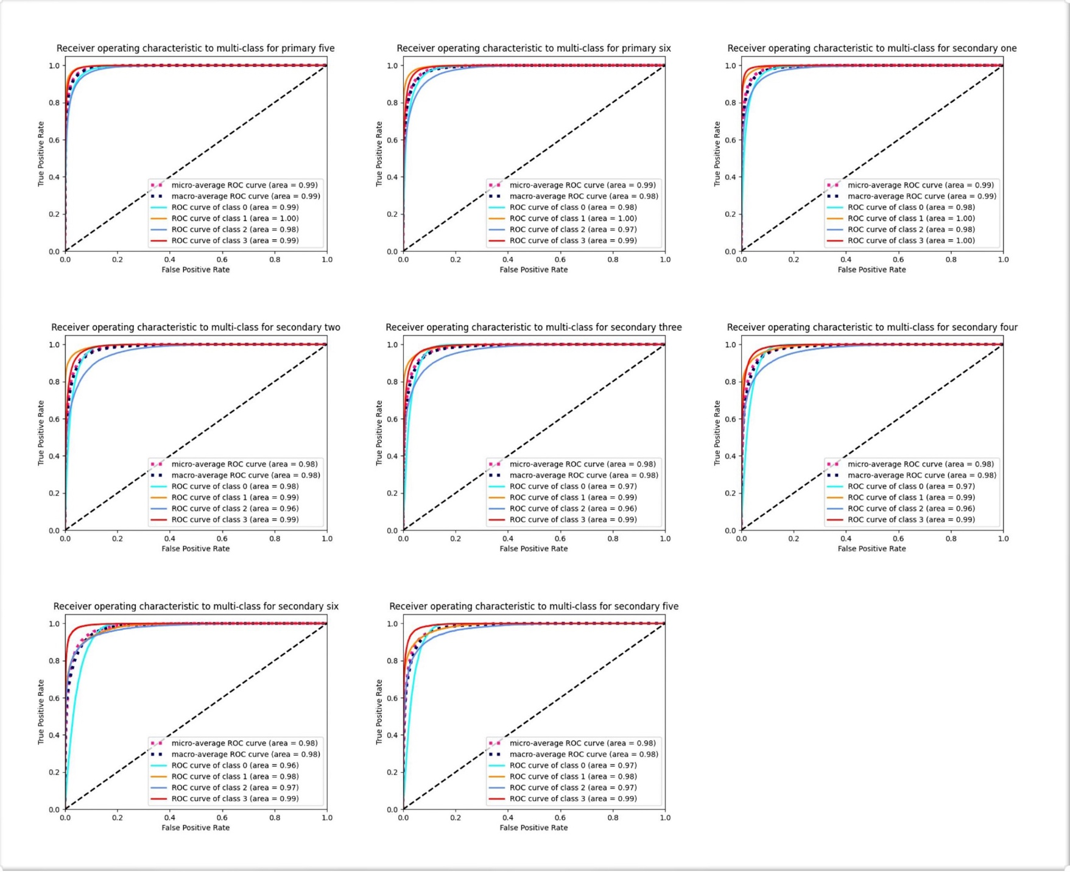
Fig. S1 Receiver operating characteristics curves for predicting a weight status based on the primary four cohort
Class 0 represents normal weight, class 1 represents underweight, class 2 represents overweight and class 3 represents obese.
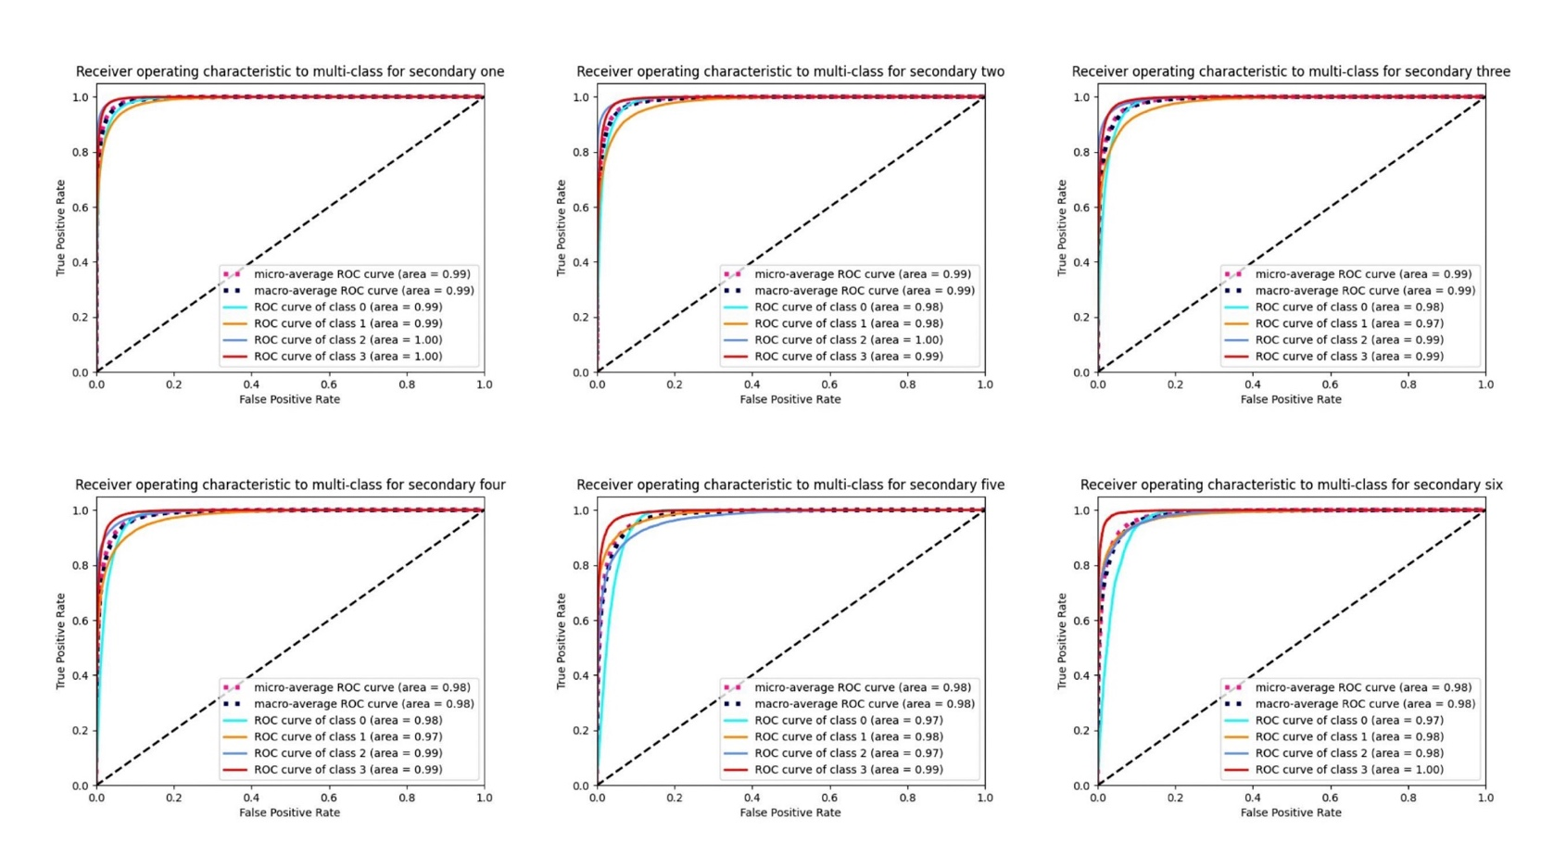
Fig. S2 Receiver operating characteristics curves for predicting a weight status based on the primary six cohort
Class 0 represents normal weight, class 1 represents underweight, class 2 represents overweight and class 3 represents obese.

