Figure S1. Conservative motifs of GbNPF
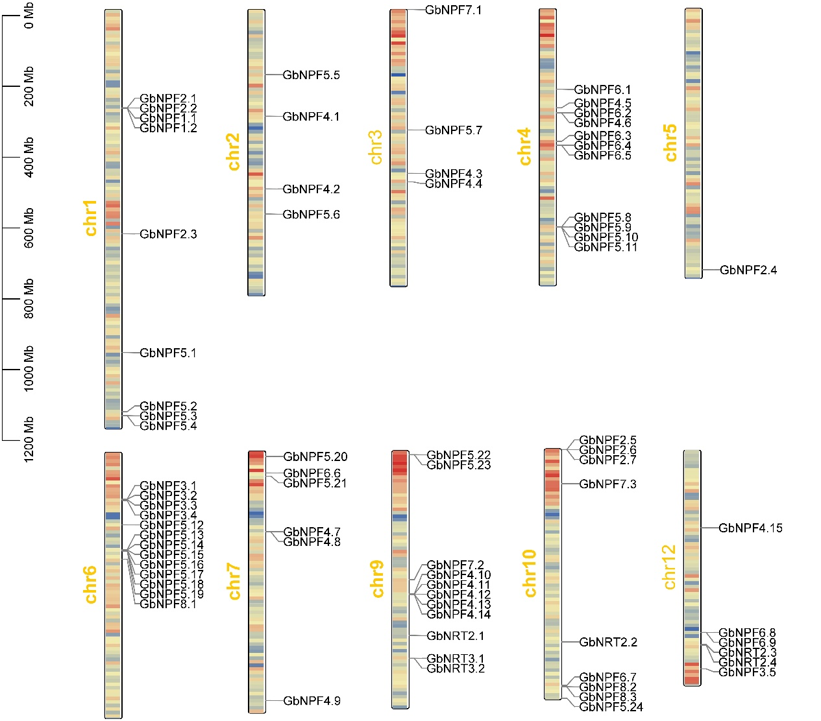

Figure S2. Chromosomal locations of GbNRTs in G. biloba genome.
The length of the chromosomes is labeled, and the density of genes on the chromosomes is calculated. With 1Mb as 1 unit length, the blue indicates that the number of genes per unit length is less, and the red indicates that there are more genes per unit length.

Figure S3. The number of gene pairs produced by different replication events of A. thaliana, P. trichocarpa and G. biloba.

