Supporting Information

Direct syntheses of stereoisomers of 3-fluoro GABA and β-fluoroamine analogues of the calcium receptor (CaR) agonists, cinacalcet, tecalcet, fendilines and NPS R-467

Yohann J. G. Renault¹ . Dr Jiayin Diao² . David B Cordes¹ . Katie Leach*^{2,3,4} . David O’Hagan*¹
¹School of Chemistry, University of St Andrews, North Haugh, St Andrews, KY16 9ST, UK.
²Drug Discovery Biology, Monash Institute of Pharmaceutical Sciences, 381 Royal Parade, Monash University, Parkville, VIC, Australia.
³Department of Pharmacology, Biomedicine Discovery Institute, Monash University, Clayton, VIC, Australia.
⁴ARC Centre for Cryo-electron Microscopy of Membrane Proteins, Monash Institute of Pharmaceutical Sciences, Monash University, Parkville, VIC, Australia.

Contents

Supporting Information 1

General 2

General procedure for α-fluorination-reductive amination protocol 3

Synthetic procedure and characterisation data 3

NMR Spectra of prepared compounds 12

Bioassay of F-cinacalcet analogues on CaSR 27

X-Ray Crystallography data 32

General

All air and moisture sensitive reactions were carried out under inert atmosphere (Argon or Nitrogen atmosphere) and oven-dried glassware. Solvents and reagents were purchased from, Alfa Aesar, TCI, Apollo, Fluorochem, Sigma-Aldrich, and used as received. Anhydrous solvents (DCM, diethyl ether, THF) were dispensed from a MBraun MB SPS-800 solvent purification system by filtration through two drying columns under an argon atmosphere. Flash column chromatography was performed using Merk Geduran silica gel 60 Å (250-400 mesh), using either manual glass columns or on Biotage Selekt 2 automatic column eluting with solvents as reported.
Melting points were recorded on an Electrothermal 9100 melting point apparatus. IR were recorded on a Shimadzu IRAffinity-1S spectrometer with a diamond ATR attachment. Spectra were recorded of either thin films or solids, with characteristic absorption wavenumbers (ν _{max}) reported in cm⁻¹.
¹H, ¹³C and ¹⁹F Nuclear Magnetic Resonance (NMR) spectra were recorded at 298 K on a Brucker Avance 400 MHz spectrometer, at ambient temperature in CDCl₃, CD₃OD or D₂O. Chemical shift (δ) are reported in parts per million (ppm), relative to the residual proton(s) of the following solvents CDCl₃ (7.26 ppm for ¹H and 77.0 ppm for ¹³C), CD₃OD (3.31 ppm for ¹H and 49.0 ppm ¹³C) or D₂O (4.79 ppm for ¹H). For ¹H and ¹³C, chemical shifts are relative to tetramethylsilane (δ = 0.00 ppm) and CFCl₃ (δ = 0.00 ppm) for ¹⁹F-NMR. NMR data were processed using MestReNova 12.0.0.
Enantiomeric excess (ee) was determined with addition of 5 to 10 equivalent of L-lactic acid to the isolated compounds sonicated with CDCl₃ in the NMR tube. Enantiomeric excess (ee) was calculated with integration of ¹⁹F{¹H}NMR signals corresponding to both enantiomers. Diastereoisomeric excess (de) was determined by integration of the 2 diastereoisomers signal by ¹⁹F{¹H}NMR.
Mass Spectrometry was performed by electrospray ionisation (ESI) on a Micromass GCT spectrometer. Results reported in m/z values and have units of Dalton (Da).
Optical rotation was performed using a Perkin Elmer Model 341 polarimeter, and values were recorded at 20°C and 589 nm using a 1 dm cell, [α]²⁰_{D} values are reported in units of 10⁻¹ deg.cm².g⁻¹.
Single crystal X-Ray analysis was carried out using a molybdenum or copper X-Ray source. The copper X-Ray source utilised an MM-007 high-brilliance generator with an AFC/Saturn 92 detector. The molybdenum source utilised an MM-007 high-brilliance generator with VariMax optics and either an AFC/Mercury or AGC/Saturne 70 detector.

General procedure for α-fluorination-reductive amination protocol

A 30% solution of either (R)-14 or (S)-14 (30%) catalyst in THF (18 mL) and i-PrOH (1.8 mL) was cooled to -10 °C. The aldehyde (1.0 equiv) was added followed by a slow addition of N-fluorobenzenesulfonimide (1.0 equiv, 0.60 mg, 2.0 mmol) in THF over 30 min and the reaction stirred for 12 h at – 10 °C and it was then cooled to -78 °C, quenched with Et₂O (15 mL) and filtered through a pad of silica gel, eluting with Et₂O. Dimethyl sulfide (1 mL) was added and the resulting mixture was washed with saturated NaHCO₃ (3 x 30 mL), brine (30 mL) and dried over MgSO₄, filtered and concentrated. The resulting fluorinated aldehyde was dissolved in DCE (22 mL), followed by addition of the amine (1.1 equiv), and then NaBH(OAc)₃ (2.0 equiv, 848 mg, 4.0 mmol) was added and the reaction stirred for 18 h at RT. The reaction was quenched with saturated NaHCO₃ (20 mL), and the product extracted into EtOAc (3 x 20 mL). The combined organic layers were dried over MgSO₄, filtered, and concentrated in vacuo.

Synthetic procedures and characterisation data

(S)-2-Amino-N-methyl-3-phenylpropanamide
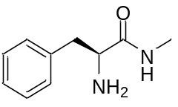

Procedure adapted from reference [1]. Ethyl (S)-2-amino-3-phenylpropionate hydrochloride salt (1.0 equiv, 2.5 g, 11 mmol) was added to a solution of methylamine in ethanol (33%) (7.0 equiv, 95 mL, 77 mmol). The mixture was stirred for 48 h at RT. The reaction mixture was concentrated in vacuo and the resulting oil was then dissolved in CHCl₃ (50 mL), washed with saturated K₂CO₃ (50 mL), extracted with CHCl₃ (3 x 50 mL) and dried over MgSO₄, filtered and concentrated in vacuo. This material was used without further purification. The desired product, was obtained as a white solid in 95% yield (1.85 g). [α]²⁰_{D} -11.5 (c 0.69, CHCl₃). IR νmax/cm⁻¹ 2822, 1735, 1498, 1228, 1228, 1209, 702. ¹H NMR (400 MHz, CDCl₃) δ 7.20 – 7.31 (m, 5H, Ph), 3.66 (dd, J = 9.5, 4.0 Hz, 1H, CH), 3.28 (dd, J = 13.7, 4.0 Hz, 1H, CH₂), 2.80 (d, J = 4.9 Hz, 1H, CH₂), 2.72 (dd, J = 13.7, 9.1 Hz, 3H, CH₃). ESI-MS calculated for C₁₁H₁₆O₂N [M+H⁺] = 194.11756, observed [M+H⁺] = 194.1167.

(R)-2-Amino-N-methyl-3-phenylpropanamide
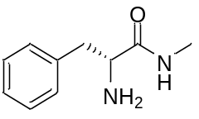

Procedure adapted from reference [1]. Ethyl (R)-2-amino-3-phenylpropionate hydrochloride salt (1.0 equiv, 2.5 g, 11 mmol) was added to a solution of methylamine in ethanol (33%) (7.0 equiv, 95 mL, 77 mmol). The mixture was stirred for 48 h at RT. The reaction mixture was concentrated in vacuo. The resulting oil was then dissolved in CHCl₃ (50 mL), washed with saturated K₂CO₃ (50 mL), and extracted with CHCl₃ (3 x 50 mL) and dried over MgSO₄, filtered and concentrated in vacuo. This material was used without further purification. The desired product, was obtained as a white solid with 93% yield (1.81 g). [α]²⁰_{D} +10.9 (c 0.81, CHCl₃). IR ν_{max}/cm⁻¹ 2825, 1738, 1453, 1233, 1224, 1213, 704. ¹H NMR (400 MHz, CDCl₃) δ 7.34 – 7.27 (m, 2H, Ph), 7.25 – 7.19 (m, 3H, Ph), 3.68 – 3.63 (m, 1H, CH-NH₂), 3.28 (dd, J = 13.7, 4.0 Hz, 1H, CH₂), 2.80 (d, J = 4.9 Hz, 3H, N-CH₃), 2.72 (dd, J = 13.7, 9.1 Hz, 1H, CH₂). ESI-MS calculated for C₁₁H₁₆O₂N [M+H⁺] = 194.11756, observed [M+H⁺] = 194.1167.

(S)-5-Benzyl-2,2,3-trimethylimidazolidin-4-one ((S)-14)
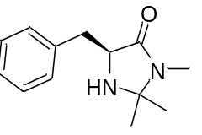

Procedure adapted from reference [2]. (S)-2-Amino-N-methyl-3-phenylpropanamide (1 equiv, 652 mg, 3.66 mmol) and p-toluenesulfonic acid (10%, 78 mg, 1.1 mmol) was added to anhydrous EtOH (80 mL) and anhydrous acetone (15 mL). The mixture was stirred for 18 h under reflux (120 °C). The reaction was then cooled down to RT and concentrated in vacuo. The crude product was purified by flash column chromatography with silica gel eluting with EtOAc/acetone (1:1). The desired product (S)-14, was obtained as a yellow oil with 85% yield (0.68 g). The compound was then moved into a salt and recrystalised in DCM/petroleum ether (1:1) to afford (S)-Cat. [α]²⁰_{D} -42.9 (c 0.92, CHCl₃). IR ν_{max}/cm⁻¹ 2988, 2361, 1720, 1651, 1591, 1427, 1369, 1240, 698. ¹H NMR (400 MHz, CDCl₃) δ 7.15 – 7.36 (m, 5H, Ph), 3.79 (dd, J = 6.6, 4.6 Hz, 1H, CH), 3.15 (dd, J = 14.2, 4.5 Hz, 1H, CH₂), 3.01 (dd, J = 14.2, 6.8 Hz, 1H, CH₂), 2.75 (d, J = 0.5 Hz, 3H, CH₃-N), 1.26 (s, 3H, CH₃), 1.16 (s, 3H, CH₃). ESI-MS calculated for C₁₃H₁₈ON₂ [M+H⁺] = 219.14919, observed [M+H⁺] = 219.1491.

(R)-5-Benzyl-2,2,3-trimethylimidazolidin-4-one ((R)-14)
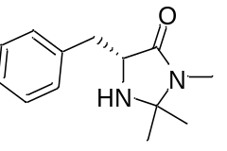

Procedure adapted from reference [2]. (R)-2-Amino-N-methyl-3-phenylpropanamide (1 equiv, 652 mg, 3.66 mmol) and p-toluenesulfonic acid (10%, 78 mg, 1.1 mmol) were added to anhydrous EtOH (80 mL) and anhydrous acetone (15 mL). The mixture was stirred for 18 h under reflux. The reaction was then cooled to RT and concentrated in vacuo. The product was purified by flash column chromatography over silica gel eluting with EtOAc/acetone (1:1). The desired product (R)-14, was obtained as a yellow oil with 95% yield (0.76 g). The compound was then converted to a salt and recrystalised in DCM/petroleum ether (1:1) to afford (R)-Cat. [α]²⁰_{D} +43.7 (c 0.70, CHCl₃). IR νmax/cm⁻¹ 2988, 2359, 1720, 1651, 1591, 1427, 1367, 1242, 698. ¹H NMR (400 MHz, CDCl₃) δ 7.35 – 7.26 (m, 4H, Ph), 7.25 – 7.23 (m, 1H, Ph), 4.17 – 4.12 (m, 1H, CH-C=O), 3.26 (d, J = 5.7 Hz, 2H, CH₂), 2.79 (d, J = 0.7 Hz, 3H, N-CH₃), 1.44 (s, 3H, CH₃), 1.29 (s, 3H, CH₃). ESI-MS calculated for C₁₃H₁₈ON₂ [M+H⁺] = 219.14919, observed [M+H⁺] = 219.1494.

Benzyl pent-4-enoate (11)
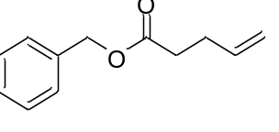

Procedure adapted from reference [3]. To a round-bottom flask, equipped with a magnetic stir bar and a Dean Stark apparatus, and charged with pent-4-enoic acid (1.0 equiv, 1.02 mL, 10 mmol), p-toluenesulfonic acid (10%, 190 mg, 1 mmol) and benzyl alcohol (1.5 equiv, 1.55 mL, 15 mmol) was added toluene (30 mL). The mixture was stirred up to full water collection under reflux (180 °C). The reaction was cooled down to RT and concentrated in vacuo. The crude product was purified by flash column chromatography with silica gel eluting with hexane/EtOAc (3:7). The desired product 11, was obtained as a yellow oil with 74% yield (1.90 g). IR ν_{max}/cm⁻¹ 3034, 2358, 1734, 1159, 696. ¹H NMR (400 MHz, CDCl₃) δ 7.30 – 7.41 (m, 5H, Ph), 5.76 – 5.89 (m, 1H, CH), 5.12 (s, 2H, CH₂-Ph), 4.97 – 5.10 (m, 2H, =CH₂), 2.35 – 2.51 (m, 4H, CH₂). ¹³C NMR (101 MHz, CDCl₃) δ 173.03 (C=O), 136.73 (CH=), 128.7 (C_{Arom}), 128.5 (C_{Arom}), 128.4 (C_{Arom}), 127.9 (C_{Arom}), 127.8 (C_{Arom}), 115.7 (CH₂=), 66.4 (CH₂-O), 33.7 (CH₂), 29.0(CH₂). ESI-MS calculated for C₁₂H₁₄O₂ [M+H⁺] = 190.09883, observed [M+H⁺] = 190.099189.

Benzyl 4-oxobutanoate (12)
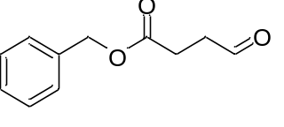

Procedure adapted from reference [4]. Ozone was bubbled through a solution of benzyl 4-pentenoate 11 (1.0 equiv, 461 mg, 2.47 mmol) in DCM (25 mL) at -78 °C until the solution became blue. NEt₃ (0.7 mL) was added to the reaction and warmed to RT. The mixture was washed with HCl (1M, 2.25 mL), NaHCO₃ (5%, 1.15 mL) and dried over MgSO₄, filtered, and concentrated in vacuo. The desired product 12, was obtained in a yield of 90% (427 mg). IR ν_{max}/cm⁻¹ 2927, 1726, 1683, 1257, 1170, 941, 696. ¹H NMR (400 MHz, CDCl₃) δ 9.82 (s, 1H, CHO), 7.33 – 7.38 (m, 5H, Ph), 5.13 (s, 2H, OCH₂), 2.75 (m, 4H, CH₂). ¹³C NMR (101 MHz, CDCl₃) δ 200.2 (C=O_{Aldehyde}), 172.1 (CO₂), 135.8 (C_{Arom}), 128.7 (C_{Arom}), 128.5 (C_{Arom}), 128.5 (C_{Arom}), 128.4 (C_{Arom}), 128.4 (C_{Arom}), 128.4 (C_{Arom}), 128.4 (C_{Arom}), 128.3 (C_{Arom}), 127.9 (C_{Arom}), 66.8 (CH₂-O), 38.6 (CH₂-CHO), 29.0 (CH₂). ESI-MS calculated for C₁₁H₁₂O₃ [M+H⁺] = 192.07810, observed [M+H⁺] = 192.078895.

Benzyl (S)-4-(dibenzylamino)-3-fluorobutanoate (13)
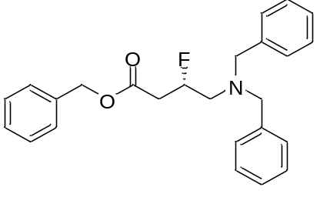

Prepared with (S)-14 according to the general procedure from benzyl 4-oxobutanoate (1.0 equiv, 769 mg, 4.0 mmol) as aldehyde, and dibenzylamine (1.1 equiv, 560 μL, 4.4 mmol) as the amine. The product was purified by flash column chromatography with silica gel eluting with hexane/DCM. The desired product (S)-216 was obtained as a yellow oil with 52% yield (814 mg, ee 78%). [α]²⁰_{D} -1.02 (c 2.1, CHCl₃). IR ν_{max}/cm⁻¹ 3030, 2802, 2360, 1735, 1170, 736, 696. ¹H NMR (400 MHz, CDCl₃) δ 7.54 – 7.09 (m, 15H, Ph), 5.25 – 5.13 (m, 1H), 5.18 (s, 2H, O-CH₂-benzyl), 3.73 (qd, J = 13.7, 2.9 Hz, 4H, N-CH₂-benzyl), 2.79 (dddt, J = 31.4, 20.8, 7.2, 4.3 Hz, 4H, CH₂). ¹³C NMR (101 MHz, CDCl₃) δ 139.1 (C=O), 129.0 (C_{Arom}), 128.7 (C_{Arom}), 128.3 (C_{Arom}), 127.2 (C_{Arom}), 89.5 (d, J = 175.6 Hz), 66.6 (CH₂O), 59.2 (CH₂-PH), 56.0 (d, J = 19.5 Hz, CH₂), 38.5 (d, J = 28.4 Hz, CH₂). ¹⁹F NMR (376 MHz, CDCl₃) δ -181.4. ESI-MS calculated for C₂₅H₂₆O₂NF [MH⁺] = 392.2026, observed [MH⁺] = 392.2020.

(S)-4-Amino-3-fluorobutanoic acid (3-F-GABA, 8) [5]
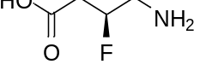

Benzyl (S)-4-(dibenzylamino)-3-fluorobutanoate 13 (1.0 equiv, 65 mg, 0.16 mmol) and Pd(OH)₂/C 20 wt.% (2.8%, 20mg, 0.005 mmol) were added to MeOH (5 mL) under an inert atmosphere. The mixture was stirred for 46 h at RT under a H₂ atmosphere (1 atm). The reaction was filtered through a pad of Celite® and concentrated in vacuo. The resulting mixture was dissolved in water (5 mL) and washed with Et₂O (5 mL). This was purified by reverse phase column chromatography on silica gel (C₁₈) eluting with water. The desired product 8 was obtained as a white solid with a 90% yield (18 mg, ee 78%). ¹H NMR (400 MHz, D₂O) δ 5.05 – 5.30 (m, 1H, CHF), 3.18 – 3.40 (m, 2H, CH₂), 2.47 – 2.72 (m, 2H, CH₂). ¹³C NMR (101 MHz, D₂O) δ 129.7 (CO₂), 129.5(CO₂), 88.9 (CHF), 87.3 (d, J = 171.5, CHF), 51.3 (d, J = 20.6 Hz, N-CH₂), 47.6 (d, J = 22.4 Hz, CH2-CO2). ¹⁹F NMR (376 MHz, D₂O) δ -185.6.

(^{F}S,R)-F-Cinacalcet (20)
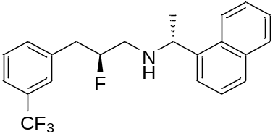

Prepared with (S)-14 according to the general procedure from 3-(trifluoromethyl)benzenepropanal 19 (1.0 equiv, 340 μL, 2.0 mmol) as the aldehyde, and (R)-(1-naphthyl)ethylamine (1.1 equiv, 350 μL, 2.2 mmol) as the amine. The crude product was purified by flash column chromatography on silica gel eluting with hexane/EtOAc. The desired product 20 was obtained as a yellow oil with 28% yield (199 mg, de 98%). [α]²⁰_{D} -47.0 (c 0.54, CHCl₃). IR νmax/cm⁻¹ 2957, 2684, 1585, 1452, 1329, 1161, 1120, 1072, 800, 779. 1H NMR (400 MHz, MeOD) δ 7.22 – 8.15 (m, 10H, Ph), 4.69 – 4.87 (m, 1H, CHF), 4.66 (q, J = 6.7 Hz, 1H, N-CH), 2.62 – 2.96 (m, 4H, CH₂), 1.47 (d, J = 6.7 Hz, 3H, CH₃). ¹³C NMR (101 MHz, MeOD) δ 132.9 (C_{Arom}), 129.6 (C_{Arom}), 129.0 (C_{Arom}), 127.2 (C_{Arom}), 126.2 (C_{Arom}), 125.2 (C_{Arom}), 121.5 (C_{Arom}), 89.8 (d, J = 173.0 Hz, CHF), 53.25 (CH-N), 48.9 (d, J = 20.6 Hz, CH₂), 37.7 (d, J = 19.2 Hz, CH₂), 18.91 (CH₃). ¹⁹F NMR (377 MHz, MeOD) δ -63.9 (CF₃), -186.2 (CHF). ESI-MS calculated for C₂₂H₂₁NF [M+H⁺] = 376.1688, observed [M+H⁺] = 376.1678.

(^{F}R,R)-F-Cinacalcet (21)
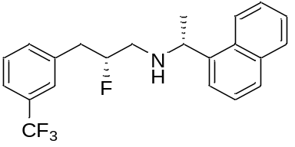

Prepared with (R)-14 according to the general procedure from 3-(trifluoromethyl)benzenepropanal 19 (1.0 equiv, 340 μL, 2.0 mmol) as the aldehyde, and (R)-(1-naphthyl)ethylamine (1.1 equiv, 350 μL, 2.2 mmol) as the amine. The crude product was purified by flash column chromatography on silica gel eluting with hexane/EtOAc. The desired product 21 was obtained as a yellow oil with 50% yield (355 mg, de 98%). [α]²⁰_{D} -15.4 (c 0.37, CHCl₃). IR νmax/cm⁻¹ 2957, 2679, 1454, 1327, 1161, 1119, 1072, 800, 777. ¹H NMR (400 MHz, MeOD) δ 7.82 – 7.88 (m, 1H, Ph), 7.74 (d, J = 8.2 Hz, 1H, Ph), 7.62 (d, J = 7.2 Hz, 1H, Ph), 7.28 – 7.53 (m, 8H, Ph), 8.17 (d, J = 8.4 Hz, 1H, Ph), 4.64 – 4.86 (m, 2H, CHF, N-CH), 2.57 – 3.01 (m, 4H, CH₂), 1.47 (d, J = 6.6 Hz, 3H, CH₃). ¹³C NMR (101 MHz, MeOD) δ 132.9 (C_{Arom}), 129.63, 129.0 (C_{Arom}), 128.9 (C_{Arom}), 127.1 (C_{Arom}), 126.2 (C_{Arom}), 125.2 (C_{Arom}), 123.5 (C_{Arom}), 121.7 (C_{Arom}), 89.9 (d, J = 176.6 Hz, CHF), 53.31 (CH-N), 49.0 (d, J = 18.1 Hz, CH₂), 37.7 (d, J = 18.6 Hz, CH₂), 18.58 (CH₃). ¹⁹F NMR (376 MHz, MeOD) δ -64.1, -185.9. ESI-MS calculated for C₂₂H₂₁NF [M+H⁺] = 376.1688, observed [M+H⁺] = 376.1679.

3,3-Diphenylpropanal (26) [6]
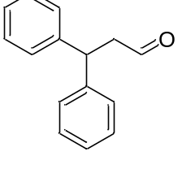

A suspension of NaHCO₃ (4.5 equiv, 1.89 g, 22.5 mmol) and Dess-Martin periodinane (1.5 equiv, 3.2 g, 7.5 mmol) in DCM (100 mL) was cooled to 0 °C, and then 3,3-diphenyl-1-propanol 275 (1.0 equiv, 1 mL, 5 mmol) was added and the reaction mixture was stirred for 1 h at 0 °C. The reaction was warmed to rt and and washed with saturated K₂CO₃ (50 mL) and then saturated NaHCO₃ (50 mL). The aqueous layer was extracted with EtOAc (3 x 70 mL), and the combined organic layers were dried over MgSO₄, filtered, and concentrated in vacuo. This material was used without further purification. The product 276, was obtained as a yellow oil in 70% yield (736 mg). IR ν_{max}/cm⁻¹ 2918, 2358, 1697, 1454, 987, 758, 746, 692. ¹H NMR (400 MHz, CDCl₃) δ 1.37 (t, J = 6.9 Hz, 1H, CH), 3.20 (dd, J = 7.8, 1.9 Hz, 2H, CH₂), 7.41 – 7.09 (m, 10H, Ph), 9.76 (s, 1H, CHO). ESI-MS calculated for C₁₅H₁₅O [M+H⁺] = 211.11174, observed [M+H⁺] = 211.1116.

(^{F}S,R)-F-Fendiline (27)

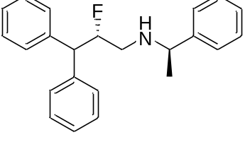

Prepared with (S)-14 according to the general procedure from 3,3-diphenylpropanal 26 (1.0 equiv, 421 mg, 2.0 mmol) as the aldehyde, and (R)-α-methylbenzylamine (1.1 equiv, 280 μL, 2.2 mmol) as the amine. The crude product was purified by flash column chromatography on silica gel eluting with hexane/EtOAc. The desired product 27 was obtained as a yellow oil with 56% yield (373 mg, de 80%). [α]²⁰_{D} +17.2 (c 0.57, CHCl₃). IR νmax/cm⁻¹ 2959, 2747, 1578, 1452, 1082, 1029, 762, 738, 698. ¹H NMR (400 MHz, MeOD) δ 7.46 – 7.35 (m, 5H, Ph), 7.34 – 7.17 (m, 10H, Ph), 5.68 – 5.49 (m, 1H, CHF), 4.41 (q, J = 6.9 Hz, 1H, CH), 4.20 (dd, J = 16.9, 8.2 Hz, 1H, N-CH), 3.02 – 2.92 (m, 2H, CH₂), 1.63 (d, J = 6.9 Hz, 3H, CH₃). ¹³C NMR (101 MHz, MeOD) δ 129.3 (C_{Arom}), 129.2 (C_{Arom}), 128.7 (C_{Arom}), 128.2 (C_{Arom}), 127.8 (C_{Arom}), 127.1 (C_{Arom}), 126.8 (C_{Arom}), 90.2 (d, J = 183.5 Hz, CHF), 58.1 (CH-N), 53.5 (d, J = 19.5 Hz, CH₂), 18.7 (CH₃). ¹⁹F NMR (376 MHz, MeOD) δ -189.9. ESI-MS calculated for C₂₃H₂₄NF [M+H⁺] = 334.1971, observed [M+H⁺] = 334.1956.

(^{F}R,R)-F-Fendiline (28)

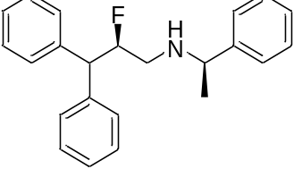

Prepared with (R)-14 according to the general procedure from 3,3-diphenylpropanal 26 (1.0 equiv, 421 mg, 2.0 mmol), and (R)-α-methylbenzylamine (1.1 equiv, 280 μL, 2.2 mmol). The product was purified by flash column chromatography on silica gel eluting with hexane/EtOAc. The desired product 28 was obtained as a yellow oil with 50% yield (333 mg, de 90%). [α]²⁰_{D} +20.7 (c 0.45, CHCl₃). IR νmax/cm⁻¹ 2974, 2747, 1577, 1452, 1082, 1029, 764, 739, 698. ¹H NMR (400 MHz, MeOD) δ 7.52 – 7.40 (m, 7H, Ph), 7.38 – 7.18 (m, 9H, Ph), 5.51 (dt, J = 50.0, 7.9 Hz, 1H, CHF), 4.44 (m, 1H, CH), 4.24 (dd, J = 18.4, 7.8 Hz, 1H, N-CH), 3.26 (dt, J = 13.8, 10.8 Hz, 1H, CH₂), 2.92 (ddd, J = 35.8, 13.8, 1.9 Hz, 1H, CH₂), 1.67 (t, J = 7.1 Hz, 3H, CH₃). ¹³C NMR (101 MHz, MeOD) δ 129.4 (C_{Arom}), 129.2 (C_{Arom}), 128.6 (C_{Arom}), 128.3 (C_{Arom}), 128.3 (C_{Arom}), 127.7 (C_{Arom}), 127.3 (C_{Arom}), 127.1 (C_{Arom}), 126.9 (C_{Arom}), 90.7(d, J = 179.1 Hz, CHF), 58.8 (CH-N), 53.5 (d, J = 21.1 Hz, CH₂), 17.98 (CH₃). ¹⁹F NMR (377 MHz, MeOD) δ -189.8. ESI-MS calculated for C₂₃H₂₄NF [MH⁺] = 334.1971, observed [MH⁺] = 334.1957.

Methyl 3-(2-chlorophenyl)propanoate (22)
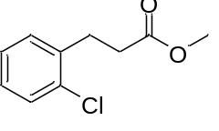

Procedure adapted from reference [7]. Thionyl chloride (0.36 equiv, 0.9 mL, 12 mmol) was added to solution of 3-(2-chlorophenyl)propionic acid (1.0 equiv, 6.2 g, 34 mmol) in MeOH (60 mL). The mixture was stirred for 2 h under reflux before the addition of further thionyl chloride (0.36 equiv, 0.9 mL, 12 mmol). The reaction was then stirred for a further 2 h under reflux. The reaction was cooled to rt and concentrated in vacuo. The resulting oil was dissolved in DCM (60 mL) and washed with saturated NaHCO₃ (60 mL). The organic layer was dried over MgSO₄, filtered, and concentrated in vacuo. The desired product 22, was obtained as a yellow oil with 99% yield (6.60 g). IR νmax/cm⁻¹ 2951, 1734, 1436, 1157, 1053, 750. ¹H NMR (400 MHz, CDCl₃) δ 2.66 (dd, J = 8.4, 7.2 Hz, 2H, CH₂), 3.07 (dd, J = 8.4, 7.2 Hz, 2H, CH₂), 3.68 (s, 3H, O-CH₃), 7.11 – 7.39 (m, 4H, Ph). ¹³C NMR (101 MHz, CDCl₃) δ 173.3 (CO₂), 138.1 (C_{Arom}), 130.6 (C_{Arom}), 129.7 (C_{Arom}), 128.0 (C_{Arom}), 127.1 (C_{Arom}), 51.82 (OCH₃), 33.9 (CH₂), 29.1 (CH₂). ESI-MS calculated for C₁₀H₁₂O₂Cl [M+H⁺] = 199.05203, observed [M+H⁺] = 199.0520.

3-(2-Chlorophenyl)propanal (23)
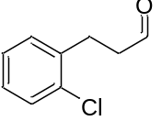

Procedure adapted from reference [8]. Diisobutylaluminum hydride solution (1.0 M in hexane, 9.4 mL, 9.4 mmol) was added dropwise to a solution of methyl 3-(2-bromophenyl)propanoate 22 (1.0 equiv, 8.25 mmol) in anhydrous Et₂O (82.5 mL) and cooled to -78 °C. The reaction was stirred for 1 h at – 78 °C and was then quenched by the addition of water (1.22 mL). The mixture was warmed to ambient and dried over MgSO₄, filtered and concentrated in vacuo. The desired product 23, was obtained as a yellow oil in 80% yield (1.11 g). ¹H NMR (400 MHz, CDCl₃) δ 2.79 (td, J = 7.6, 1.4 Hz, 2H, CH₂), 3.05 (t, J = 7.5 Hz, 2H, CH₂), 7.04 – 7.40 (m, 4H, Ph), 9.82 (s, 1H, CHO).

(^{F}S,R)-F-Tecalcet (24)
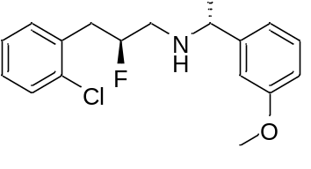

Prepared with (S)-14 according to the general procedure from 3-(2-chlorophenyl)propanal 23 (1.0 equiv, 337 mg, 2.0 mmol) as the aldehyde, and (R)-3-methoxy-α-methylbenzylamine (1.1 equiv, 365 μL, 2.2 mmol) as the amine. The product was purified by flash column chromatography on silica gel eluting with hexane/EtOAc and was obtained as a yellow oil in 54% yield (347 mg, de 86%). [α]²⁰_{D} +22.6 (c 0.67, CHCl₃). IR νmax/cm⁻¹ 2965, 2621, 1595, 1469, 1255, 1055, 1036, 860, 799, 752, 704. ¹H NMR (400 MHz, MeOD) δ 7.44 – 7.34 (m, 2H, Ph), 7.33 – 7.24 (m, 3H, Ph), 7.06 – 6.97 (m, 3H, Ph), 5.23 – 4.99 (m, 1H, CHF), 4.35 (q, J = 6.5 Hz, 1H, CH-N), 3.85 (s, 3H, O-CH₃), 3.21 – 2.93 (m, 4H, CH₂), 1.65 (dd, J = 6.8, 2.7 Hz, 3H, CH₃). ¹³C NMR (101 MHz, MeOD) δ 131.7 (C_{Arom}), 130.2 (C_{Arom}), 129.3 (C_{Arom}), 128.7 (C_{Arom}), 126.9 (C_{Arom}), 119.1 (C_{Arom}), 114.3 (C_{Arom}), 112.8 (C_{Arom}), 88.8 (d, J = 174.7 Hz, CHF), 58.3 (CH-N), 54.4 (CH₃-O), 48.8 (d, J = 17.8 Hz, CH₂), 36.0 (d, J = 19.9 Hz, CH₂), 19.1 (CH₃). ¹⁹F NMR (377 MHz, MeOD) δ -186.8. ESI-MS calculated for C₁₈H₂₁ONClF [MH⁺] = 322.1374, observed [MH⁺] = 322.1365.

(^{F}R,R)-F-Tecalcet (25)
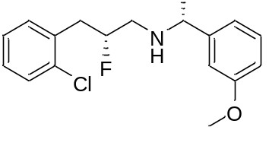

Prepared with (R)-14 according to the general procedure from 3-(2-chlorophenyl)propanal 23 (1.0 equiv, 337 mg, 2.0 mmol) as the aldehyde, and (R)-3-methoxy-α-methylbenzylamine (1.1 equiv, 365 μL, 2.2 mmol)as the amine. The product was purified by flash column chromatography on silica gel eluting with hexane/EtOAc and was obtained as a yellow oil in56% yield (360 mg, de 86%). [α]²⁰_{D} -27.4 (c 0.50, CHCl₃). IR νmax/cm⁻¹ 2943, 2648, 1585, 1489, 1259, 1049, 786, 746, 704. ¹H NMR (400 MHz, MeOD) δ 7.44 – 7.34 (m, 3H), 7.34 – 7.15 (m, 6H), 7.07 – 7.00 (m, 3H), 5.07 – 4.87 (m, 1H, CHF), 3.84 (s, 3H, O-CH₃), 3.61 (t, J = 6.5 Hz, 1H, CH-N), 3.23 – 2.95 (m, 2H, CH₂), 2.90 – 2.78 (m, 2H, CH₂), 1.70 (d, J = 6.8 Hz, 3H, CH₃). ¹³C NMR (101 MHz, MeOD) δ 131.7 (C_{Arom}), 130.4 (C_{Arom}), 129.3 (C_{Arom}), 129.0 (C_{Arom}), 128.8 (C_{Arom}), 127.4 (C_{Arom}), 127.2 (C_{Arom}), 126.9 (C_{Arom}), 126.7 (C_{Arom}), 119.2 (C_{Arom}), 114.7 (C_{Arom}), 113.1 (C_{Arom}), 88.8 (d, J = 176.9 Hz, CHF) , 59.00 (N-CH), 54.5 (O-CH₃), 48.7 (d, J = 12.2 Hz, CH₂), 35.8 (d, J = 16.9 Hz, CH₂), 32.3, 29.5, 17.9 (CH₃). ¹⁹F NMR (377 MHz, MeOD) δ -186.4. ESI-MS calculated for C₁₈H₂₁ONClF [M+H⁺] = 322.1374, observed [M+H⁺] = 322.1366.

(^{F}S,R)-F-NPS R-467 (30)

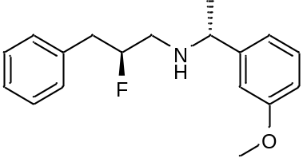

Prepared with (S)-14 according to the general procedure from 3-phenylpropanal 29 (1.0 equiv, 266 μL, 2.0 mmol) as the aldehyde, and (R)-3-methoxy-α-methylbenzylamine (1.1 equiv, 365 μL, 2.2 mmol) as the amine. The product was purified by flash column chromatography on silica gel eluting with hexane/EtOAc and was obtained as a yellow oil with 47% yield (270 mg, de 70%). [α]²⁰_{D} +28.9 (c 0.23, CHCl₃). IR νmax/cm⁻¹ 2972, 2746, 1577, 1496, 1452, 1056, 1029, 738, 698. ¹H NMR (400 MHz, MeOD) δ 7.39 (t, J = 7.9 Hz, 1H, Ph), 7.34 – 7.16 (m, 4H, Ph), 7.09 – 6.97 (m, 3H, Ph), 5.08 (d, J = 50.9 Hz, 1H, CHF), 4.49 – 4.34 (m, 1H, N-CH), 3.84 (d, J = 1.7 Hz, 3H, O-CH₃), 3.28 – 2.87 (m, 4H, CH₂), 1.76 – 1.60 (m, 3H, CH₃). ¹³C NMR (101 MHz, MeOD) δ 130.4 (C_{Arom}), 129.0 (C_{Arom}), 128.3 (C_{Arom}), 126.8 (C_{Arom}), 119.1 (C_{Arom}), 114.7 (C_{Arom}), 112.9 (C_{Arom}), 89.7 (d, J = 168.5 Hz, CHF), 58.5 (N-CH), 54.5 (O-CH₃), 48.5 (d, J = 21.2 Hz, CH₂), 38.1 (d, J = 17.6 Hz, CH₂), 18.4 (CH₃). ¹⁹F NMR (377 MHz, MeOD) δ -186.3. ESI-MS calculated for C₁₈H₂₂ONF [M+H⁺] = 288.1764, observed [M+H⁺] = 288.1757.

(^{F}R,R)-F-NPS R-467 (31)

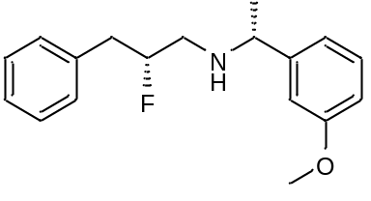

Prepared with (R)-14 according to the general procedure from 3-phenylpropanal 29 (1.0 equiv, 266 μL, 2.0 mmol) as the aldehyde, and (R)-3-methoxy-α-methylbenzylamine (1.1 equiv, 365 μL, 2.2 mmol) as the amine. The product was purified by flash column chromatography on silica gel eluting with hexane/EtOAc and was obtained as a yellow oil with 62% yield (356 mg, de 68%). [α]²⁰_{D} +42.6 (c 0.96, CHCl₃). IR νmax/cm⁻¹ 2968, 2731, 1583, 1490, 1454, 1259, 1049, 786, 698. ¹H NMR (400 MHz, MeOD) δ 7.40 – 7.34 (m, 1H, Ph), 7.33 – 7.18 (m, 6H, Ph), 7.04 – 6.94 (m, 3H, Ph), 4.87 – 4.77 (m, 1H, CHF), 4.27 (q, J = 6.8 Hz, 1H, CH-N), 3.83 (d, J = 2.2 Hz, 3H, O-CH₃), 3.15 (td, J = 13.3, 9.7 Hz, 1H, CH₂), 3.04 – 2.85 (m, 3H, CH₂), 1.62 (d, J = 6.8 Hz, 3H, CH₃). ¹³C NMR (101 MHz, MeOD) δ 130.1 (C_{Arom}), 129.0 1 (C_{Arom}), 128.2 1 (C_{Arom}), 126.7 1 (C_{Arom}), 119.1 1 (C_{Arom}), 114.2 1 (C_{Arom}), 112.8 1 (C_{Arom}), 90.8 (d, J = 174.5 Hz, CHF), 58.7 (CH-N), 54.4 (O-CH₃), 49.0 (d, J = 20.0 Hz, CH₂), 38.4 (d, J = 20.0 Hz, CH₂), 18.9 (CH₃). ¹⁹F NMR (377 MHz, MeOD) δ -185.9. ESI-MS calculated for C₁₈H₂₂ONF [M+H⁺] = 288.1764, observed [M+H⁺] = 288.1756.

NMR Spectra

Benzyl (S)-4-(dibenzylamino)-3-fluorobutanoate (13)
¹H NMR (400 MHz, CDCl₃)
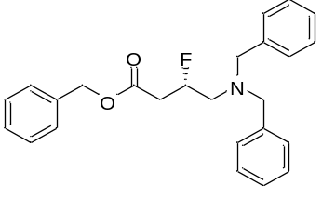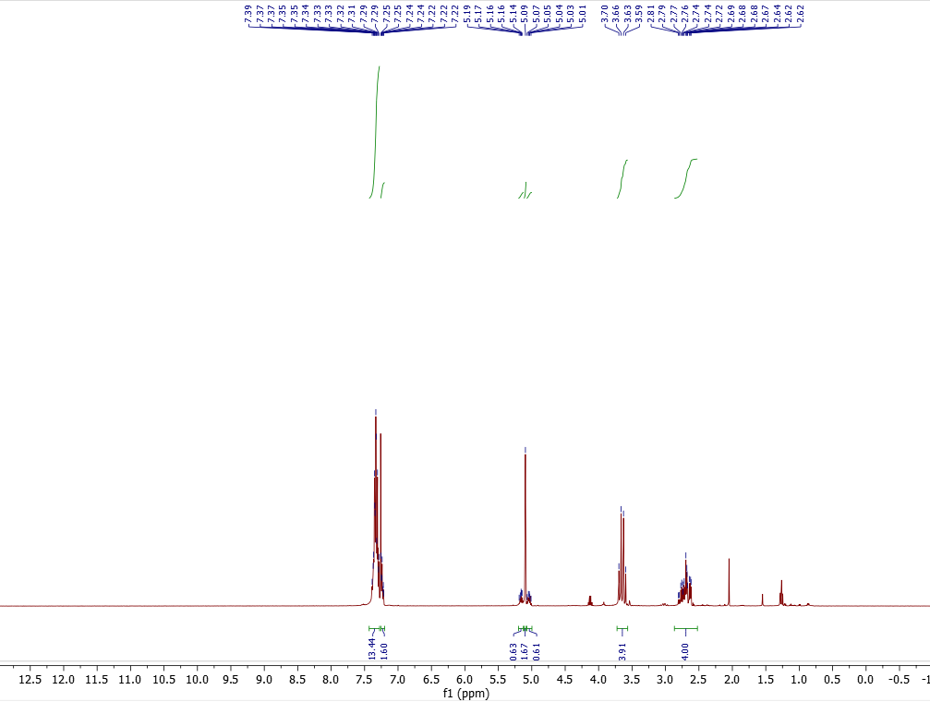

¹³C NMR (101 MHz, CDCl₃)
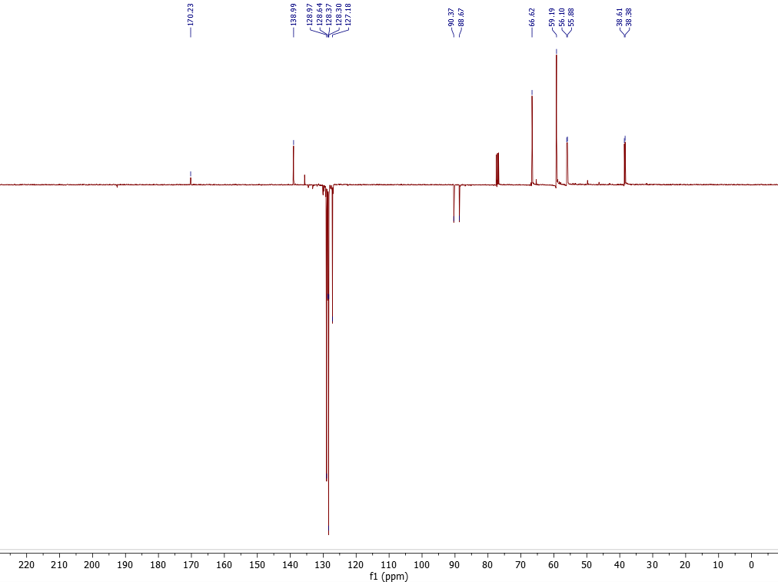
¹⁹F NMR (377 MHz, CDCl₃)
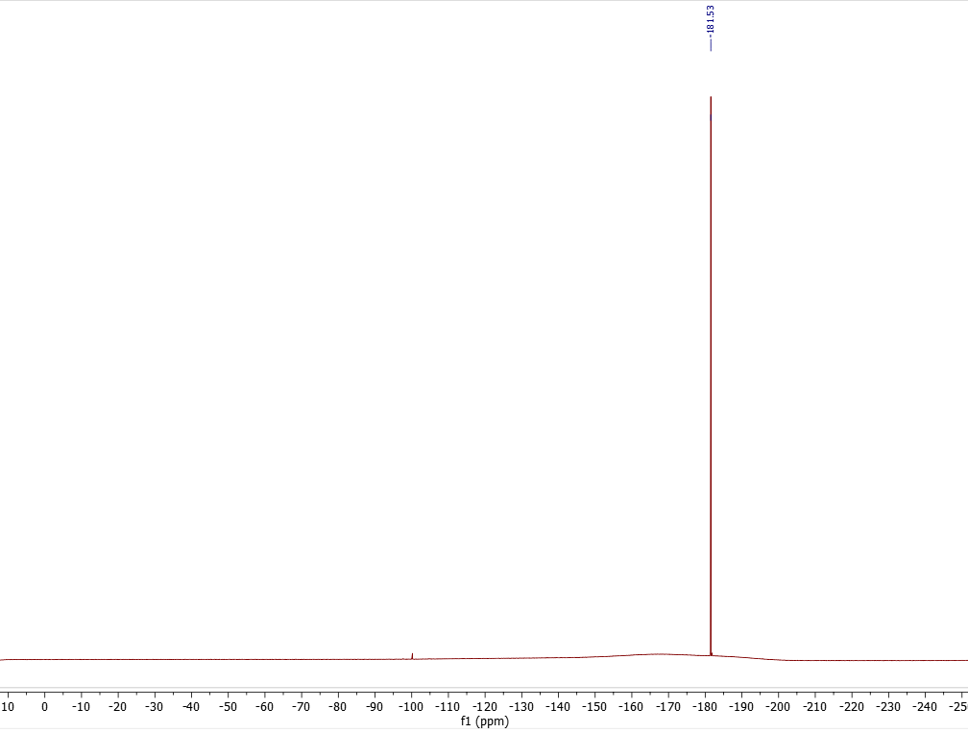

(S)-4-Amino-3-fluorobutanoic acid (3-F-GABA, 8)

¹H NMR (400 MHz, D₂O)
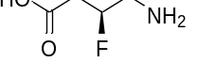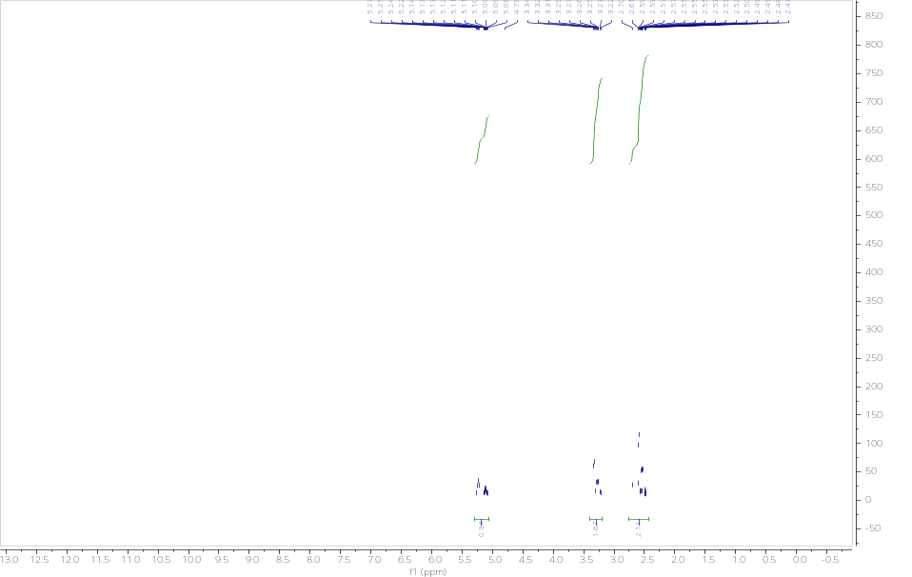

¹⁹F NMR (377 MHz, D₂O)
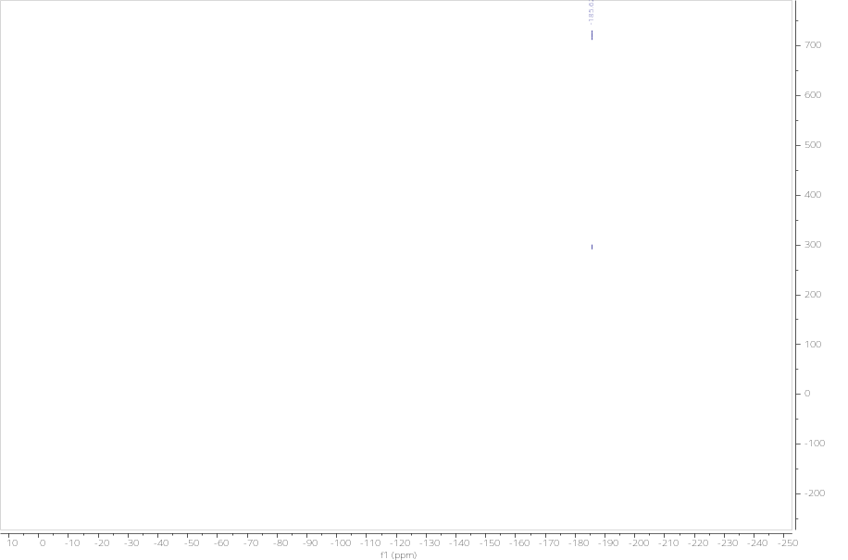

(^{F}S,R)-F-Cinacalcet (20)

¹H NMR (400 MHz, MeOD)

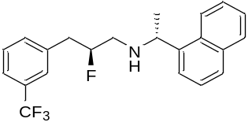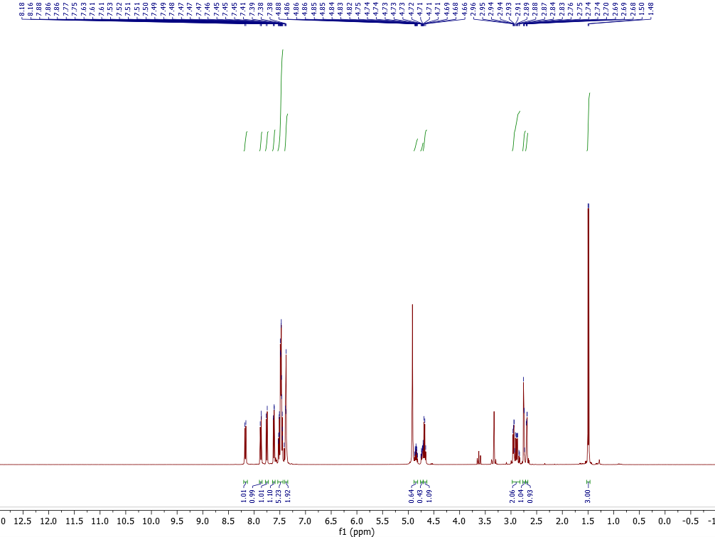

¹³C NMR (101 MHz, MeOD)
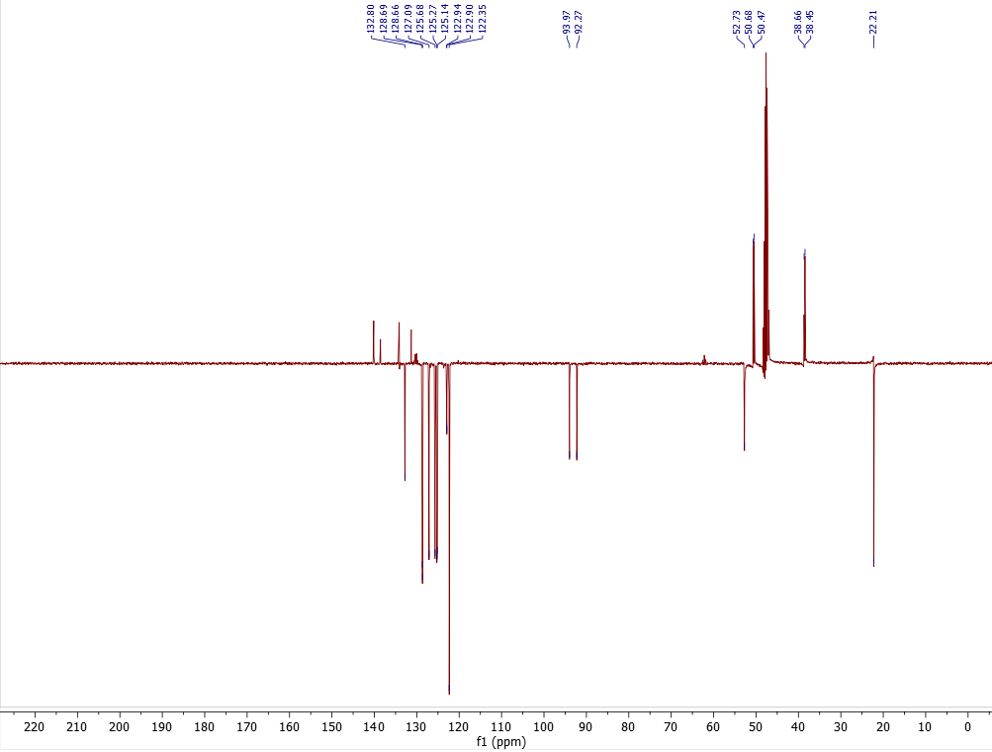
¹⁹F NMR (377 MHz, MeOD)

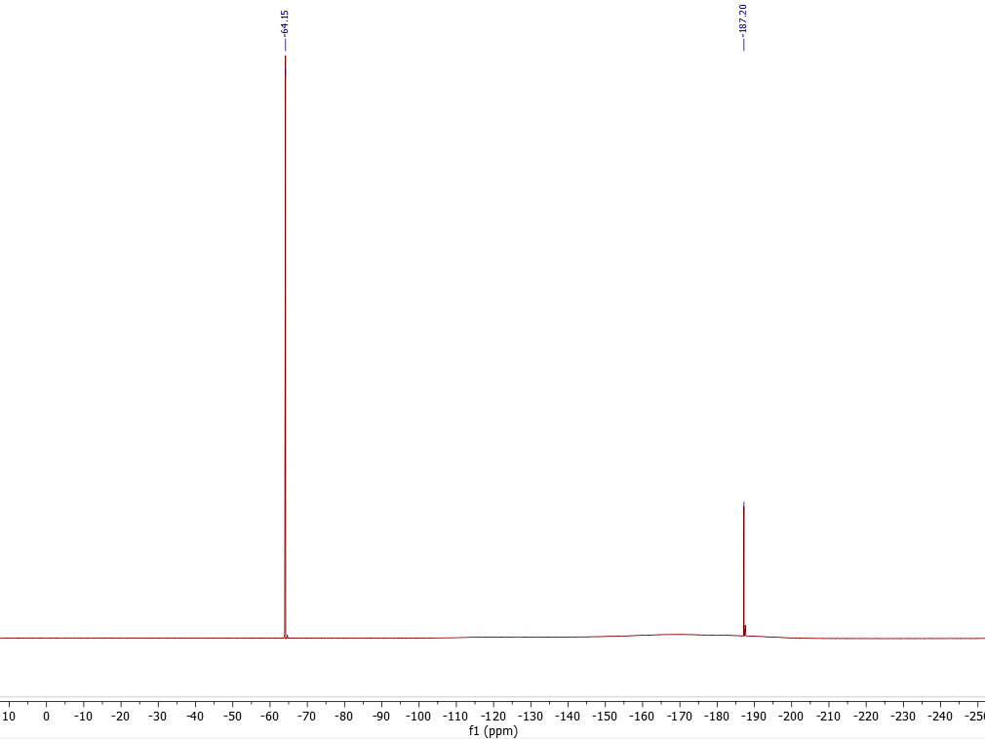

(^{F}R,R)-F-Cinacalcet (21)

¹H NMR (400 MHz, MeOD)
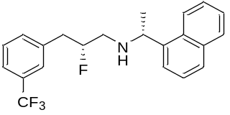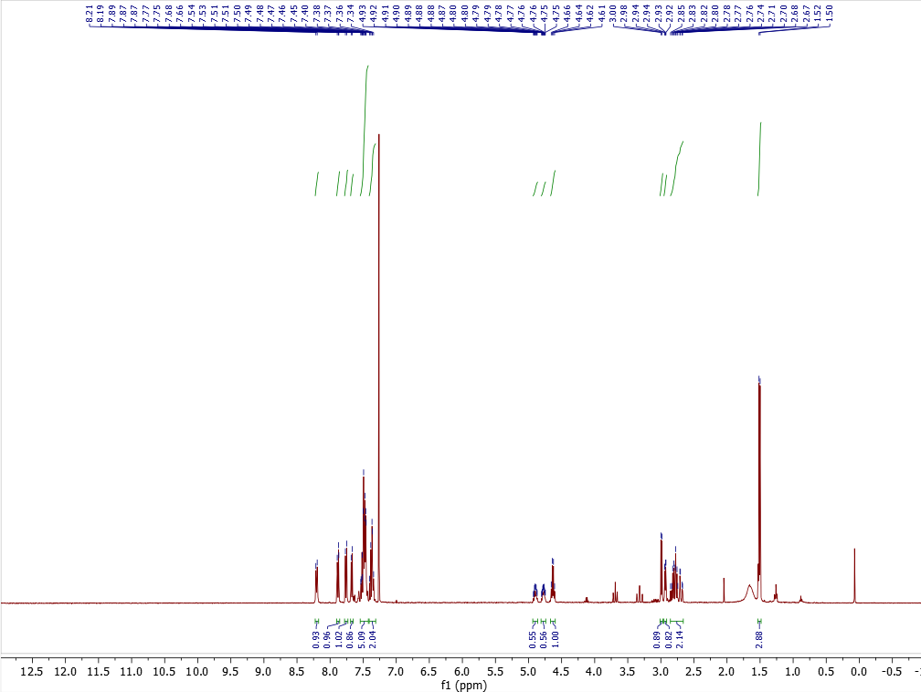
¹³C NMR (101 MHz, MeOD)
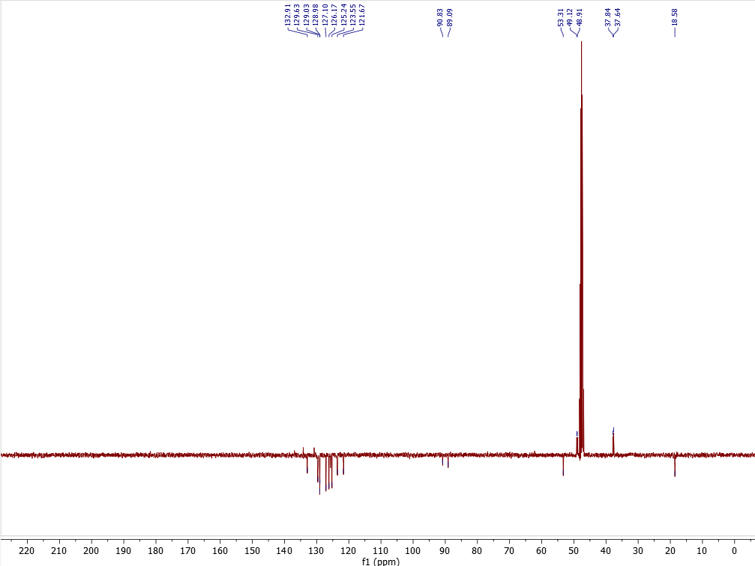

¹⁹F NMR (377 MHz, MeOD)

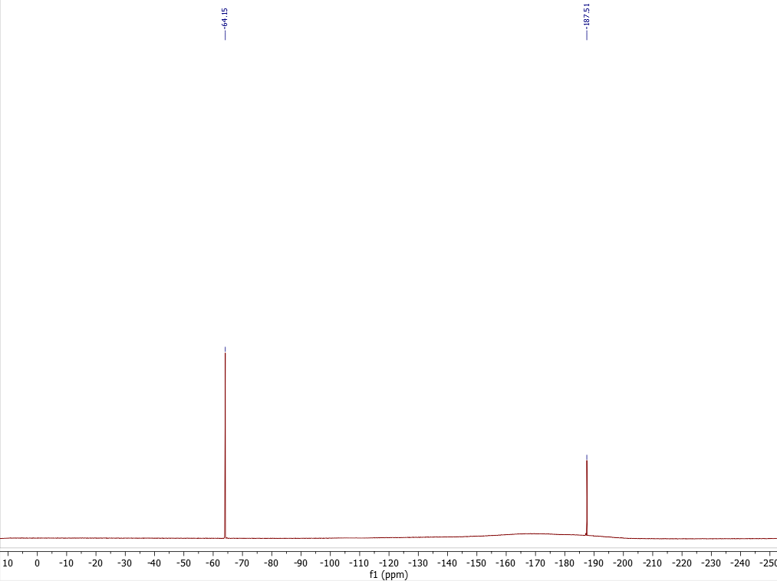

(^{F}S,R)-F-Fendiline (27)

¹H NMR (400 MHz, MeOD)
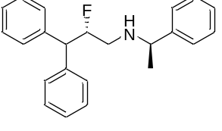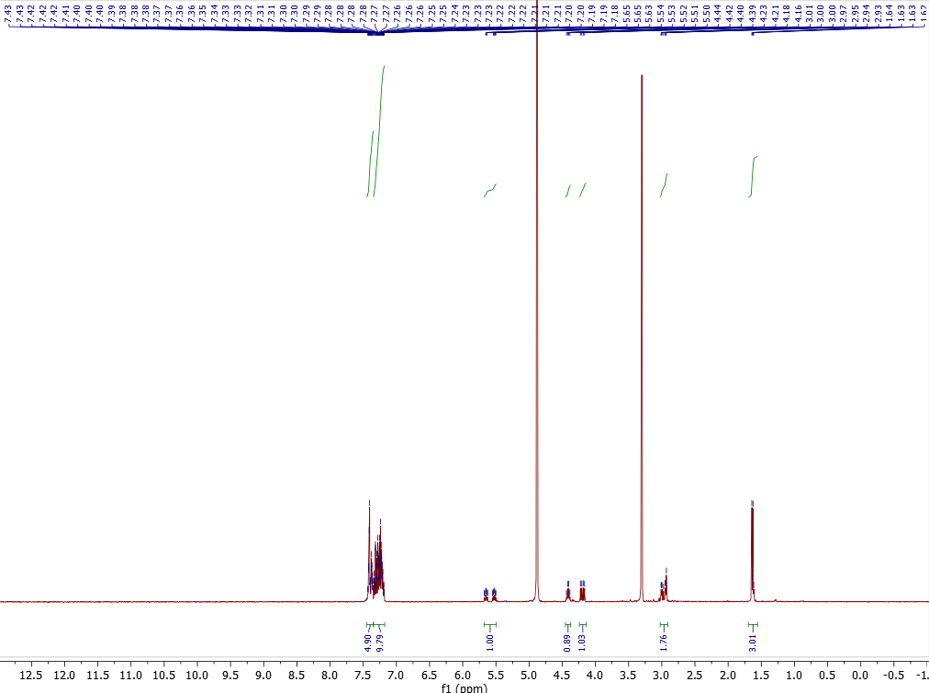

¹³C NMR (101 MHz, MeOD)
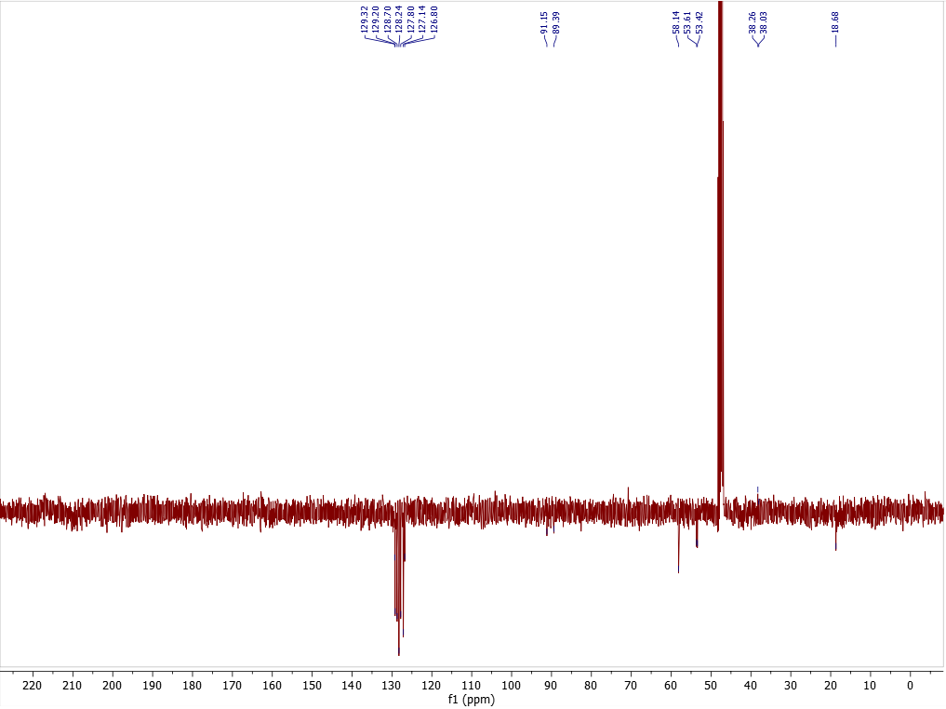

¹⁹F NMR (377 MHz, MeOD)
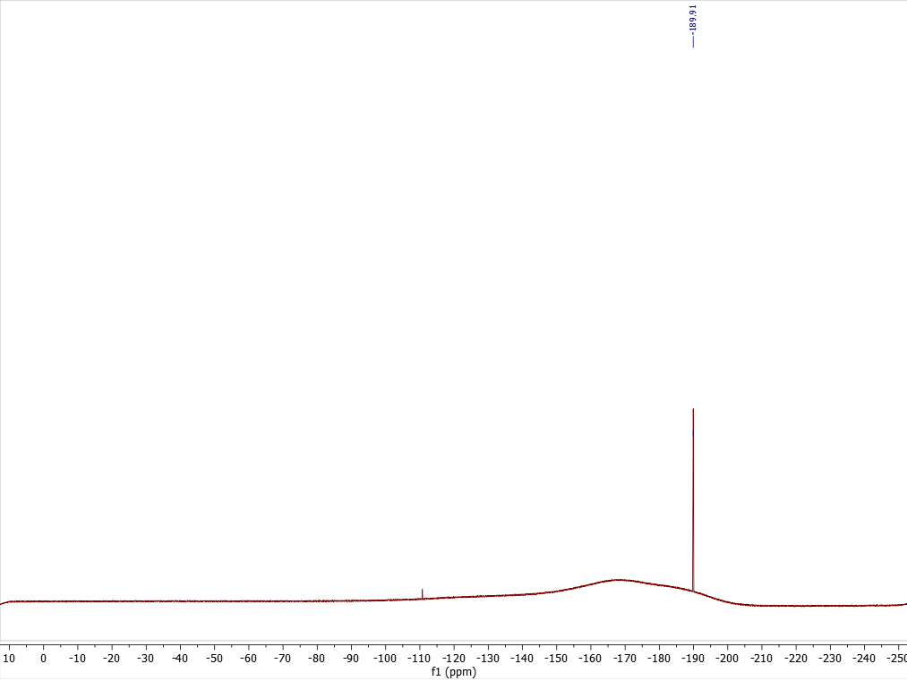

(^{F}R,R)-F-Fendiline (28)

¹H NMR (400 MHz, MeOD)
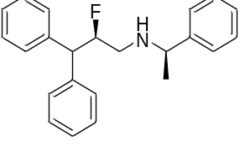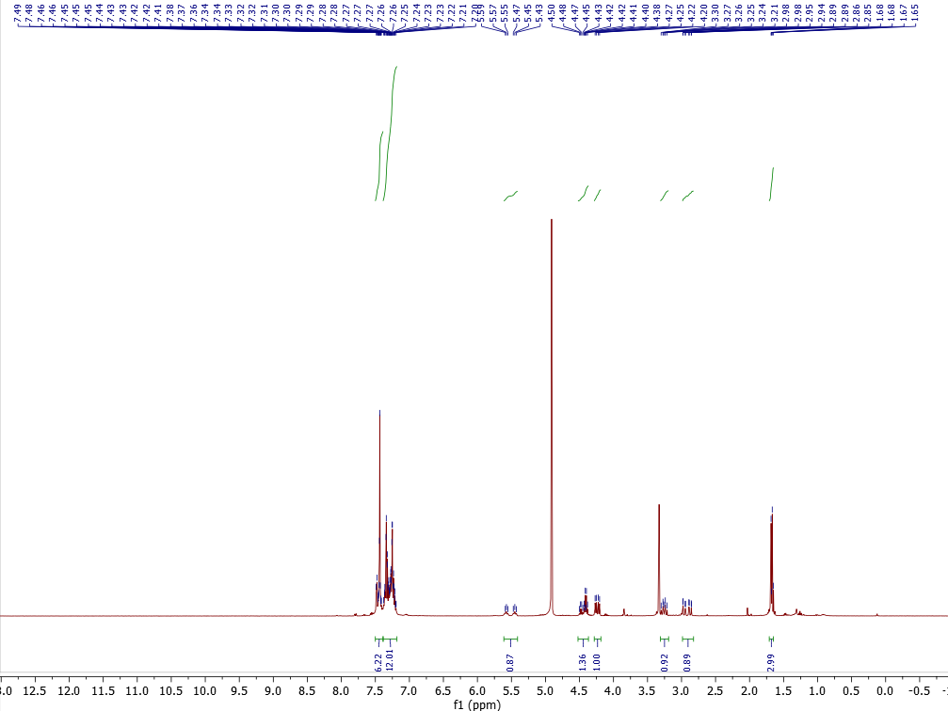

¹³C NMR (101 MHz, MeOD)
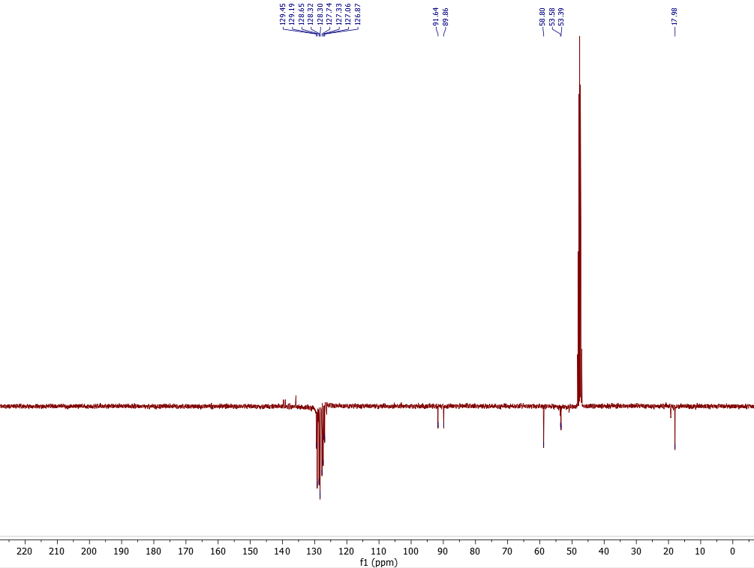
¹⁹F NMR (377 MHz, MeOD)
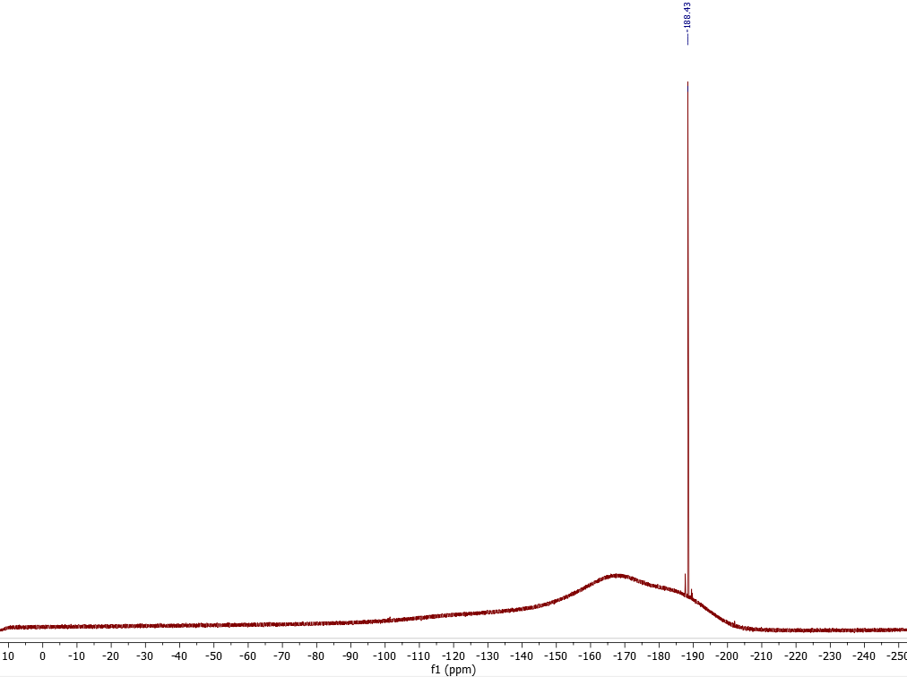

(^{F}S,R)-F-Tecalcet (24)

¹H NMR (400 MHz, MeOD)
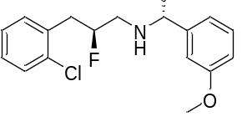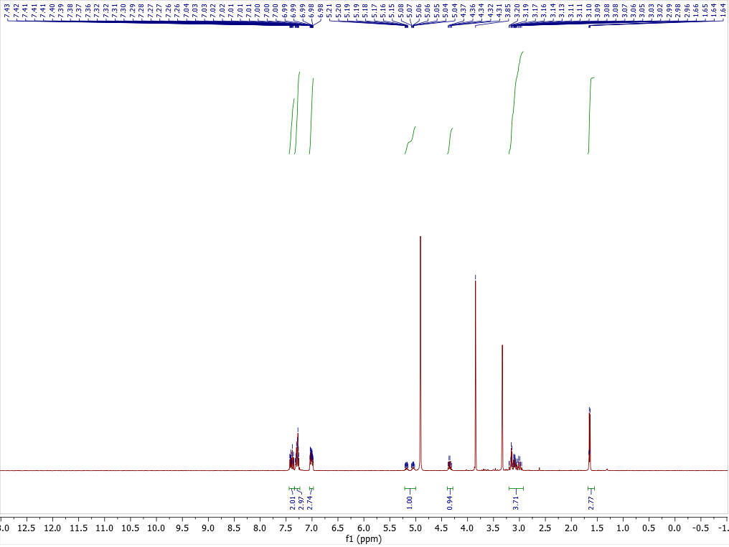

¹³C NMR (101 MHz, MeOD)

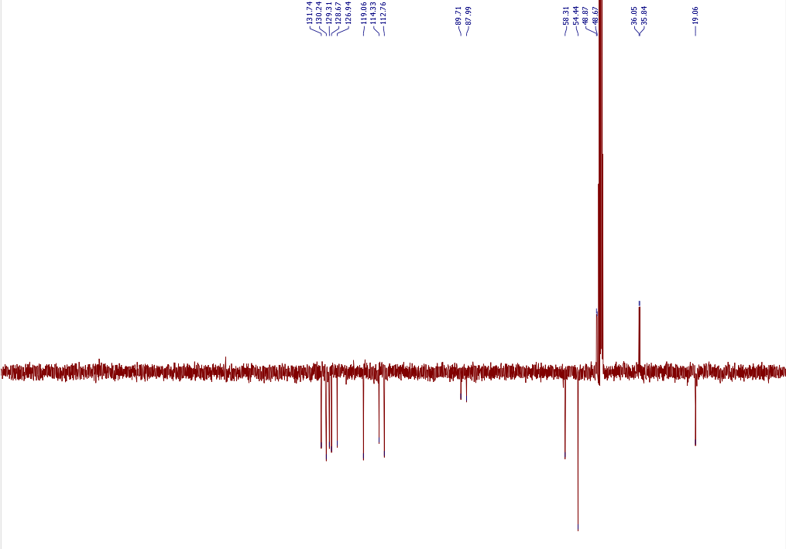

¹⁹F NMR (377 MHz, MeOD)
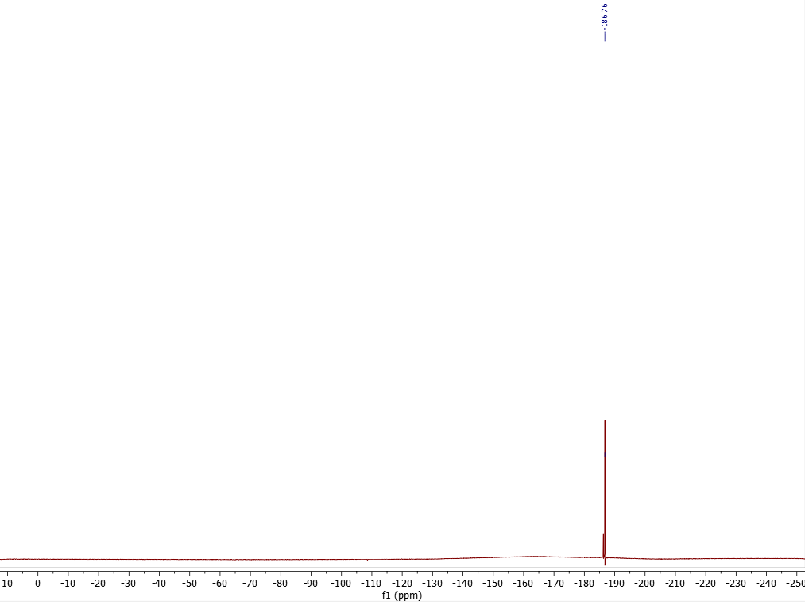

(^{F}R,R)-F-Tecalcet (25)

¹H NMR (400 MHz, MeOD)
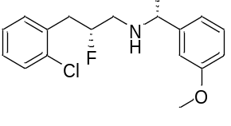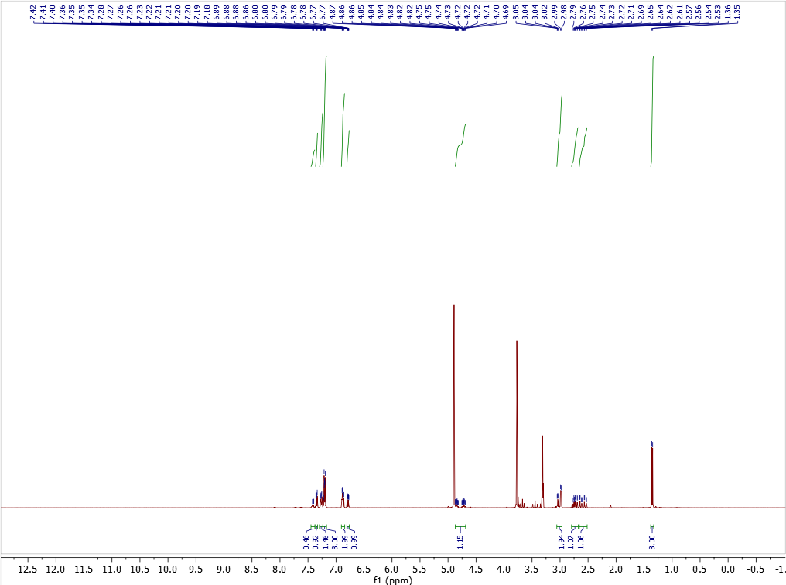

¹³C NMR (101 MHz, MeOD)
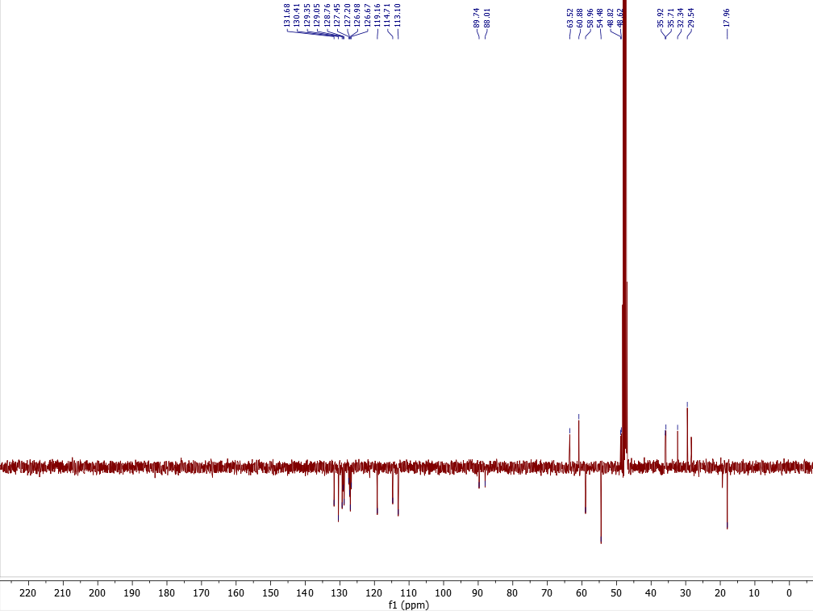

¹⁹F NMR (377 MHz, MeOD)

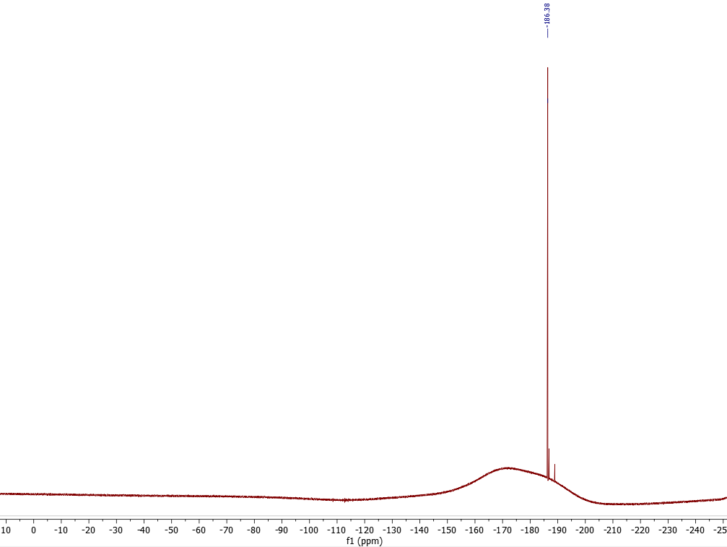
(^{F}S,R)-F-NPS R-467 (30)

¹H NMR (400 MHz, MeOD)
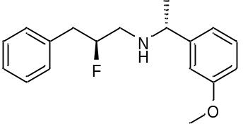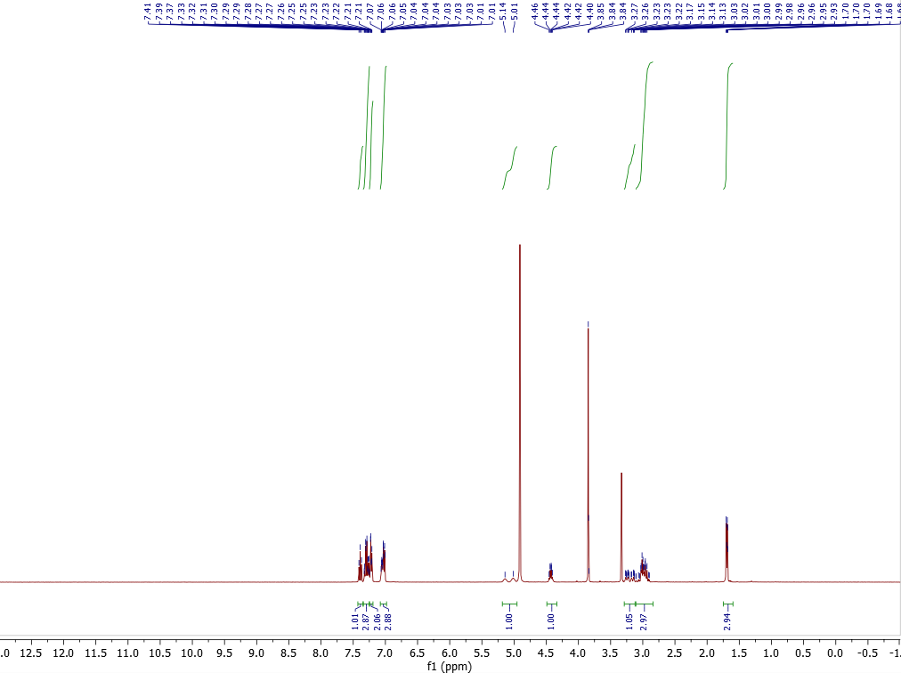

¹³C NMR (101 MHz, MeOD)

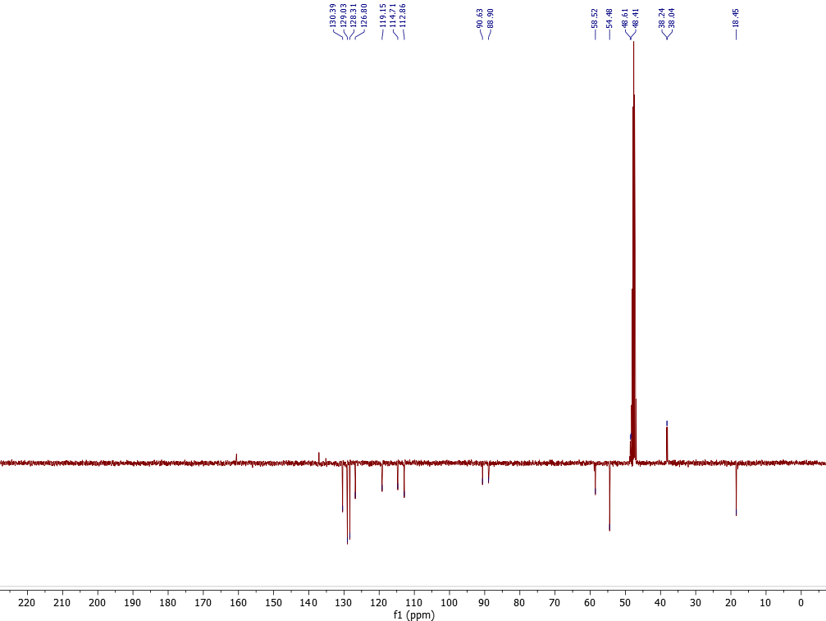

¹⁹F NMR (377 MHz, MeOD)
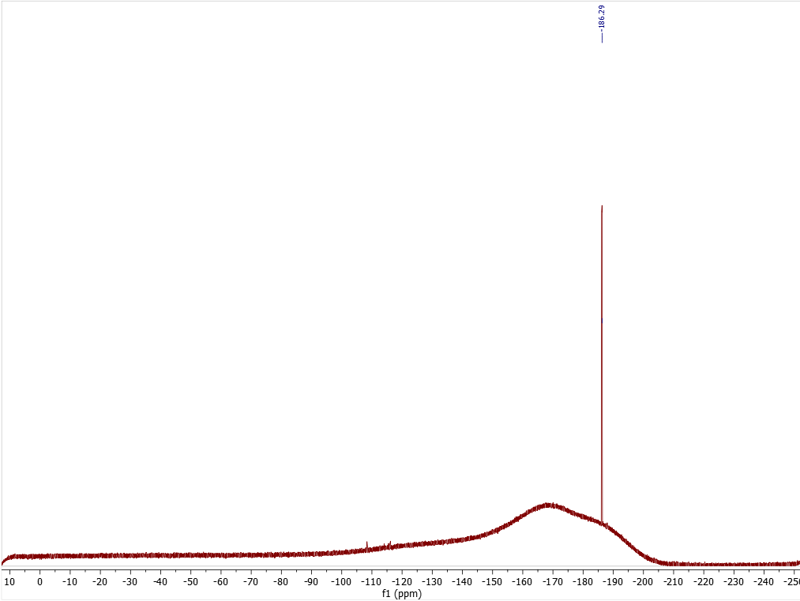

(^{F}R,R)-F-NPS R-467 (31)

¹H NMR (400 MHz, MeOD)
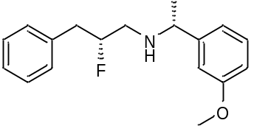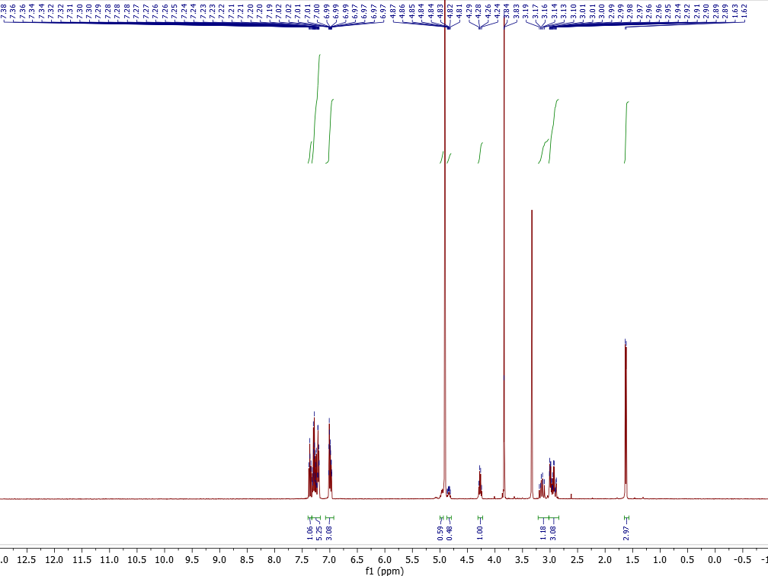

¹³C NMR (101 MHz, MeOD)
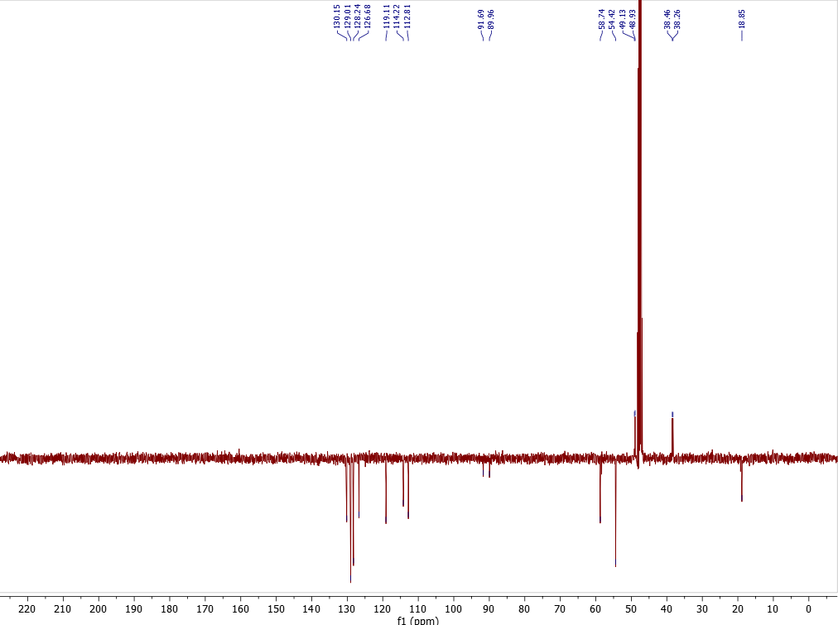

¹⁹F NMR (377 MHz, MeOD)
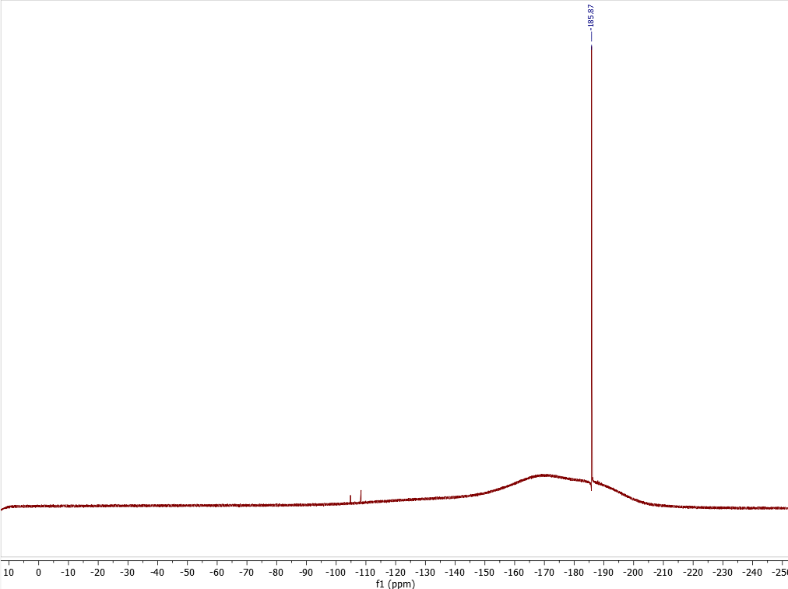

Bioassay of F-cinacalcet analogues on CaSR

Methods
Materials
The following materials were purchased: Fluo-8-AM (acetoxymethyl ester) (Abcam, Cambridge, USA); ionomycin and poly-D-lysine (Merck, New Jersey, USA); hygromycin B (Roche, Mannheim, Germany); Flp-InTM TREXTM Human Embryonic Kidney (HEK) 293 cells and all other reagents (Thermo Scientific, Massachusetts, USA).

Cell lines
Generation of DNA and FlpIn HEK TREx cells stably expressing c-myc-tagged wild type CaSR in pcDNA5/frt/TO has been described previously [10]. FlpIn HEK TREx CaSR cells were maintained in DMEM containing 5% FBS, 200μg/mL hygromycin B and 5 μg/mL blasticidin S HCl.
Ca²⁺_{i} mobilization assay in FlpIn HEK293 TRex-expressing CaSR cells
FlpIn HEK293 TRex-expressing CaSR cells were seeded in clear 96-well plates coated with poly-D-lysine (50 µg mL⁻¹) at 80,000 cells/well and incubated overnight in the presence of 100 ng mL⁻¹ tetracycline to induce CaSR expression. The following day, cells were washed with assay buffer (150 mM NaCl, 2.6 mM KCl, 1.18 mM MgCl₂, 10 mM D-Glucose, 10 mM HEPES, 0.1 mM CaCl₂, 0.5 % BSA and 4 mM probenecid at pH 7.4) and loaded with Fluo-8 AM (1 μM in assay buffer) for 1 hr at 37 ºC. Cells were washed once with assay buffer and fresh buffer was added to wells. Extracellular calcium (Ca²⁺_{o}) and positive allosteric modulators (PAMs) were co-added to wells and measurements of Ca²⁺_{i} elevations were performed at 37°C using a Flexstation (Molecular Devices). Fluorescence was detected for 60 sec at 490 nm excitation and 520 nm emission and peak fluorescence was used as a readout of the agonist response. Relative peak fluorescence units were normalised to the fluorescence stimulated by 1 μM ionomycin to account for differences in cell number and loading efficiency.

Data and Statistical analysis
The following operational model of allosterism [11] was fitted to data describing Ca²⁺_{o} concentration-response relationships in the absence and presence of PAMs:

$$\text{Effect=}\frac{{{\text{E}}_{\text{m}}\left({\text{[A+C]}}^{\text{nB}}\left({\text{K}}_{\text{B}}\text{+αβ[B]}\right)\text{+}{\text{τ}}_{\text{B}}\left[\text{B}\right]{\text{[}{\text{EC}}_{\text{50}}\text{]}}^{\text{nB}}\right)}^{\text{nT}}}{{{{\text{[EC}}_{\text{50}}\text{]}}^{\text{nB}}\left({\text{K}}_{\text{B}}\text{+[B]}\right)\text{+}\left({\text{[A+C]}}^{\text{nB}}\left({\text{K}}_{\text{B}}\text{ + αβ [B]}\right)\text{+}{\text{τ}}_{\text{B }}\left[\text{B}\right]{\text{[}{\text{EC}}_{\text{50}}\text{]}}^{\text{nB}}\right)}^{\text{nT}}}$$
Eq. 1
where EC₅₀ is the agonist concentration producing a half maximal response; K_{B} is the allosteric ligand affinity; τ_{B} is the efficacy of the allosteric ligand; α and β describe the allosteric effects on orthosteric agonist affinity and efficacy, respectively; [A] and [B] are the Ca²⁺_{o} and PAM concentrations, respectively; E_{m} is the maximal system response; nT is the slope of the transducer function linking agonist receptor occupancy to response and was constrained to unity; nB is the slope of agonist binding linking agonist concentration to occupancy; and [C] is the contaminating Ca²⁺_{o} concentration present in the assay buffer.
Non-linear regression analyses were performed in GraphPad Prism 9. Affinity, cooperativity and efficacy parameters were estimated as logarithms [12]. An F-test was used to determine whether the model fitted the data better when τ_{B} was constrained to 0, meaning the PAMs had no agonism. A one-way ANOVA with Dunnett’s multiple comparisons post-test was used to determine statistical differences between PAM pK_{B} and Logαβ compared to cinacalcet. Significance was determined by p < 0.05.

Table 1. Affinity (pK_{B}), cooperativity (Logαβ) and efficacy (Logτ_{B}) of CaSR PAMs determined in Ca²⁺_{i} mobilization assays. Data are mean ± SD from the indicated number of independent experiments (n).

PAM | pK_{B} ± SEM | Log𝜏_{B} ± SEM | Logαβ ± SEM | n
15 | 5.64 ± 0.11 | 0.27 ± 0.09^{b} | 1.63 ± 0.15 | 6
30 | 5.69 ± 0.14 | -100^{c} | 1.86 ± 0.13 | 5
18 | 5.57 ± 0.13 | -100^{c} | 2.03 ± 0.13 | 5
24 | 5.75 ± 0.14 | -100^{c} | 2.06 ± 0.14 | 4
16 | 5.82 ± 0.15 | 0.20 ± 0.11^{b} | 1.41 ± 0.21 | 4
31 | 4.11 ± 1.21 | -100^{c} | 2.92 ± 1.15 | 5
20 | 6.20 ± 0.11 | -100^{c} | 1.81 ± 0.12 | 5
21 | 5.75 ± 0.12 | -100^{c} | 1.60 ± 0.11 | 4
25 | 4.19 ± 0.68 | -100^{c} | 2.79 ± 0.63 | 4
28 | n.d.ª | n.d.ª | n.d.ª | 4
27 | 4.15 ± 0.73 | -100^{c} | 2.81 ± 0.68 | 5
ª Not determined due to a lack of saturable allosteric effect
^{b} The model fitted the data best when 𝜏_{B} was not constrained to 0 (p<0.05, F-test)
^{c} The model fitted the data best when 𝜏_{B} was constrained to 0 (p<0.05, F-test)

All PAMs retained some activity, with most have similar cooperativity to cinacalcet. 28 lost activity, therefore its affinity and cooperativity could not be quantified. 31, 25 and 27 also lost some affinity (although retained cooperativity), therefore affinity estimates are approximations with large standard error. This large standard error meant that differences in affinity or cooperativity of other PAMs compared to cinacalcet were not significant, but 20 is trending towards a higher affinity compared to cinacalcet.

References for Synthesis and Bioassay

[1] Abas H, Mas-Roselló J, Amer MM, Durand DJ, Groleau RR, Fey N, Clayden J. Angew Chem Int. Ed. 2019; 58: 2418–2422.
[2] Grošelj U, Beck A, Schweizer WB, Seebach D, Helv Chim Acta. 2014; 97: 751–796.
[3] Yue Q, Yang T, Yang Y, Zhang C, Zhang Q, Li D, Asian J. Org. Chem., 2017, 6, 936–942.
[4] L. Ghosez L, G. Yang G, J. R. Cagnon JR, F. Le Bideau F, Marchand-Brynaert J. Tetrahedron. 2004; 60: 7591–7606.
[5] Deniau G, Slawin AMZ, Lebl T, Chorki F, Issberner JP, Van Mourik T, Heygate JM, Lambert JJ, Etherington L, Sillar KT, O. Hagan D. ChemBioChem. 2007; 8: 2265–2274.
[6] Huang H, Yu C, Zhang Y, Zhang Y, Mariano PS, Wang W. J Am Chem Soc. 2017; 139: 9799–9802.
[7] Doušová H, Horák R, Růžičková Z, Šimůnek P, Beilstein J Org Chem. 2015; 11: 884–892.
[8] Chalyavi F, Gilmartin PH, Schmitz AJ, Fennie MW, Tucker MJ, Angew Chemie Int Ed, 2018; 57: 7528–7532.
[9] O’Hagan D, Rzepa HS, Schüler M, Slawin AMZ, Beilstein J Org Chem. 2006; 2: 1–13.
[10] Davey AE, Leach K, Valant C, Conigrave AD, Sexton PM, Christopoulos A. Endocrinol. 2012; 15:, 1232–1241.
[11] Gregory KJ, Giraldo J, Diao J, Christopoulos A, Leach K. Mol Pharmacol. 2020; 97: 48.
[12] Christopoulos A. Trends Pharm Sci. 1998; 19: 351–357.

X_Ray Crystallography

X-Ray diffraction data for compounds 24 and 28 were collected using a Rigaku MM-007HF High Brilliance RA generator/confocal optics with XtaLAB P100 diffractometer [Cu Kα radiation (λ = 1.54187 Å)]. Diffraction data for compound 25 were collected using a Rigaku FR-X Ultrahigh Brilliance Microfocus RA generator/confocal optics with XtaLAB P200 diffractometer [Mo Kα radiation (λ = 0.71073 Å)]. Intensity data were collected at 173 K using either both ω and φ steps or just ω steps accumulating area detector images spanning at least a hemisphere of reciprocal space. Data for all compounds analysed were collected using CrystalClear[14] and processed (including correction for Lorentz, polarization and absorption) using CrysAlisPro [15]. Structures were solved by direct methods (SIR2011) [16] and refined by full-matrix least-squares against F² (SHELXL-2018/3) [17]. Non-hydrogen atoms were refined anisotropically, and hydrogen atoms were refined using a riding model, except for those bound to nitrogen which were located from the difference Fourier map and refined isotropically subject to a distance restraint. The structure of 25 displayed rotational disorder in the orientation of the chlorophenyl ring. Atoms positions were split and refined anisotropically with restraints to bond distances and thermal motion. This structure also showed void space (164 Å³) containing diffuse electron density, and the SQUEEZE [18] routine implemented in PLATON [19] was used to remove the contribution to the diffraction pattern of the unordered electron density in the void spaces. All calculations except SQUEEZE were performed using the Olex2 [20] interface. Selected crystallographic data are presented in Table 2. CCDC 2259658-2259690 contains the supplementary crystallographic data for this paper. These data can be obtained free of charge from The Cambridge Crystallographic Data Centre via www.ccdc.cam.ac.uk/structures.

Table 2. Selected crystallographic data.

 | 24 | 25 | 28
CCDC number | 2259658 | 2259659 | 2259660
formula | C₁₈H₂₂Cl₂FNO | C₁₈H₂₂Cl₂FNO | C₂₃H₂₅ClFN
fw | 358.26 | 358.26 | 369.89
crystal description | Colourless needle | Colourless prism | Colourless prism
crystal size [mm³] | 0.16×0.03×0.01 | 0.20×0.02×0.02 | 0.11×0.08×0.05
space group | P2₁2₁2₁ | P4₁ | P2₁2₁2₁
a [Å] | 7.3528(4) | 16.6794(7) | 9.62111(9)
b [Å] | 10.6598(5) |  | 9.94701(9)
c [Å] | 23.949(2) | 7.1292(4) | 20.1391(2)
α [°]
β [°]
γ [°]
vol [Å]³ | 1877.1(2) | 1983.4(2) | 1927.34(3)
Z | 4 | 4 | 4
ρ (calc) [g/cm³] | 1.268 | 1.200 | 1.275
μ [mm⁻¹] | 3.215 | 0.339 | 1.867
F(000) | 752 | 752 | 784
reflections collected | 19872 | 12142 | 20184
independent reflections (R_{int}) | 3428 (0.0883) | 3938 (0.0365) | 3502 (0.0274)
parameters, restraints | 219, 2 | 282, 276 | 244, 2
GoF on F² | 1.017 | 1.045 | 1.044
R₁ [I > 2σ(I)] | 0.0453 | 0.0556 | 0.0237
wR₂ (all data) | 0.1183 | 0.1559 | 0.0640
largest diff. peak/hole [e/Å³] | 0.251, -0.250 | 0.770, -0.292 | 0.201, -0.132
Flack parameter | -0.001(13) | -0.02(3) | -0.019(4)

References for crystallography
[14] CrystalClear-SM Expert v2.1. Rigaku Americas, The Woodlands, Texas, USA, and Rigaku Corporation, Tokyo, Japan, 2015.

[15] CrysAlisPro v1.171.40.14a and v1.171.40.40a. Rigaku Oxford Diffraction, Rigaku Corporation, Oxford, U.K., 2018-2020.

[16] Burla, M. C.; Caliandro, R.; Camalli, M.; Carrozzini, B.; Cascarano, G. L.; Giacovazzo, C.; Mallamo, M.; Mazzone, A.; Polidori, G.; Spagna, R. SIR2011: a new package for crystal structure determination and refinement. J. Appl. Crystallogr. 2012, 45, 357-361. doi: 10.1107/S0021889812001124.

[17] Sheldrick, G. M. Crystal structure refinement with SHELXL. Acta Crystallogr., Sect. C: Struct. Chem. 2015, 71, 3-8. Doi: 10.1107/S2053229614024218.

[18] Spek, A. L. PLATON SQUEEZE: a tool for the calculation of the disordered solvent contribution to the calculated structure factors. Acta Crystallogr. Sect C: Struct. Chem. 2015, 71, 9-18. doi: 10.1107/S2053229614024929.

[19] Spek, A. L. Structure validation in chemical crystallography. Acta Crystallogr. Sect D: Biol. Crystallogr. 2009, 65, 148-155. doi: 10.1107/S090744490804362X.

[20] Dolomanov, O. V.; Bourhis, L. J.; Gildea, R. J.; Howard, J. A. K.; Puschmann, H. OLEX2: a complete structure solution, refinement and analysis program. J. Appl. Crystallogr. 2009, 42, 339-341. doi: 10.1107/S0021889808042726.

